Supplementary Inforamtion
The supplementary information file consists of five supplementary figures.

Supplementary Figure
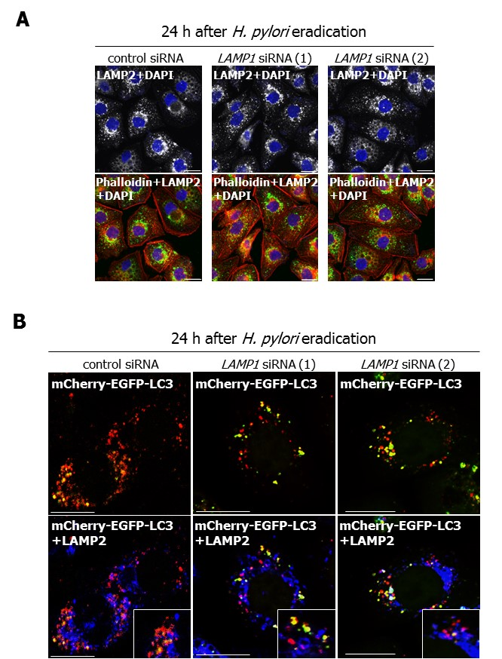
Figure S1. Expression and distribution of LAMP2 in AGS cells treated with LAMP1 siRNA. (A) AGS cells were transfected with control, LAMP1 siRNA-1, or LAMP1 siRNA-2, infected with H. pylori for 5 h (multiplicity of infection [MOI] 50) and incubated in a medium containing antibiotic for 24 h. Then, LAMP2 and phalloidin staining were performed. Nuclei (blue) were stained with DAPI. Scale bar: 20 μm. (B) AGS cells, which had been transfected with pTet-On and TRE2hyg-mCherry-EGFP-LC3 plasmids, were transfected with control, LAMP1 siRNA-1, or LAMP1 siRNA-2, infected with H. pylori for 5 h (MOI 50), and incubated in a medium containing antibiotic for 24 h, and then immunostained for LAMP2. Scale bar: 20 μm.

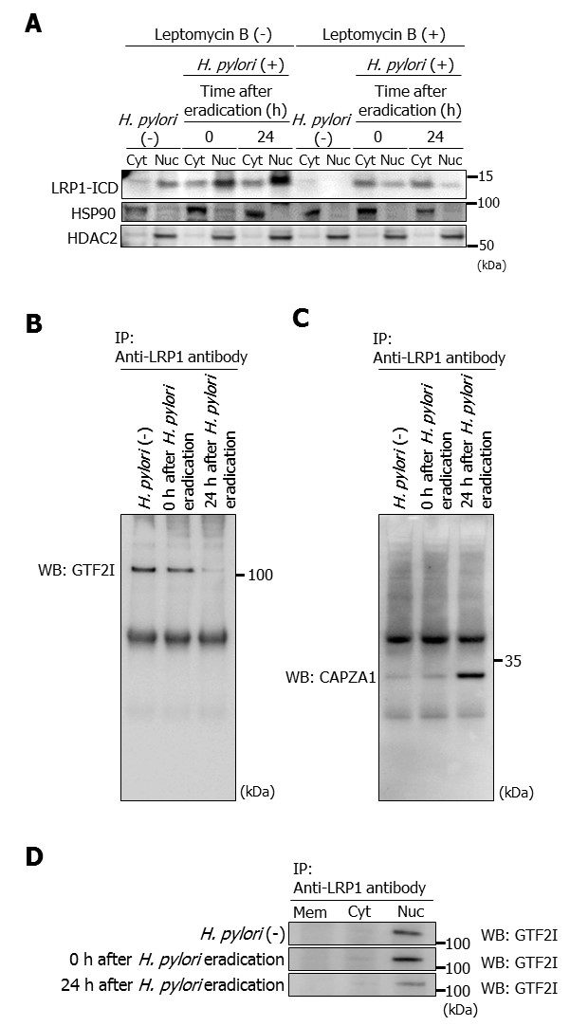
Figure S2. Confirmation of interaction of GTF2I and CAPZA1 with LRP1-ICD by western blot analysis of the immunoprecipitates. (A) AGS cells were treated with 200 nM leptomycin B overnight, infected with H. pylori for 5 h (MOI 50), and incubated in a medium containing antibiotic for the indicated times. Then, subcellular fractionation of these cells indicated the localization of LRP1-ICD in cytoplasmic (Cyt) and nuclear (Nuc) extracts. (B and C) AGS cells were infected with H. pylori for 5 h (MOI 50) and incubated in a medium containing antibiotic for 0 and 24 h. An immunoprecipitation assay was performed on these cells with an anti-LRP1-carboxyterminal end antibody. GTF2I (B) and CAPZA1 (C) were detected. (D) AGS cells were infected with H. pylori for 5 h (MOI 50) and incubated in a medium containing antibiotic for 0 and 24 h. After subcellular fractionation of these cells, an immunoprecipitation assay was performed with an anti-LRP1-carboxyterminal end antibody. The localization of GTF2I was detected in cell membrane (Mem), cytoplasmic (Cyt) and nuclear (Nuc) extracts.

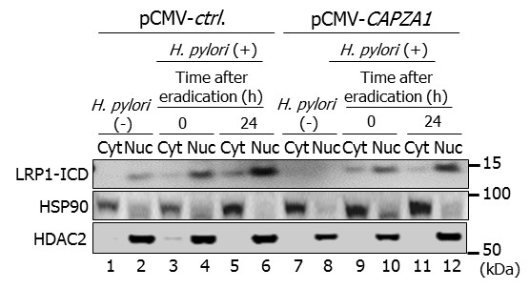
Figure S3. Effect of CAPZA1 overexpression on cytoplasm-nuclear transport of LRP1-ICD. AGS cells were transfected with pCMV-control or pCMV-CAPZA1 plasmids, infected with H. pylori for 5 h (MOI 50), and incubated in a medium containing antibiotic for the indicated times. Then, subcellular fractionation of these cells indicated the localization of LRP1-ICD in cytoplasmic (Cyt) and nuclear (Nuc) extracts.

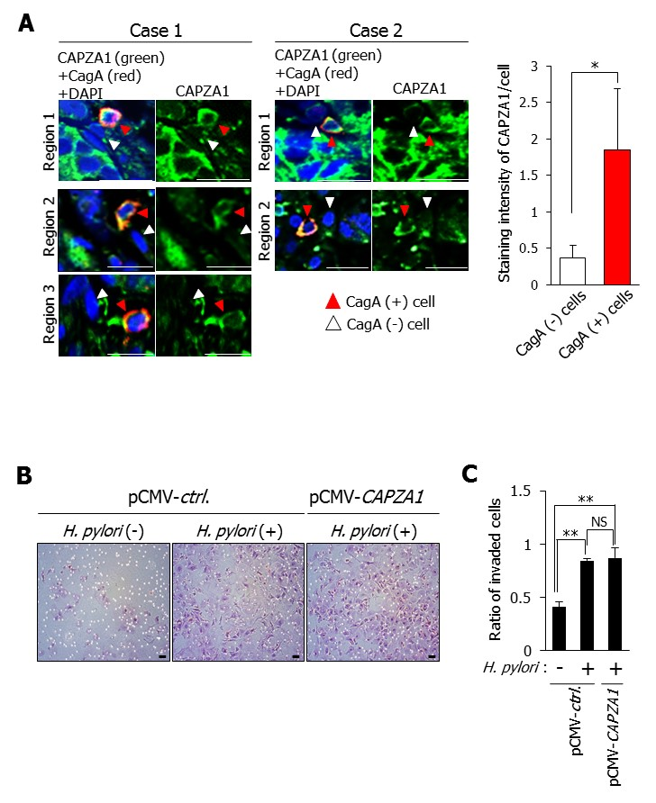
Figure S4. Staining intensity of CAPZA1 in CagA-staining cells and cell invasion ability of CAPZA1-overexpressing AGS cells. (A) The staining intensity of CagA-positive cells (red arrowhead) and their adjacent CagA-negative cells (white arrowhead) were quantified by using the ImageJ program. Data are presented as the mean ± SD of 5 cells. *P < 0.05. Scale bar: 20 μm. (B) AGS cells were transfected with pCMV-control or pCMV-CAPZA1 plasmids and infected with H. pylori for 5 h (MOI 50). The cells were added to the top chambers of 24-well Trans-well plates, which were either coated with Matrigel® barriers or uncoated. After 24-h incubation, invaded cells were stained with hematoxylin and eosin. Scale bar: 20 μm. (C) The numbers of invading cells were counted and fractions of invaded cells were calculated. Data are presented as the mean ± SD of 3 independent assays. **P < 0.01, NS, not significant.

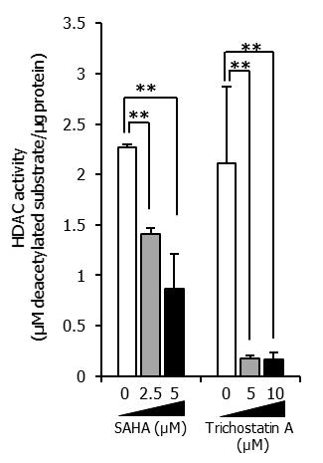
Figure S5. HDAC activity in AGS cells treated with SAHA or trichostatin A. AGS cells were incubated with SAHA or trichostatin A for 24 h, and HDAC activities were measured. Data are presented as the mean ± SD of 3 independent assays. **P < 0.01.

