**Supplementary Data**

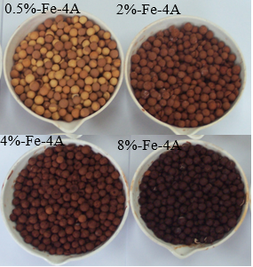

**Figure S1.** The photographs of the n-Fe-4A catalyst with different iron-load



**Figure S2.** The pore width of 4%-Fe-4A catalyst based on the N2 adsorption-desorption isotherms.



**Figure S3.** Dimensionless concentration of TBA versus time in the presence of 4%-Fe-4A. Conditions: TBA initial concentration = 1 mM, catalyst dose = 0.4 g/L.



**Figure S4.** Aqueous ozone profile versus time in different treatment systems.



**Figure S5.** Non-linear regression fitting curve of ozone concentration versus time in 4%-Fe-4A/O3 system.



**Figure S6.** Effect of solution pH on ATZ degradation by plain ozonation and catalytic ozonation. Conditions: ATZ initial concentration = 40 mg/L, catalyst dose = 0.4 g/L.

**Table S1.** The value of parameter a, b, c in different systems.

|  |  |  |  |  |
| --- | --- | --- | --- | --- |
| Different system | a | b | c | R2 |
| O3  4A**/**O3 | 2.89×10-4  2.97×10-4 | 2.96×10-4  3.06×10-4 | -0.00420  -0.00462 | 0.992  0.993 |
| 0.5%Fe-4A**/**O3 | 2.48×10-4 | 2.55×10-4 | -0.00503 | 0.993 |
| 2%Fe-4A**/**O3 | 1.74×10-4 | 1.81×10-4 | -0.00689 | 0.983 |
| 4%Fe-4A**/**O3 | 1.54×10-4 | 1.60×10-4 | -0.00724 | 0.983 |
| 8%Fe-4A**/**O3 | 2.03×10-4 | 2.10×10-4 | -0.00613 | 0.991 |