An experimental investigation on the application potential of heterogeneous catalyzed Nahar biodiesel and its diesel blends as diesel engine fuels
Santosh Kumar Dash,*ª Pradip Lingfa ª and Supriya B. Chavan ^{b}
ª Department of Mechanical Engineering, NERIST, Nirjuli-791109, Arunachal Pradesh, India, Email: 90nash@gmail.com
^{b} Department of Chemistry, Bhagwant University, Ajmer-305004, Rajasthan, India
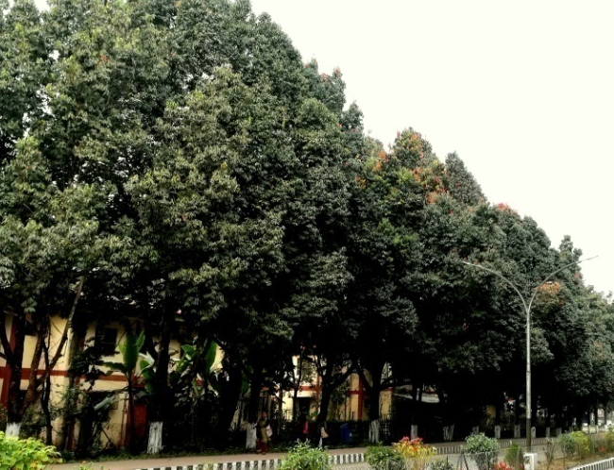
Figure 9 Nahar tree with fruits in NERIST college campus, Arunachal Pradesh, India
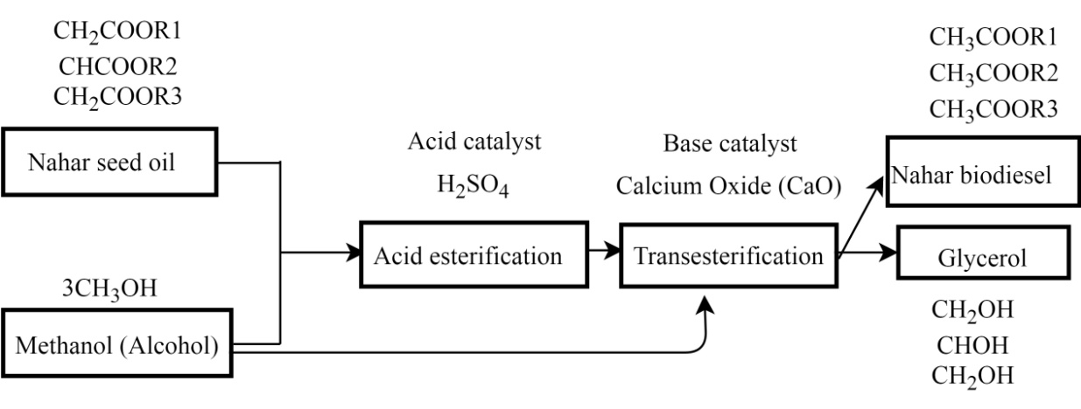
Figure 10 Nahar biodiesel production process
Table 2
Fatty acid composition (%) of Nahar oil
Fatty acid name | Formula | Composition (%)
Myristic acid | C14:0 | 2.3
Palmitic acid | C16:0 | 16.690
Stearic acid | C18:0 | 8.8
Behenic acid | C22:0 | 0.445
Tricosanoic acid | C23:0 | 0.199
Oleic acid | C18:1n9c | 45.859
Cis-11 Ecosenoic acid | C20:1 | 0.992
Linoleic acid | C18:2n6c | 22.099
Alpha-Linolenic acid | C203n6 | 0.013
Cis-8,11,14-Ecosatrienoic acid | C18:3n3 | 0.197
Arachidonic acid | C20:4n6 | 0.331
Cis-13,16 Docosadienoic acid | C22:2 | 0.103

Biodiesel Yield (%) = (Weight of biodiesel obtained/Weight of raw oil used) ×100
(Chavan et al., 2017)
Biodiesel conversion (%) =$\frac{p-q}{p} ×100$, where p= Initial acid value and q= Final acid value
(Madhu et al., 2016)
Table 3
Elemental composition of Nahar biodiesel and diesel
Parameter | Nahar biodiesel  wt. % | Diesel  wt. % | Test method ASTM
Carbon (%) | 77.19 | 86.4 | D 3178
Hydrogen (%) | 10.37 | 13.1 | D 3178
Nitrogen (%) | 0.03 | 0.14 | D 3228
Oxygen (%) | 12.02 | Nil | E 385
Sulfur (%) | Nil | 0.22 | D 3177
C/H ratio | 7.44 | 6.59 | —

Table 4
Accuracy and uncertainty of instruments
Instruments | Measured parameter | Accuracy | Uncertainty (%)
Loading unit | Load (kg) | ±0.01 | ±0.2
Speed sensor | Engine speed | ±10 rpm | ±2.1
Pressure transmitter | Cylinder pressure, bar | ±0.1 | ±0.1
Crank angle encoder | Crank angle position | ±1˚CA | ±0.01
Burette | Fuel consumption | ±0.2 cm³ | ±0.5
AVL gas analyzer | HC | ±4 ppm | ±0.6
 | CO | ±0.02 % vol | ±0.03
 | NO | 5 ppm | 1.22
AVL smoke meter | Smoke density | ±0.1 | ±0.1

Uncertainty Analysis
Some amount of uncertainty is always associated with any kind of experimental work. Hence, to judge the fitness value, uncertainty analysis is highly recommended. In the present study, Kline and Mc-Clintock method was used to calculate the uncertainty of the known physical parameter$R$, which is a function of independent variables${ x}_{i }$.
$R=R(x_{1}, x_{2},x_{3}……… x_{n})$ (1)
In the above equation, R is a function of the independent variables $x_{1}, x_{2},x_{3}……… x_{n}$
(n numbers)
In this method, the uncertainty of the result$R$ is calculated from the uncertainties of the various independent variables.
Let $U_{R}$ be the uncertainty of the result $R$ and $w_{1}, w_{2}, w_{3}, ……… w_{n}$ be the uncertainties in the independent variables $x_{1}, x_{2},x_{3}……… x_{n}$ respectively.
From the Taylor series expansion of the$R$, after truncation of all non-linear terms, the effect of uncertainty in $x_{i}$ on the uncertainty of the result R as $U_{Rx_{i}}=\frac{∂R}{{∂x}_{i}}w_{i}$ (2)
Combining optimally the effect of all independent variables is given by
${ U}_{R}={\left[ \sum_{i=1}^{n}{{\left(\frac{∂R}{{∂x}_{i}}w_{i}\right)}^{2} }\right]}^{1/2}$ (3)
For the error analysis, as many as 20 sets of observation have been recorded at the same engine operating condition and analyzed. Overall uncertainty of the instruments is found to be less than ± 3%. The uncertainties of various parameters calculated in this experiment are listed in Table 4.
Table 5 Technical specification of gas analyzer
Measured parameter | Range | Resolution | Accuracy | Principle of measurement
CO | 0-15% vol. | 0.01% vol. | <10% vol: ±0.02% vol.  ≥10% vol: ± 5% O. M.* | NDIR
CO2 | 0-20% vol. | 0.01% vol. | <16% vol: ± 0.3% vol.  ≥16% vol: ±5% O. M. | NDIR
HC | 0-30000 ppm | 1 ppm vol. | <2000 ppm: ±4 ppm vol.  ≥5000 ppm: ±5% O. M.  ≥10000 ppm: ±10% O. M. | NDIR
O2 | 0-25% vol. | 0.01% vol. | ±0.02 % vol.± 1% O.M. | Electro-chemical
NO | 0-5000 ppm. | 1 ppm vol. | ±5 ppm ± 1% O.M. | Electro-chemical
*O.M. = Original Measurement
CO emission in g/kWh=$\left[\left\{\frac{\left(mf+ma\right)}{29}×10\right\}×CO (in \% Vol.)×\frac{28}{BP}\right]$
HC emission in g/kWh= =$\left[\left\{\frac{\left(mf+ma\right)}{29}×1000\right\}×HC (in ppm)×\frac{13}{BP}\right]$
(Reference for CO and HC conversion: PhD thesis-2016, Dr. Debabrata Barik, NIT Rourkela, India)

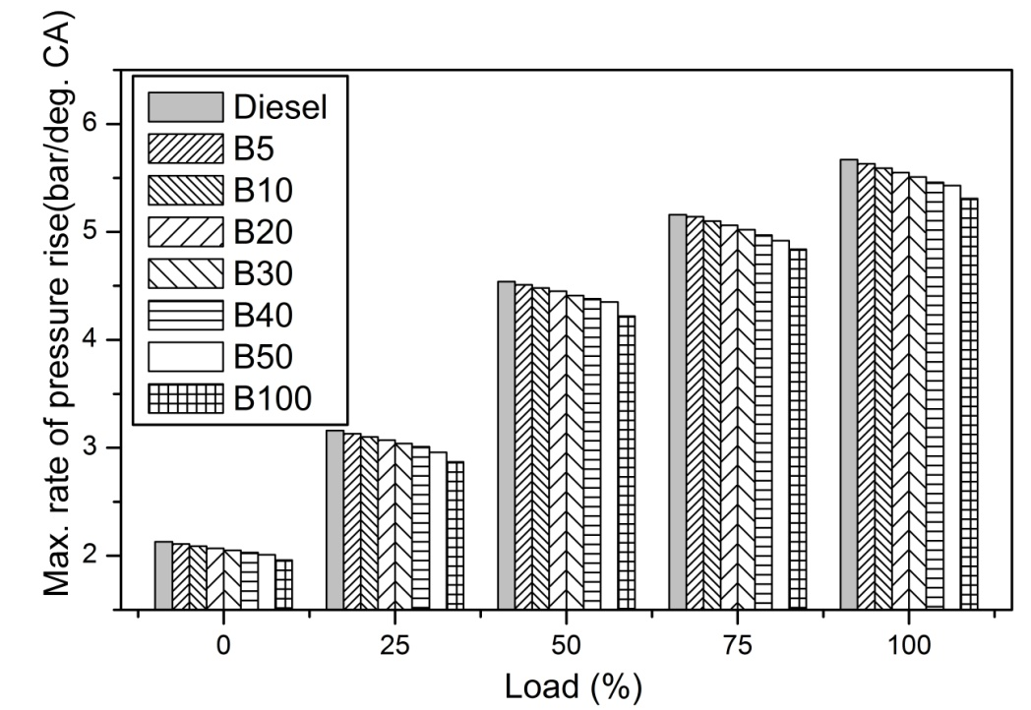
Maximum rate of pressure rise:
Figure 11 Variation of maximum rate of pressure rise with load
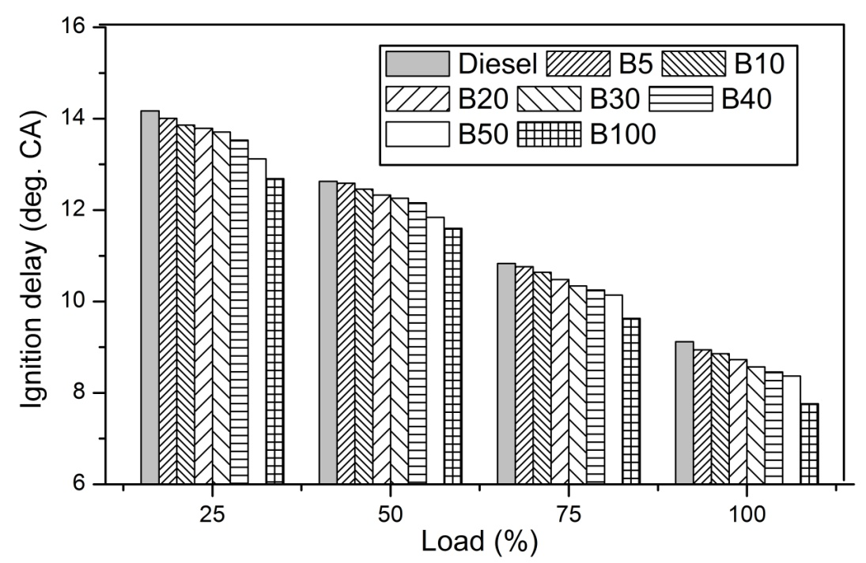
Ignition delay:
Figure 12 Variation of ignition delay with load

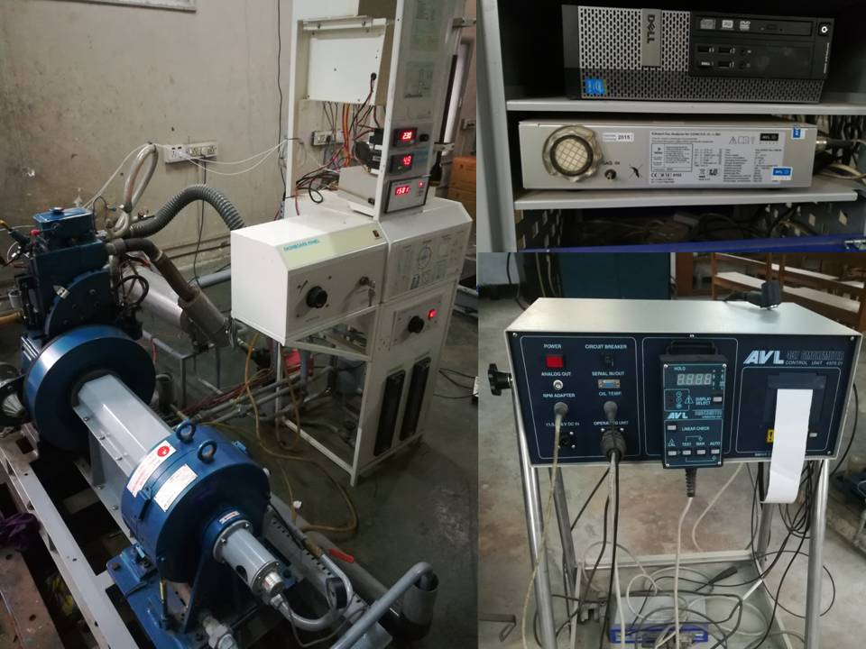
Test engine

AVL gas analyzer

AVL smoke meter

Figure 13 Experimental setup.

Table 6 Specification of the test engine setup
Engine parameter | Specification
Make | Kirloskar
Details | 1 cylinder, 4 stroke, Direct injection, VCR, water cooled diesel engine
Bore and stroke | 87.5 mm × 110 mm
Capacity | 661cc
Compression ratio | 17.5:1
Rated power output | 3.5 kW at 1500 rpm
Injection timing | 23 °BTDC
Pressure sensor | Piezo sensor, 5000 psi range
Temperature sensor | PT100 and Thermocouple, Type K
Load cell | Sensortronics make, Model 60001
Eddy current dynamometer | Model AG10 of Saj Test Plant pvt. Ltd.
Data acquisition device | NI USB-6210,16 bit
Crank angle sensor | Resolution 1 degree, speed 5500 RPM with TDC pulse.
Inlet valve open | 4.5 ° CA before TDC
Inlet valve close | 35.5 °CA after BDC
Exhaust valve open | 35.5 °CA before BDC
Exhaust valve close | 4.5 °CA after TDC

