

**[a]**



**[b]**



**[c]**

**Supporting information S1: Powder XRD profile of Lanthanum complexes (a) [La(C15H12N2OH)2(H2O)Cl] (b) [La(C15H12N2OH)(C5H10NS2)(2H2O)Cl] (c) [La(C15H12N2OOCH3(C2H5OCS2)(2H2O)Cl]**

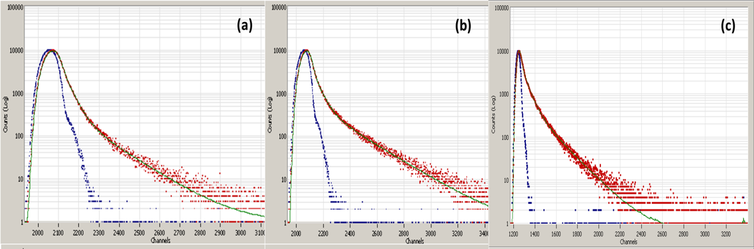

**Supporting information S2: Fluorescence life-time decay curve for the complexes (a) [La(C15H12N2OH)(C5H10NS2)(2H2O)Cl] (b) [La(C15H12N2OOCH3)(C2H5OCS2)(2H2O)Cl]**

**and (c) [La(C15H12N2OH)2(H2O)Cl]**