Appendix A. News stories provided to participants in risk information group and control group prior to email judgement task.
Rio Olympics 2016: Spectacular closing ceremony (both groups)

The spectacular ending of this summer’s Olympic Games in Rio de Janeiro featured a colorful carnival parade and ceremony lasting almost 3 hours. The 16-day games, which showcased over 11,000 athletes, were officially closed by the chief of the International Olympic Committee, Thomas Bach. The closing ceremony on Aug. 21. was watched by billions of people around the world and included a dramatic extinguishing of the Olympic flame.

The rise in online scams (risk information group only)

A number of public-safety forums have been established to warn residents of the dangers of scams in the digital age. Criminals are making use of advancements in technology to make scams increasingly targeted and convincing. Anyone can fall victim to a scam, young or old. Across the world the problem of fake websites, emails and fraudulent phone calls is on the rise, so people need to increasingly be on their guard in this technological era.

The challenge of sedentary lifestyles (control group only)

Sitting down all day is not good for you. The rise in desk jobs and inactivity means that many of us have a sedentary lifestyle. Research has shown that the long periods of physical inactivity associated with a sedentary lifestyle are bad for our health. Reducing this risk remains a challenge across the globe, but one thing is for sure, we should all be trying to keep ourselves moving -so stand up, move more and ‘watch’ less.

Appendix B. Example stimuli for each of the email conditions.
a) High authenticity email related to Rio Olympics.
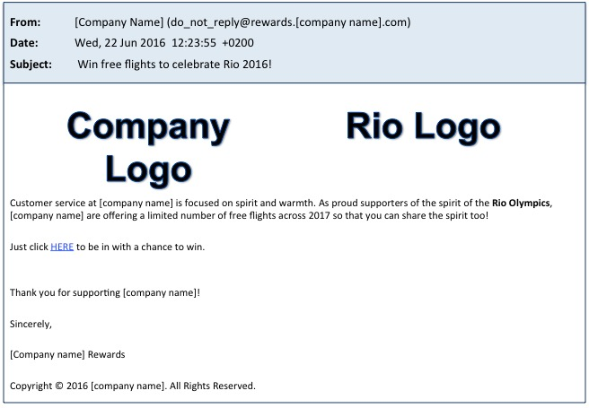
b) High authenticity email unrelated to Rio Olympics.
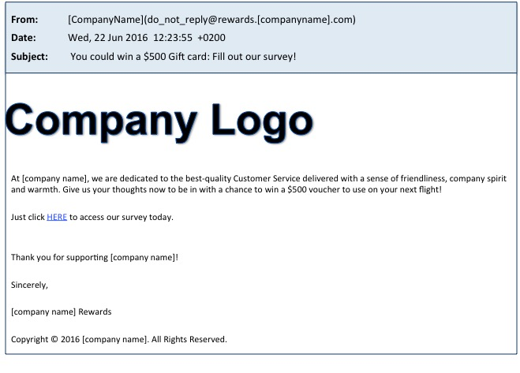
c) Low authenticity email related to Rio Olympics.
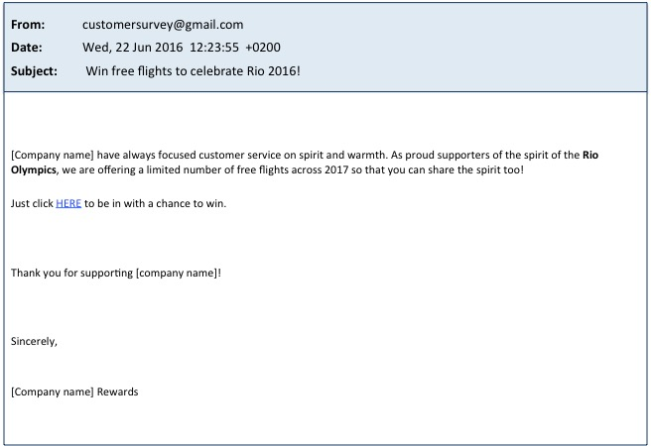
d) Low authenticity email unrelated to Rio Olympics.
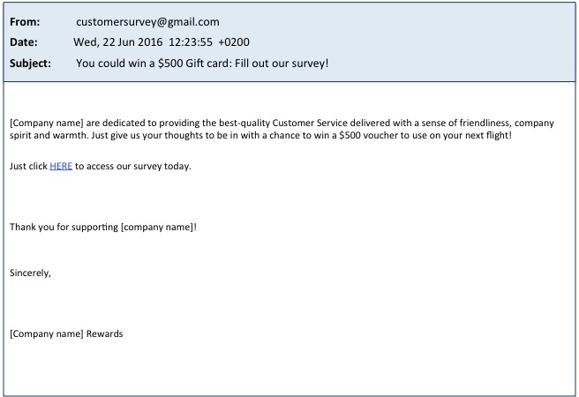
e) High authenticity loss email.
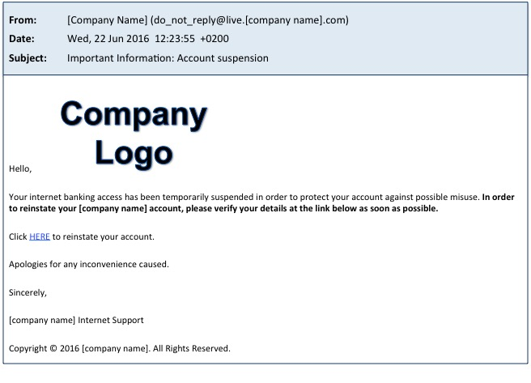
f) Low authenticity loss email.
