**Supporting Information**

**A green chemical oligomerization of phloroglucinol induced by plasma as a new class of -glucosidase inhibitor**

Soonho Choi a#, Gyeong Han Jeong b#, Kyung-Bon Lee c#, Cheorun Jo d, Tae Hoon Kim b,*

a Department of Crop Science and Biotechnology, Seoul National University, Seoul 08826, Republic of Korea

b Department of Food Science and Biotechnology, Daegu University, Gyeongsan 38453, Republic of Korea

c Department of Biology Education, Chonnam National University, Gwangju 61186, Republic of Korea

d Department of Agricultural Biotechnology and Research Institute of Agriculture and Life Science, Seoul National University, Seoul 08826, Republic of Korea

* Corresponding Author.

*E-mail address*: [skyey7@daegu.ac.kr](mailto:skyey7@daegu.ac.kr) (T.H.Kim).

# These authors contributed equally to this work.

**Contents of Supplementary Data**

**Figure S1.** 1H NMR spectrum of compound **5** in CD3OD.

**Figure S2.** 13C NMR spectrum of compound **5** in CD3OD.

**Figure S3.** HRFABMS spectrum of compound **5**.

**Figure S4.** HPLC chromatograms of plasma treated phloroglucinol (**1**) for 60 min and the isolates **2**–**5***.*

* Spectroscopic data for known compounds **2**-**4**.

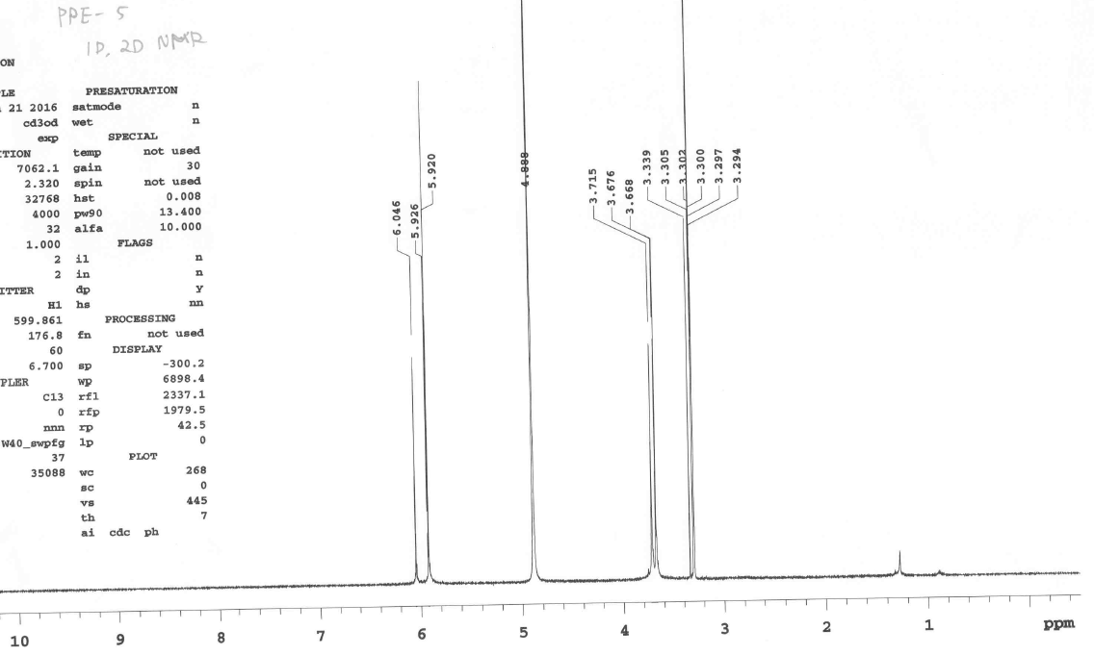

**Figure S1.** 1H NMR spectrum of compound **5** in CD3OD.

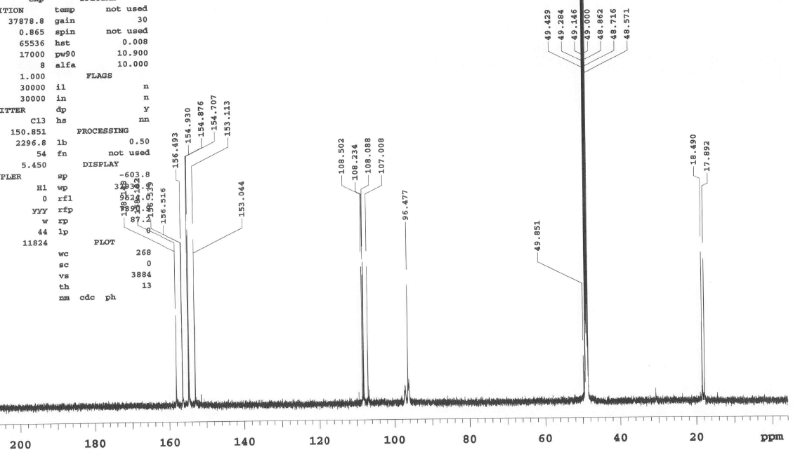

**Figure S2.** 13C NMR spectrum of compound **5** in CD3OD.

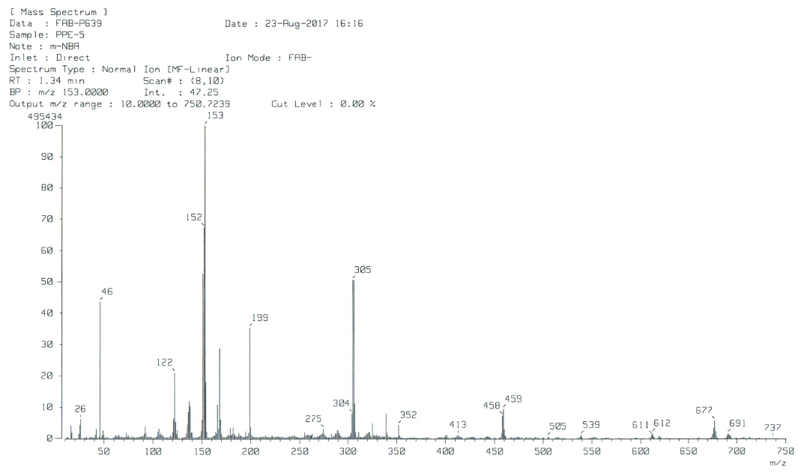

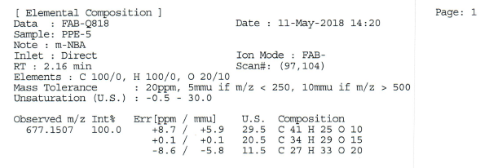

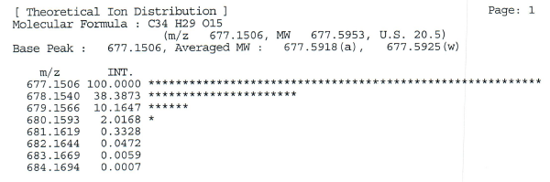

**Figure S3.** HRFABMS spectrum of compound **5**.

EMB00000e503098EMB00000e50309cEMB00000e50309fEMB00000e5030a2EMB00000e5030a5

Compound **4**

Plasma treated for 60 min

Compound **5**

Compound **2**

Compound **3**

EMB00000e5030ab

Phloroglucinol (**1)**

**Figure S4.** HPLC chromatograms of plasma treated phloroglucinol (**1**) for 60 min and the isolates **2**–**5***.*

**\*Spectroscopic data for known compounds 2-4**

***Bis*(2,4,5-Trihydroxy-3-(2',4',5'-trihydroxybenzyl)phenyl)methane** (**2**): Yellow amorphous powder, FABMS *m/z* 539 [M-H]-, 1H NMR (CD3OD, 600 MHz): *δ* 6.04 (2H, s, H-4ꞌ, 10), 5.92 (4H, s, H-2, 4, 8ꞌ, 10ꞌ), 3.71 (2H, s, H-8a), 3.67 (4H, s, H-6a, 6ꞌa), 13C NMR (CD3OD, 150 MHz): *δ* 157.0 (C-1, 5, 7ꞌ, 11ꞌ), 155.5 (C-9ꞌ, 11), 153.5 (C-3, 5’,), 152.7 (C-1, 5, 7ꞌ, 11’), 106.6 (C-2ꞌ, 6), 106.4 (C-12, 12ꞌ), 105.1 (C-6ꞌ, 8ꞌ), 96.0 (C-4ꞌ, 10), 95.4 (C-2, 4, 8ꞌ, 10ꞌ), 17.5 (C-8a), 16.9 (C-6a, 6ꞌa).

**2,4-*Bis*(2',4',6'-Trihydroxylbenzyl)phloroglucinol** (**3**): Yellow amorphous powder, FABMS *m/z* 401 [M-H]-, 1H NMR (CD3OD, 600 MHz): *δ* 6.03 (1H, s, H-10), 5.91 (4H, s, H-2, 4, 4ꞌ, 6ꞌ), 3.66 (2H, s, H-6a, 8a), 13C NMR (CD3OD, 150 MHz): *δ* 158.1 (C-3, 5ꞌ), 156.5 (C-1, 1ꞌ, 3ꞌ, 5), 154.4 (C-9, 11), 153.1 (C-7), 108.4 (C-2ꞌ, 6), 107.1 (C-8, 12), 97.4 (C-10), 94.5 (C-1, 1ꞌ, 3ꞌ, 5), 17.9 (C-6a, 8a).

***Bis*(2,4,6-Trihydroxyphenyl)methane** (**4**): Yellow amorphous powder, FABMS *m/z* 263 [M-H]-, 1H NMR (CD3OD, 600 MHz): *δ* 5.83 (4H, s, H-2, 4, 8, 10), 3.47 (2H, s, H-6a), 13C NMR (CD3OD, 150 MHz): *δ* 156.9 (C-3, 9), 155.5 (C-1, 5, 7, 11), 103.4 (C-6, 12), 95.4 (C-2, 4, 8, 10), 16.4 (C-6a).