**Supplementary data**

**Effect of sulfobutyl ether--cyclodextrin and propylene glycol alginate on the solubility of clozapine**

Takayuki Furuishi1, Kohei Sekino1, Mihoko Gunji1, Kaori Fukuzawa1, Hiromasa Nagase2, Tomohiro Endo3, Haruhisa Ueda1, Etsuo Yonemochi1

1 *Department of Physical Chemistry, School of Pharmacy and Pharmaceutical Sciences, Hoshi University, 2-4-41 Ebara, Shinagawa-ku, Tokyo, 142-8501, Japan*

*2 Central Research Laboratories, School of Pharmacy and Pharmaceutical Sciences, Hoshi University, 2-4-41 Ebara, Shinagawa-ku, Tokyo, 142-8501, Japan*

*3School of Pharmacy, Tokyo University of Pharmacy and Life Sciences, 1432-1 Horinouchi, Hachioji, Tokyo 192-0392, Japan*

Corresponding author: Takayuki Furuishi, Ph.D.

Department of Physical Chemistry, Hoshi University, 2-4-41 Ebara, Shinagawa-ku, Tokyo 142-8501, Japan

Phone: +81-3-5498-5159; Fax: +81-3-5498-5159

E-mail: t-furuishi@hoshi.ac.jp

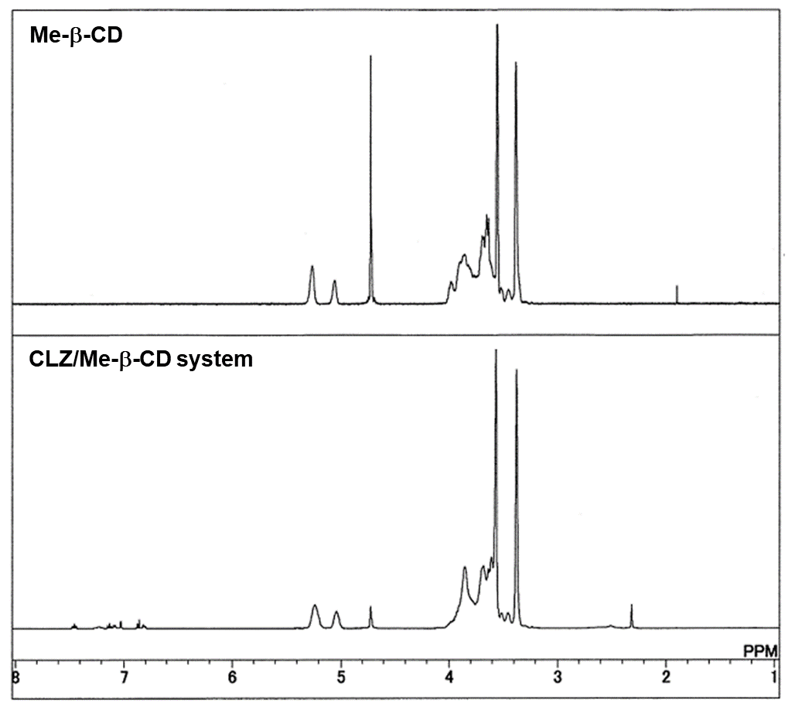**Figure S1 1H-NMR spectra of CLZ and CLZ/Me--CD complex**

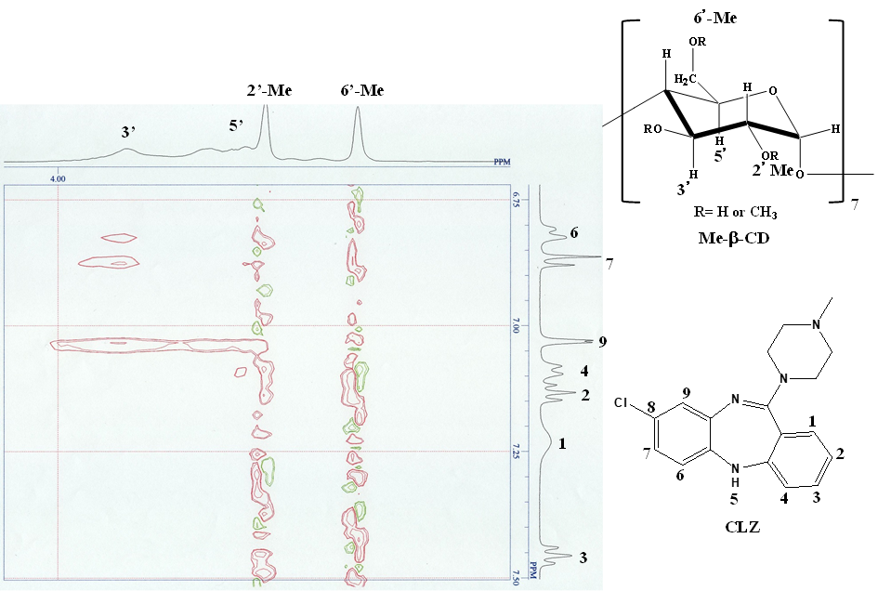

**Figure S2 ROESY-NMR spectrum of CLZ/Me--CD complex**



**Figure S3 1H-NMR spectra of CLZ and CLZ/SBE--CD complex**