Supporting Information
Kinetics, Thermodynamics and Metal Separation Studies of Transition (Co²⁺, Ni²⁺, Cu²⁺, Zn²⁺) and Heavy Metal ions (Cd²⁺, Hg²⁺, Pb²⁺) Using Novel Hybrid Ion Exchanger- Zirconium Amino tris methylene phosphonic acid
Brijesh Shah# and Uma chudasama*
*Applied Chemistry Department, Faculty of Technology and Engineering, The M. S. University of Baroda, Post Box No. 51, Kalabhavan, Vadodara - 390 001, Gujarat, India. Email: uvcres@gmail.com
#Present Address - School of Liberal Studies and Educations, Navrachana University,Vadodara 391 410, Gujarat, India Email id: brijeshkumars@nuv.ac.in & brijeshshah27@gmail.com
Section-1 Table Captions
Table-S1: Parameters optimized for synthesis of Zr-ATMP [Shah et al. 2012]
Parameters | No | Mole ratio  Metal: Anion  (M) | Volume ratio  Metal: Anion  (mL) | Temperature  (ºC) | Stirring Time  (h) | Aging Time  (h) | IEC  (meq/g)
Concentration | 1 | 0.1-0.1 | 50 : 50 | RT | 1 hr | 1 hr | 3.19
 | 2 | 0.1-0.2 | 50 : 50 | RT | 1 hr | 1 hr | 3.61**
 | 3 | 0.2-0.1 | 50 : 50 | RT | 1 hr | 1 hr | 2.68
Volume | 4 | 0.1-0.2 | 50 : 100 | RT | 1 hr | 1 hr | 2.46
 | 5 | 0.1-0.2 | 100 : 50 | RT | 1 hr | 1 hr | 2.24
Temperature | 6 | 0.1-0.2 | 50:50 | 70 | 1 hr | 1hr | 3.19
Aging Time | 7 | 0.1-0.2 | 50:50 | RT | 1 hr | 15 hr | 2.99
 | 8 | 0.1-0.2 | 50:50 | RT | 1 hr | 3 hr | 2.84
Stirring Time | 9 | 0.1-0.2 | 50:50 | RT | 2hr | 1 hr | 2.61
 | 10 | 0.1: 0.2 | 50:50 | RT | 3 hr | 1 hr | 2.94
pH=1 | 11 | 0.1: 0.2 | 50:50 | RT | 1 hr | 1hr | 3.09
Mode of addition | 12 | 0.1: 0.2 | 50:50 | RT | 1 hr | 1hr | 3.12*
*Change in mode of addition-ZrOCl₂ to ATMP, RT = Room Temperature (25 ºC)
**Optimum condition
Table S2: Physical and ion exchange characteristics [31]
Characteristics | Observation
Appearance | White hard granules
Particle size(range) | 250-590 µm
% Moisture content | 6.49 %
True density | 1.78 g∙mL⁻¹
Apparent density | 0.35 g∙mL⁻¹
Void volume fraction | 0.79
Concentration of fixed ionogenic groups | 6.30 mmol∙g⁻¹
Volume capacity of resin | 1.26 meq∙mL⁻¹
Nature of Exchanger | Weak cation exchanger
CEC (RT) | 3.61 meq∙g⁻¹
100°C | 2.93 meq∙g⁻¹
200°C | 2.11 meq∙g⁻¹
300°C | 2.26 meq∙g⁻¹
400°C | 2.73 meq∙g⁻¹
500°C | 1.76 meq∙g⁻¹
Chemical stability | Maximum tolerable limits
- Acids | 18 N H₂SO₄, 16.3 N HNO₃, 11.3 N HCl
- Bases | 0.01 N NaOH, 0.01 N KOH
- Organic solvents | Ethanol, Benzene, Acetone, Acetic acid

Section-2Figure Captions.
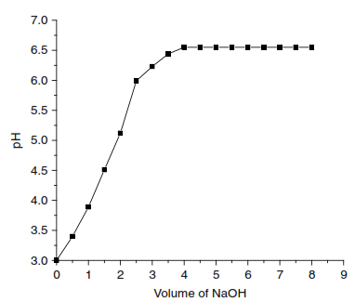
Fig. S1pH Titration Curve of Zr-ATMP
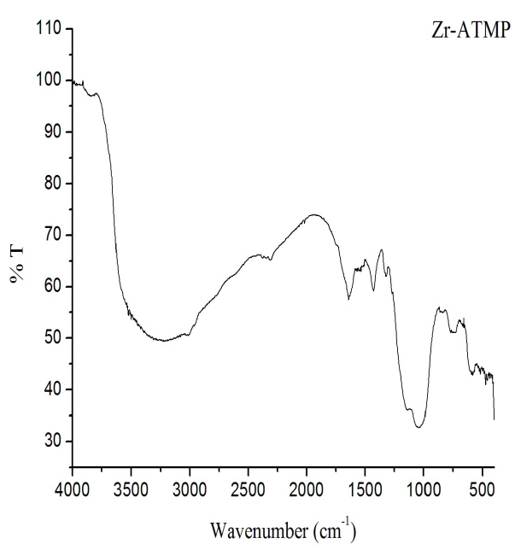
Fig. S2: FTIR of Zr-ATMP
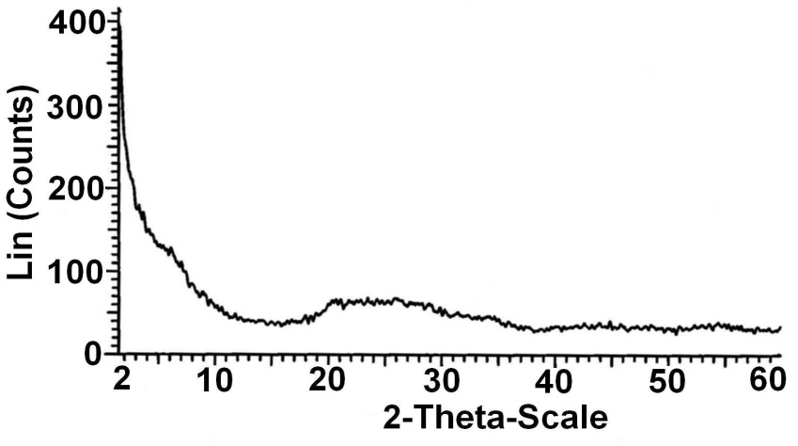
Fig. S3: XRD of Zr-ATMP
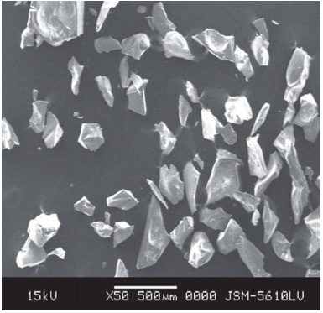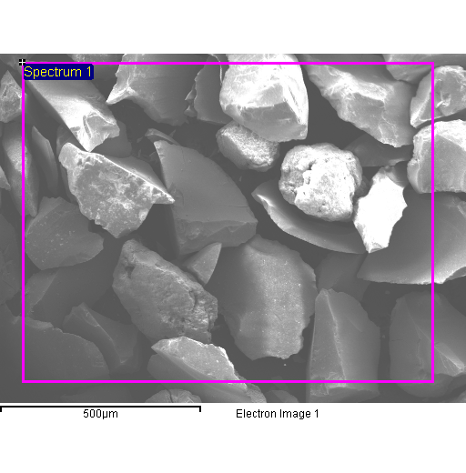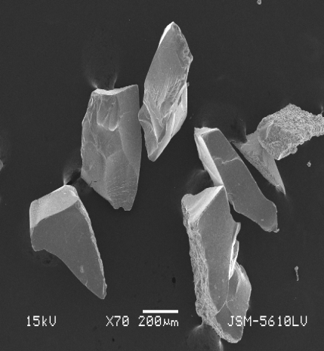
Fig. S4 SEM of Zr-ATMP

Fig. S5: Plots of τ vs. time for Cu²⁺-H⁺ exchange for 0.014 M concentration using Zr-ATMP

Fig. S6: τ vs. time plots for different temperatures for Cu²⁺-H⁺ exchanger using Zr-ATMP

Fig. S7: Arrhenius plots of ln D_{a} versus 1/T for Cu²⁺ metal ions using Zr-ATMP
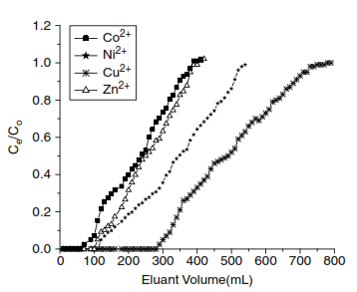
Fig. S8 Breakthrough curves for Transition metal ions using Zr-ATMP
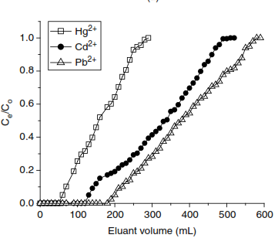
Fig. S9 Breakthrough curves for Heavy metal ions using Zr-ATMP

Section-3 Theory
S3.1 Explanation about the Thermodynamics parameters of ion exchange
Negative ΔG° values indicate that the exchange process is feasible and spontaneous in nature. A negative enthalpy change (ΔH°) indicates that the exchange reaction is exothermic while a positive enthalpy change indicates that the exchange reaction is endothermic. The enthalpy change (ΔH°) for an ion exchange reaction can be either of the reasons or a net effect of the following factors: (1) the heat consumed in bond breaking, as H⁺ is released from the resin (2) the heat released in the formation of bonds with the incoming cation (3) the heat corresponding to the energy required for crossing the barrier (distance between exchange phase and solution phase) (4) the enthalpy change accompanying hydration and dehydration of exchanging ion in the solution. The entropy change (ΔS°) normally depends on the extent of hydration of the exchangeable and exchanging ions along with any change in water structure around ions that may occur when they pass through the channels of the exchanger, introducing a high degree of disorder into the resin matrix due to the ion exchange process.
S3.2 Kinetics of Exchange
Ion exchange was studied at 30◦C by varying the concentration of metal ions and effect of reaction temperature on ion exchange was studied in the temperature range 30◦C – 60◦C with 10◦C intervals for Cu²⁺, Zn²⁺, Ni²⁺,Co²⁺ (transition metal ions) and Pb²⁺,Cd²⁺,Hg²⁺ (heavy metal ions). The plots of τ versus t (Supporting Information Figure S6) for Cu²⁺ – H⁺ exchanges at different temperatures were linear. From the slope (S) of the τ versus t plots, values of D_{A} were calculated using the relationship D_{A} = S × r₀² where, S= slope values (obtained from τ versus t) and r₀₌ bead radius. It is observed from (Supporting Information Figure S7) that the plots of ln D_{A} versus 1/T are linear, verifying the validity of the Arrhenius relation, D_{A} = D₀ exp(-E_{a}/RT). The energy of activation (E_{a}) and the pre-exponential constant (D₀) were evaluated from the slope and intercept of these plots. The entropy of activation (ΔS*) was then calculated using the equation D₀ = 2.72 d² kT / h exp (ΔS*/R) where d is the average distance between two exchanging sites taken as 5 Å , while other terms have their usual meaning. Since the exchanger is not dynamic, ion exchange process depends on mobility of the exchanging ions. Self-diffusion coefficient (D₀) gives an idea about the mobility of the migrating ions and depends on the size and charge of the ion and also on the extent of hydration in aqueous medium. During the exchange, the orientation of the exchanger sites and mobile ions are equally important and is expressed as the orientation factor. Orientation factor being related to randomness, is given by entropy of activation (ΔS*). The overall rate of exchange reaction thus depends on D₀, E_{a} and ΔS*. It is thus expected that larger values of D₀ and ΔS*, and smaller values of E_{a} indicate a faster rate of exchange. The entropy reflects the changes in hydration sphere of the exchanging cation during the ion exchange process. When ion exchange occurs, cation of high entropy in the external aqueous phase, passes to one of lower entropy in the exchanger phase, which results in a significant negative contribution of entropy change.
S3.3 Adsorption Isotherm
Equilibrium behaviour is described in terms of equilibrium isotherms which depend on the system temperature, concentration of the solution, contact time, and pH. Adsorption equilibrium is usually established when the concentration of an adsorbate (metal ions) in a bulk solution is in dynamic balance with that of the adsorbent (exchanger) interface. The variation in adsorption with concentration and temperature is generally expressed in terms of adsorption isotherms - Langmuir and Freundlich adsorption isotherms.
The linearized form of the Langmuir isotherm equation is given as: Ce/(X/m) = 1/(bVm) + Ce/Vm, where X is the amount of adsorbate, m, the amount of adsorbent, Ce, the equilibrium concentration of the adsorbate in solution and ‘b’ is a constant that represents adsorption bond energy, which is related to the affinity between the adsorbent and adsorbate. It is also a direct measure for the intensity of the sorption process. Vm is a constant related to the area occupied by a monolayer of sorbate, reflecting the maximum adsorption capacity. A dimensionless constant equilibrium parameter R_{L} can also be used to express an essential characteristic of the Langmuir isotherm. The R_{L} value indicates the shape of the isotherm and expressed as an equation, R_{L} = 1/(1 + bC0). A value 0 < R_{L} < 1 indicates favourable adsorption, R_{L} = 0 indicates irreversible adsorption, R_{L} = 1 means linear adsorption while a value, R_{L} > 1 indicates an unfavorable adsorption
Freundlich isotherm is expressed as, log(X/m) = logK + (1/n)logCe, where, X and m have the same meaning as described in Langmuir isotherm, K and 1/n are the Fruendlich constants, describing the adsorption capacity and intensity respectively. A value, 0 < 1/n < 1 indicates a normal isotherm, while 1/n > 1 is indicative for cooperative sorption, for n = 1 the partition between the two phases is independent of the concentration.
The isotherm constants are important in understanding the adsorption mechanism and their subsequent application for prediction of some important design parameters. Plots of Ce/(X/m) vs Ce and log(X/m) vs log Ce are drawn for Langmuir and Freundlich isotherms respectively which are straight lines from which the constants can be determined by the slopes and intercepts. In order to decide which type of isotherm fits better, the R² values (goodness of fit criterion) computed by linear regression for both type of isotherms and a value 0 < R² < 1 indicates that the isotherm provides a good fit to the sorption experimental data where R² values should be close to unity.
Langmuir constants (b and Vm) and Freundlich constants (K and 1/n) obtained from the slopes and intercepts of the linear plots of Ce/(X/m) vs Ce and log(X/m) vs log Ce respectively as well as R² and R_{L} values are listed in Table 5. The R² values show that the Langmuir and Fruendlich isotherms provides a good fit to the experimental data, where R² values are found to be close to unity indicating both isotherms to be most appropriate for sorption of all the metal ions under study. Variation in R² values is attributed to the fact that the surface adsorption is not a monolayer with single site. Two or more sites with different affinities may be involved in metal ion sorption.

