Supplementary material to:
Suitability of a lumped rainfall–runoff model for flashy tropical watersheds in New Caledonia

Térence Desclaux¹, Hugues Lemonnier¹, Pierre Genthon², Benoit Soulard¹, and Romain Le Gendre¹

Prominent time-scales of the runoff

Methods
The wavelet scalogram and wavelet spectrum of river runoff were computed (Torrence and Compo, 1998). The usual Morlet wavelet was used to analyse the runoffs, as it efficiently describes both the temporal and frequency components of the signal (Labat, 2005), and is well suited for describing hydrological processes (Labat, 2005; Santos and Ideião, 2006; Massei et al., 2010; Restrepo et al., 2014;). Bias correction for short scales (Liu et al., 2007) was applied. Confidence levels of 95% were computed by comparing the analysed signal to a red-noise process with a lag-1 coefficient calculated from the data set (Torrence and Compo, 1998).

Results
Dumbéa Est was selected, as its runoff presented the best quality of high flow rating curve and was characterised by less than 5% of missing data. The results described for Dumbéa Est are qualitatively valid for the other watersheds (not shown here). The time series of the runoff from 2003 to 2016 is shown in Figure S1(a). This time series revealed several high and short peaks unevenly spaced in time superposed on a smaller annual cycle, whose maximum usually occurs between January and March. The wavelet scalogram and spectrum of the Dumbéa Est runoff are shown in Figure S1(b) and (c), where 95% confidence intervals are indicated by black lines. The wavelet power spectrum exhibited four significant periods of variation. The highest significant values of the power spectrum occurred with hourly to daily events, reaching more than 200 m⁶ s⁻². The annual component of the spectral power was the second most noticeable feature, with the highest power spectrum values exceeding 85 m⁶ s⁻². Lastly, the spectrum of the 6-month and 3-month events was significant, but its power spectrum values did not exceed 50 m⁶ s⁻².
To improve the comprehensibility of the time location and amplitude of the hourly to daily events, the automated procedure of flood event selection was used to select 12 flood events for each catchment over the 12-year study period. The upper strip of Figure S1(b) thus displays the date of the 12 largest floods, identified by black stars, whose size is proportional to the flood peak magnitude. The temporal occurrence of the major floods was not equally distributed, because more than one flood occurred in 2007, 2011, 2013 and 2014, whereas no significant floods were detected in 2006, 2008, 2010 and 2012. Furthermore, the wavelet scalogram annual component shows that 2008 to mid-2009 and 2011 were relatively wet years compared to others. In addition, to present the overall context, the lower strip shows the change in the CPI. This reveals that 2007/08, 2008/09, 2010/11 and 2011/12 were La Niña periods, while 2002/03, 2006/07, 2009/10 and 2015/16 were subject to El Niño. Lastly, infra-annual variability exhibited several significantly wet periods of 3- and 6-month feature scales, especially for the 6 months of the tropical summers of 2008, 2011 and 2014 and the tropical winter of 2013. This was also the case for shorter 3-month periods in early 2004, 2005, 2011 and 2012 and from early 2013 to early 2014.
One notable feature occurred during the 2013/14 period. While annual wavelet component was relatively low, 6- and 3-month components were high. Moreover, the upper strip reveals that several high floods occurred during this period. The inverse feature can be seen during the 2007/08 tropical summer. Here annual and 6-month components of the streamflow were relatively high, while no severe floods occurred over this period.
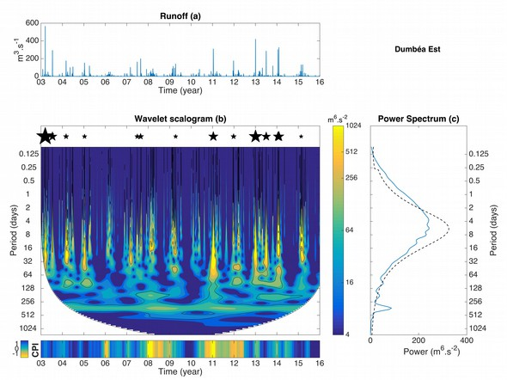
Figure S1. (a) Time series, (b) wavelet scalogram and (c) spectrum of the Dumbéa Est runoff. In (b) the bottom strip shows CPI values, and the upper strip with stars represents the temporal location of the 12 flood events selected, with the size of the star proportional to the flood magnitude. Black, plain and dashed, lines represent 95% confidence level.

