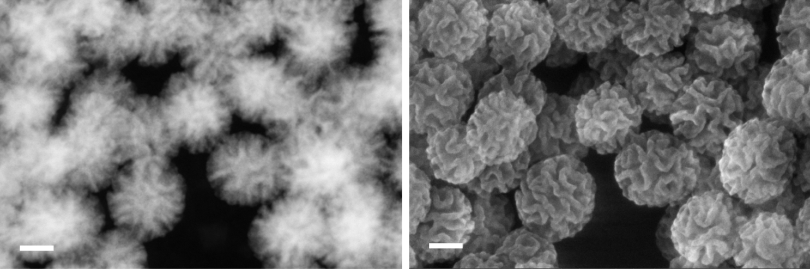

Figure S1. STEM (left) and SEM (right) images of un-functionalized MSNs. Scale bar: 50 nm.

Sample | Particle size (nm) | Pore size distribution (nm) | Pore volume (cm³/g) | Surface area (m²/g)
Un-MSN | 133 ± 50 | 4 - 45 | 1.4 | 390
MSN-NTA | 152 ± 54 | 4 - 40 | 1.1 | 275

Table S1. Summary of characterization data of un-MSNs and MSN-NTAs.

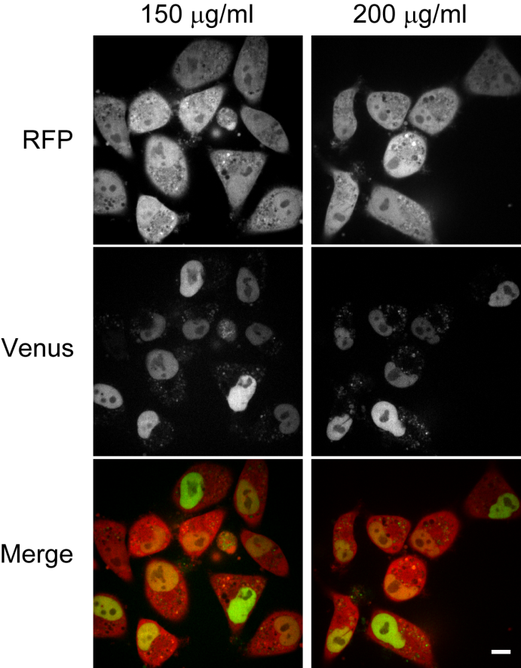

Figure. S2 Live cell confocal imaging of MSN-mediated intracellular protein delivery in the cytosolic protein delivery detection system. HeLa-FKBP-VN cells were incubated with 150 µg/ml and 200 µg/ml of MSN-FRB-VC, respectively, and images were taken 20 h post endosomal release trigger (chloroquine shock). Scale bar: 10 µm.

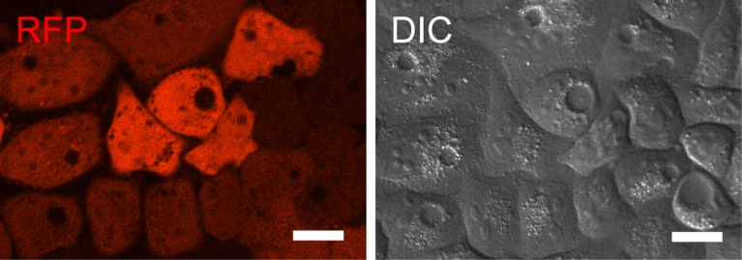

Figure. S3 Live cell images at 15 h post chloroquine shock. Swollen vesicles can be observed in cells after 15 h of chloroquine shock. Scale bar: 10 µm.

