Designing and fabrication of a novel gold nanocomposite structure: Application in electrochemical sensing of bisphenol A
Mehdi Baghayeriª*, Reza Ansari^{b}, Marzieh Nodehi ^{b}, Hojat Veisi^{c}
ªDepartment of Chemistry, Faculty of Science, Hakim Sabzevari University, PO. Box 397, Sabzevar, Iran
^{b}Department of Chemistry, Faculty of Science, University of Guilan, Namjoo Street, PO. Box 1914, Rasht, Iran
^{c}Department of Chemistry, Payame Noor University, 19395-4697, Tehran, Iran

*Corresponding author. E-mail address: m.baghayeri@hsu.ac.ir

1. Synthesis process of MWCNTs/Fe₃O₄-SH/Au
1.1 Amine treatment of MWCNTs
According to previously practice in the literature [1], carboxylated MWCNTs (MWCNTs-COOH) were prepared base of the pre-treatment of pristine MWCNTs with acid solutions. Briefly, the pristine MWCNTs was refluxed in H₂SO₄ and HNO₃ (3:1 v/v) for 8 h, washed with distilled water, and dried at laboratory ambient temperature for 1 h. Then, 5 g of MWCNTs-COOH was placed in a 150 ml ethylenediamine solution while stirring at 100 rpm and temperature of 25 °C, at the next, 5 g of N,N´-dicyclohexylcarbodiimide was added and refluxed for 48 h at 80 °C. The product was named MWCNTs-NH₂, passed through a filter paper, washed with ethanol, and dried at moderate temperature for 8 h [2].

1.2. Preparation of the magnetic Fe₃O₄ nanoparticles
Naked Fe₃O₄ nanoparticles were prepared by chemical precipitation of Fe³⁺ and Fe²⁺ ions with a molar ratio of 2:1. Typically, FeCl₃.6H₂O (5.838 g, 0.0216 mol) and FeCl₂.4H₂O (2.147 g, 0.0108 mol) were dissolved in 100 mL deionized water at 85 ºC under N₂ atmosphere and vigorous mechanical stirring (500 rpm). Then, 10 mL of 25% NH₄OH was quickly injected into the reaction mixture in one portion. The addition of the base to the Fe²⁺/Fe³⁺ salt solution resulted in the formation of the black precipitate of magnetic Fe₃O₄ nanoparticles (Fe₃O₄ NPs) immediately. The reaction continued for another 25 min and the mixture was cooled to room temperature. Subsequently, the resultant ultrafine magnetic particles were treated by magnetic separation and washed several times by deionized water.

1.3 Preparation of the Fe₃O₄-SH
The obtained Fe₃O₄ NPs powder (500 mg) was dispersed in 50 mL toluene solution by sonication for 20 min, and then triethoxypropylthiole (3 mmol) was added to the mixture. The mixture was refluxed under argon atmosphere at 100 ºC for 48 h. The product was isolated by an external magnet, washed with ethanol, and dried under vacuum for 24 h at 50 ºC. The precipitated product named Fe₃O₄-SH.

1.4 Preparation of the Fe₃O₄-SH/Au
The Fe₃O₄-SH (500 mg) were dispersed in H₂O (100 mL) by ultrasonic bath for 30 min. Subsequently, a solution of HAuCl₄ (10 mL, 0.1 M) was added to dispersion of Fe₃O₄-SH and the mixture was stirred for 2 hours at 25 ºC. Then, 20 mL of NaBH₄ (0.1 M) was added in one portion and the mixture was stirred for another 2 hours at 25 ºC. The final product Fe₃O₄-SH/Au nanoparticles were isolated by an external magnet, washed with water and ethanol, and dried under vacuum for 24 h at 50 ºC.

1.5 Preparation of the MWCNTs/Fe₃O₄-SH/Au nanocomposite
100 mg of the synthesized Fe₃O₄-SH/Au were dispersed in 100 ml of H₂O and the resultant suspension was added dropwise into 500 mg of MWCNTs-NH₂ that was initially dispersed in 50 mL DI water by sonication. The resulted mixture was then stirred for 24 h at room temperature. After the reaction time, the MWCNTs/Fe₃O₄-SH/Au nanocomposite was separated by magnetic decantation and washed by ethanol, H₂O and acetone respectively to remove the unattached substrates and dried in vacuum at 40 ºC for 24 h. Scheme S1 depicted the synthetic procedures of MWCNTs/Fe₃O₄-SH/Au nanocomposite.
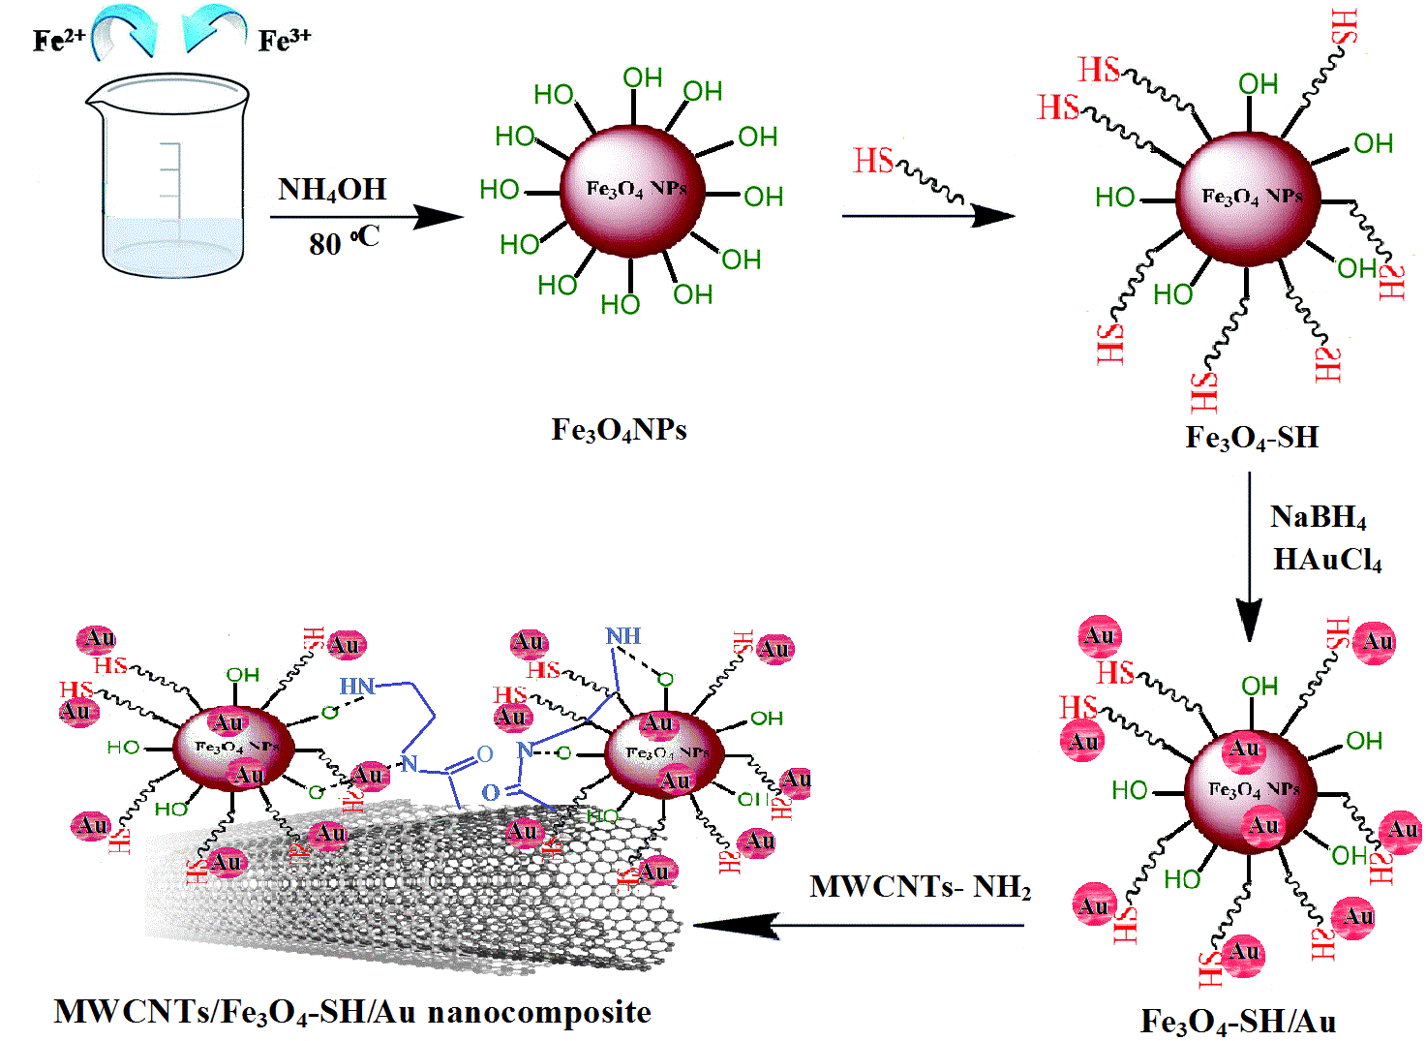
Scheme S1. Scheme for the preparation of MWCNTs/Fe₃O₄-SH/Au nanocomposite.

2. Characterization of MWCNTs/Fe₃O₄-SH/Au nanocomposite
Since the cyclic voltammetry can be used as a significant method to confirm the presence of AuNPs at the structure of nanocomposite, electrochemical properties of nanocomposite were investigated at the surface of GCE. Figure S1 shows the CVs of the GCE/MWCNTs/Fe₃O₄-SH (a) and the GCE/MWCNTs/Fe₃O₄-SH/Au (b) 0.5 M H₂SO₄. As can be seen, there is no observable peak on the GCE/MWCNTs/Fe₃O₄-SH electrode. In contrast, the GCE/MWCNTs/Fe₃O₄-SH/Au shows two anodic peaks at 0.83 V and 1.15 V in the anodic potential sweep, along with two cathodic peak at 0.95 V and 0.8 V, at the reverse scan, respectively. The similar redox properties have been reported at literatures for the electrochemical behavior of AuNPs on various modified electrodes [3-5]. Also, MWCNTs/Fe₃O₄-SH/Au modified GCE shows a large background current in comparison with GCE/MWCNTs/Fe₃O₄-SH which can be attributed to the large electroactive surface area [6], and better electron transfer kinetics of Au on the electrode surface.
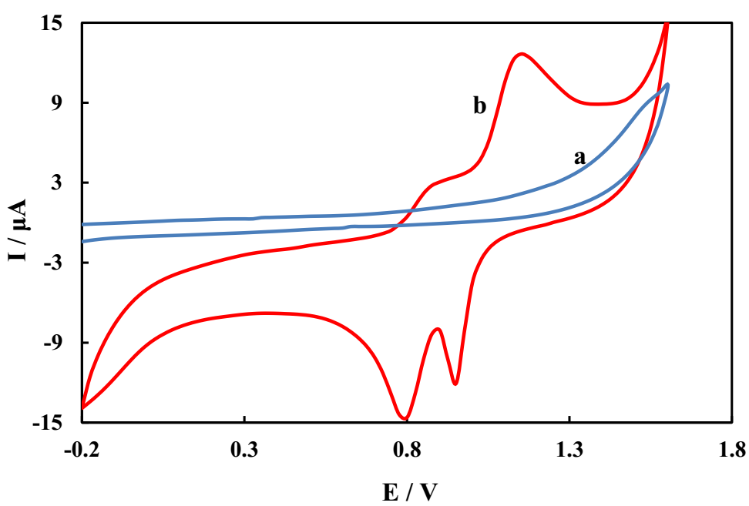

Figure S1. Cyclic voltammograms of GCE/MWCNTs/Fe₃O₄-SH (a) and GCE/MWCNTs/Fe₃O₄-SH/Au (b) in 0.5 M H₂SO₄ at scan rate 0.05 V s⁻¹.
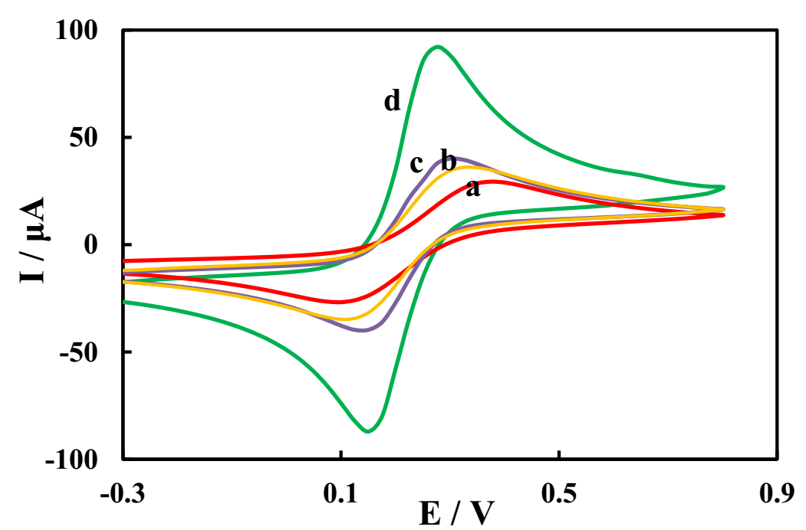

Figure S2. Cyclic voltammograms of GCE (a), GCE/MWCNTs (b), GCE/MWCNTs/Fe₃O₄-SH (c) and GCE/MWCNTs/Fe₃O₄-SH/Au (d) in 5 mM Fe(CN)₆³⁻/⁴⁻ (1:1) solution containing 0.1 M KCl at scan rate 0.1 V s⁻¹.

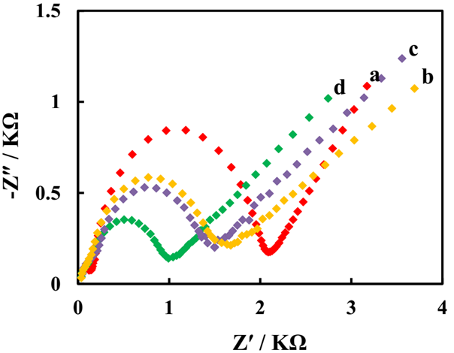
Figure S3. Nyquist plots of GCE (a), GCE/MWCNTs (b), GCE/MWCNTs/Fe₃O₄-SH (c) and GCE/MWCNTs/Fe₃O₄-SH/Au (d) in 5 mM Fe(CN)₆³⁻/⁴⁻ (1:1) solution containing 0.1 M KCl

Table S1. Electrochemical parameters of BPA.
Electrode | ΔE_{p} (mV) | j_{a} (μA cm⁻²) | j_{c} (μA cm⁻²) | A* (cm²)
GCE | 225 | 2727 | -2636 | 0.011
GCE/MWCNTs | 200 | 3010 | -2855 | 0.012
GCE/MWCNTs/Fe₃O₄-SH | 175 | 3636 | -3605 | 0.013
GCE/MWCNTs/Fe₃O₄-SH/Au | 125 | 8363 | -6255 | 0.032
*Electroactive area

3. Effect of accumulating conditions
Since the electrode process of BPA was adsorption controlled on the GCE/MWCNTs/Fe₃O₄-SH/Au, we investigated the effect of the accumulation potential in the range of −0.3 to 0.3 V on the CV peak currents of 100 µM BPA in PBS of pH 9. The results illustrated that the oxidation peak current unchanged. Therefore. the accumulations of BPA can be performed under the open circuit condition (Figure S4). The effect of accumulation time, t_{acc} was studied for 100 µM BPA in various accumulation times while stirring the solution at 500 rpm. As shown in Figure S5, with the increase of accumulating time the oxidation peak current increased to 60 s and then remind, which indicated that the adsorption of BPA on the GCE/MWCNTs/Fe₃O₄-SH/Au was saturated. Therefore, the accumulation time of 60 s was used for the following experiments.

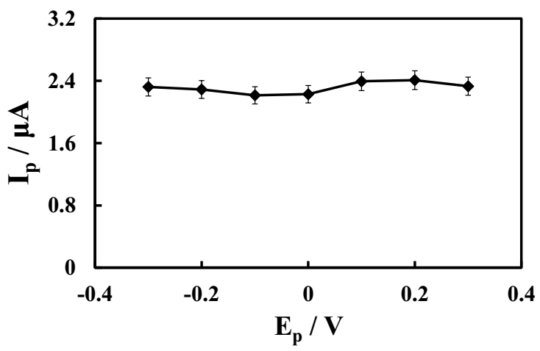

Figure S4. Effect of accumulation potential on the peak current of 100 µM BPA in 0.1 M PBS (pH 9) at the scan rate of 0.1 V s⁻¹.

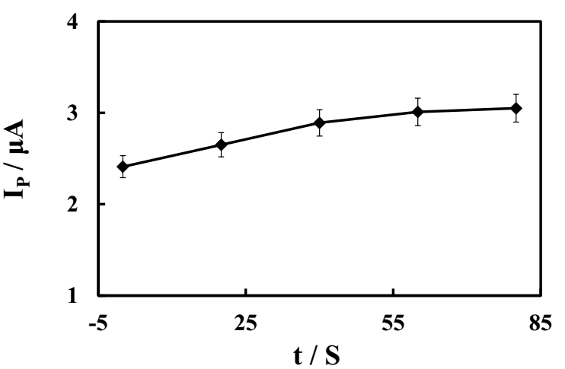

Figure S5. Effect of accumulation time on the peak current of 100 µM BPA in 0.1 M PBS (pH 9) at the scan rate of 0.1 V s⁻¹.

References
[1] J.B. Raoof, R. Ojani, M. Baghayeri, M. Amiri-Aref, Anal. Methods, 4, 1579 (2012).
[2] M. Hadavifar, N. Bahramifar, H. Younesi, Q. Li, Biochem. Eng. J., 237, 217 (2014).
[3] S. Palanisamy, B. Thirumalraj, S.-M. Chen, RSC Adv., 5, 94591 (2015).
[4] Y. Wang, E. Laborda, K.R. Ward, K. Tschulik, R.G. Compton, Nanoscale, 5, 9699 (2013).
[5] H. Angerstein-Kozlowska, B. E. Conway, Electrochim. Acta, 31, 1031 (1986).
[6] J.-H. Lee, B.-K. Oh, J.-W. Choi, Biosens. Bioelectron., 49, 531 (2013).

