Simultaneous Voltammetric Analysis of Lead, Copper and Mercury Ions by Carbon Paste Electrode Based on 1-(3-Aminopropyl) Imidazole Modified Polymer

Cansu Bayraktarª, Husnu Cankurtaran^{a,*}, Bahire Filiz Senkal^{b}
ª Yıldız Technical University, Department of Chemistry, 34220, Davutpasa, İstanbul-Turkey
^{b} İstanbul Technical University, Department of Chemistry, 34469, İstanbul, Turkey
*Corresponding author. Email: husnu3500@yahoo.com

SUPPLEMENTARY INFORMATION

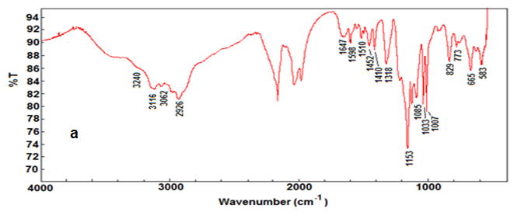
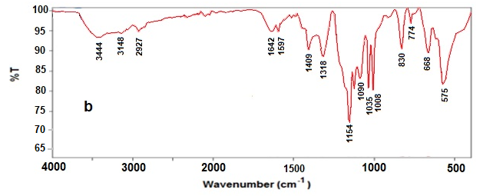
Suppl. 1. FTIR spectrum of CSPS-API resin before (a) and after (b) Pb²⁺ accumulation.

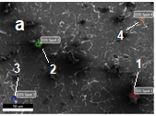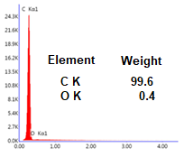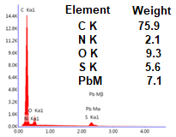
c
EDS Spot 1 4
EDS Spot 4
b
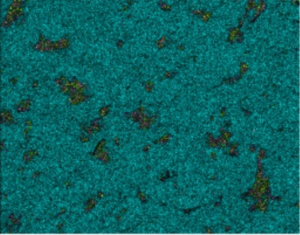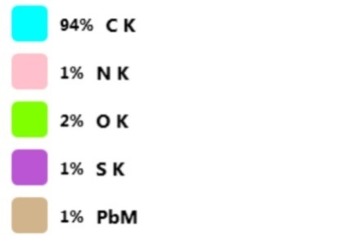
d
Suppl. 2. a) SEM image of MCPE2 electrode after Pb²⁺ accumulation. b) EDS spectrum of graphitic zone (spot 4), c) EDS spectrum of CSPS-API zone (spot 1) and d) elemental map of MCPE2 surface.

Suppl. 3. The effect of pH on the stripping peak currents. Pb²⁺: 100 μgL⁻¹, Cu²⁺: 200 μgL⁻¹, Hg²⁺: 100 μgL⁻¹. Preconcentration time: 2 min, scan rate: 200 mVs⁻¹.

Suppl. 4. The effect of scan rate on stripping peak currents of lead, copper and mercury. Pb²⁺: 40 μgL⁻¹, Cu²⁺: 200 μgL⁻¹, Hg²⁺: 100 μgL⁻¹. Preconcentration time: 2 min.

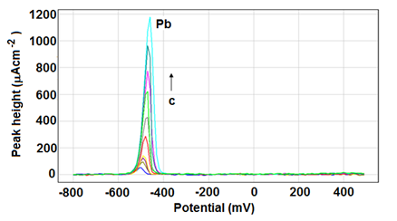
a
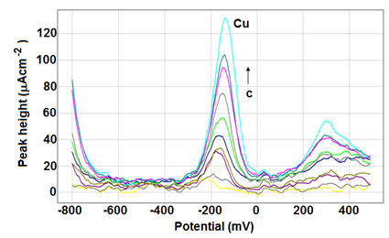
b
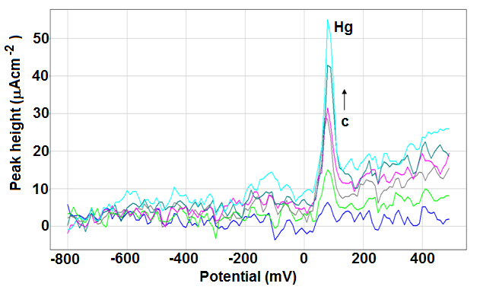
c
Suppl. 5. SWAS voltammograms of a) Pb²⁺ (μgL⁻¹): 20, 40, 60, 100, 200, 300, 500, 600, 700, 800; b) Cu²⁺ (μgL⁻¹): 40, 60, 80, 100, 200, 300, 400, 500, 600, 800 and c) Hg²⁺ (μgL⁻¹): 20,100,200,300,400,600. Supporting electrolyte: 0.5 M HCl, preconcentration time: 2 min, scan rate: 100 mVs⁻¹.
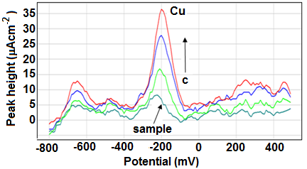
Suppl. 6. SWAS voltammograms of 200 fold diluted and 50, 100 and 150 μgL⁻¹ Cu²⁺ standard added ground and waste water pollution standard solution sample. Preconcentration time: 4 min, scan rate: 100 mVs⁻¹.

