Complexes between H₂ and neutral oxyacid beryllium derivatives.
The role of angular strain

Ibon Alkorta, M. Merced Montero-Campillo, José Elguero, Manuel Yáñez and Otilia Mó
Contribution from: Instituto de Química Médica, IQM-CSIC. Juan de la Cierva, 3. 28006 Madrid, Spain and Departamento de Química, Módulo 13, Facultad de Ciencias, and Institute of Advanced Chemical Sciences (IadChem). Universidad Autónoma de Madrid, Campus de Excelencia UAM-CSIC, Cantoblanco, 28049-Madrid, Spain.

Supporting Information

(A total of 12 Pages)

Table S1. Molecular graphs, energies and geometries of 1:1 complexes.
Table S2. Molecular graphs, energies and geometries of 1:2 complexes .
Figure S1. Comparison of NO₄HBe and PO₄HBe structures.

Table S1. Molecular graph, electron energy (Hartree) and geometry of the 1:1 complexes optimized at the MP2/aug-cc-pVTZ computational level.
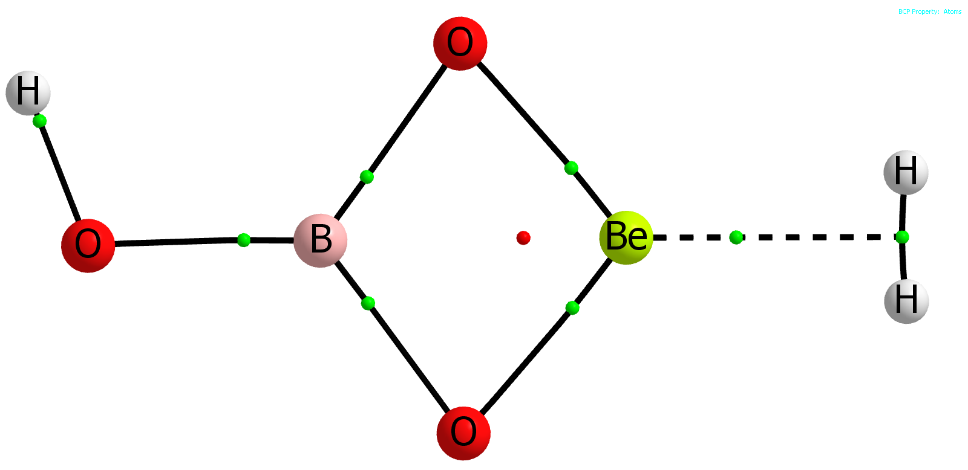 | BO₃HBe:H₂  MP2= -266.83397245 NIMAG= 0  Be,0.,-0.0045106672,-0.0019760751  O,0.,-1.1613254024,0.9489823173  O,0.,1.1273569171,0.9757730892  B,0.,-0.0192102746,1.7930190877  O,0.,-0.0134333553,3.155802663  H,0.,-0.3572545829,-1.6502472099  H,0.,0.3989683663,-1.6385039782  H,0.,-0.9161095767,3.4897842154
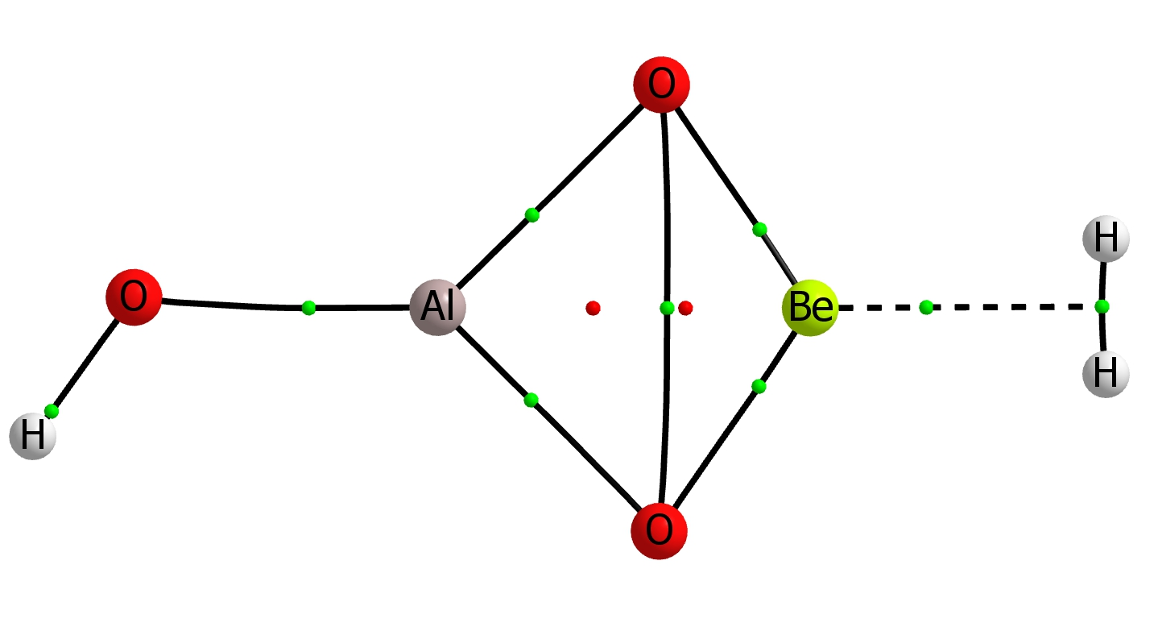 | AlO₃HBe:H₂  MP2= -484.07109827 NIMAG= 0  Be,0.,0.0071076282,-0.1829802423  O,0.,-1.2732146213,0.6008565012  O,0.,1.215547001,0.7067506971  Al,0.,-0.0780735979,1.8973282813  O,0.,-0.0934545981,3.5955851251  H,0.,-0.2930850674,-1.8520960168  H,0.,0.4619276956,-1.8165018871  H,0.,-0.8922730159,4.1236916509
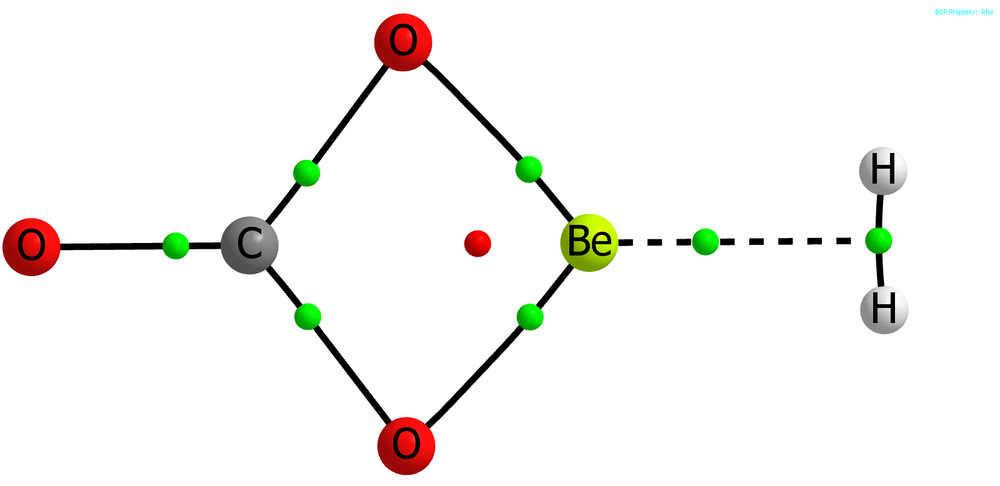 | CO₃Be:H₂  MP2= -279.34313020 NIMAG= 0  Be  X,1,1.  X,1,1.,2,90.  O,1,r1,2,a1,3,90.,0  O,1,r1,2,a1,3,-90.,0  C,1,r2,3,90.,2,0.,0  O,1,r21,3,90.,2,0.,0  X,1,r3,3,90.,2,180.,0  H,8,r4,1,90.,3,90.,0  H,8,r4,1,90.,3,-90.,0  r1=1.49427611  a1=47.59059905  r2=1.85544422  r21=3.04680454  r3=1.60876866  r4=0.37955738
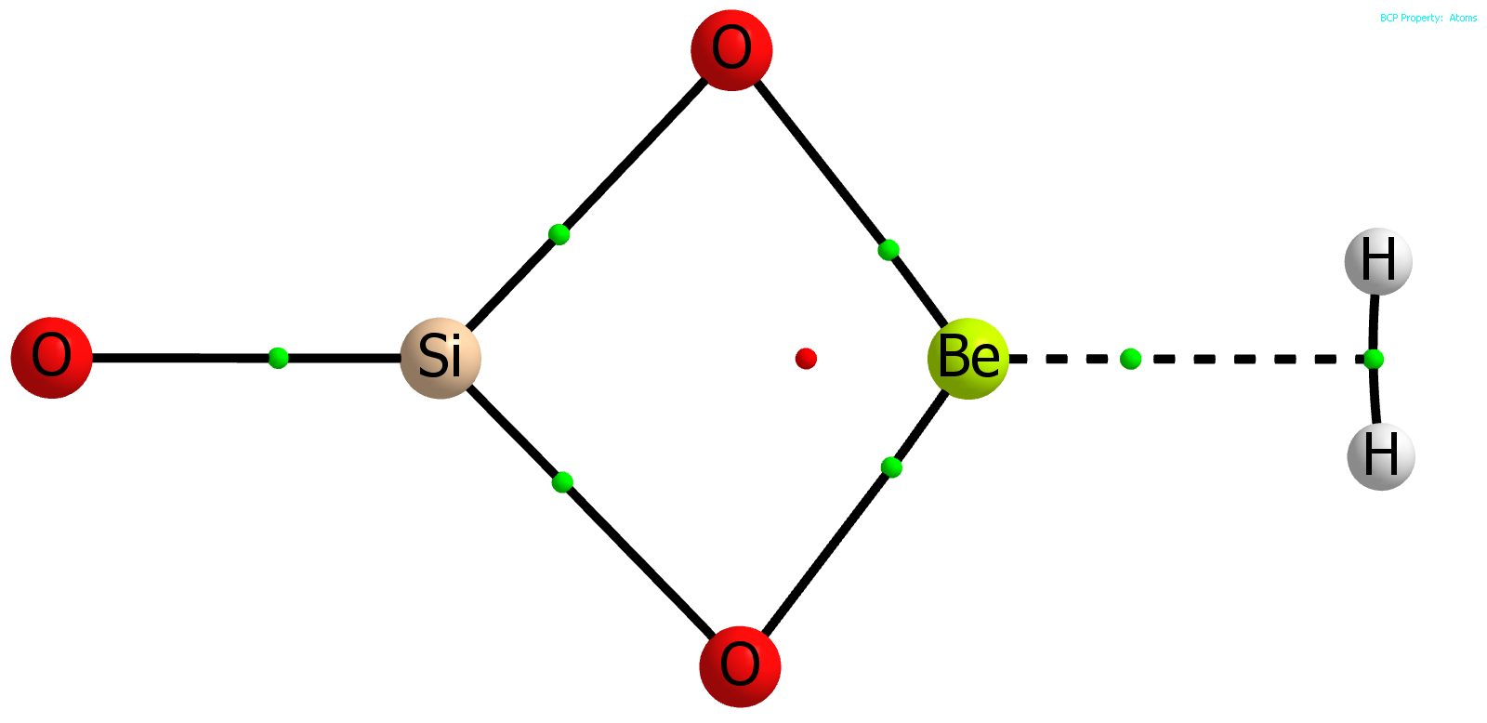 | SiO₃Be:H₂  MP2= -530.47103712 NIMAG= 0  Be  X,1,1.  X,1,1.,2,90.  O,1,r1,2,a1,3,90.,0  O,1,r1,2,a1,3,-90.,0  Si,1,r2,3,90.,2,0.,0  O,1,r21,3,90.,2,0.,0  X,1,r3,3,90.,2,180.,0  H,8,r4,1,90.,3,90.,0  H,8,r4,1,90.,3,-90.,0  r1=1.50756209  a1=52.63503616  r2=2.0783607  r21=3.60894082  r3=1.62020985  r4=0.37921362
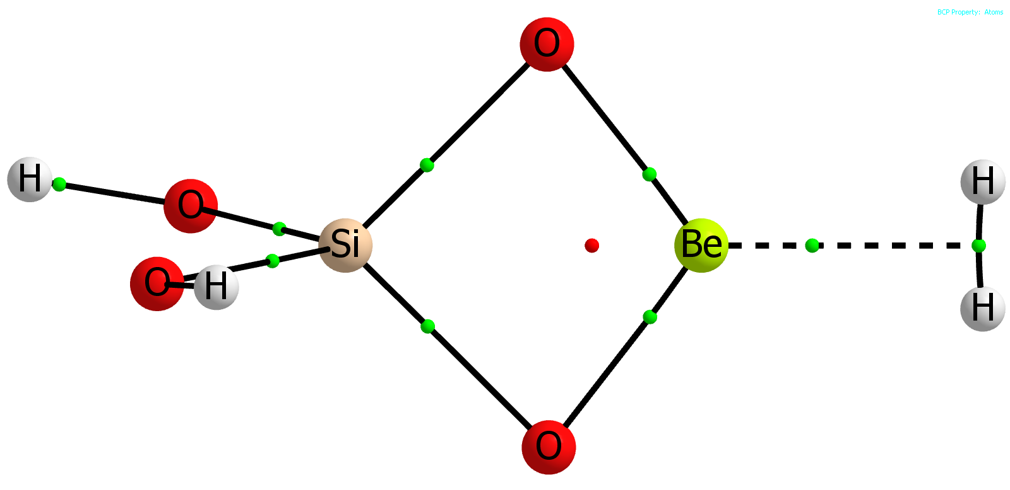 | SiO₄H₂Be:H₂  MP2= -606.90674566 NIMAG= 0  Be,-0.0354990394,-1.7722344923,0.0155786703  O,-0.0473141589,-0.8987736521,1.2304301788  O,-0.0215636643,-0.8604828602,-1.1707099837  Si,0.0092987558,0.2978947813,0.0458454984  O,1.371863617,1.2064214364,0.0196334082  O,-1.2270998853,1.3838824462,0.0905720528  H,1.2495301676,2.137338333,0.220386138  H,-2.1066157608,1.0310666059,0.2423454856  H,-0.0110914992,-3.3999856251,-0.3976715841  H,-0.0196335325,-3.4168189732,0.3585901356
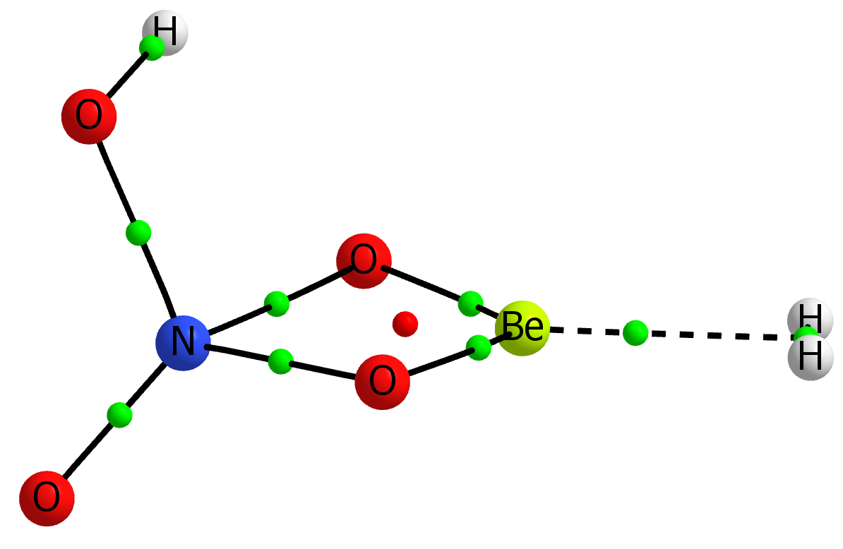 | NO₄HBe:H₂  MP2= -371.50329614 NIMAG= 0  Be,0.0250576639,0.1126597218,0.2691340873  O,-0.1676885473,-1.1613573524,1.0564458059  O,0.0670332375,1.2464197147,1.1807053049  N,-0.2737345249,-0.2916739127,2.1818734162  O,0.9422962242,-0.2767653492,2.9097326334  O,-1.2774141281,-0.3094469672,2.8143712376  H,0.1785189964,-0.3013338162,-1.3652022066  H,0.2504959272,0.4521883743,-1.3573769992  H,1.3377201026,0.5293095868,2.5252276202
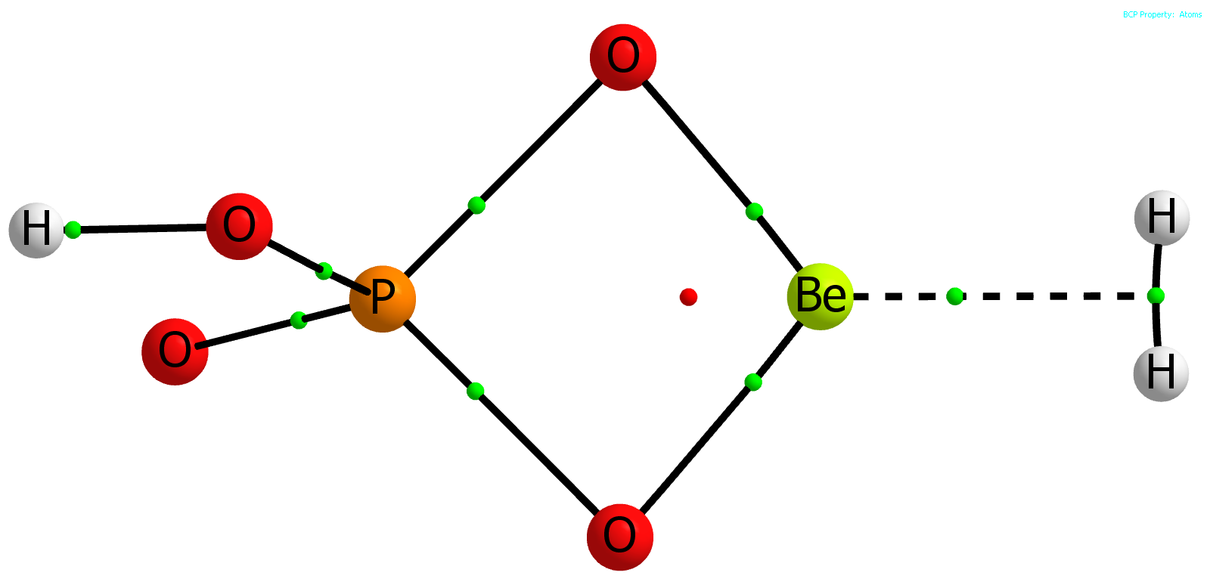 | PO₄HBe:H₂  MP2= -658.07662298 NIMAG= 0  Be,0.0023419807,-0.0001716858,-0.0054229352  O,-0.0602041765,-1.1677793892,0.9333336312  O,-0.0606395929,1.1673868931,0.9333255475  P,-0.1544995334,-0.000255988,2.0617250356  O,1.2836132851,0.0000257015,2.7779486806  O,-1.2799668843,-0.0004413411,3.0136439798  H,0.1000074753,-0.3786835422,-1.6172152471  H,0.0996014252,0.3798156166,-1.6168258376  H,1.1520309723,0.000103735,3.7343980449
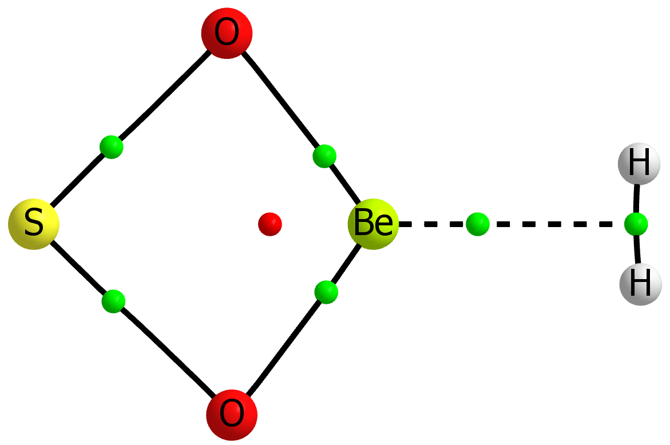 | SO₂Be:H₂  MP2= -563.84959638 NIMAG= 0  Be  X,1,1.  X,1,1.,2,90.  O,1,r1,2,a1,3,90.,0  O,1,r1,2,a1,3,-90.,0  S,1,r2,3,90.,2,0.,0  X,1,r3,3,90.,2,180.,0  H,7,r4,1,90.,3,90.,0  H,7,r4,1,90.,3,-90.,0  r1=1.49258782  a1=53.27513526  r2=2.10495525  r3=1.65258664  r4=0.37764536
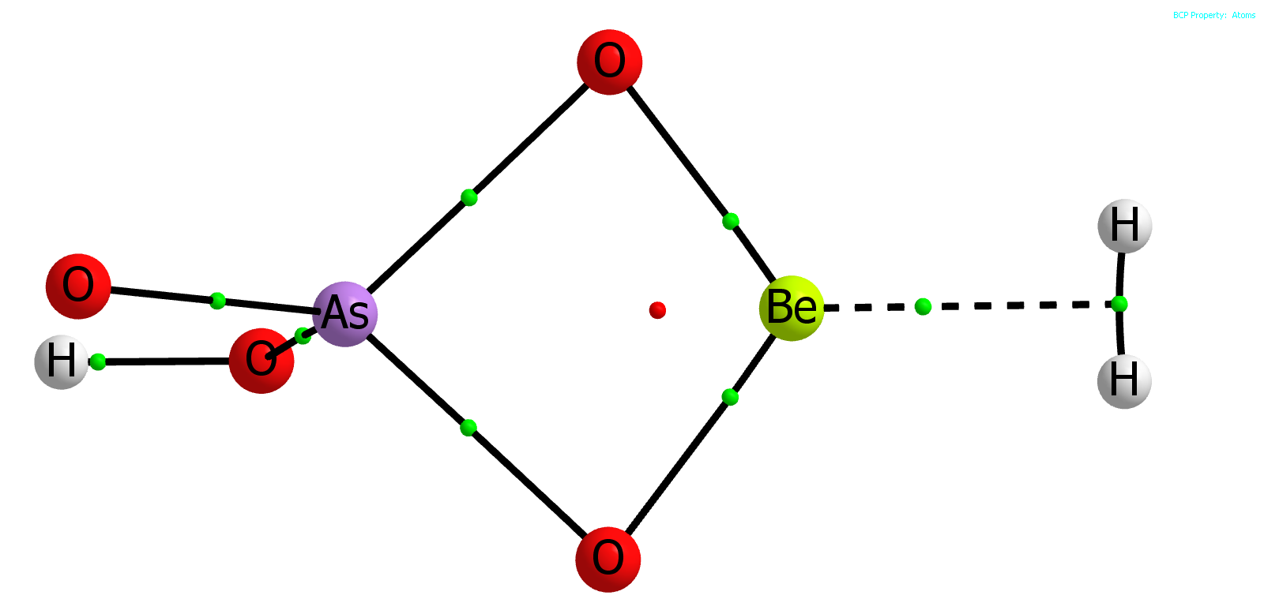 | AsO₄HBe:H₂  MP2= -2551.54604568 NIMAG= 0  Be,-0.0086201333,0.,-0.0554203673  O,-0.0821797415,-1.2133076131,0.8317747278  O,-0.0821797415,1.2133076131,0.8317747278  As,-0.2009763519,0.,2.1095786142  O,1.3685328484,0.,2.8537033613  O,-1.4164954275,0.,3.1683889883  H,0.1334147164,-0.3790087896,-1.6688749416  H,0.1334147164,0.3790087896,-1.6688749416  H,1.2369559468,0.,3.8125788037
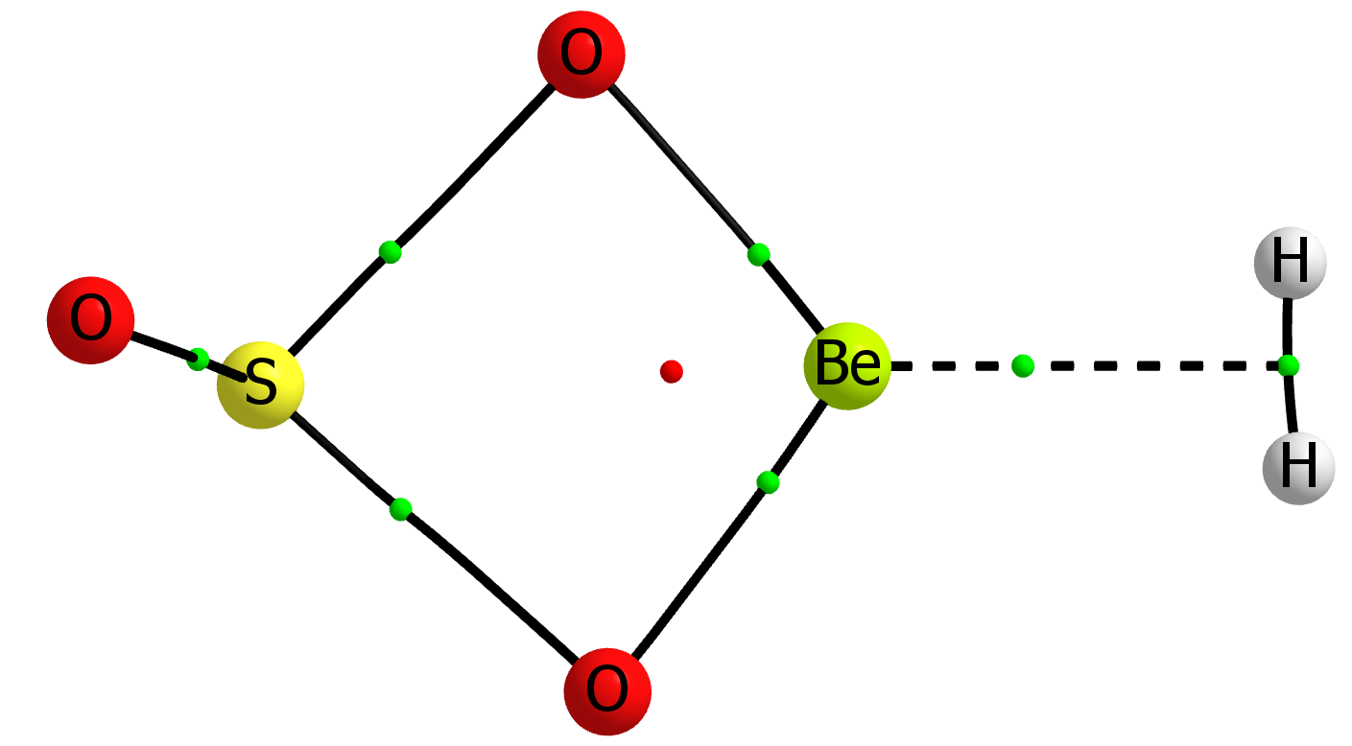 | SO₃Be:H₂  MP2= -639.01938131 NIMAG= 0  Be,-0.0927892334,0.,0.0115491311  O,-0.0555674895,-1.1750691887,0.9268144258  O,-0.0555674895,1.1750691887,0.9268144258  S,0.0432967593,0.,2.1297283012  O,-1.2066554343,0.,2.8731493741  H,0.0645720711,-0.3782018162,-1.6284027411  H,0.0645720711,0.3782018162,-1.6284027411
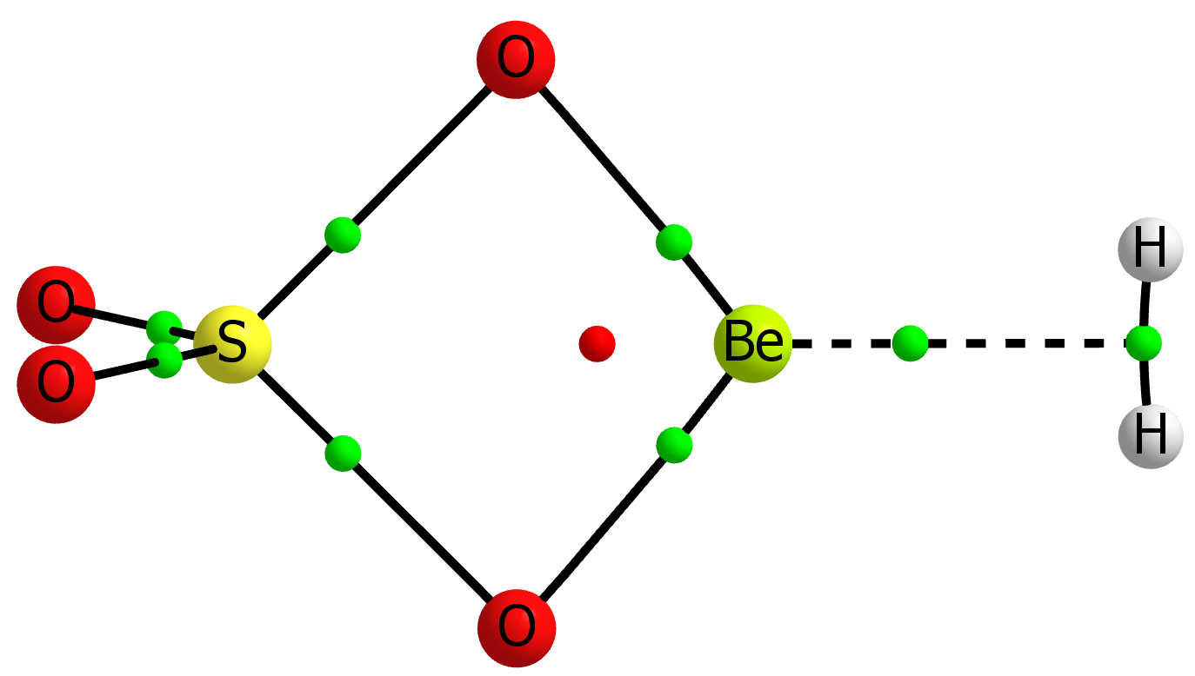 | SO₄Be:H₂  MP2= -714.14816524 NIMAG= 0  Be  X,1,1.  X,1,1.,2,90.  O,1,r1,2,a1,3,90.,0  O,1,r1,2,a1,3,-90.,0  S,1,r2,3,90.,2,0.,0  O,6,r11,1,a11,3,0.,0  O,6,r11,1,a11,3,180.,0  X,1,r3,3,90.,2,180.,0  H,9,r4,1,90.,3,90.,0  H,9,r4,1,90.,3,-90.,0  r1=1.49989161  a1=50.47635495  r11=1.43729219  a11=119.66241088  r2=2.09881849  r3=1.6033096  r4=0.37989483
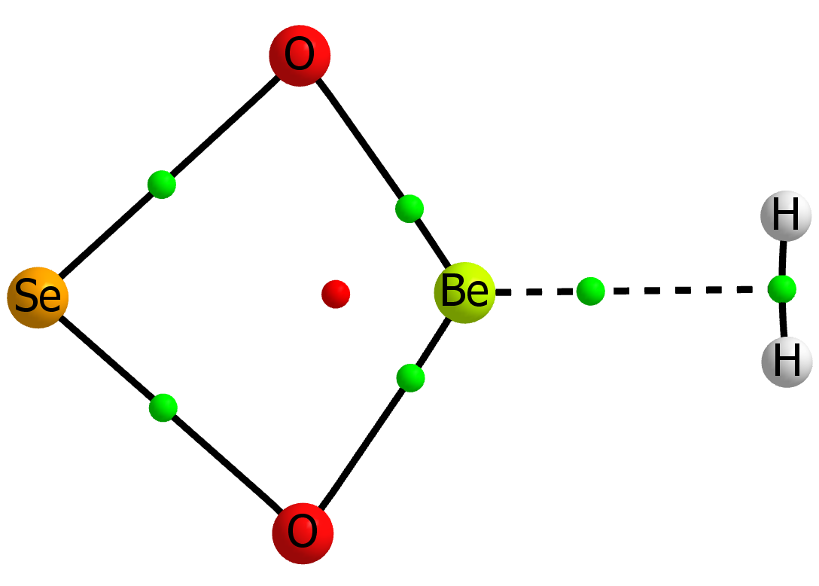 | seo2be_h2 MP2= -2566.25462415 NIMAG= 0  Be  X,1,1.  X,1,1.,2,90.  O,1,r1,2,a1,3,90.,0  O,1,r1,2,a1,3,-90.,0  Se,1,r2,3,90.,2,0.,0  X,1,r3,3,90.,2,180.,0  H,7,r4,1,90.,3,90.,0  H,7,r4,1,90.,3,-90.,0  r1=1.49466406  a1=55.68837681  r2=2.20082019  r3=1.65850115  r4=0.37739331
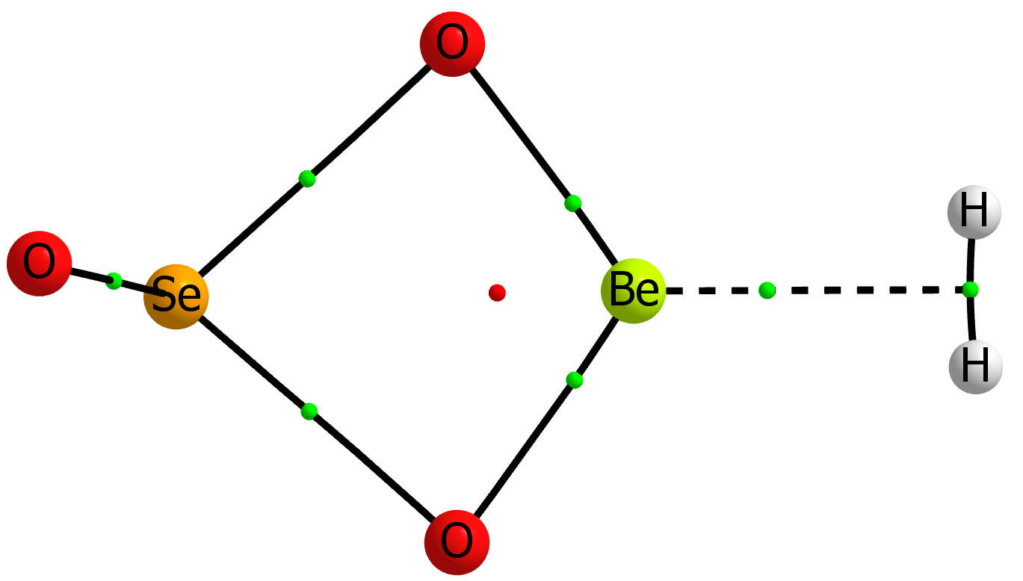 | SeO₃Be:H₂  MP2= -2641.40416606 NIMAG= 0  Be,-0.0295288546,0.,0.0100245659  O,0.0189412383,-1.2170444259,0.8763364085  O,0.0189412383,1.2170444259,0.8763364085  Se,0.0859629802,0.,2.2262344471  O,-1.3572733151,0.,2.9173271836  H,0.0124089837,-0.3779691451,-1.6475044189  H,0.0124089837,0.3779691451,-1.6475044189
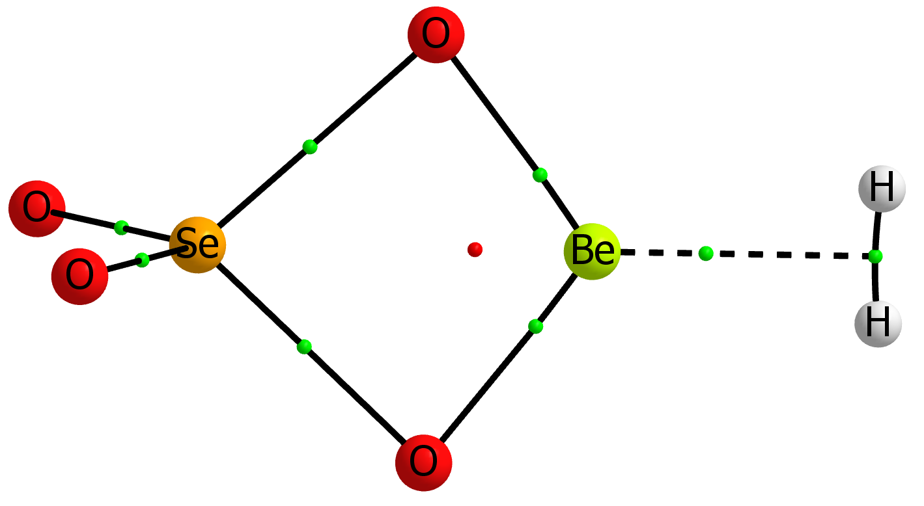 | SeO₄Be:H₂  MP2= -2716.48474010 NIMAG= 0  Be  X,1,1.  X,1,1.,2,90.  O,1,r1,2,a1,3,90.,0  O,1,r1,2,a1,3,-90.,0  Se,1,r2,3,90.,2,0.,0  O,6,r11,1,a11,3,0.,0  O,6,r11,1,a11,3,180.,0  X,1,r3,3,90.,2,180.,0  H,9,r4,1,90.,3,90.,0  H,9,r4,1,90.,3,-90.,0  r1=1.50672635  a1=53.00063656  r11=1.5891976  a11=119.28294705  r2=2.20429221  r3=1.60807493  r4=0.37963322

Table S2. Molecular graph, electron energy (Hartree) and geometry of the 1:2 complexes optimized at the MP2/aug-cc-pVTZ computational level.
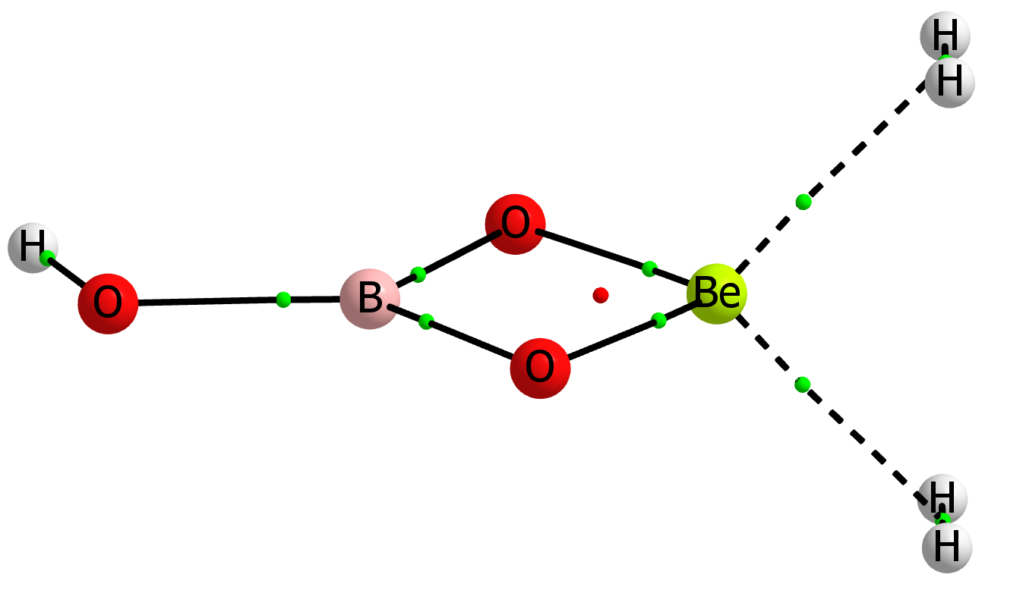 | BO₃HBe:2H₂  MP2= -268.00387847 NIMAG= 0  Be,0.,-0.010055102,0.014857576  O,0.,-1.1631712996,0.9895446341  O,0.,1.1221776452,1.0112851977  B,0.,-0.0209352117,1.8245858454  O,0.,-0.0121491742,3.1917172624  H,-1.2844082353,0.3890131637,-1.167912147  H,-1.2777175778,-0.3618981473,-1.1934925661  H,1.2777175778,-0.3618981473,-1.1934925661  H,1.2844082353,0.3890131637,-1.167912147  H,0.,-0.9156154652,3.5233577105
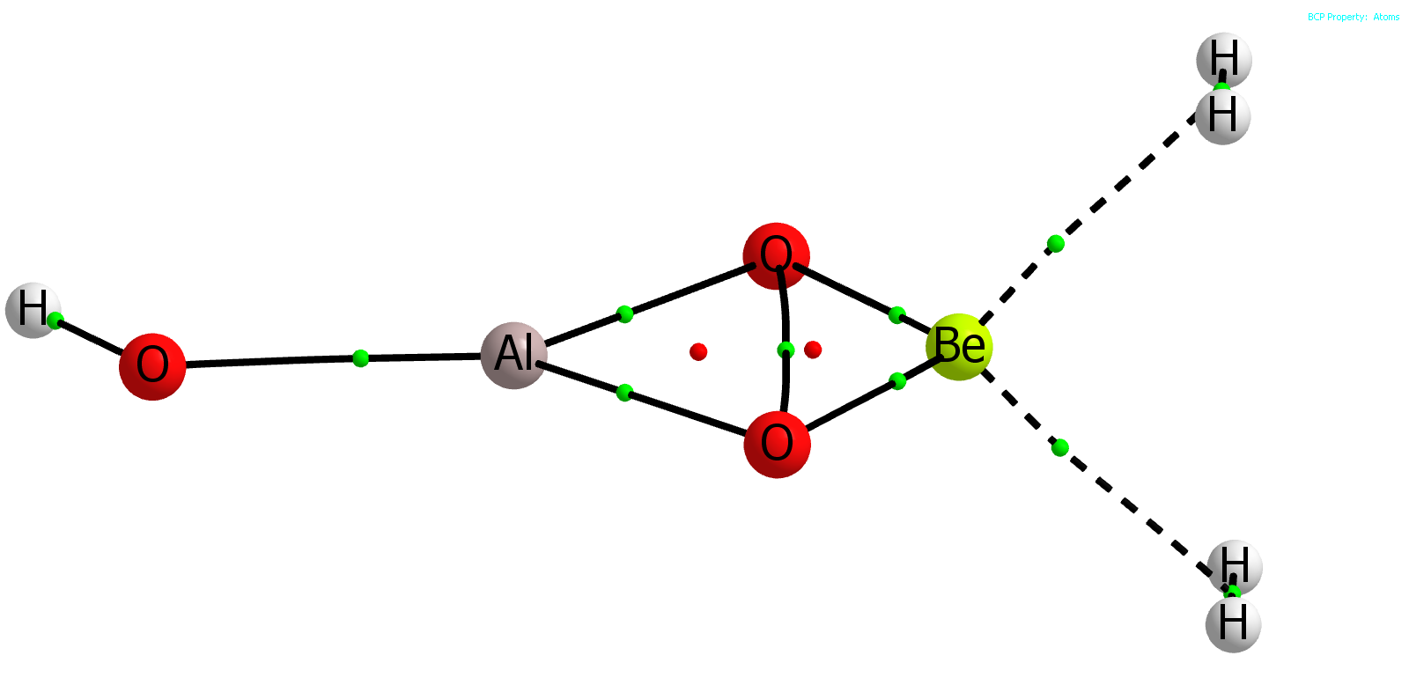 | AlO₃HBe:2H₂  MP2= -485.23841029 NIMAG= 0  Be,0.,-0.0039957688,-0.1025010427  O,0.,-1.2837916282,0.7034256305  O,0.,1.2044795277,0.8061716174  Al,0.,-0.0873280006,1.9907053753  O,0.,-0.0979984417,3.6914494536  H,-1.2786838062,0.429628794,-1.3495513381  H,-1.2767721892,-0.3195446249,-1.3883575215  H,1.2767721892,-0.3195446249,-1.3883575215  H,1.2786838062,0.429628794,-1.3495513381  H,0.,-0.8970525993,4.2191054818
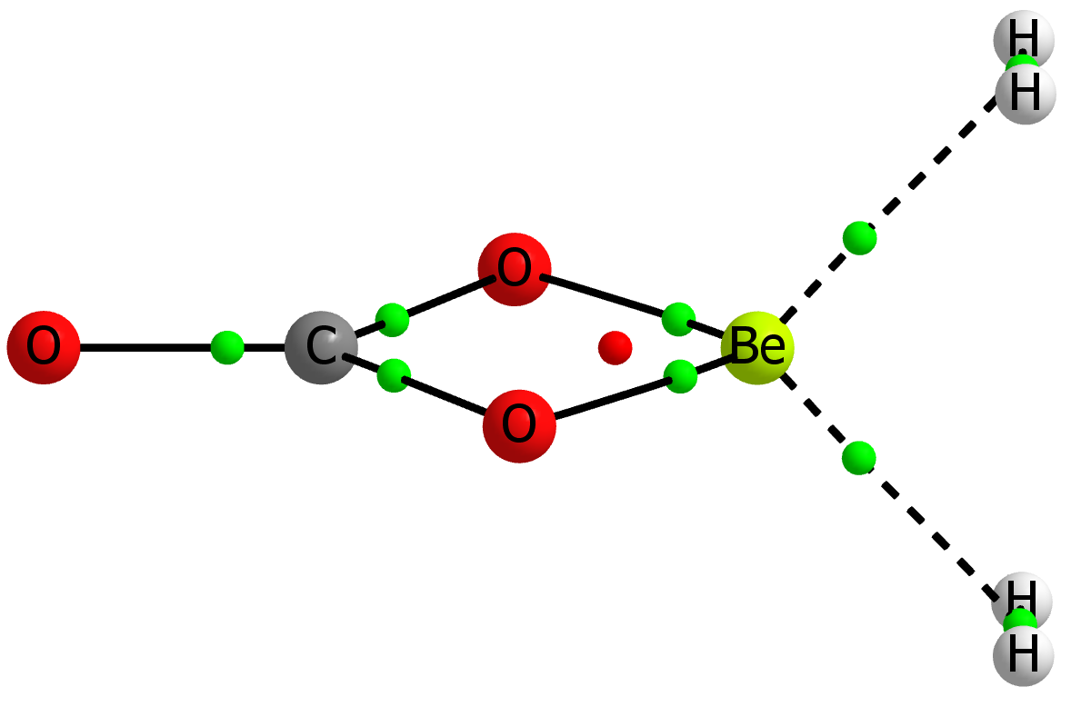 | CO₃Be:2H₂  MP2= -280.51487969 NIMAG= 0  Be  X,1,1.  X,1,1.,2,90.  O,1,r1,2,a1,3,90.,0  O,1,r1,2,a1,3,-90.,0  C,1,r2,3,90.,2,0.,0  O,1,r21,3,90.,2,0.,0  X,1,r3,3,90.,2,180.,0  X,8,r31,1,90.,3,0.,0  X,8,r31,1,90.,3,180.,0  H,10,r4,8,90.,1,90.,0  H,10,r4,8,90.,1,-90.,0  H,9,r4,8,90.,1,90.,0  H,9,r4,8,90.,1,-90.,0  r1=1.50929033  a1=46.7291445  r2=1.87699118  r21=3.07104419  r3=1.1452973  r31=1.27043769  r4=0.37667349
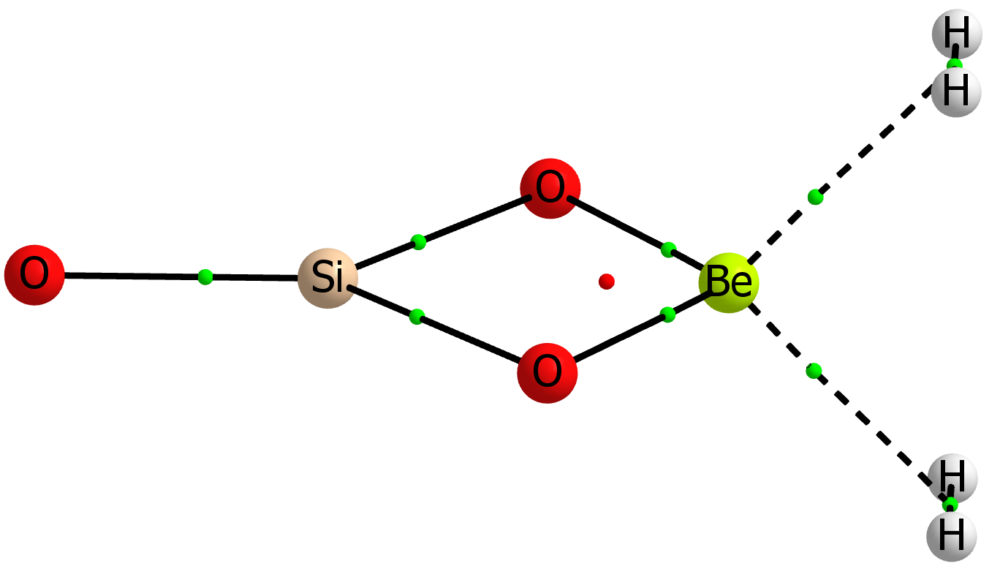 | SiO₃Be:2H₂  MP2= -531.64202367 NIMAG= 0  Be  X,1,1.  X,1,1.,2,90.  O,1,r1,2,a1,3,90.,0  O,1,r1,2,a1,3,-90.,0  Si,1,r2,3,90.,2,0.,0  O,1,r21,3,90.,2,0.,0  X,1,r3,3,90.,2,180.,0  X,8,r31,1,90.,3,0.,0  X,8,r31,1,90.,3,180.,0  H,10,r4,8,90.,1,90.,0  H,10,r4,8,90.,1,-90.,0  H,9,r4,8,90.,1,90.,0  H,9,r4,8,90.,1,-90.,0  r1=1.52264  a1=51.85904101  r2=2.09551049  r21=3.62772409  r3=1.17838511  r31=1.26760918  r4=0.37631631
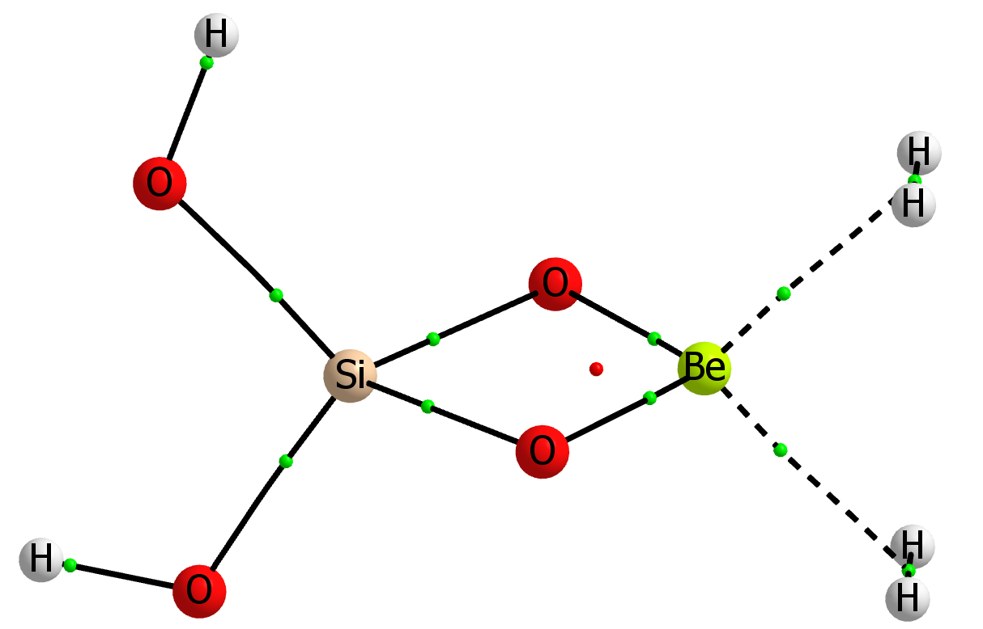 | SiO₄H₂Be:2H₂  MP2= -608.07528756 NIMAG= 0  Be,-0.0252339642,-0.0167870159,-0.0271045427  O,0.023087495,-1.2271886986,0.8732223089  O,-0.0982257706,1.1694109813,0.9026166097  Si,0.0002152931,-0.0382367566,2.057785947  O,1.3543230151,0.0753449961,2.9779537075  O,-1.2311611137,-0.1551957866,3.1484534235  H,1.3217564159,-0.3027158712,-1.2119261329  H,1.2833437396,0.4468944467,-1.1974812315  H,-1.2596338043,0.3180398023,-1.2966627033  H,-1.2173673624,-0.4314436322,-1.3148299795  H,1.2331764247,-0.1250970757,3.9090779525  H,-2.096672424,-0.3727090495,2.7957761761
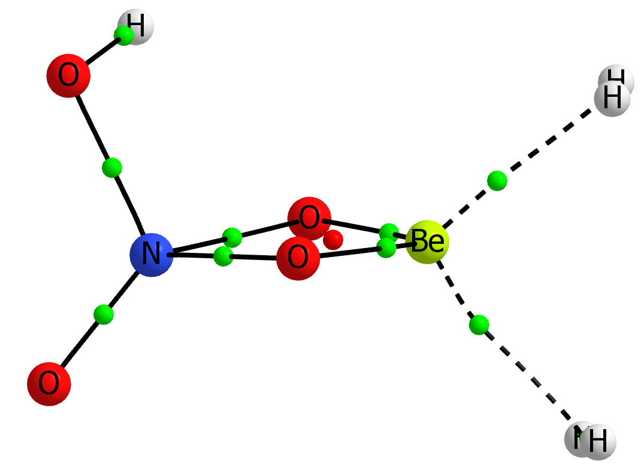 | NO₄HBe:2H₂  MP2= -372.67024172 NIMAG= 0  N,0.5998634556,0.3263041199,-0.2382219476  O,0.1593603662,1.6690268454,-0.0818619224  O,1.7721369573,0.1558534464,-0.3130080092  O,-0.2547330886,-0.3364997908,1.2576592691  O,-0.2434275464,-0.3665400118,-1.1482009742  H,-0.3510351371,1.5534989381,0.743335018  Be,-0.8749310808,-0.9791287985,0.0926981319  H,-2.6075044623,-1.1105045146,-0.3891379001  H,-2.6307351525,-1.0844258057,0.3619630045  H,-0.6706973988,-2.7976220144,0.4467631281  H,-0.8130079126,-2.852272414,-0.2869877981
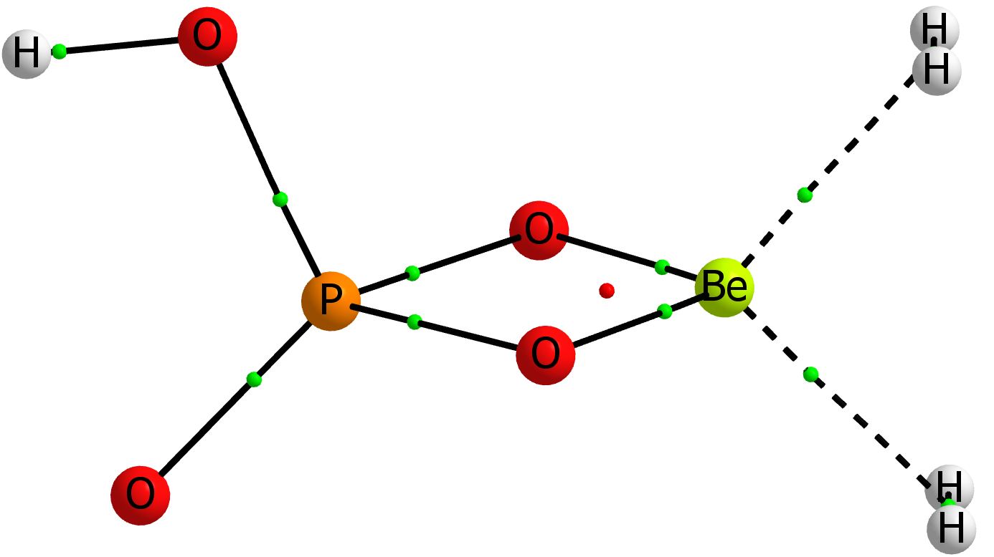 | PO₄HBe:2H₂  MP2= -659.24801313 NIMAG= 0  P,-0.0017531959,0.4984602021,0.  O,-1.2620790145,-0.5045410876,0.  O,-0.4045040682,1.9182718732,0.  O,0.9750755502,-0.0558605703,1.1660688412  O,0.9750755502,-0.0558605703,-1.1660688412  H,-2.0713990924,0.0215248962,0.  Be,1.8211921279,-0.5247016028,0.  H,2.2124967783,-2.203803967,-0.3763340559  H,2.2124967783,-2.203803967,0.3763340559  H,3.4558524738,0.0180891024,0.3763077242  H,3.4558524738,0.0180891024,-0.3763077242
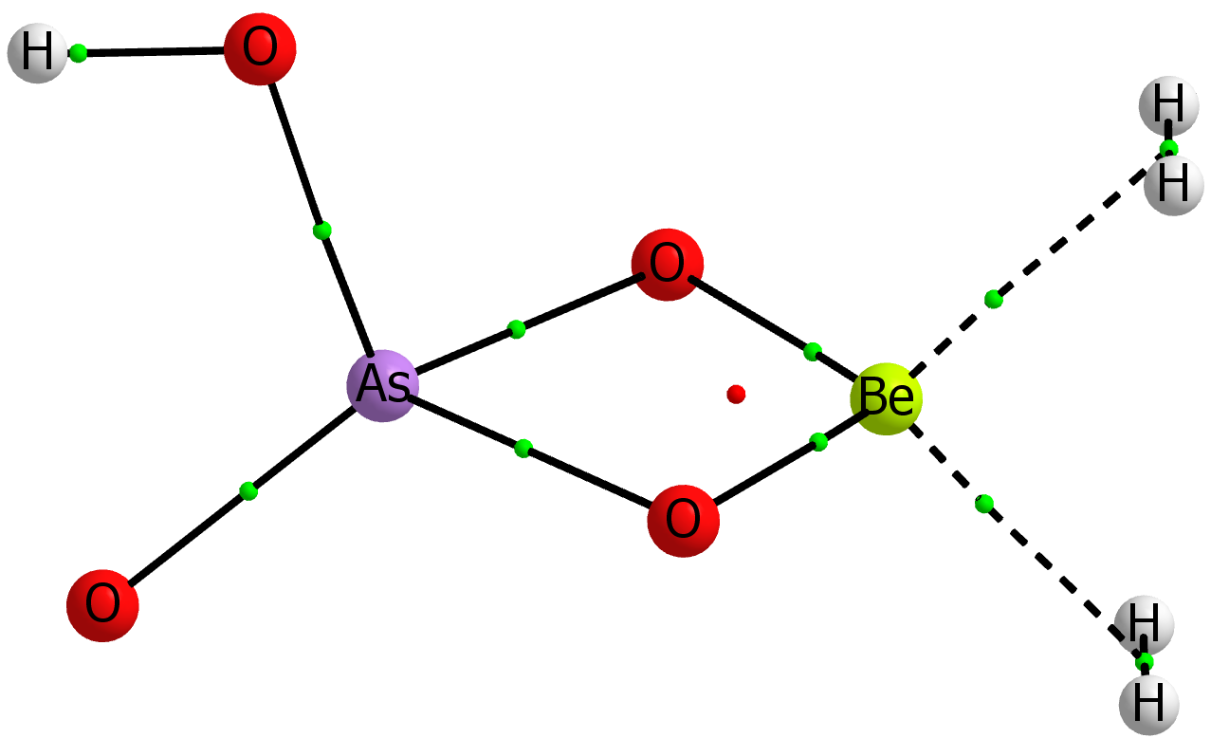 | AsO₄HBe:2H₂  MP2= -2552.71638006 NIMAG= 0  As,-0.0451589194,0.5629638827,0.  O,-1.3838504876,-0.5482305442,0.  O,-0.5061232279,2.1091798699,0.  O,1.0577241963,-0.0748546263,1.2122149561  O,1.0577241963,-0.0748546263,-1.2122149561  H,-2.1974086366,-0.0244405515,0.  Be,1.8549080384,-0.5296388395,0.  H,2.2470719001,-2.2246044067,-0.376105095  H,2.2470719001,-2.2246044067,0.376105095  H,3.5181737008,-0.0225261701,0.3761182313  H,3.5181737008,-0.0225261701,-0.3761182313
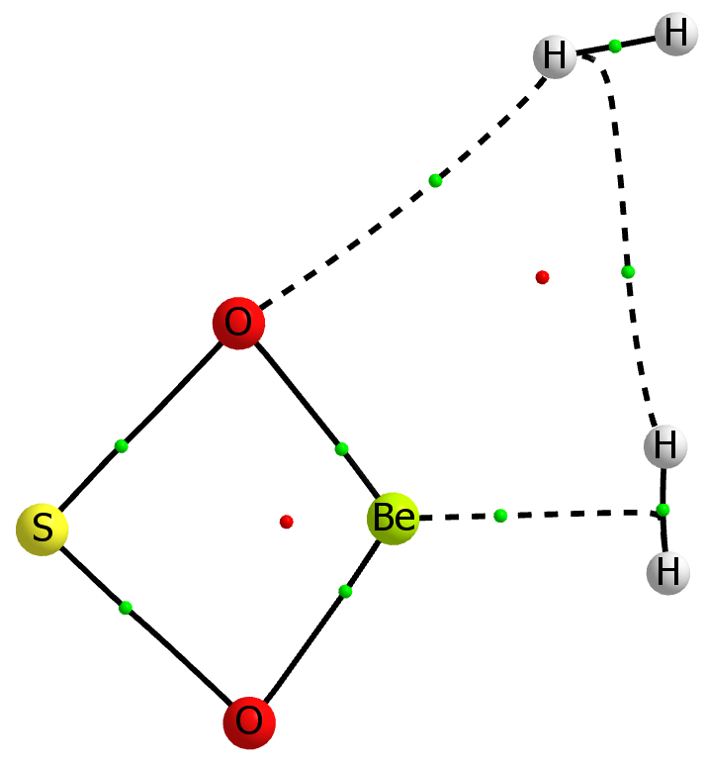 | SO₂Be:2H₂  MP2= -565.01727420 NIMAG= 0  Be,0.,-0.0576050337,-0.0510172525  O,0.,-1.2706265143,0.8219323145  O,0.,1.1208509286,0.8662306503  S,0.,-0.0955086654,2.0565391883  H,0.,-0.407268475,-1.7037326794  H,0.,0.3488329716,-1.685741617  H,0.,-2.7686826411,-1.1451446258  H,0.,-2.8699925708,-1.8794027402
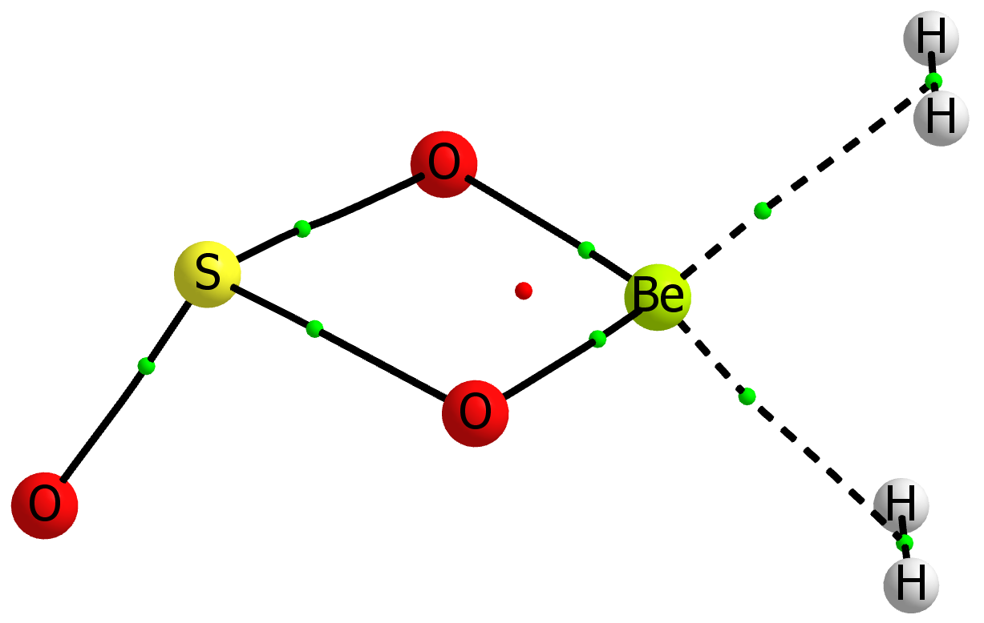 | SO₃Be:2H₂  MP2= -640.18769589 NIMAG= 0  Be,0.0089440116,0.,0.0589348824  O,0.012240434,-1.1719532764,0.9993172927  O,0.012240434,1.1719532764,0.9993172927  S,0.037951199,0.,2.1977501397  O,-1.2578276489,0.,2.8641271016  H,1.2615784705,-0.3758518715,-1.1592156967  H,1.2615784705,0.3758518715,-1.1592156967  H,-1.291858719,0.3746363105,-1.226582887  H,-1.291858719,-0.3746363105,-1.226582887
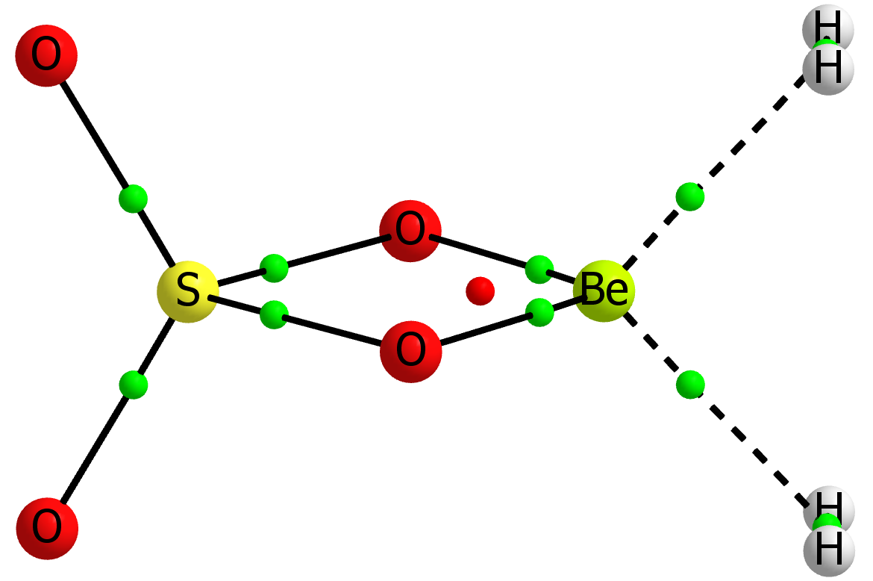 | SO₄Be:2H₂  MP2= -715.32067256 NIMAG= 0  Be  X,1,1.  X,1,1.,2,90.  O,1,r1,2,a1,3,90.,0  O,1,r1,2,a1,3,-90.,0  S,1,r2,3,90.,2,0.,0  O,6,r11,1,a11,3,0.,0  O,6,r11,1,a11,3,180.,0  X,1,r3,3,90.,2,180.,0  X,9,r31,1,90.,3,0.,0  X,9,r31,1,90.,3,180.,0  H,10,r4,9,90.,1,90.,0  H,10,r4,9,90.,1,-90.,0  H,11,r4,9,90.,1,90.,0  H,11,r4,9,90.,1,-90.,0  r1=1.51663168  a1=49.55587702  r11=1.43914406  a11=119.9460698  r2=2.11680764  r3=1.14296524  r31=1.26972525  r4=0.37678666
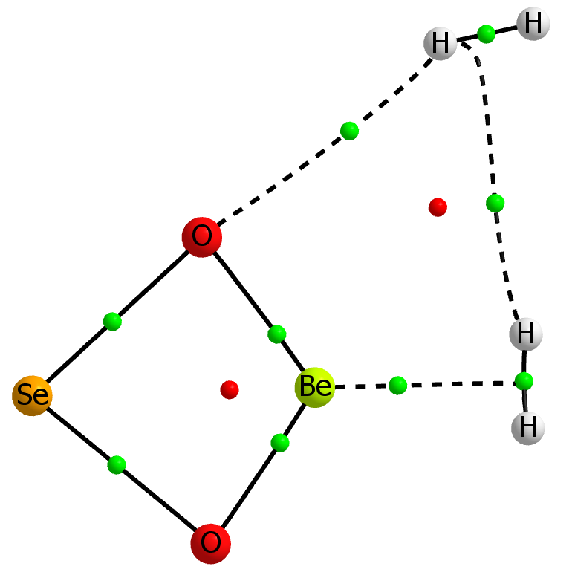 | seo2be_2h2_B MP2= -2567.42257162 NIMAG= 0  Be,0.,-0.0538878536,-0.0453416103  O,0.,-1.3046313812,0.7771704509  O,0.,1.1627700821,0.8241426209  Se,0.,-0.0950517582,2.1585183506  H,0.,-0.4002426142,-1.7093982653  H,0.,0.3552228941,-1.6897714823  H,0.,-2.769935593,-1.1523224684  H,0.,-2.8942437761,-1.883334358
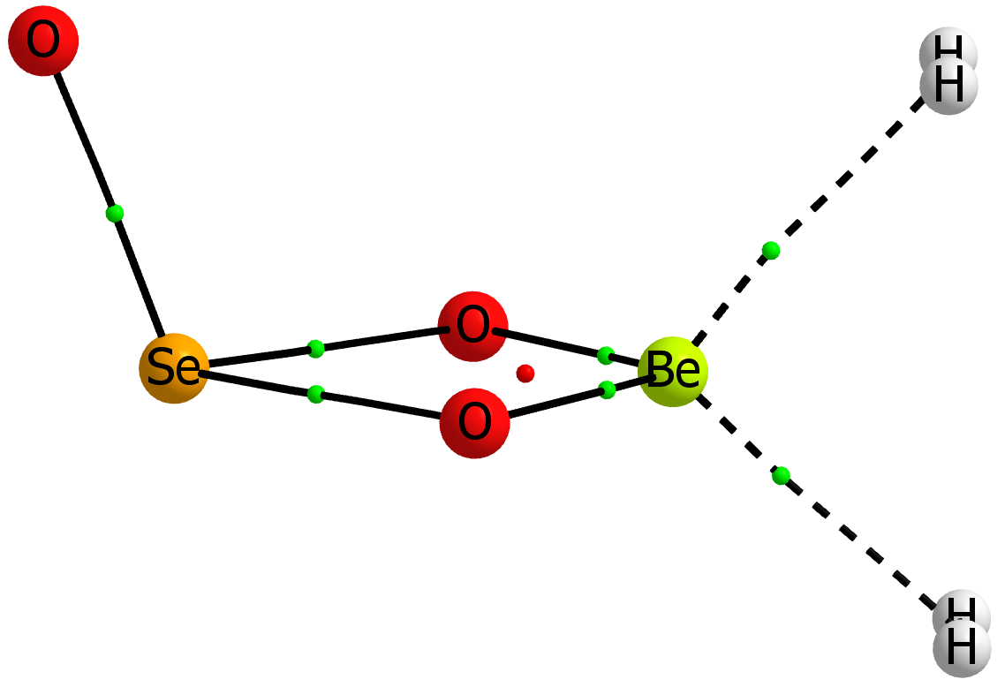 | SeO₃Be:2H₂  MP2= -2642.57219943 NIMAG= 0  Be,0.0670082594,0.,0.0632250978  O,0.0812482819,-1.2148600057,0.9547916887  O,0.0812482819,1.2148600057,0.9547916887  Se,0.0514013649,0.,2.297150001  O,-1.4401072212,0.,2.8835910238  H,1.2588664805,-0.375611391,-1.2314736592  H,1.2588664805,0.375611391,-1.2314736592  H,-1.3027719976,0.3744814564,-1.17137632  H,-1.3027719976,-0.3744814564,-1.17137632
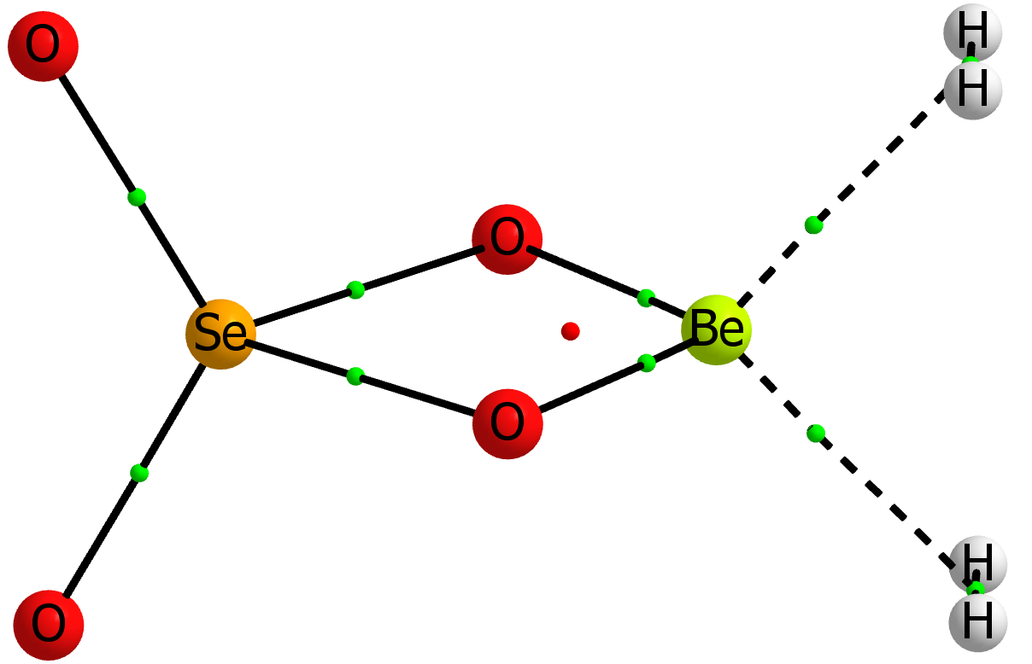 | SeO₄Be:2H₂  MP2= -2717.65643270 NIMAG= 0  Be  X,1,1.  X,1,1.,2,90.  O,1,r1,2,a1,3,90.,0  O,1,r1,2,a1,3,-90.,0  Se,1,r2,3,90.,2,0.,0  O,6,r11,1,a11,3,0.,0  O,6,r11,1,a11,3,180.,0  X,1,r3,3,90.,2,180.,0  X,9,r31,1,90.,3,0.,0  X,9,r31,1,90.,3,180.,0  H,10,r4,9,90.,1,90.,0  H,10,r4,9,90.,1,-90.,0  H,11,r4,9,90.,1,90.,0  H,11,r4,9,90.,1,-90.,0  r1=1.52340043  a1=52.04754678  r11=1.59100281  a11=119.54312271  r2=2.22241084  r3=1.16168054  r31=1.2726961  r4=0.37659693

Table S3. . Dipole moment enhancement (Debye) of the 1:1 complexes obtained at the MP2/aug-cc-pVTZ computational level.

1:1 Complexes | Dipole moment enhancement
BO₃HBe:H₂ | 1.47
AlO₃HBe:H₂ | 1.17
CO₃Be:H₂ | 1.54
SiO₃Be:H₂ | 1.64
SiO₄HBe:H₂ | 1.41
NO₄HBe:H₂ | 1.97
PO₄HBe:H₂ | 1.56
AsO₄HBe:H₂ | 1.63
SO₂Be:H₂ | 1.66
SO₃Be:H₂ | 1.93
SO₄Be:H₂ | 1.72
SeO₂Be:H₂ | 1.69

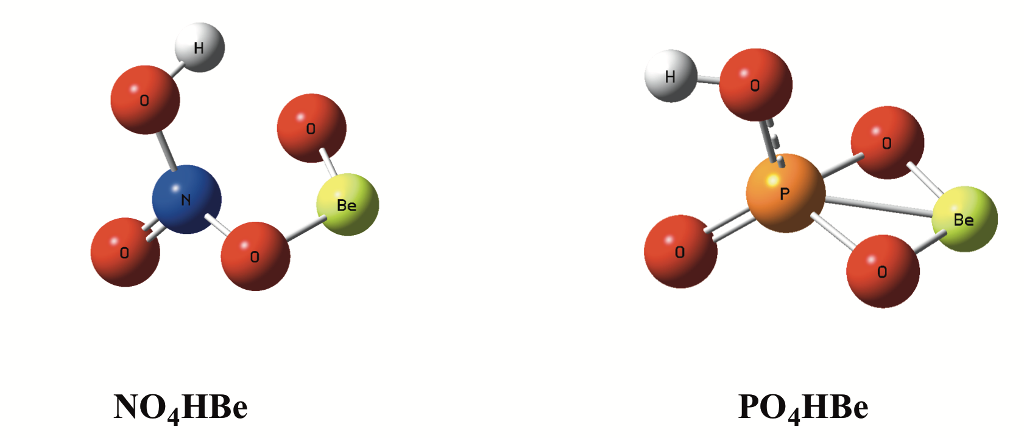

Figure S1. Comparison of the structures of NO₄HBe and PO₄HBe salts to show that whereas in the latter the central P atoms is tetracoordinated in NO₄HBe the N atom is not.

