Supplementary material to:
Potential evapotranspiration changes in Lancang River Basin and Yarlung Zangbo River Basin, southwest China
Di Maª, Tianyang Wangª, Chao Gaoª, Suli Panª, Zhilin Sun^{b}, and Yue-Ping Xuª

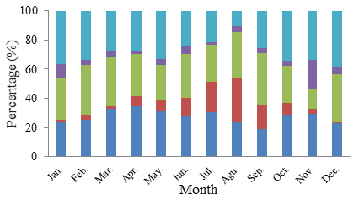
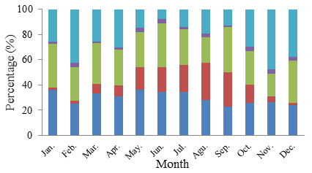
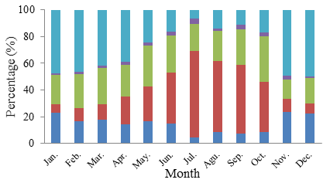
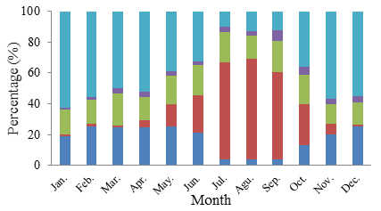
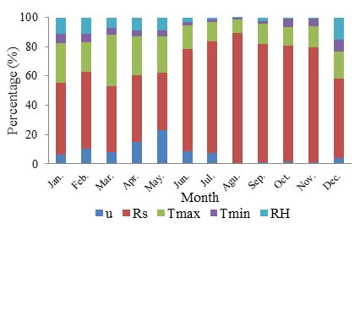
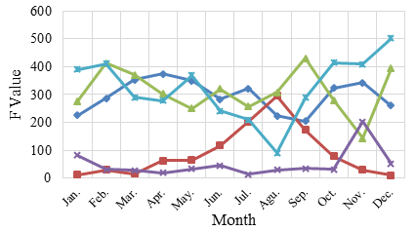
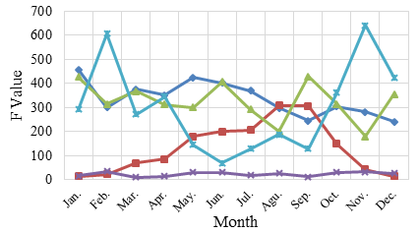
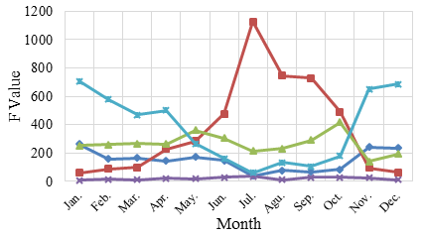
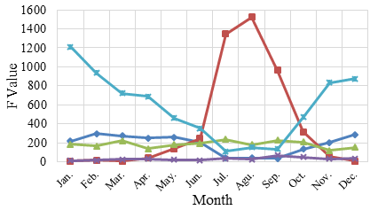
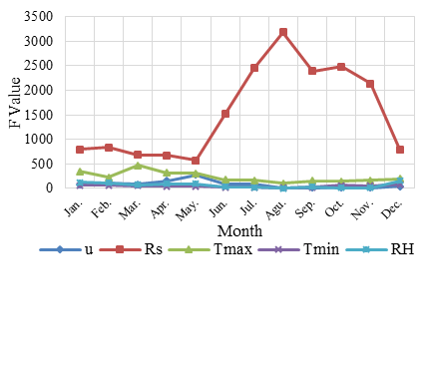

Figure S1. F values of single factors (left column) and their percentages of the total variance (right column) at a significance level of p = 0.05 for the five representative stations in the LRB: (a) Nangqian, (b) Changdu, (c) Weixi, (d) Dali and (e) Jinghong. u: wind speed at 2 m height; Rs: solar radiation; Tmax and Tmin: maximum and minimum air temperature, respectively; and RH: relative humidity.

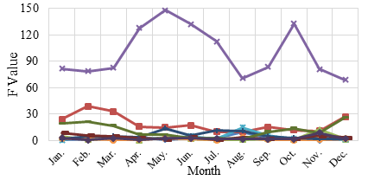
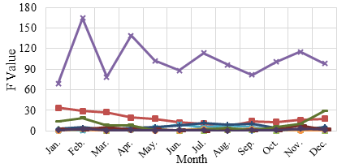
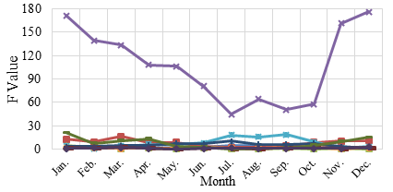
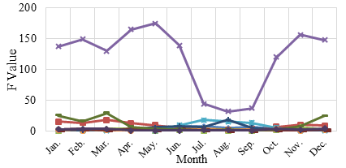
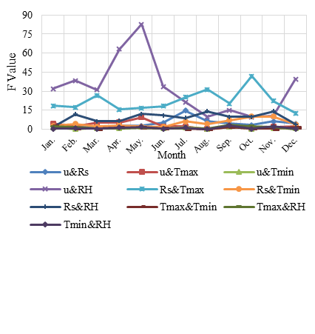
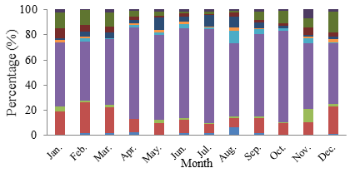
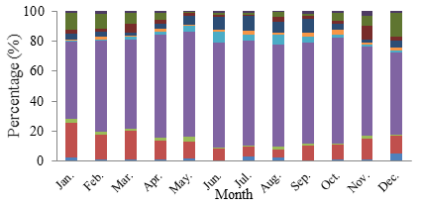
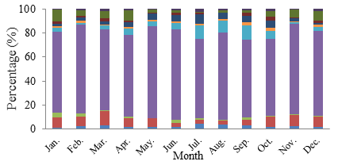
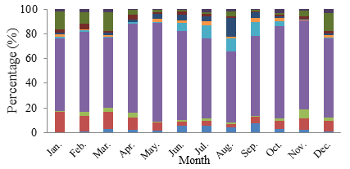
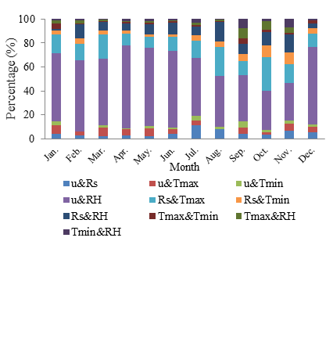
(a)

(b)

(c)

(d)

(e)

Figure S2. F values of interactions between two factors (left column) and their percentages of the total variance (right column) at a significance level of p = 0.05 for the five representative stations in the LRB: (a) Nangqian, (b) Changdu, (c) Weixi, (d) Dali and (e) Jinghong. See Fig. S1 caption for definition of variables.

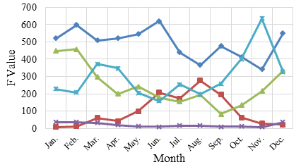
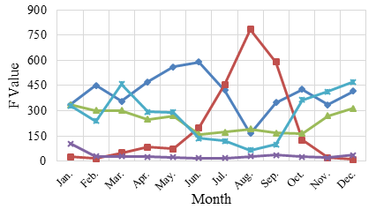
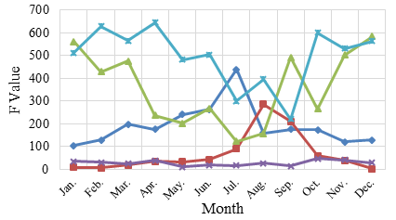
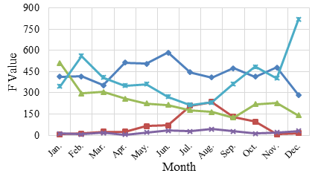
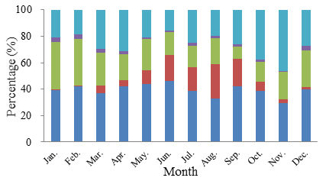
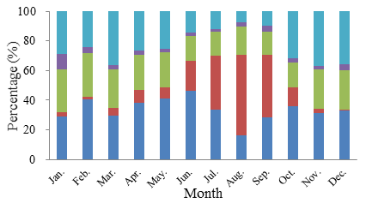
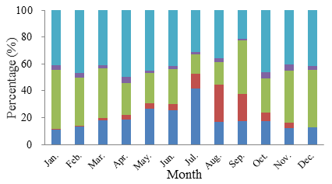
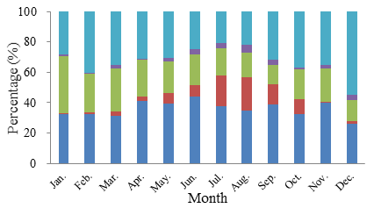
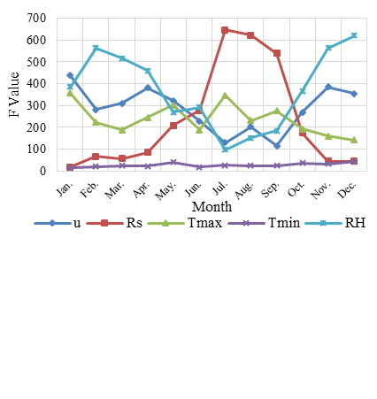
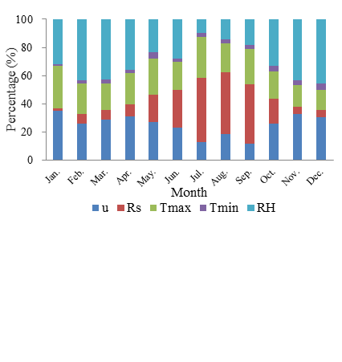
(a)

(b)

(c)

(d)

(e)

Figure S3. F values of single factors (left column) and their percentages of the total variance (right column) at a significance level of p = 0.05 for the five representative stations in the YRB: (a) Lhazê, (b) Shigatse, (c) Damxung, (d) Zetang and (e) Nyingchi. See Fig. S1 caption for definition of variables.

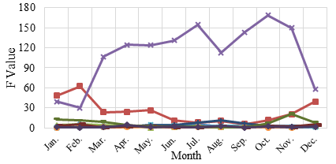
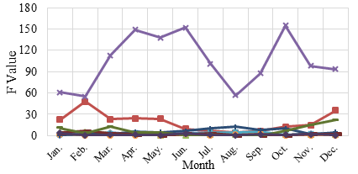
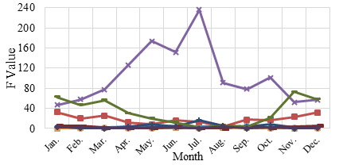
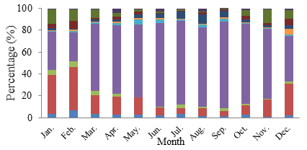
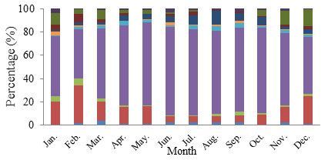
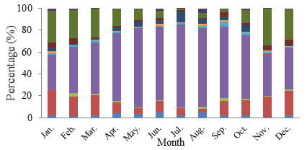
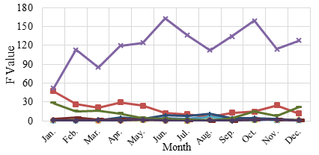
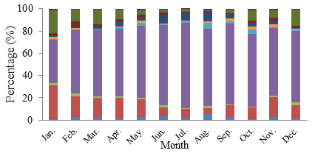
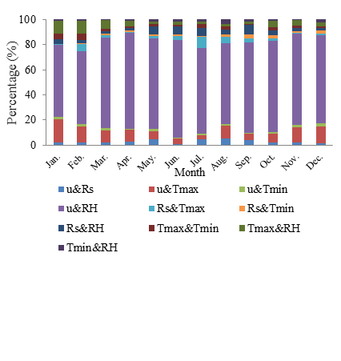
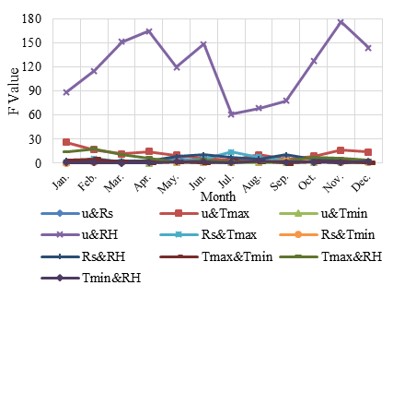
(a)

(b)

(c)

(d)

(e)

Figure S4. F values of interactions between two factors (left column) and their percentages of the total variance (right column) at a significance level of p = 0.05 for the five representative stations in the YRB: (a) Lhazê, (b) Shigatse, (c) Damxung, (d) Zetang and (e) Nyingchi. See Fig. S1 caption for definition of variables.

