Supplemental Figures

Figure S1. Mechanism of filter-aid operation on filter media in filter press system

Figure S2. Photograph of the KUO₂PO₄ particle cake formed on cloth media in a filter press system.

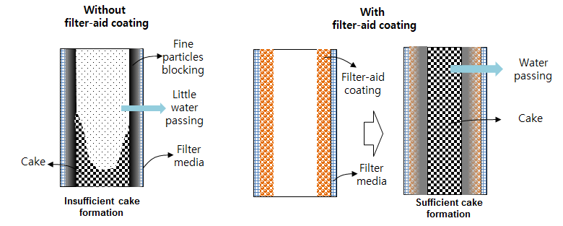

Figure S1. Mechanism of filter-aid operation on filter media in filter press system

Figure S2. Photograph of the KUO₂PO₄ particle cake formed on cloth media of a filter press system.

