Table S1: Different species of microorganisms in Cr remediation.

Bacteria | Cr concentration | %Cr reduction | Description | References
Bacillus  sp. (CSB-4) | 10–500 mg L⁻¹ | 90 | Bacillus  sp. (CSB-4) reduced 90% of 100 mg L⁻¹ Cr (VI) at pH 7.0 and temperature 35⁰C in 144 h | [4]
Methanothermobacter thermautotrophicus | 0.2- 5 mM | 43.6% | Methanothermobacter thermautotrophicus reduces 43.6%, 13.0%, and 3.7% at higher Cr⁶⁺ concentrations  of 1, 3 and 5 mM, respectively | [34]
Bacillus cereus isolate PGBw4 and Bacillus cereus strain ES-4a1 | 100mg/L to 500mg/L | 70.67 | Bacillus cereus isolate PGBw4 and Bacillus cereus strain ES-4a1 reduced maximum amount of Cr at 100 mg/L after 48 h of incubation time. | [35]
Staphylococcus arlettae strain Cr11 | 100 mg L⁻¹, 500 and 1000 mg L⁻¹, | 98, 98, 75 | Staphylococcus arlettae strain Cr11 reduces 100 mg L⁻¹, 500 and 1000 mg L⁻¹ Cr (VI) in 24 h and 120 h | [36]
Sporosarcina saromensis M52 | 50-200 mg /L | 100 | 100 % reduction was achieved at 35⁰C at pH 7.0-8.5 in 24 h | [37]
Pseudomonas stutzeri | 1000 mg L⁻¹, | - | Reduction was achieved in 120 h. | [38]
Vigribacillus sp. | 100 mg/L | 90.2 and 99.2 | Reduced 90.2 -99.2 & of Cr within 70 h in presence and absence of 6 wt % NaCL. | [39]

Characterization and 16S rRNA gene sequencing
Bacterial morphological characterization like cell morphology, colony count and Gram–reaction was performed. Cell lysis was carried out in ‘B Cube’ lysis buffer by repeated pipetting. After addition of RNAse and “B Cube” neutralization buffer vortexing was done and the tubes were incubated for 30 min. at 65⁰ C in water bath. Centrifugation was done at 14,000 rpm at 10˚C for 15 min, and the supernatant was transferred with the addition of “B Cube” binding buffer to the content following incubation at room temperature for 5 min. The content was transferred to a spin column, and centrifugation was carried out for 2 minutes at 14,000 rpm and repeated twice.
“B Cube” washing buffer I was added and centrifugation were carried out at 14,000 rpm for 2 mins followed by addition of “B Cube” washing buffer II and centrifugation. “B Cube” Elution buffer was added and was incubated at room temperature for 5 minutes and centrifugation at 6000 rpm for 1min. DNA concentrations were measured by running aliquots on 1% agarose gel. The Partial 16S rRNA gene was amplified by PCR using bacterial universal primers 27F (AGAGTTTGATCMTGGCTCAG) and 1492R (TACGGYTACCTTGTTACGACTT) ([15]Rainey et al. 1996), and PCR products were analyzed at the laboratory of Yazzh xenomics, Chennai. Sequencing reactions were performed using a ABI PRISM® BigDyeTM Terminator Cycle Sequencing Kits with AmpliTaq® DNA polymerase (FS enzyme) (Applied Biosystems). Single-pass sequencing was performed on each template using below 16s rRNA universal primers. The fluorescent-labeled fragments were purified from the unincorporated terminators with an ethanol precipitation protocol. The samples were resuspended in distilled water and subjected to electrophoresis in an ABI 3730xl sequencer (Applied Biosystems). National Center for Biotechnology Information blast was used for sequence similarity (http://www.ncbi.nlm.nih.gov/blast/) [40] and similarity was calculated from the EzTaxon database (http://www.ezbiocloud.net/eztaxon) . MEGA version 7.0 was used for analysis of 16s rRNA gene sequence data using (MUSCLE) as an alignment, and the result was exported in ‘.mega’ format. Construction of phylogenetic tree was done from the exported data using MEGA version 7 using Neighbor-Joining method [41]. The phylogeny test was executed in Bootstrap method (10000 replications) with Jukes-Cantor substitution model [42] and partial deletion was done for missing data treatment.

Fig. S1 Phylogenetic tree based on 16s rRNA sequences showing evolutionary relationship between the isolates and Serratia rubidaea

(A)

Fig. S2 (A) SU.ISM.1 growth curve in MSM; (B) SU.ISM.1 in LB medium

Fig. S3 Total mass conversion of Cr (VI) converted to Cr (III)

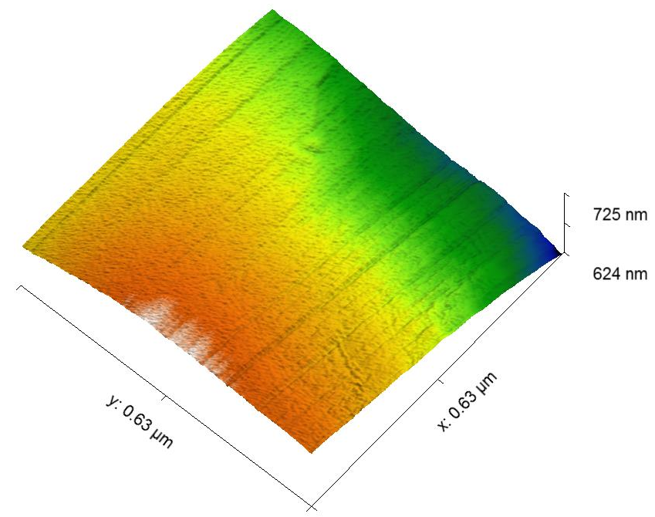
(A1)
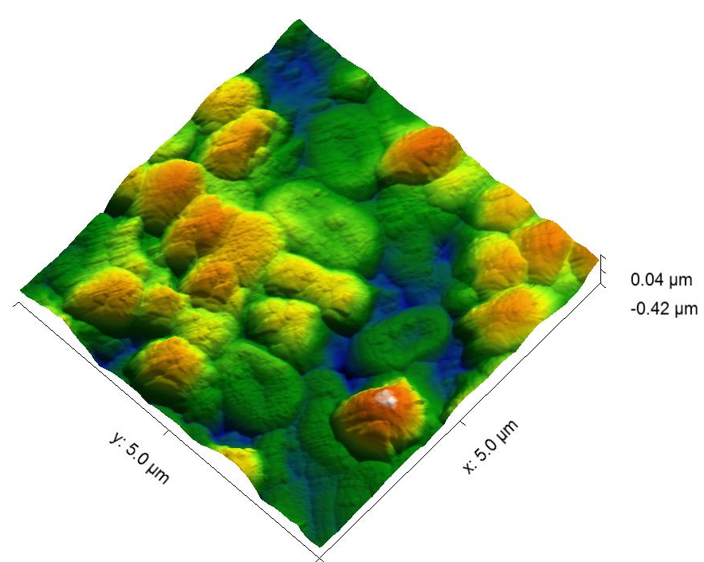
(A2)
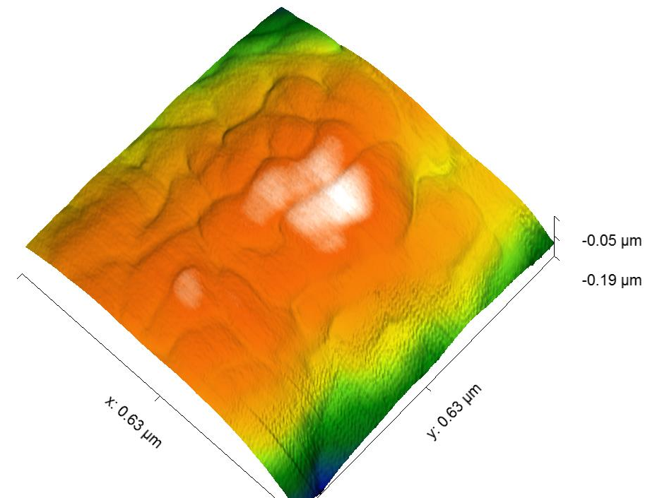
(B1)
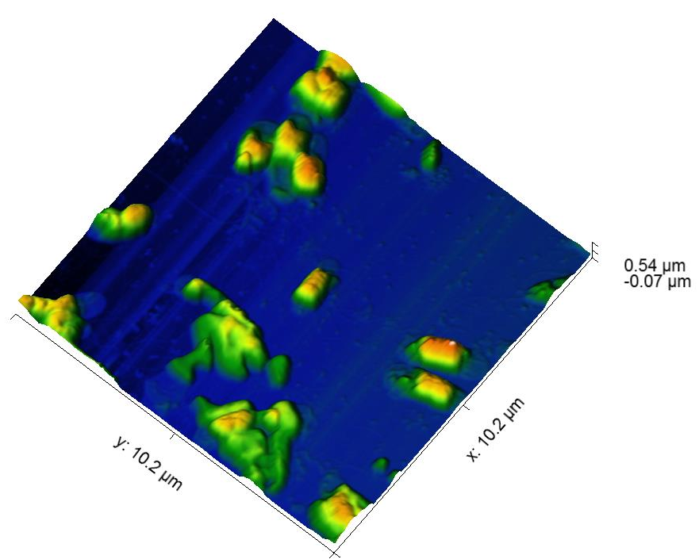
(B2)
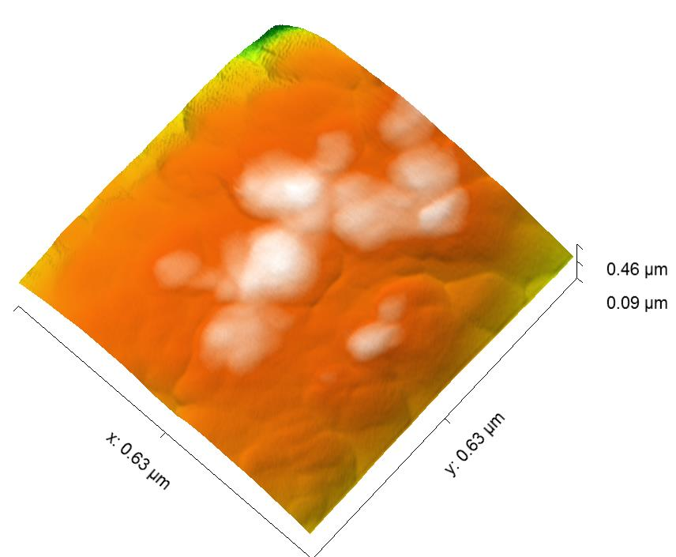
(C1)
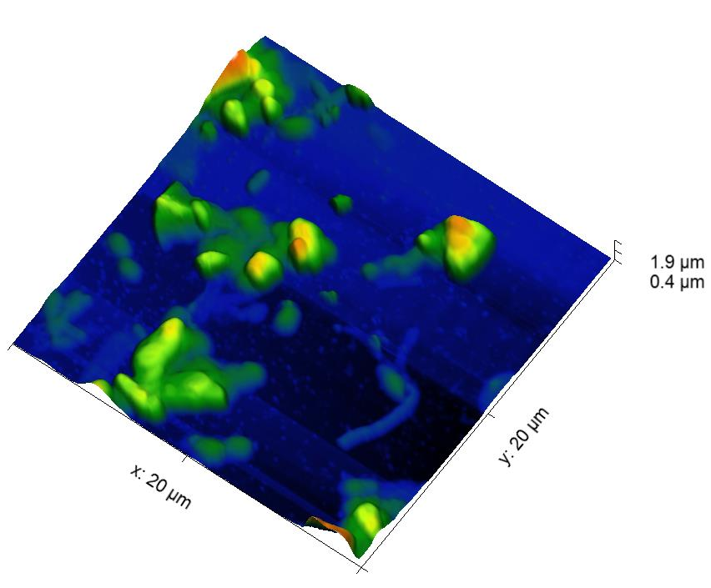
(C2)
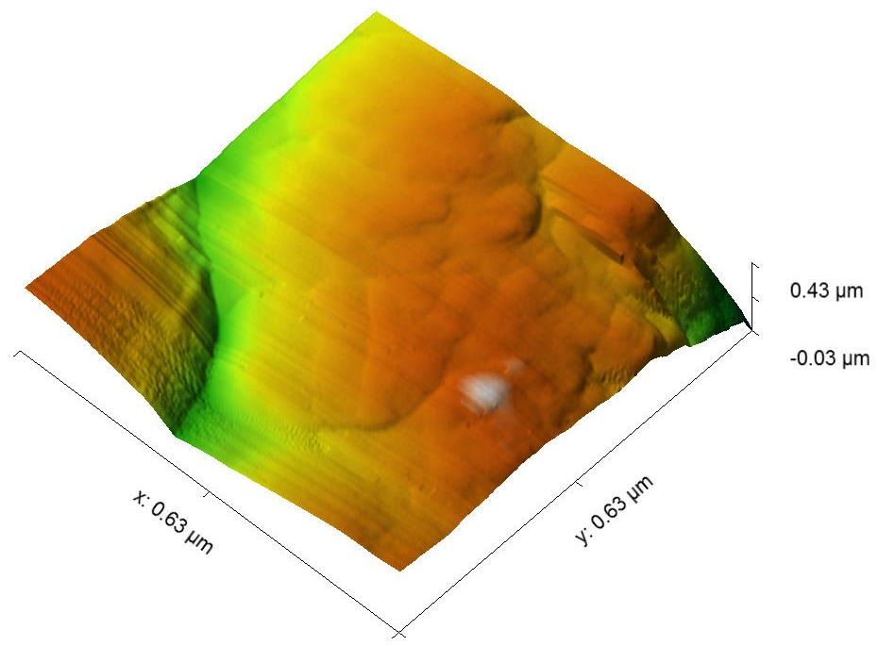(D1)
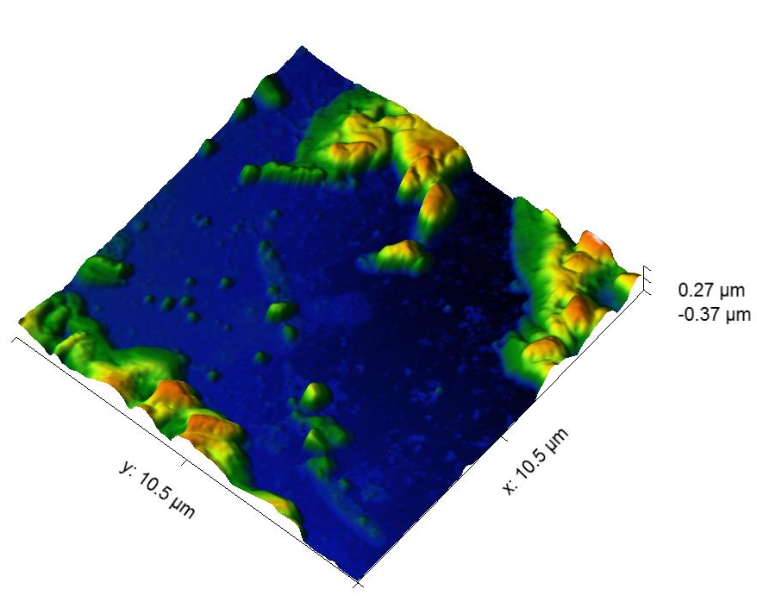(D2)
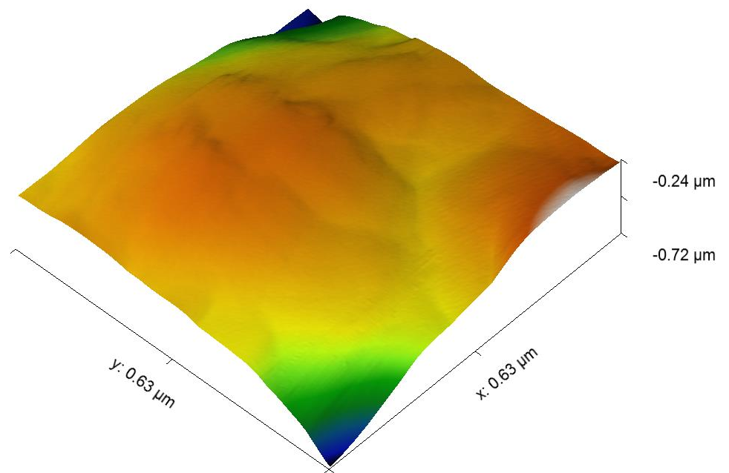(E1)
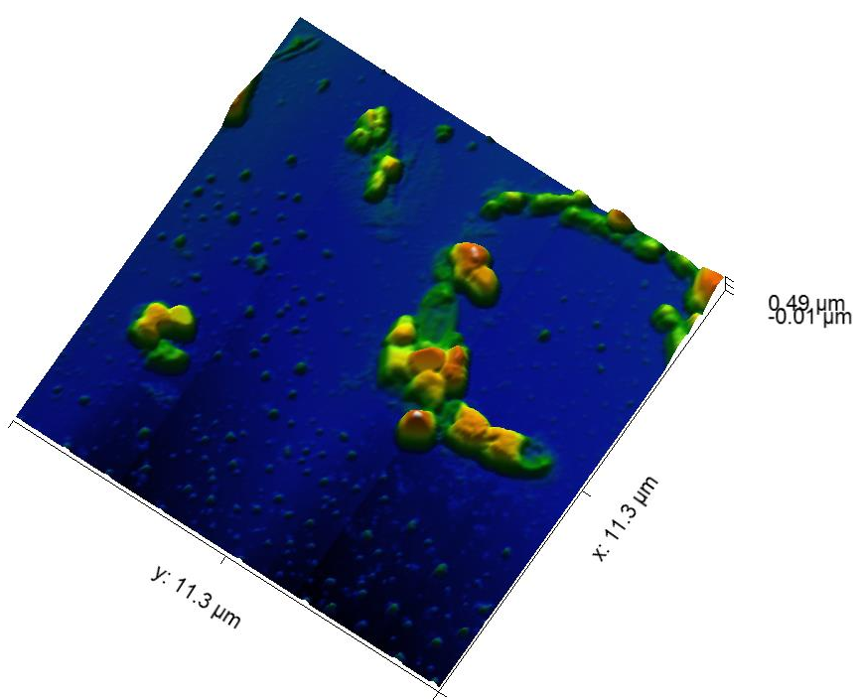(E2)
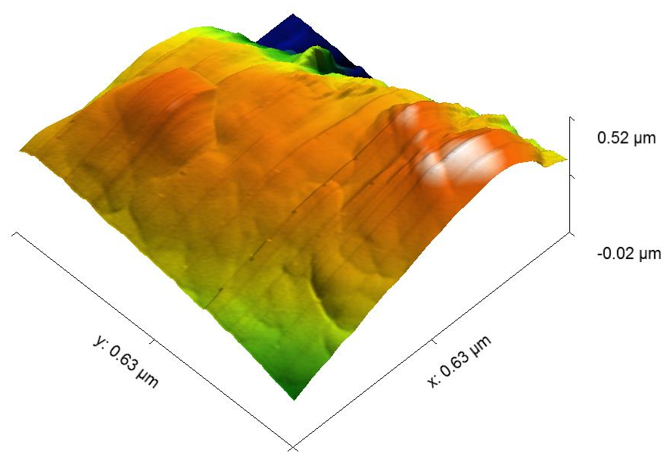
(F1)

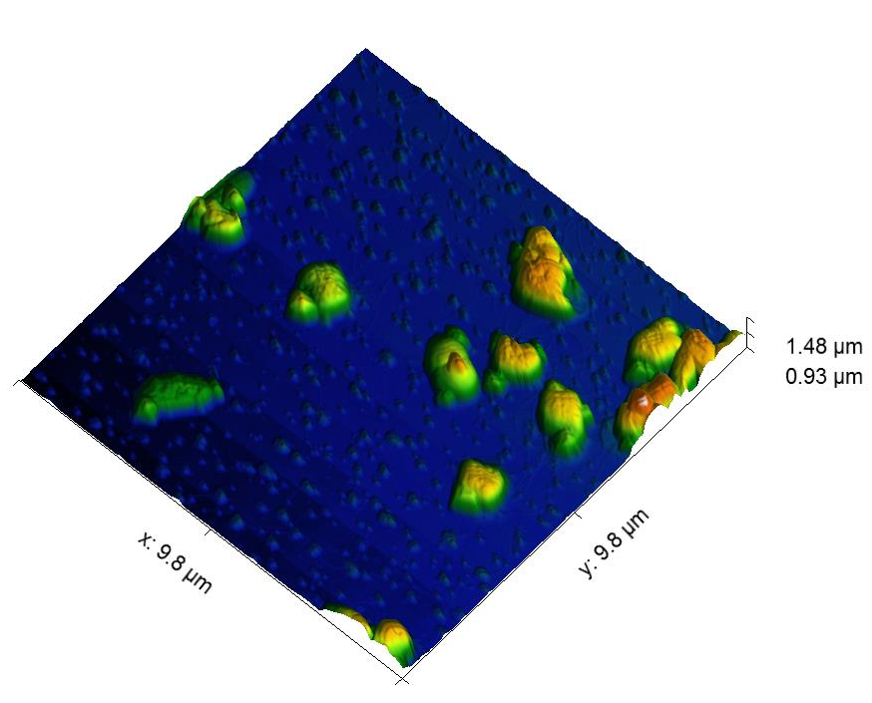
(F2)
Fig. S4 (A1-A2) bacterial cell surface without Cr (VI) concentration, Smaller and Bigger scan size (B1-B2) Cellular surface after getting exposed to 4 ppm Cr (VI) concentration, Smaller and Bigger scan size (C) Structural changes after treatment of 8ppm Cr (VI) concentration, Smaller and Bigger scan size (D) At 12 ppm of Cr (VI) concentration, Smaller and Bigger scan size (E) After treatment of 16ppm Cr (VI) concentration, Smaller and Bigger scan size (F) 20ppm Cr (VI) concentration, Smaller and Bigger scan size
(a)
(b)
(c)
(d)
Fig. S5 (a) Exposure to 4 ppm Cr (VI) concentration (b) At 8 ppm Cr (VI) concentration (c) 12 ppm Cr (VI) concentration (d) Treatment of 16 ppm Cr (VI) concentration

References
[34] Tanu, F.Z., Hakim, A., & Hoque, S. (2016). Bacterial Tolerance and Reduction of Chromium (VI) by Bacillus cereus Isolate PGBw4. American Journal of Environmental Protection, 5(2), 35-38
[35] Singh, R., Dong, H., Liu, D., Zhao, L., Marts, A.R., Farquhar, E., Tierney, D.L., Almquist, C.B., & Briggs, B. R. (2015). Reduction of hexavalent chromium by the thermophilic methanogen Methanothermobacter thermautotrophicus. Geochimica et Cosmochimica Acta, 148, 442–456.
[36] Sagar, S., Dwivedi, A., Yadav, S., Tripathi, M., & Kaistha, S. D. (2012). Hexavalent chromium reduction and plant growth promotion by Staphylococcus arlettae Strain Cr11.Chemosphere, 86, 847–852.
[37] Ran, Z., Bi, W., Tao, C. Q., Xia, L. X., Min, L., Dong, H., Bei, G.D., Juan, W., & Chun, F. (2016). Bioremediation of Hexavalent Chromium Pollution by Sporosarcina saromensis M52 Isolated from Offshore Sediments in Xiamen, China*. Biomedical and Environmental Science, 29(2), 127-136.
[38] Kumari, D., Pan, X., Zhang, D., Zhao, C., Al-Misned, F. A., & Mortuza, G. M. (2015). Bioreduction of Hexavalent Chromium from Soil Column Leachate by Pseudomonas stutzeri. Bioremediation Journal, 19(4), 249–258.
[39] Mishra, R.R., Dhal, B., Dutta, S.K., Dangar, T.K., Dase, N.N., & Thatoi, H.N. (2012). Optimization and characterization of chromium (VI) reduction in saline condition by moderately halophilic Vigribacillus sp. isolated from mangrove soil of Bhitarkanika, India. Journal of Hazardous Materials, 227– 228, 219– 226.
[40] Altschul SF, Gish W, Miller W, Myers EW, Lipman DJ. Basic local alignment search tool. J Mol Biol. 1990; 215 (3):403-10.
[41] Saitou, N., & Nei, M. (1987). The neighbor-joining method: A new method for reconstructing phylogenetic trees. Molecular Biology and Evolution, 4, 406-425.
[42] Jukes, T.H., & Cantor, C.R. (1969). Evolution of protein molecules. In Munro HN, editor, Mammalian Protein Metabolism, pp. 21-132, Academic Press, New York.

