**Electronic Supplementary Information for**

Recognition of dicarboxylates in aqueous acetonitrile by a dinuclear zinc(II) complex of 2,2'-binaphthalene-based receptor

**Shin-ichi Kondo,\*1 Yasunori Nakadai2 and Masafumi Unno\*2**

1Department of Science, Faculty of Science, Yamagata University, 1-4-12 Kojirakawa-machi, Yamagata 990-8560, Japan

2Department of Chemistry and Chemical Biology, Graduate School of Science and Technology, Gunma University, Kiryu, Gunma 376-8515, Japan

**Contents**

**UV-vis spectral changes of [Zn2L]4+ upon the addition of dicarboxylates** S2

**Job plots of [Zn2L]4+ with dicarboxylates** S3

**Fluorescence spectral changes of [Zn2L]4+ upon the addition of dicarboxylates** S4

**The optimized structure of the complexes of [Zn2L]4+ with dicarboxylates** S5

(a) C:\Users\Shin-ichi\AppData\Local\Microsoft\Windows\INetCache\Content.Word\UV_malonate.emf (b) C:\Users\Shin-ichi\AppData\Local\Microsoft\Windows\INetCache\Content.Word\UV_glutarate.emf

(c)UV_adipate (d)UV_pimerate

(e)UV_isophthalate (f)UV_terephthalate

**Figure S1.** UV-vis spectral changes of [Zn2**L**]4+ upon the addition of malonate (a), glutarate (b), adipate (c), pimelate (d), isophthalate (e), and terephthalate (f) in 20%MeCN–MES buffer (10 mM, pH 5.6) at 298 K. [[Zn2**L**]4+] = 2.0 × 10−5 mol dm−3.



**Figure S2.** Job plots of [Zn2**L**]4+ with malonate (⯁), succinate (□), and phthalate (○) in 20%MeCN–MES buffer (10 mM, pH 5.6) at 298 K. [[Zn2**L**]4+]+[dicarboxylate] = 2.0 × 10−5 mol dm−3.

(a) C:\Users\Shin-ichi\AppData\Local\Microsoft\Windows\INetCache\Content.Word\Fl_malonate.emf (b)Fl_glutarate

(c)Fl_adipate (d)Fl_pimerate

(e)Fl_isophthalate (f)Fl_terephthalate

**Figure S3.** Fluorescence spectral changes of [Zn2**L**]4+ upon the addition of malonate (a), glutarate (b), adipate (c), pimelate (d), isophthalate (e), and terephthalate (f) in 20%MeCN–MES buffer (10 mM, pH 5.6) at 298 K. [[Zn2**L**]4+] = 2.0 × 10−5 mol dm−3, ex = 296 nm.

(*a*)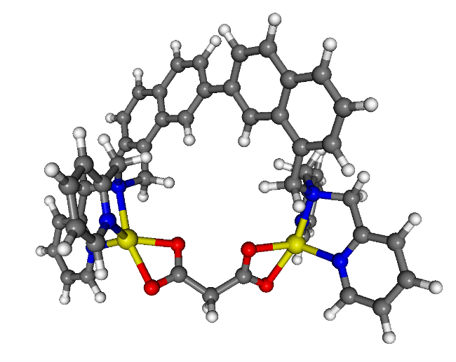 (*b*)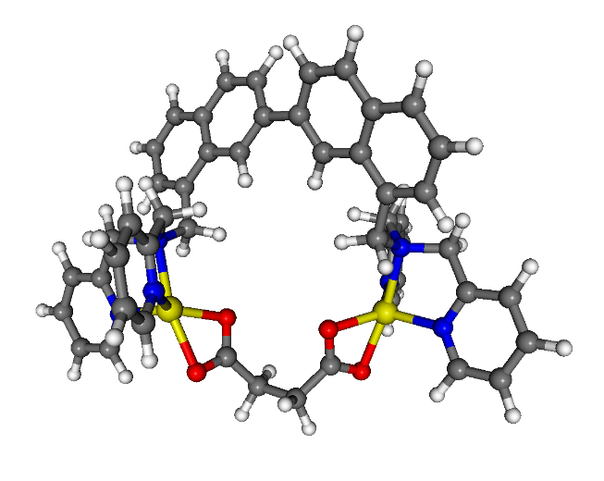

(*c*)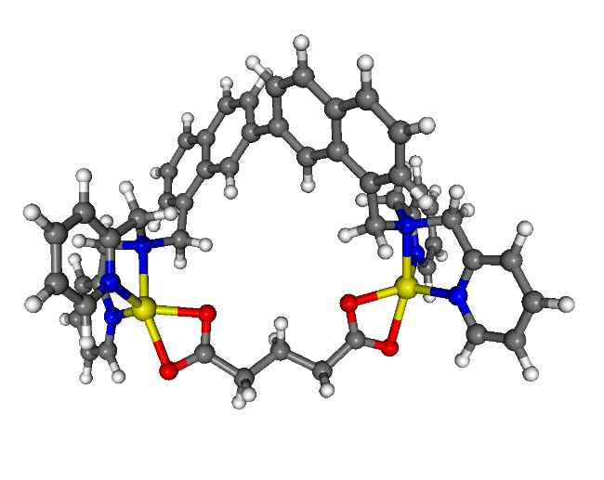 (*d*)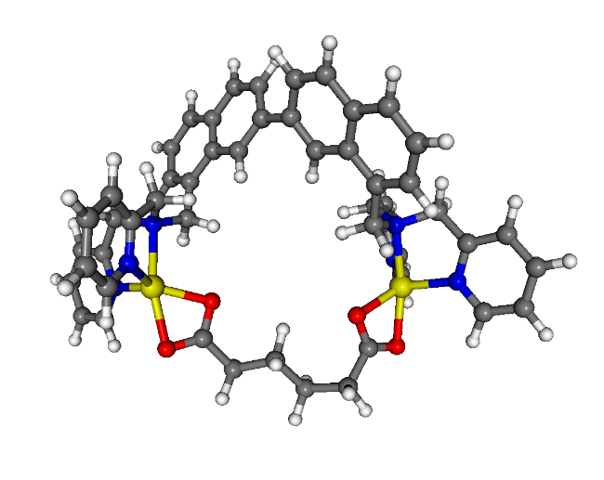

(*e*)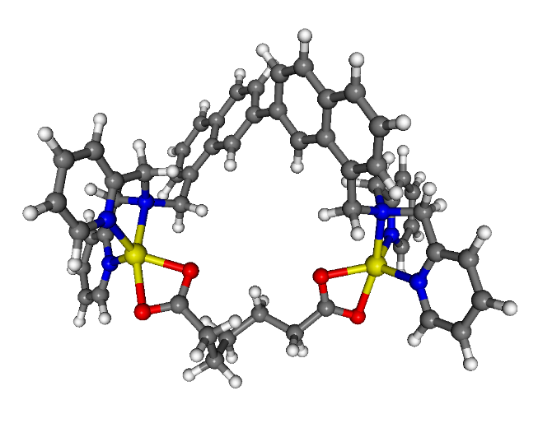 (*f*) 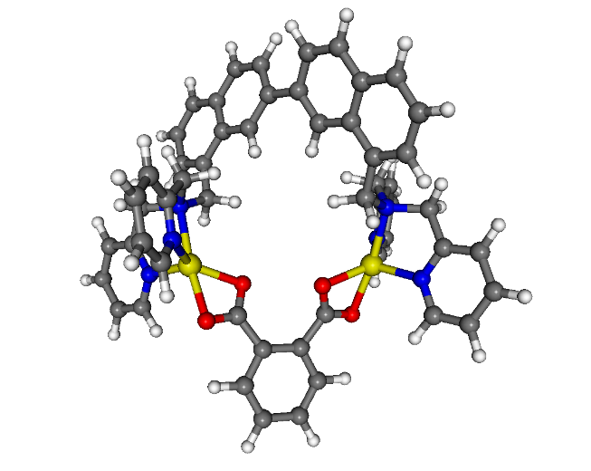

(*g*)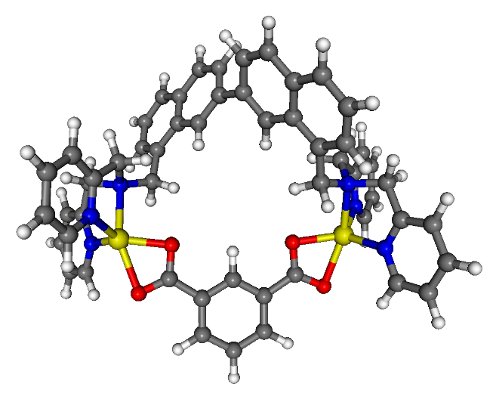 (*h*) 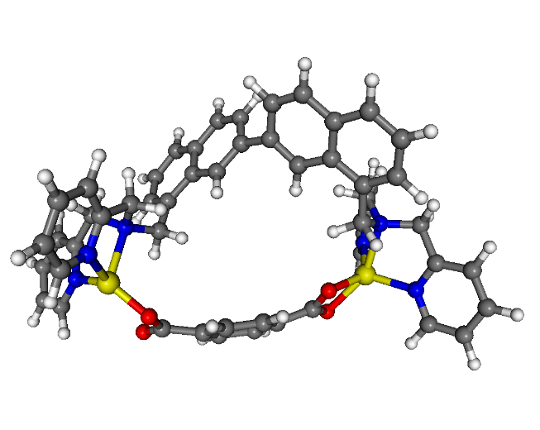

(*i*)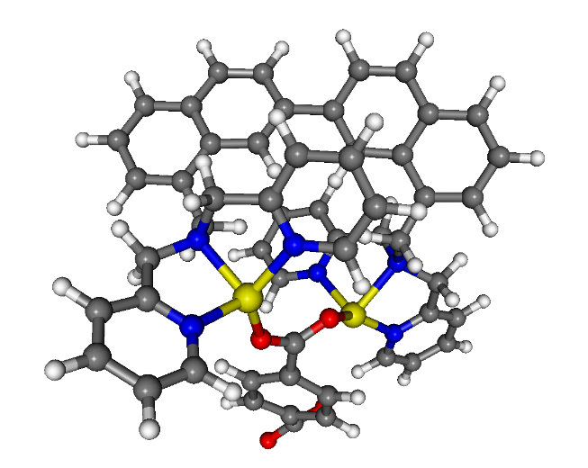

**Figure S4**. The optimized structure of the complexes of [Zn2**L**]4+ with malonate (*a*), succinate (*b*), glutarate (*c*), adipate (*d*), pimelate (*e*), phthalate (*f*), isophthalate (*g*), and terephthalate (bidentate: *h*; monodentate: *i*) calculated by DFT calculations (B3LYP/6-31+G(d) level of theory) with Spartan ’14 (Wavefunction, Inc.).