Synthesis of PAMAM dendrimer and its derivative PAMOL: Determination of thermophysical properties by DFT

Indumoni Dasª, Hirok Jyoti Borahª, Diganta Sarma^{b} and Swapnali Hazarikaª*
ªChemical Engineering Group, Engineering Science and Technology Division

CSIR-North East Institute of Science and Technology
Jorhat – 785 006, Assam, India
^{b}Department of Chemistry, Dibrugarh University
Dibrugarh-786004, Assam, India

*Author for correspondence
Email: shrrljt@yahoo.com
Phone: ++913762370012; Fax No: ++913762370011

Table of Contents

Sl No Description
1 . Fig. SI1: ¹H NMR spectra of G-0.5 generation PAMAM dendrimer
2. Fig. SI2: ¹³C NMR spectra of G-0.5 generation PAMAM dendrimer
3. Fig. SI3: IR spectra of G-0.5 generation PAMAM dendrimer
4. Fig. SI4: ¹H NMR spectra of G0 generation PAMAM dendrimer
5. Fig. SI5: ¹³C NMR spectra of G0 generation PAMAM dendrimer
6. Fig. SI6: IR spectra of G0 generation PAMAM dendrimer
7. Fig. SI7: ¹H NMR spectra of hydroxy substituted PAMOL dendrimer
8. Fig. SI8: ¹³C NMR spectra of hydroxy substituted PAMOL dendrimer
9. Fig. SI9: IR spectra of hydroxy substituted PAMOL dendrimer

IR, NMR Spectra of Dendrimers

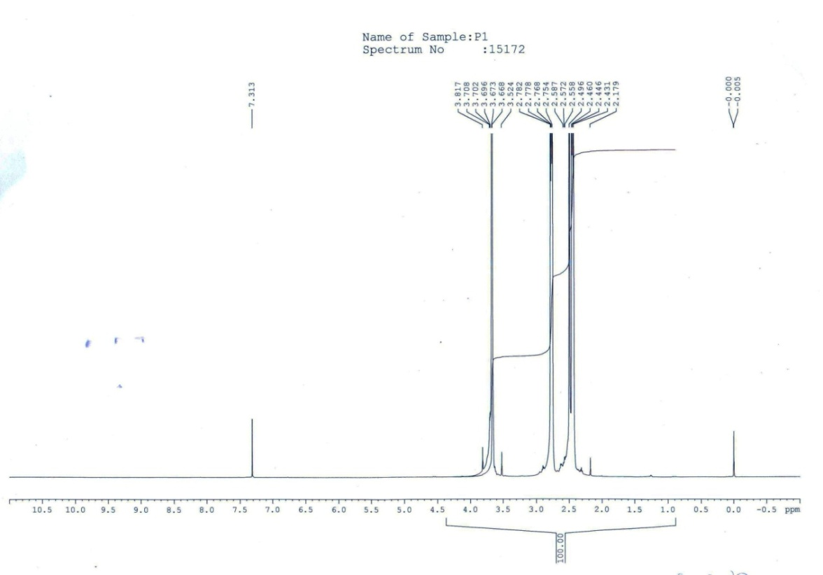
Fig. SI1
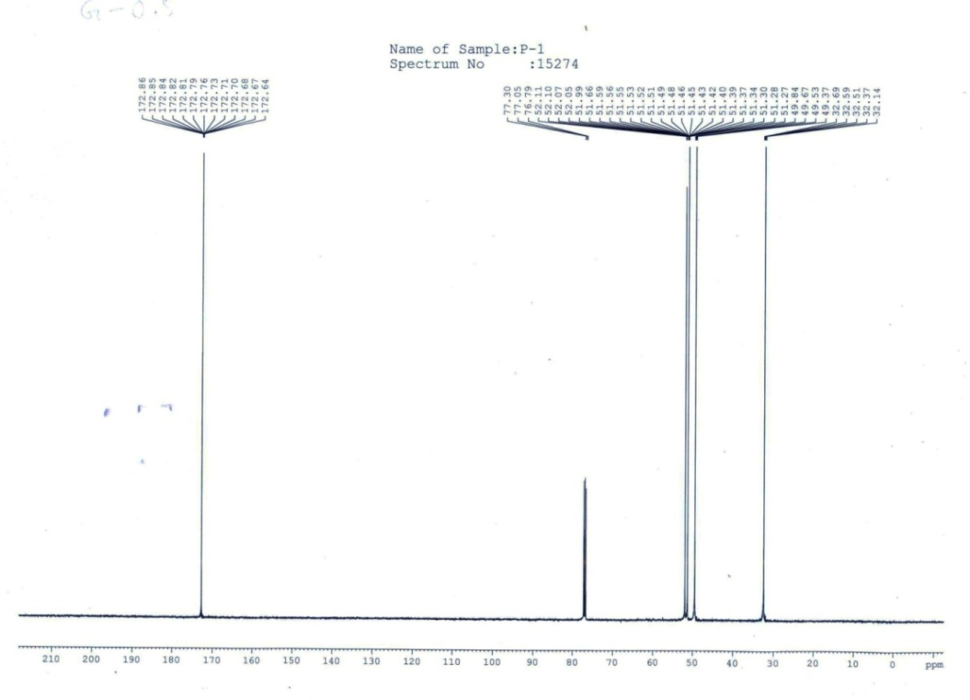
Fig. SI2
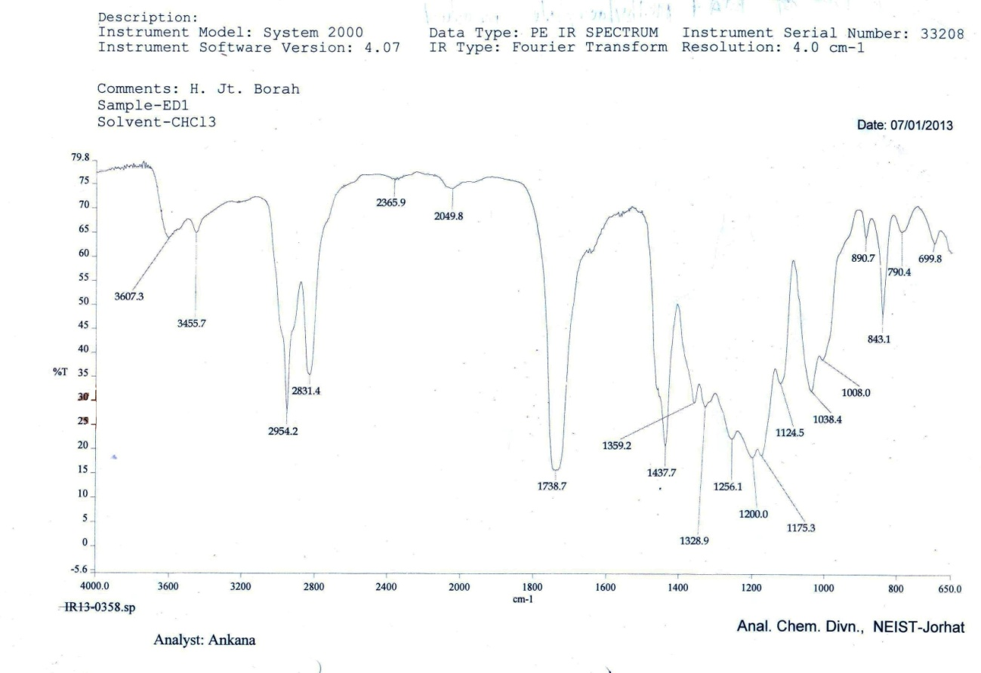
Fig. SI3

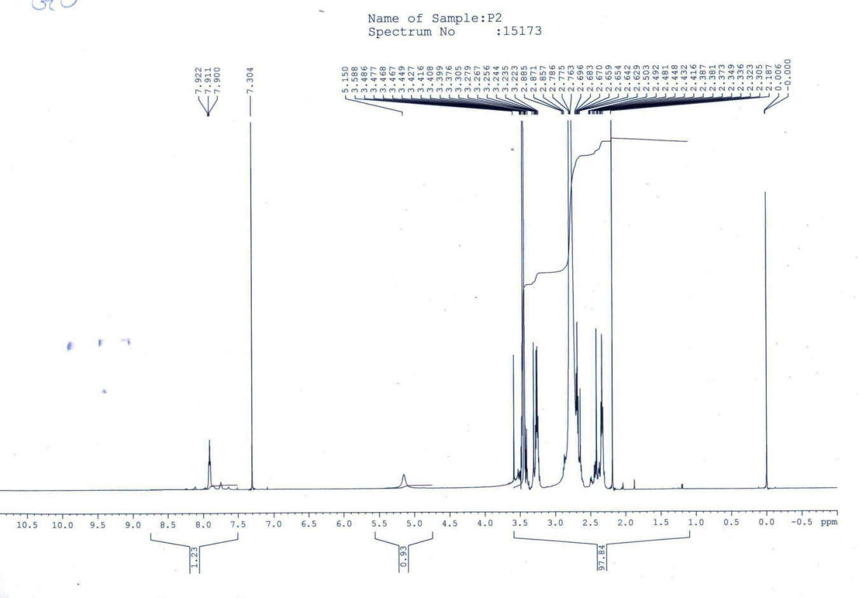
Fig. SI4
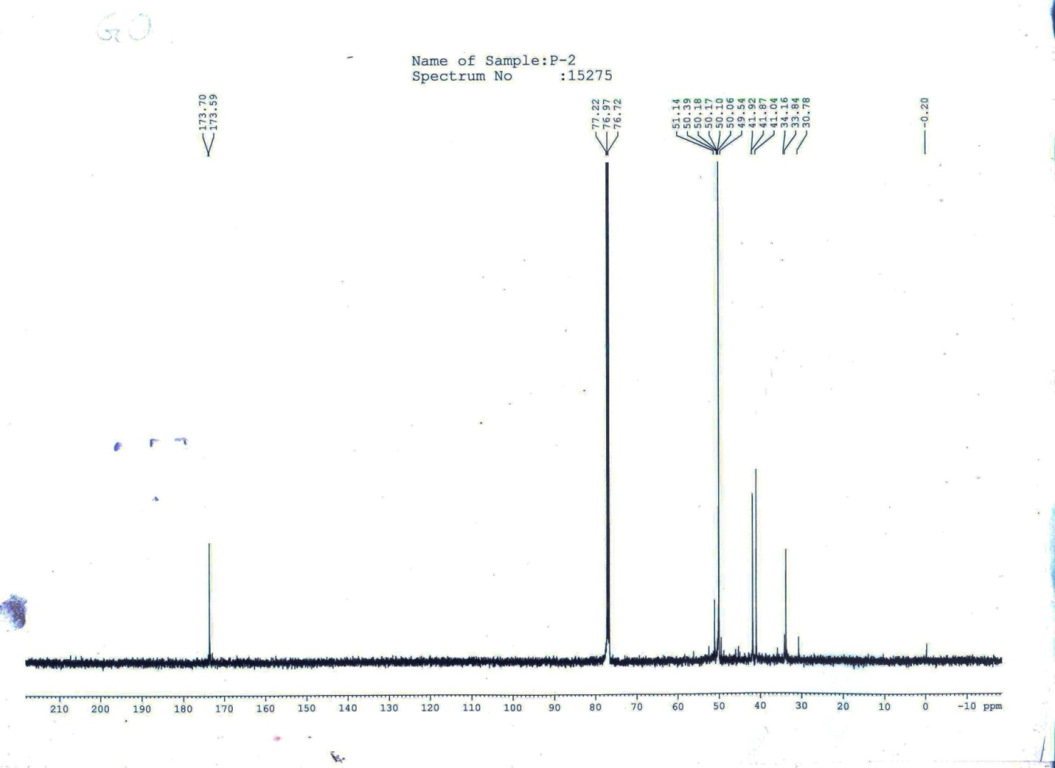
Fig. SI5
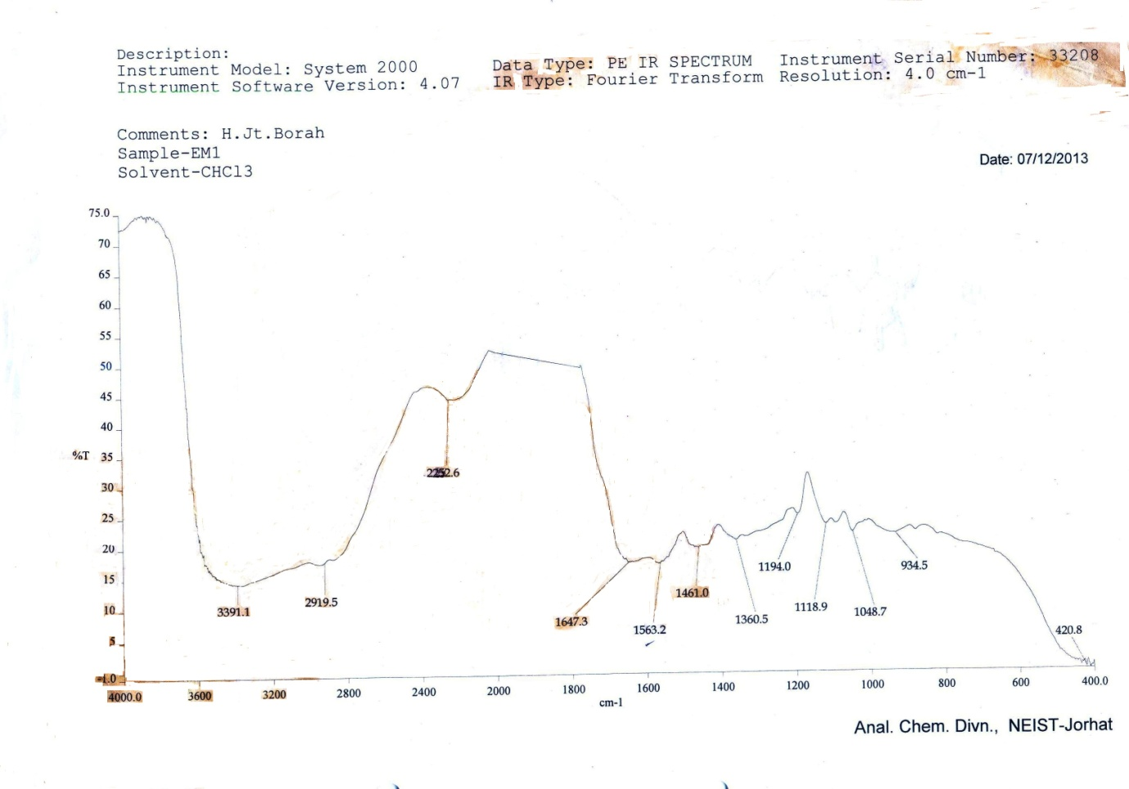
Fig. SI6

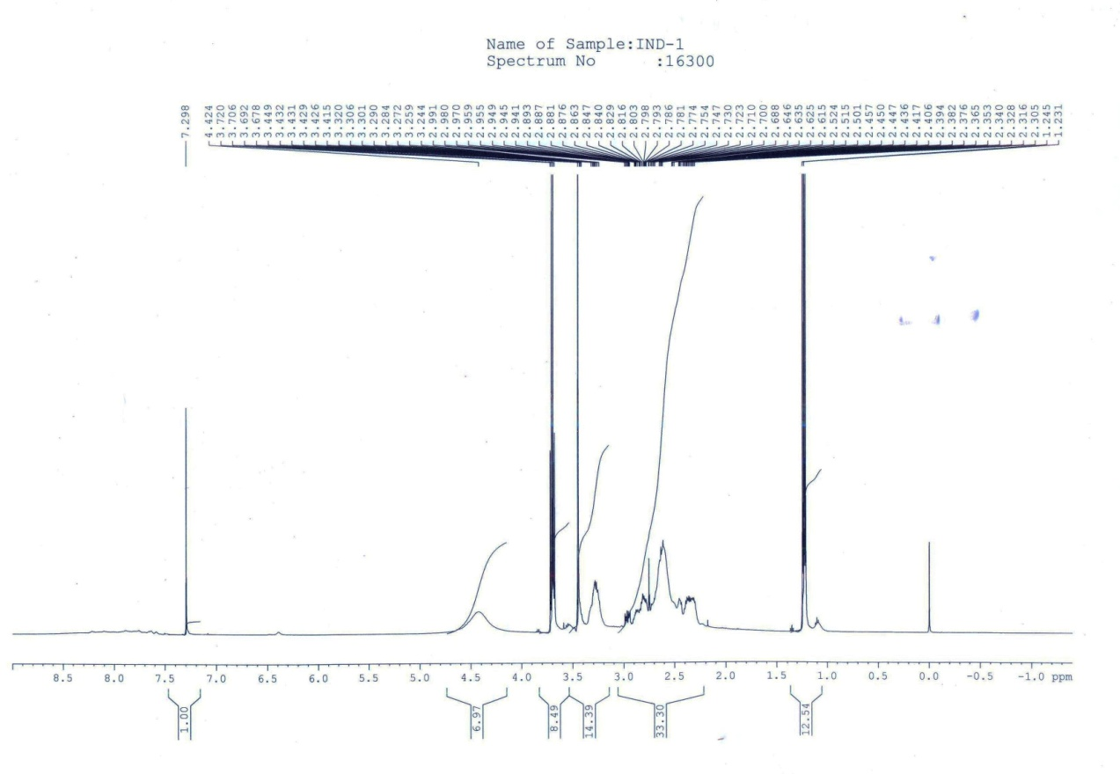
Fig. SI7

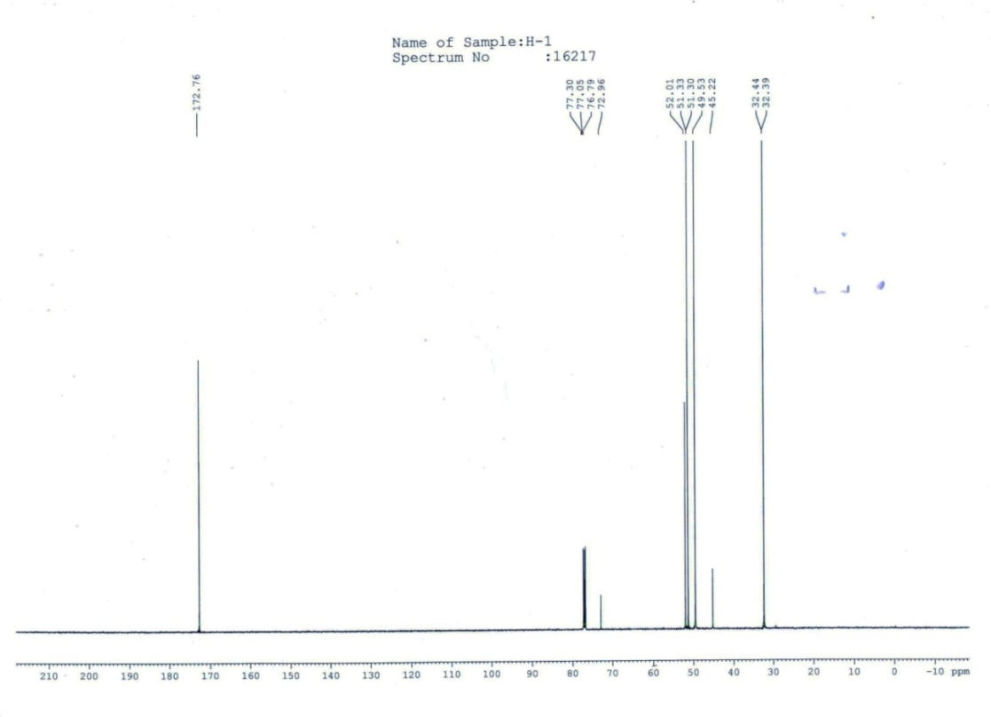
Fig. SI8
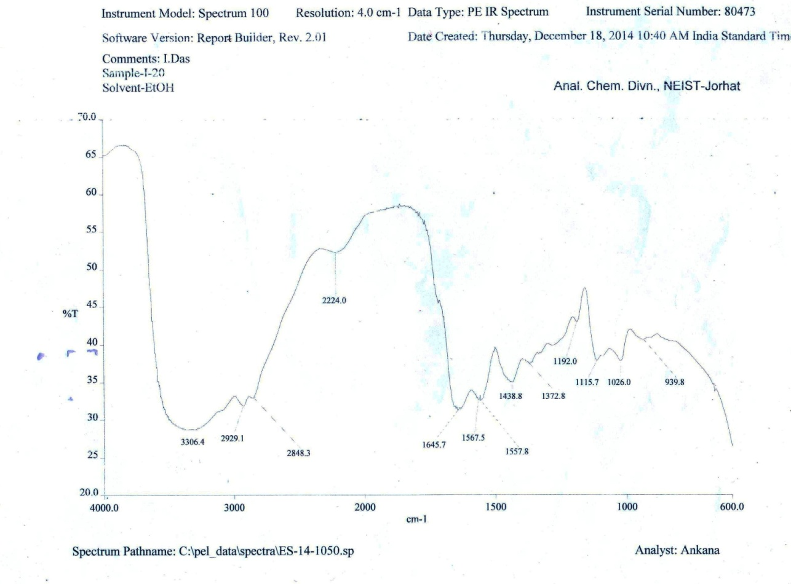
Fig. SI9

