Supporting Information

Facile and rapid synthesis of piperidinium-6-amino-4-aryl-3,5-dicyano-1,4-dihydropyridine-2-thiolate
Fahimeh Sadat Hosseiniª, Mohammad Bayat*ª, Milad Masoumi ª
ª Chemistry Department, Imam Khomeini International University, Qazvin, Iran
Tel: +98 (28)33780040; Fax: +98 (28)33780040; E-mail: bayat_mo@yahoo.com; m.bayat@sci.ikiu.ac.ir

The Table of Contents
Title | Page
Title, author’s name, address and table of contents | 1
General information | 1
Fig 1. Structure of all products 4 | 2
¹H and ¹³C NMR and IR and Mass spectrums of 4a | 3-6
¹H and ¹³C NMR and IR and Mass spectrums of 4b | 7-10
¹H and ¹³C NMR and IR and Mass spectrums of 4c | 11-14
¹H and ¹³C NMR and IR and Mass spectrums of 4d | 15-18
¹H and ¹³C NMR and IR and Mass spectrums of 4e | 19-22
¹H and ¹³C NMR and IR and Mass spectrums of 4f | 23-26
¹H and ¹³C NMR and IR and Mass spectrums of 4g | 27-30
¹H and ¹³C NMR and IR and Mass spectrums of 4h | 31-34
¹H and ¹³C NMR and IR and Mass spectrums of 4i | 35-38
¹H and ¹³C NMR and Mass spectrums of 4j | 39-41

General information:
The cyanothioacetamide, aromatic aldehydes, piperidine and solvents were obtained from Merck and Aldrich and were used without further purification. NMR spectra were recorded with a Bruker DRX-300 Avance instrument (300 MHz for ¹H and 75.4 MHz for ¹³C) with DMSO-d₆ as solvent. Chemical shifts are given in ppm (δ), and coupling constant (J) are reported in hertz (Hz). Melting points were measured with an electrotherma1 9100 apparatus. Mass spectra were recorded with an Agilent 5975C VL MSD with Triple-Axis Detector operating at an ionization potential of 70 eV. IR spectra were measured with, Bruker Tensor 27 spectrometer. Elemental analyses for C, H and N were performed using a PerkinElmer 2004 series [II] CHN elemental analyzer.
The structures all of the products 4a-j (Figure 1) were deduced from their IR, Mass, ¹H NMR, and ¹³C NMR spectra.

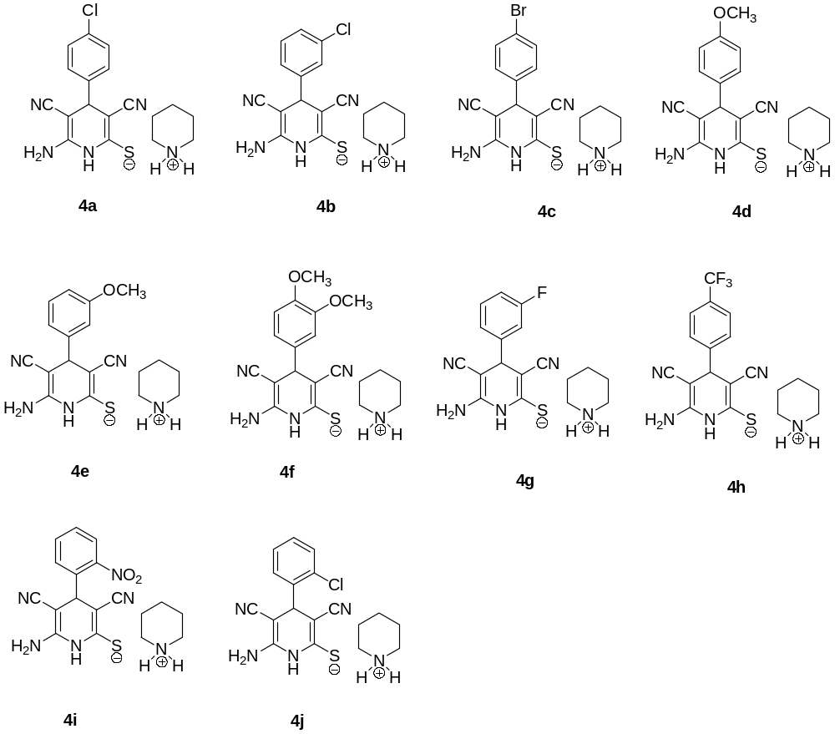
Fig 1. Structure of all products 4a-j.

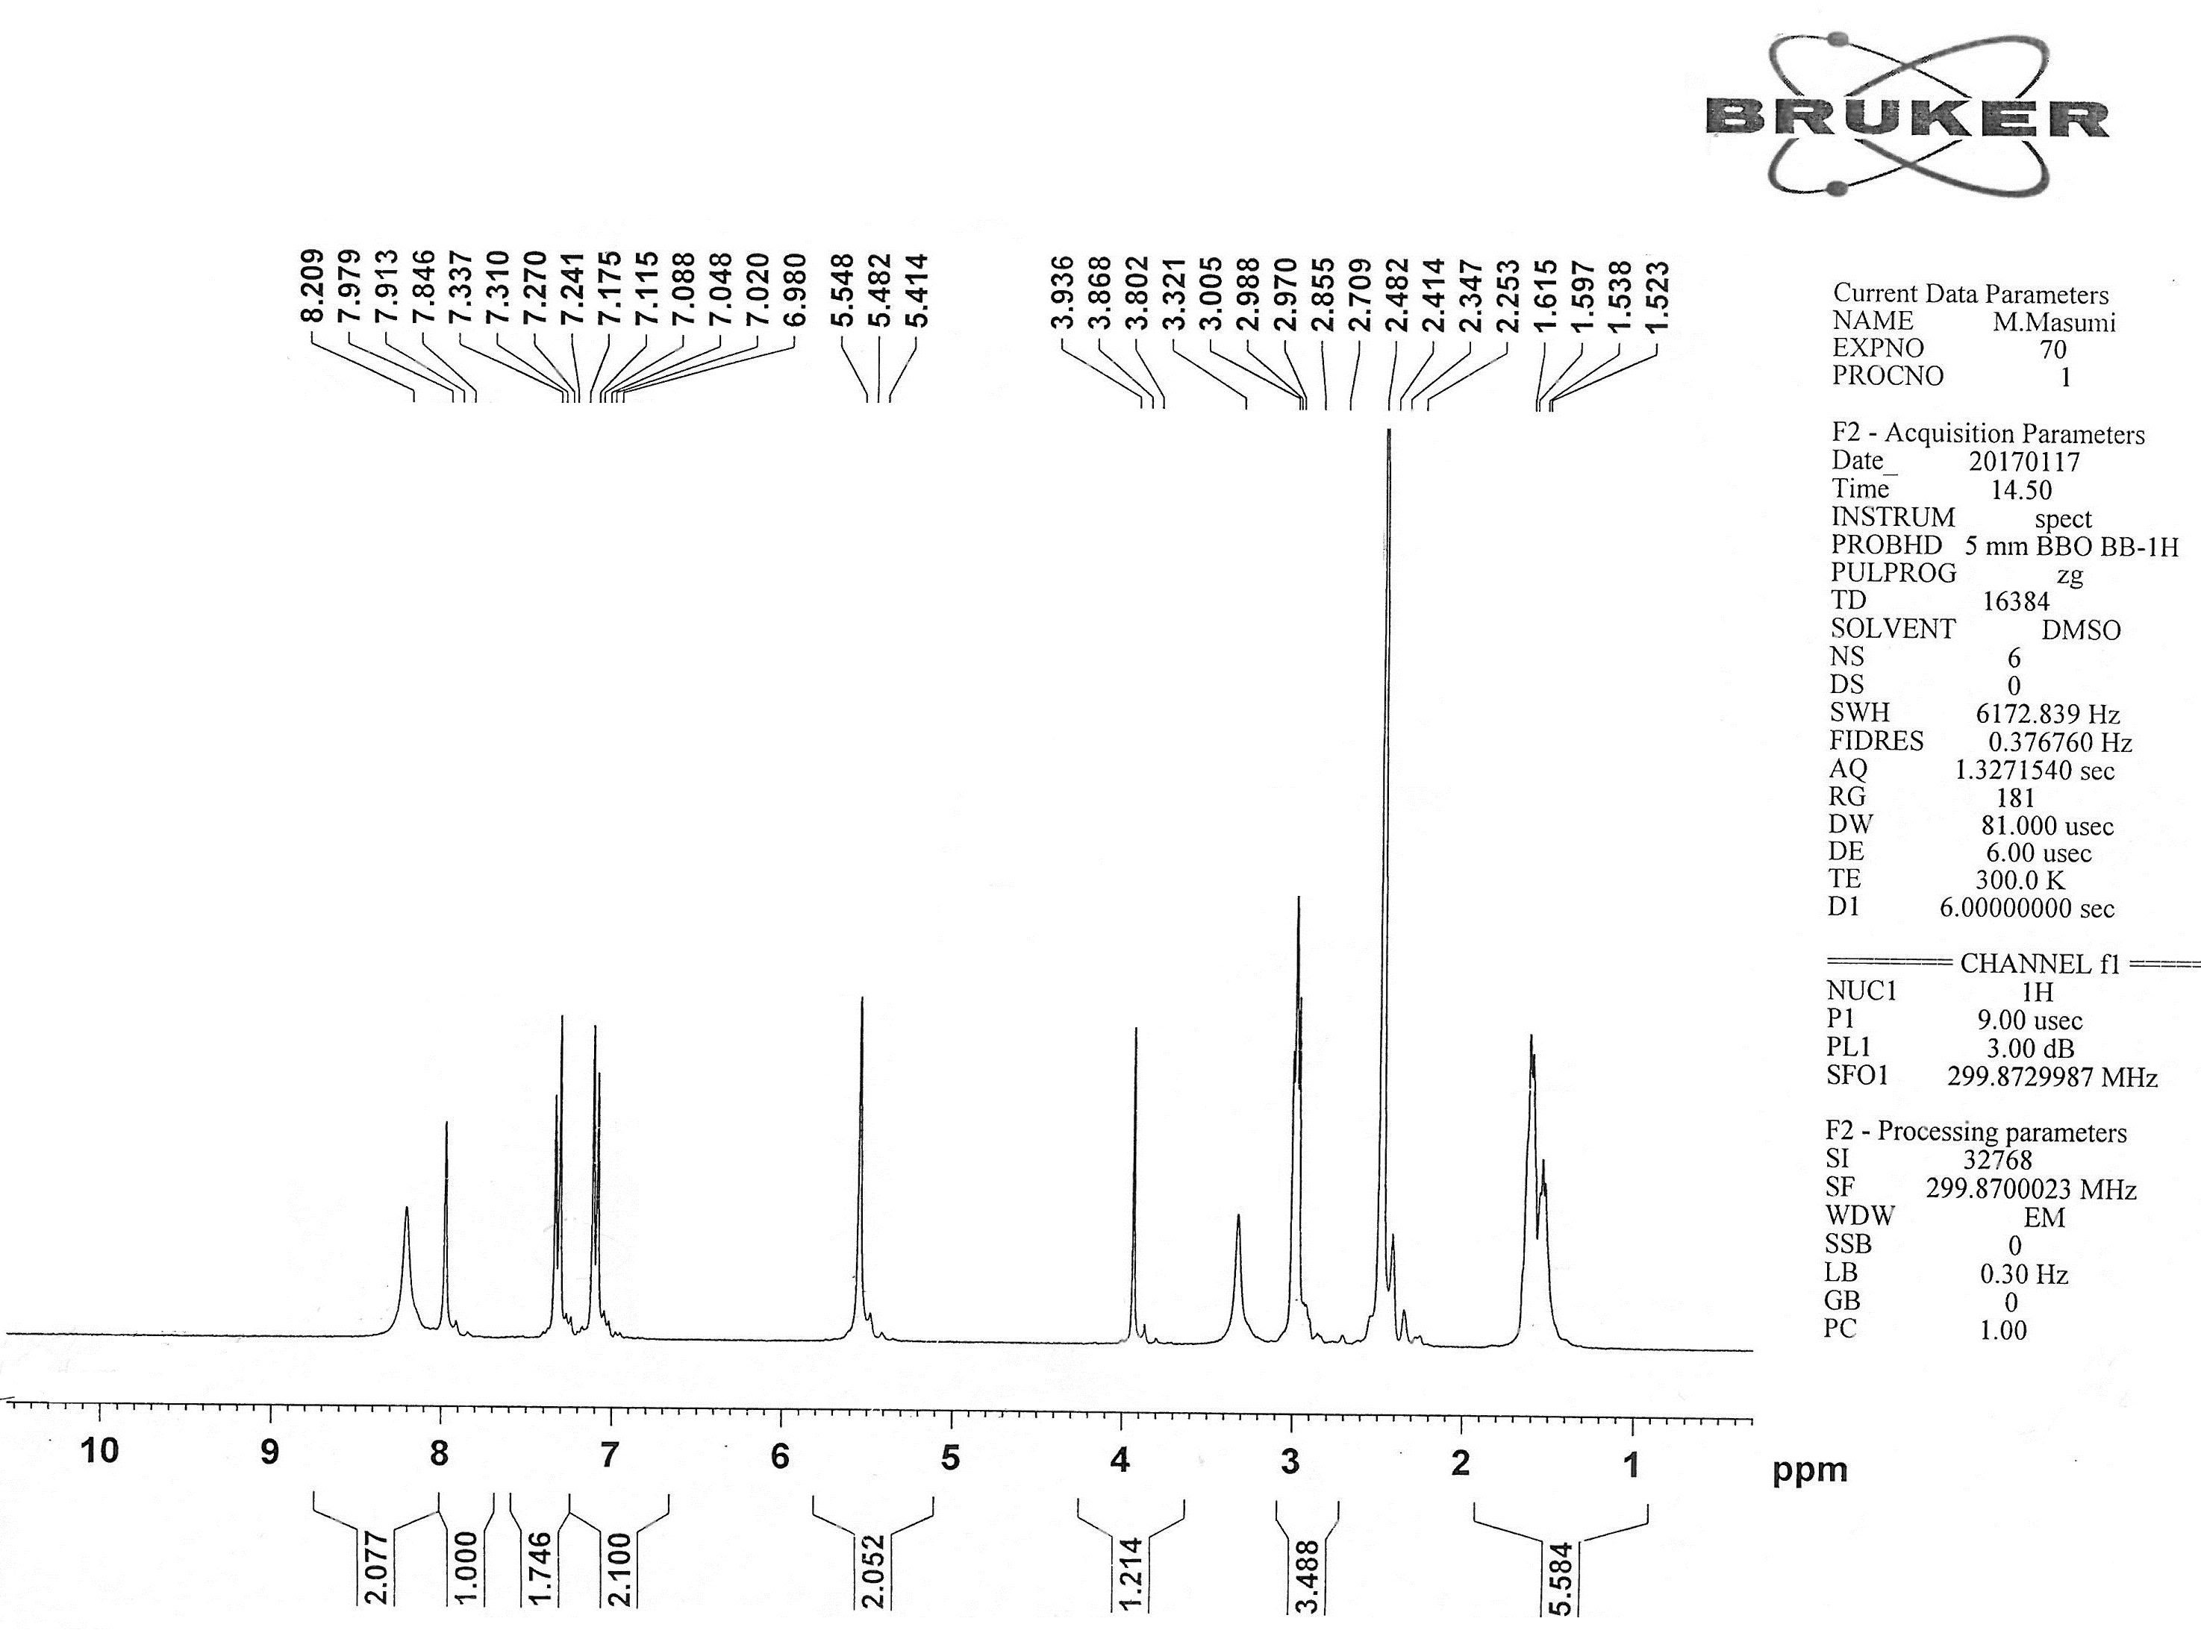
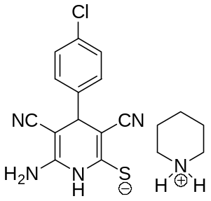

¹H NMR of 4a
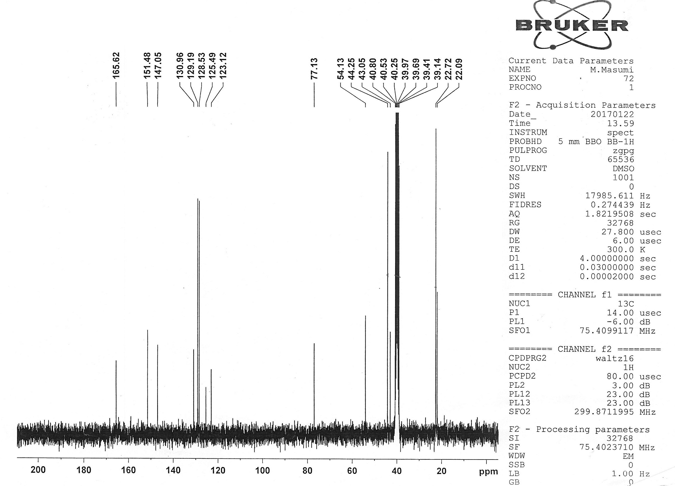

¹³C NMR of 4a
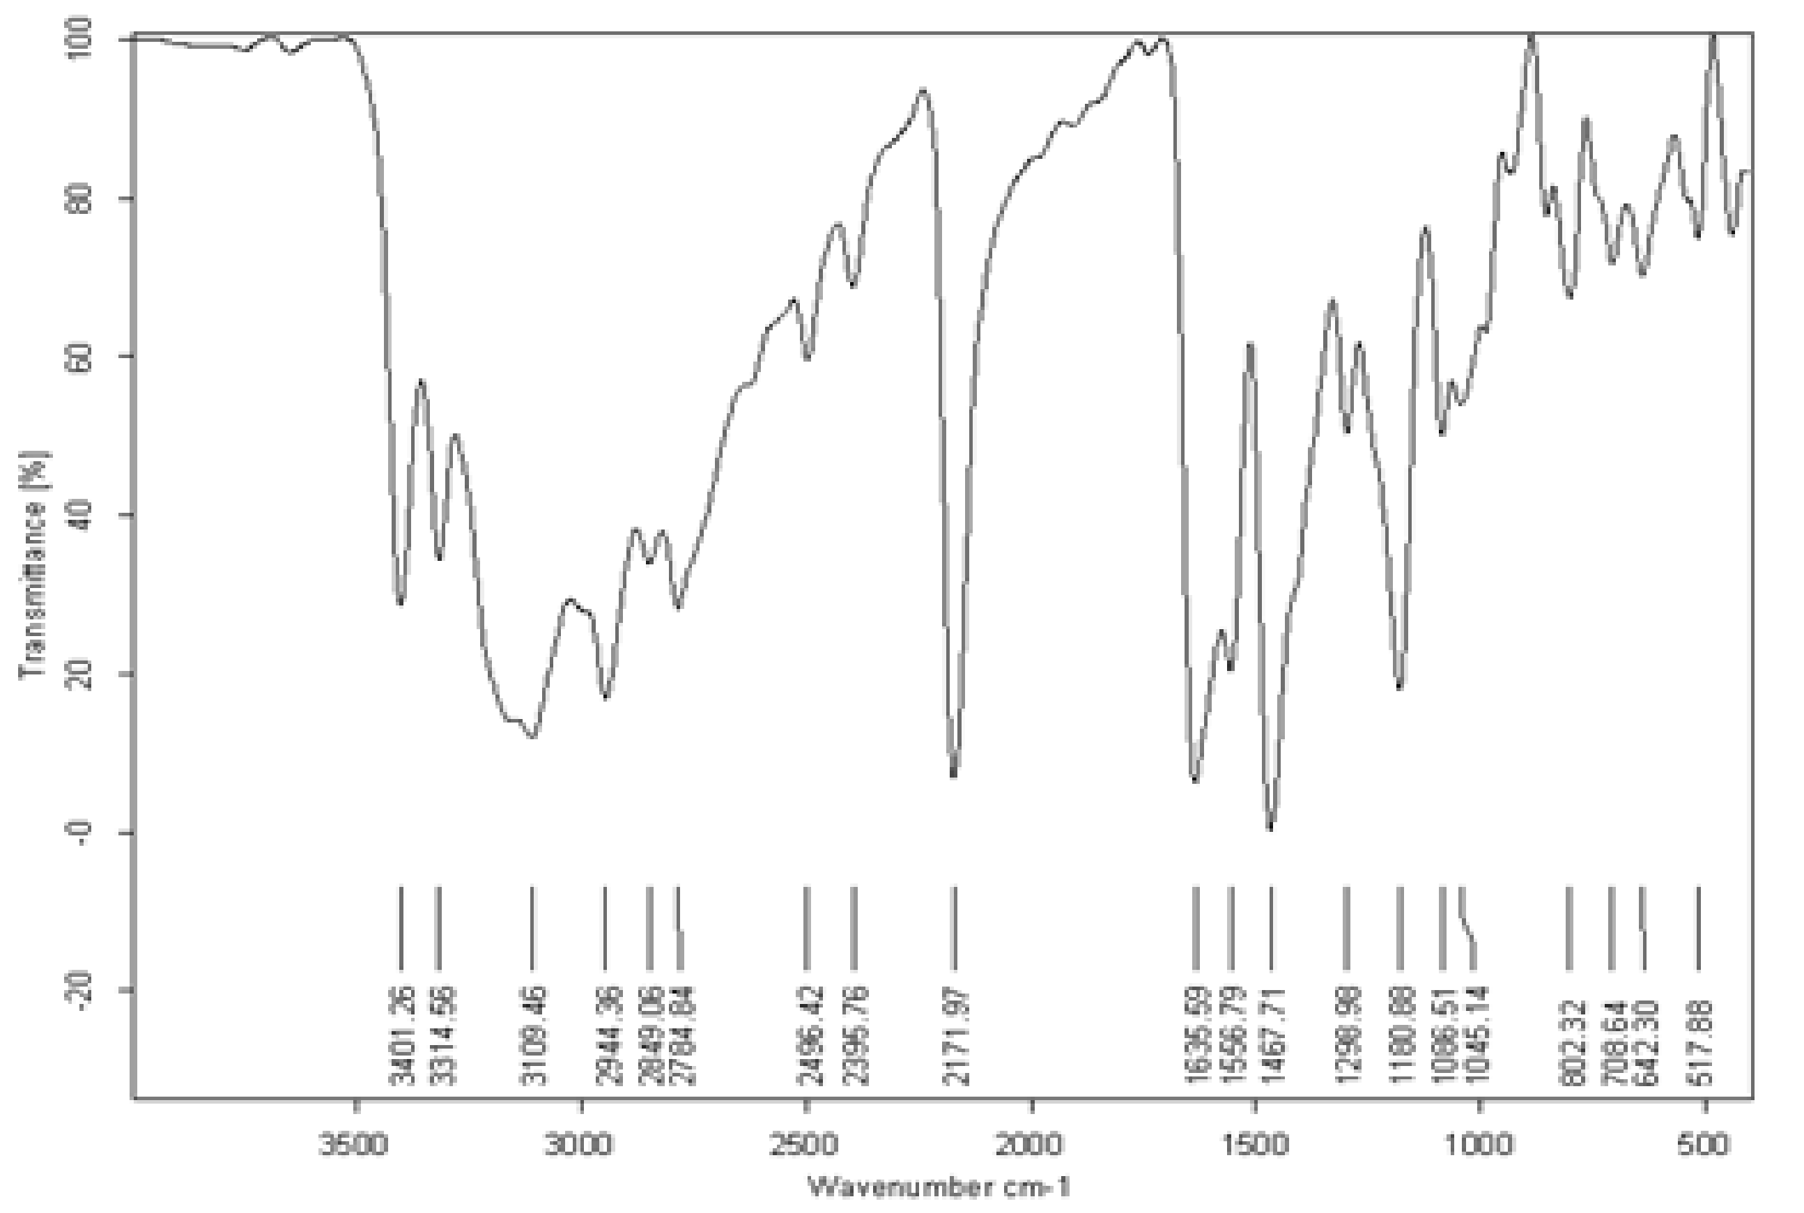

IR of 4a

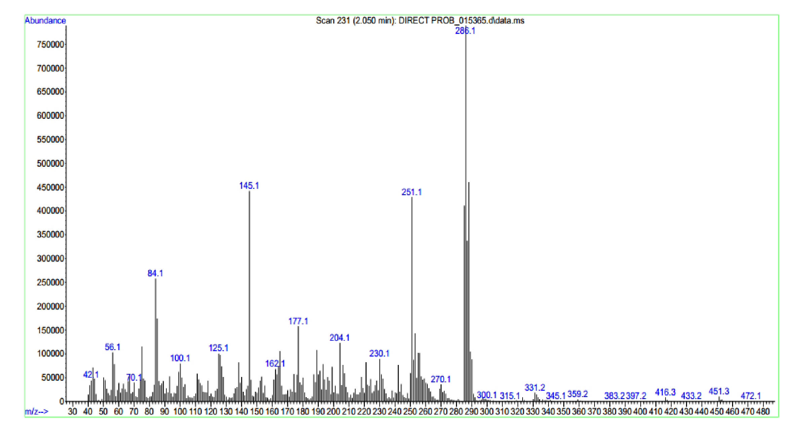

Mass of 4a

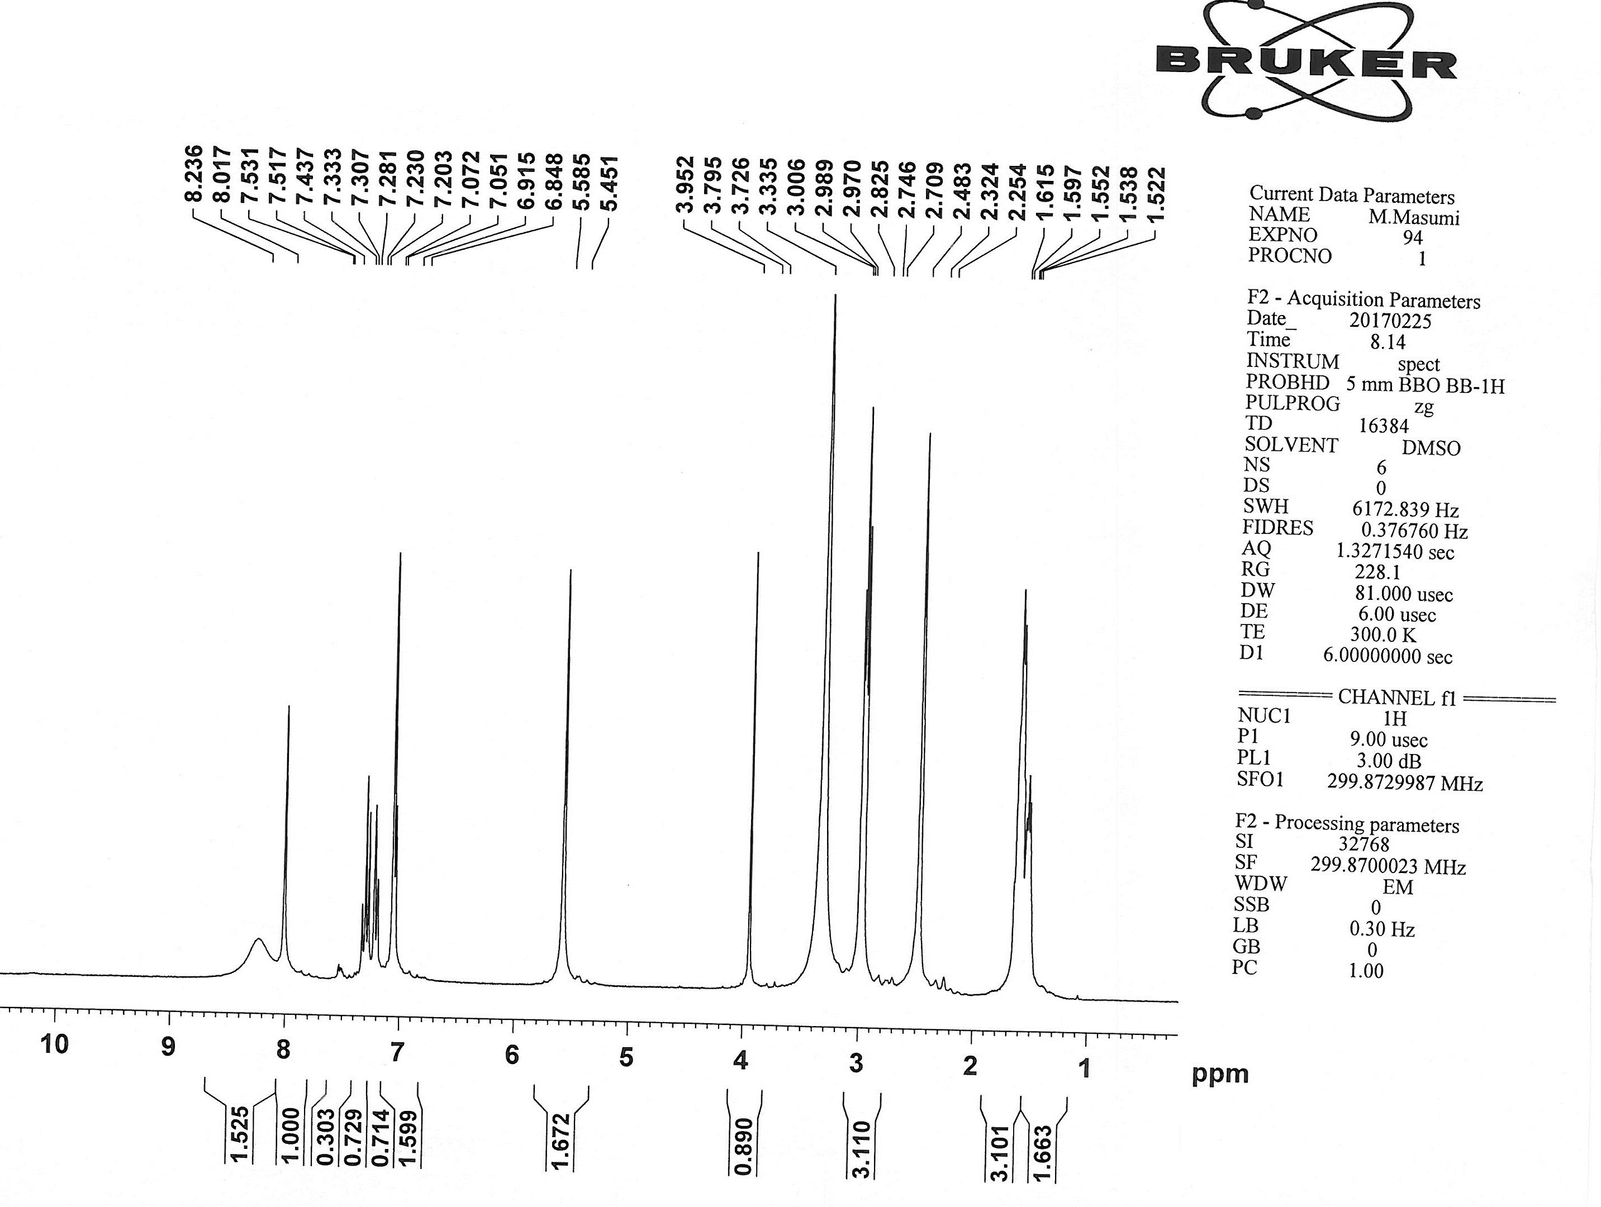

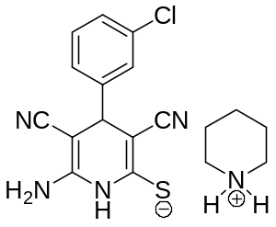

¹H NMR of 4b

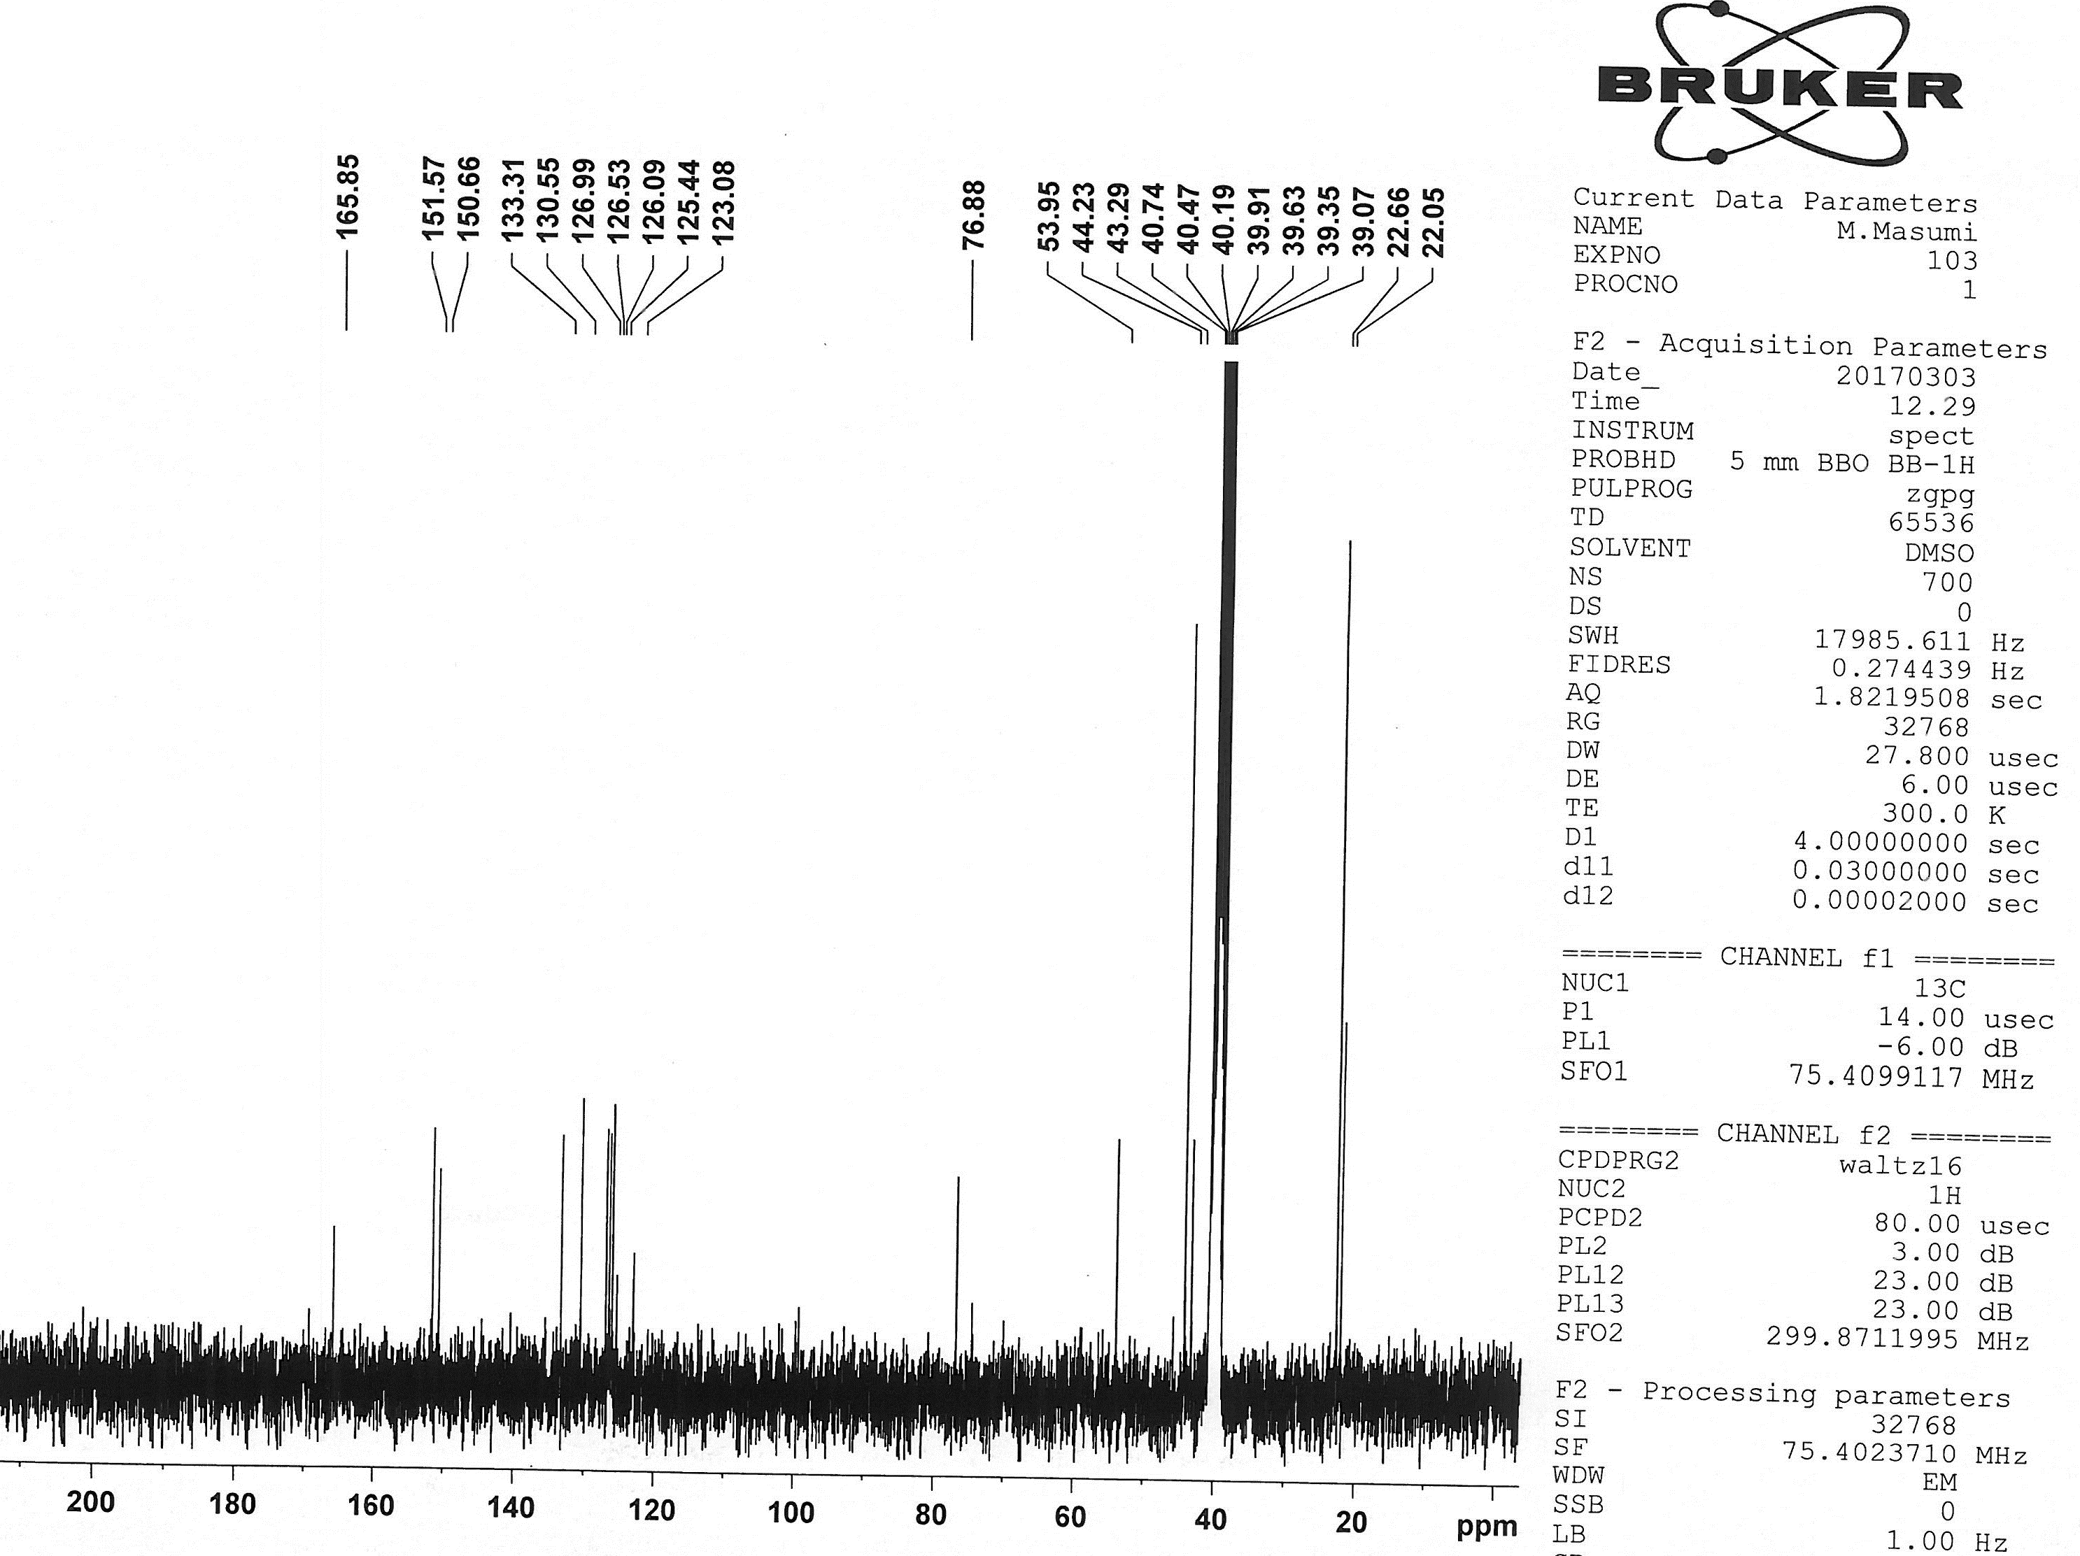

¹³C NMR of 4b

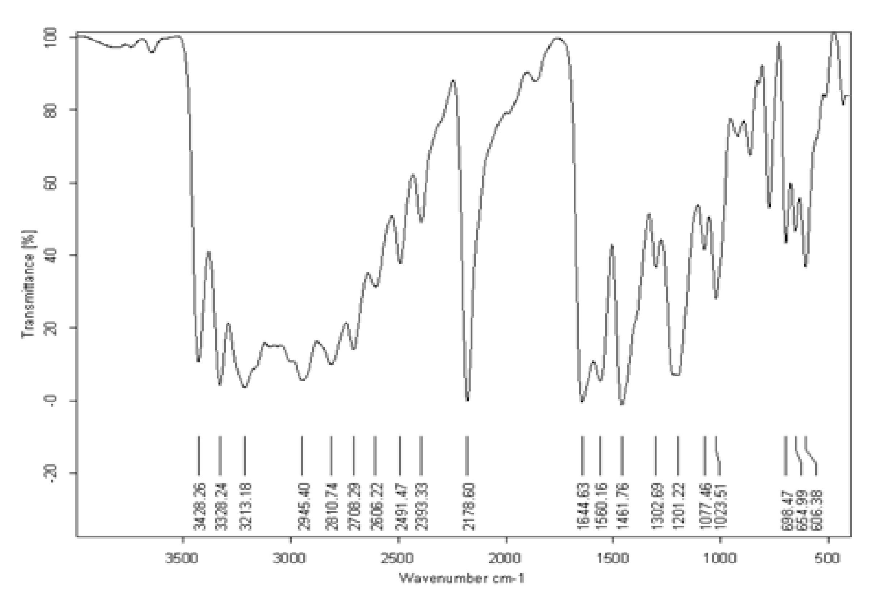

IR of 4b

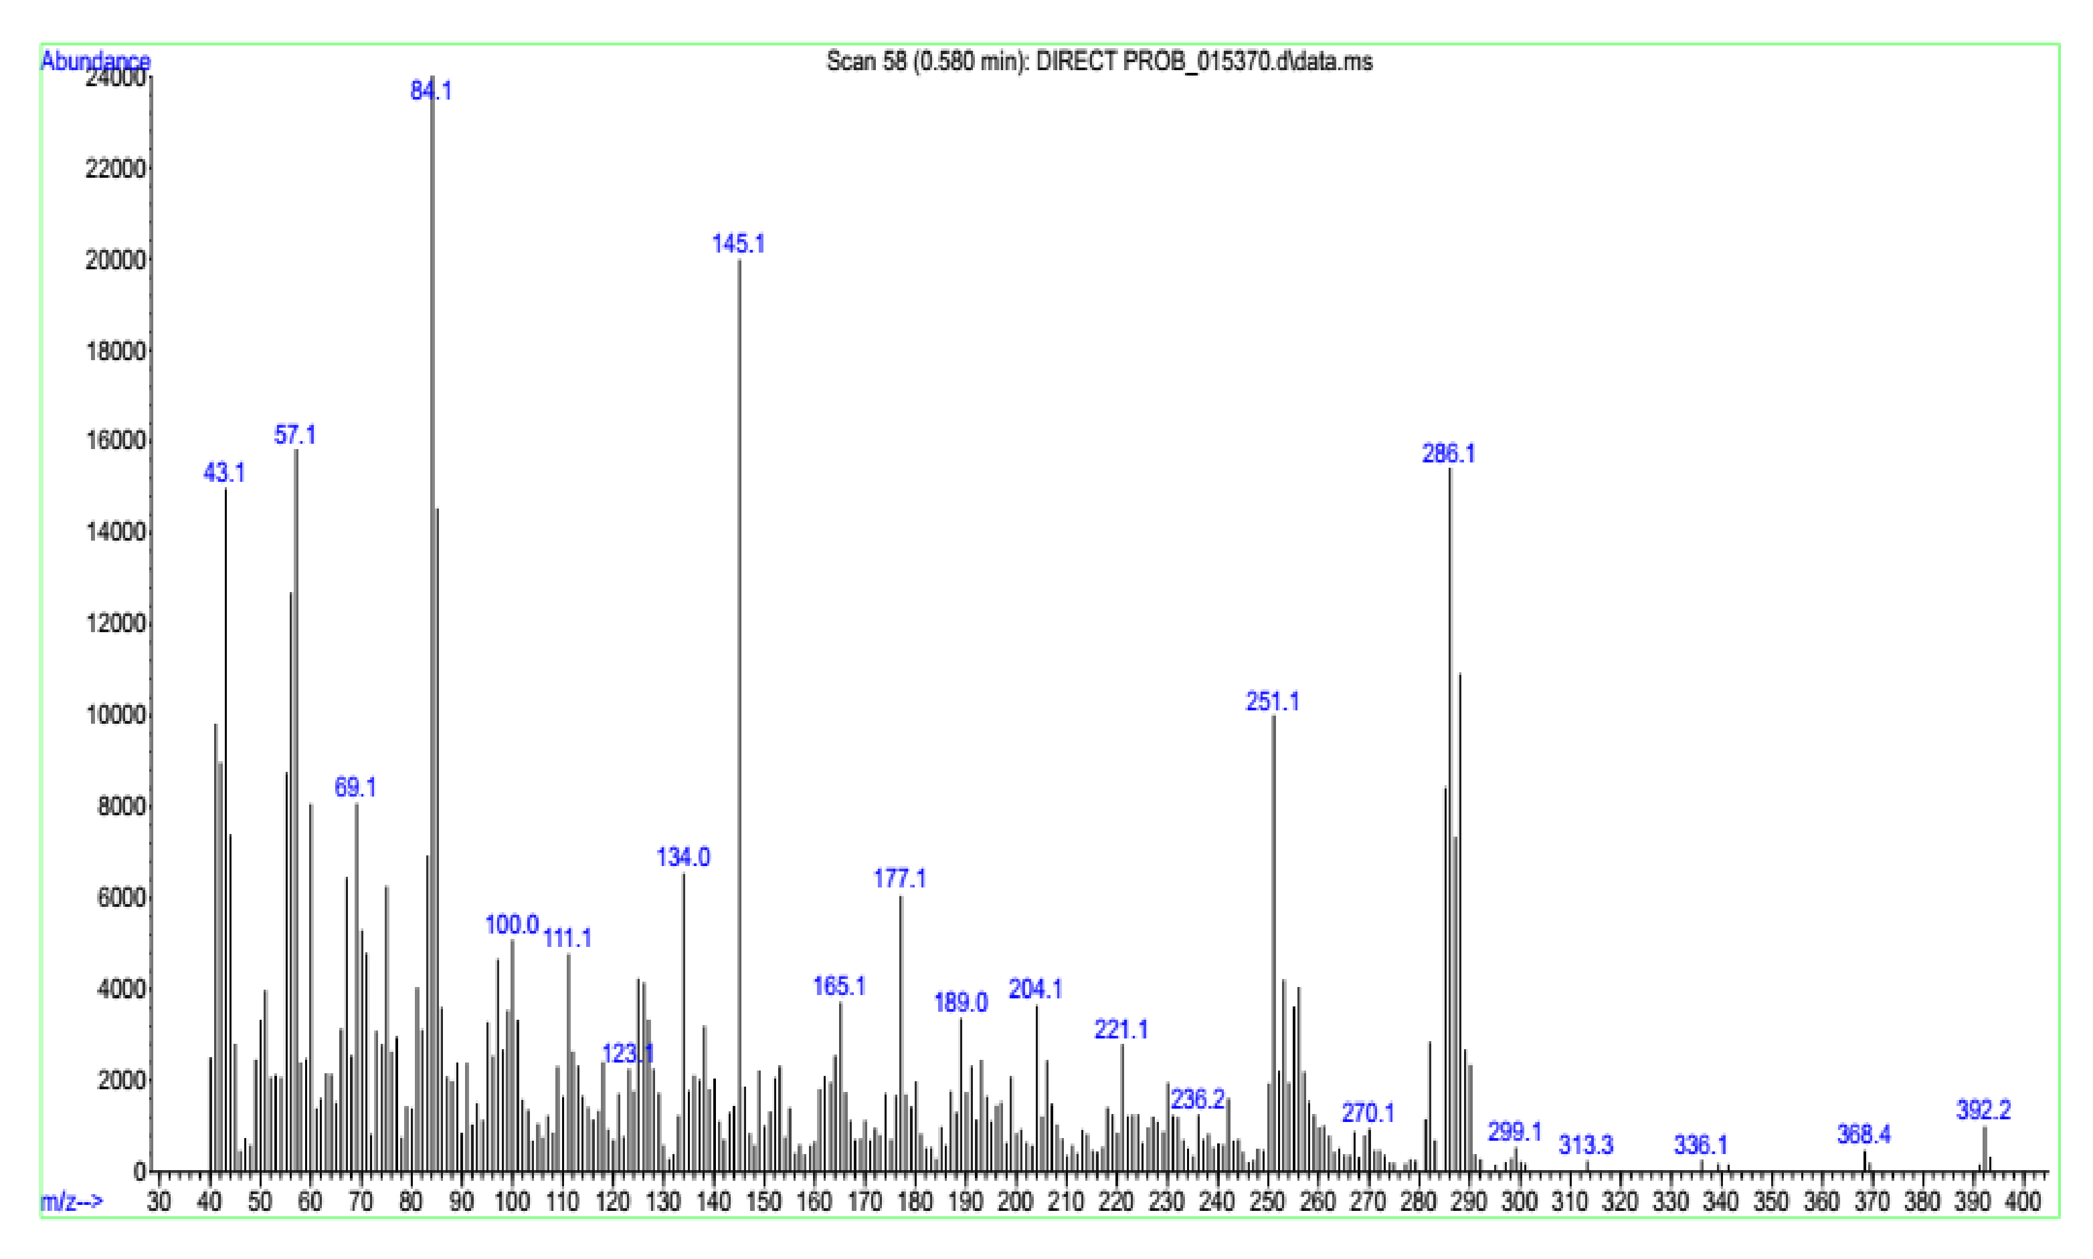

Mass of 4b

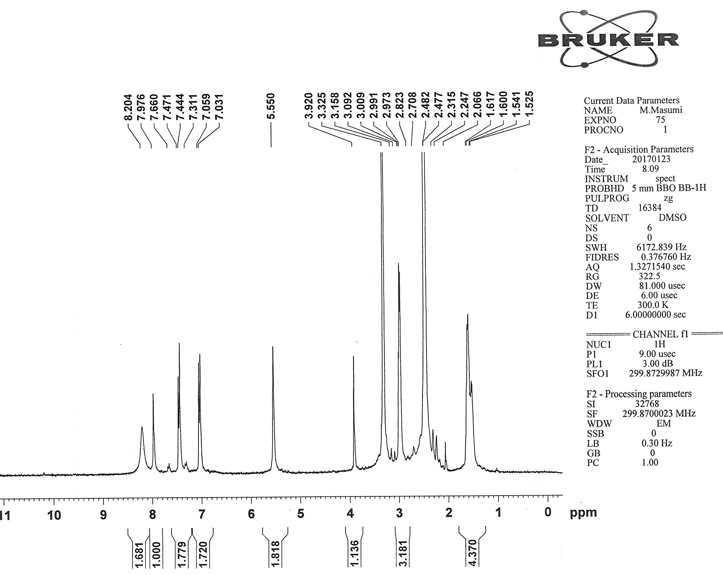
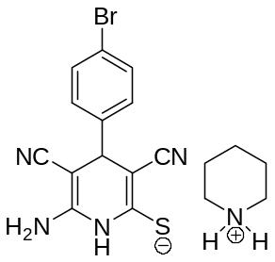

¹H NMR of 4c
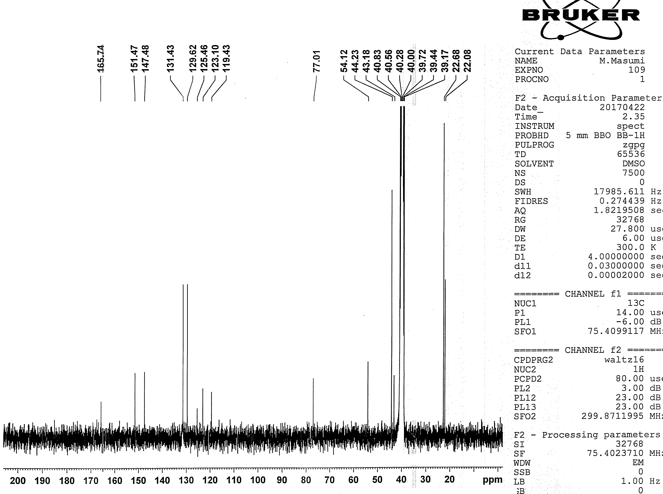

¹³C NMR of 4c
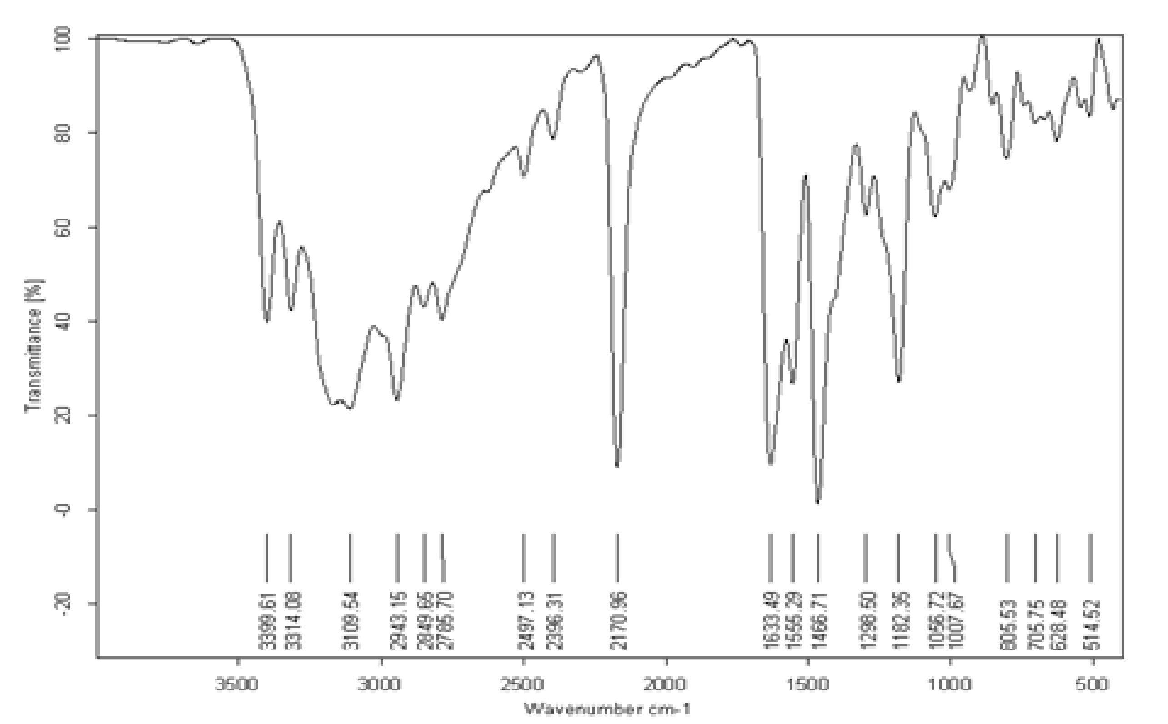

IR of 4c

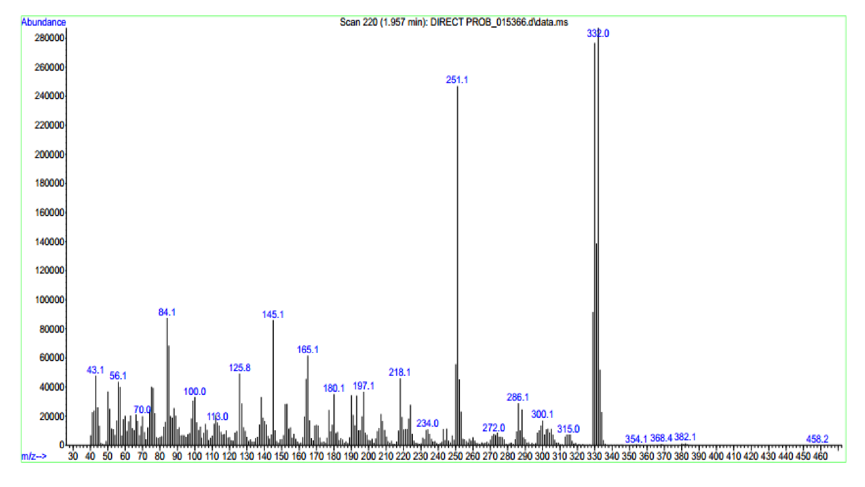

Mass of 4c
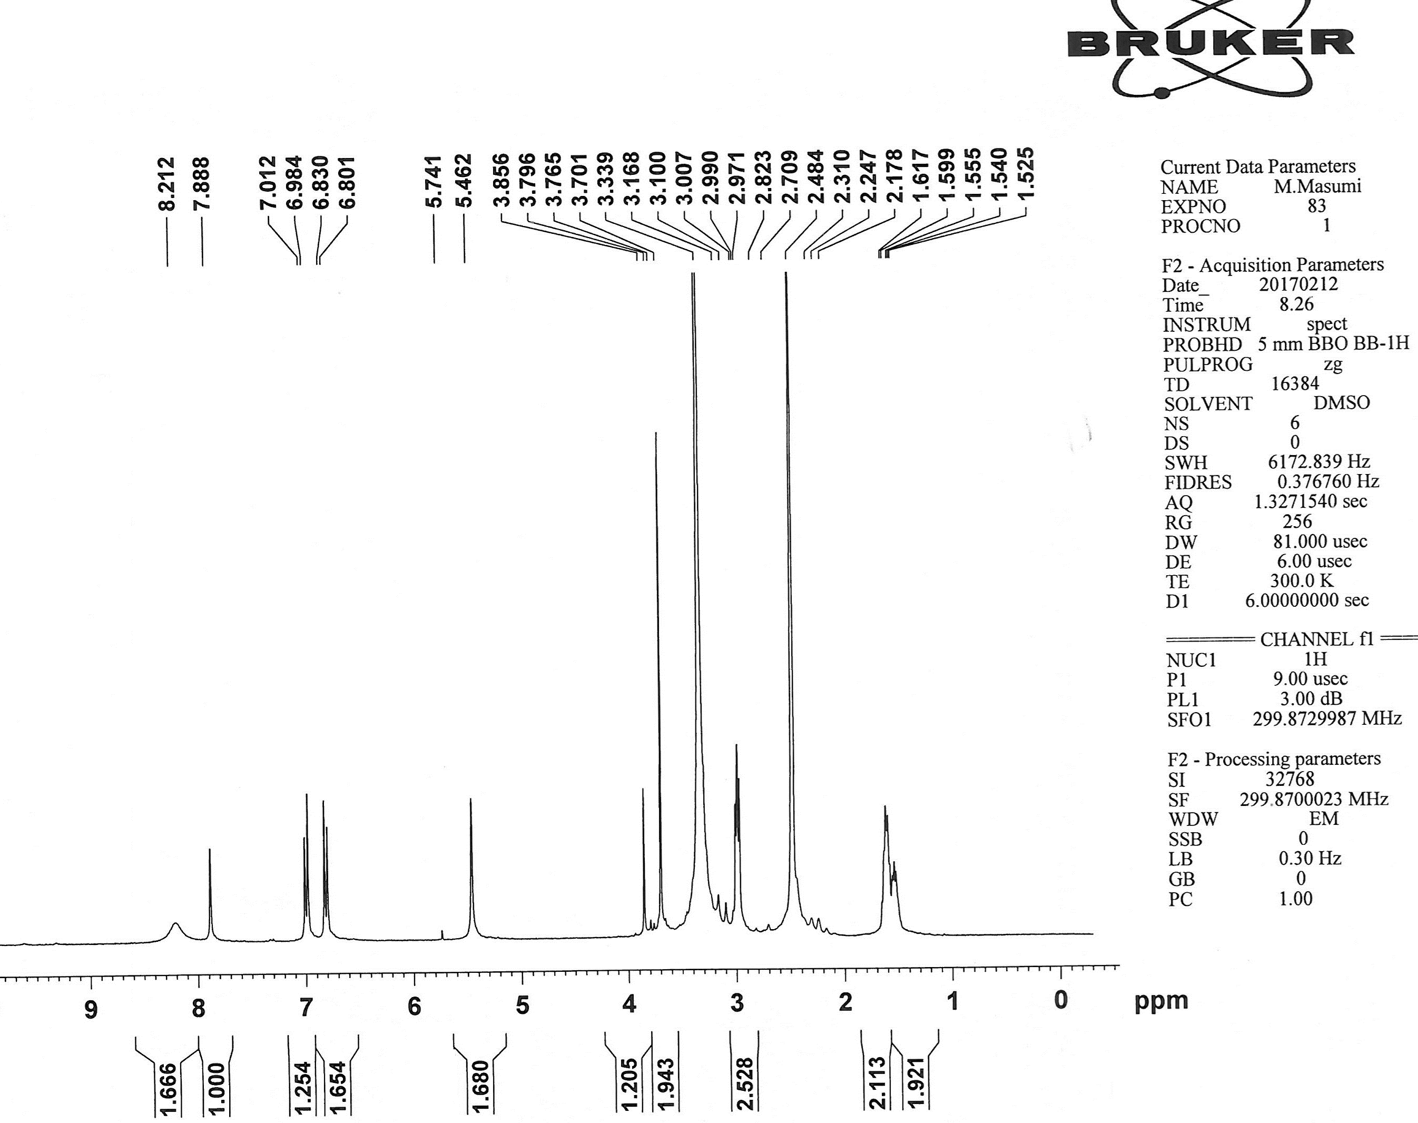
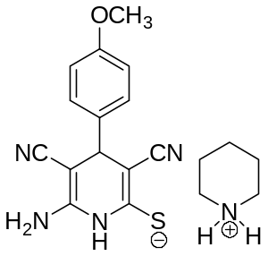

¹H NMR of 4d
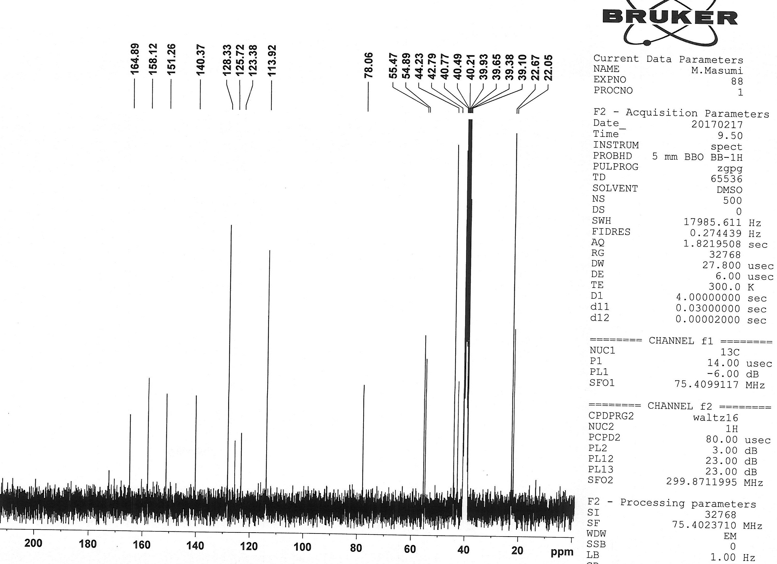

¹³C NMR of 4d
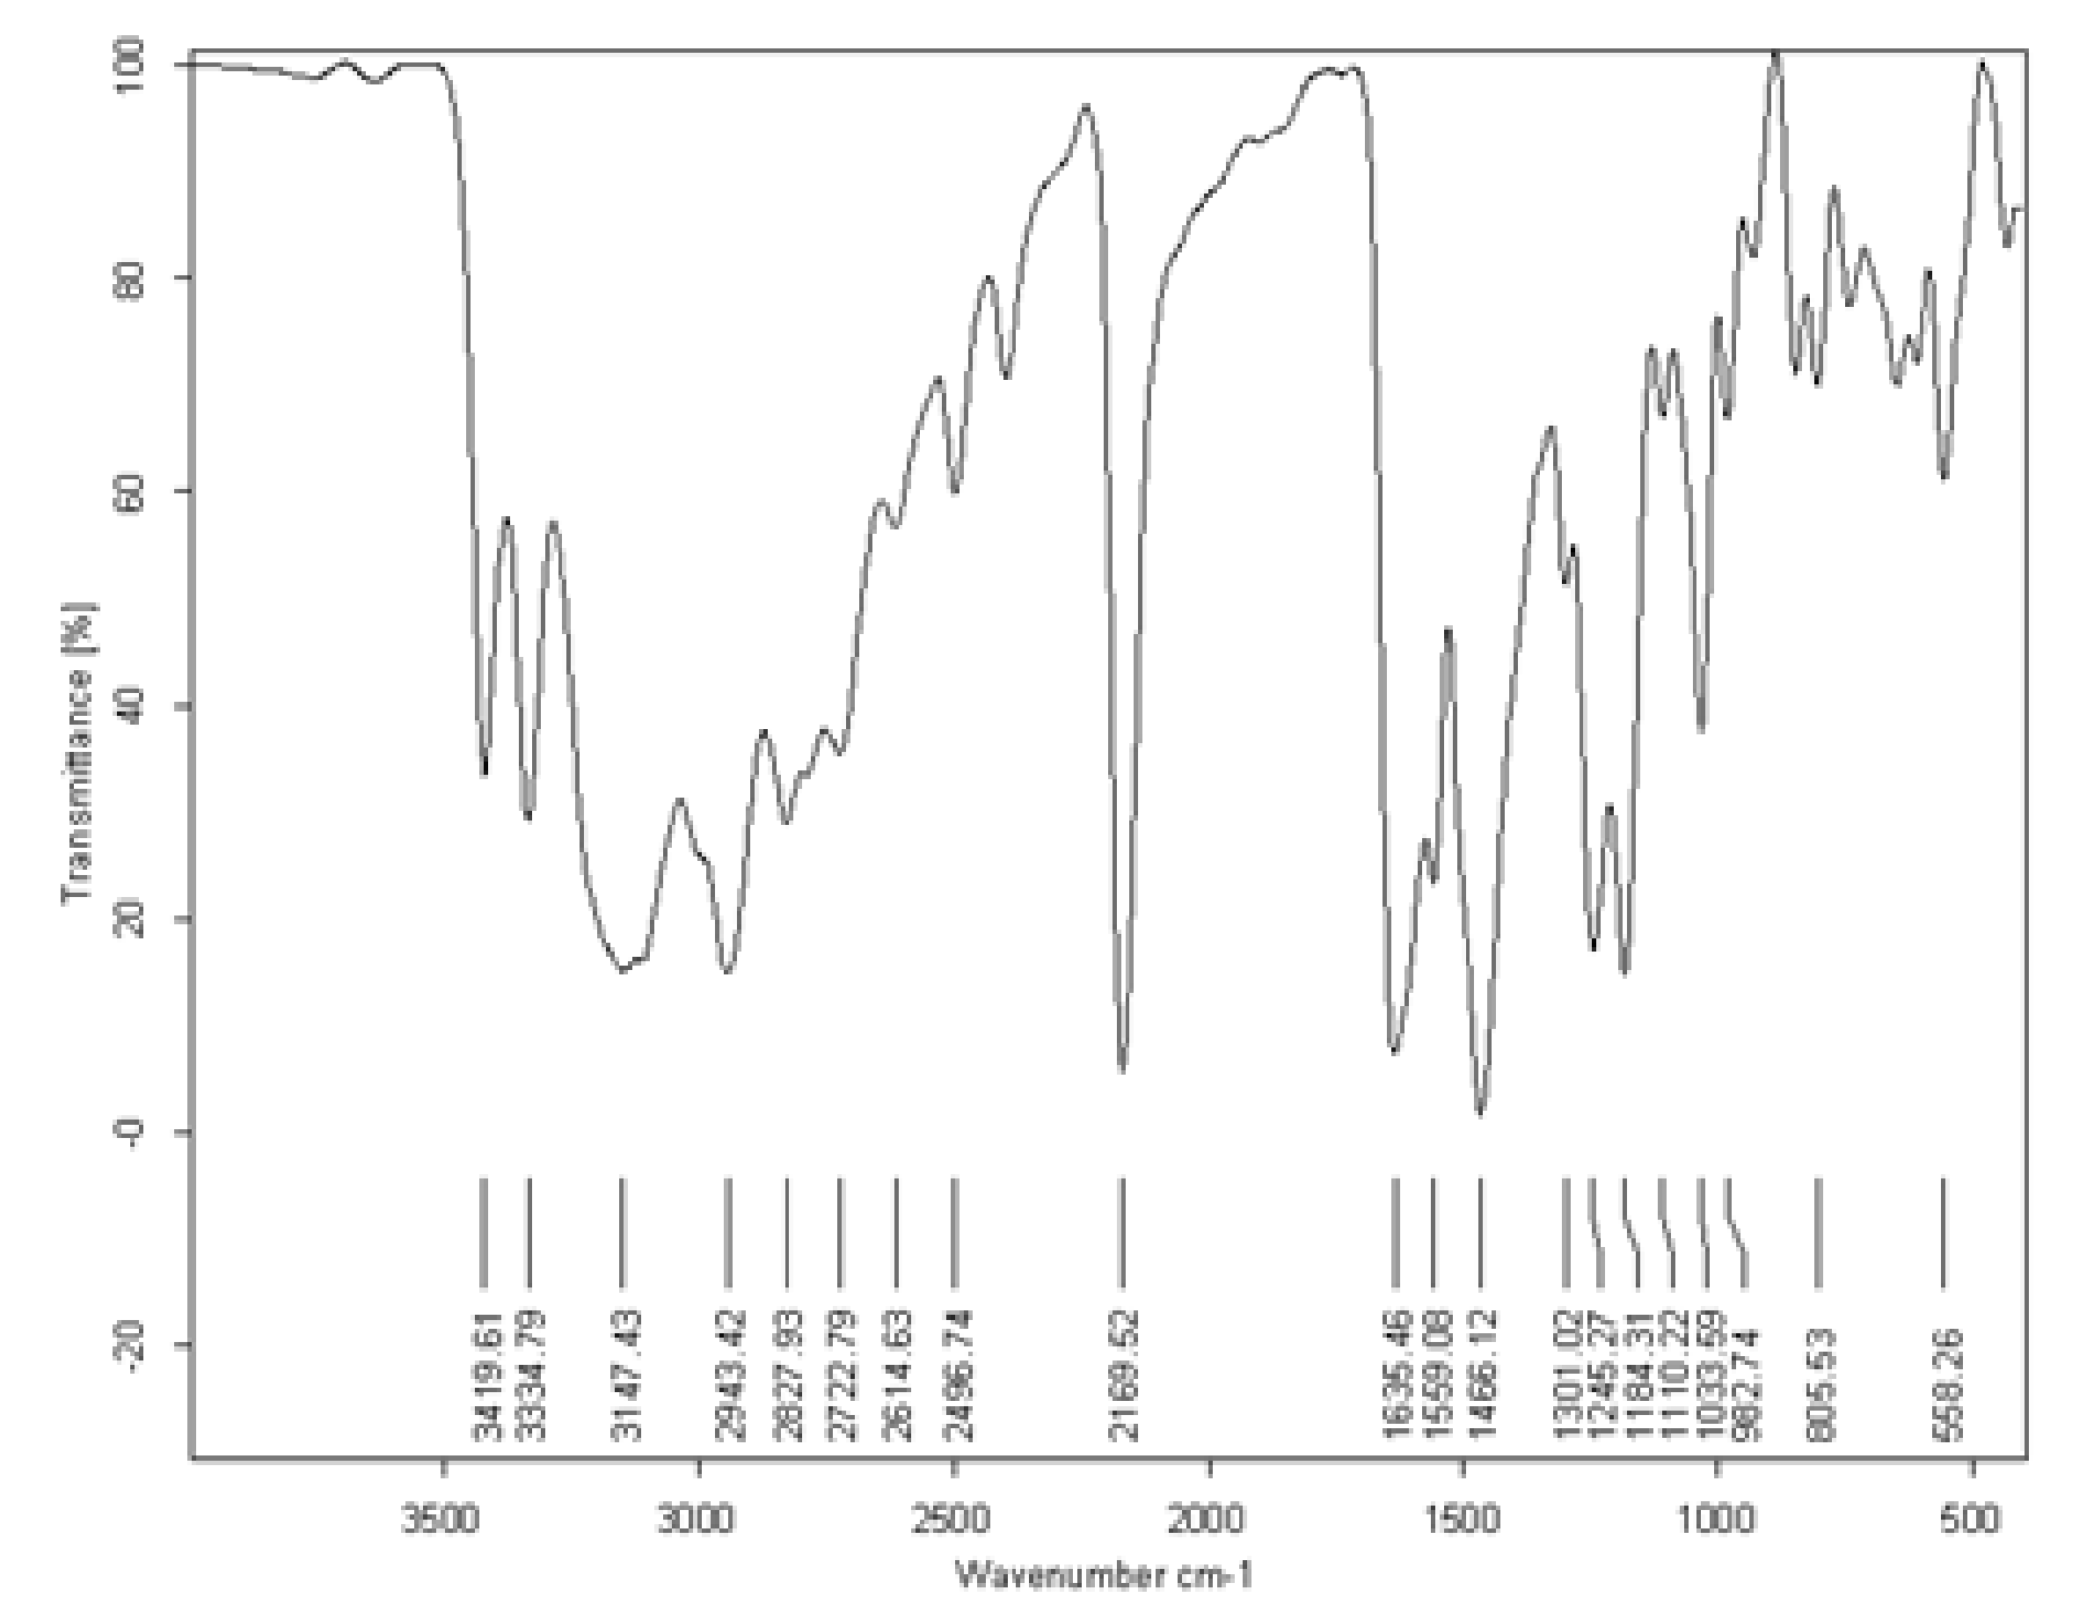

IR of 4d
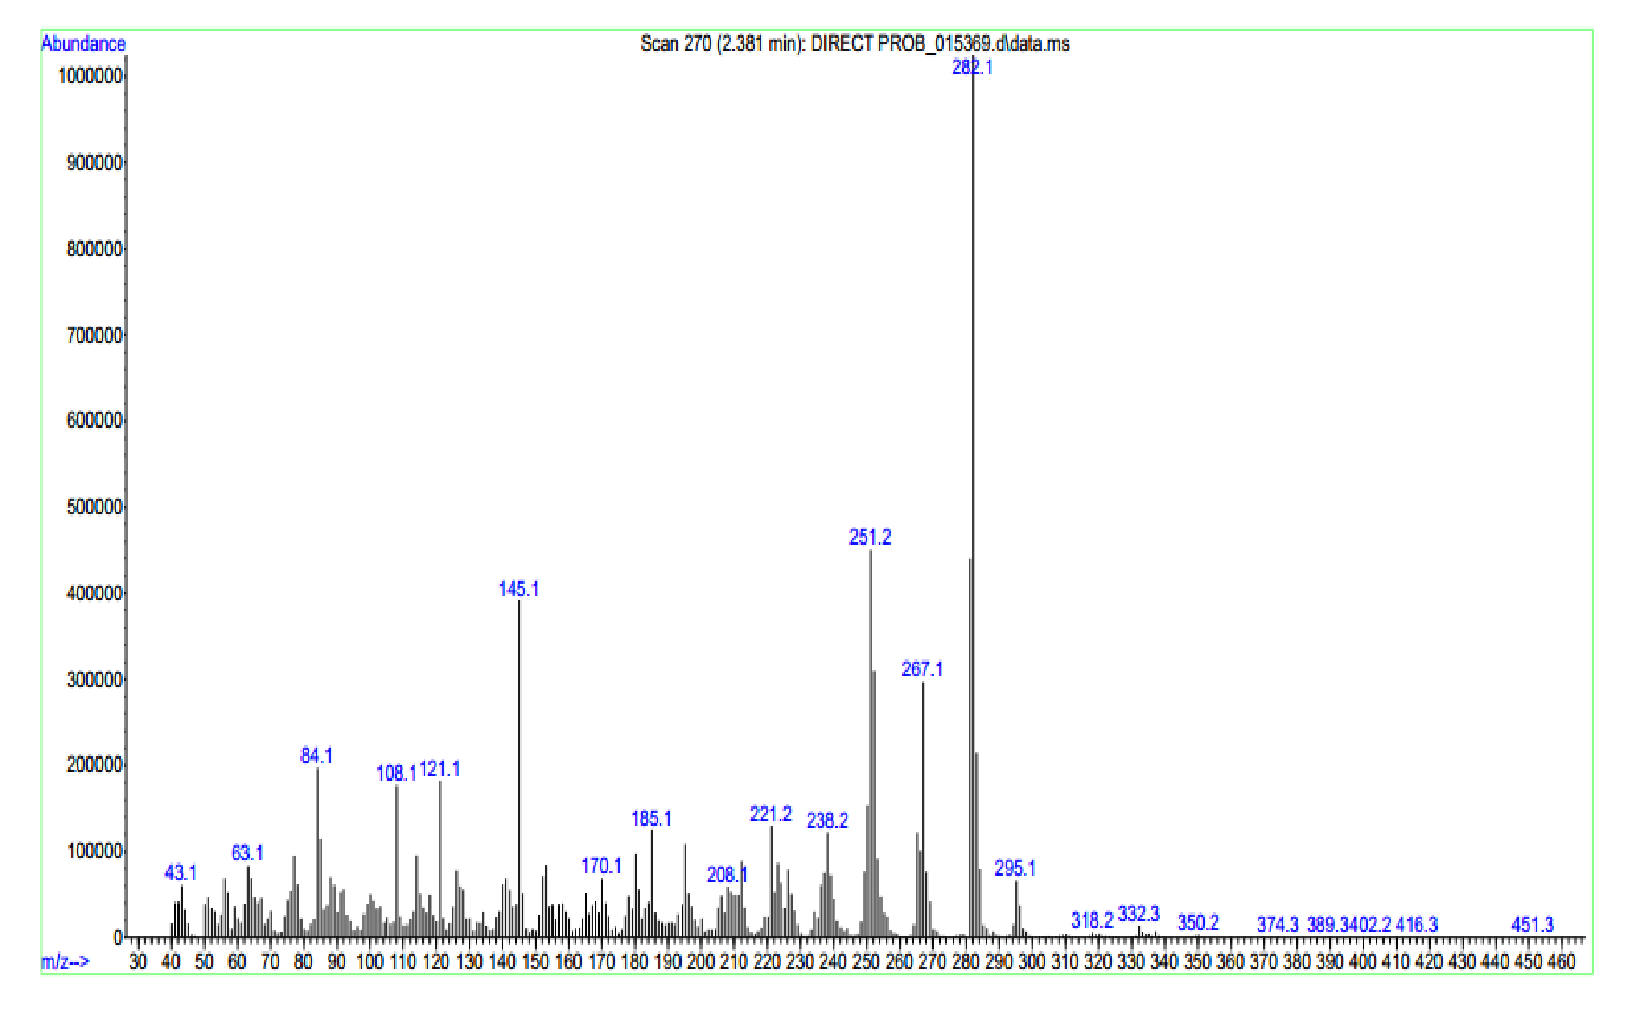

Mass of 4d

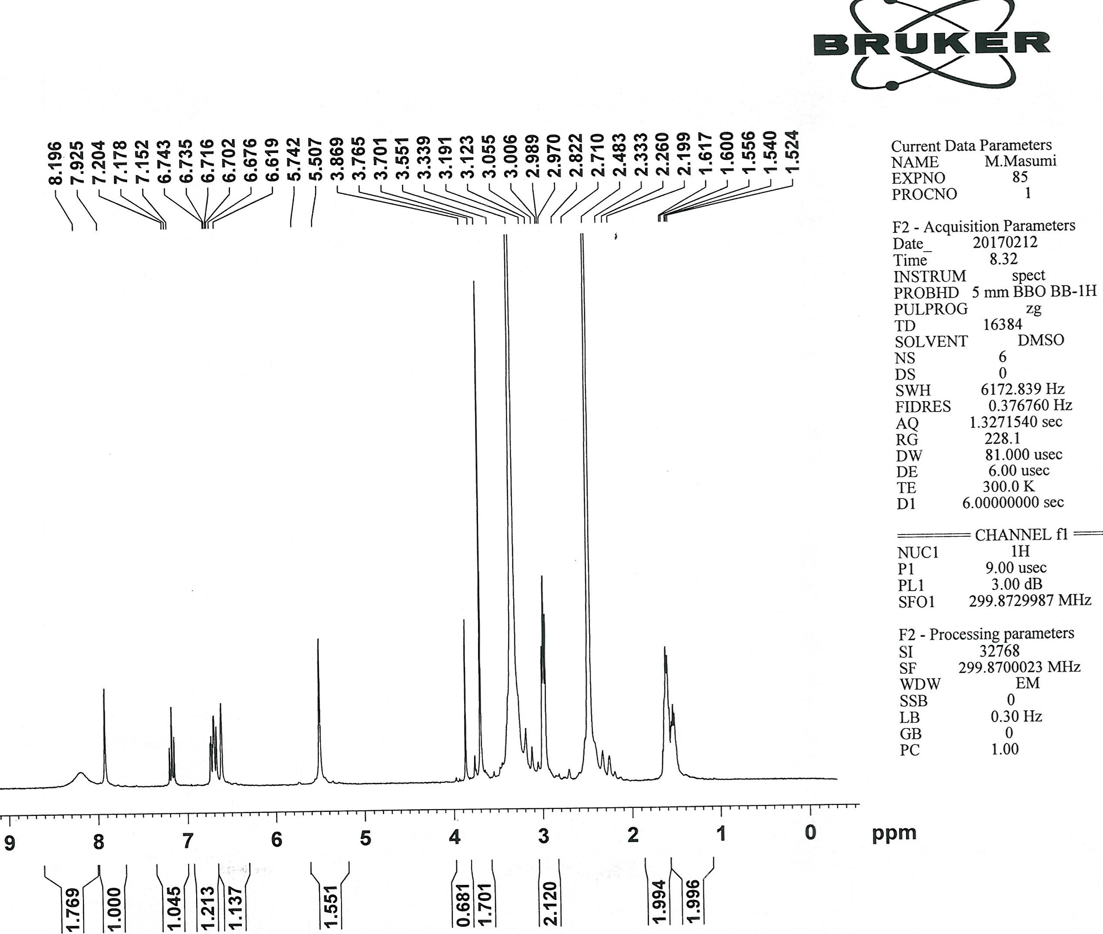

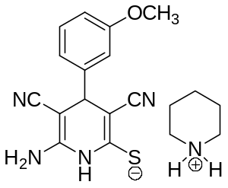

¹H NMR of 4e

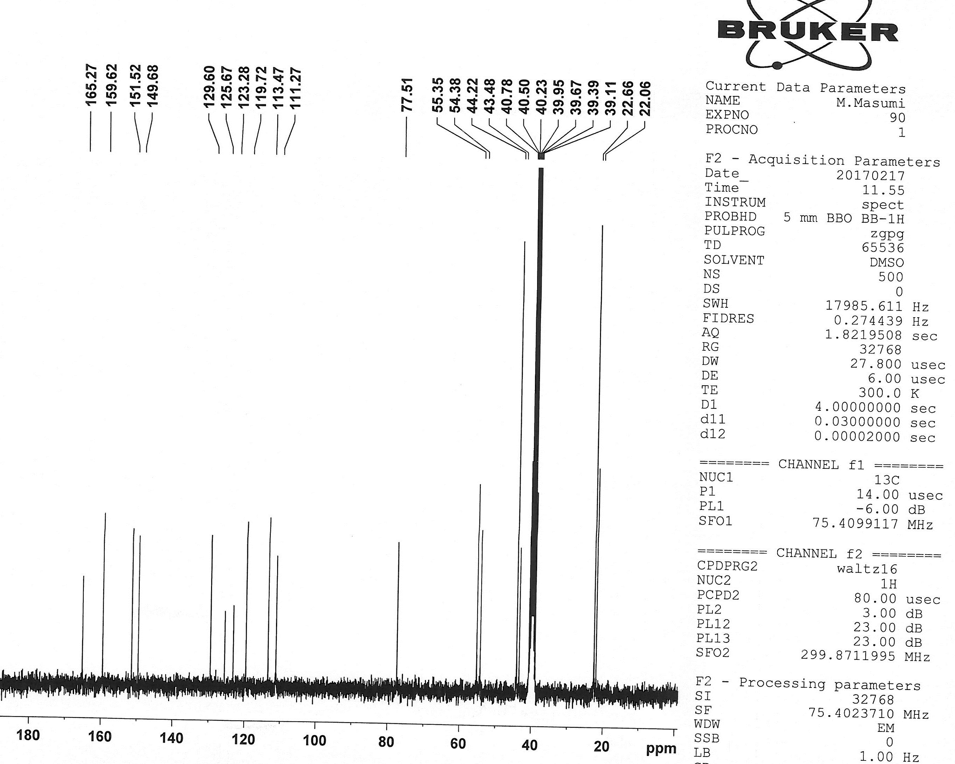

¹³C NMR of 4e

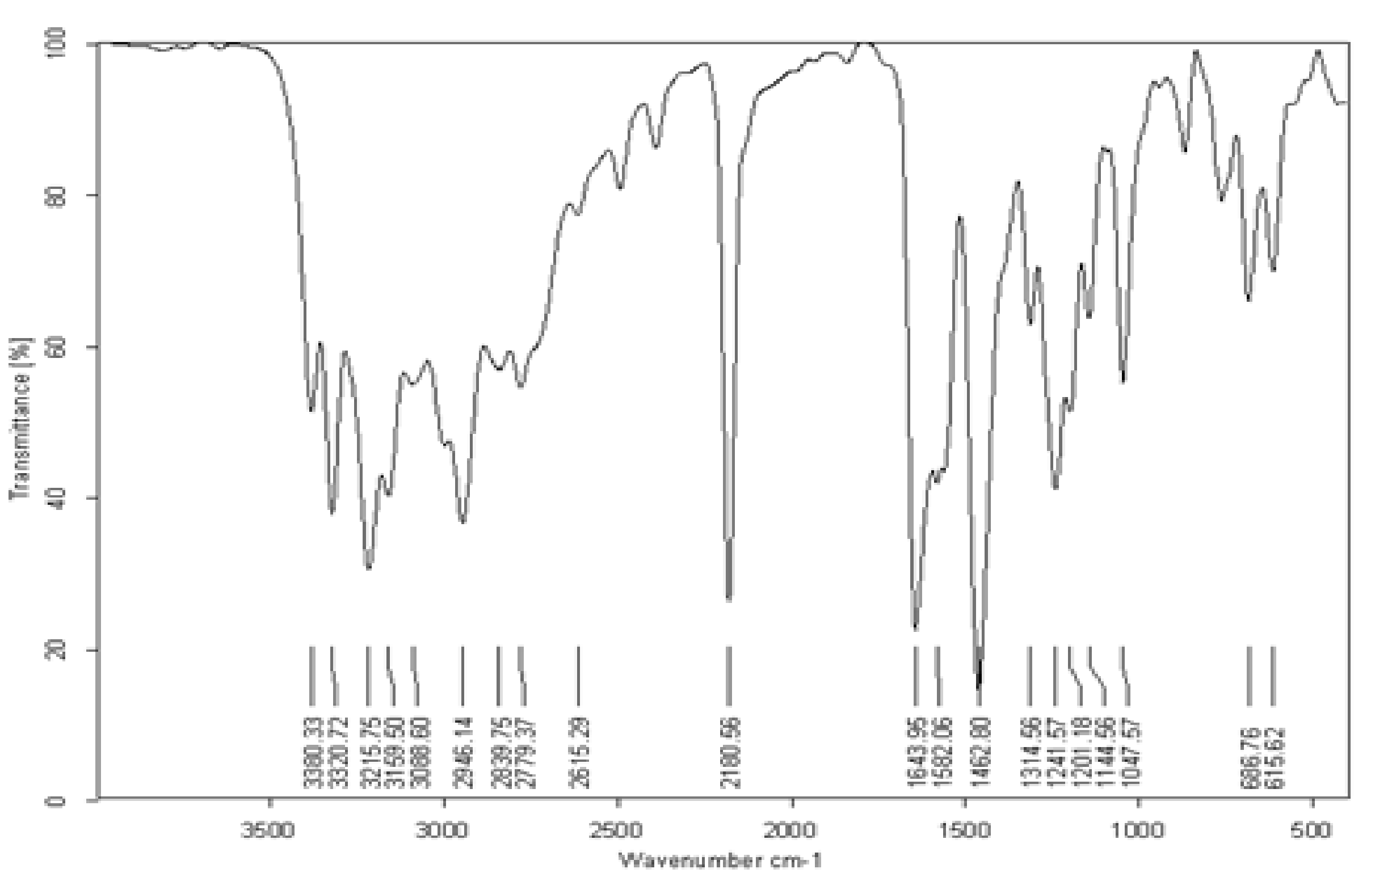

IR of 4e

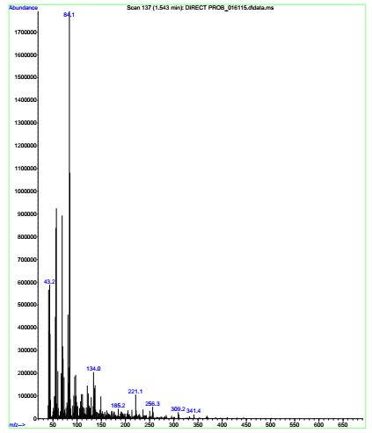

Mass of 4e
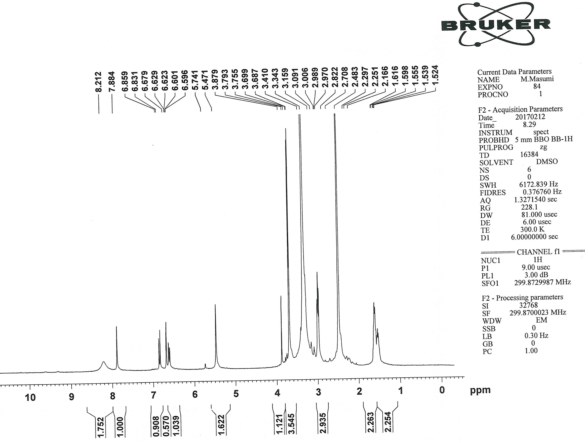

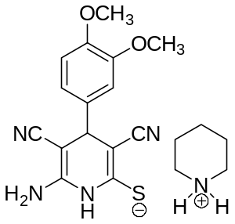

¹H NMR of 4f
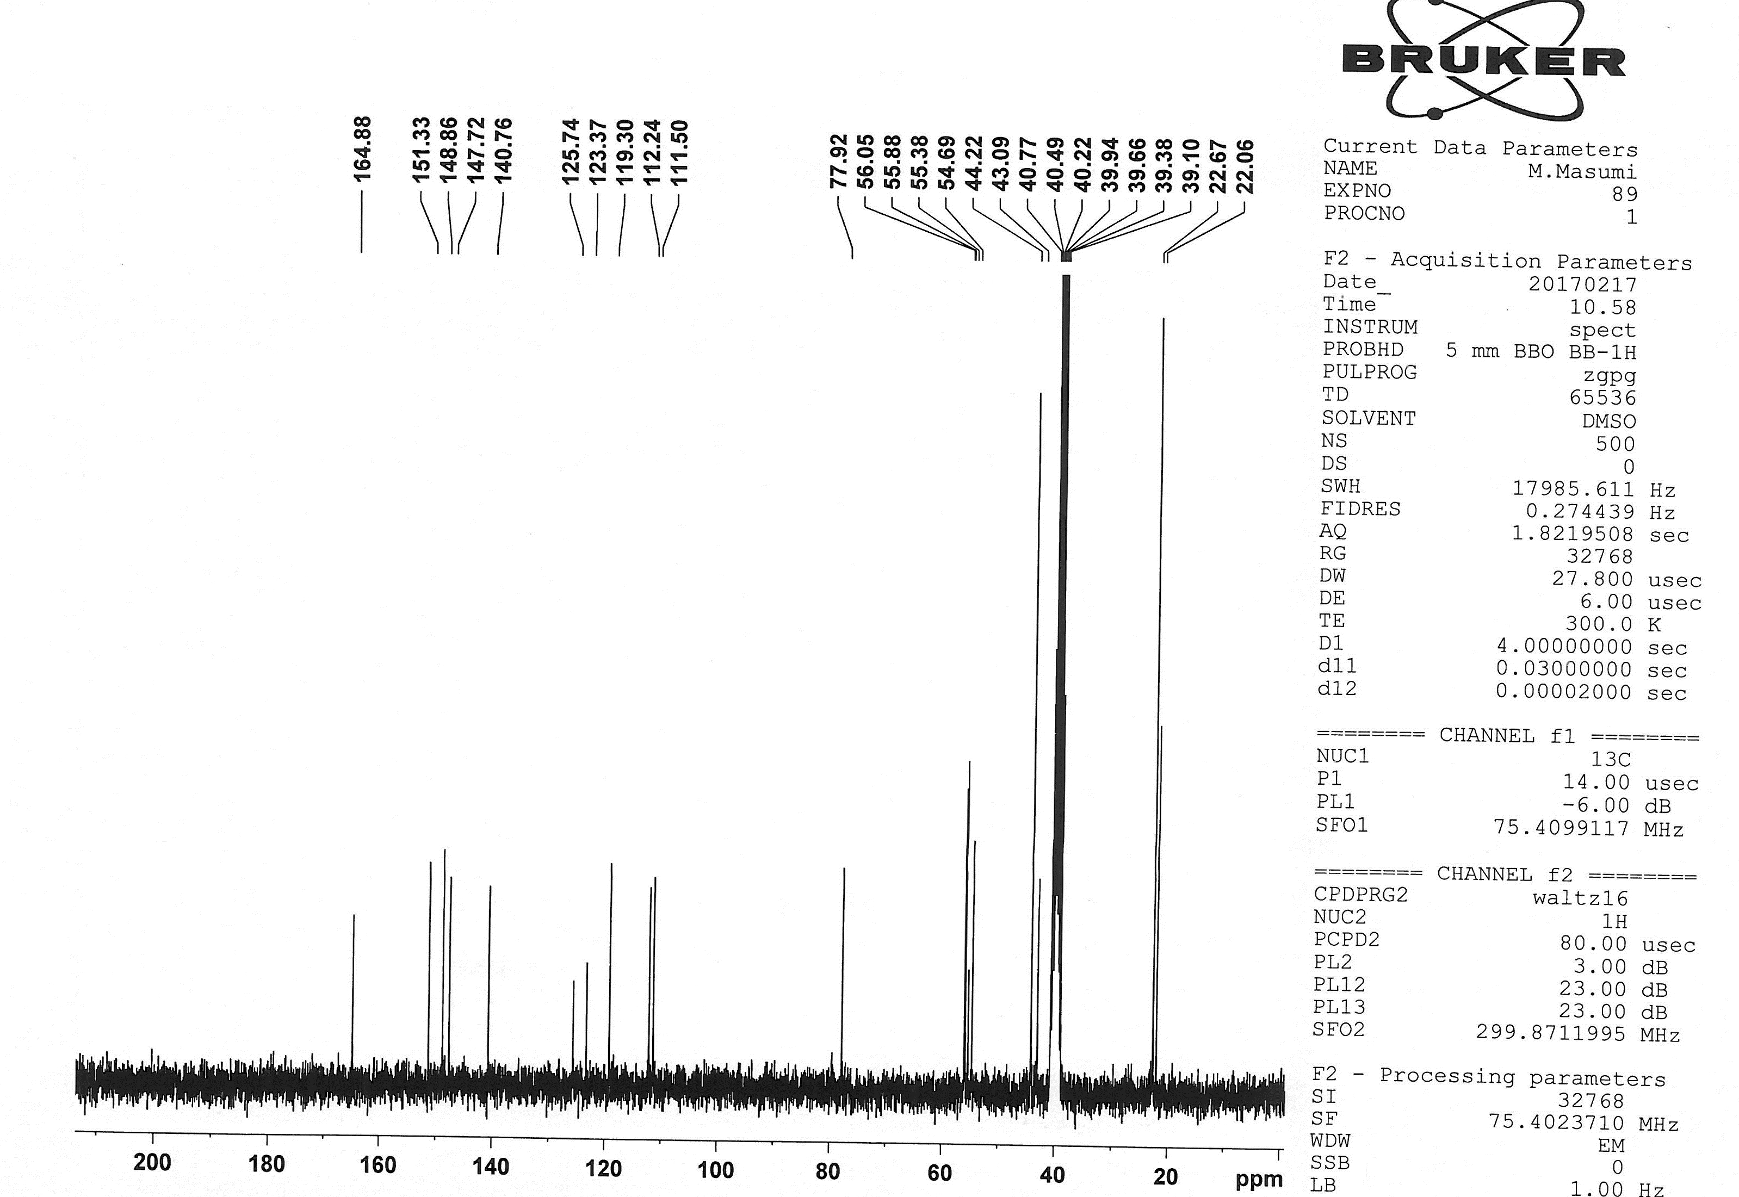

¹³C NMR of 4f
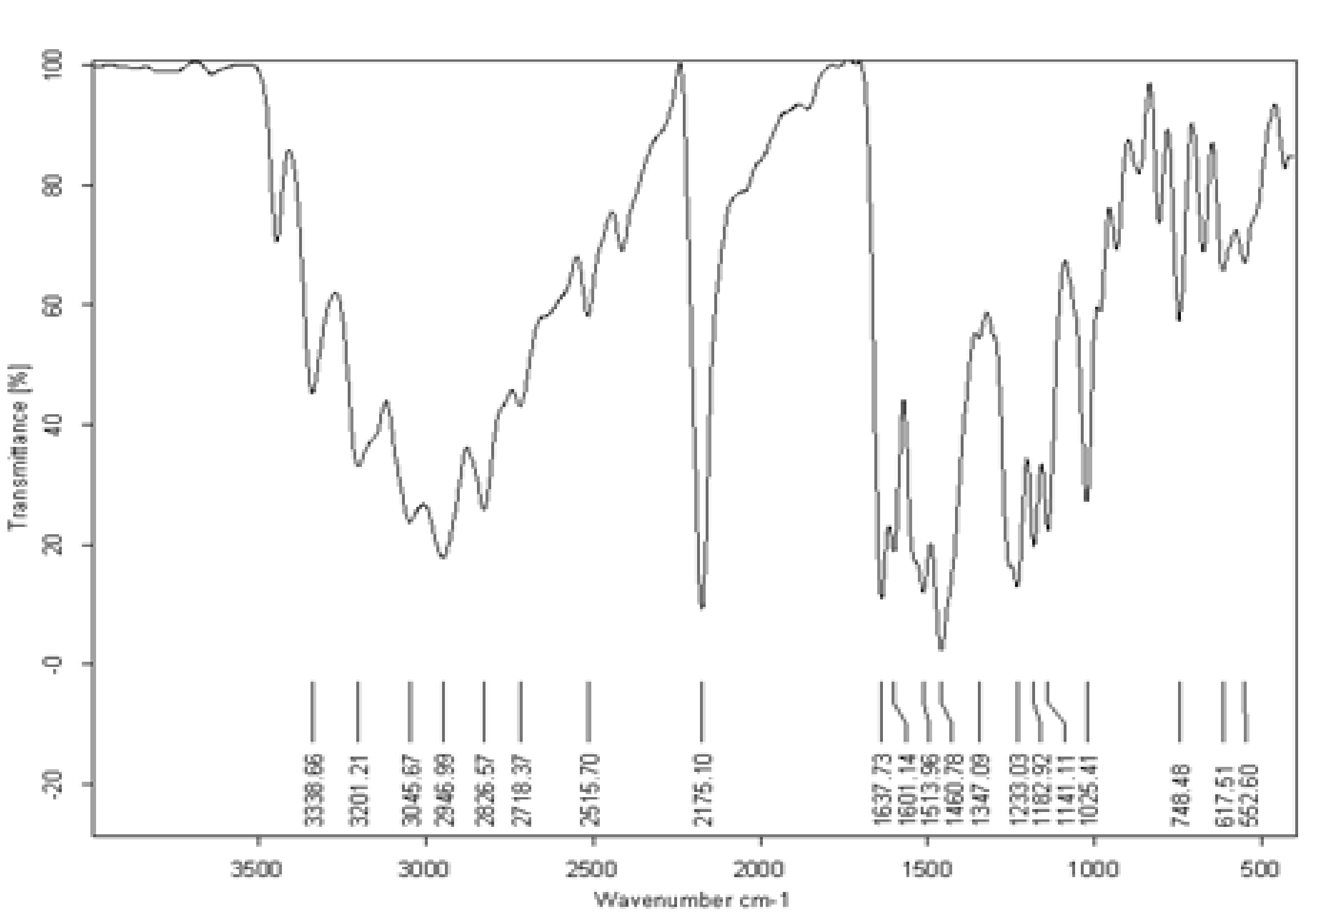

IR of 4f

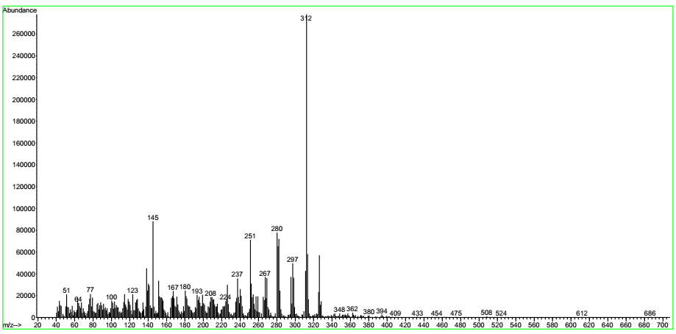

Mass of 4f

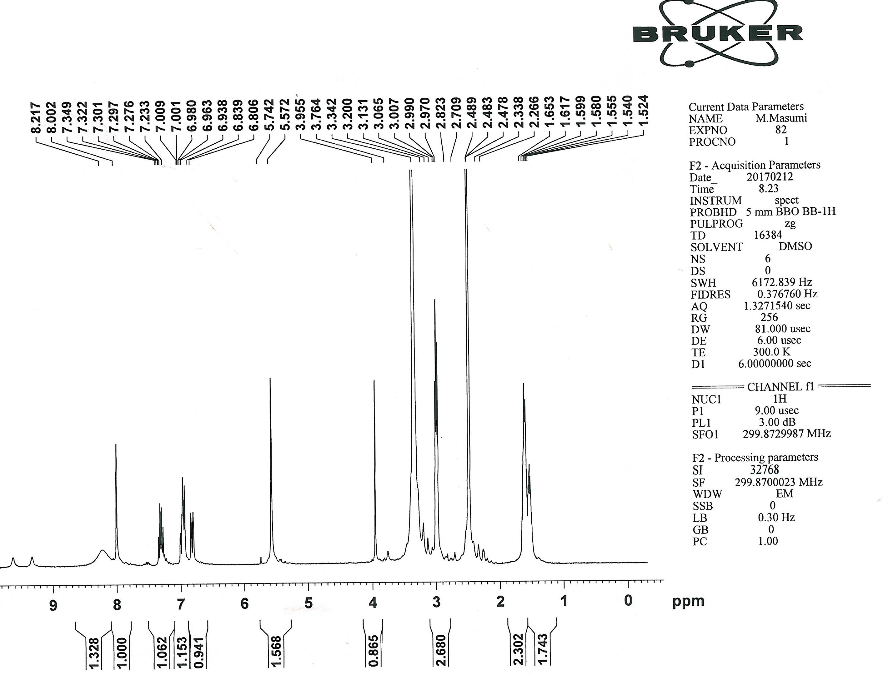

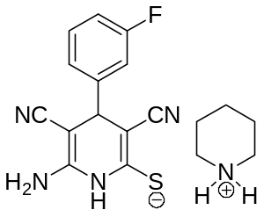

¹H NMR of 4g
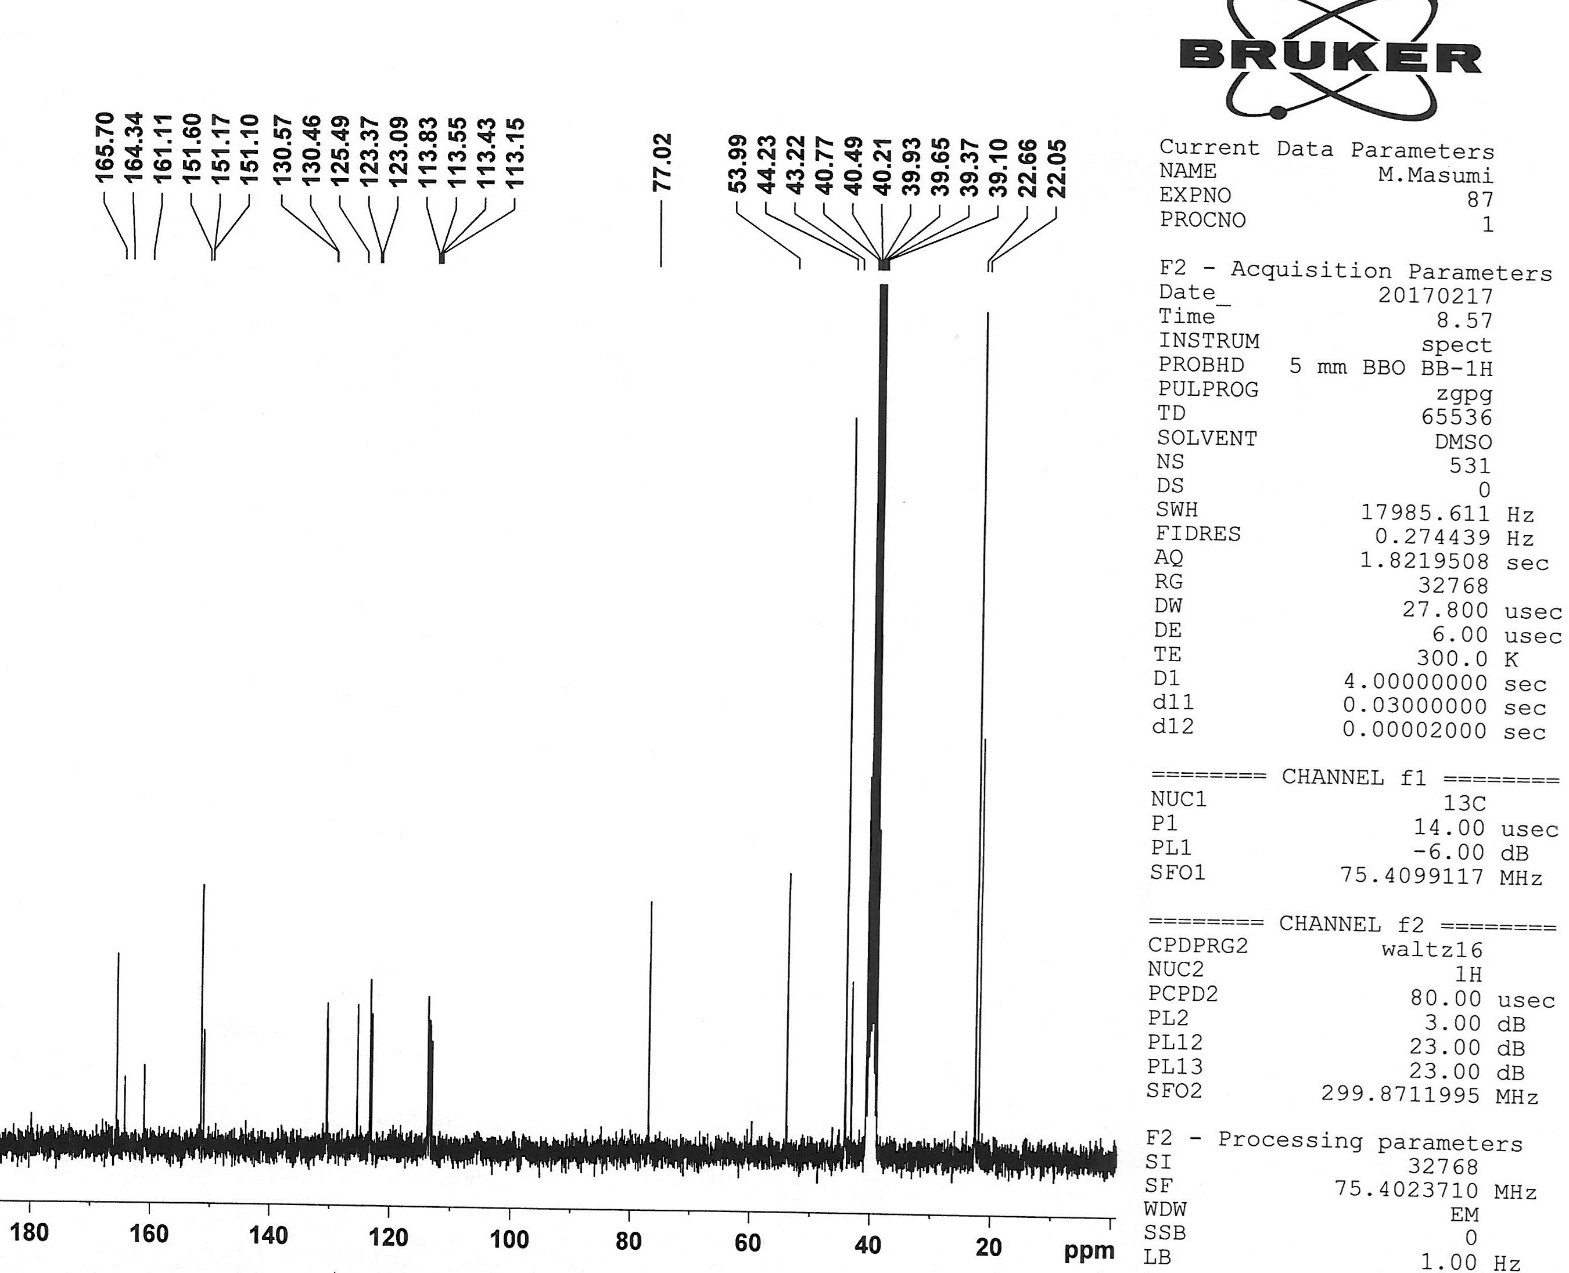

¹³C NMR of 4g
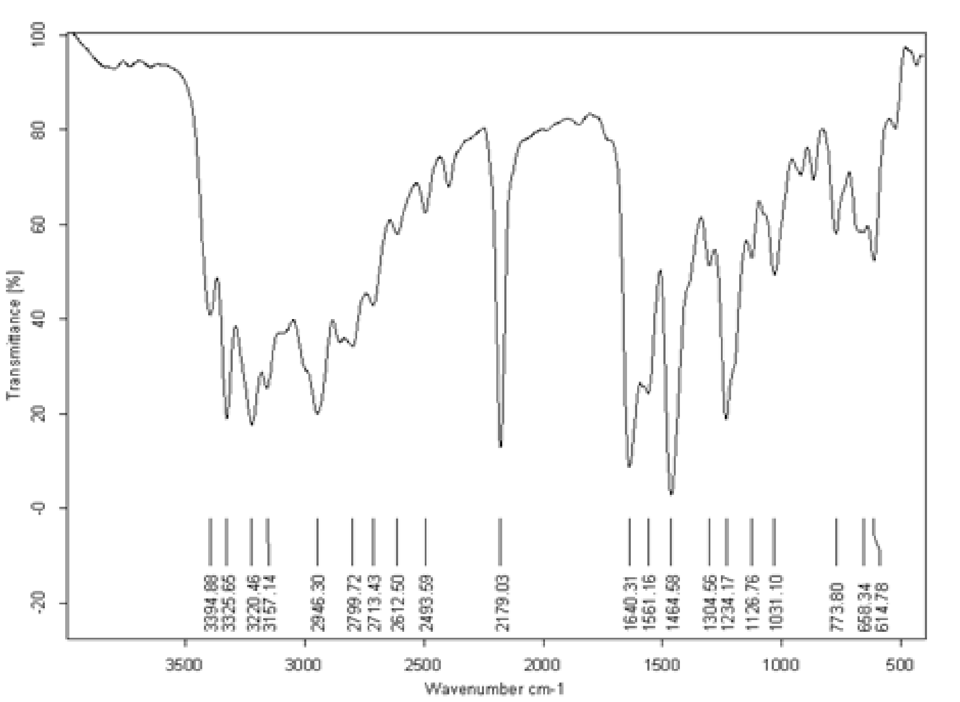

IR of 4g

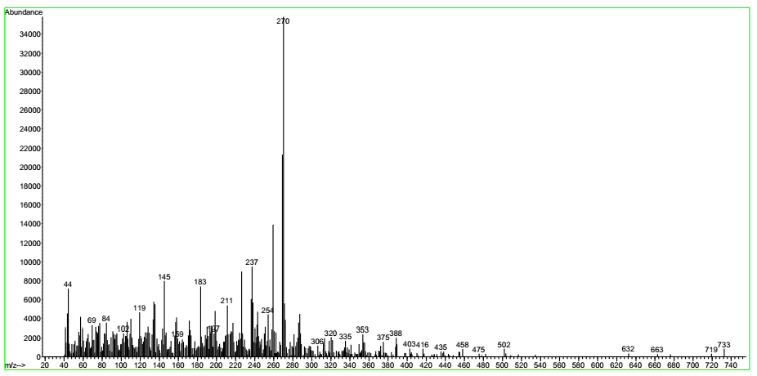

Mass of 4g

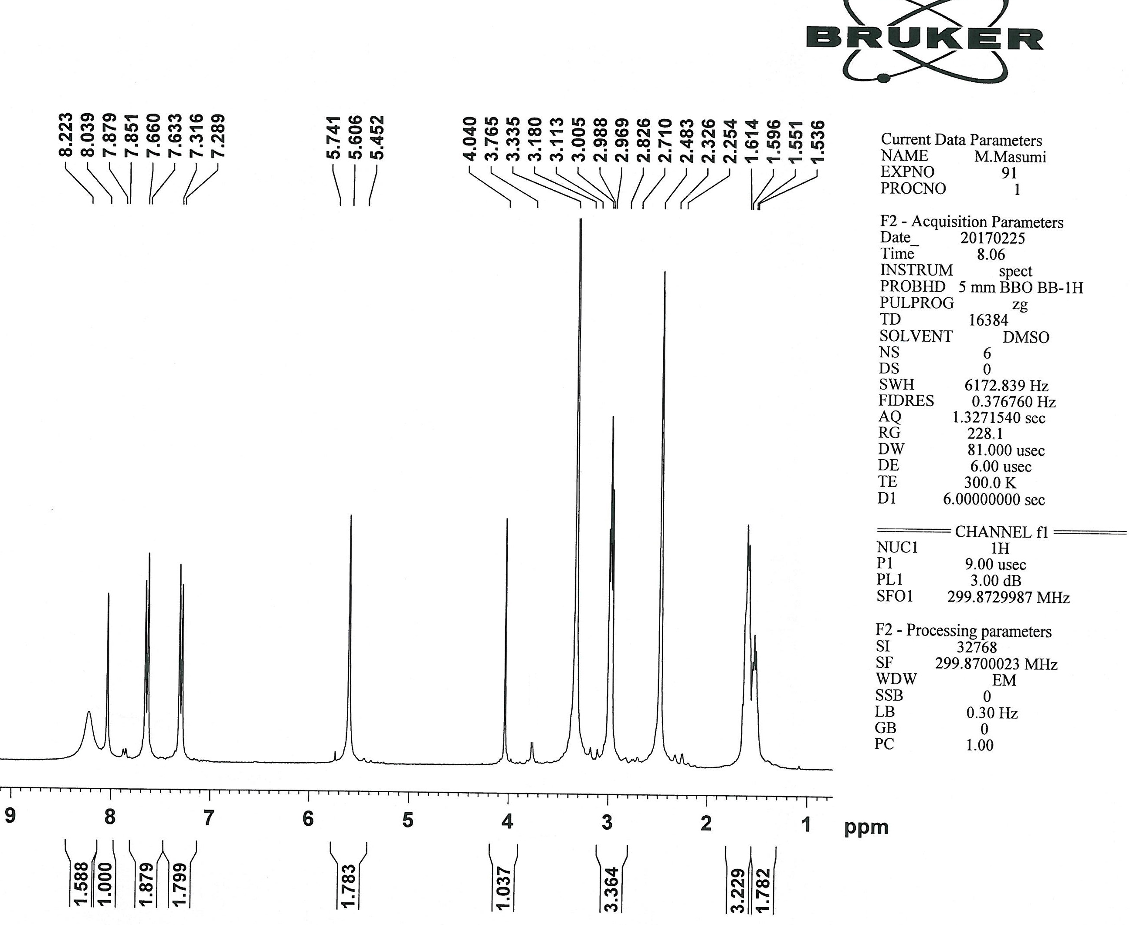

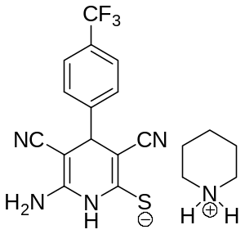
¹H NMR of 4h

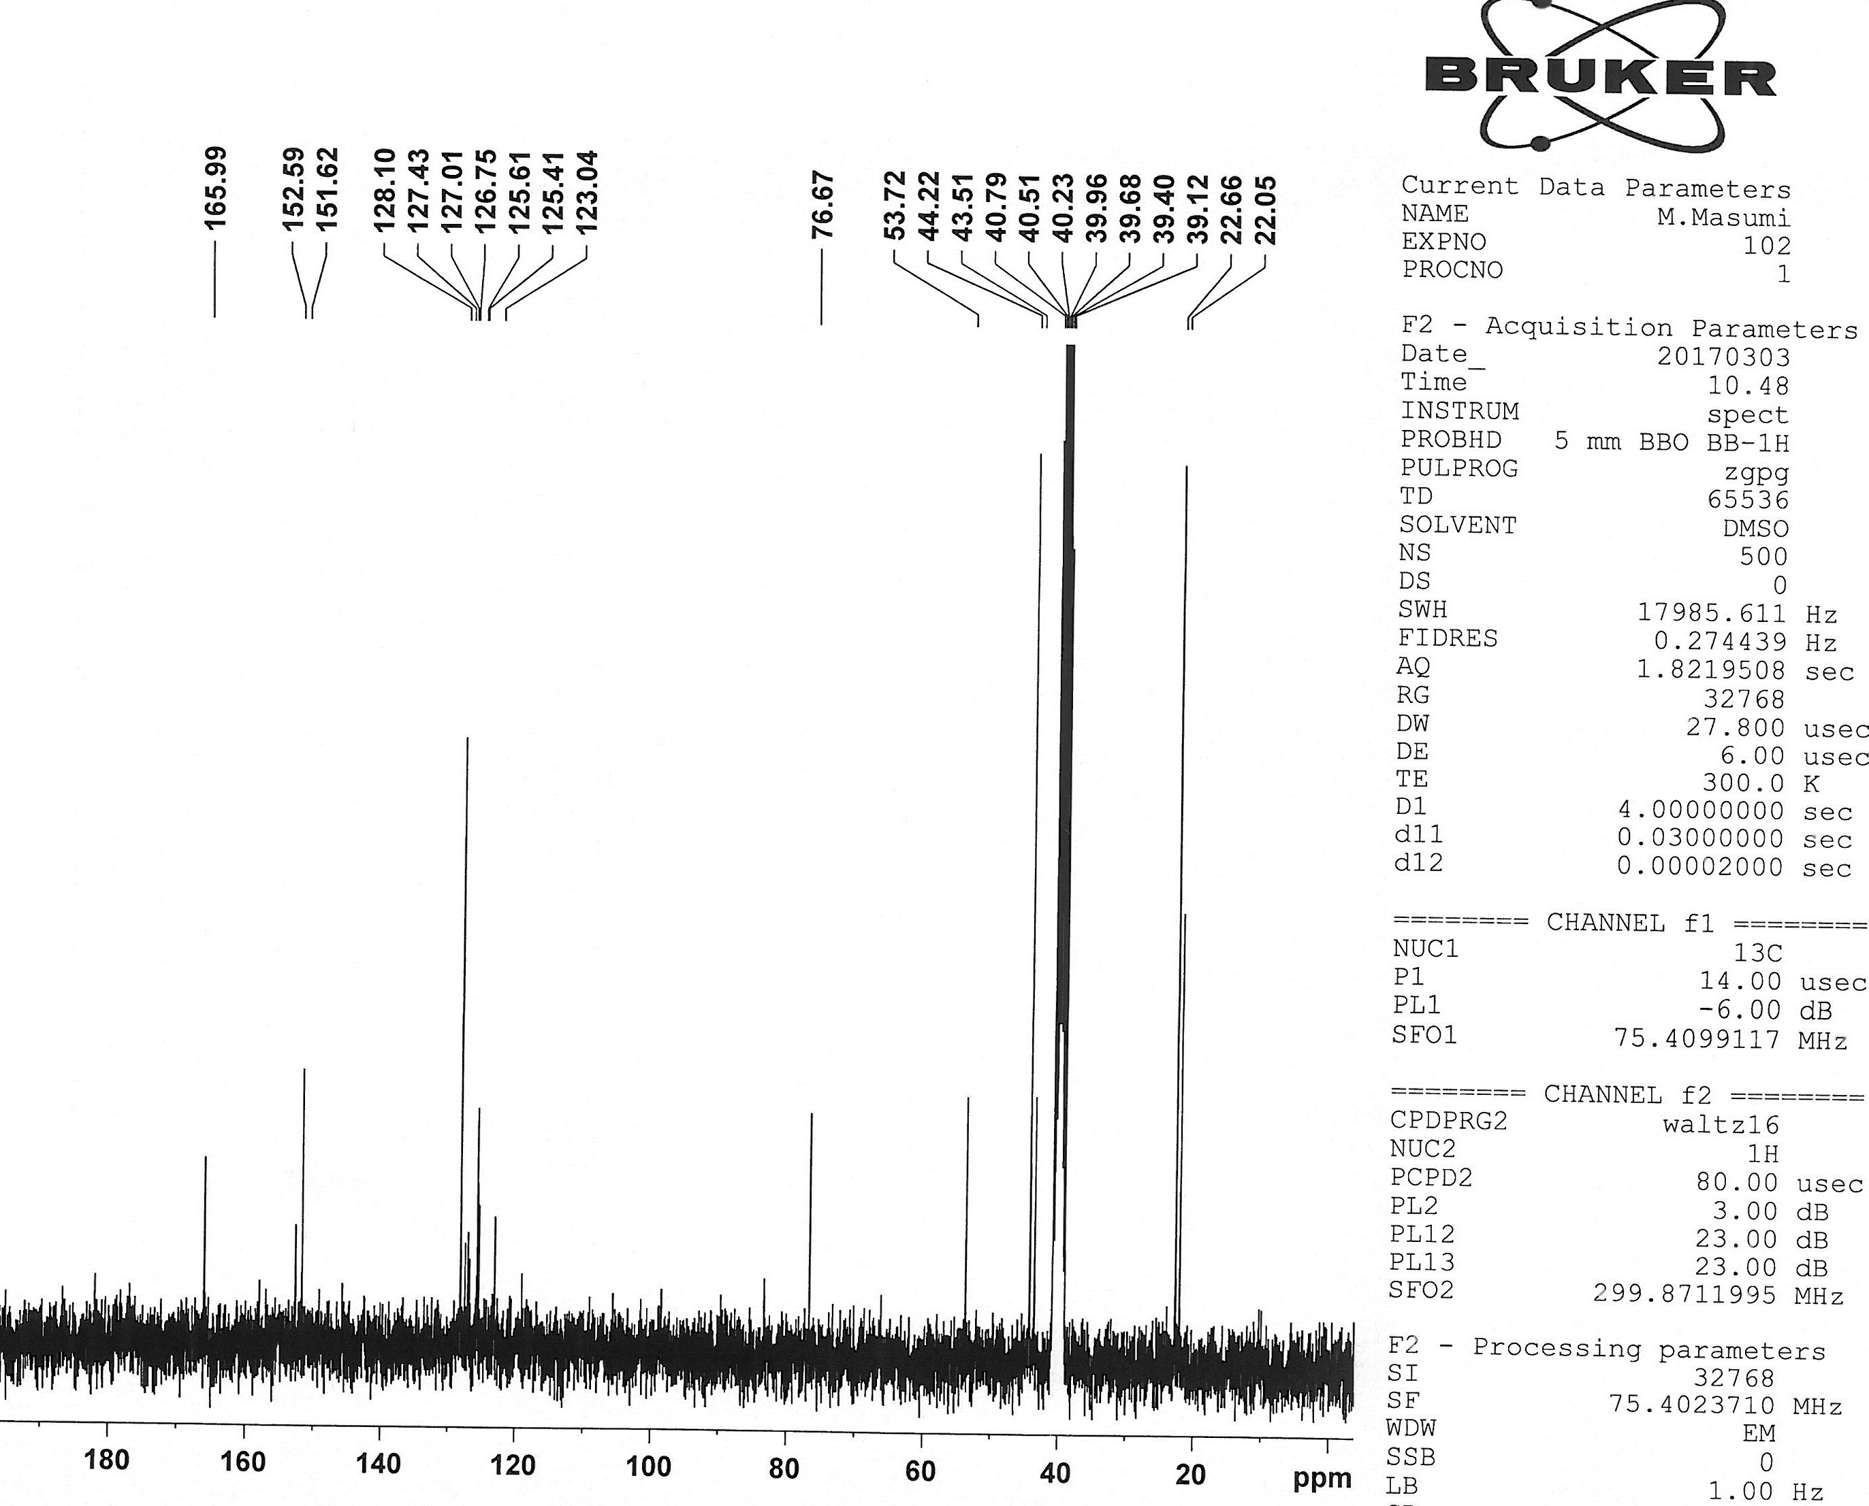

¹³C NMR of 4h

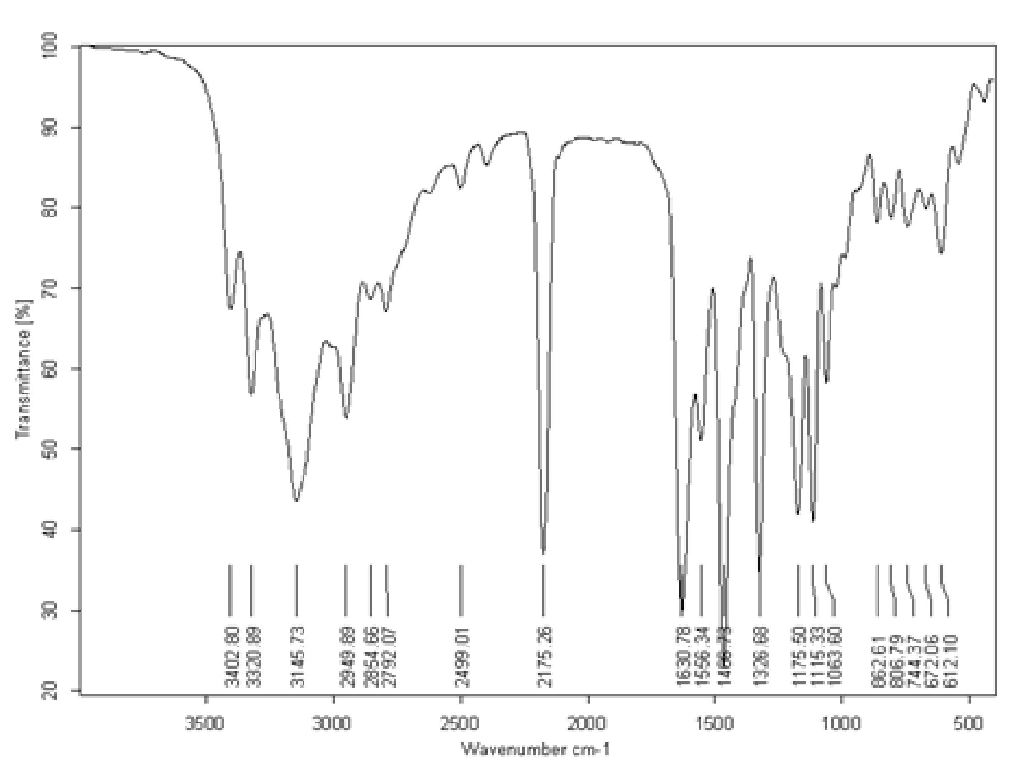

IR of 4h

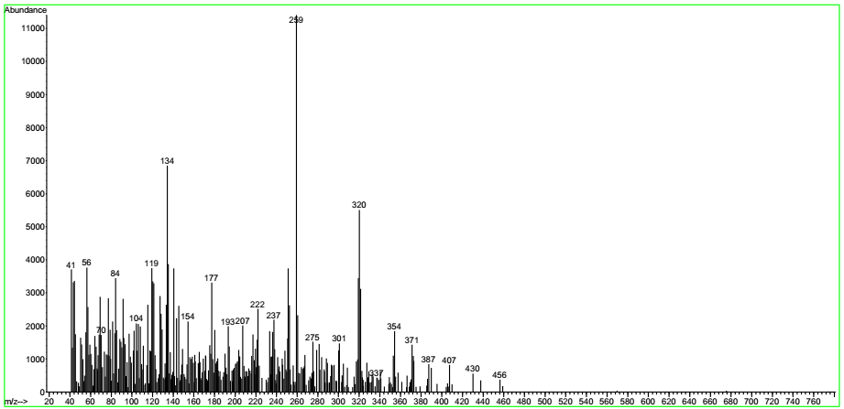

Mass of 4h
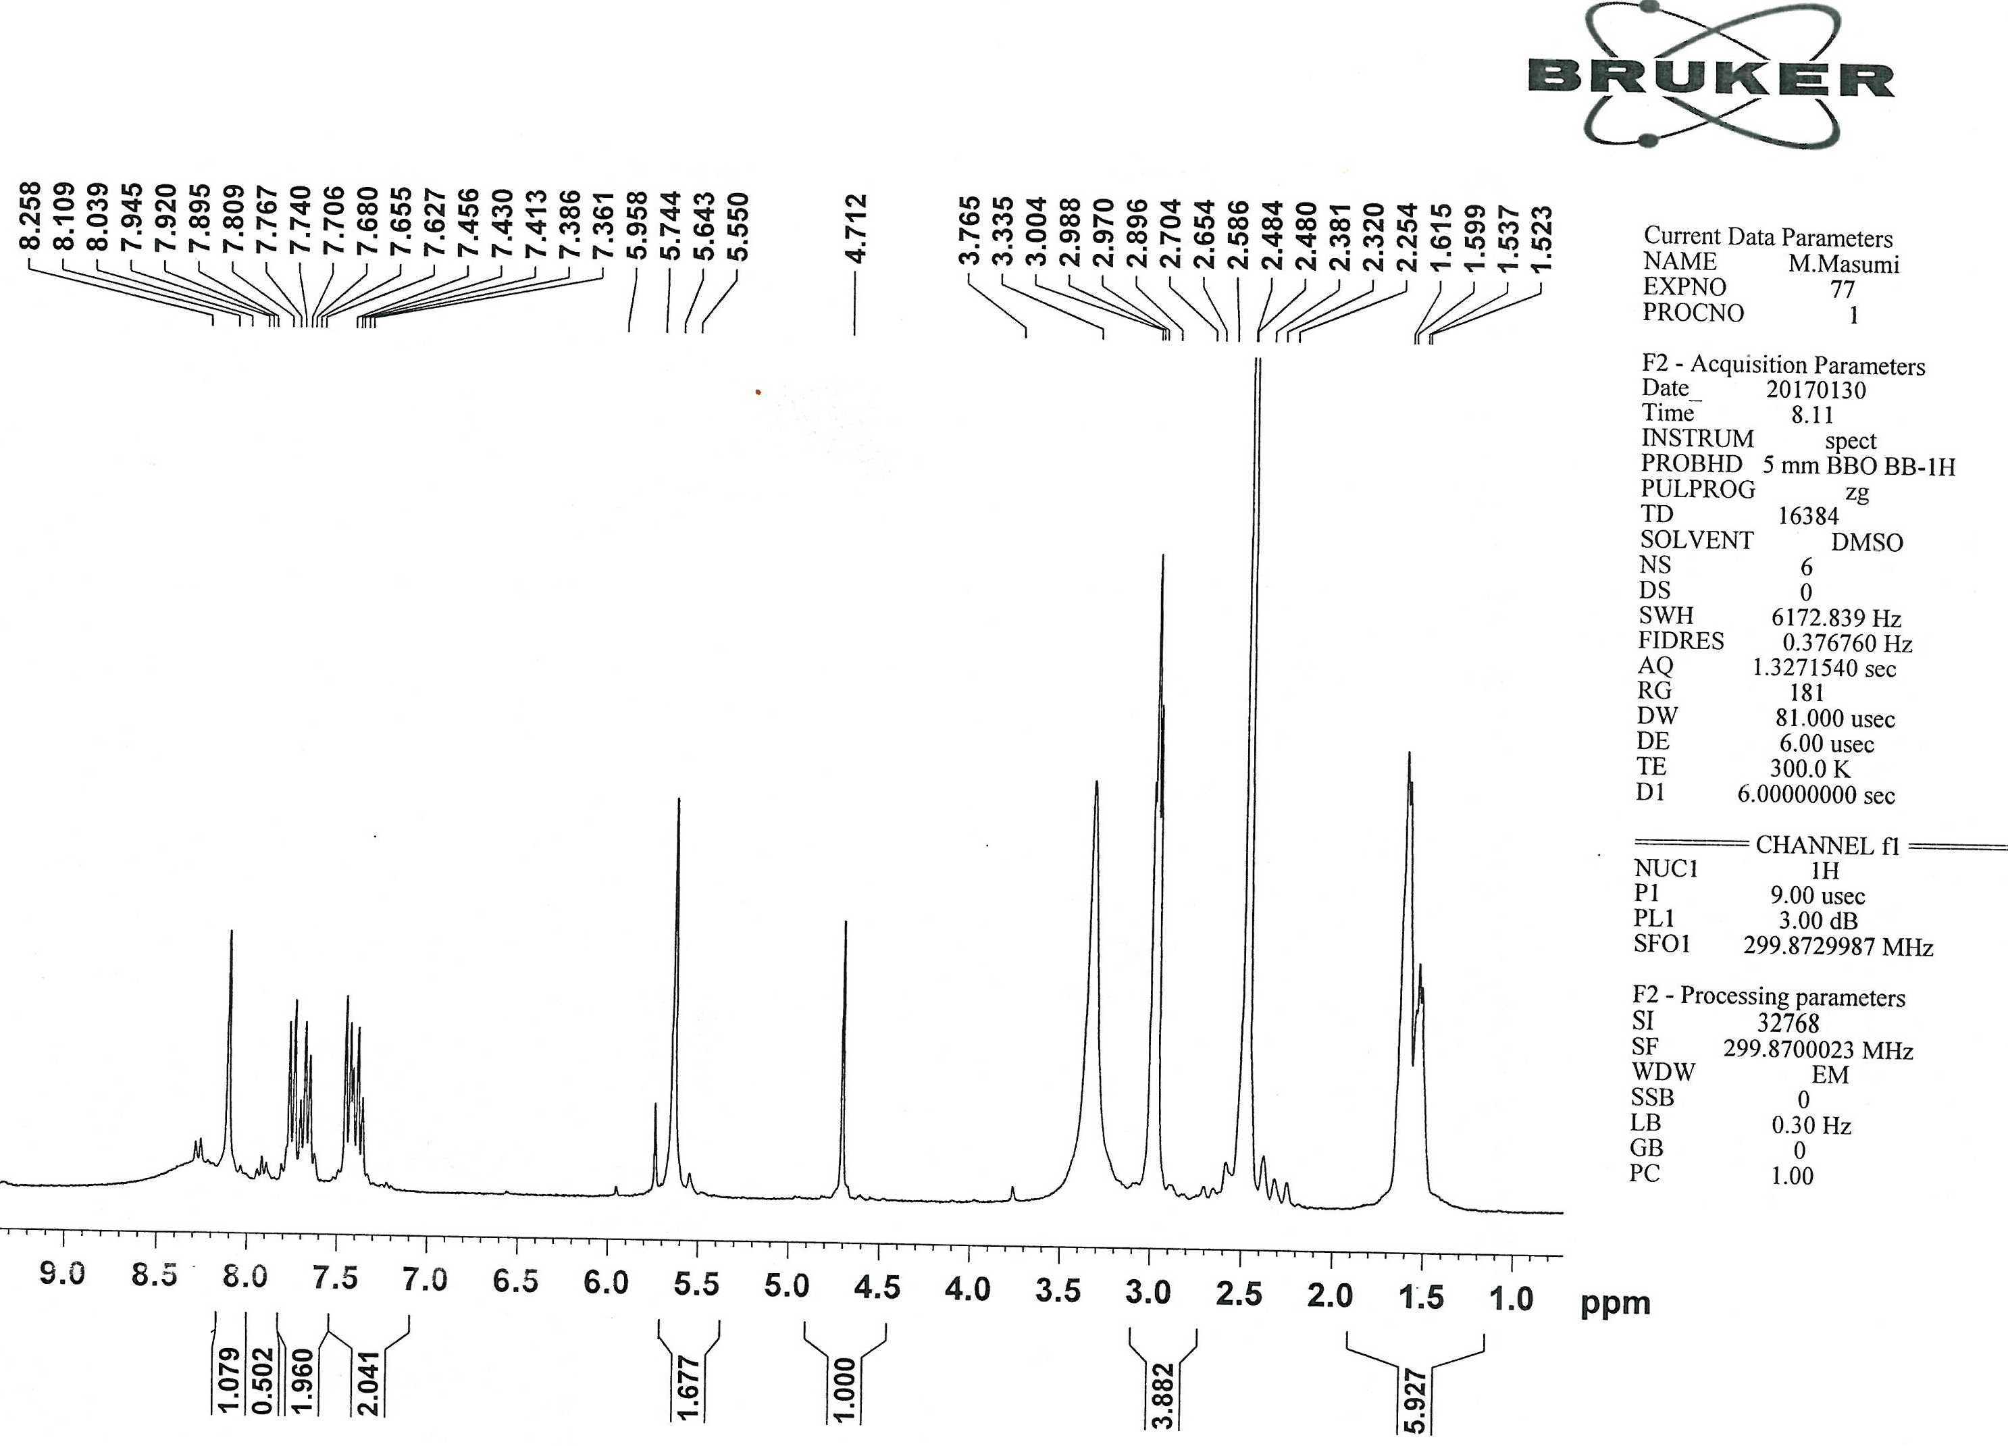

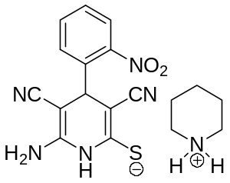
¹H NMR of 4i

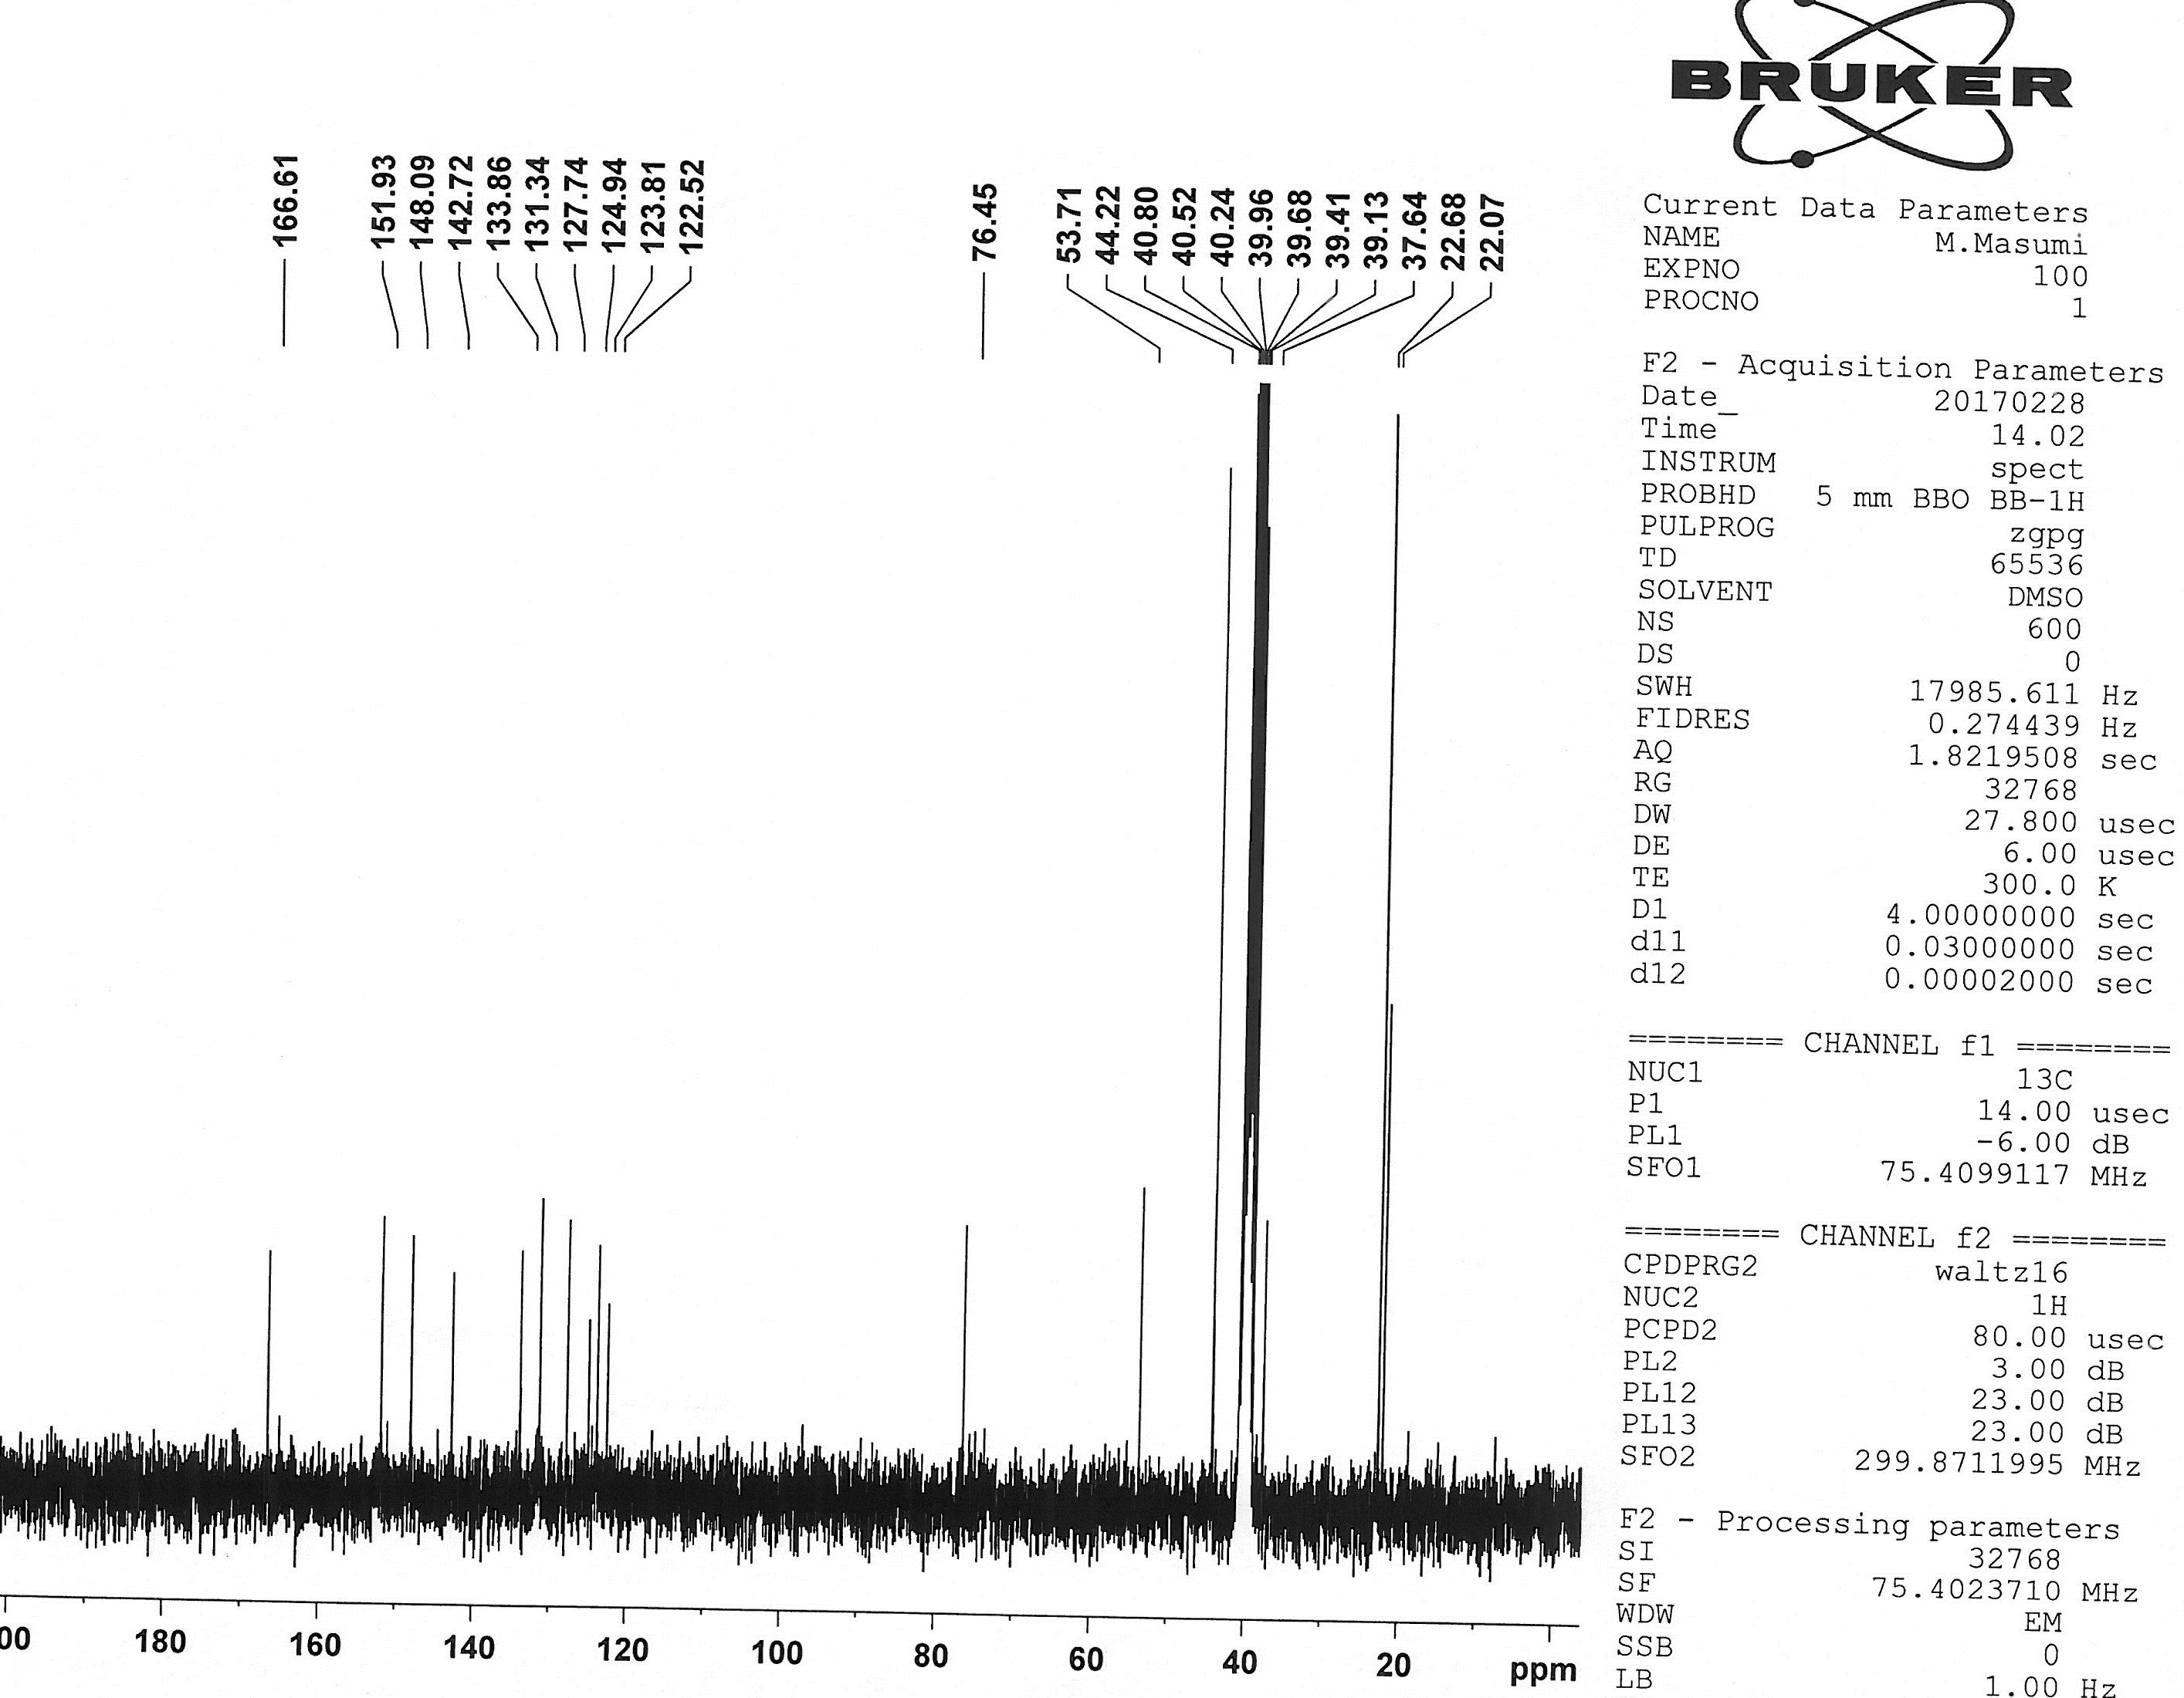

¹³C NMR of 4i

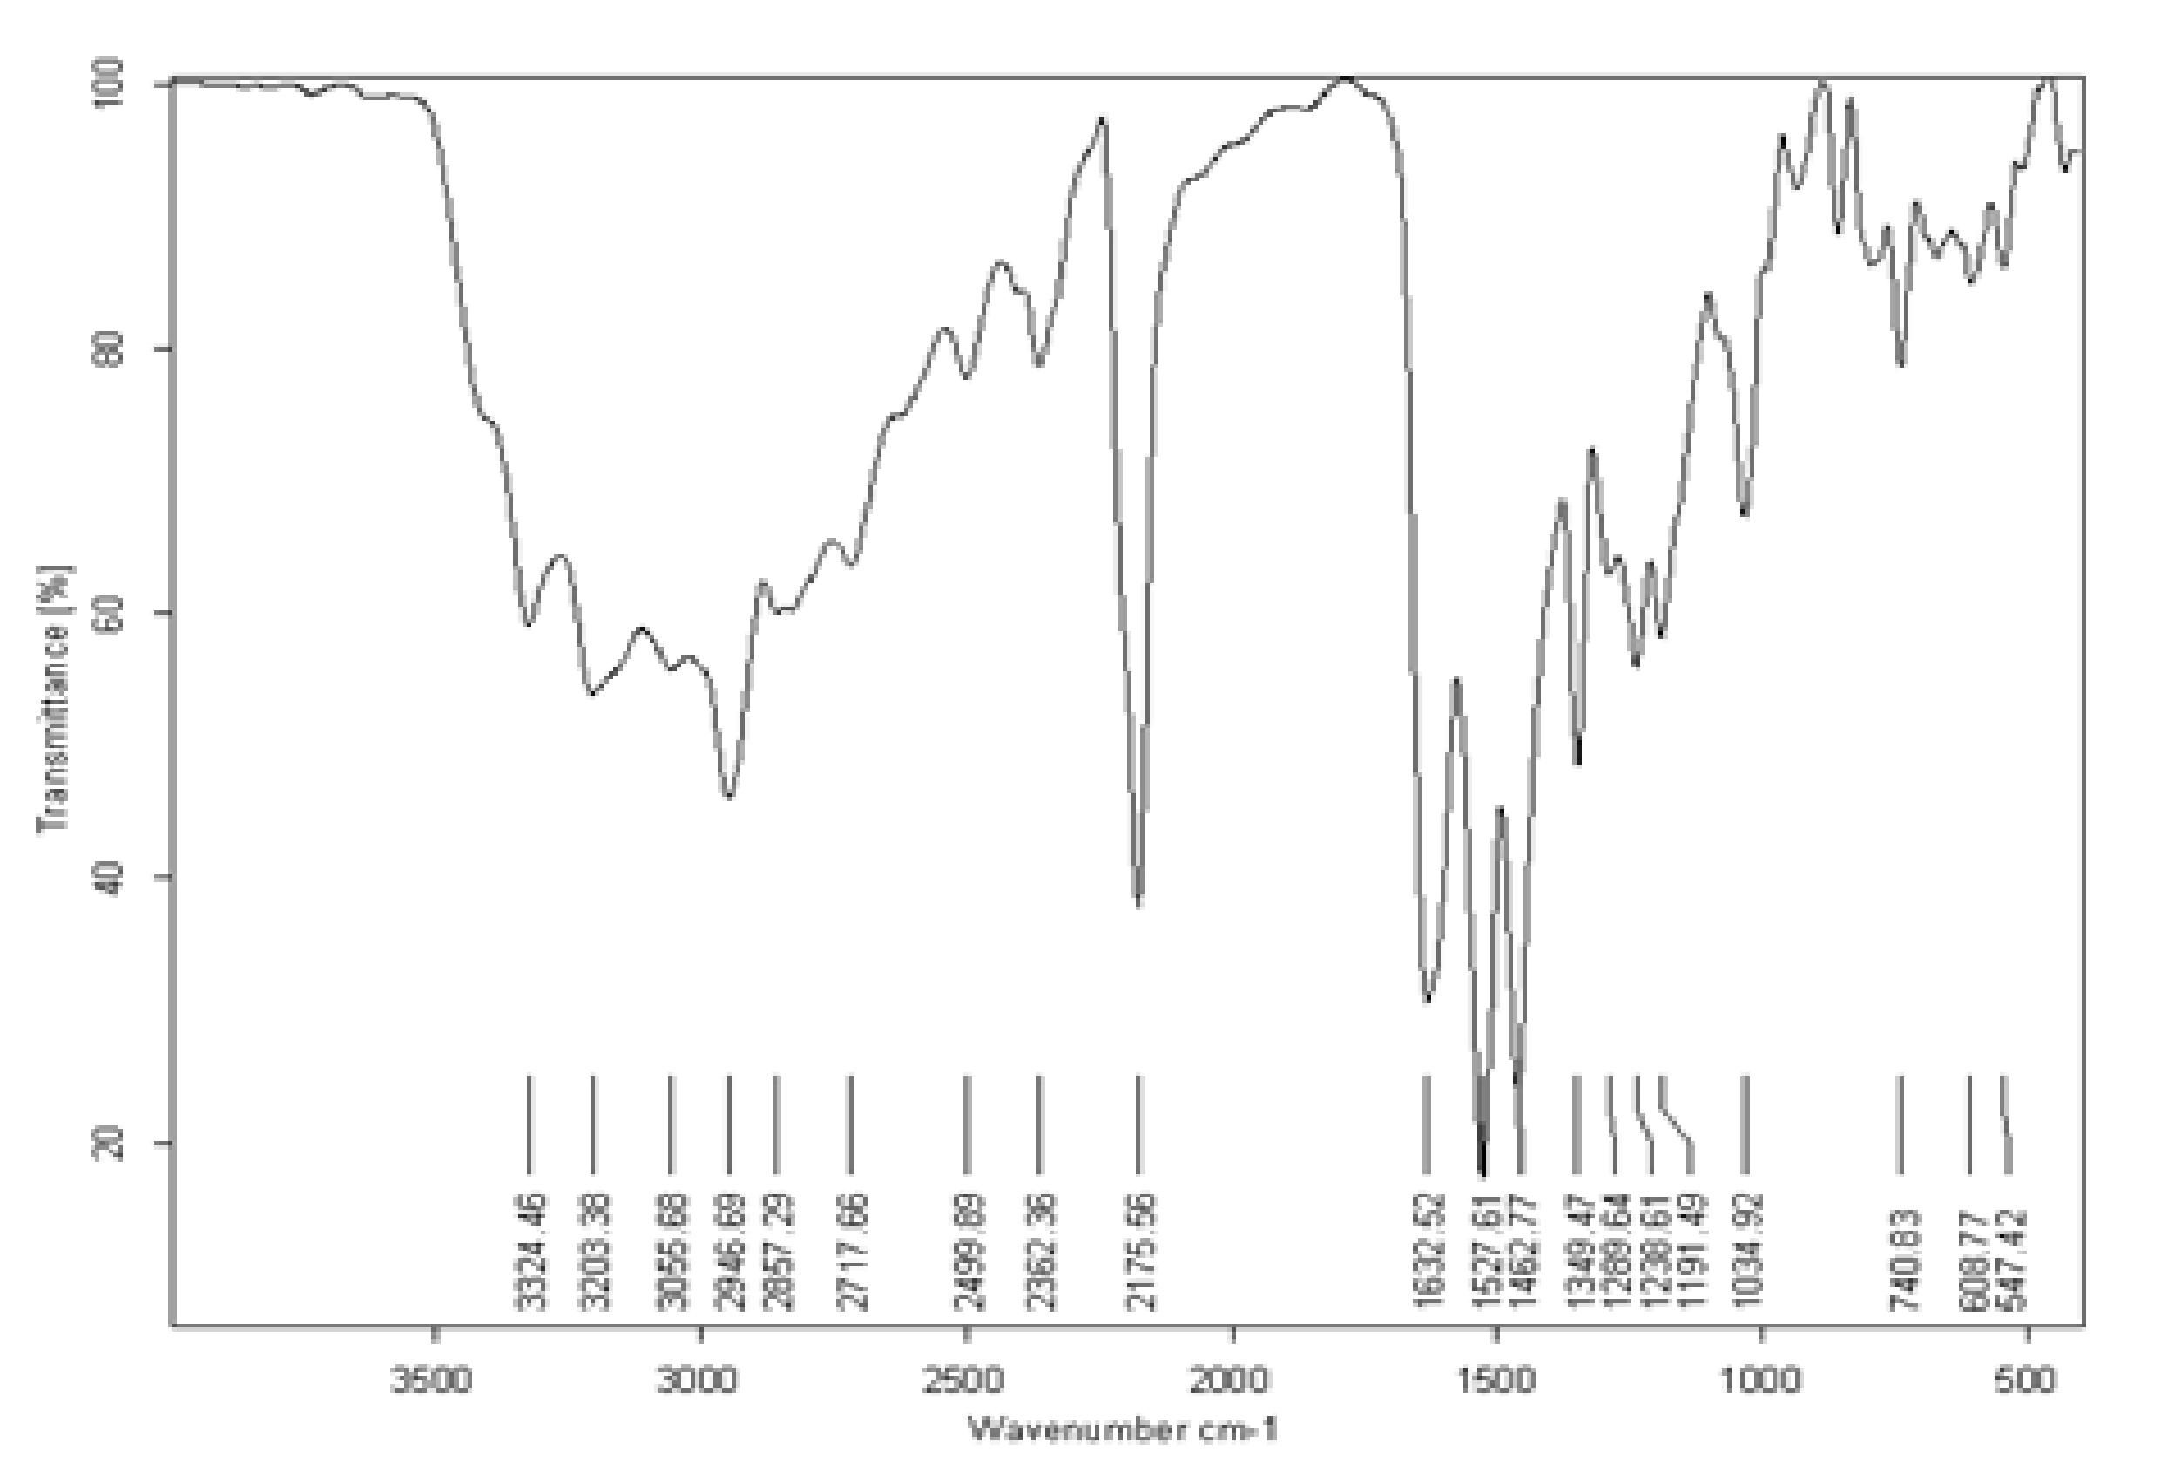

IR of 4i

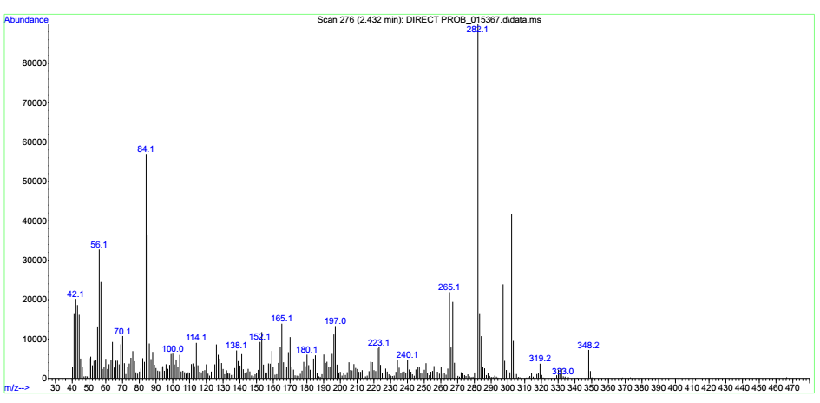

Mass of 4i

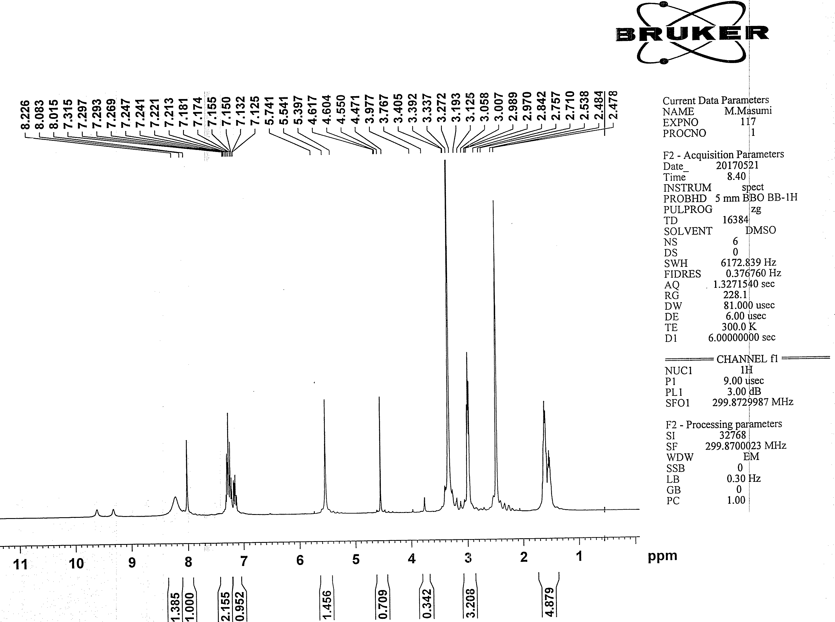

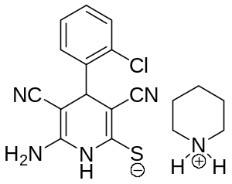
¹H NMR of 4j

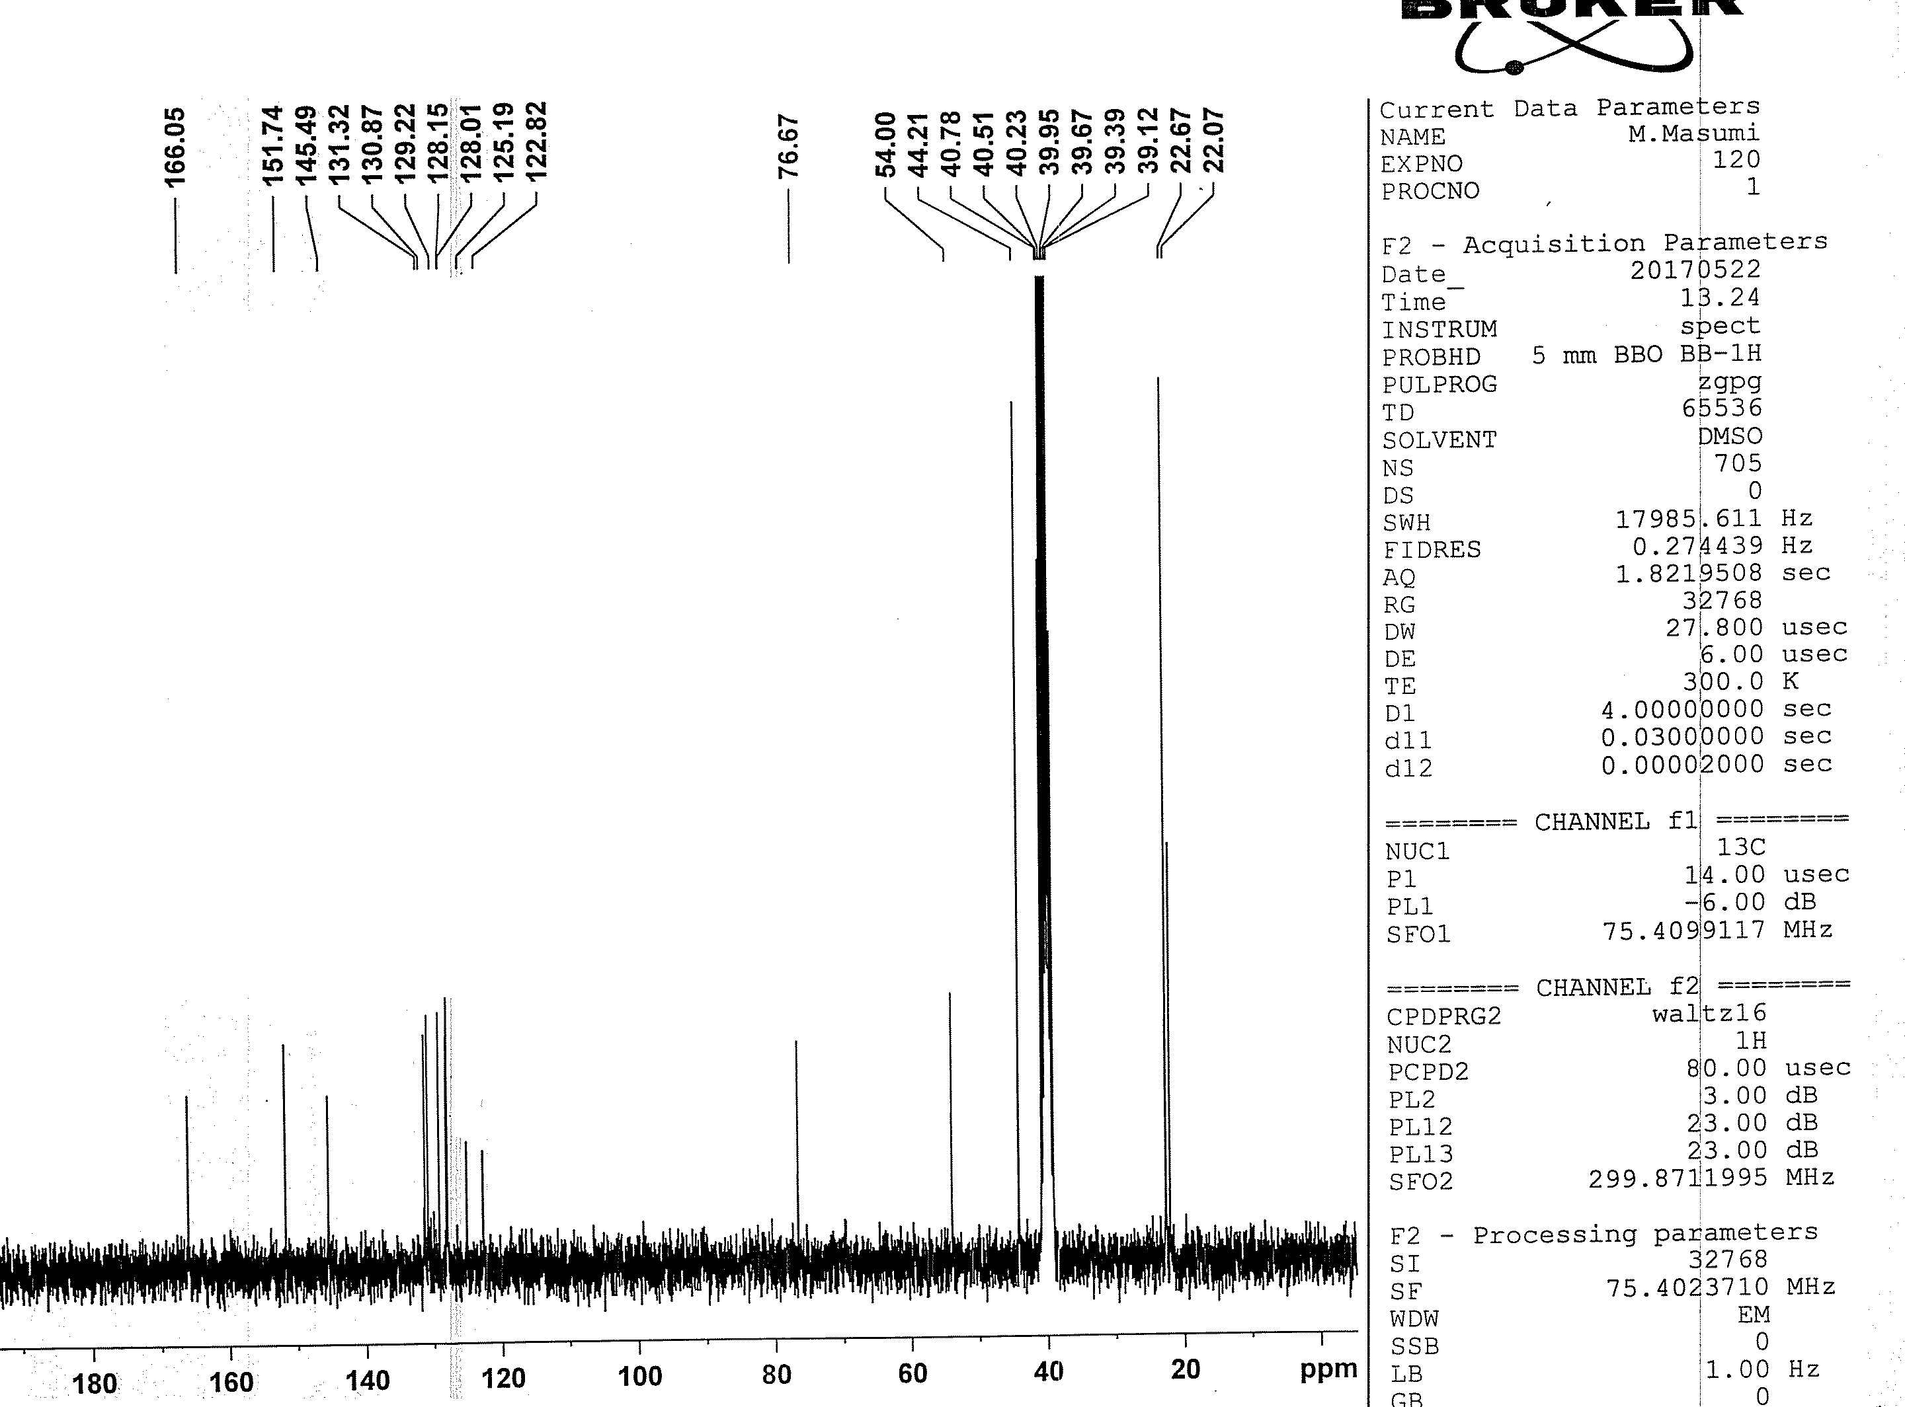

¹³C NMR of 4j

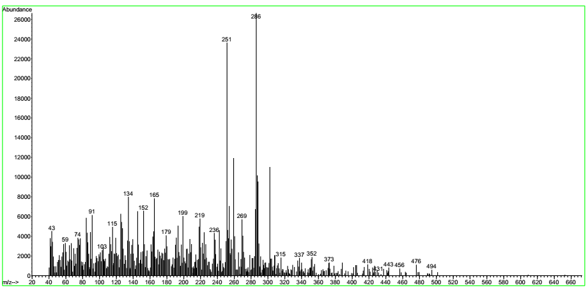

Mass of 4j

