Supplementary Information
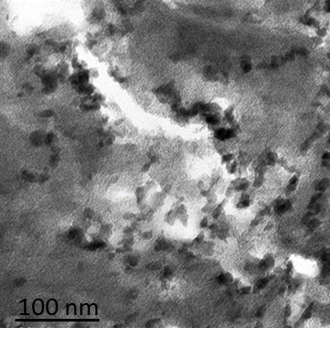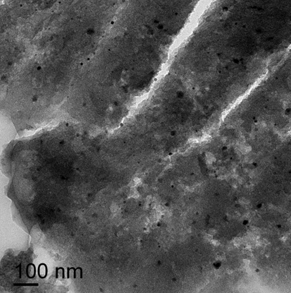
- (b)

Figure S1. TEM micrographs of fresh catalysts (reprinted from [20]): (a) Fe/AC and (b) Cu/AC.

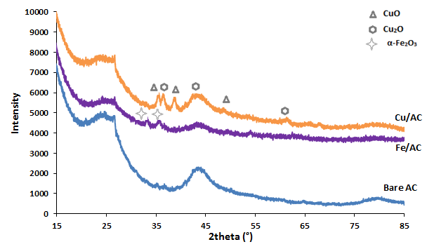

Figure S2. X-ray diffractograms of bare and metal loaded ACs.

Figure S3. Evolution of TOC in solution during first and third peroxide-promoted oxidations on Fe/AC (large symbols) and during third peroxide-promoted oxidation on bare AC (lines with small symbols). See Figure 5 for corresponding operating conditions.

Figure S4. Evolution of TOC in solution during first and third peroxide-promoted oxidations on Cu/AC (large symbols) and during third peroxide-promoted oxidation on bare AC (lines with small symbols). See Figure 6 for corresponding operating conditions.

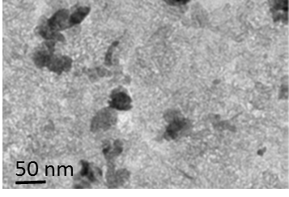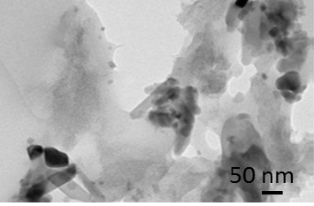
- (b)

Figure S5. TEM micrographs of used catalysts: (a) Fe/AC and (b) Cu/AC.
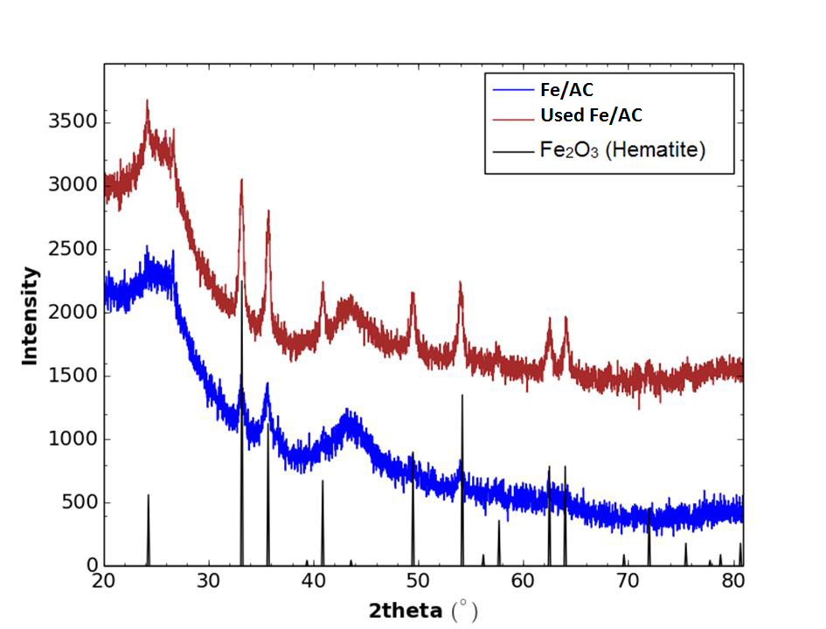

Figure S6. X-ray diffractograms of fresh and used Fe/AC.

Figure S7. Residual COD in solution after 4 h of CWAO in batch autoclave (reprinted from [20]): C₀ = 1 g/L (prior to adsorption step), m_{cat} = 1 g, V_{L} = 200 mL, T = 150°C, P_{O2} = 3.3 bar, Q_{air} = 30 NL/h.

