Supplemental File
Appendix

Appendix A: Correlation Matrix and Cronbach’s α for LC policy
 |  |  |  |  |  |  |  |  | Cronbach’s α
Influence | 1 | 2 | 3 | 4 | 5 | 6 | 7 | Reliability |  | if item deleted
Licensing reg. | 1.00 |  |  |  |  |  |  | 0.888 |  | 0.868
Ownership reg. | .633 | 1.00 |  |  |  |  |  |  |  | 0.871
Firm reg. | .580 | 0.626 | 1.00 |  |  |  |  |  |  | 0.875
Labour Mrkt reg | .612 | 0.692 | 0.666 | 1.00 |  |  |  |  |  | 0.854
Tax incentives | .450 | 0.297 | .335 | 0.484 | 1.00 |  |  |  |  | 0.884
Import Tariff | .474 | 0.384 | 0.347 | 0.507 | 0.658 | 1.00 |  |  |  | 0.879
Monitoring | .550 | 0.526 | 0.514 | 0.705 | 0.512 | 0.589 | 1.00 |  |  | 0.865

Appendix C: Correlation Matrix and Cronbach’s α for LINK
 |  |  |  |  |  | Cronbach’s α
 | 1 | 2 | 3 | 4 | 5
 |  |  |  |  |  | Reliability if item deleted
Inputs developt | 1.00 |  |  |  |  | 0.775 | 0.692
Info exchange | 0.533 | 1.00 |  |  |  |  | 0.746
Tech upgrading | 0.579 | 0.380 | 1.00 |  |  |  | 0.693
Negotiation | 0.368 | 0.441 | 0.342 | 1.00 |  |  | 0.766
Labour training | 0.429 | 0.223 | 0.563 | 0.232 | 1.00 |  | 0.759

Appendix B: Correlation Matrix and Cronbach’s α for IOFP
 |  |  |  |  |  | Cronbach’s α
 | 1 | 2 | 3 | 4 | 5
 |  |  |  |  |  | Reliability if item deleted
Business opport | 1.00 |  |  |  |  | 0.752 | 0.681
Environ condu | 0.486 | 1.00 |  |  |  |  | 0.703
Tech skill | 0.274 | 0.374 | 1.00 |  |  |  | 0.748
Fin accessibility | 0.503 | 0.396 | 0.313 | 1.00 |  |  | 0.679
Non-fin incentive | 0.415 | 0.286 | 0.229 | 0.482 | 1.00 |  | 0.720

Appendix D: Correlation Matrix and Cronbach’s α for JOB
 |  |  |  |  |  | Cronbach’s α
 | 1 | 2 | 3 | 4 | 5
 |  |  |  |  |  | Reliability if item deleted
Availability | 1.00 |  |  |  |  | 0.751 | 0.696
Placement | 0.717 | 1.00 |  |  |  |  | 0.700
Application | 0.339 | 0.319 | 1.00 |  |  |  | 0.713
Requirement | 0.229 | 0.229 | 0.477 | 1.00 |  |  | 0.715
Offer | 0.326 | 0.337 | 0.342 | 0.486 | 1.00 |  | 0.709

Appendix E: Observed indicators with Factor loadings
 |  | Factor Loadings
Local content policy (LC policy) |  |  |  | 0.793
LCP1 | I can say our company has influenced with licensing regulation in the oil sector
LCP2 | Ownership regulation has an important part in influencing our company to actively engage in the service business activities in the sector |  |  | 0.771
LCP3 | I perceive the method of firm registration influenced our company’s to start up the business in the industry |  |  | 0.761
LCP4 | Labour market regulation influenced our company’s performance in the industry |  |  | 0.794
LCP5 | Tax reduction policy favourably influenced the participation of our company in the business activities in the sector |  |  | 0.707
LCP6 | The tariff policy on imported oil influence more contracts to be awarded for our company |  |  | 0.751
LCP7 | Monitoring plays a key role in influencing our company’ participation in the business activities in the industry |  |  | 0.824
Indigenous oil firms’ Participation (IOFP)
IOFP1 | How would you describe the business opportunity in the industry towards your company’s participation |  |  | 0.659
IOFP2 | The social environment where our company located is conducive for the company’s activities |  |  | 0.724
IOFP3 | Our company always meeting technical skill required to carry out its business activities |  |  | 0.668
IOFP4 | The accessibility of financial funds enhances participation of our company in the business activities in the industry |  |  | 0.725
IOFP5 | Non-financial incentives, such as government support training and technology transfer programmes enhances our company’s participation in the industry business activities |  |  | 0.664
Backward Linkages (LINK)
How would you describe your company cooperation in the following forms?
LINK1 | Local inputs development |  |  | 0.815
LINK2 | Information exchange |  |  | 0.712
LINK3 | Labour training |  |  | 0.653
LINK4 | Tech upgrading |  |  | 0.811
LINK5 Negotiation of payment and delivery  Job Creation (JOB) |  |  |  | 0.633
JOB1 | Jobs often available in our company |  |  | 0.827
JOB2 | Our company often places job vacancies in creating awareness for submission of applications for the available positions |  |  | 0.835
JOB3 | Our company frequently receives job applications from the local applicants |  |  | 0.657
JOB4 | Local applicants do meet the job requirements our company often required |  |  | 0.509
JOB5 | We do often offer jobs to local applicants |  |  | 0.549

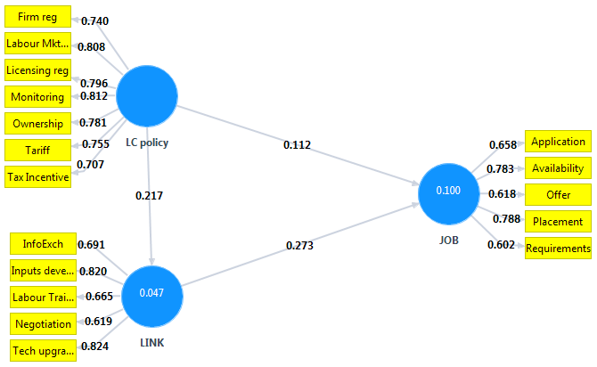
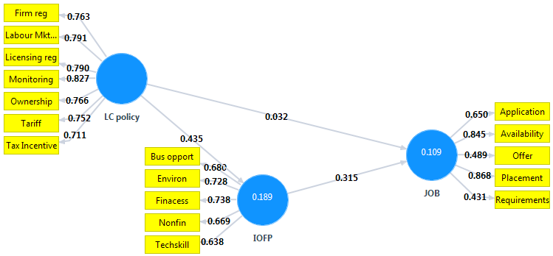
Appendix F: Single Mediator Estimation
