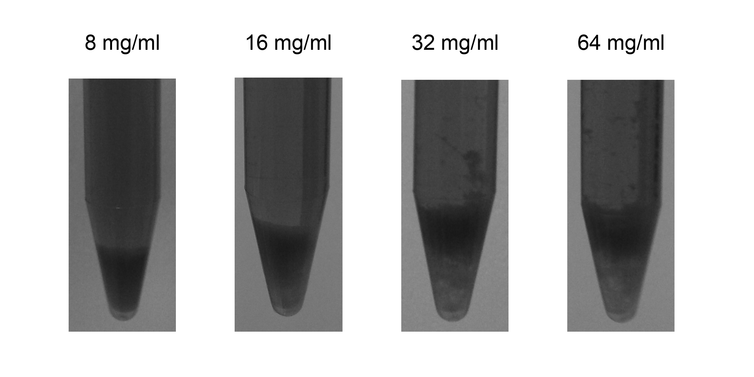
Supplementary Figure 1: Effect of different chitosan concentrations on sediment morphology. Chitosan was added up to different final concentrations to samples from inactivated cultures and left settling overnight at room temperature. Digital images obtained from the bottom portion of representative tubes are displayed on this figure. Flocculant concentration is indicated above each image.

