Supplementary material

Differences in brain regions of three mice strains identified by label-free Micro-Raman. Segura-Uribe et al.

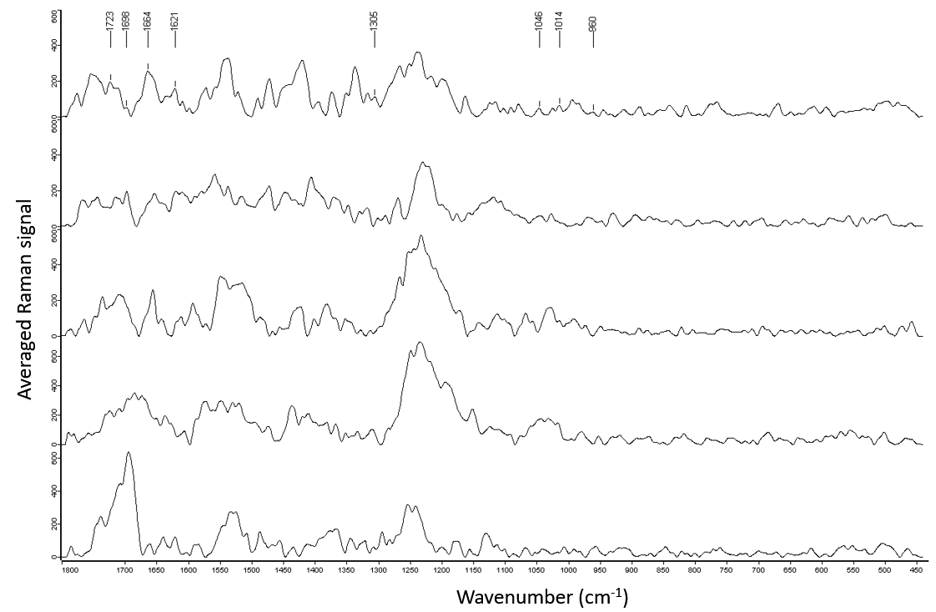
Suppl. Fig. 1. Spectra of brain areas related to memory, learning and spatial navigation (group 1) in C57BL6 mice. Raman average spectra from the hippocampus (A), olfactory bulb (B), prefrontal cortex (C), basal forebrain (D) and temporal cortex (E) in C57BL6 mice. The labeled signals correspond to the lipid components of the brain (Table 1).
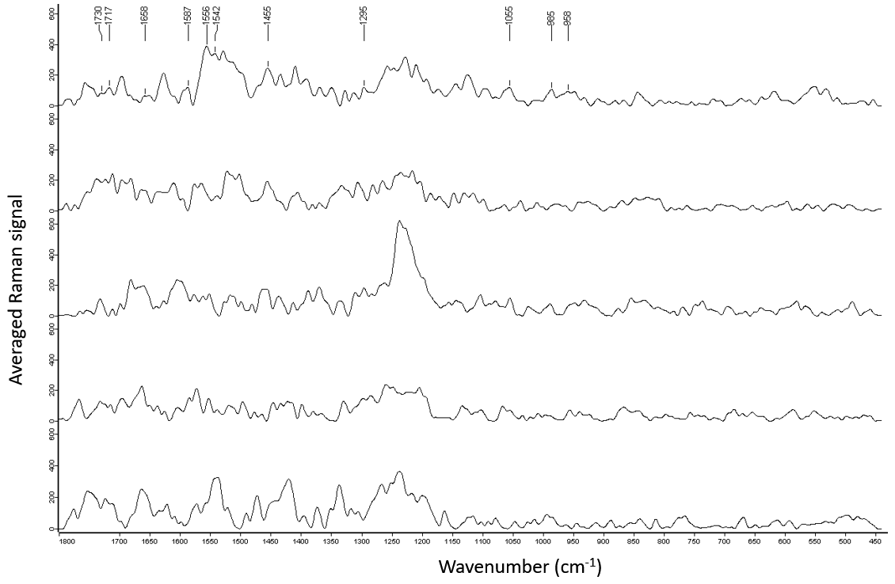
Suppl. Fig. 2. Spectra of brain areas related to motor control (group 2) in C57BL6 mice. Raman average spectra from the substantia nigra (A), striatum (B), cerebellum (C), thalamus (D) and hypothalamus (E) in C57BL6 mice. The labeled signals correspond to the lipid components of the brain (Table 1).
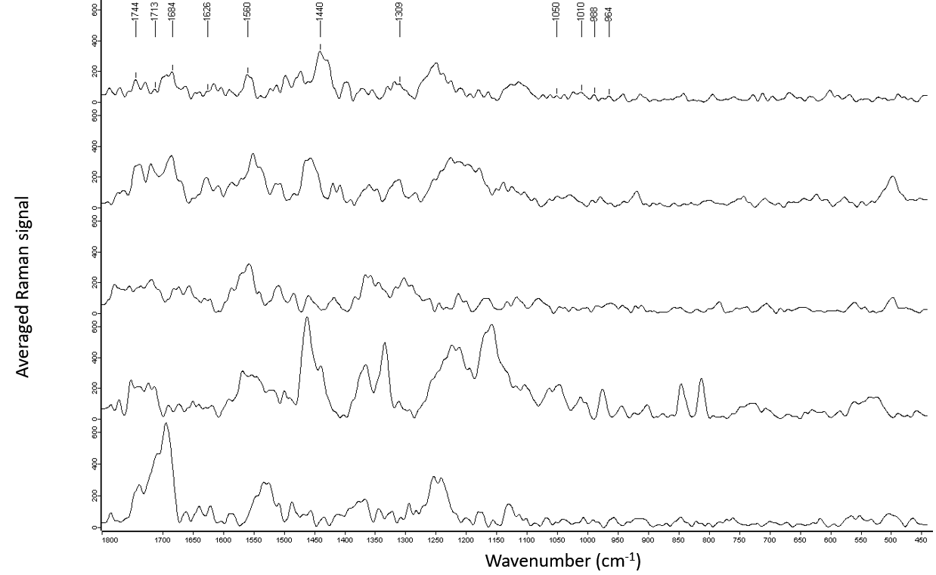
Suppl. Fig. 3. Spectra of brain areas related to memory, learning and spatial navigation (group 1) in CD1 mice. Raman average spectra from the hippocampus (A), olfactory bulb (B), prefrontal cortex (C), basal forebrain (D) and temporal cortex (E) in CD1 mice. The labeled signals correspond to the lipid components of the brain (Table 1).
Suppl. Fig. 4. Spectra of brain areas related to motor control (group 2) in CD1 mice. Raman average spectra from the substantia nigra (A), striatum (B), cerebellum (C), thalamus (D) and hypothalamus (E) in CD1 mice. The labeled signals correspond to the lipid components of the brain (Table 1).

