Supplementary Figures

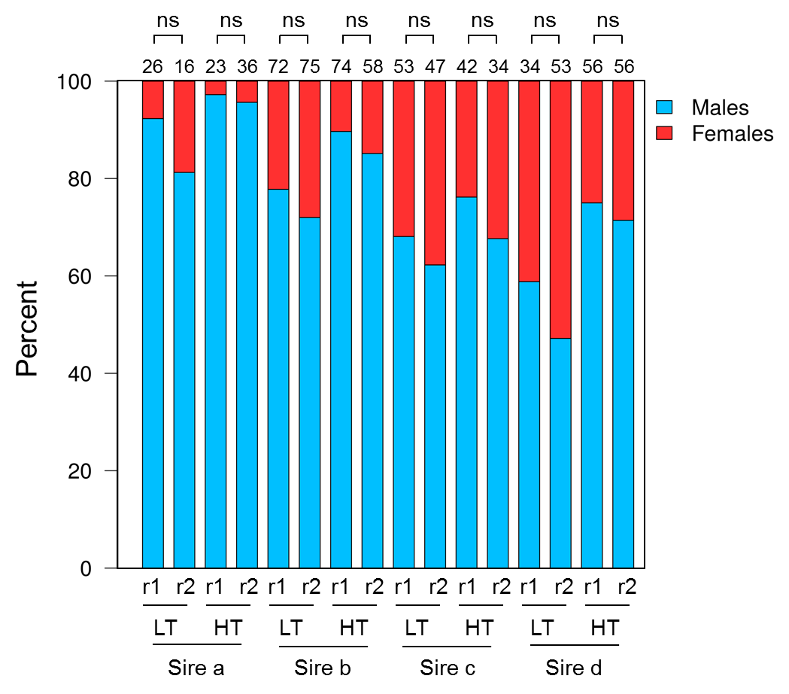

Fig S1. Percent of males and females per experimental tank and group. Two replicate tanks (r1 and r2) were used for low (LT) and high (HT) temperature per each sire. The total number of fish sampled per group is indicated above the bars. Statistical differences between tanks as assessed by Fisher’s exact test for count data are indicated with the following equivalence: ns=not significant.
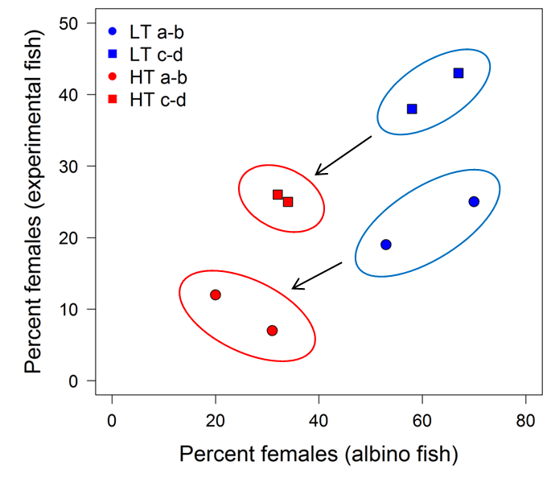

Fig S2. Sex ratio of experimental and albino fish. Datapoint symbols indicate the percent of females of experimental and albino fish in the same tank and circles surround the two replicate tanks for each experimental group: offspring of sires a and b (circles) at low (LT; blue) and high (HT; red) temperature and offspring of sires c and d (squares) at low (blue) and high (red) temperature. The average female percent in the albino fish reared at both low and high temperature was 45.63% and their sex ratio not different from 1:1.
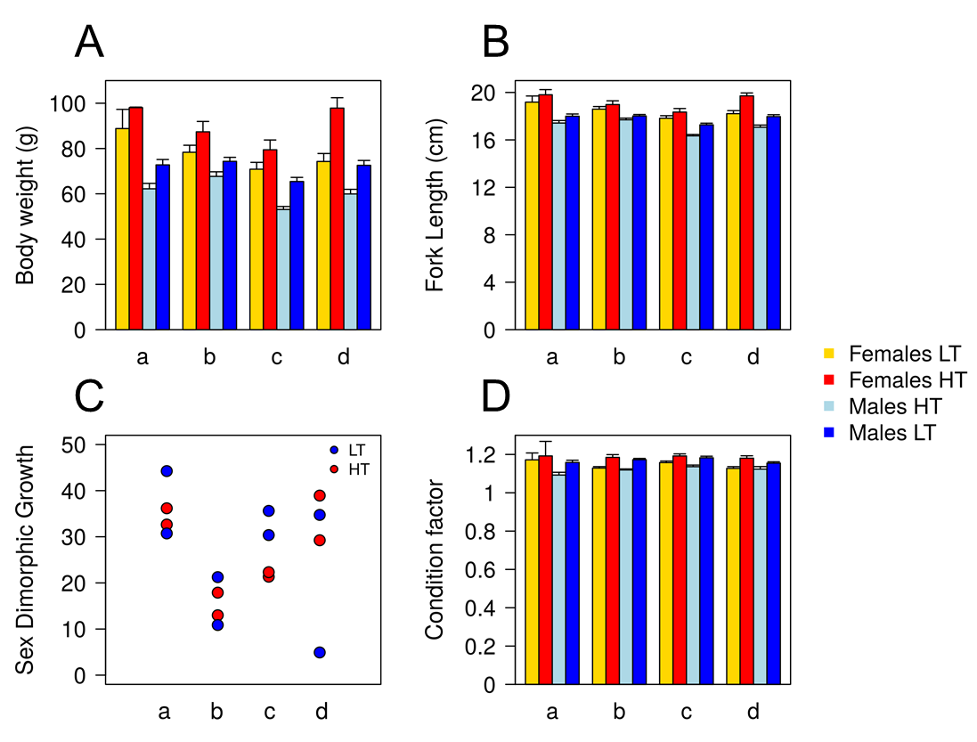

Fig S3. European sea bass growth as a function of genetic and environmental factors. A) Body weight, B) fork length, C) sex dimorphic growth and D) condition factor, according to sire (a, b, c and d), sex and temperature (LT, low; HT, high). In A, B and D data is shown as mean ± S.E.M. In C the double datapoints per sire and temperature refer to the replicate tanks. Refer to S2 Table for details on statistical significance as assessed by a multifactorial ANOVA.
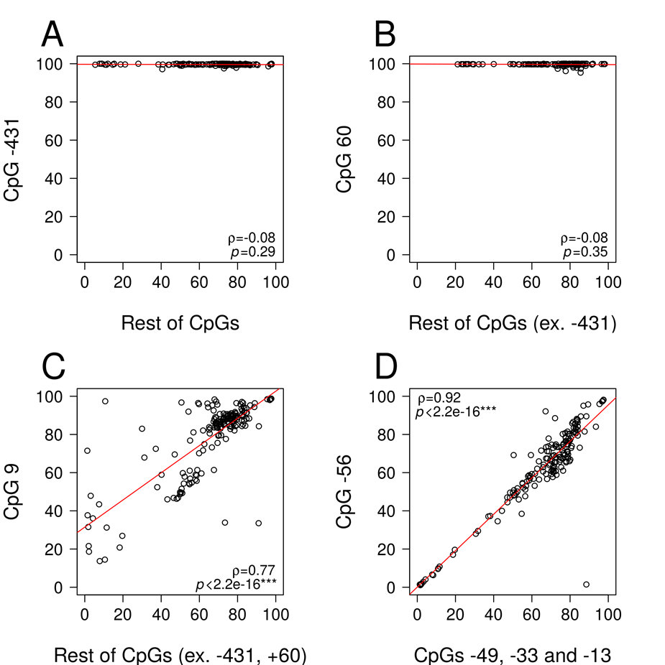

Fig S4. Correlations of DNA methylation among the different CpGs of the cyp19a1a promoter. Correlations of DNA methylation are shown for the CpG at position -431 vs. the rest CpGs (A), the CpG at position 60 vs. the rest CpGs excluding the position -431 (B), the CpG at position 9 vs. the rest CpGs excluding positions -431 and 60, and the CpG at position -56 vs the CpGs at positions -49, -33 and -13. Pearson’s product-moment correlation coefficients (ρ) and p-values of correlation significance are shown.

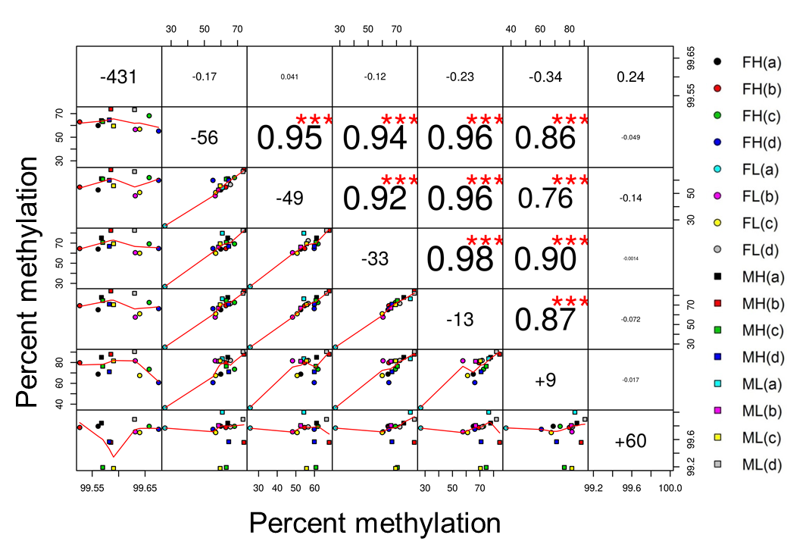

Fig S5. Pairwise correlations of methylation levels of the 7 CpGs of the cyp19a1a promoter and first exon. In the diagonal cells, the positions of the CpG relative to the transcription start site (TSS) is shown, from -431 to +60. The cells below the diagonal display scatterplots of the mean methylation of the vertical CpG (x-axis) and the horizontal CpG (y-axis) per temperature (L, low and H, high temperature), sire (a, b, c, d) and sex (F, females indicated by circles and M, males by squares). Loess smoothers are shown in red in each scatterplot. Pearson’s correlation coefficients are displayed in the cells above the diagonal with the significance level of the correlation denoted (*** =p<0.001).

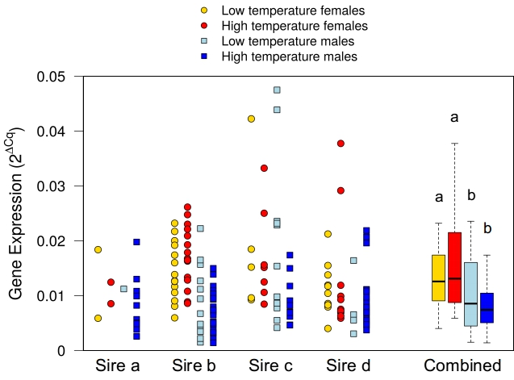

Fig S6. Expression of cyp19a1a in European sea bass gonads. Four groups of dotplots are shown for each sire (a, b, c and d) indicating females (circles) and males (squares) reared at low or high temperature. Expression is shown as 2^{ΔCq} values. In the right part, the offspring of the four sires is combined per group and expression is displayed as 2^{ΔCq} values by boxplots where the boxes include the values distributed between the lower and upper quartiles, the upper whisker = min(max(x), Q3 + 1.5 * IQR), the lower whisker = max(min(x), Q1 – 1.5 * IQR), where IQR= third quartile (Q3) – first quartile (Q1) and the black horizontal line in the box indicates the median. . The effects of sex and temperature on gene expression independently of the sire are shown using letters for the combined values (p < 0.001).

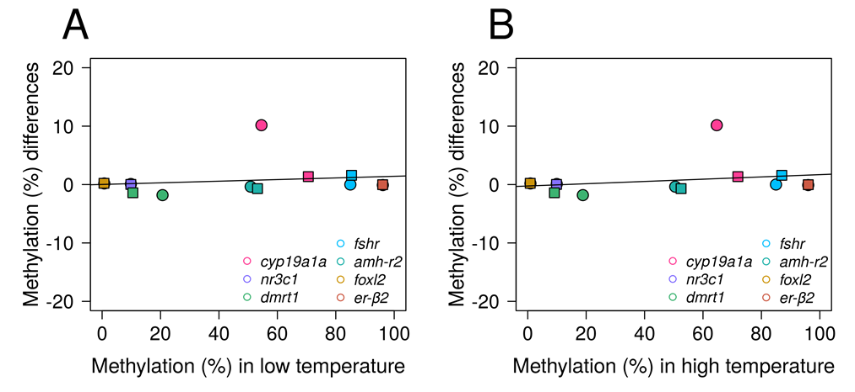

Fig S7. Methylation differences between fish reared at low and high temperature. Scatterplot of the mean methylation differences per gene calculated as levels in offspring reared at high temperature minus levels in offspring reared at low temperature offspring reared at low temperature. The value mean of these differences is plotted against the corresponding mean methylation of female (circles) and male (squares) fish reared at low temperature (A) and high temperature (B).

Supplementary Tables

Table S1. Fisher’s exact test for count data for sex ratios

 | Sire | Odds Ratio | p-value
Departure from Fisherian sex ratio | a | 7.214 | 0.001
 | b | 2.962 | 1.359^{e-05}
 | c | 1.851 | 0.045
 | d | 1.071 | 0.880
Effect of temperature | a | 0.263 | 0.124
 | b | 0.441 | 0.010
 | c | 0.710 | 0.330
 | d | 0.394 | 0.003

Table S2. ANOVAs for body weight, length and condition factor

Variable | Factor | Sums of Squares | d.f | F-value | P-value | Significance level
Body weight | Sex | 6.741 | 1 | 115.51 | <2^{e-16} | ***
 | Sire | 2.557 | 3 | 14.603 | 2.98^{e-09} | ***
 | Temperature | 5.025 | 1 | 86.102 | <2^{e-16} | ***
 | Residuals | 44.005 | 754
Fork length | Sex | 0.6284 | 1 | 112.753 | <2^{e-16} | ***
 | Sire | 0.3592 | 3 | 21.484 | 2.31^{e-13} | ***
 | Temperature | 0.2715 | 1 | 48.711 | 6.49^{e-12} | ***
 | Residuals | 4.2186 | 757
Condition factor
 | Sex | 0.00718 | 1 | 12.457 | 0.0004418 | ***
 | Sire | 0.0201 | 3 | 11.626 | 1.87^{e-07} | ***
 | Temperature | 0.07652 | 1 | 132.743 | <2^{e-16} | ***
 | Residuals | 0.43404 | 753

Table S3. Primers used in MBS library preparation

Gene symbol | Forward (5' to 3') | Reverse (5' to 3') | Annealing Temperature
amhr-2 | GTGGGAAATTTTTTTTATATTTTTAGGA | ACAACGACCTAAACCCTTTACTACA | 55
cyp19a1a | TTAGTTTTTCGTTGTTTGTTTTT | ACCTACAAAAATCATTACCCGTTCA | 55
dmrt1 | TGAGAGTGGGTGTATGTTATTGTTT | ACTAACAATCCCTCCAATTACAAAA | 55
er-b2 | ATTATATTTTTATTTTGGTATTTTTTAGTT | ACCGACATTAAAAATTCCAACTTCCT | 58
fshr | AATATAGAGGGAAATAATAGTGAGAGAGTG | AACAAAAACTCAAAATTCGTTTAACCAAAC | 60
foxl2 | TAGTTTGTGAGGATATGTTTGAGAAG | TTCCCAATAAAAACAATACATCATC | 55
nr3c1 | TTATTGTAGGGATTGGAGGATTAAA | ACCGCTAACTATCGATCCAATAACA | 55
Adapters | TCGTCGGCAGCGTCAGATGTGTATAAGAGACAG | GTCTCGTGGGCTCGGAGATGTGTATAAGAGACAG

