Supporting Information

Contents
Scheme S1. The sixteen possible stereoisomers……………..……………………………………2
Figure S1. Optimized structures and relative energy of TCPs-ions complexes calculated at the M06-2X level of theory in gas phase …………………………………..…………………………3
Figure S2. Relative energy of TCPs-ions complexes calculated at the M06-2X level of theory in gas and aqueous phases……………………………………………………………………………4
Figure S3. Optimized structures and relative energy of TCPs-ions complexes calculated at the M06-2X level of theory in aqueous phase ……………………………………………….………5
Scheme S2. Intramolecular interaction in TCP-ions in the gas phase…………………………….6
Table S1. Calculated NBO partial charges of the selected atoms of TCP3-ion complexes at M06-2X level of theory in the gas phase..………………………………………………………..….…7
Table S2. The bond length, R_{HB}, and bond angle of hydrogen bonds in TCP-anion complexes at the level of MP2/6-311++G(d,p) in the gas phase...………………………………………………8

Scheme S1: The sixteen possible stereoisomers, the structures with the same color are enantiomer and those in a framework are equivalent.
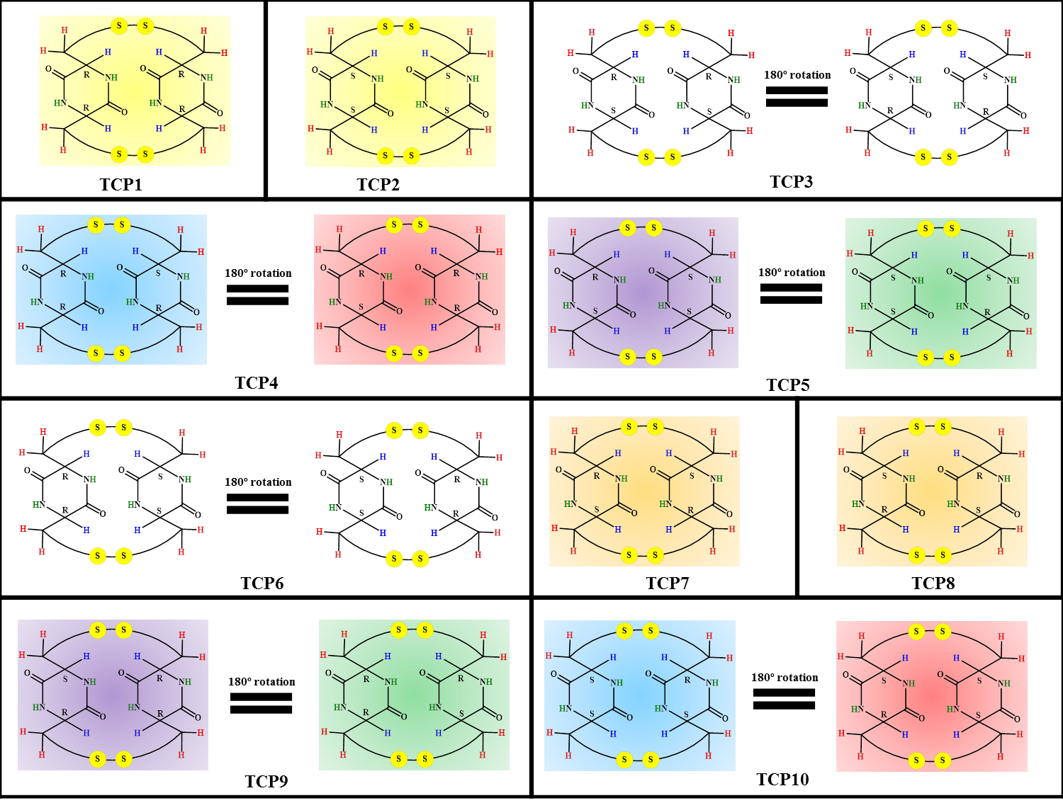

- Optimized structures and relative energy of TCPs-F⁻ | - Optimized structures and relative energy of TCPs-Cl⁻
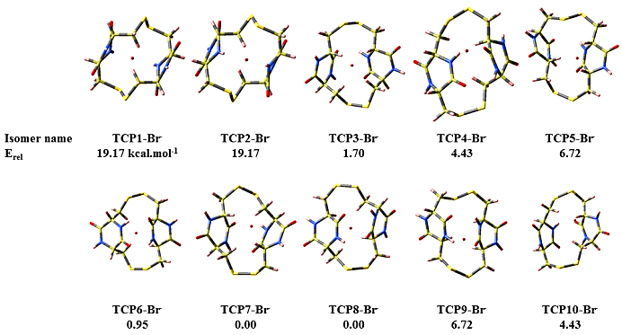
- Optimized structures and relative energy of TCPs-Br⁻ | - Optimized structures and relative energy of TCPs-Li⁺
 | 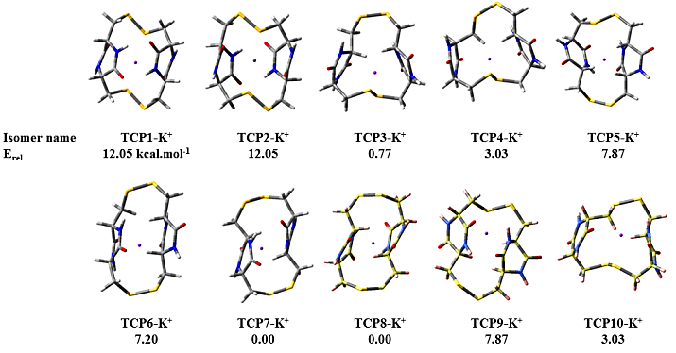
- Optimized structures and relative energy of TCPs-Na⁺ | - Optimized structures and relative energy of TCPs-K⁺
Figure S1: Optimized structures and relative energy of TCPs-ions complexes calculated at the M06-2X level of theory in the gas phase.

- Optimized structures and relative energy of TCPs-F⁻ | - Optimized structures and relative energy of TCPs-Cl⁻
- Optimized structures and relative energy of TCPs-Br⁻ | - Optimized structures and relative energy of TCPs-Li⁺
- Optimized structures and relative energy of TCPs-Na⁺ | - Optimized structures and relative energy of TCPs-K⁺
Figure S2: Optimized structures and relative energy of TCPs-ions complexes calculated at the M06-2X level of theory in aqueous phase.

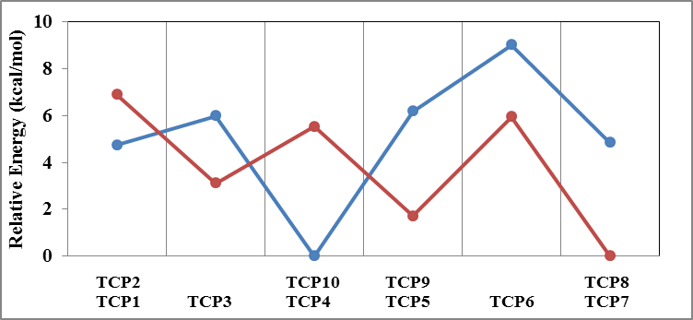  TCP-F⁻ | 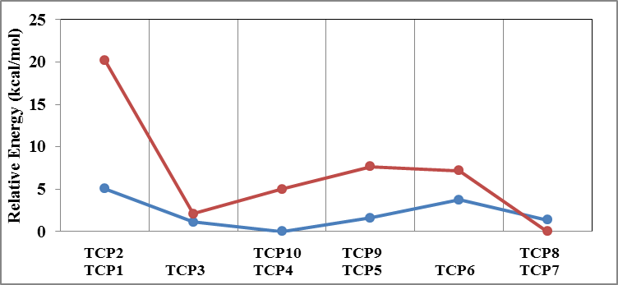  TCP-Cl⁻
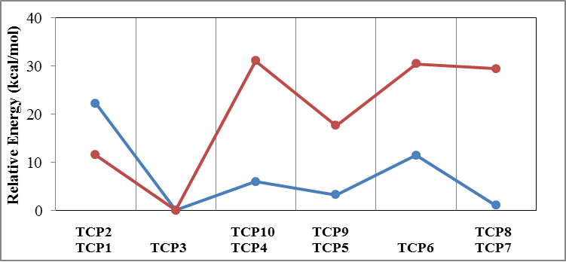  TCP-Li⁺ | 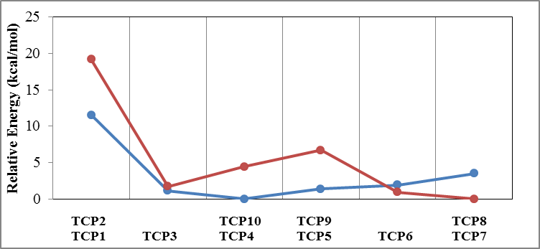  TCP-Br⁻
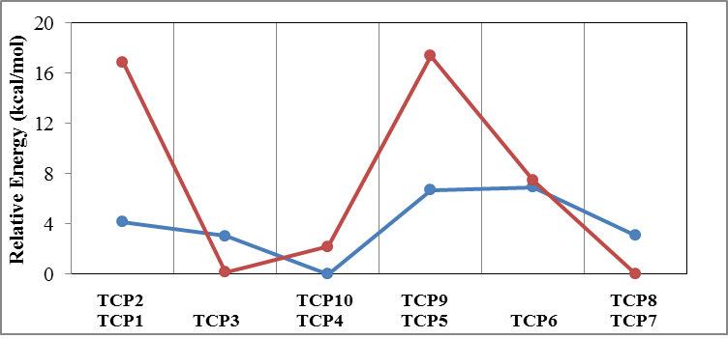  TCP-Na⁺ | 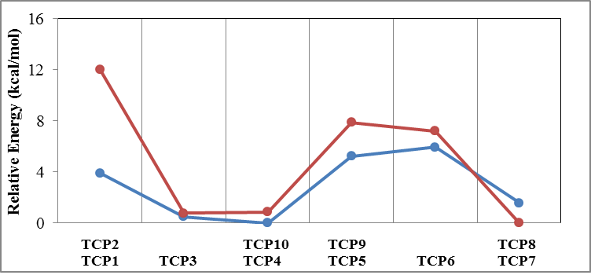  TCP-K⁺
Figure S3. Relative energy of TCPs-ions complexes calculated at the M06-2X level of theory in gas-phase (red line) and aqueous-phase (blue line).

 | F⁻ | Cl⁻ | Br⁻ | Li⁺ | Na⁺ | K⁺
TCP1 |  |  | 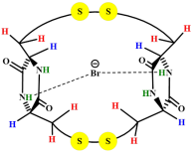
TCP2 |  |  | 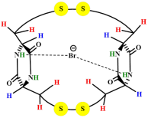
TCP3
TCP4
TCP5
TCP6
TCP7
TCP8 | 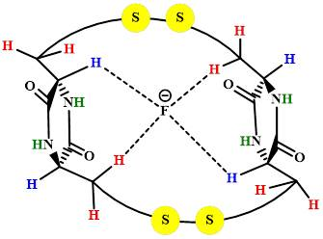 | 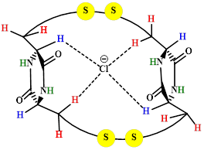 | 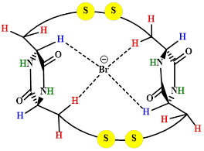 | 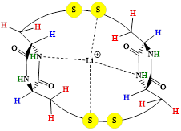 | 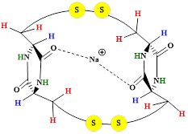 | 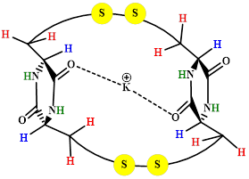
TCP9 | 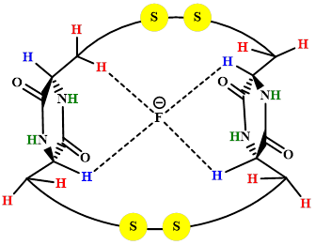 | 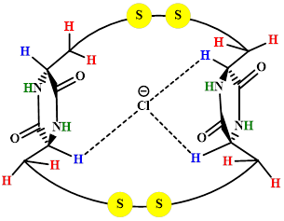 | 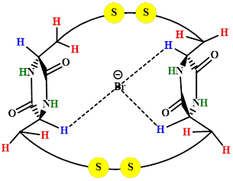 | 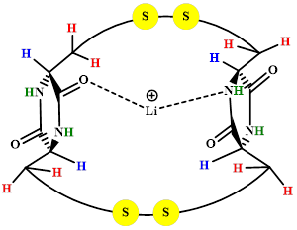 | 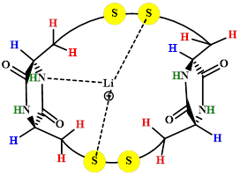 | 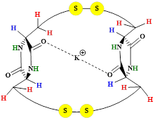
TCP10 | 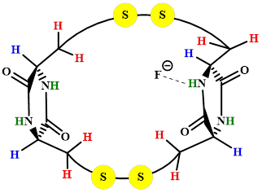 | 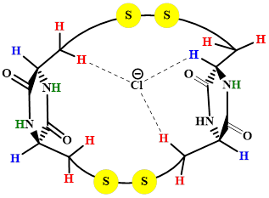 | 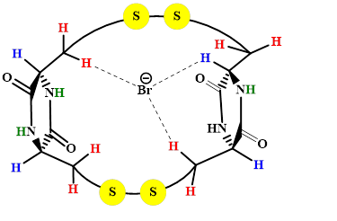 |  | 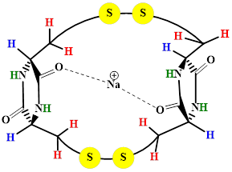 | 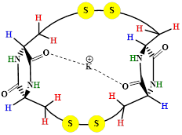
Scheme S2: Intramolecular interaction in TCP-ions in the gas phase.

Table S1: Calculated NBO partial charges of the selected atoms of TCP-ion complexes at M06-2X level of theory in the gas phase.
TCP1,2 | before | Li⁺ | Na⁺ | K⁺ | TCP1,2 | before | F⁻ | Cl⁻ | Br⁻
S5 | 0.087 | 0.153 | 0.043 | 0.003 | H10 | 0.244 | 0.210 | 0.244 | 0.279
S24 | 0.087 | 0.153 | 0.043 | 0.003 | H11 | 0.234 | 0.324 | 0.215 | 0.256
N14 | -0.661 | -0.731 | -0.667 | -0.667 | H13 | 0.248 | 0.311 | 0.241 | 0.252
O8 | -0.623 | -0.567 | -0.542 | -0.654 | H16 | 0.406 | 0.409 | 0.469 | 0.409
O27 | -0.623 | -0.567 | -0.542 | -0.654 | H29 | 0.244 | 0.210 | 0.244 | 0.280
N33 | -0.661 | -0.731 | -0.667 | -0.667 | H30 | 0.234 | 0.324 | 0.215 | 0.255
ion | 1.000 | 0.256 | 0.658 | 0.850 | H32 | 0.248 | 0.311 | 0.241 | 0.252
 |  |  |  |  | H35 | 0.406 | 0.409 | 0.469 | 0.409
 |  |  |  |  | ion | -1.000 | -0.887 | -0.85 | -0.943
TCP4,10 |  |  |  |  | TCP4,10
S5 | 0.097 | 0.154 | 0.142 | 0.121 | H10 | 0.244 | 0.26762 | 0.308 | 0.299
S23 | 0.128 | 0.196 | 0.182 | 0.036 | H16 | 0.410 | 0.55568 | 0.412 | 0.417
S24 | 0.074 | 0.128 | 0.026 | 0.115 | H17 | 0.259 | 0.19445 | 0.297 | 0.288
O8 | -0.612 | -0.508 | -0.783 | -0.741 | H29 | 0.228 | 0.20748 | 0.264 | 0.255
O27 | -0.615 | -0.567 | -0.772 | -0.734 | ion | -1.000 | -0.65936 | -0.91 | -0.911
N14 | -0.674 | -0.738 | -0.630 | -0.661
N34 | -0.669 | -0.745 | -0.664 | -0.628
ion | 1.000 | 0.332 | 0.943 | 0.927
TCP5,9 |  |  |  |  | TCP5,9
S5 | 0.098 | 0.118 | 0.084 | 0.111 | H10 | 0.261 | 0.316 | 0.252 | 0.252
O8 | -0.633 | -0.751 | -0.747 | -0.761 | H17 | 0.229 | 0.321 | 0.305 | 0.295
O27 | -0.633 | -0.522 | -0.543 | -0.752 | H28 | 0.214 | 0.308 | 0.300 | 0.293
N15 | -0.678 | -0.782 | -0.759 | -0.649 | H36 | 0.212 | 0.331 | 0.298 | 0.285
ion | 1.000 | 0.733 | 0.859 | 0.966 | ion | -1.000 | -0.892 | -0.900 | -0.905
TCP6 |  |  |  |  | TCP6
S24 | 0.098 | 0.103 | 0.098 | 0.099 | H10 | 0.267 | 0.258 | 0.226 | 0.268
O8 | -0.621 | -0.533 | -0.756 | -0.743 | H17 | 0.223 | 0.335 | 0.293 | 0.291
O27 | -0.629 | -0.535 | -0.763 | -0.748 | H28 | 0.235 | 0.306 | 0.310 | 0.286
N34 | -0.685 | -0.772 | -0.630 | -0.636 | H32 | 0.267 | 0.313 | 0.252 | 0.252
ion | 1.000 | 0.582 | 0.944 | 0.965 | ion | -1.000 | -0.886 | -0.910 | -0.910
TCP7,8 |  |  |  |  | TCP7,8
S5 | 0.058 | 0.151 | 0.087 | 0.083 | H9 | 0.245 | 0.289 | 0.290 | 0.288
S24 | 0.058 | 0.151 | 0.087 | 0.084 | H13 | 0.250 | 0.315 | 0.299 | 0.258
O8 | -0.614 | -0.566 | -0.767 | -0.750 | H28 | 0.245 | 0.289 | 0.294 | 0.281
O27 | -0.614 | -0.566 | -0.767 | -0.750 | H32 | 0.250 | 0.315 | 0.271 | 0.294
N14 | -0.673 | -0.739 | -0.685 | -0.685 | ion | -1.000 | -0.900 | -0.890 | -0.895
N33 | -0.673 | -0.739 | -0.685 | -0.685
ion | 1.000 | 0.250 | 0.934 | 0.958

Table S2: The bond length, R_{HB}, and bond angle of hydrogen bonds in TCP-anion complexes at the level of M06-2X in the gas phase.
 |  | Geometry parameters |  |  | Geometry parameters |  |  | Geometry parameters
Complex | H-bond | R_{HB}/A˚ | θ (˚) | H-bond | R_{HB}/A˚ | θ (˚) | H-bond | R_{HB}/A˚ | θ (˚)
TCP1, 2 | C3-H11…F⁻ | 1.8 | 166.4 | N15-H16…Cl⁻ | 2.2 | 152.4 | N15-H16…Br⁻ | 2.5 | 151.3
 | C6-H13…F⁻ | 1.8 | 166.8
 | C22-H30…F⁻ | 1.8 | 166.4 | N34-H35…Cl⁻ | 2.2 | 152.4 | N34-H35…Br⁻ | 2.5 | 151.0
 | C25-H32…F⁻ | 1.8 | 166.8
TCP3 | C1- H9…F⁻ | 1.7 | 158.5 | C1-H9…Cl⁻ | 2.3 | 147.3 | C1-H9…Br⁻ | 2.5 | 145.2
 | C7- H17…F⁻ | 1.9 | 150.6 | C7-H17…Cl⁻ | 2.5 | 161.2 | C7-H17…Br⁻ | 2.7 | 163.9
 | C22- H30…F⁻ | 1.8 | 171.0 | C22-H30…Cl⁻ | 2.5 | 167.7 | C22-H30…Br⁻ | 2.7 | 161.5
 | C25- H32…F⁻ | 1.9 | 164.4 | C25-H32…Cl⁻ | 2.5 | 161.9 | C25-H32…Br⁻ | 2.7 | 160.5
TCP4, 10 | F⁻-H16…N15⁻ | 1.6 | 175.6 | C3-H10…Cl⁻ | 2.4 | 160.7 | C3-H10…Br⁻ | 2.6 | 168.9
 |  |  |  | C7-H17…Cl⁻ | 2.4 | 136.4 | C7-H17…Br⁻ | 2.6 | 134.1
 |  |  |  | C22-H29…Cl⁻ | 2.7 | 114.6 | C22-H29…Br⁻ | 2.9 | 111.8
TCP5, 9 | C3-H10…F⁻ | 1.9 | 156.5 | C7-H17…Cl⁻ | 2.5 | 145.8 | C7-H17…Br⁻ | 2.7 | 144.8
 | C7-H17…F⁻ | 1.9 | 152.2 | C20-H28…Cl⁻ | 2.4 | 151.1 | C20-H28…Br⁻ | 2.5 | 149.3
 | C20-H28…F⁻ | 1.9 | 145.3 | C26-H36…Cl⁻ | 2.4 | 156.9 | C26-H36…Br⁻⁻ | 2.6 | 149.8
 | C26-H36…F⁻ | 1.8 | 153.0
TCP6 | C3- H10…F⁻ | 1.9 | 123.9 | C3- H10…Cl⁻ | 2.8 | 109.1 | C3-H10…Br⁻ | 2.8 | 152.3
 | C7- H17…F⁻ | 1.8 | 156.4 | C7- H17…Cl⁻ | 2.5 | 152.5 | C7-H17…Br⁻ | 2.6 | 160.7
 | C20- H28…F⁻ | 1.9 | 146.9 | C20- H28…Cl⁻ | 2.3 | 162.2 | C20-H28…Br⁻ | 2.7 | 154.3
 | C3-25H32…F⁻ | 1.8 | 133.0 | C25- H32…Cl⁻ | 2.6 | 133.5 | C25-H31…Br⁻ | 2.8 | 127.7
TCP7, 8 | C1- H9…F⁻ | 1.8 | 131.8 | C1- H10…Cl⁻ | 2.5 | 141.4 | C1-H9…Br⁻ | 2.6 | 155.9
 | C6- H13…F⁻ | 1.8 | 142.6 | C6- H13…Cl⁻ | 2.4 | 161.0 | C6-H13…Br⁻ | 2.7 | 138.0
 | C20- H28…F⁻ | 1.8 | 131.8 | C20- H28…Cl⁻ | 2.4 | 153.2 | C20-H28…Br⁻ | 2.7 | 138.9
 | C25- H32…F⁻ | 1.8 | 142.6 | C25- H32…Cl⁻ | 2.5 | 146.7 | C25-H32…Br⁻ | 2.5 | 164.2

