Supplementary File

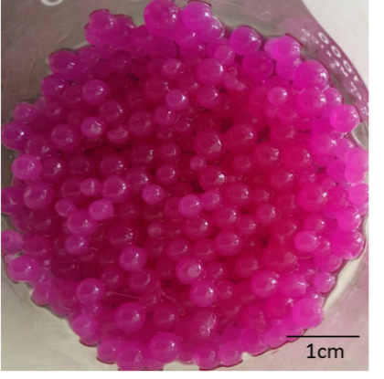

Figure S.1. Calcium alginate beads containing ethanolic extract of bougainvillea bracts.

2 min
4min
6 min
8 min
10 min
12 min
14 min
16 min
18 min
20 min

Figure S.2. Changes in the color of the ethanolic release medium for different times.

Table S.1. Chemical characterization and color parameters of Bougainvillea spectabilis extracts obtained by two extraction methods.
Extraction  Solvent | Total Polyphenols  (mgEAG/g) |  | Betalains  (mg/g_{dry basis}) |  | Antioxidant Activity  (I%) |  |  | Color Parameters
 |  | BC |  | BX | DPPH | ABTS | L* | a* | b*
Aqueous | 5.79±0.33^{b} | 3.93±0.12^{b} |  | 1.32±0.04ª | 45.73±2.12^{b} | 65.43±3.94^{b} | 60.10±2.74^{b} | 9.16±0.34^{b} | -13.02±1.04ª
Ethanolic | 6.78±0.24ª | 5.04±0.13ª |  | 1.35±0.06ª | 69.24±3.50ª | 81.31±4.23ª | 75.02±2.14ª | 15.12±0.82ª | -10.01±0.94^{b}
BC: betacyanins, BX: betaxhantins. Results are expressed as mean ± standard deviation of triplicate measurements. Values in the same column followed by a different letter differ significantly (P˂0.05).

