Supplementary Materials
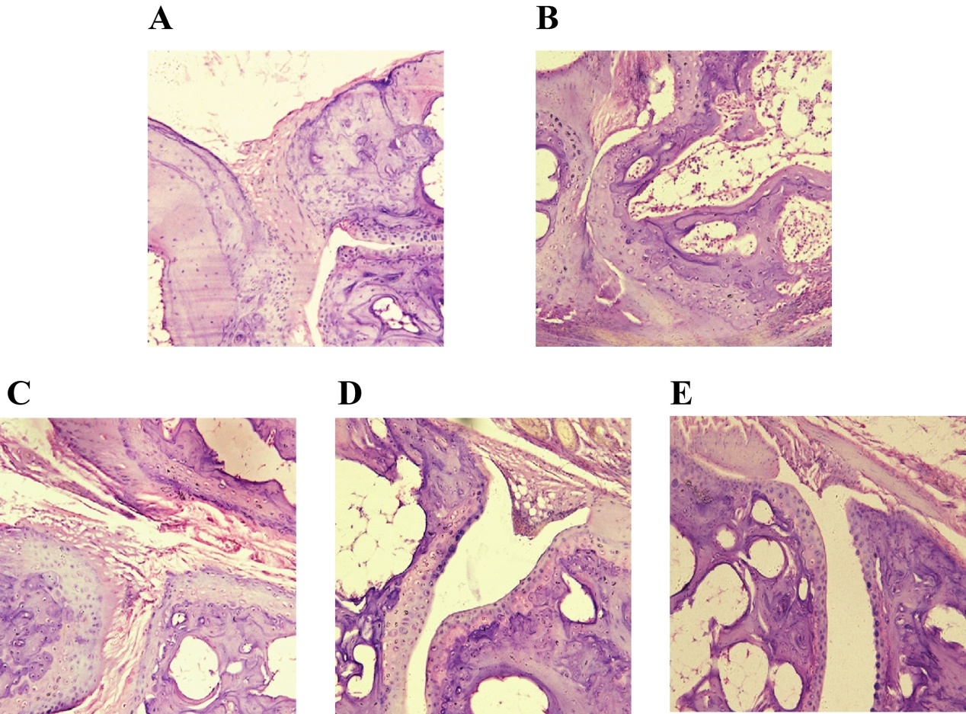
Supplementary Figure S1. The effects of crocin on the H&E stained histopathological characteristics of joints and synovial tissues in CIA rats (×40). A–E: normal rats (A), control CIA rats (B), CIA rats treated with crocin at 10 (C), 20 (D), and 40 (E) mg/kg per day.

