**Deformation-Assisted Diffusion for Enhanced Kinetics of Dynamic Phase Transformation**

Lijia Zhaoa,b*, Nokeun Parka,d, Yanzhong Tiana,c,e, Akinobu Shibataa,c and Nobuhiro Tsujia,c

a Department of Materials Science and Engineering, Kyoto University, Yoshida-honmachi, Sakyo-ku, Kyoto 606-8501, Japan; b Advanced Steel Processing and Products Research Center, Department of Metallurgical and Materials Engineering, Colorado School of Mines, Golden, CO 80401, USA; c Elements Strategy Initiative for Structural Materials (ESISM), Kyoto University, Yoshida-honmachi, Sakyo-ku, Kyoto, 606-8501, Japan; d School of Materials Science and Engineering, Yeungnam University, Gyeongsan 712-749, Republic of Korea; e Shenyang National Laboratory for Materials Science, Institute of Metal Research, Chinese Academy of Sciences, 72 Wenhua Road, Shenyang 110016, P.R. China

*Corresponding author. E-mail: zhaolj618@gmail.com; Tel: +1-303-384-2338

**Keywords:** dynamic phase transformation, deformation, diffusion, kinetics, grain growth

**Supporting information**

Figure 2.3.emf

**Supplementary Figure S1** Time-temperature-transformation (TTT) diagram of the 10Ni-0.1C steel.

Figure 3.2.emf

**Supplementary Figure S2 Microstructure evolution in static transformation without deformation.** OM images of the specimens austenitized at 1000°C and then isothermally held at 520 °C for (a) 12,600 s, (b) 19,800 s, (c) 37,800 s and (d) 88,200 s followed by water-quenching. “F” and “M” indicate ferrite (light area) and martensite (dark area), respectively. The volume fraction of (statically transformed) ferrite is shown on the top right corner of each image.

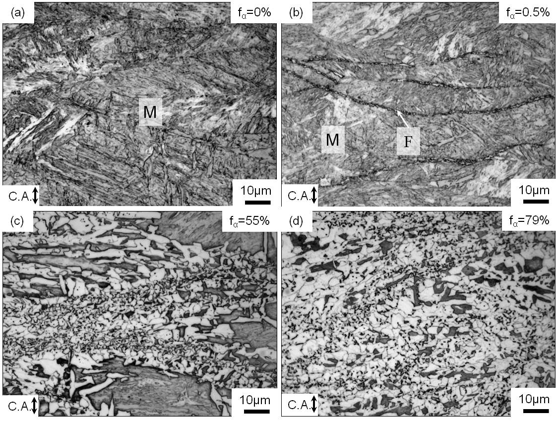

**Supplementary Figure S3 Microstructure evolution in static transformation from deformed austenite (route-ST).** OM images of the specimens austenitized at 1000°C, deformed to a strain of 0.92 at a strain rate of 100 s-1 at 520 °C and then isothermally held at 520 °C for (a) 0 s, (b) 8 s, (c) 91 s and (d) 915 s followed by water-quenching in the route-ST. “F” and “M” indicate ferrite and martensite, respectively. The volume fraction of ferrite is shown on the top right corner of each image. Compression axis is along the vertical direction of the images.

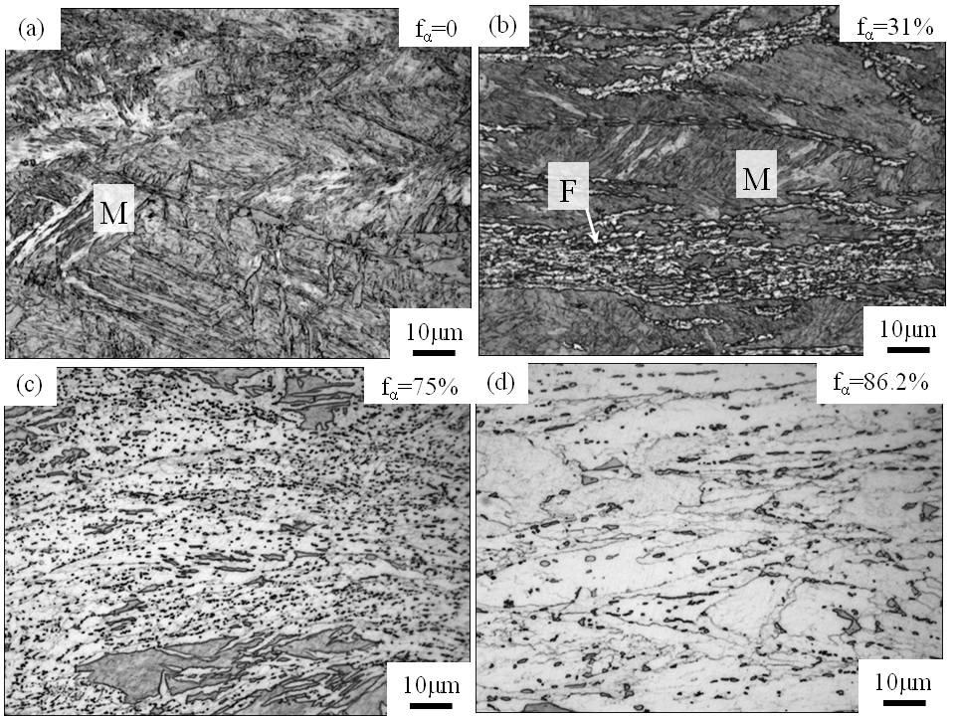

**Supplementary Figure S4** **Microstructure evolution in dynamic ferrite transformation (route-DT).** OM images of the specimens austenitized at 1000°C, held at 520°C for 60 s, and then deformed to a strain of 0.92 at strain rates of (a) 100 s-1, (b) 10-1 s-1, (c) 10-2 s-1 and (d) 10-3 s-1 at 520 °C in the route-DT2. “F” and “M” indicate ferrite and martensite, respectively. The volume fraction of ferrite is shown on the top right corner of each image. Compression axis is along the vertical direction of the images.