Supplementary material for
Combined effects of straw-derived biochar and bio-based polymer-coated urea on nitrogen use efficiency and cotton yield
Xiaojing Yu ª, Xiaofei Tian^{b, &}, Yanyan Luª, Zhiguang Liuª, Yanle Guoª, Jianqiu Chen^{c}, Chengliang Li^{a*}, Min Zhang^{a,c*}, Yongshan Wan^{d}
ª National Engineering Laboratory for Efficient Utilization of Soil and Fertilizer Resources, College of Resources and Environment, Shandong Agricultural University, Tai’an 271018, China
^{b} School of Environment and Planning, Liaocheng University, Liao’cheng 252059, China
^{c} State Key Laboratory of Nutrition Resources Integrated Utilization, Kingenta Ecological Engineering Group Co., Ltd. Lin’shu 276700, China
^{d} Department of Soil and Water Sciences, Tropical Research and Education Center, IFAS, University of Florida, Homestead, FL 33031, USA
& Yu and Tian contributed equally to this work and should be considered co-first authors.
*Corresponding authors E-mail addresses: chengliang_li11@163.com (C. Li), minzhang-2002@163.com (M. Zhang).

Supplementary Table 1 Source of variance of soil NO₃⁻-N and NH₄⁺-N contents
Supplementary Figure 1 Temperature and precipitation during the incubation and cotton growth period
Supplementary Figure 2 Structural characterizations of BPCU (A) and biochar (B) by FTIR
Supplementary Figure 3 Biochar N₂ adsorption/ desorption isotherms and pore size distribution

Supplementary Table 1 Source of variance of soil NO₃⁻-N and NH₄⁺-N contents
Stage | Seeding stage | First bloom stage | Full bolling stage | Initial boll opening stage | Maturity stage
NO₃⁻-N contents
C | <0.0001 | 0.0052 | 0.0005 | 0.0014 | 0.0121
N | <0.0001 | <0.0001 | <0.0001 | <0.0001 | <0.0001
Interaction | 0.0414 | 0.8536 | 0.3184 | 0.2049 | 0.0184
NH₄⁺-N contents
C | 0.0031 | <0.0001 | 0.4901 | 0.3110 | 0.0515
N | <0.0001 | <0.0001 | <0.0001 | <0.0001 | 0.0008
Interaction | 0.4972 | 0.1636 | 0.5058 | 0.9745 | 0.7555

Supplementary Figure 1 Temperature during the incubation and cotton growth period.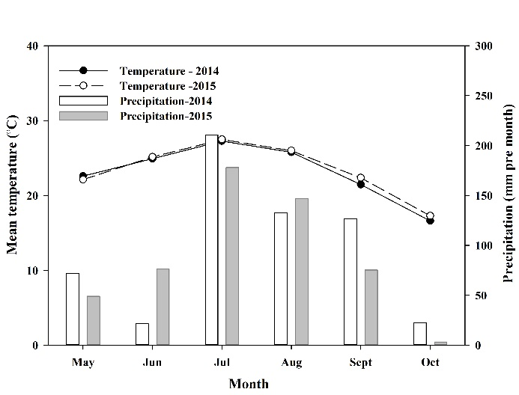
Supplementary Figure 2 Structural characterizations of BPCU (A) and biochar (B) by FTIR.
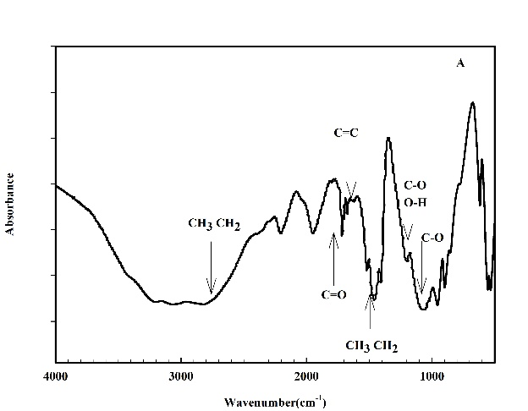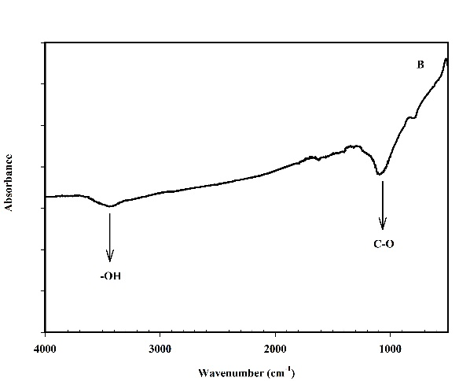

Supplementary Figure 3 Biochar N₂ adsorption/ desorption isotherms and pore size distribution
