Comparative Efficacy of Brigatinib versus Ceritinib and Alectinib in Patients with Crizotinib-Refractory Anaplastic Lymphoma Kinase–Positive Non-Small Cell Lung Cancer
Karen Reckamp, et al

Supplementary Material
Supplementary Table 1. Comparison of trial designs
 | Brigatinib | Ceritinib |  | Alectinib
 | ALTA | ASCEND-1 | ASCEND-2 | NP28761 | NP28673
Design | Phase 2, randomized, open-label, multicenter | Phase 1, open-label, multicenter | Phase 2, single-arm, open-label, multicenter | Phase 2, single-arm, open-label, multicenter | Phase 2, single-arm, open-label, multicenter
Sample size | 110 | 163 (crizotinib-resistant subgroup) | 140 | 87 | 138
Age category | ≥ 18 years | ≥ 18 years | ≥ 18 years | ≥ 18 years | ≥ 18 years
Diagnosis | Histologically or cytologically confirmed locally advanced or metastatic NSCLC that is ALK+, progressed while on crizotinib | ALK+ NSCLC, locally advanced or metastatic NSCLC that had progressed despite therapy, or for which no effective standard therapy existed | Locally advanced or metastatic ALK+ NSCLC, progressed while on crizotinib | Histologically confirmed, locally advanced not amenable to curative therapy, or metastatic ALK+ NSCLC, crizotinib resistant | Locally advanced or metastatic NSCLC, ALK+, crizotinib resistant
ECOG performance status | 0-2 | 0-2 | 0-2 | 0-2 | 0-2
Tumor response measure | RECIST v1.1 | RECIST v1.0 | RECIST v1.1 | RECIST v1.1 | RECIST v1.1
Assessment | INV, IRC | INV | IRC | IRC | IRC
Geography | North America, Europe, Asia, Australia | North America, Europe, Asia, Australia | North America, Europe, Asia, Australia | North America | North America, Europe, Asia, Australia
ALK Rearrangement
Documented rearrangement | x | x | x | x | x
Ascertained with an FDA-approved test | x |  | x | x | x
FISH test | x |  | x | x | x
Prior Treatment
Treated with crizotinib | x | x | x | x | x
Progressed on crizotinib | x | x | x | x | x
Abbreviations: ALK, Anaplastic lymphoma kinase; ECOG, Eastern Cooperative Oncology Group; FDA, Food and Drug Administration; INV, Investigator; IRC, Independent review committee; NSCLC, Non-small cell lung cancer

Supplementary Table 2. Comparison of duration of response outcomes before and after matching
 | ASCEND-1⁺ |  |  | ASCEND-2 |  |  | NP28761 |  |  | NP28673
 | Ceritinib ASCEND-1 | Brigatinib Pre-Match | Brigatinib Post-Match | Ceritinib ASCEND-2 | Brigatinib Pre-Match | Brigatinib Post-Match | Alectinib NP28761 | Brigatinib Pre-Match | Brigatinib Post-Match | Alectinib NP28673 | Brigatinib Pre-Match | Brigatinib Post-Match
 | N=92 | N=61 | ESS=40.5 | N=50 | N=60 | ESS=27.8 | NA |  |  | N=62 | N=60 | ESS=38.2
Number of events | 62 | 35 | 23.6 | 26 | 26 | 9.3 |  |  |  | 36 | 26 | 15.7
Median duration of response (95% CI), months | 7.7*  (6.2, 9.4) | 13.8  (10.2, 17.6) | 13.8  (9.9, 19.3) | 11.1*  (6.0, 13.1) | 14.8  (12.7, NR) | NR  (3.0, NR) |  |  |  | 16.4*  (11.1, NR) | 14.8  (12.7, NR) | 15.6  (12.7, NR)
HR (95% CI) | ‒ | 0.45  (0.29, 0.69) | 0.44  (0.27, 0.73) | ‒ | 0.45  (0.25, 0.80) | 0.28  (0.13, 0.61) |  |  |  | ‒ | 1.10  (0.66, 1.84) | 0.95  (0.52, 1.73)
P-value |  | <0.001 | 0.001 |  | 0.007 | 0.001 |  |  |  |  | 0.714 | 0.871
HR<1 suggests better outcome from brigatinib trial
⁺ALK TKI-pretreated cohort, *Estimated from VPL data
Abbreviations: CI, Confidence interval; ESS, Effective sample size; HR, Hazard ratio; NA, Not available; NR, Not reached; VPL, Virtual patient-level.

Supplementary Figure. Pre-match-adjusted and post-match-adjusted duration of response comparison. (A) Kaplan-Meier estimates of brigatinib ALTA vs ceritinib ASCEND-1 duration of response. (B) Kaplan-Meier estimates of brigatinib ALTA vs ceritinib ASCEND-2 duration of response. (C) Kaplan-Meier estimates of brigatinib ALTA vs alectinib NP28673 duration of response.

(A) Duration of Response: Brigatinib (ALTA) vs. Ceritinib (ASCEND-1)  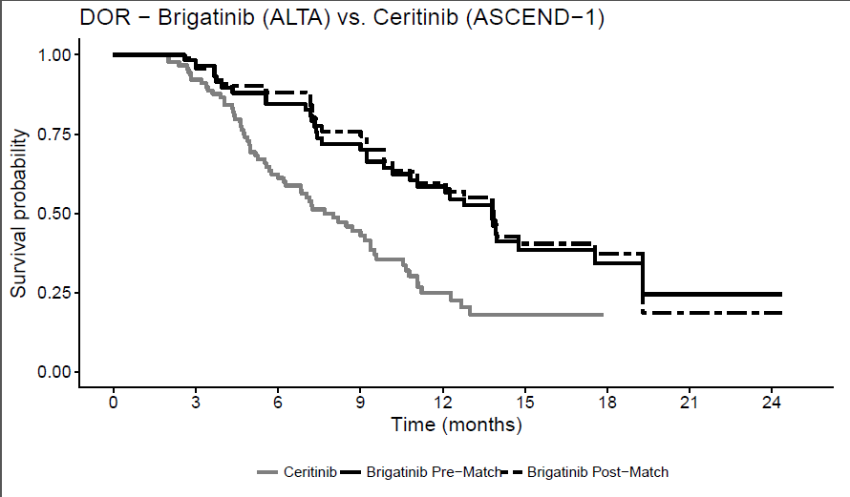 | (B) Duration of Response: Brigatinib (ALTA) vs. Ceritinib (ASCEND-2)  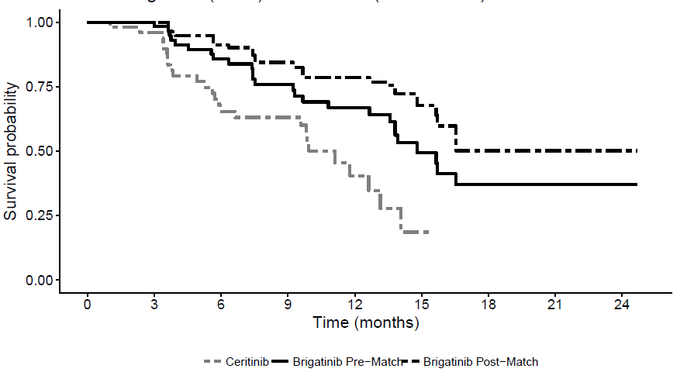

(C) Duration of Response: Brigatinib (ALTA) vs. Alectinib (NP28673)
