Table S1. Key characteristics of the included studies
Study Id | Population |  |  | Intervention; Number of participants | Comparator; Number of participants | Outcomes
 | Mean age (years) | Mean gravida; Mean parity | Mean gestational age (weeks)
Adamczak 2007 [19]; Italy; Conference abstract | NS | NS | 8-14 | Methylprednisolone 8 mg thrice daily for 6 days; 55 | Promethazine 25 mg Q6h for 6 days; 55 | Vomiting episodes
Babaei 2014 [20]; Iran | 25 | NS; 1 | 10.5 | Vitamin B6 50 mg/day orally for 7 days; 70 | Dimenhydrinate 50 mg/day orally for 7 days; 70 | Nausea and vomiting scores; AE
Basirat 2009 [21]; Iran | 19-35 | NS | 7-17 | Ginger biscuit 2.5 g/day for 4 days; 35 | Placebo for 4 days; 30 | Vomiting episodes; nausea and vomiting scores; AE
Belluomini 1994 [22]; USA | 33.5 | 1; 1 | 8.5 | Acupressure at P6 point for 7 days; 30 | Placebo for 7 days; 30 | Nausea and vomiting score
Biswas 2011 [23]; India | 22 | 1; 1 | < 16 | Ginger 150 mg three times daily; 34 | Doxylamine 10 mg and pyridoxine 10 mg two or three times daily; 29 | Nausea and vomiting score
Bsat 2003 [24]; USA | 26 | 1;1 | 8.5 | Pyridoxine 50 mg intramuscular injection with oral metoclopramide 10 mg Q6h to a group of 54 participants; Another group received promethazine 25 mg orally Q6h; 52 | Prochlorperazine 25 mg rectal suppositories Q12h; 50 | Vomiting episodes; Adverse neonatal outcomes
Chittumma 2007 [25]; Thailand | 24 | 1;1 | 11.5 | Oral ginger 650 mg three times daily for 4 days; 61 | 25 mg vitamin B6 three times daily for 4 days; 62 | Nausea and vomiting score; AE
Ensiyeh 2009 [26]; Iran | 25 | 1; 1 | < 17 weeks | Ginger orally 1 g/day for 4 days; | Vitamin B6 40 mg/day orally for 4 days; | Vomiting episodes; nausea and vomiting scores; AE
Firouzbhakt 2014 [27]; Iran | 25 | 1;1 | 9 | Ginger orally 250 mg Q6h for 4 days to a group of 40; Vitamin B6 40 mg Q6h for 4 days to a group of 40 | Placebo for 4 days; 40 | Nausea score; Vomiting episodes; AE
Can Gurkan 2008 [28]; Turkey | NS | 1; 1 | NS | Acupressure at P6 point for 6 days; 26 | Placebo for 6 days; 24 | Vomiting episodes; Nausea scores
Hsu 2003 [29]; USA; Conference abstract | 23.6 | NS | 9 | Acupressure at P6 pint; 38 | Placebo; 39 | Nausea scores; Hospital stay; Rescue anti-emetic use
Hyde 1989 [30]; USA | NS | NS | NS | Acupressure at P6 point; 8 | Placebo; 8 | Nausea score; anxiety, depression, hostility, psychosocial scores
Jafari-Dehkordi 2017 [31]; Iran | 27.5 | 1; 1 | 9.6 | Quince 5 ml three times daily for 7 days; 45 | Vitamin B6 20 mg three times daily for 7 days; 45 | Nausea scores; AE
Jamigorn 2007 [32]; Thailand | 28 | NS;1 | 8.1 | Acupressure at P6 point; 33 | Vitamin B6 40 mg daily; 33 | Nausea scores; rescue anti-emetic use; satisfactory rating; AE
Haji Seid Javadi 2013 [33]; Iran | 26.5 | 1; 1 | 9.5 | Ginger 250 mg Q6h; | Vitamin B6 40 mg Q12h; | Nausea scores; AE
Keating 2002 [34]; USA | 24-37 | NS; 1 | < 11 | Ginger syrup 1 g daily; | Placebo Q6h; | Control of vomiting; degree of nausea and vomiting; AE
Knight 2001 [35]; UK | 30.3 | 1;1 | 8 | Acupressure at P6 point; 28 | Placebo; 27 | Nausea scores; AE
Koren 2010 [36]; USA | 25 | NS | 5.5 | Doxylamine 10 mg and Vitamin B6 10 mg per day; 140 | Placebo; 140 | Nausea scores; well-being score; rescue anti-emetic use
Koren 2015 [37]; USA | 25 | NS | 5.5 | Doxylamine 10 mg and Vitamin B6 10 mg per day; 131 | Placebo; 125 | AE
Modares 2012 [38]; Iran | NS | NS | < 16 | Ginger and chamomile at 500 mg per day to two separate groups of 35 each | Placebo; 35 | Nausea scores
Mohammadbeigi 2011 [39]; Iran | 27 | 2;1 | NS | Metoclopramide 10 mg and ginger 200 mg three times daily to each groups of 34 each | Placebo; 34 | Nausea and vomiting scores
Narenji 2012 [40]; Iran | 25.5 | NS | NS | Ginger syrup; 98 | Vitamin B6; 99 | Rate of nausea and vomiting
Norheim 2001 [41]; Norway | 28.4 | NS; 1.5 | NS | Acupressure; NS | Placebo; NS | Nausea scores; Duration of nausea
O’Brien 1996 [42]; Canada | 29.5 | 2; 1 | 10.1 | Acupressure P6 point; 54 | Placebo; 53 | Nausea and vomiting scores
Oliviera 2014 [43]; USA |  | 2; 1 | 8 | Ondansetron 4 mg Q8h for 5 days; 18 | Pyridoxine 25 mg with 12.5 mg of doxylamine Q8h for 5 days; 18 | Nausea and vomiting scores; AE
Ozgoli 2009 [44]; Iran | 24 | NS; 1 | 13 | Ginger 250 mg Q6h for 4 days; 35 | Placebo for 4 days; 35 | Vomiting episodes; Nausea score
Pasha 2012 [45]; Iran | 25 | NS | 8 | Mint oil; 30 | Placebo; 30 | Nausea and vomiting scores
Pongrojpaw 2007 [46]; Thailand | 27 | 1; 1 |  | Ginger 500 mg twice daily for 7 days; 85 | Dimenhydrinate 50 mg twice daily for 7 days; 85 | Nausea scores; AE
Rad 2012 [47]; Iran | 26 | 1; 1 | 9.5 | KID21 acupressure 20 minutes a day for 4 days; 40 | Placebo; 40 | Nausea and vomiting scores
Rosen 2003 [48]; USA | 29.5 | 1; 1 | 9 | Nerve stimulation at P6 point for 21 days; 95 | Placebo for 21 days; 92 | Nausea scores; medication use,  weight gain, and presence of urinary ketones
Rukh 2016 [49]; Pakistan | 47 | NS | NS | Ginger 500 mg twice daily for 60 days; 35 | Vitamin B6 25 mg twice daily for 60 days; 30 | Nausea and vomiting scores; well-being scores; Heartburn and palpitation
Saberi 2013 [50]; Iran | 26 | 1; 1 | 9 | Ginger (250 mg Q8h) to a group of 53; Acupressure at P6 point to another group of 53; | No intervention; 53 | Nausea and vomiting scores; control of symptoms of nausea and vomiting
Sahakian 1991 [51]; USA | 29 | 1; 1 | 9.5 | Vitamin B6 25 mgQ8h for 3 days; 31 | Placebo; 28 | Nausea scores; control of vomiting;
Sharifzadeh 2017 [52]; Iran | 28.5 | 1; 1 | 10.5 | Ginger 500 mg Q12h for 4 days to one group of 28; Vitamin B6 40 mg Q12h to another group of 26 | Placebo; 23 | Nausea and vomiting scores
Smith 2004 [53]; Australia | 29 | 1; 1 | 8.5 | Ginger 350 mg Q8h for 3 weeks; 146 | Vitamin B6 25 mg Q8h for 3 weeks; 145 | Nausea and vomiting scores; adverse pregnancy and neonatal outcomes
Sripramote 2003 [54]; Thailand | 27 | 1; 1 | 10.1 | Ginger 500 mg Q8h for 3 days; 68 | Vitamin B6 10 mg Q8h for 3 days; 70 | Vomiting scores; Nausea scores
Steele 2001 [55]; USA | 27.5 | 1; 2 | 8.6 | Acupressure at P6 point; 17 | Placebo; 11 | Severity and frequency of nausea and vomiting
Tara 2015 [56]; Iran; Conference abstract | 26.4 | NS | 9.4 | Acupressure at P6 point and vitamin B6 to groups of 30 each | Placebo; 30 | Control of vomiting
Vutyavanich 1995 [57]; Thailand | 27 | 1; 1 | 10.9 | Vitamin B6 30 mg/day for 5 days; 169 | Placebo for 5 days; 167 | Nausea scores; vomiting episodes; compliance to therapy
Vutyavanich 2001 [58]; Thailand | 28.3 | 1; 1 | 10.3 | Ginger 250 mg Q8h for 4 days; 32 | Placebo for 4 days; 38 | Vomiting episodes; control of vomiting; nausea scores; AE
Werntoft 2001 [59]; Sweden | 30 | NS | 5.8 | Acupressure at P6 point; 20 | Placebo; 20 | Nausea scores
Willetts 2003 [60]; Australia | 32 | NS | 9 | Ginger 125 mg Q6h for 4 days; 60 | Placebo for 4 days; 60 | Nausea scores; adverse pregnancy outcomes;
Yavari 2014 [61]; Iran | 26 | 1; 1 | 10.5 | Lemon oil inhalation; 50 | Placebo; 50 | Nausea scores
Shin 2005 [62]; South Korea | NS | 1; 1 | 8.6 | Acupressure at P6 point; 23 | Placebo; 22 | Vomiting episodes
Smith 2002 [63]; Australia | 30 | NS | 8 | Traditional acupuncture to a group of 148; Two other groups received PC6 acupuncture and sham acupuncture | No acupuncture control; 149 | Nausea scores
Ghani 2013 [64]; Saudi Arabia | 25 | NS | 10 | Essential oils (peppermint and lavender) aromatherapy; 50 | Standard of care; 51 | Episodes of nausea and vomiting; nausea and mood scores
Khavandizadeh 2010 [65]; Iran | NS | Primigravida | 10-16 | Acupressure; 50 | Placebo; 50 | Nausea scores
Ghahiri 2011 [66]; Iran | 25.3 | NS | 11 | Metoclopramide for 3 weeks; 35 | Ondansetron for 3 weeks; 35 | Nausea and vomiting episodes
Puangsricharern 2008 [67]; Thailand | 26.6 | 50% primigravida | 11.1 | Acupressure; 45 | Placebo; 46 | Nausea scores; Satisfaction scores
De Veciana 2001 [68]; USA; Conference abstract | NS | NS | 6-12 | Acupressure; NS | Placebo; NS | Weight gain; nausea scores
NS – not specified; AE – adverse events.

Figure S1. Funnel plot for nausea scores between ginger and placebo
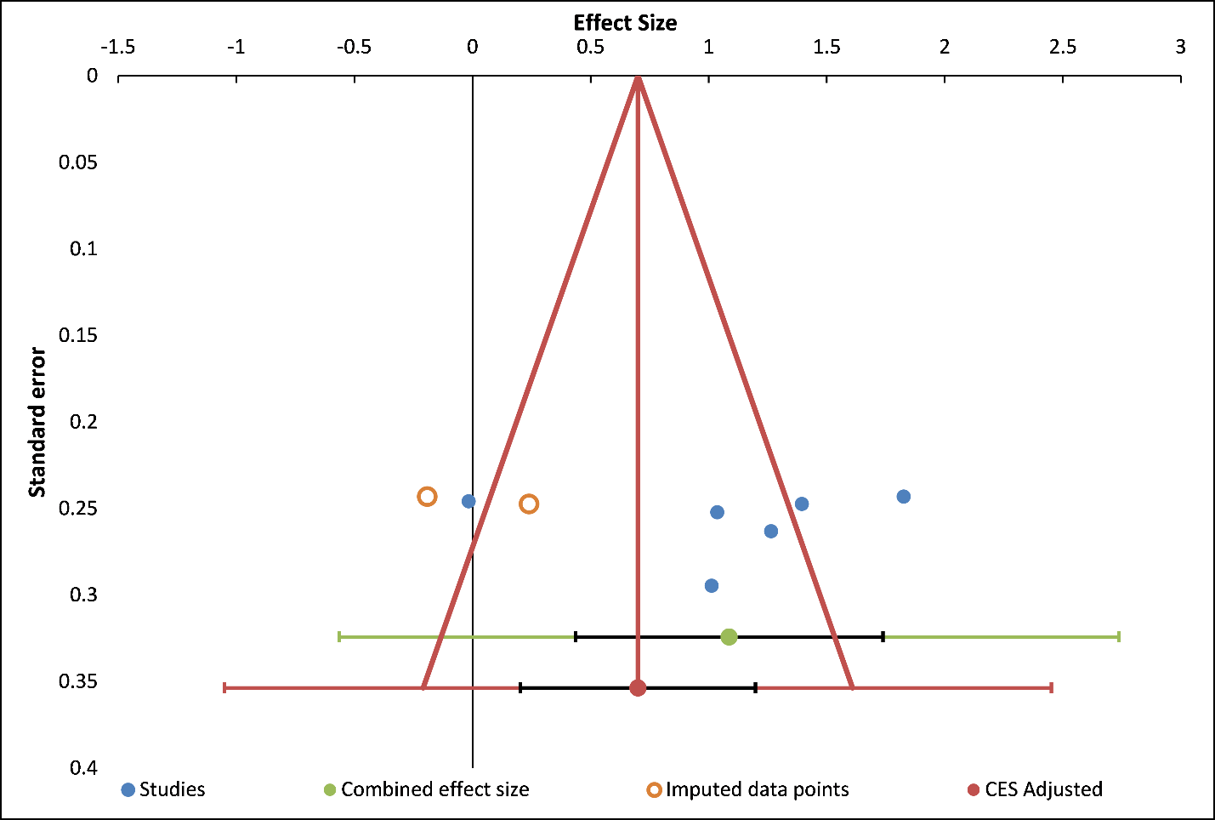
CES – Combined effect size.
No asymmetry was observed in the distribution of the pooled estimates and no publication bias was detected by Egger’s regression test (P = 0.9).

Figure S3. Funnel plot for nausea scores between acupressure and placebo
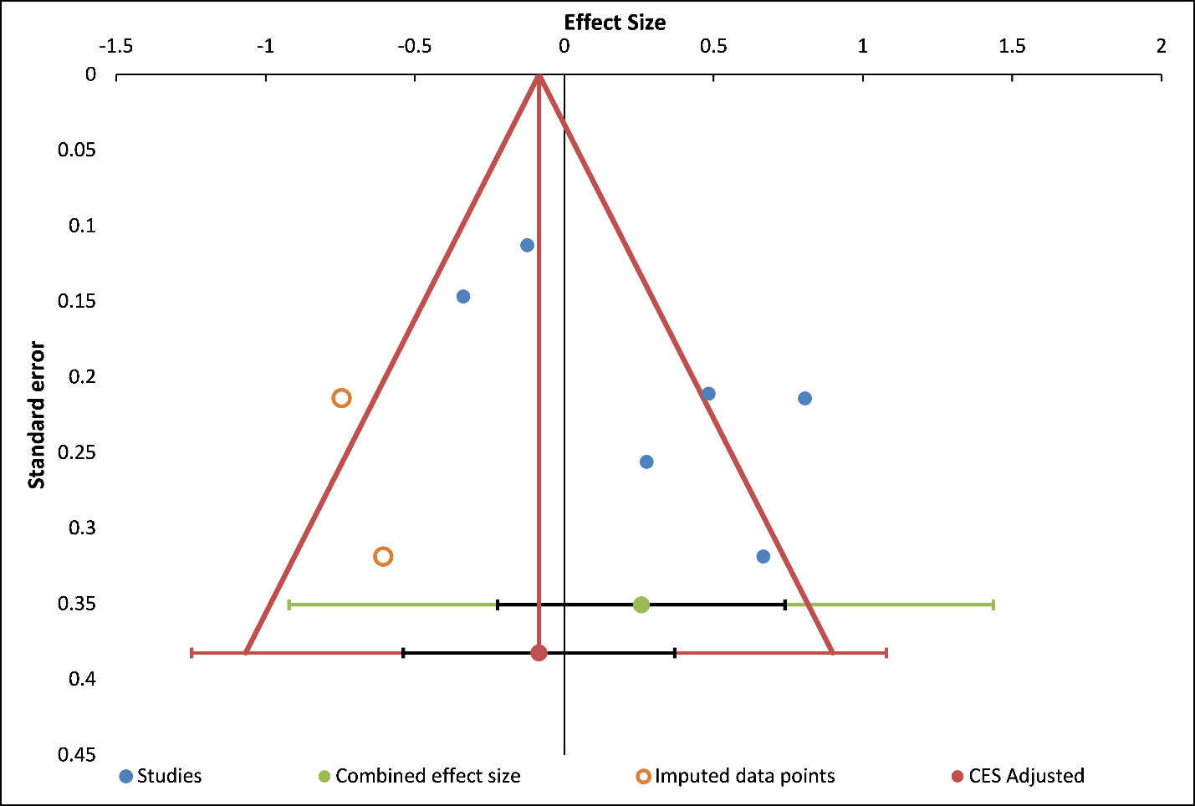
CES – Combined effect size.
No asymmetry in the distribution of pooled estimates was observed and no publication bias was detected by Egger’s regression test (P = 0.1).

Figure S4. Funnel plot for nausea scores between ginger and vitamin B6
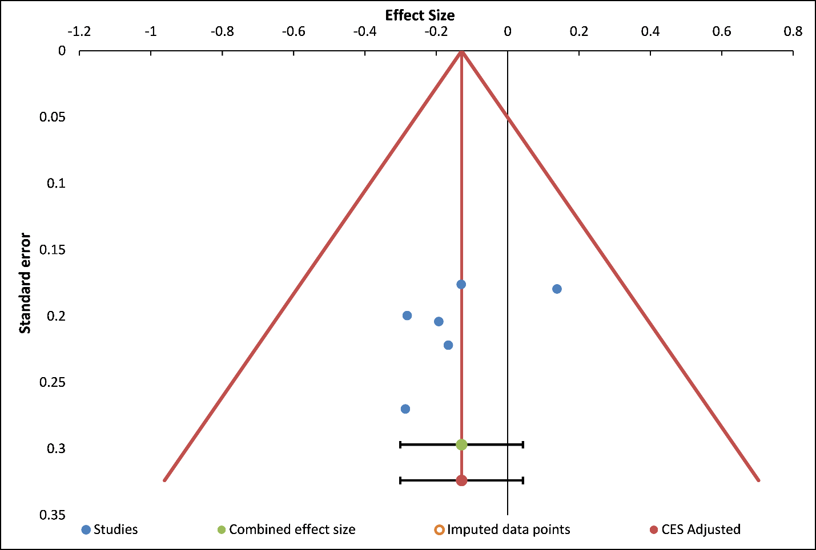
CES – Combined effect size.
No asymmetry was observed in the funnel plot and no publication bias was observed with Egger’s regression analysis (P = 0.2).

Figure S5. Forest plot for nausea scores for the interventions compared to placebo in the sensitivity analysis
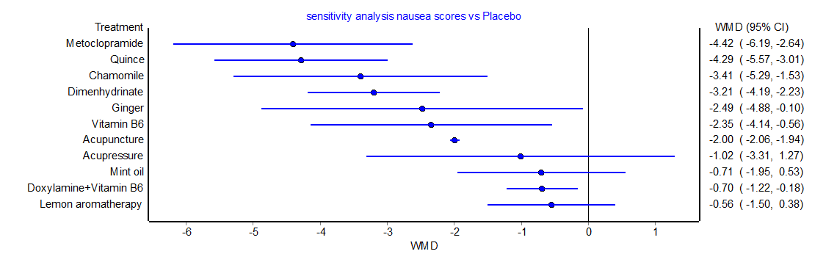
Vitamin B6, ginger, doxylamine/vitamin B6, chamomile, metoclopramide and acupuncture were observed with significantly reduced nausea scores compared to placebo.

Figure S6. Trial sequential analysis graph for nausea scores for the comparison between ginger and placebo
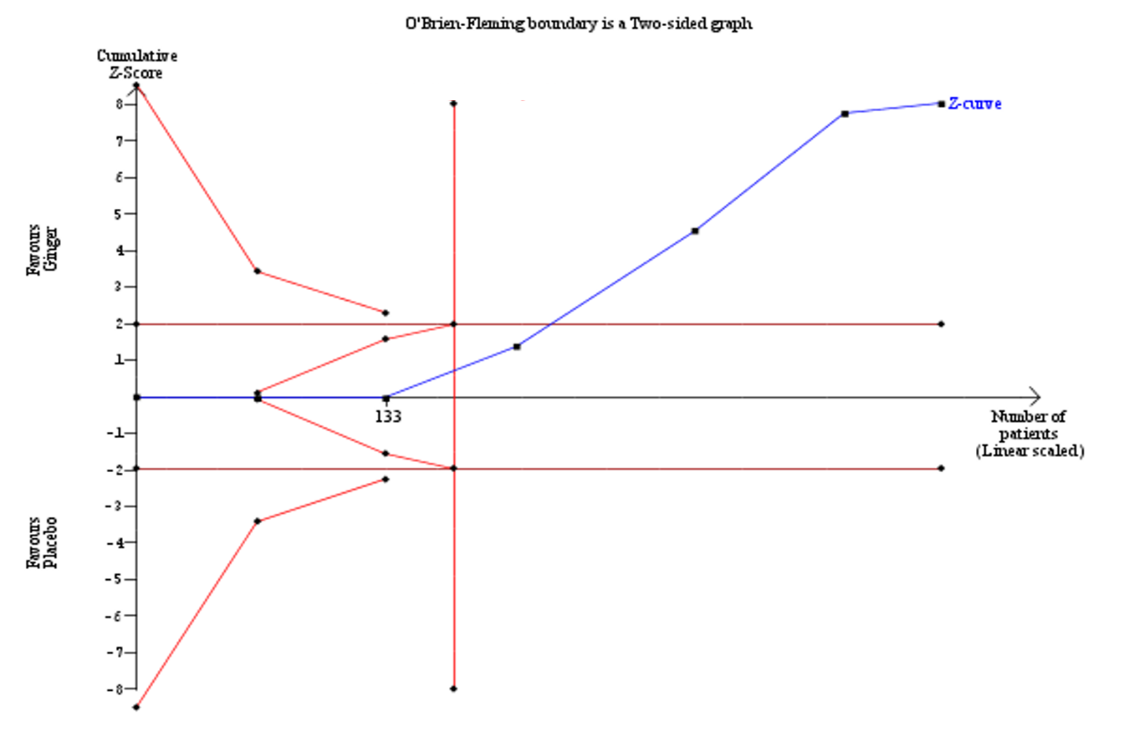
Blue line in the figure indicates the trend of the pooled estimates after adjusting for the type 1 error. Ginger was associated with reduced nausea scores than placebo.

Figure S7. Trial sequential analysis graph for nausea scores for acupressure compared with placebo.
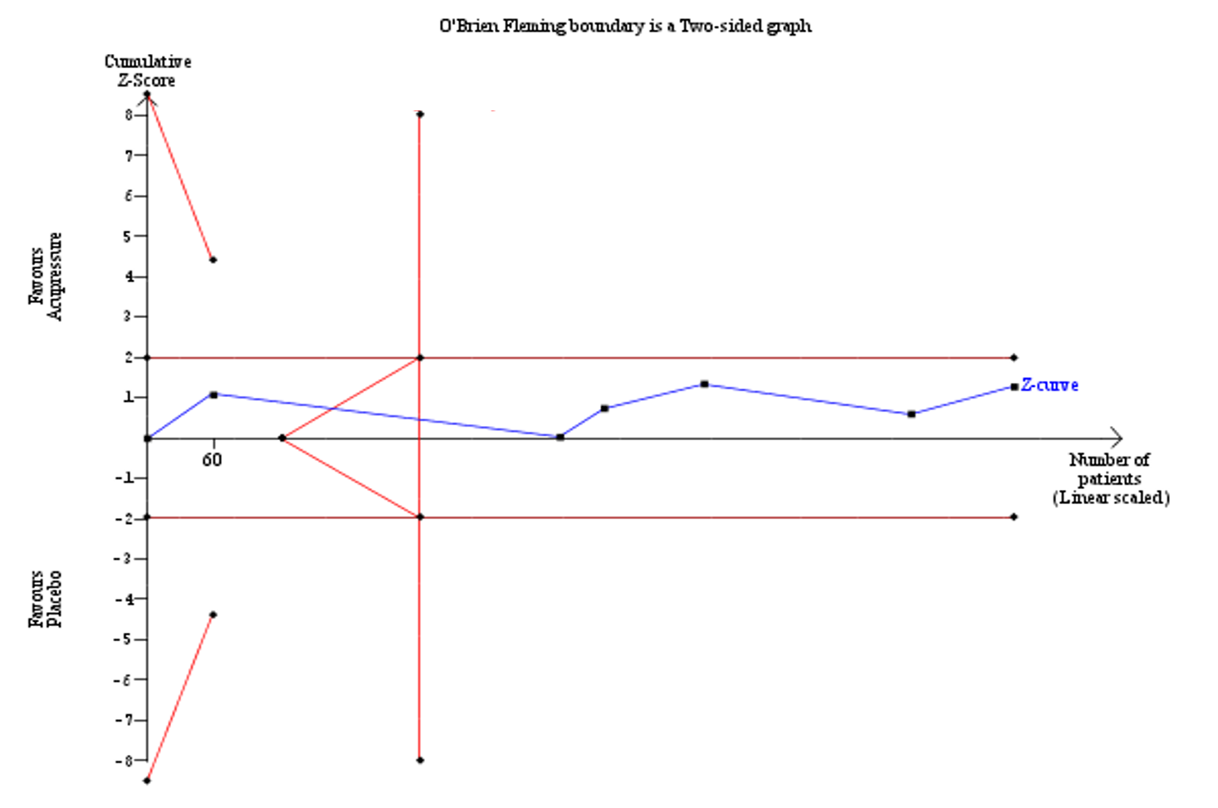
No significant differences were observed between acupressure and placebo.

