SUPPORTING INFORMATION

-aminobutyric acid and Collagen Peptides as recyclable bifunctional biocatalysts for the Solvent-free One-pot Synthesis of 2-aminobenzothiazolomethyl-2-naphthols

Maryam Fardpoura, Ali Safaria, Shahrzad Javanshira*

a Heterocyclic Research Laboratory, Department of Chemistry, Iran University of Science and Technology, Tehran 16846-13114, Iran.

E-mail: [shjavan@iust.ac.ir](mailto:shjavan@iust.ac.ir)

Phone.: +98-21- 772-40-516; Fax: +98-21-732-27-703

|  |  |
| --- | --- |
| **TABLE OF CONTENTS** |  |
| **Experimental** | **2** |
| **General procedure for 2-Aminobenzo[d]thiazolomethylnaphthols synthesis** | **2** |
| **Spectroscopic data of compounds 5d, 5i, 5n and 5o** | **2-3** |
| **1H NMR spectrum of 2-aminobenzothiazolo-(3-benzyloxy,4-methoxy phenyl)methyl-2-naphtol (5d)** | **4** |
| **13C NMR spectrum of 2-aminobenzothiazolo-(3-benzyloxy,4-methoxy phenyl)methyl-2-naphtol (5d)** | **5** |
| **IR spectra, of 2-aminobenzothiazolo-(2-chloro-phenyl)methyl-2-naphthol (5i)** | **6** |
| **13C NMR spectrum of 2-aminobenzothiazolo-(2-chloro-phenyl)methyl-2-naphthol (5i)** | **7** |
| **Mass spectrum of 2-aminobenzothiazolo-(3-phenyl propyl)methyl-2-naphthol (5n)** | **8** |
| **IR spectra of 2-aminobenzothiazolo-(Thiophenyl)methyl -2-naphthol (5o)** | **9** |
| **1H NMR spectrum of 2-aminobenzothiazolo-(Thiophenyl)methyl -2-naphthol (5o)** | **10** |
| **1H NMR spectrum of 2-aminobenzothiazolo-(Thiophenyl)methyl -2-naphthol (expanded aromatic region) (5o)** | **11** |
| **13C NMR spectrum of 2-aminobenzothiazolo-(Thiophenyl)methyl -2-naphthol (5o)** | **12** |

**Experimental**

All chemicals and reagents were purchased from commercial sources without further purification except benzaldehyde which was purified as a fresh distilled sample. The reaction progress was monitored by TLC using Merck 0.2 mm silica gel 60 F-254 Al-plates. Melting points were determined on a Barnstead Electro thermal apparatus and were uncorrected. FT-IR spectra were determined using KBr pellets on an FT-IR Shimadzu 8400S spectrometer and absorptions were reported as wave numbers (cm-1). 1H NMR (500 MHz) and 13C NMR (125 MHz) spectra were determined on a JEOL, using TMS as the internal standard and DMSO-d6 as the solvent at room temperature. The model reaction was once done in a Memmert UFB500 oven at 120°C. Microwave irradiation was performed using a Samsung (CE290DN) microwave.

**General procedure for 2-Aminobenzo[d]thiazolomethylnaphthols synthesis**

In a general procedure, 2-naphthol (1 mmol), (hetero) aromatic aldehyde (1 mmol), 2-aminobenzothiazole (1 mmol) and -aminobutyric acid (10 mol% - 0.010g) or isinglass () were mixed and then transferred into a flask (25 cm3) and subjected to microwave irradiation or heating at 110° C for the appropriate time according to Table 3 and 5. After completion of the reaction, as indicated by TLC, the reaction mixture was cooled to room temperature, stirred in water to bring out the catalyst, filtered and dried. The pure solid products were obtained by recrystallization from ethanol-ethyl acetate (1:2). The catalyst -aminobutyric acid could be recycled by a simple recrystallization from ethanol after treatment of the crude product with water (3×5 ml) and then reused for 4 more times.

**Spectroscopic data of compounds 5d, 5i, 5n and 5o**

**2-aminobenzothiazolo-(3-benzyloxy,4-methoxy phenyl)methyl-2-naphtol (5d).** The title compound was prepared according to the general procedure. The product was obtained as a white solid, mp 192–194 ⁰C. Yeild: 95%. IR (KBr): 3331, 1542, 1514, 1450,1265; 1H NMR (500 MHz, DMSO-d6) *δ* 3.66 (3H, s, CH3O), 4.85 (2H, s,CH2O), 6.73–7.89(19H, m), 8.7 (1H, s, NH), 10.10 (1H, s, OH); 13C NMR (125 MHz, DMSO-d6) *δ* 53.97, 56.48,71.04, 112.87, 113.56, 118.95, 119.35, 119.60, 119.83, 121.76, 121.83, 123.27, 126.32, 127.05, 128.6, 128.74, 129.12, 129.45, 129.57, 130.31, 131.59, 133.07, 135.52, 137.81, 148.33, 153.02, 154.02, 167.15.



**2-aminobenzothiazolo-(2-chloro-phenyl)methyl-2-naphthol (5i).** The title compound was prepared according to the general procedure. The product was obtained as a cream powder, mp 194-194 ⁰C. Yield: 96%. IR (KBr): 3379, 1626, 1545, 1515, 1465, 1450; 1H NMR (500 MHz, DMSO-d6): *δ* 6.97–8.01 (15H, m), 8.89 (1H, s, NH), 9.91 (1H, s, OH); 13 C NMR (125 MHz, DMSO-d6) *δ* 52.59, 118.62, 119.47, 121.45, 121.68, 122.45, 122.68, 123.19, 123.69, 126.32, 126.60, 126.99, 129.13, 129.16, 129.49, 129.81, 131.16, 142.52, 153.20, 154.29, 167.17; MS (EI, 70 eV) (m/z): 416, 231, 202, 150, 144.



**2-aminobenzothiazolo-(3-phenyl propyl)methyl-2-naphthol (5n).** The title compound was prepared according to the general procedure. The product was obtained as a cream powder, mp 189-191 ⁰C. Yield: 89%. IR (KBr: 3353, 1614, 1542, 1515, 1155; 1H NMR (500 MHz, DMSO-d6): *δ* 2.22 (2H, m, CH2), 2.71 (2H, t, CH2), 5.85 (1H, t, CH), 7.0-8.02 (15H, m), 8.9 (1H, s, NH), 10.00 (1H, s, OH); 13C NMR (125 MHz, DMSO-d6): *δ* 40.56, 40.73, 53.7, 117.23, 118.93, 119.42, 121.84, 121.96, 123.2, 123.75, 126.03, 126.37, 127.26, 127.36, 129.27, 129.53, 129.80, 130.32, 130.58, 130.66, 131.29, 133.32, 133.66, 140.23, 154.67, 166.26; MS (EI, 70 eV) (m/z): 410, 231, 202, 150, 144, 91.



**2-aminobenzothiazolo-(Thiophenyl)methyl -2-naphthol (5o). ).** The title compound was prepared according to the general procedure. The product was obtained as a cream powder, mp 191-193 ⁰C. Yield: 94%. cream powder mp 189–191 C; IR (KBr): 3336, 1540, 1510, 1334, 1269; 1H NMR (500 MHz, DMSO-d6): *δ* 6.78–7.78 (14H, m), 8.92 (1H, s, NH), 10.22 (1H, s, OH); 13C NMR (125 MHz, DMSO-d6 ): *δ* 49.56, 107.27, 111.35, 117.02, 119.01, 119.28, 121.80, 121.95, 123.32, 124.24, 125.42, 126.36, 127.12, 129.37, 130.66, 131.51, 133.25, 142.74, 152.76, 154.31, 155.37, 166.72.





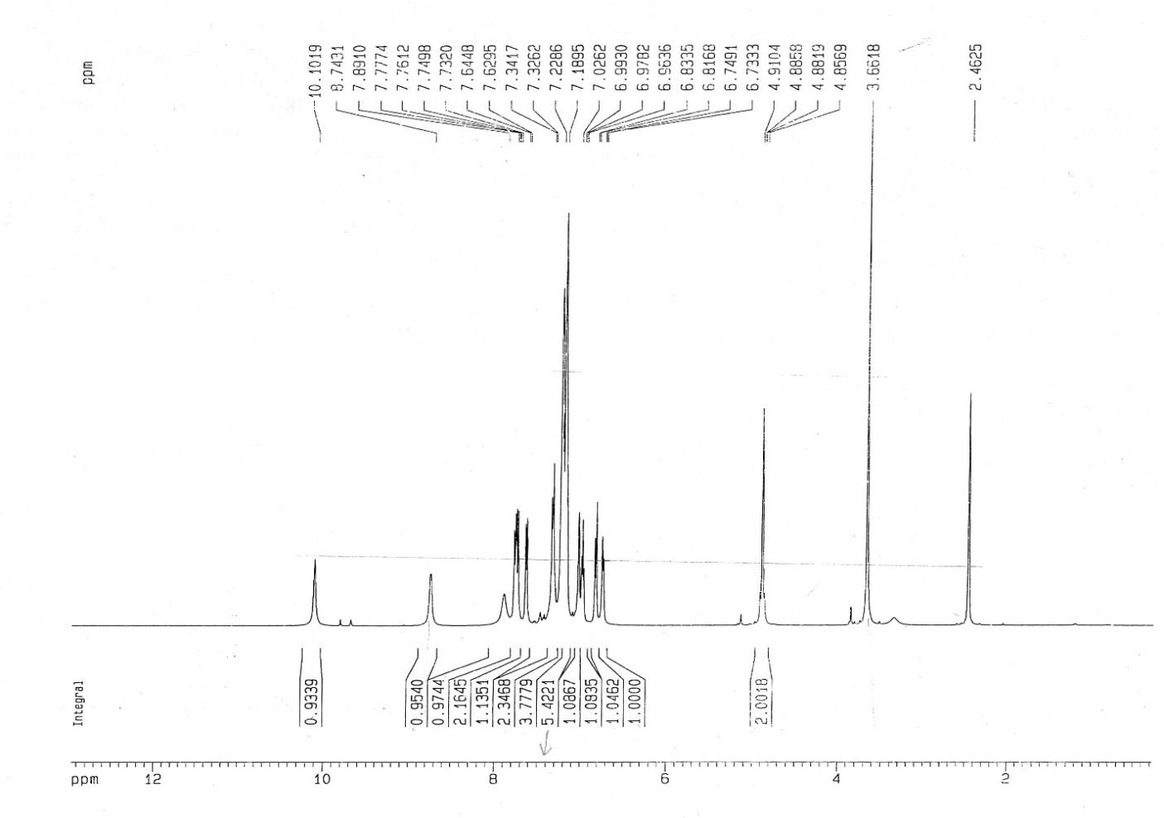

**Fig. 1.**  1H NMR spectrum of 2-aminobenzothiazolo-(3-benzyloxy,4-methoxy phenyl)methyl-2-naphtol



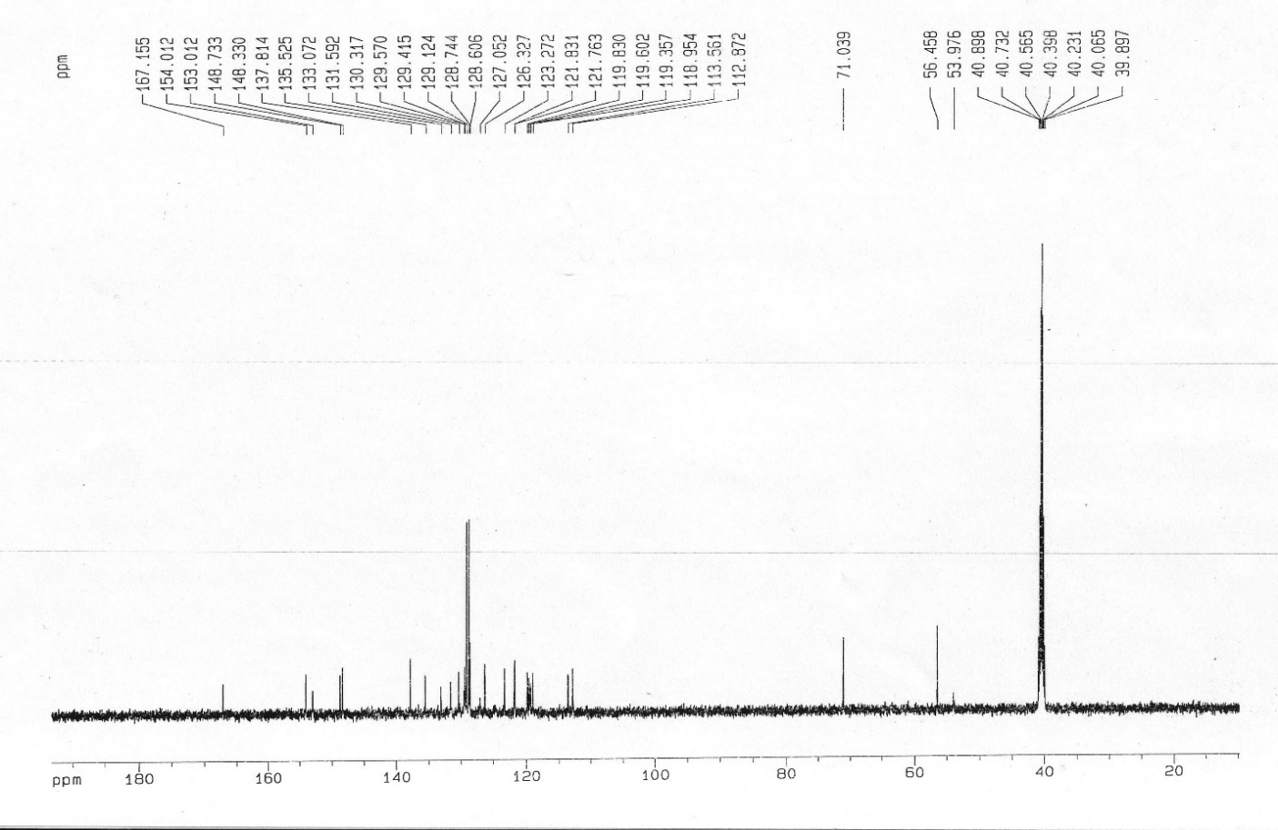

**Fig. 2.**  13C NMR spectrum of 2-aminobenzothiazolo-(3-benzyloxy,4-methoxy phenyl)methyl-2-naphtol



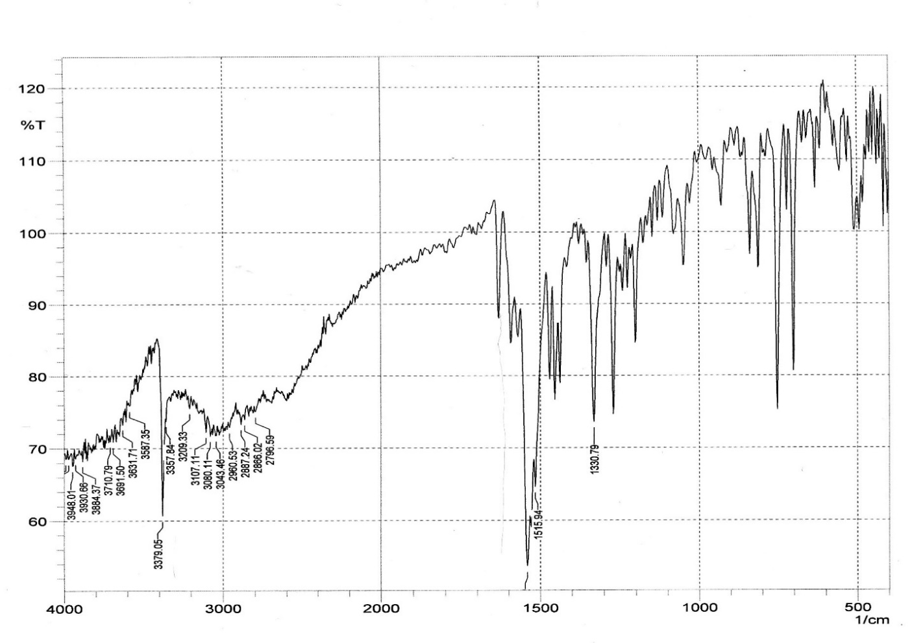

**Fig. 3.** IR spectra of 2-aminobenzothiazolo-(2-chloro-phenyl)methyl-2-naphthol



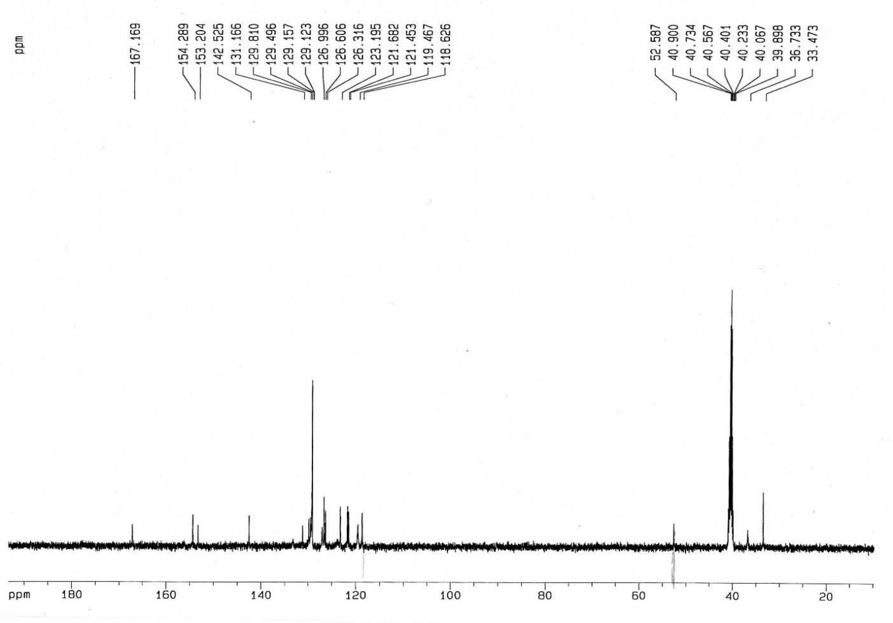

**Fig. 4.**  13C NMR spectrum of 2-aminobenzothiazolo-(2-chloro-phenyl)methyl-2-naphthol



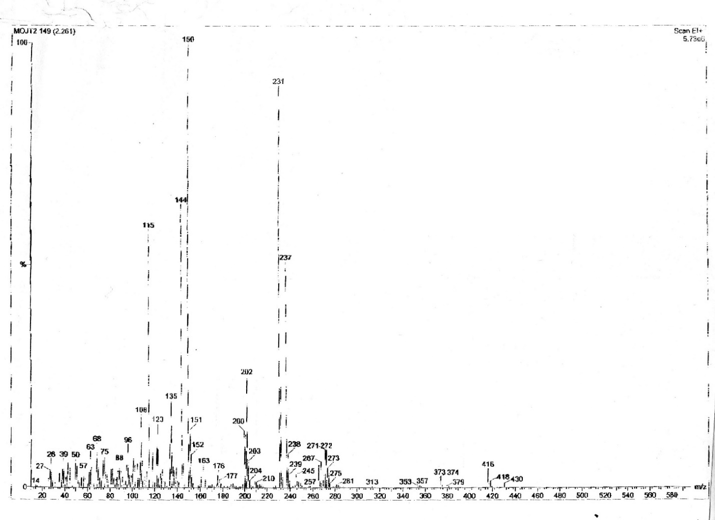

**Fig. 5.** Mass spectrum of 2-aminobenzothiazolo-(3-phenyl propion)methyl-2-naphthol



5o

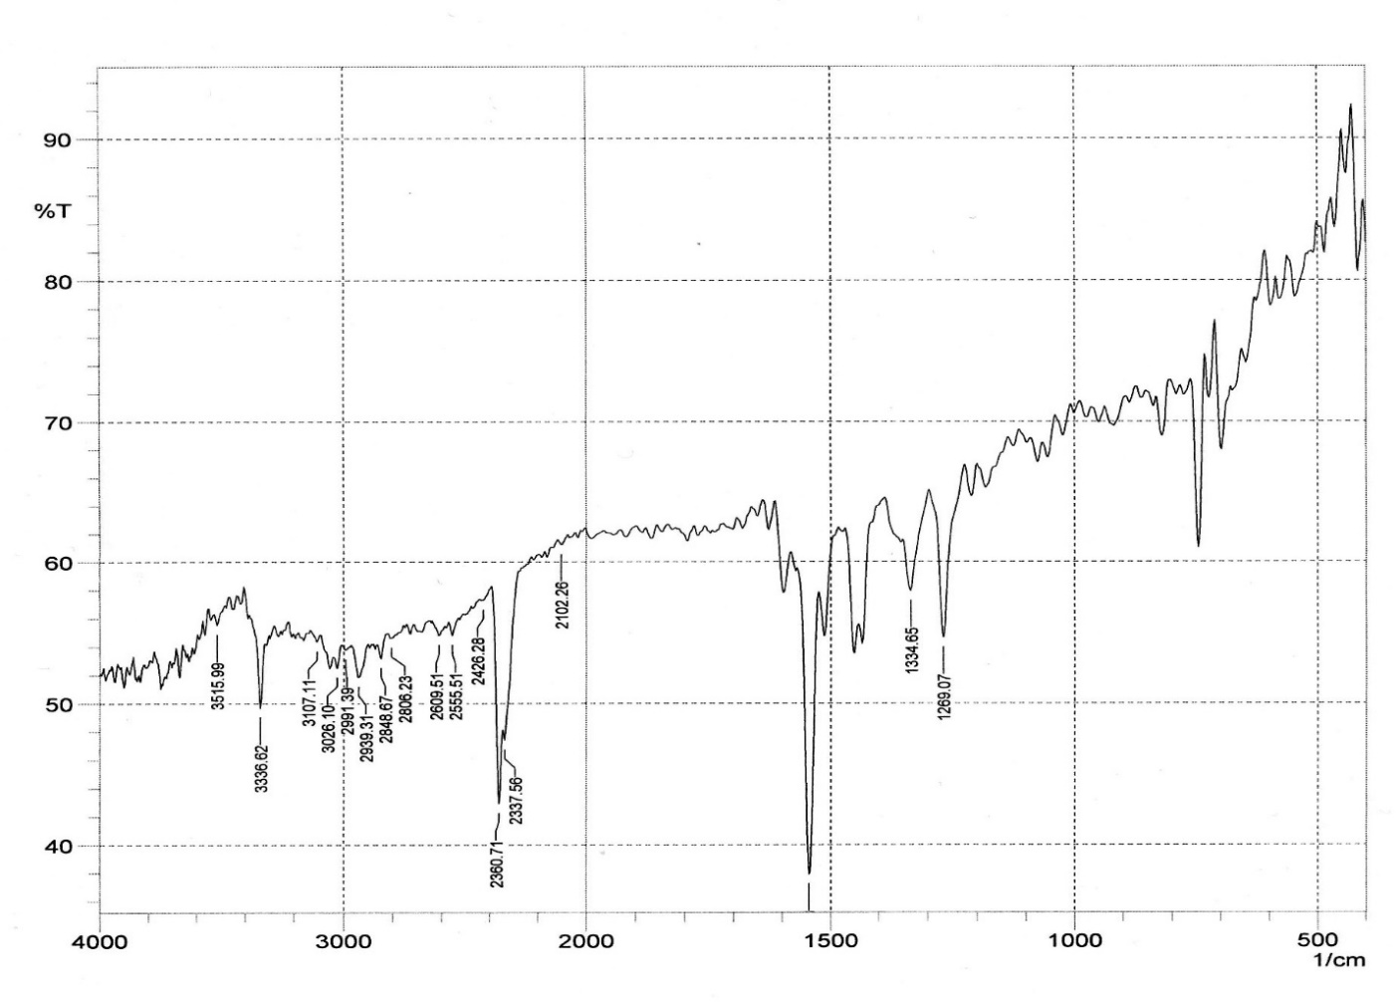

**Fig 6.**  IR spectra of 2-aminobenzothiazolo-(Thiophenyl)methyl-2-naphthol



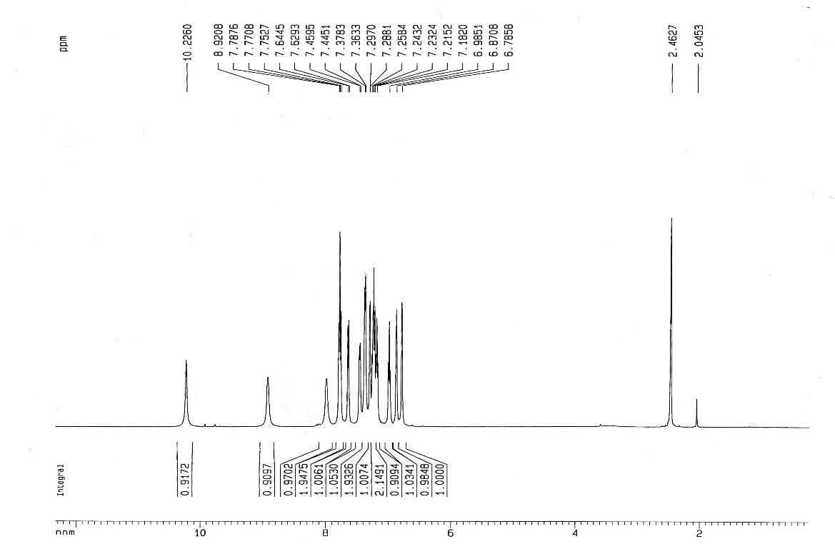

**Fig. 7.** 1H NMR spectrum of 2-aminobenzothiazolo-(Thiophenyl)methyl-2-naphthol

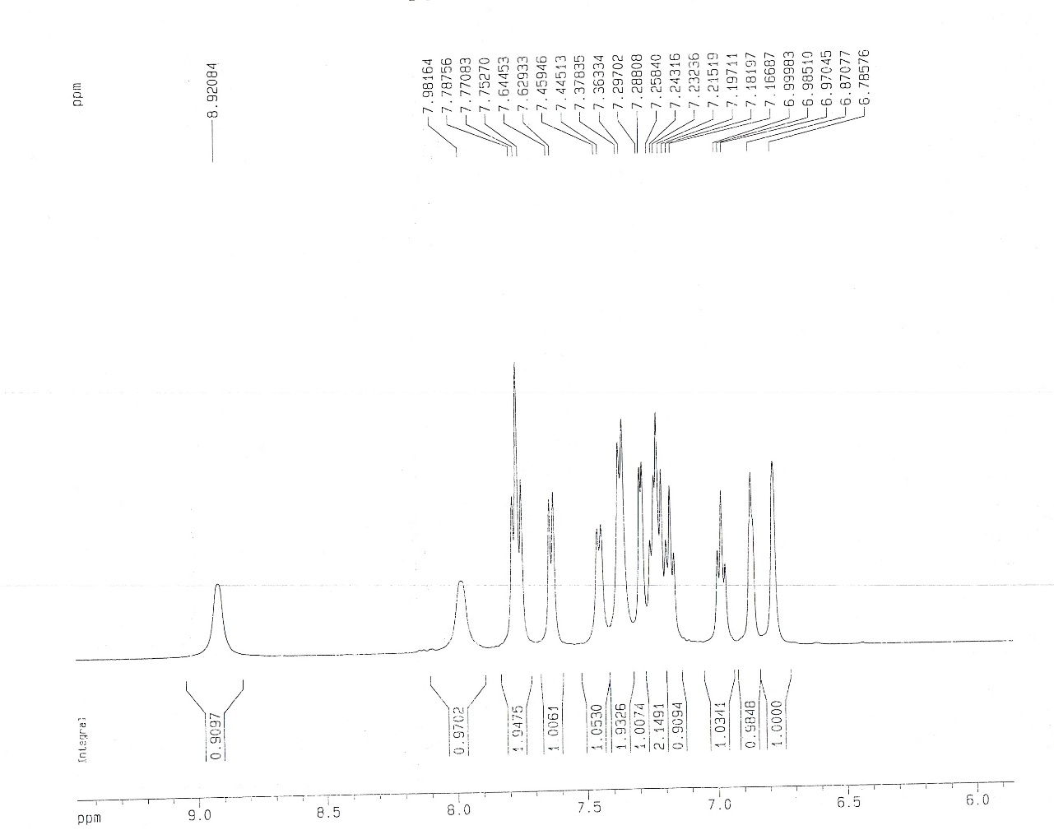

**Fig. 8.** 1H NMR spectrum of 2-aminobenzothiazolo-(Thiophenyl)methyl-2-naphthol (Expanded aromatic region)



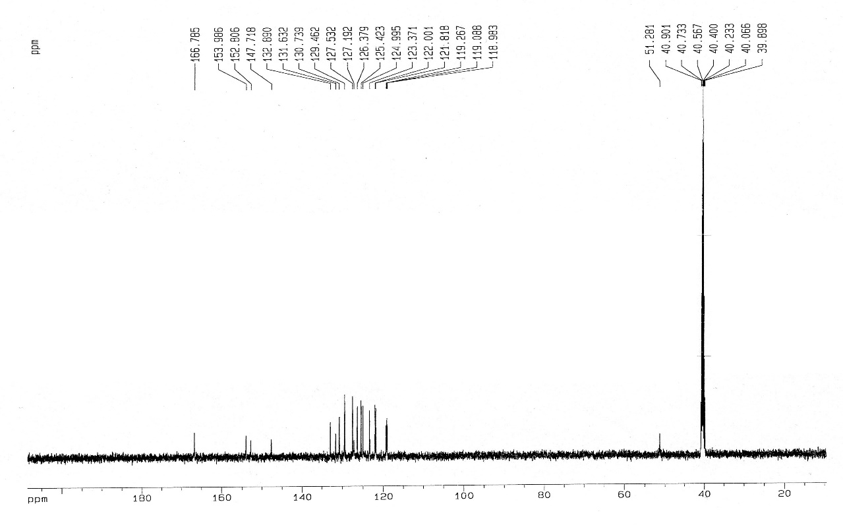

**Fig 9.**  13C NMR spectrum of 2-aminobenzothiazolo-(Thiophenyl)methyl-2-naphthol

**Checking FT-IR spectrum compound 2-Aminobenzothiazolomethylnaphtols**

In the checking spectrum of FT-IR observed peak is in 3375 ${cm}^{-1}$ related to the group NH ,OH , and observed peak in the area of 1899 ${cm}^{-1}$ is related to aromatic CH and observed peak in 750 ${cm}^{-1}$ is related to vibration C-S.

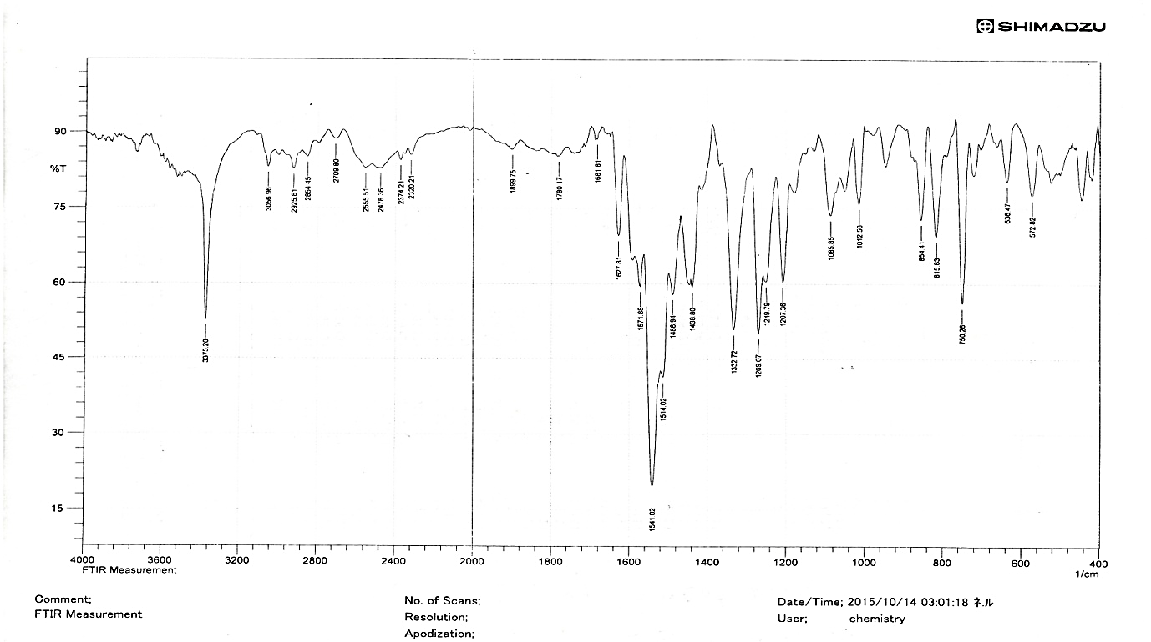

**Checking 1HNMR spectrum compound 2-Aminobenzothiazolomethylnaphtols**

In HNMR observed peak in 6/97 is related to CH and 14 aromatic hydrogen in 7/15-7/75 become visible and peak of 8/76-10/15 is related to NH,OH

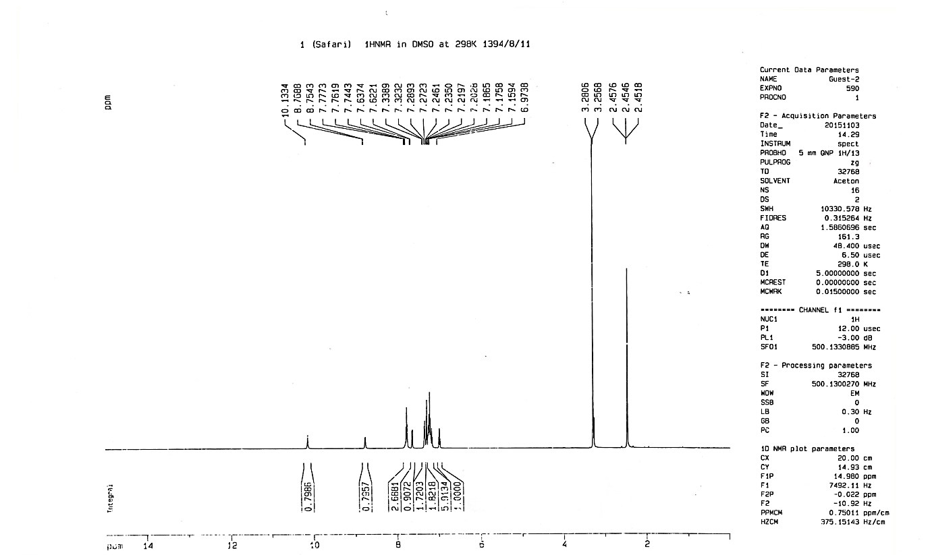

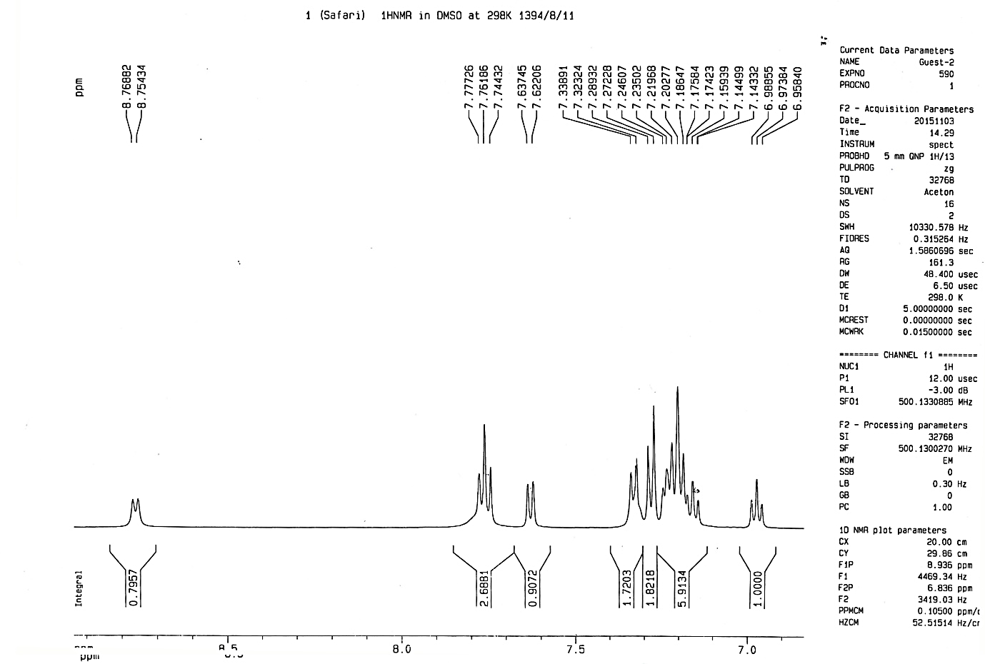

**checking 13CNMR spectrum compound 2-Aminobenzothiazolomethylnaphtols**

In CNMR observed peak in 5/53 is related to the chiral carbon , aromatic carbon have been appeared in the area 119/1-132/9. Carbon peak that is connected to sulfur in 142/5 and observed peaks in 152/9-154/1related to connected carbon to oxygen and nitrogen . carbon peak that is related to nitrogenhas been appeared in 167.

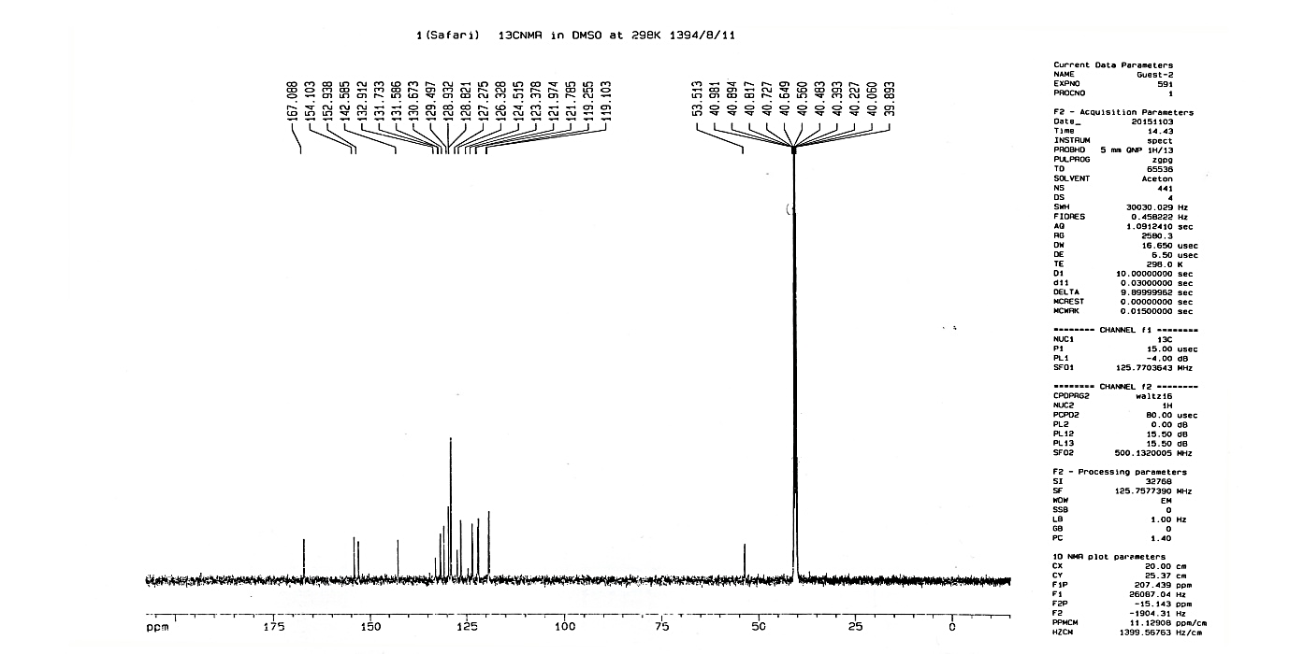

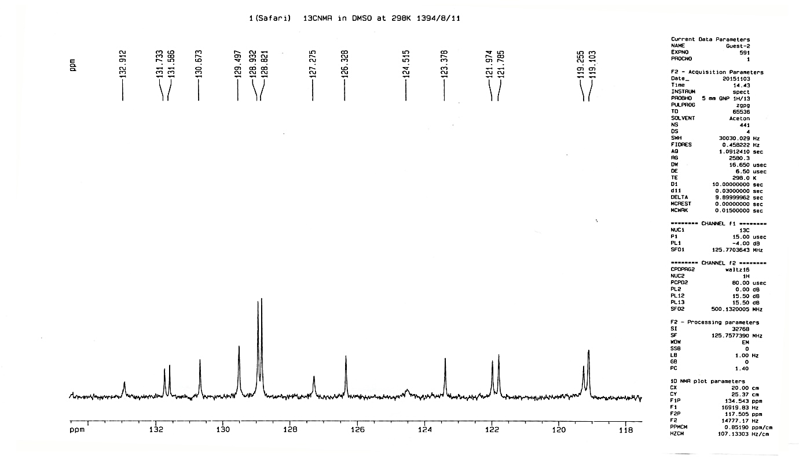

**FT-IR spectrum isinglass**

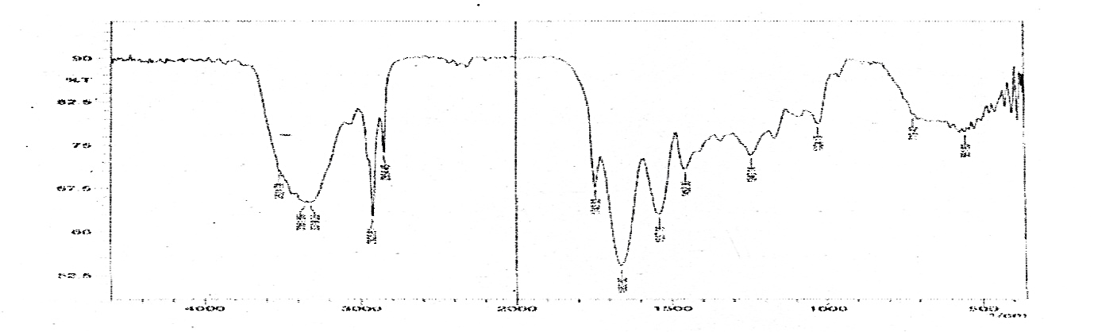

**SEM images of isinglass**

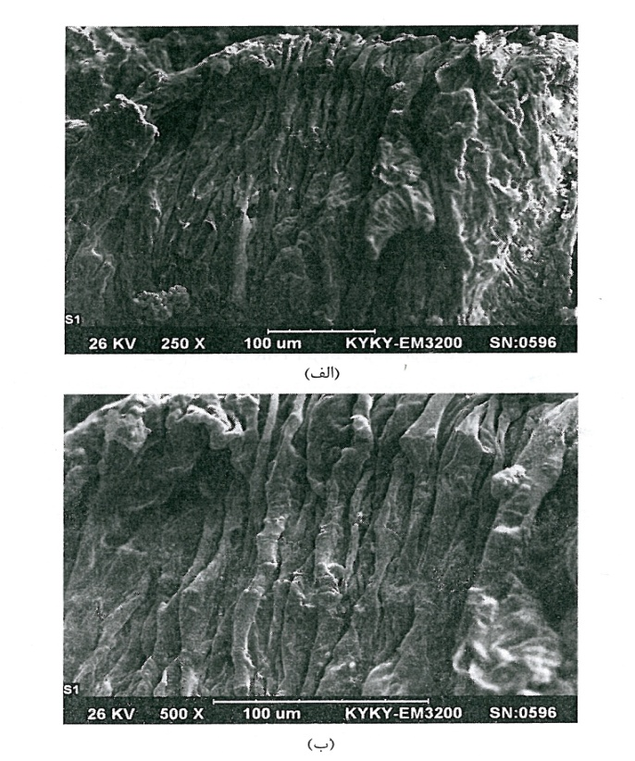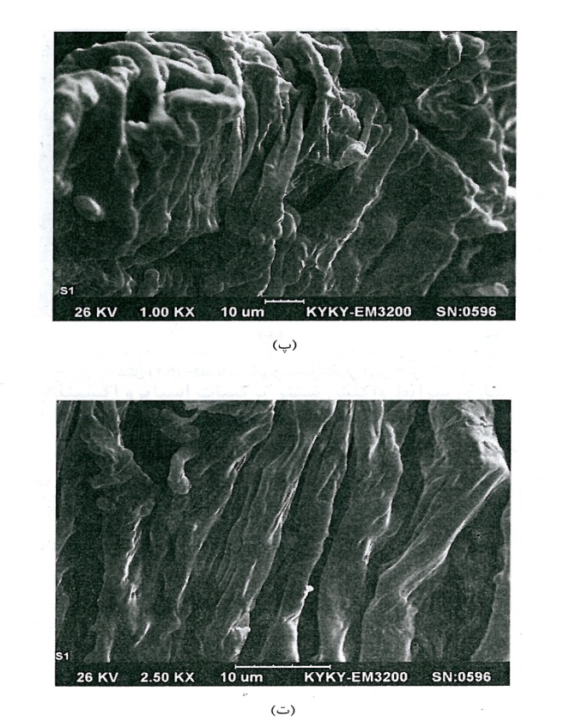

A

D

B

C

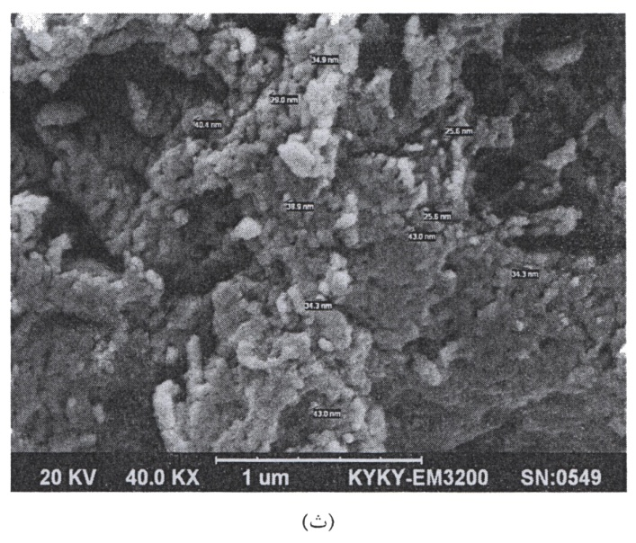

E

**XDR of isinglass**

