Real-world anaplastic lymphoma kinase (ALK) rearrangement testing patterns, treatment sequences, and survival of ALK inhibitor-treated patients

Jessica Daviesª, Michael Martinec^{b}, Mathieu Coudert^{c}, Paul Delmar^{b}, Gracy Craneª

ªRoche Products Ltd, Welwyn, UK; ^{b}F. Hoffmann-La Roche AG, Basel, Switzerland;
^{c}F. Hoffmann-La Roche, Boulogne-Billancourt Cedex, France

Corresponding author: Jessica Davies, Roche Products Ltd, Hexagon Place, Falcon Way, Shire Park, Welwyn Garden City, AL7 1TW, UK; Email: jessica.davies@roche.com

Supplementary Materials
Table 1. Concomitant biomarker alterations and PD-L1 expression
Table 2. Timing of first biomarker testing
Table 3. ALK inhibitor dosing in first cycle of treatment
Figure 1. Survival from advanced diagnosis, segmented by central nervous system metastases at any time

Supplementary Table 1. Concomitant biomarker alterations and PD-L1 expression
Biomarker | Number of patients tested | Number of patients with a valid result | Number of patients with an alteration
ALK | 300 | 293 | 280
EGFR | 255 | 240 | 4
KRAS  ROS-1 | 72  64 | 65  60 | 8  0
RET  PD-L1 | 14  7 | 13  6 | 1  2

Abbreviations: ALK, anaplastic lymphoma kinase; EGFR, epidermal growth factor receptor; PD-L1, programmed death-ligand 1

Supplementary Table 2. Timing of first biomarker testing
Biomarker | Test date | N | Frequency (%)
ALK | Prior to first line  During first line | 247  11 | 82.3  3.7
 | During second line | 3 | 1.0
 | During or after third line | 1 | 0.3
 | Missing test date | 12 | 4.0
 | Not treated, tested after diagnosis | 7 | 2.3
 | Not treated, tested prior to aNSCLC diagnosis | 19 | 6.3
EGFR | Prior to first line  During first line | 218  7 | 85.0  2.7
 | During second line | 1 | 0.4
 | During or after third line | 1 | 0.4
 | Missing test date | 6 | 2.4
 | Not treated, tested after diagnosis | 6 | 2.4
 | Not treated, tested prior to aNSCLC diagnosis | 16 | 6.3
KRAS | Prior to first line  During first line | 62  2 | 86.1  2.8
 | Missing test date | 1 | 1.4
 | Not treated, tested after diagnosis | 2 | 2.8
 | Not treated, tested prior to aNSCLC diagnosis | 5 | 6.9
PD-L1 | Prior to first line  During first line | 3  2 | 42.9  28.6
 | During second line | 1 | 14.3
 | Missing test date | 1 | 14.3
RET | Prior to first line  During first line | 13  1 | 92.9  7.1
ROS1 | Prior to first line  During first line | 52  3 | 81.2  4.7
 | During second line | 1 | 1.6
 | Missing test date | 1 | 1.6
 | Not treated, tested after diagnosis | 2 | 3.1
 | Not treated, tested prior to aNSCLC diagnosis | 5 | 7.8
Abbreviations: ALK, anaplastic lymphoma kinase; aNSCLC, advanced non-small-cell lung cancer; EGFR, epidermal growth factor receptor; PD-L1, programmed death-ligand 1

Supplementary Table 3. ALK inhibitor dosing in first cycle of treatment
ALK inhibitor | Dosing schedule | Dose | N | Frequency (%)
Ceritinib | Once daily | 300 mg | 16 | 11.0
 | Once daily | 450 mg | 23 | 15.8
 | Once daily | 600 mg | 26 | 17.8
 | Once daily | 750 mg | 54 | 37.0
 | Once daily | Other | 12 | 8.2
 | Once daily | Unknown | 2 | 1.4
 | Twice daily | 750 mg | 1 | 0.7
 | Unknown | Unknown | 12 | 8.2
Crizotinib | Once daily | 200 mg | 9 | 2.1
 | Once daily | 250 mg | 48 | 11.1
 | Once daily | Unknown | 1 | 0.2
 | Once every other day | 200 mg | 2 | 0.5
 | Once every other day | 250 mg | 4 | 0.9
 | Other | 200 mg | 1 | 0.2
 | Other | 250 mg | 17 | 3.9
 | Twice daily | 200 mg | 28 | 6.5
 | Twice daily | 250 mg | 271 | 62.6
 | Twice daily | Other | 3 | 0.7
 | Twice daily | Unknown | 5 | 1.2
 | Unknown | 200 mg | 2 | 0.5
 | Unknown | 250 mg | 19 | 4.4
 | Unknown | Unknown | 23 | 5.3

Supplementary Figure 1. Survival from advanced diagnosis, segmented by central nervous system metastases at any time

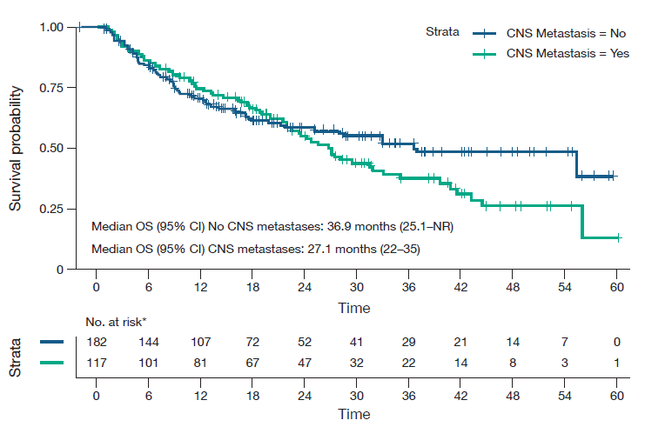
Abbreviations: CI, confidence intervals; CNS, central nervous system; NR, not reached; OS, overall survival.

