Supporting Information
Crystal structures and luminescent properties of a cadmium(II) metal-organic framework based on tri(4-pyridylphenyl)amine

JUN-FENG LI, XIU-DIAN XU, ZE-YU ZHOU, LI-ZHUANG CHEN and FANG-MING WANG*

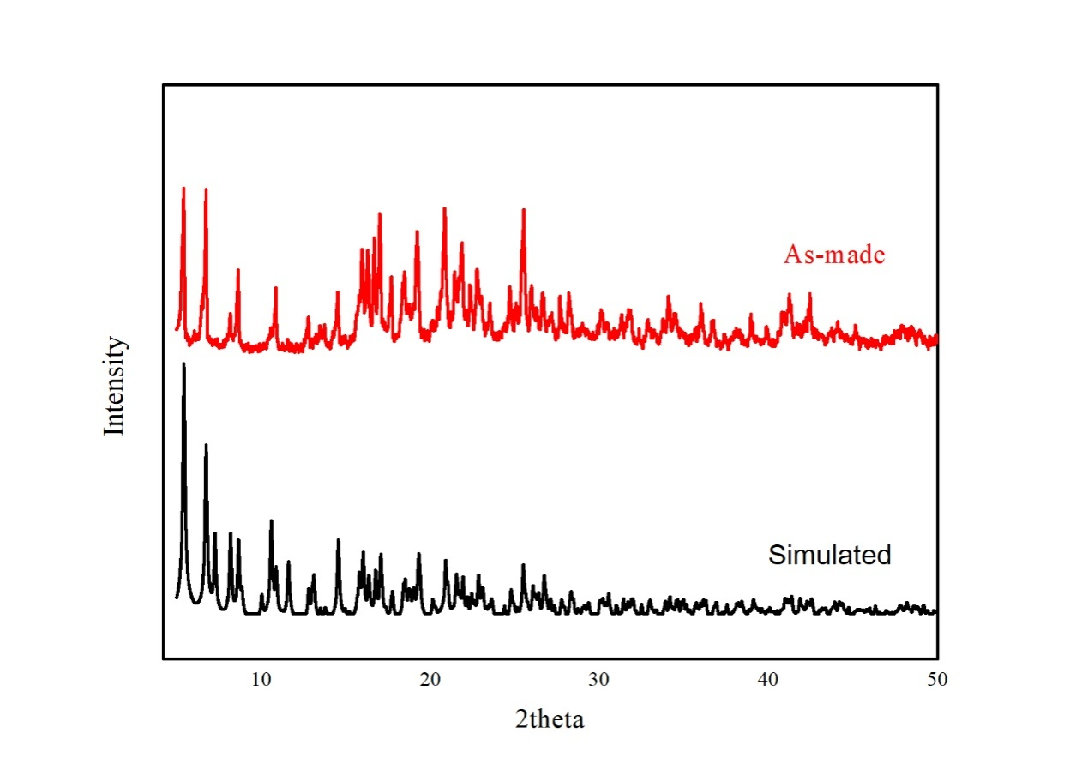
Figure S1. PXRD curve of 1.

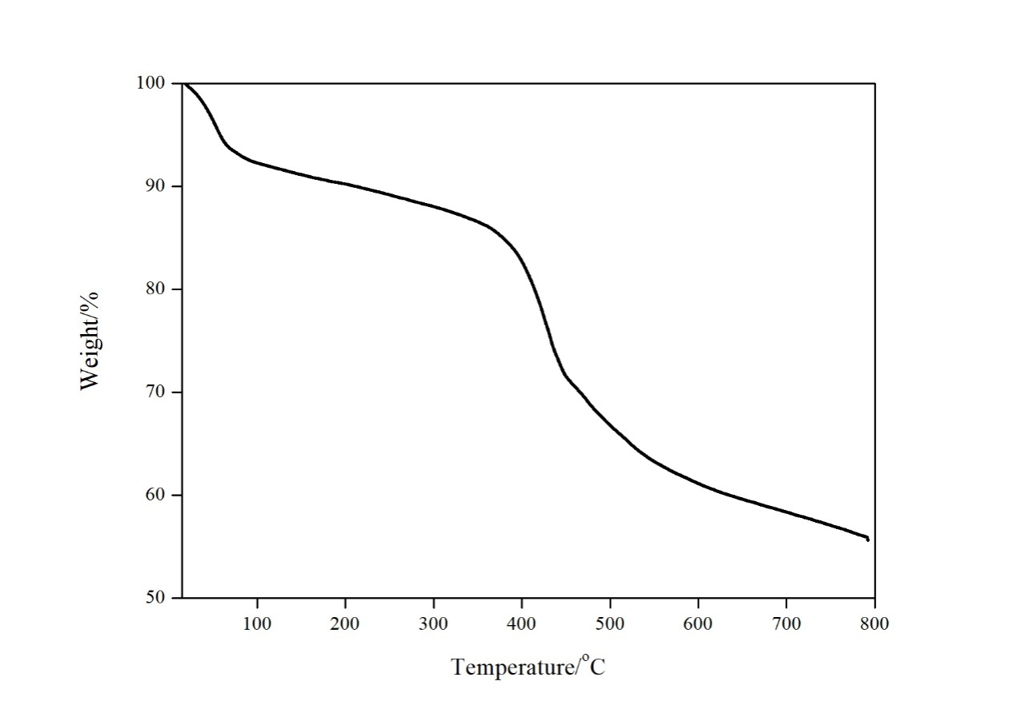
Figure S2. TG curve of 1.

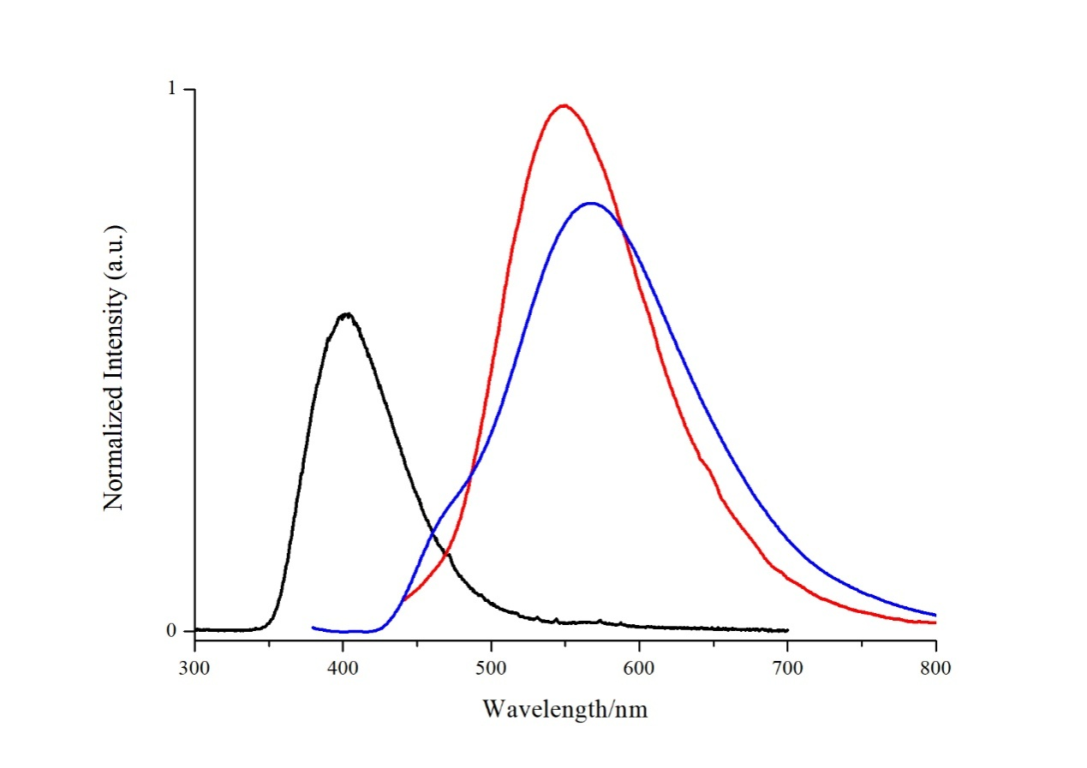
Figure S3. Emission spectra of bpdc (black), tppa (red), 1 (blue) (λ_{ex} = 455 nm).

