Supplementary Material
Supplementary Table 1. Mean AUDPC values for each isolate x variety/accession interaction (germplasm set 1).
B. napus entry
Isolate ID | 06_06_3792 | Marlin | Mystic | Skipton | Tawriffic TT | Thunder TT | Bravo TT | AV Garnet | Warrior | Charlton | Additive AUDPC | Isolates selected for germplasm set 2
CU10.12 | 172 | 243 | 451 | 479 | 494 | 848 | 881 | 1058 | 1152 | 1256 | 7034 | -
CU11.4 | 307 | 406 | 399 | 1340 | 747 | 1031 | 1061 | 1021 | 1239 | 1283 | 8834 | -
CU4.2 | 444 | 491 | 1343 | 1958 | 773 | 1485 | 1424 | 1172 | 1923 | 2215 | 13227 | -
CU11.7 | 774 | 1517 | 694 | 1352 | 1246 | 1497 | 1898 | 1412 | 1345 | 1820 | 13553 | -
CU10.7 | 1087 | 1721 | 923 | 1101 | 899 | 1510 | 1596 | 2258 | 1572 | 2121 | 14786 | -
CU6.1 | 852 | 1724 | 1552 | 1809 | 798 | 1310 | 1434 | 1826 | 2017 | 1797 | 15119 | -
CU10.20 | 539 | 1855 | 1551 | 2477 | 1252 | 1412 | 1093 | 2145 | 1472 | 2142 | 15936 | -
CU10.17 | 1034 | 2148 | 1196 | 2135 | 1310 | 1838 | 2309 | 2206 | 1241 | 1541 | 16956 | yes
CU11.19 | 1280 | 1162 | 1316 | 2444 | 1586 | 1454 | 1709 | 2456 | 2048 | 1880 | 17331 | yes
CU8.20 | 1144 | 1157 | 1721 | 1953 | 1792 | 1749 | 2140 | 1774 | 1889 | 2132 | 17449 | -
CU8.24 | 775 | 1840 | 1862 | 2098 | 1874 | 1145 | 1940 | 1398 | 2366 | 2769 | 18066 | yes
Additive AUDPC | 8406 | 14262 | 13005 | 19144 | 12769 | 15277 | 17485 | 18726 | 18262 | 20955
Supplementary Table 2. Growth on PDA, mycelial compatibility group and IGS haplotype
Isolate ID | Collection location | Collection date | Host species | Adequate growth on PDA | Mycelial compatibility group | IGS haplotype (from Clarkson et al. (2017) | Isolates selected for screening of B. napus germplasm set 1 and 2, respectively
CU1.1 | Mount Barker, Western Australia | 2014 | Brassica napus | No | N/A | 3
CU1.2 | Mount Barker, Western Australia | 2014 | Brassica napus | No | N/A | 3
CU1.3 | Mount Barker, Western Australia | 2014 | Brassica napus | No | N/A | 3
CU2.1 | Mount Barker, Western Australia | 2014 | Brassica napus | Yes | I | 7
CU2.3 | Mount Barker, Western Australia | 2014 | Brassica napus | Yes | I | 7
CU3.1 | Mount Barker, Western Australia | 2014 | Brassica napus | Yes | Unique | 3
CU3.2 | Mount Barker, Western Australia | 2014 | Brassica napus | Yes | I | 7
CU4.1 | Mount Barker, Western Australia | 2014 | Brassica napus | Yes | I | 7
CU4.2 | Mount Barker, Western Australia | 2014 | Brassica napus | Yes | I | 7 | 1
CU5.1 | Mount Barker, Western Australia | 2014 | Brassica napus | Yes | IX | 7
CU5.2 | Mount Barker, Western Australia | 2014 | Brassica napus | Yes | IX | 7
CU5.3 | Mount Barker, Western Australia | 2014 | Brassica napus | No | N/A | 7
CU6.1 | Mount Barker, Western Australia | 2014 | Brassica napus | Yes | II | 7 | 1
CU6.3 | Mount Barker, Western Australia | 2014 | Brassica napus | No | N/A | 7
CU7.2 | Mount Barker, Western Australia | 2014 | Brassica napus | Yes | II | 7
CU7.3 | Mount Barker, Western Australia | 2014 | Brassica napus | Yes | II | 7
CU8.2 | South Stirling, Western Australia | 2014 | Brassica napus | Yes | III | 5
CU8.3 | South Stirling, Western Australia | 2014 | Brassica napus | Yes | IX | 7
CU8.5 | South Stirling, Western Australia | 2014 | Brassica napus | Yes | II | 7
CU8.12 | South Stirling, Western Australia | 2014 | Brassica napus | No | N/A | 5
CU8.13 | South Stirling, Western Australia | 2014 | Brassica napus | Yes | IX | 7
CU8.14 | South Stirling, Western Australia | 2014 | Brassica napus | Yes | I | 7
CU8.19 | South Stirling, Western Australia | 2014 | Brassica napus | Yes | III | 5
CU8.20 | South Stirling, Western Australia | 2014 | Brassica napus | Yes | III | 5 | 1
CU8.21 | South Stirling, Western Australia | 2014 | Brassica napus | Yes | III | 5
CU8.22 | South Stirling, Western Australia | 2014 | Brassica napus | Yes | IV | 3
CU8.23 | South Stirling, Western Australia | 2014 | Brassica napus | Yes | I | 7
CU8.24 | South Stirling, Western Australia | 2014 | Brassica napus | Yes | IV | 3 | 1 and 2
CU8.25 | South Stirling, Western Australia | 2014 | Brassica napus | Yes | III | 5
CU8.30 | South Stirling, Western Australia | 2014 | Brassica napus | Yes | XII | 7
CU8.31 | South Stirling, Western Australia | 2014 | Brassica napus | Yes | Unique | 3
CU10.1 | Geraldton, Western Australia | 2014 | Brassica napus | Yes | X | 5
CU10.2 | Geraldton, Western Australia | 2014 | Brassica napus | Yes | Unique | 5
CU10.3 | Geraldton, Western Australia | 2014 | Brassica napus | Yes | VII | 5
CU10.4 | Geraldton, Western Australia | 2014 | Brassica napus | Yes | Unique | 7
CU10.5 | Geraldton, Western Australia | 2014 | Brassica napus | Yes | V | 5
CU10.6 | Geraldton, Western Australia | 2014 | Brassica napus | Yes | XII | 7
CU10.7 | Geraldton, Western Australia | 2014 | Brassica napus | Yes | V | 5 | 1
CU10.8 | Geraldton, Western Australia | 2014 | Brassica napus | Yes | V | 5
CU10.9 | Geraldton, Western Australia | 2014 | Brassica napus | Yes | Unique | 7
CU10.10 | Geraldton, Western Australia | 2014 | Brassica napus | Yes | V | 5
CU10.11 | Geraldton, Western Australia | 2014 | Brassica napus | No | N/A | 5
CU10.12 | Geraldton, Western Australia | 2014 | Brassica napus | Yes | VI | 3 | 1
CU10.13 | Geraldton, Western Australia | 2014 | Brassica napus | Yes | Unique | 5
CU10.14 | Geraldton, Western Australia | 2014 | Brassica napus | Yes | VI | 3
CU10.15 | Geraldton, Western Australia | 2014 | Brassica napus | Yes | Unique | 5
CU10.16 | Geraldton, Western Australia | 2014 | Brassica napus | Yes | Unique | 7
CU10.17 | Geraldton, Western Australia | 2014 | Brassica napus | Yes | VII | 5 | 1 and 2
CU10.18 | Geraldton, Western Australia | 2014 | Brassica napus | Yes | Unique | 5
CU10.19 | Geraldton, Western Australia | 2014 | Brassica napus | Yes | Unique | 5
CU10.20 | Geraldton, Western Australia | 2014 | Brassica napus | Yes | VIII | 3 | 1
CU11.1 | Eneabba, Western Australia | 2013 | Lupinus albus | Yes | VIII | 3
CU11.2 | Geraldton, Western Australia | 2014 | Lupinus albus | Yes | XI | 5
CU11.3 | Eneabba, Western Australia | 2013 | Lupinus albus | Yes | IX | 7
CU11.4 | Eneabba, Western Australia | 2013 | Lupinus albus | Yes | IX | 7 | 1
CU11.5 | Eneabba, Western Australia | 2013 | Lupinus albus | Yes | Unique | 7
CU11.6 | Eneabba, Western Australia | 2013 | Lupinus albus | Yes | Unique | 7
CU11.7 | Eneabba, Western Australia | 2013 | Lupinus albus | Yes | X | 5 | 1
CU11.8 | Eneabba, Western Australia | 2013 | Lupinus albus | Yes | IX | 7
CU11.9 | Eneabba, Western Australia | 2013 | Lupinus albus | Yes | IX | 7
CU11.10 | Eneabba, Western Australia | 2013 | Lupinus albus | Yes | Unique | 5
CU11.11 | Eneabba, Western Australia | 2013 | Lupinus albus | Yes | XII | 7
CU11.12 | Eneabba, Western Australia | 2013 | Lupinus albus | Yes | V | 5
CU11.13 | Eneabba, Western Australia | 2013 | Lupinus albus | Yes | Unique | 3
CU11.14 | Eneabba, Western Australia | 2013 | Lupinus albus | Yes | Unique | 5
CU11.15 | Eneabba, Western Australia | 2013 | Lupinus albus | Yes | Unique | 5
CU11.17 | Eneabba, Western Australia | 2013 | Lupinus albus | Yes | IX | 7
CU11.18 | Eneabba, Western Australia | 2013 | Lupinus albus | Yes | Unique | 5
CU11.19 | Geraldton, Western Australia | 2014 | Lupinus albus | Yes | XI | 5 | 1 and 2
CU11.20 | Eneabba, Western Australia | 2013 | Lupinus albus | Yes | Unique | 5
CU11.21 | Eneabba, Western Australia | 2013 | Lupinus albus | Yes | III | 5
CU1.1 | Mount Barker, Western Australia | 2014 | Brassica napus | No | N/A | 3
CU1.2 | Mount Barker, Western Australia | 2014 | Brassica napus | No | N/A | 3
CU1.3 | Mount Barker, Western Australia | 2014 | Brassica napus | No | N/A | 3
CU2.1 | Mount Barker, Western Australia | 2014 | Brassica napus | Yes | I | 7
CU2.3 | Mount Barker, Western Australia | 2014 | Brassica napus | Yes | I | 7
CU3.1 | Mount Barker, Western Australia | 2014 | Brassica napus | Yes | Unique | 3

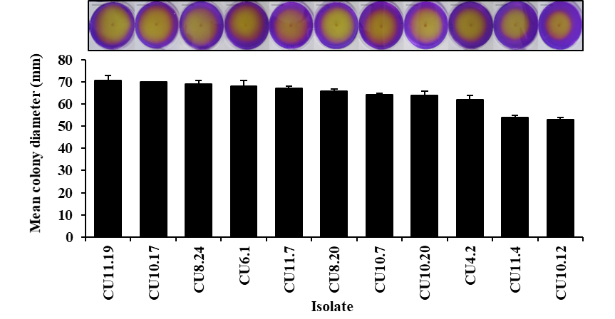
Supplementary Fig 1. Images show 11 S. sclerotiorum isolates grown on PDA supplemented with the pH indicator, bromophenol blue, which turns the initial purple medium at pH 7 to yellow at pH 4 (scale bar = 15 mm). The histogram shows the mean colony diameter on PDA of the same isolates at 48 hpi. Error bars = 1 standard deviation.

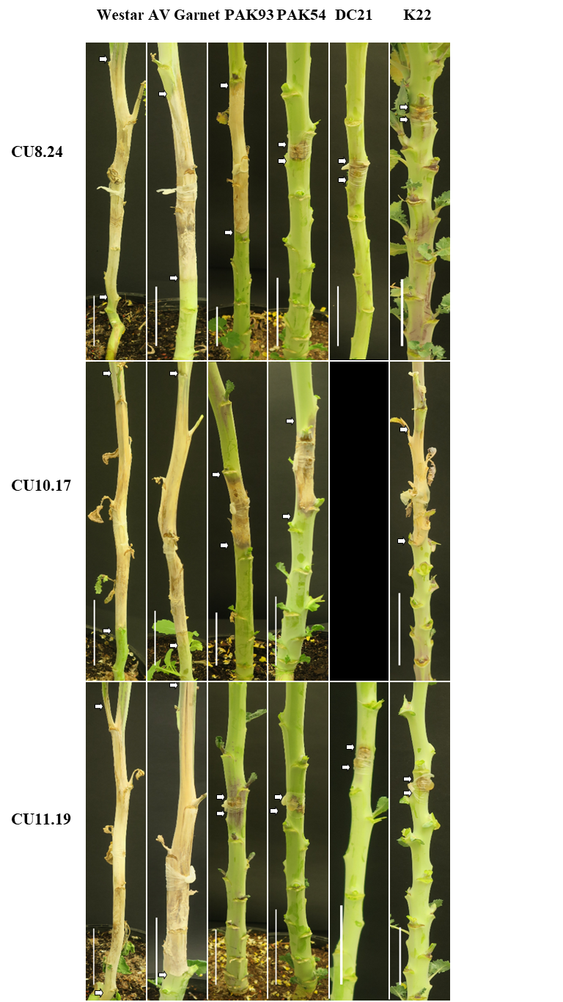
Supplementary Fig. 2. Six B. napus accessions in germplasm set 2 inoculated with three S. sclerotiorum isolates separately. The white arrows indicate lesion boundaries on each stem 21 days post inoculation. Scale bar = 50 mm.

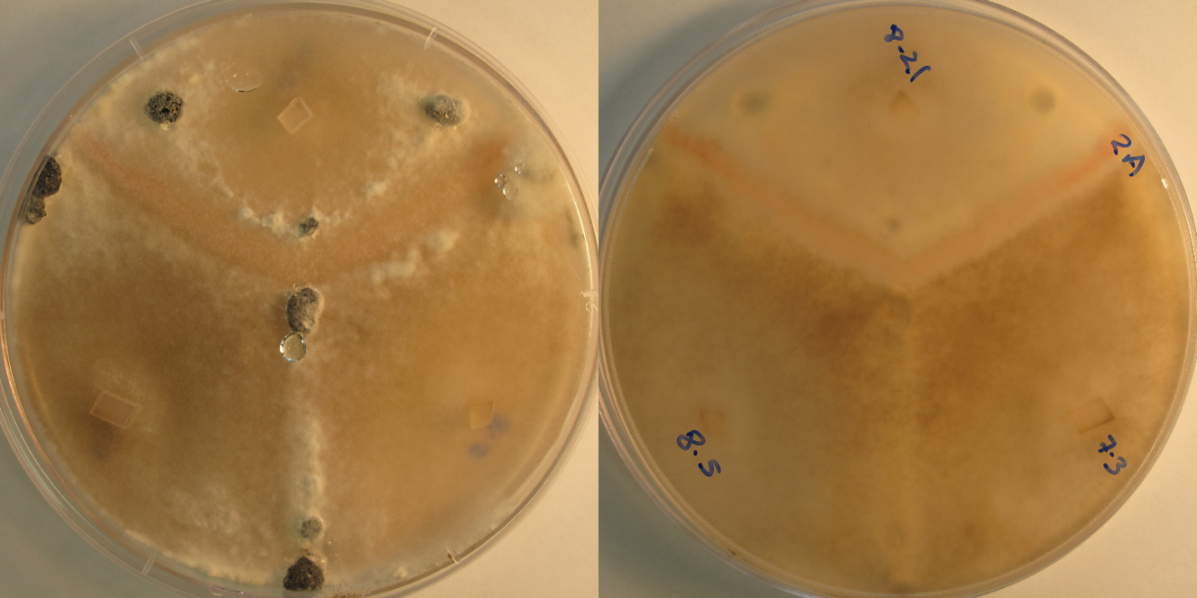
Supplementary Fig. 3. Three S. sclerotiorum isolates grown on PDA amended with red food colouring seen from above (left side) and below (right side). Isolate CU8.21 is incompatible with the two other isolates, CU7.3 and CU8.5, as evident by the barrage between their mycelium (left) and the red V-shaped border (right).

