**Supporting Information**

**Poly (methyl methacrylate)-graphene oxide supported palladium catalyst: A ligand free protocol for Suzuki and Heck coupling reaction in water medium**

Puja Basak and Pranab Ghosh**\***

*Department of Chemistry, University of North Bengal, District-Darjeeling, West Bengal, India.*

Tel.: +91 (0353) 2776381; fax: +91 (0353) 2699001

E-mail address: [pizy12@yahoo.com](mailto:pizy12@yahoo.com) (P.Ghosh).

**List of contents**

1. Experimental section [1-3]
2. Spectroscopy data of synthesized Suzuki and Heck cross coupled products [4-8]
3. Scanned copies of 1H and 13C NMR spectra of prepared products [7-19]

**Experimental Section**

**Materials and physical measurements**

Palladium (II) acetate 99.98% was purchased from Sigma Aldrich. Graphite powder, H2O2 (solution 30%), 98.5% pure methyl methacrylate were purchased from commercial supplier. The morphology of the catalyst (GO-PMMA-Pd) was analyzed by Transmission Electron Microscope (TEM, Model: JEM-2100, accelerating voltages 60-200 KV in 50 V steps; resolution: 1.9 Å to 1.4Å). Inductively coupled plasma spectroscopy (ICP) was analysed on ARCOS, Simultaneous ICP spectrometer (SPECTRO analytical instruments GmbH, Germany). Powder XRD data was obtained from Bruker D8 Advanced X-ray Powder Diffractometer (Cu Kα radiation, *λ* = 1.54 Å). NMR spectra were taken in CDCl3 using a Bruker AV‒300 spectrometer operating for 1H at 300 MHz and for 13C at 75 MHz. 1H NMR spectroscopic data are represented as follows: chemical shift (ppm), multiplicity (s = singlet, d= doublet, t = triplet, dd = doublet of doublets, m = multiplet, br = broad), integration, coupling constants in Hertz (Hz). 13C NMR spectroscopic data are reported in ppm. Coupling constants were reported as *J* values in Hertz (Hz).

**General procedure for preparation of GO-PMMA-supported Pd catalyst**

Initially for the preparation of catalyst 20 mg GO was suspended in 20 mL of toluene. The slurry was then dispersed for ultrasonication through 60 min. After ultrasonication methyl methacrylate was injected to well dispersed solution of GO. Benzoyl peroxide (BZP) 0.1 mol% was added to initiate the polymerization of methyl methacrylate (MMA). The resulting mixture was then stirred well at 90 oC for 4 h.The temp of the solution was maintained at 90 oC. Stirring was continued for another 3h followed by the addition of 40 mg Pd(OAc)2 and 100 mg of HCOOH. The dark brown precipitate instantly turned into black after the addition of HCOOH. The obtained residue was washed several times with water and residual solvent was shuffled off by rotary evaporator, and dried at 60 oC.

**Procedure for cross coupling of 4-iodo anisole and phenyl boronic acid using GO-PMMA-Pd catalyst**

25-ml RB was charged with 4-iodo anisole (1.0 mmol), phenyl boronic acid (1.5 mmol), GO-PMMA-Pd catalyst (0.3 mol %), K2CO3 (1 mmol), TBAB (10 mol %) and 2 ml water. The mixture was allowed to stir at 90 oC for an appropriate time (Table 1) and the extent of the reaction was monitored by thin layer chromatography (TLC). After the completion of the reaction, the reaction mixture was extracted by ethyl acetate (2×25 mL) and washed with water repeatedly. The catalyst was filtered off and washed several times with ether and water (1:1) until no significant product was obtained in the wash. The recoverd catalyst was reused for the next coupling experiment. The reaction mixture was dried over anhydrous Na2SO4, concentrated in vacuum and purified by column chromatography on silica gel 60-120 mesh using petroleum ether as eluent to obtain pure product. The catalyst recoverd after 5th run was subjected to ICP-AES for Pd content analysis. The isolated products were analysed by 1H NMR and 13C NMR spectroscopy.

**General procedures for the Heck coupling reactions**

A mixture of 4-iodo anisole (1 mmol), methyl acrylate (2 mmol), GO-PMMA-Pd catalyst (0.2 mol %), K2CO3 (1 mmol), TBAB (10 mol %) and 3ml water was stirred under 100 oC. The reaction took significant time for completion (Table. 3) and the progress of the reaction was monitored by TLC. After completion, the reaction mixture was extracted with ethyl acetate and washed with water repeatedly. The combined organic mixture was dried over anhydrous NaSO4 and purified by column chromatography using petroleum ether/ethyl acetate as eluent to afford pure product. The catalyst was separated and washed for several times with ether and water. The recovered catalyst was used in next cycles and the isolated products were characterized by 1H and 13C NMR spectroscopy.

All products were prepared by the same method and were all known compounds with spectroscopic data identical to those reported in the literature. [A-H]

**2. Spectral data of compounds**



**4-methoxy-1,1׳ biphenyl** : (Yield 90%) 1H NMR (CDCl3, 300 MHz) δ 3.85 (s, 3H), 6.98 (d, 2H, *J* = 6.9 Hz), 7.24-7.32 (1H, m), 7.39 (d, 2H, *J* = 7.8Hz), 7.51-7.56 (m, 4H, *J* = 8.7 Hz); 13C NMR δ 55.37, 114.22, 126.68, 126.76, 128.18, 128.75, 133.80, 140.85,159.16.[D]



**3-methoxy-1,1׳-biphenyl** : (Yield 88%) 1H NMR (CDCl3, 300 MHz) δ 3.84 (s,3H), 6.89 (d, *J* = 8.1 Hz, 1H), 7.12-7.18 (m, 2H), 7.31-7.36 (m, 2H), 7.39-7.44 (m, 2H), 7.58 (d, *J* = 8.1 Hz, 2H); 13C NMR δ 55.33, 112.72, 112.95, 119.74, 127.25, 127.47, 128.79, 129.81, 141.15, 142.82, 159.89. [D]



**3-nitro-1,1’-biphenyl** : (Yield 92%) 1H NMR (CDCl3, 300MHz) δ 8.41 (s, 1H), 8.15 (s,1H), 7.87 (s,1H), 7.41-7.59 (m, 7H, *J* = 8.4Hz); ); 13C NMR δ 121.93, 122.04, 127.17, 128.58, 129.20, 129.70, 133.06, 138.65, 142.86, 148.74.[D]



**4-methyl-1,1׳-biphenyl** : (Yield 86%) 1H NMR (CDCl3, 300MHz) δ 2.174(s, 3H), 6.95-6.99( d, 2H, *J* = 6.9Hz), 7.23-7.31(m, 1H), 7.384-7.511( m, 2H), 7.52-7.56(q, 4H); 13C NMR δ 21.12, 122.00, 127.01, 128.74, 129.20, 129.50, 133.07.[D]



**3-methyl 1,1’-biphenyl**: (Yield 84%) 1H NMR(CDCl3, 300MHz) δ 2.39 (s, 3H), 6.88 (d, *J* = 8.1Hz, 1H), 7.13-7.19(m, 2H), 7.31-7.36 (m, 2H), 7.42-7.44 (m, 2H), 7.59 (d, *J* = 8.1Hz, 2H); 13C NMR δ 26.68, 124.30, 127.20, 127.28, 128.02, 128.69, 128.78, 138.35, 141.26, 141.37. [H]



**4-acetyl 1,1’-biphenyl :** (Yield 93%) 1H NMR (CDCl3, 300MHz) δ 2.68 ( s,3H), 7.39-7.49 ( m, 3H, *J* = 7.5Hz), 7.61-7.68 (M, 4H, *J* = 7.2Hz), 8.00 ( d, 2H, *J* = 8.1Hz); 13C NMR δ 26.68, 127.24, 127.29, 128.26, 128.94, 128.98, 135.86, 139.87, 145.79, 197.80.[C]



**4-methoxy-3-methyl-1,1’-biphenyl** : (Yield 85%) 1H NMR (CDCl3, 300MHz) δ 2.28 (s, 3H), 3.86 (s, 3H), 7.17 (s, 1H), 6.81(s, 1H), 7.39 (4H, ), 7.559 (2H, ); 13C NMR δ 16.43, 55.45, 110.17, 126.40, 126.55, 126.78, 126.91, 128.69, 129.52, 133.36, 141.07, 157.39.[C]



**4-methyl-4’-methoxy-1,1’-biphenyl** : (Yield 86%) 1H NMR (CDCl3, 300MHz) δ 2.39 (s,3H), 3.84 (s, 3H), 6.97 (d, 2H, *J* =7.5Hz), 7.23 ( d, 2H, *J* = 8.4Hz), 7.44-7.55 (m, 4H); 13C NMR δ 24.25, 58.52, 117.34, 129.77, 131.14, 132.64, 136.92, 139.55, 141.14, 162.10.[D]



**2-phenylthiophene :** (Yield 58%)13C NMR (CDCl3, 300MHz) δ 118.98, 126.24, 127.97, 129.06, 130.63, 131.21, 132.06, 137.51.[A]



**(E)-methyl 3-(3-nitrophenyl) acrylate :**  (Yield 88%) 1H NMR(CDCl3, 300MHz) δ 3.84(s, 3H), 6.57 ( d, *J* = 15.9Hz), 7.57-7.84(m, 3H), 8.24( d, 1H, *J* = 8.1Hz), 8.38 ( s,1H); 13C NMR δ 55.18, 124.10, 125.58, 127.70, 133.12, 136.78, 139.24, 145.12, 151.81, 169.73. [F]



**(E)-methyl 3-(4-methoxyphenyl) acrylate :** (Yield 85%) 1H NMR(CDCl3, 300MHz) δ 3.68 ( s, 1H), 3.77 (s, 1H), 6.47 (d, 1H, *J* = 15.9Hz), 6.95 (d, 2H, *J* = 8.7Hz), 7.65 (d, 3H, J = 8.8Hz); 13C NMR δ 51.27, 55.29, 114.33, 115.03, 126.57, 130.13, 144.31, 161.11, 166.91.[B]



**(E)-ethyl 3-(4-methoxyphenyl) acrylate :** (Yield 83%) 1H NMR (CDCl3, 300MHz) δ 0.982-1.026 ( t, 3H), 3.47 (s, 1H), 4.13-4.17 (q, 2H), 6.43 (d, *J* =16.2Hz, 1H), 6.92-6.95 (d, 2H, *J* = 8.4Hz), 7.58-7.62 (m,3H); 13C NMR δ 14.06, 55.08, 59.71, 114.21, 115.30, 116.53, 126.58, 129.92, 137.84, 144.00, 161.04, 166.39. [E]



**(E)-butyl 3-(4-methoxyphenyl) acrylate :** (Yield 84%) 1H NMR(CDCl3, 300MHz) δ1.00 (t, 3H, *J* = 6.6Hz), 1.44 (m, 2H), 1.69 (m,2H), 3.80 (s, 3H), 4.16-4.23 ( t, 2H, *J* = 6.6Hz), 6.89 (2H, d, *J* = 8.7Hz), 7.63 (d, 1H, *J* = 16.2Hz), 7.47 (t, 3H); 13C NMR δ 16.90, 22.35, 33.96, 58.43, 67.37, 117.42, 118.85, 130.30, 132.81, 147.34, 164.46, 170.54. [G]



**1-(4-styrylphenyl)ethanone :** (Yield 79%) 1H NMR(CDCl3, 300MHz) δ 2.55 (s, 3H), 7.08-7.19(m, 2H), 7.21 (d, 1H, *J* = 16.8Hz), 7.29-7.58 (m, 5H), 7.97 ( d, 2H, *J* = 8.4Hz); 13C NMR δ 29.79, 129.70, 130.02, 130.62, 131.52, 132.00, 132.08, 134.65, 139.12, 139.87, 145.19, 200.71.[E]

**3. Scanned copies of 1H and 13C NMR spectra of prepared products**

**1H and 13C NMR of 4-methoxy-1,1׳ biphenyl**

**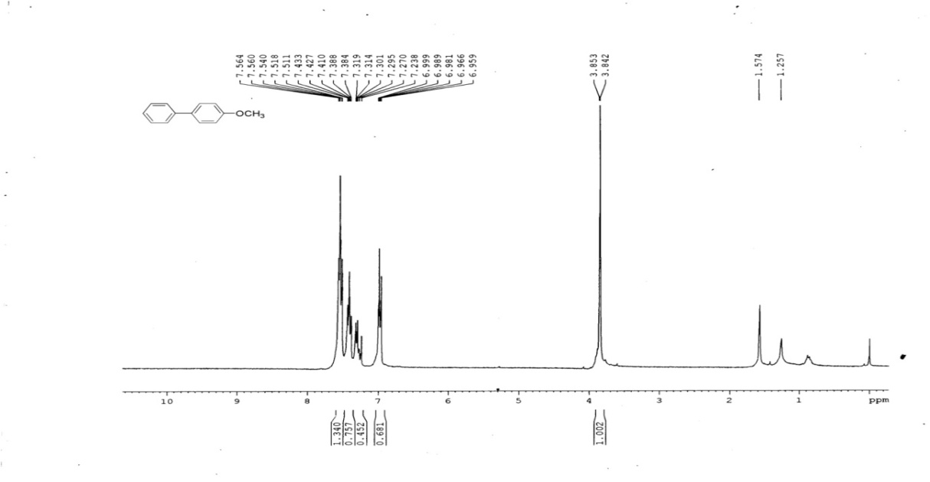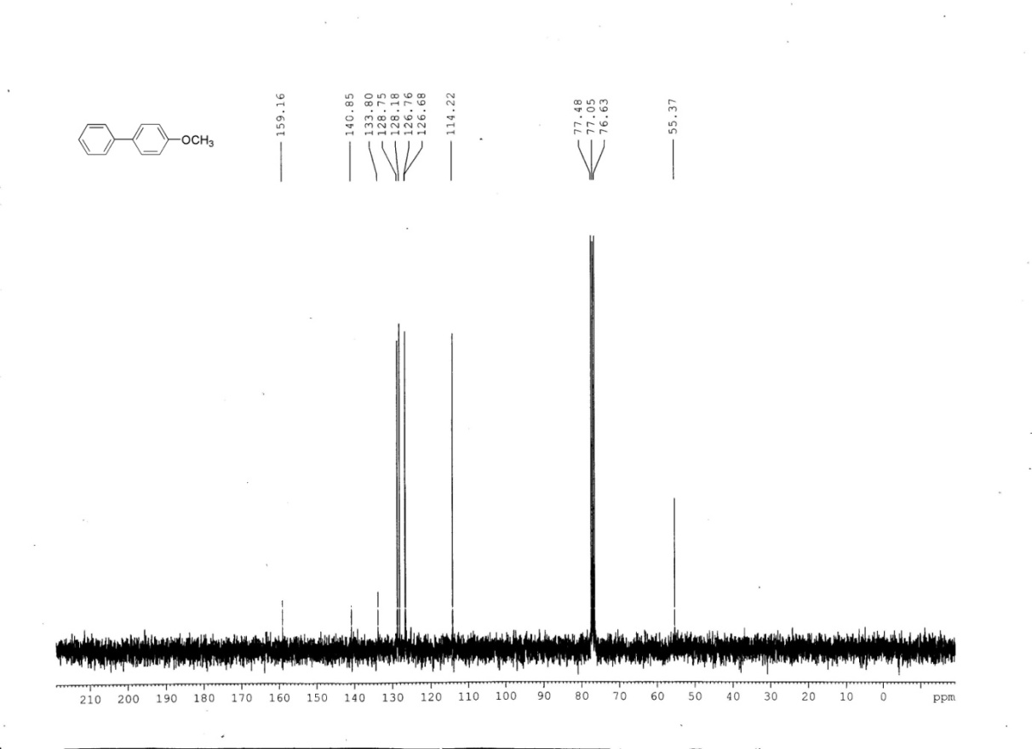**

**1H and 13C NMR of 3-methoxy-1,1׳-biphenyl**

**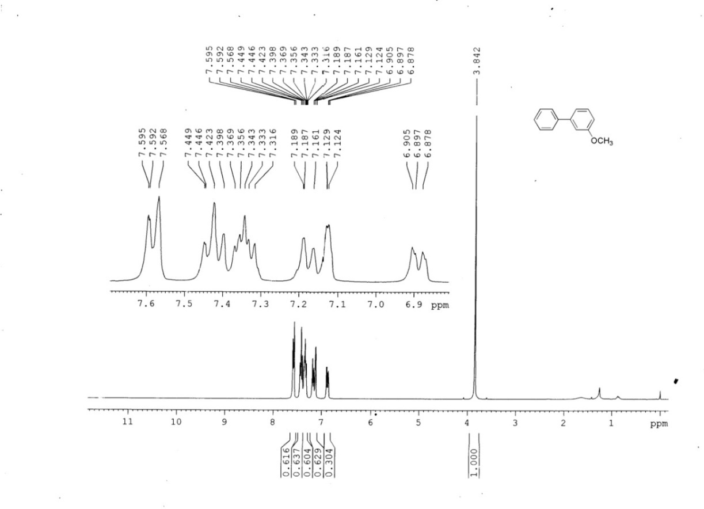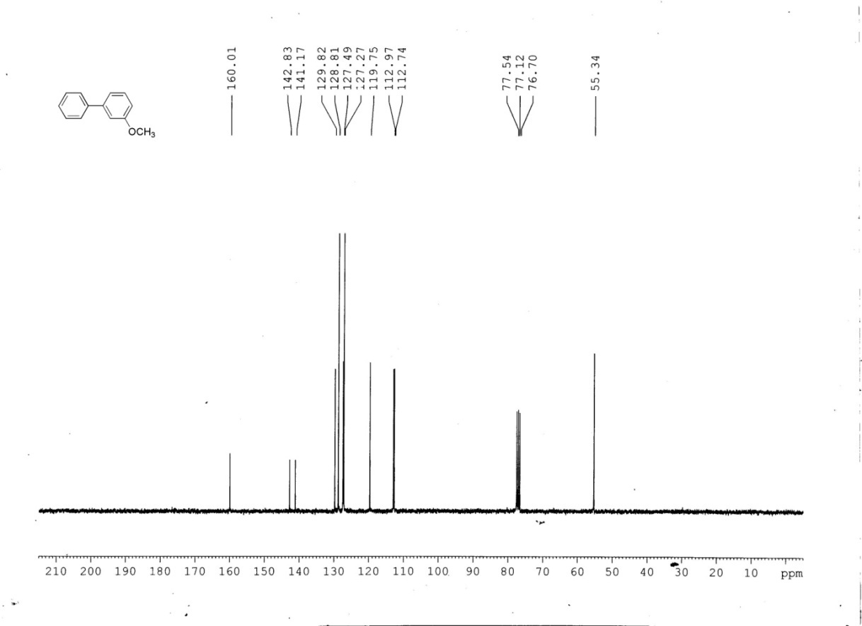**

**1H and 13C NMR of 3-nitro-1,1’-biphenyl**

**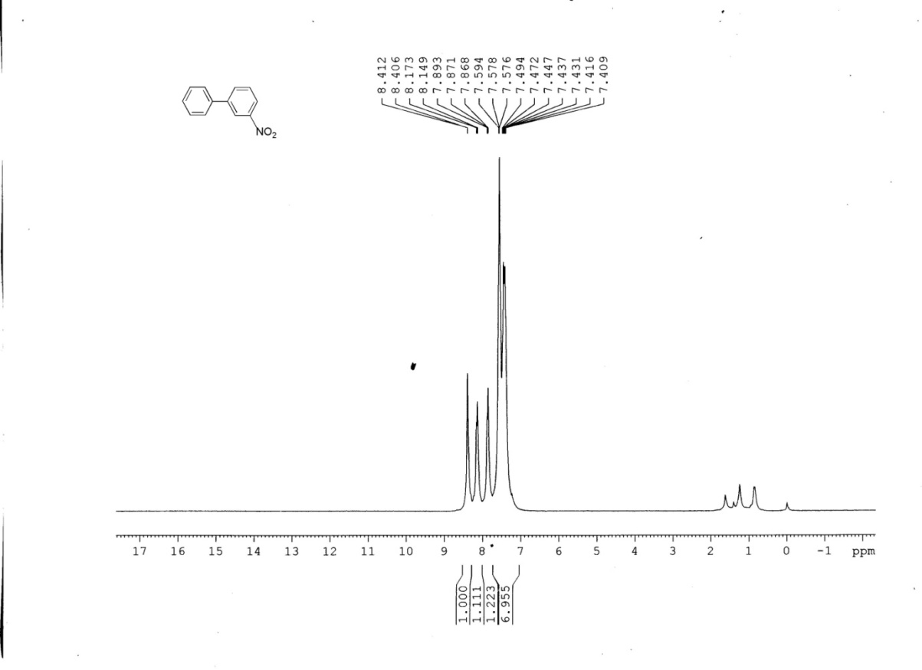C:\Users\Lenovo\Desktop\paper nmr revised\scan0001_002.tif**

**1H and 13C NMR of 4-methyl-1,1׳-biphenyl**

**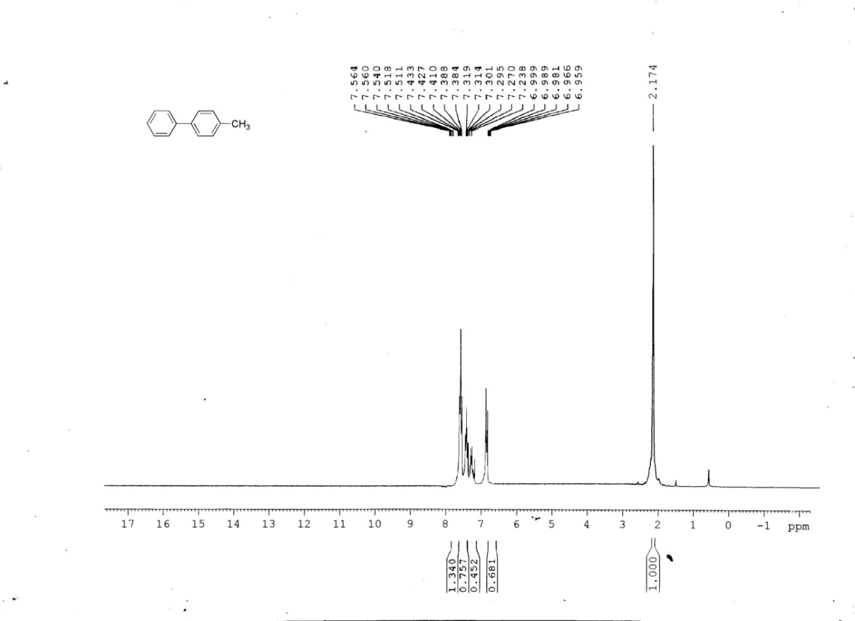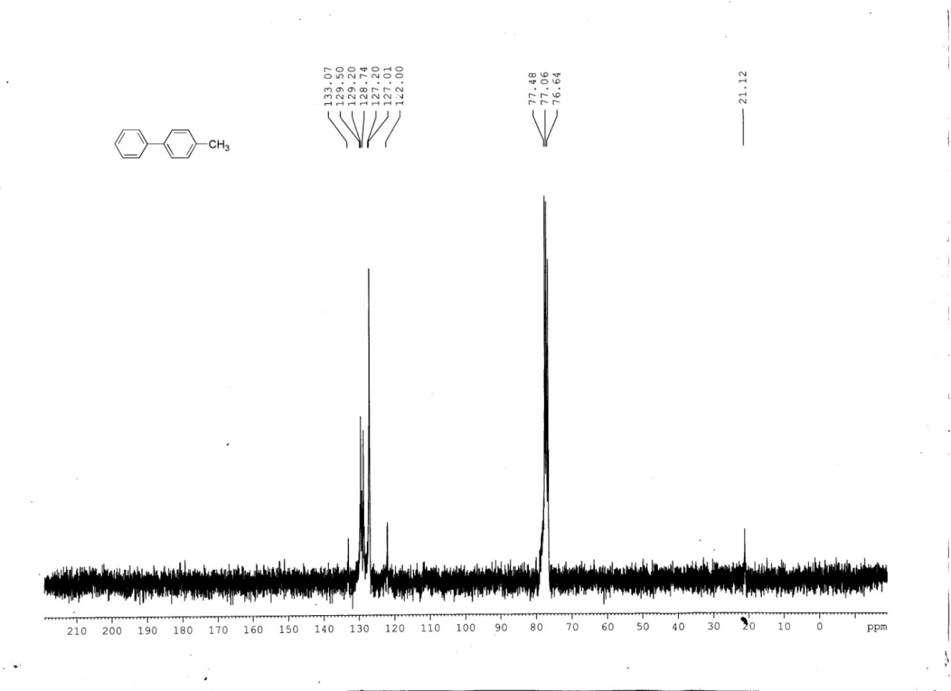**

**1H and 13C NMR of 4-acetyl-1,1’-biphenyl**

C:\Users\Lenovo\Desktop\paper nmr revised\scan0001_004.tifF:\Edited\scan0001\scan0001_003.tif

**1H and 13C NMR of 4-methoxy-3-methyl-1,1’-biphenyl**

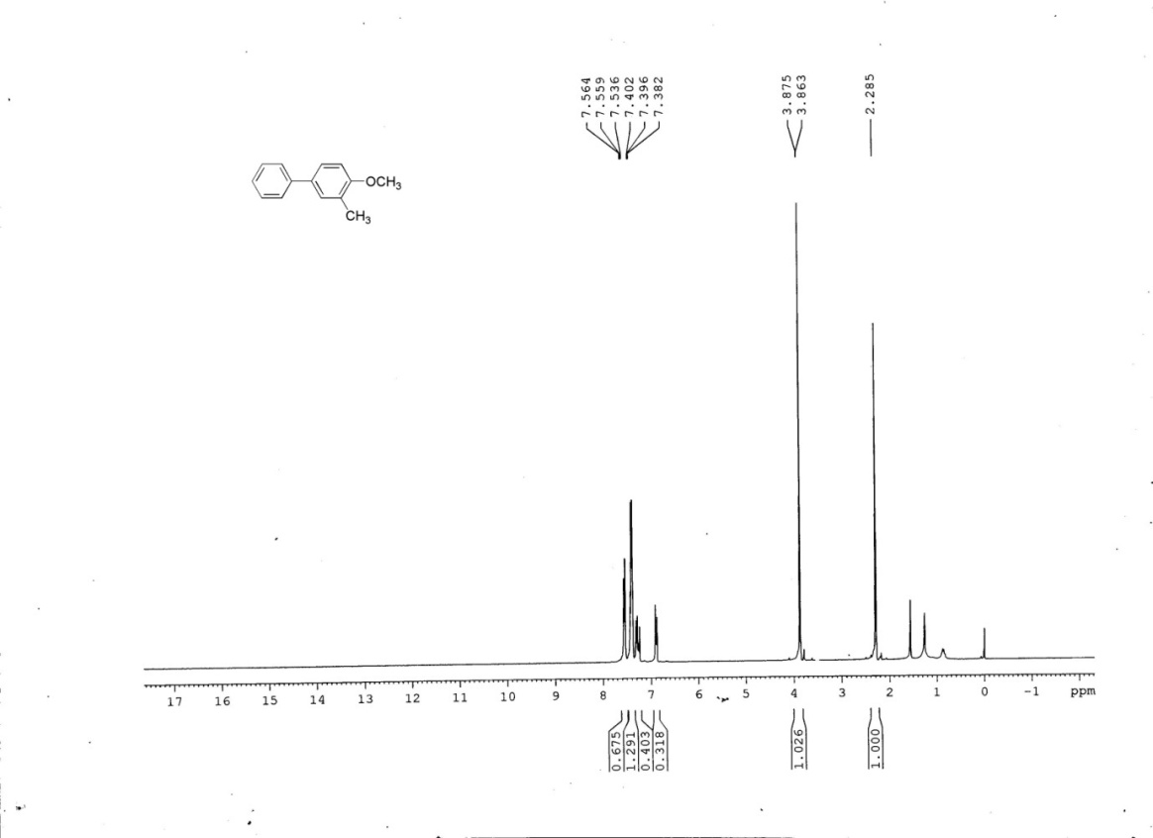

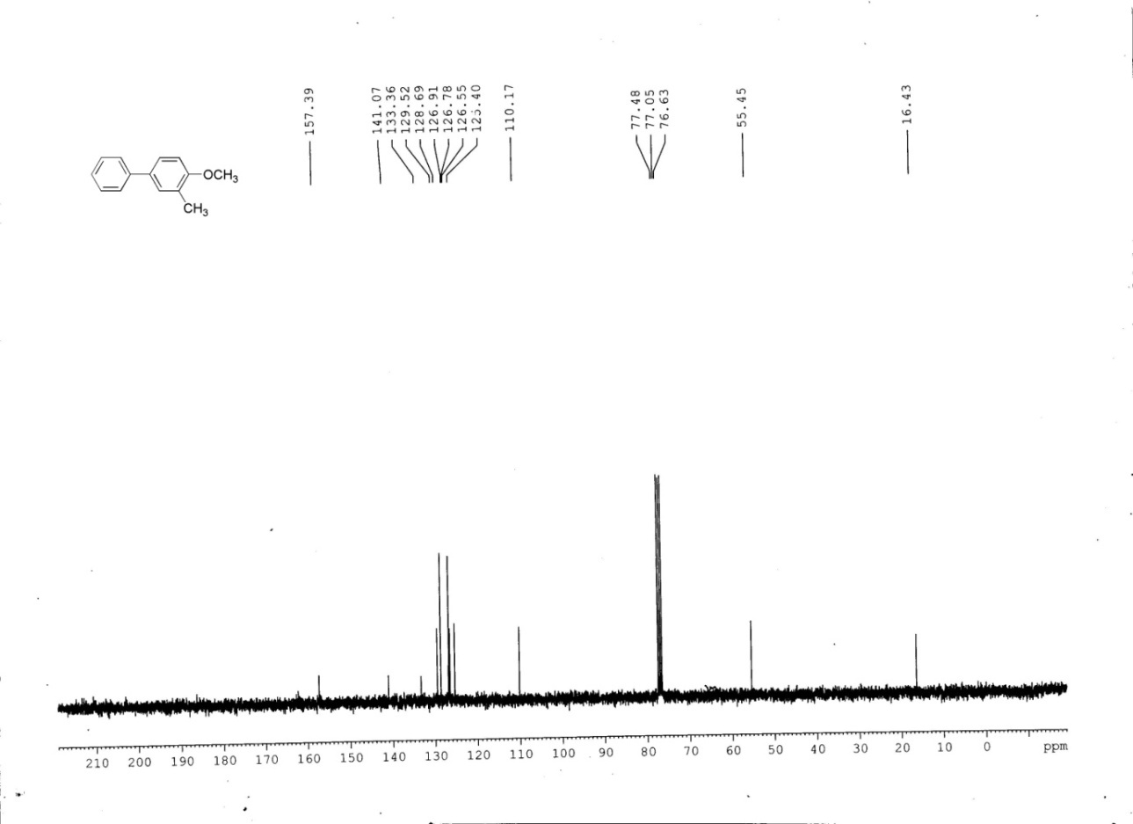

**1H and 13C NMR of 4-methyl-4’-methoxy-1,1’-biphenyl**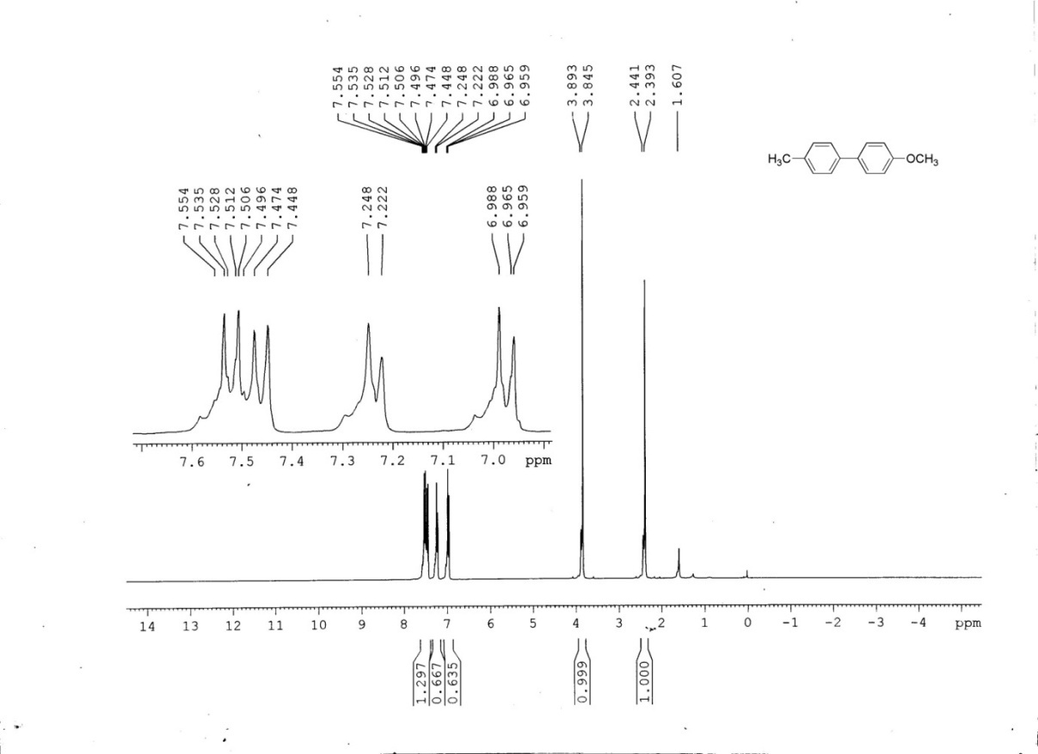**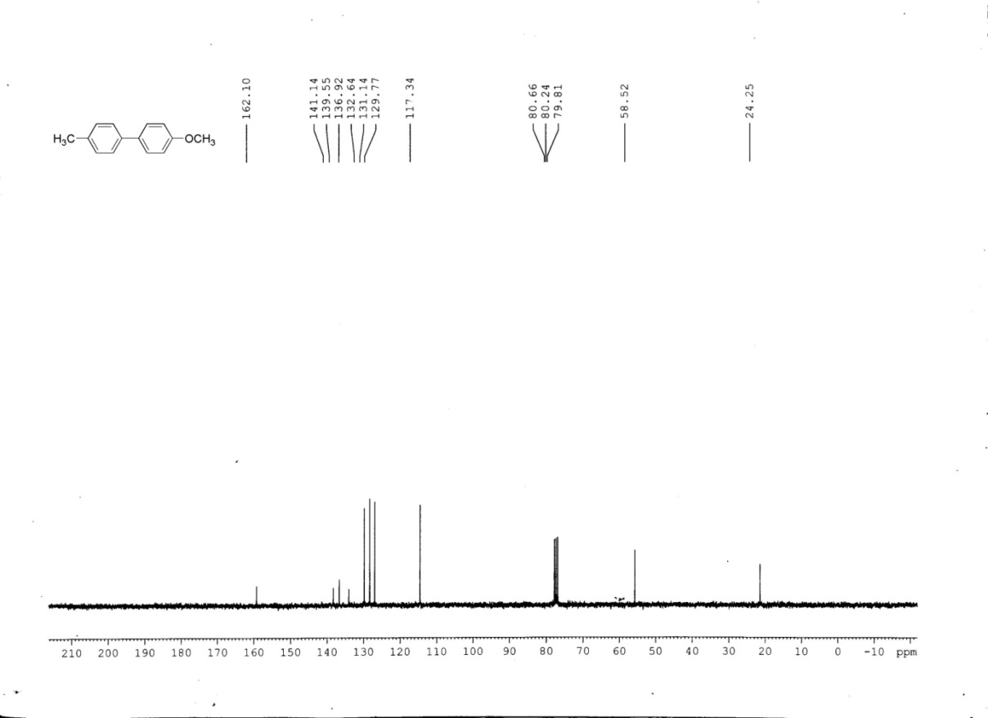**

**1H and 13C NMR of (E)-methyl 3-(3-nitrophenyl) acrylate**

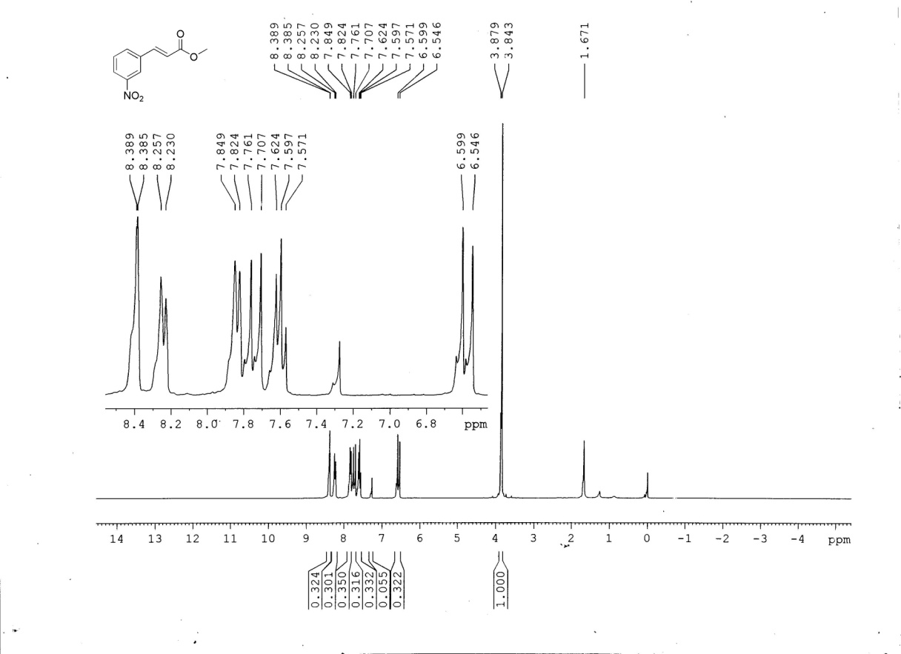

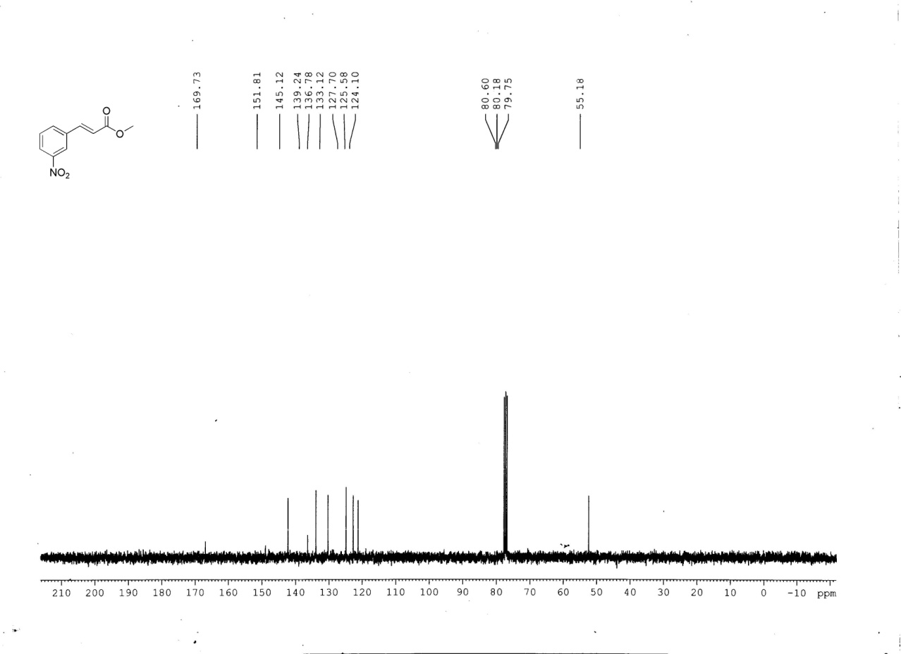

**1H and 13C NMR of (E)-methyl 3-(4-methoxyphenyl) acrylate**

**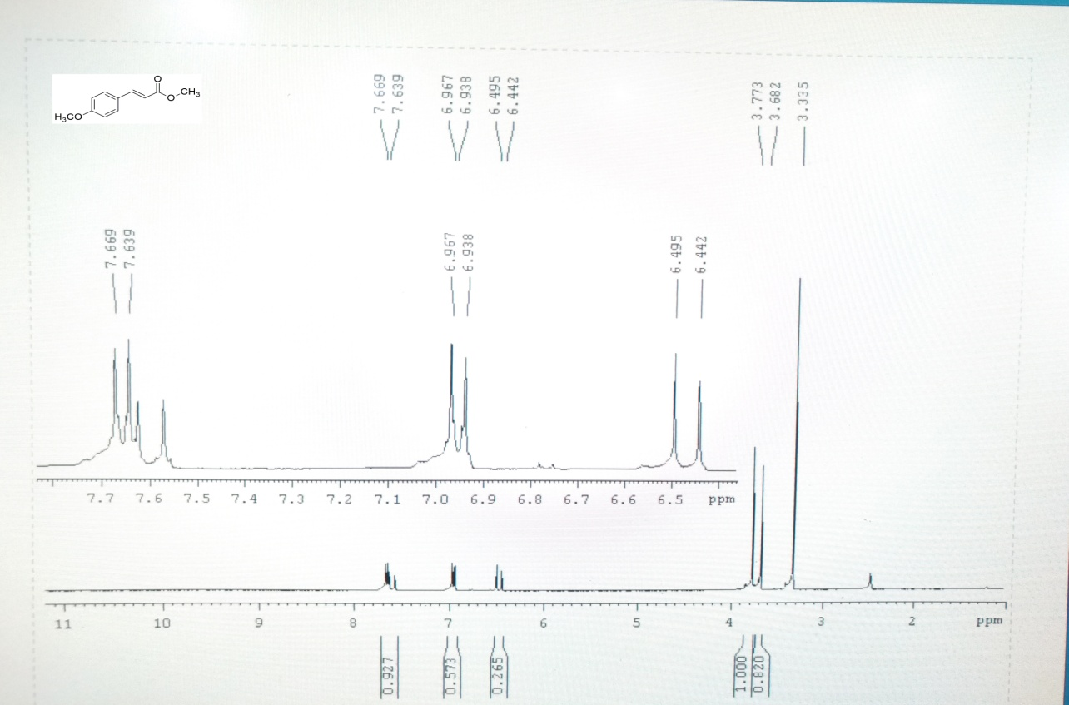**

**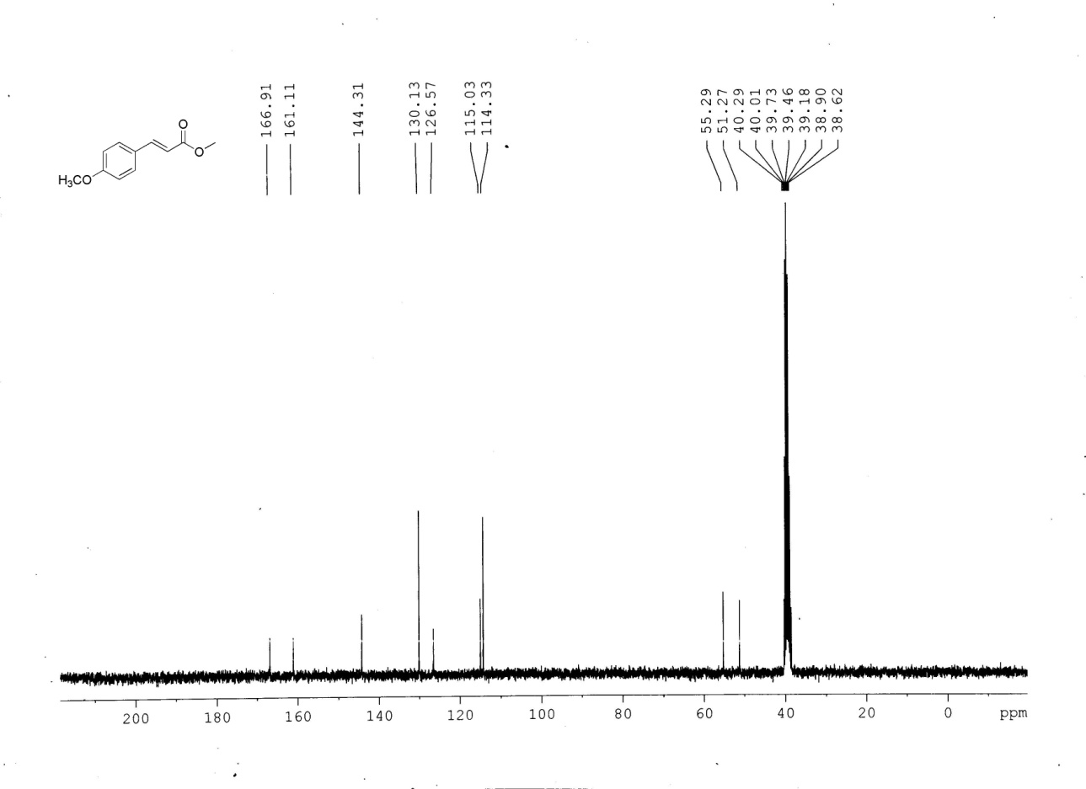**

**1H and 13C NMR of (E)-ethyl 3-(4-methoxyphenyl) acrylate**

**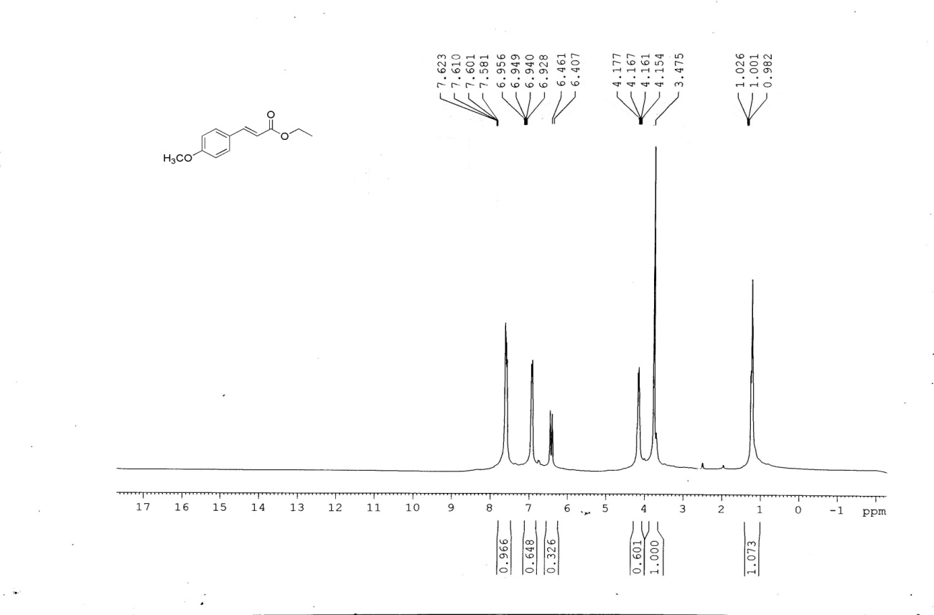**

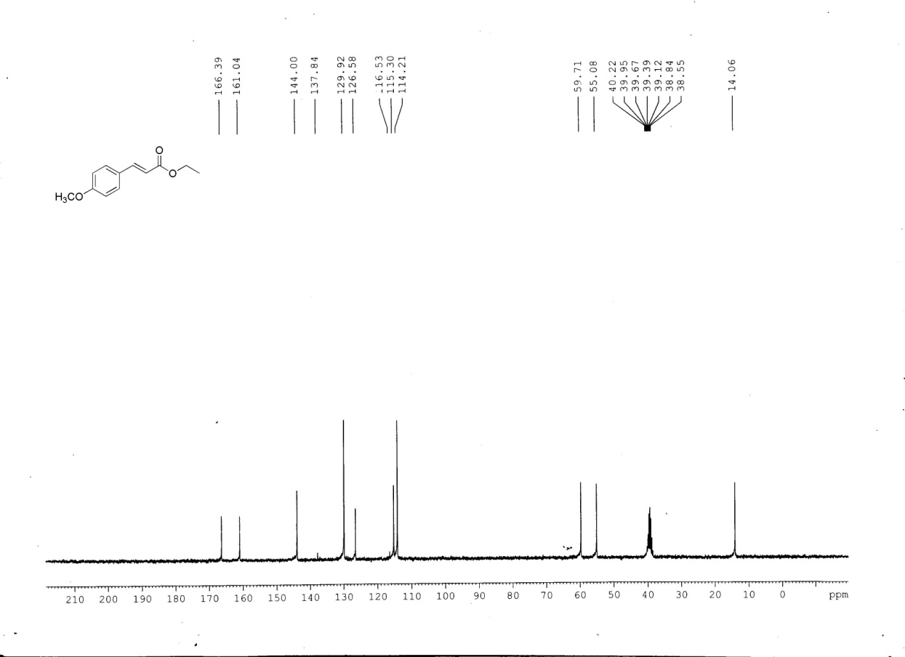

**1H and 13C NMR of (E)-butyl 3-(4-methoxyphenyl) acrylate 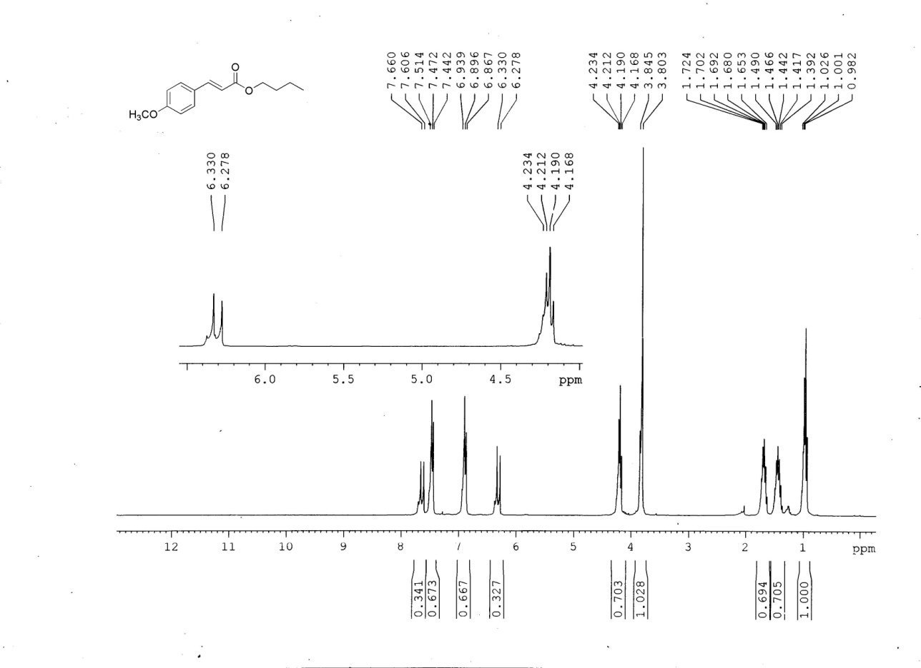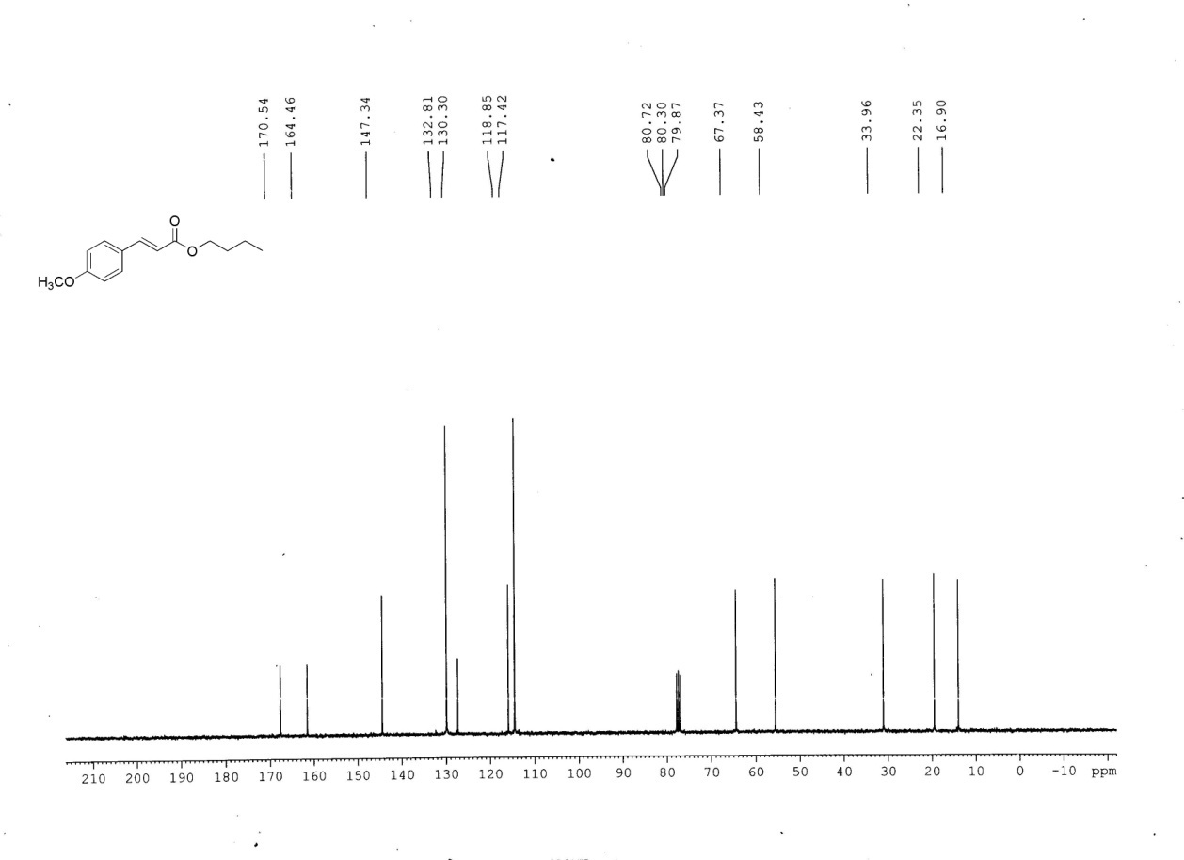**

**1H and 13C NMR of 1-(4-styrylphenyl)ethanone**

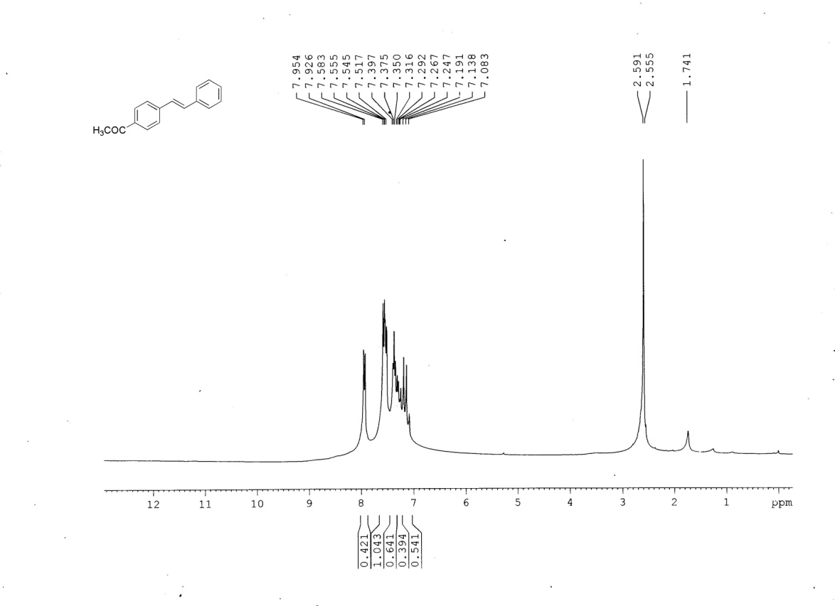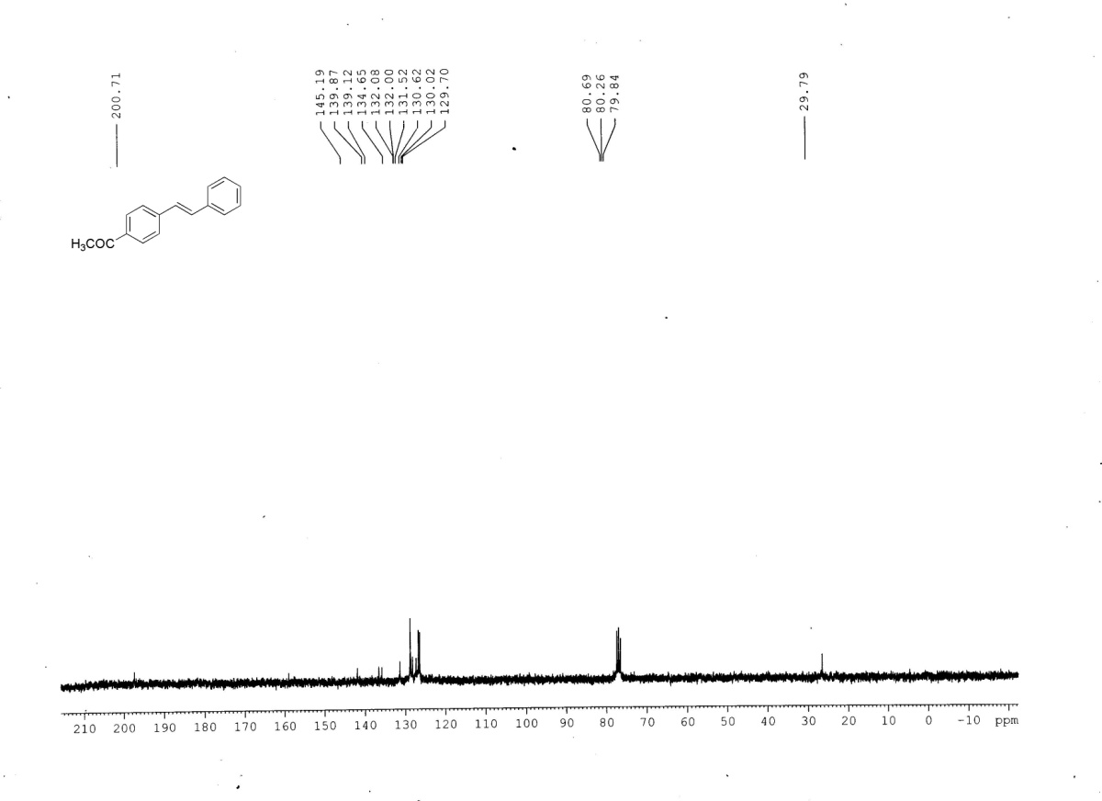

**References**

[A]. Ohtaka, A.; Okagaki, T.; Hamasaka, G.; Uozumi, Y.; Shinagawa, T.; Shimomura, O.; Nomura, R. *Catalysts*. **2015**, *5*, 106-118.

[B]. Sanjaykumar, S. R.; Kumari, B.D.; Patil, S.; Madras, G.; Hegde, M. S. *J. Chem. Sci.* **2011**, *123*, 47-54.

[C]. Basu, B.; Biswas, K.; Kundu, S.; Ghosh, S. *GreenChem*. **2010**, *12*, 1734–1738.

[D]. Mahanta, A.; Mondal, M.; Thakur, A.J.; Bora, U. *Tetrahedron Letters*. **2016**, *57*, 3091–3095.

[E]. Bhattacharya, S.; Srivastava, A.; Sengupta, S. *Tetrahedron Letters*. **2005**, *46*, 3557-3560.

[F]. Bakherad, M.; Keivanloo, A.; Samangooei, S. *Tetrahedron Letters*. **2012**, *53*, 5773–5776.

[G]. Calo, V.; Nacci, A.; Monopoli, A.; Fornaro, A.; Sabbatini, L.; Cioffi, N.; Ditaranto, N. *Organometallics.* **2004**, *23*, 5154-5158.

[H]. Bin, l.; Qing, W.J.; Hua, G. D.; Ming, L. X.; Qin, C. X.; Yue, P.; Wei, G. H. *Sci China Chem*. **2014**, 57, 1310-1314.