Supplementary information
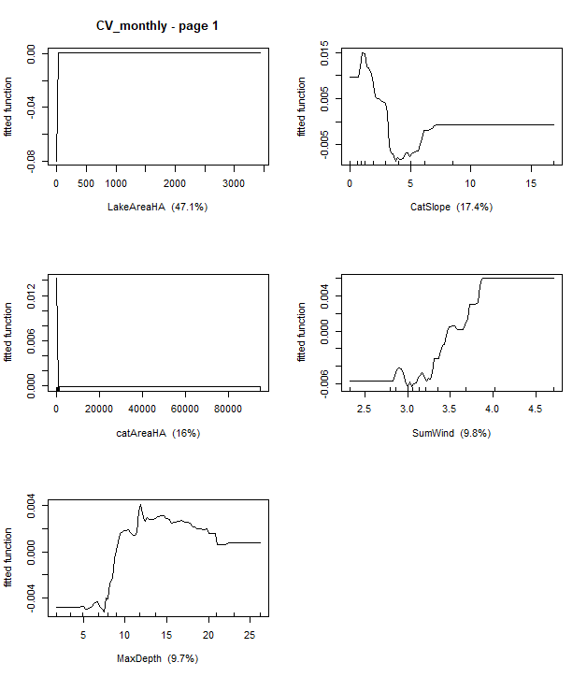
Figure S1: Partial dependence plots for Boosted Regression Tree (BRT) analyses relating monthly variability (calculated as coefficient of variation values) to key lake and catchment characteristics.
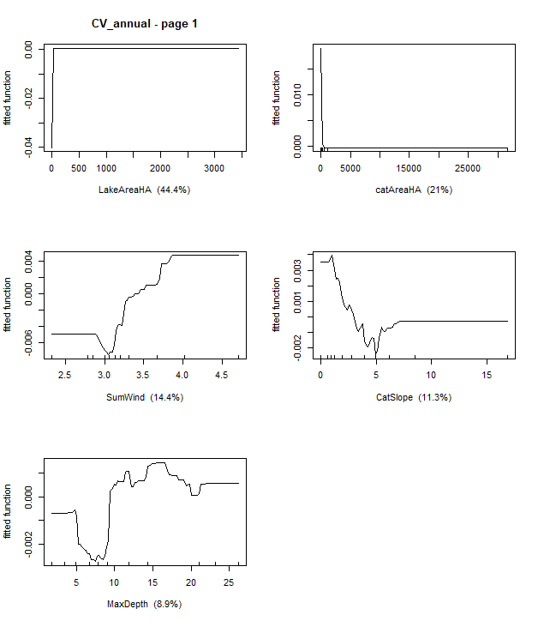
Figure S2: Partial dependence plots for Boosted Regression Tree (BRT) analyses relating annual variability (calculated as coefficient of variation values) to key lake and catchment characteristics.
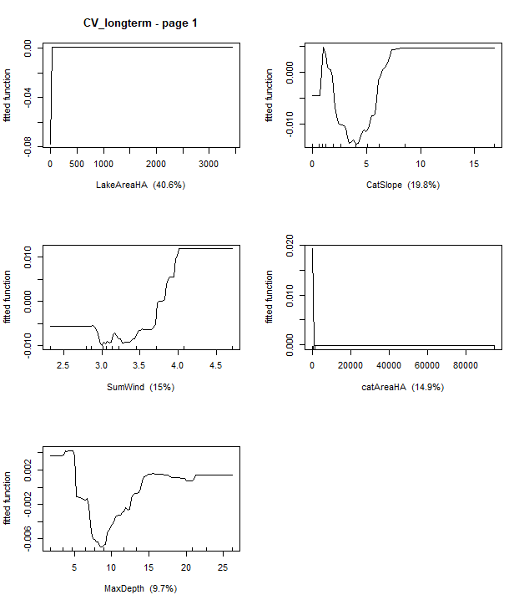
Figure S3: Partial dependence plots for Boosted Regression Tree (BRT) analyses relating long-term variability (calculated as coefficient of variation values) to key lake and catchment characteristics.
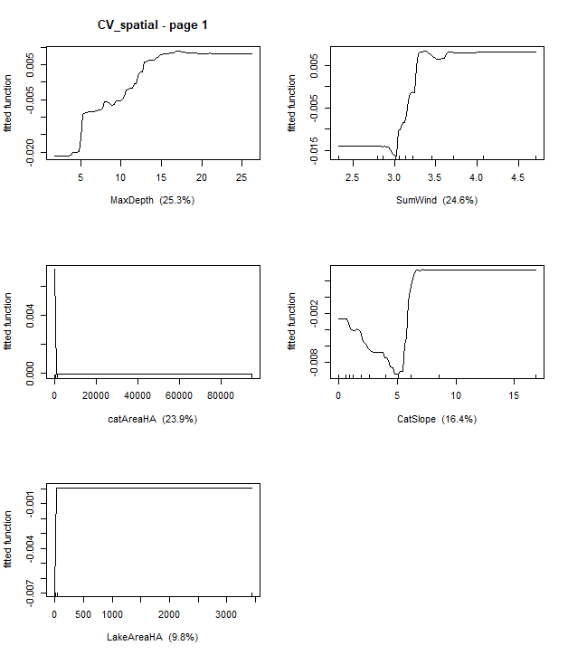
Figure S4: Partial dependence plots for Boosted Regression Tree (BRT) analyses relating spatial variability (calculated as coefficient of variation values) to key lake and catchment characteristics.

