SUPPLEMENTAL DATA

APPENDIX A
Table A.1 Summary of the sociodemographic attributes in the household survey
Attributes | Parameter | Percentage from total 430 participants (%)
 |  | Farmer (%) | Non-Farmer (%) | Total (%)
Place in five districts within CMR  (political boundaries) | Cirebon Municipality | 7.5 | 15.1 | 22.6
 | Cirebon Regency | 27.0 | 22.5 | 49.5
 | Indramayu Regency | 4.4 | 2.6 | 7.0
 | Kuningan Regency | 8.6 | 5.4 | 14.0
 | Majalengka Regency | 4.9 | 2.1 | 7.0
Level of urbanisation | Rural | 10.5 | 6.5 | 17.0
 | Peri-urban | 27.0 | 15.3 | 42.3
 | Urban-Peri-urban Transition | 7.4 | 9.8 | 17.2
 | Urban | 7.4 | 16.1 | 23.5
Gender | Male | 35.8 | 24.9 | 60.7
 | Female | 16.5 | 22.8 | 39.3
Type of settlement | Formal | 0.7 | 8.8 | 9.5
 | Non-Formal | 51.6 | 38.9 | 90.5
Length Stay | Less than 10 years | 3.0 | 8.9 | 11.9
 | 10 – less than 20 years | 2.3 | 5.6 | 7.9
 | 20 – 30 years | 6.5 | 7.5 | 14.0
 | More than 30 years | 40.5 | 25.5 | 66.0
Distance from the coast | Less than 5 km | 15.8 | 21.4 | 37.2
 | 5 – less than 10 km | 4.4 | 6.8 | 11.2
 | 10 – less than 15 km | 16.0 | 9.8 | 25.8
 | 15 – less than 20 km | 6.8 | 5.1 | 11.9
 | More than 20 km | 9.3 | 4.6 | 13.9
Household size | Less than and/or equal 3 persons | 14.0 | 11.9 | 25.9
 | 4 – 6 persons | 32.9 | 28.8 | 61.7
 | More than 6 persons | 5.4 | 7.0 | 12.4
Total participants in each type of occupation |  | 52.3 | 47.7

Table A.2 Reliability coefficient of the questionnaire in the urban-rural continuum of CMR
Group to Measure | Attributes of Importance |  |  | Attributes of Satisfaction
 | Cronbach’s Alpha | Highest Cronbach’s Alpha if one Item Deleted | One Item deleted | Cronbach’s Alpha | Highest Cronbach’s Alpha if one Item Deleted | One Item deleted
Urban (N=101) | 0.72 | 0.73 | Drought prevention | 0.81 | 0.82 | Mobility
UPT (N=74) | 0.68 | 0.70 | Well-maintained river | 0.75 | 0.75 | Mobility
Peri-urban (N=182) | 0.71 | 0.72 | Flood protection | 0.79 | 0.79 | Mobility
Rural (N=73) | 0.76 | 0.76 | Employment | 0.83 | 0.84 | Mobility
CMR (N=430) | 0.74 | 0.74 | Mobility | 0.80 | 0.81 | Mobility

APPENDIX B
Table B.1. Satisfaction structure and composite index of ecohydrological satisfaction-based liveability within CMR
Principal Components | Cronbach's Alpha | Variance Accounted For (VAF) |  | Satisfaction to ecohydrology related services | Satisfaction Factors (Principal Components)
 |  | Total Eigenvalue | % of variance |  | 1 | 2 | 3 | 4 | 5
Overall participants (n=430, valid cases 392, Expectation maximization imputation) |  |  |  |  | Residential | Watershed | Personal | Regional | Neighbourhood
1 | 0.75 | 2.77 | 18.45% | Sufficient water availability | 0.18 | 0.83 | 0.06 | 0.01 | -0.22
2 | 0.66 | 1.99 | 13.25% | Well-maintained river | 0.47 | 0.22 | -0.07 | -0.07 | 0.37
3 | 0.64 | 1.81 | 12.07% | Green open spaces in the public area | 0.66 | -0.06 | 0.18 | -0.26 | 0.10
4 | 0.42 | 1.54 | 10.24% | Housing with garden spaces | 0.69 | 0.07 | 0.32 | -0.22 | -0.04
5 | 0.52 | 1.38 | 9.17% | Healthy housing | 0.80 | 0.16 | 0.16 | 0.16 | 0.10
Total | 0.96* | 9.48 | 63.19% | Healthy human settlement | 0.81 | 0.11 | 0.08 | 0.17 | 0.09
 |  |  |  | Healthy waterways | 0.44 | 0.16 | -0.02 | 0.36 | 0.50
KMO (Kaiser-Meyer-Olkin Measure of Sampling Adequacy) within CMR= 0.75; Bartlett’s Test of Sphericity: Approx. Chi-square = 1826.21; df = 105; Sig. 0.000 (p<0.001) |  |  |  | Facilities and services for education, public health, amenities | 0.09 | 0.07 | 0.05 | 0.77 | -0.14
 |  |  |  | Flood protection | 0.11 | 0.08 | 0.17 | -0.07 | 0.85
 |  |  |  | Drought prevention | 0.04 | 0.75 | 0.19 | -0.04 | 0.29
 |  |  |  | Housing affordability | 0.20 | 0.11 | 0.63 | -0.07 | 0.01
 |  |  |  | Employment | 0.16 | 0.01 | 0.71 | 0.19 | 0.15
 |  |  |  | Mobility | -0.15 | 0.01 | 0.12 | 0.74 | 0.12
 |  |  |  | Income | 0.05 | 0.24 | 0.79 | 0.09 | 0.01
 |  |  |  | water and sanitation infrastructure/ waste water treatment | 0.09 | 0.73 | 0.18 | 0.19 | 0.22
Index of each satisfaction factor (scale 0-100) |  |  |  |  | 63.1 | 59.9 | 49.2 | 28.6 | 56.2
Index of ecohydrological satisfaction based-liveability using weighted method CATPCA/FA and public opinion (scale 0-100) |  |  |  |  | 59.7 and 56.6
*Total Cronbach's Alpha is based on the total Eigenvalue; Model summary of satisfaction factors using CATPCA/FA with rotation method: Varimax; normalization method: Variable Principal

Table B.2. Satisfaction structure and composite index of ecohydrological satisfaction-based liveability at urban CMR
Principal Components | Cronbach's Alpha | Variance Accounted For (VAF) |  | Satisfaction to ecohydrology related services | Satisfaction Factors (Principal Components)
 |  | Total Eigenvalue | % of variance |  | 1 | 2 | 3 | 4 | 5
Urban participants (n=101, valid cases 99, Expectation-maximization imputation) |  |  |  |  | Residential | Neighbourhood | Personal | Regional | Watershed
1 | 0.69 | 2.69 | 17.94 | Sufficient water availability | 0.03 | -0.05 | 0.17 | 0.03 | 0.83
2 | 0.72 | 2.64 | 17.59 | Well-maintained river | 0.12 | 0.31 | -0.10 | -0.51 | 0.39
3 | 0.61 | 2.00 | 13.34 | Green open spaces in the public area | 0.01 | 0.72 | -0.14 | -0.33 | 0.04
4 | 0.55 | 1.95 | 12.99 | Housing with garden spaces | 0.97 | 0.05 | 0.05 | -0.01 | -0.07
5 | 0.63 | 1.78 | 11.85 | Healthy housing | 0.18 | 0.62 | 0.45 | -0.17 | 0.34
Total | 0.98* | 11.06 | 73.71 | Healthy human settlement | 0.15 | 0.56 | 0.40 | -0.28 | 0.32
 |  |  |  | Healthy waterways | 0.10 | 0.62 | 0.31 | 0.09 | 0.14
KMO (Kaiser-Meyer-Olkin Measure of Sampling Adequacy) within Urban CMR= 0.63; Bartlett’s Test of Sphericity: Approx. Chi-square = 1095.26; df = 105; Sig.<0.001 |  |  |  | Facilities and services for education, public health, amenities | 0.06 | -0.19 | 0.07 | 0.80 | 0.07
 |  |  |  | Flood protection | -0.08 | 0.84 | -0.14 | 0.15 | -0.02
 |  |  |  | Drought prevention | -0.02 | 0.39 | -0.01 | 0.07 | 0.72
 |  |  |  | Housing affordability | 0.97 | 0.03 | 0.04 | 0.00 | -0.06
 |  |  |  | Employment | 0.84 | 0.03 | 0.04 | 0.01 | 0.21
 |  |  |  | Mobility | 0.00 | 0.22 | 0.01 | 0.88 | 0.09
 |  |  |  | Income | 0.02 | 0.04 | 0.88 | 0.05 | -0.12
 |  |  |  | water and sanitation infrastructure/ waste water treatment | 0.06 | -0.02 | 0.82 | 0.14 | 0.31
Index of each satisfaction factor (scale 0-100) |  |  |  |  | 94.6 | 68.6 | 80.7 | 34.9 | 64.8
Index of ecohydrological satisfaction based-liveability using weighted method CATPCA/FA and public opinion (scale 0-100) |  |  |  |  | 73.2 and 73.1
*Total Cronbach's Alpha is based on the total Eigenvalue; Model summary of satisfaction factors using CATPCA/FA with rotation method: Varimax; normalization method: Variable Principal
Table B.3. Satisfaction structure and composite index of ecohydrological satisfaction-based liveability at UPT CMR
Principal Components | Cronbach's Alpha | Variance Accounted For (VAF) |  | Satisfaction to ecohydrology related services | Satisfaction Factors (Principal Components)
 |  | Total Eigenvalue | % of variance |  | 1 | 2 | 3 | 4 | 5
Urban-peri-urban transition participants (n=74, valid cases 67, Expectation-maximization imputation) |  |  |  |  | Residential | Neighbourhood | Watershed | Personal | Regional
1 | 0.73 | 2.92 | 19.47 | Sufficient water availability | -0.02 | -0.04 | 0.63 | 0.16 | -0.55
2 | 0.61 | 2.21 | 14.70 | Well-maintained river | 0.32 | 0.29 | 0.55 | 0.09 | 0.18
3 | 0.57 | 1.81 | 12.05 | Green open spaces in the public area | 0.69 | -0.15 | 0.05 | 0.32 | -0.22
4 | 0.54 | 1.77 | 11.77 | Housing with garden spaces | 0.48 | -0.32 | 0.06 | 0.57 | -0.18
5 | 0.43 | 1.63 | 10.89 | Healthy housing | 0.86 | 0.11 | 0.03 | 0.05 | 0.06
Total | 0.97* | 10.33 | 68.89 | Healthy human settlement | 0.91 | 0.12 | 0.01 | -0.09 | 0.03
 |  |  |  | Healthy waterways | 0.65 | 0.28 | 0.26 | -0.15 | 0.18
KMO (Kaiser-Meyer-Olkin Measure of Sampling Adequacy) within UPT CMR= 0.63; Bartlett’s Test of Sphericity: Approx. Chi-square = 362.09; df = 105; Sig. < 0.001 |  |  |  | Facilities and services for education, public health, amenities | 0.13 | 0.76 | -0.15 | 0.13 | 0.16
 |  |  |  | Flood protection | 0.19 | 0.65 | 0.45 | -0.14 | -0.12
 |  |  |  | Drought prevention | 0.04 | -0.10 | 0.81 | 0.10 | 0.13
 |  |  |  | Housing affordability | 0.26 | -0.21 | 0.19 | 0.30 | 0.57
 |  |  |  | Employment | -0.07 | 0.22 | 0.34 | 0.65 | 0.01
 |  |  |  | Mobility | -0.10 | 0.09 | 0.06 | 0.07 | 0.85
 |  |  |  | Income | 0.00 | -0.01 | -0.04 | 0.84 | 0.25
 |  |  |  | water and sanitation infrastructure/ waste water treatment | 0.00 | 0.88 | 0.04 | -0.01 | -0.09
Index of each satisfaction factor (scale 0-100) |  |  |  |  | 56.3 | 12.0 | 35.1 | 35.6 | 70.3
Index of ecohydrological satisfaction based-liveability using weighted method CATPCA/FA and public opinion (scale 0-100) |  |  |  |  | 44.7 and 45.8
*Total Cronbach's Alpha is based on the total Eigenvalue; Model summary of satisfaction factors using CATPCA/FA with rotation method: Varimax; normalization method: Variable Principal
Table B.4. Satisfaction structure and composite index of ecohydrological satisfaction-based liveability at peri-urban CMR
Principal Components | Cronbach's Alpha | Variance Accounted For (VAF) |  | Satisfaction to ecohydrology related services | Satisfaction Factors (Principal Components)
 |  | Total Eigenvalue | % of variance |  | 1 | 2 | 3 | 4 | 5
Peri-urban participants (n=182, valid cases 164, Expectation-maximization imputation) |  |  |  |  | Watershed | Residential | Personal | Neighbourhood | Regional
1 | 0.65 | 2.17 | 14.44 | Sufficient water availability | 0.83 | 0.13 | 0.00 | 0.06 | 0.12
2 | 0.68 | 2.11 | 14.07 | Well-maintained river | 0.05 | 0.14 | -0.05 | 0.28 | 0.72
3 | 0.62 | 1.89 | 12.61 | Green open spaces in the public area | 0.03 | -0.02 | -0.02 | 0.77 | 0.17
4 | 0.58 | 1.78 | 11.84 | Housing with garden spaces | 0.19 | 0.48 | 0.07 | 0.62 | -0.03
5 | 0.57 | 1.71 | 11.43 | Healthy housing | 0.10 | 0.91 | 0.14 | 0.15 | 0.13
Total | 0.96* | 9.66 | 64.38 | Healthy human settlement | 0.05 | 0.92 | 0.06 | 0.04 | 0.19
 |  |  |  | Healthy waterways | 0.01 | 0.21 | 0.22 | -0.01 | 0.78
KMO (Kaiser-Meyer-Olkin Measure of Sampling Adequacy) within peri-urban CMR= 0.72; Bartlett’s Test of Sphericity: Approx. Chi-square = 813.18; df = 105; Sig.< 0.001 |  |  |  | Facilities and services for education, public health, amenities | 0.22 | -0.01 | -0.02 | -0.13 | 0.55
 |  |  |  | Flood protection | -0.16 | 0.18 | 0.57 | 0.18 | 0.29
 |  |  |  | Drought prevention | 0.84 | -0.08 | 0.07 | 0.12 | 0.00
 |  |  |  | Housing affordability | 0.06 | 0.13 | 0.33 | 0.64 | -0.12
 |  |  |  | Employment | 0.14 | 0.07 | 0.77 | 0.21 | 0.01
 |  |  |  | Mobility | 0.11 | -0.04 | 0.60 | -0.39 | 0.00
 |  |  |  | Income | 0.49 | 0.12 | 0.61 | 0.17 | -0.03
 |  |  |  | water and sanitation infrastructure/ waste water treatment | 0.61 | 0.22 | 0.23 | -0.08 | 0.28
Index of each satisfaction factor (scale 0-100) |  |  |  |  | 61.6 | 61.5 | 54.2 | 63.4 | 62.8
Index of ecohydrological satisfaction based-liveability using weighted method CATPCA/FA and public opinion (scale 0-100) |  |  |  |  | 67.1 and 64.6
*Total Cronbach's Alpha is based on the total Eigenvalue; Model summary of satisfaction factors using CATPCA/FA with rotation method: Varimax; normalization method: Variable Principal
Table B.5. Satisfaction structure and composite index of ecohydrological satisfaction-based liveability at rural CMR
Principal Components | Cronbach's Alpha | Variance Accounted For (VAF) |  | Satisfaction to ecohydrology related services | Satisfaction Factors (Principal Components)
 |  | Total Eigenvalue | % of variance |  | 1 | 2 | 3 | 4 | 5
Rural participants (n=73, valid cases 62, Expectation-Maximization imputation) |  |  |  |  | Residential | Watershed | Personal | Regional | Neighbourhood
1 | 0.81 | 3.40 | 22.69 | Sufficient water availability | 0.08 | 0.80 | 0.03 | -0.04 | -0.08
2 | 0.75 | 2.50 | 16.67 | Well-maintained river | 0.40 | 0.32 | 0.07 | 0.20 | -0.60
3 | 0.50 | 1.72 | 11.44 | Green open spaces in the public area | 0.76 | 0.20 | -0.07 | -0.10 | -0.09
4 | 0.52 | 1.58 | 10.51 | Housing with garden spaces | 0.75 | 0.22 | -0.11 | -0.34 | 0.11
5 | 0.46 | 1.51 | 10.07 | Healthy housing | 0.82 | 0.13 | 0.17 | 0.22 | 0.21
Total | 0.97* | 10.71 | 71.38 | Healthy human settlement | 0.80 | 0.16 | 0.06 | 0.30 | 0.15
 |  |  |  | Healthy waterways | 0.47 | 0.36 | -0.29 | 0.49 | -0.17
KMO (Kaiser-Meyer-Olkin Measure of Sampling Adequacy) within rural CMR= 0.76; Bartlett’s Test of Sphericity: Approx. Chi-square = 419.51; df = 105; Sig. <0.001 |  |  |  | Facilities and services for education, public health, amenities | 0.18 | 0.16 | -0.10 | 0.36 | 0.72
 |  |  |  | Flood protection | -0.16 | 0.27 | 0.79 | -0.02 | -0.03
 |  |  |  | Drought prevention | 0.20 | 0.81 | 0.18 | 0.02 | 0.13
 |  |  |  | Housing affordability | 0.37 | 0.36 | -0.08 | 0.04 | 0.63
 |  |  |  | Employment | 0.51 | -0.11 | 0.41 | 0.40 | -0.01
 |  |  |  | Mobility | -0.02 | -0.05 | -0.04 | 0.85 | 0.16
 |  |  |  | Income | 0.15 | 0.09 | 0.83 | -0.07 | -0.12
 |  |  |  | water and sanitation infrastructure/ waste water treatment | 0.24 | 0.77 | 0.21 | 0.04 | 0.22
Index of each satisfaction factor (scale 0-100) |  |  |  |  | 60.0 | 55.3 | 84.1 | 31.3 | 65.3
Index of ecohydrological satisfaction based-liveability using weighted method CATPCA/FA and public opinion (scale 0-100) |  |  |  |  | 67.1 and 61.7
*Total Cronbach's Alpha is based on the total Eigenvalue; Model summary of satisfaction factors using CATPCA/FA with rotation method: Varimax; normalization method: Variable Principal

APPENDIX C
Table C.1 Weights for the liveability indicators within CMR
Liveability Aspects (Satisfaction Assessment) | Weight CATPCA/FA | Ranks | Liveability Aspects (Importance Assessment) | Weight  Public Opinion | Ranks
Healthy human settlement | 0.11 | 1 | Employment | 0.13 | 1
Healthy housing | 0.11 | 1 | Income | 0.11 | 2
Sufficient water availability | 0.09 | 2 | Sufficient water availability | 0.11 | 2
Housing with garden spaces | 0.08 | 3 | Drought prevention | 0.08 | 3
Green open spaces in the public area | 0.07 | 4 | Healthy housing | 0.07 | 4
Income | 0.07 | 4 | Mobility | 0.07 | 4
Drought prevention | 0.07 | 4 | Green open spaces in the public area | 0.07 | 4
Water and sanitation infrastructure/ waste water treatment | 0.07 | 4 | Housing affordability | 0.06 | 5
Flood protection | 0.06 | 5 | Healthy waterways | 0.05 | 6
Employment | 0.06 | 5 | Healthy human settlement | 0.05 | 6
Facilities and services for education, public health, amenities | 0.06 | 5 | Facilities and services for education, public health, amenities | 0.05 | 6
Mobility | 0.05 | 6 | Flood protection | 0.04 | 7
Housing affordability | 0.04 | 7 | Water and sanitation infrastructure/ waste water treatment | 0.04 | 7
Well-maintained river | 0.04 | 7 | Housing with garden spaces | 0.03 | 8
Healthy waterways | 0.02 | 8 | Well-maintained river | 0.03 | 8

Table C.2 Weights for the liveability indicators within urban area
Liveability Aspects (Satisfaction Assessment) | Weight CATPCA/FA | Ranks | Liveability Aspects (Importance Assessment) | Weight  Public Opinion | Ranks
Housing affordability | 0.12 | 1 | Housing affordability | 0.12 | 1
Housing with garden spaces | 0.12 | 1 | Employment | 0.12 | 1
Employment | 0.09 | 2 | Income | 0.12 | 1
Flood protection | 0.09 | 2 | Drought prevention | 0.11 | 2
Income | 0.07 | 3 | Sufficient water availability | 0.08 | 3
Mobility | 0.07 | 3 | Healthy housing | 0.08 | 3
Green open spaces in the public area | 0.06 | 4 | Healthy waterways | 0.06 | 4
Water and sanitation infrastructure/ waste water treatment | 0.06 | 4 | Healthy human settlement | 0.06 | 4
Facilities and services for education, public health, amenities | 0.06 | 4 | Facilities and services for education, public health, amenities | 0.05 | 5
Sufficient water availability | 0.06 | 4 | Well maintained river | 0.05 | 5
Healthy housing | 0.05 | 5 | Water and sanitation infrastructure/ waste water treatment | 0.04 | 6
Healthy waterways | 0.05 | 5 | Mobility | 0.04 | 6
Drought prevention | 0.04 | 6 | Green open spaces in the public area | 0.03 | 7
Healthy human settlement | 0.04 | 6 | Flood protection | 0.02 | 8
Well-maintained river | 0.02 | 7 | Housing with garden spaces | 0.02 | 8

Table C.3 Weights for the liveability indicators within urban-peri-urban transition area
Liveability Aspects (Satisfaction Assessment) | Weight CATPCA/FA | Ranks | Liveability Aspects (Importance Assessment) | Weight  Public Opinion | Ranks
Healthy human settlement | 0.13 | 1 | Green open spaces in the public area | 0.11 | 1
Healthy housing | 0.12 | 2 | Employment | 0.11 | 1
Water and sanitation infrastructure/ waste water treatment | 0.10 | 3 | Housing affordability | 0.11 | 1
Green open spaces in the public area | 0.08 | 4 | Income | 0.11 | 1
Facilities and services for education, public health, amenities | 0.07 | 5 | Well-maintained river | 0.11 | 1
Income | 0.07 | 5 | Housing with garden spaces | 0.10 | 2
Healthy waterways | 0.06 | 6 | Sufficient water availability | 0.08 | 3
Mobility | 0.06 | 6 | Facilities and services for education, public health, amenities | 0.05 | 4
Drought prevention | 0.06 | 6 | Healthy human settlement | 0.04 | 5
Flood protection | 0.06 | 6 | Drought prevention | 0.04 | 5
Employment | 0.05 | 7 | Healthy housing | 0.04 | 5
Sufficient water availability | 0.04 | 8 | Water and sanitation infrastructure/ waste water treatment | 0.03 | 6
Housing with garden spaces | 0.04 | 8 | Healthy waterways | 0.03 | 6
Well-maintained river | 0.04 | 8 | Flood protection | 0.02 | 7
Housing affordability | 0.02 | 9 | Mobility | 0.01 | 8

Table C.4 Weights for the liveability indicators within peri-urban area
Liveability Aspects (Satisfaction Assessment) | Weight CATPCA/FA | Ranks | Liveability Aspects (Importance Assessment) | Weight  Public Opinion | Ranks
Healthy human settlement | 0.12 | 1 | Drought prevention | 0.13 | 1
Healthy housing | 0.11 | 2 | Flood protection | 0.13 | 1
Drought prevention | 0.10 | 3 | Income | 0.10 | 2
Sufficient water availability | 0.10 | 3 | Sufficient water availability | 0.09 | 3
Employment | 0.07 | 4 | Mobility | 0.08 | 4
Healthy waterways | 0.07 | 4 | Green open spaces in the public area | 0.07 | 5
Green open spaces in the public area | 0.07 | 4 | Employment | 0.06 | 6
Well-maintained river | 0.06 | 5 | Healthy waterways | 0.06 | 6
Water and sanitation infrastructure/ waste water treatment | 0.05 | 6 | Well-maintained river | 0.06 | 6
Housing affordability | 0.05 | 6 | Housing affordability | 0.05 | 7
Income | 0.05 | 6 | Water and sanitation infrastructure/ waste water treatment | 0.04 | 8
Housing with garden spaces | 0.04 | 7 | Healthy human settlement | 0.04 | 8
Mobility | 0.04 | 7 | Healthy housing | 0.03 | 9
Flood protection | 0.04 | 7 | Facilities and services for education, public health, amenities | 0.03 | 9
Facilities and services for education, public health, amenities | 0.03 | 8 | Housing with garden spaces | 0.03 | 9

Table C.5 Weights for the liveability indicators within rural area
Liveability Aspects (Satisfaction Assessment) | Weight CATPCA/FA | Ranks | Liveability Aspects (Importance Assessment) | Weight  Public Opinion | Ranks
Healthy housing | 0.12 | 1 | Drought prevention | 0.13 | 1
Healthy human settlement | 0.11 | 2 | Flood protection | 0.13 | 1
Green open spaces in the public area | 0.10 | 3 | Mobility | 0.12 | 2
Housing with garden spaces | 0.10 | 3 | Water and sanitation infrastructure/ waste water treatment | 0.11 | 3
Drought prevention | 0.08 | 4 | Employment | 0.10 | 4
Sufficient water availability | 0.08 | 4 | Sufficient water availability | 0.09 | 5
Water and sanitation infrastructure/ waste water treatment | 0.08 | 4 | Housing affordability | 0.07 | 6
Income | 0.06 | 5 | Well-maintained river | 0.05 | 7
Mobility | 0.06 | 5 | Housing with garden spaces | 0.05 | 7
Flood protection | 0.06 | 5 | Healthy housing | 0.04 | 8
Employment | 0.05 | 6 | Income | 0.03 | 9
Facilities and services for education, public health, amenities | 0.04 | 7 | Facilities and services for education, public health, amenities | 0.03 | 9
Housing affordability | 0.03 | 8 | Healthy waterways | 0.03 | 9
Well-maintained river | 0.03 | 8 | Healthy human settlement | 0.02 | 10
Healthy waterways | 0.02 | 9 | Green open spaces in the public area | 0.01 | 11

APPENDIX D
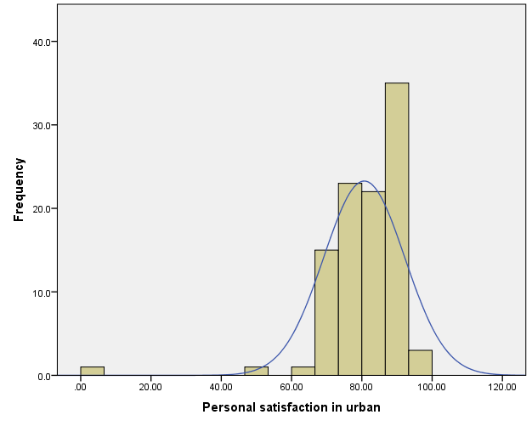
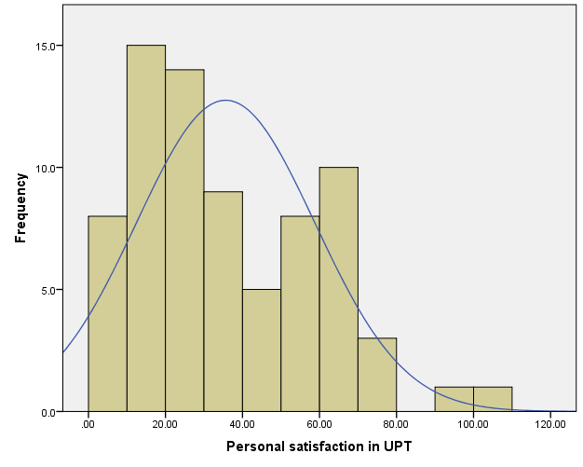
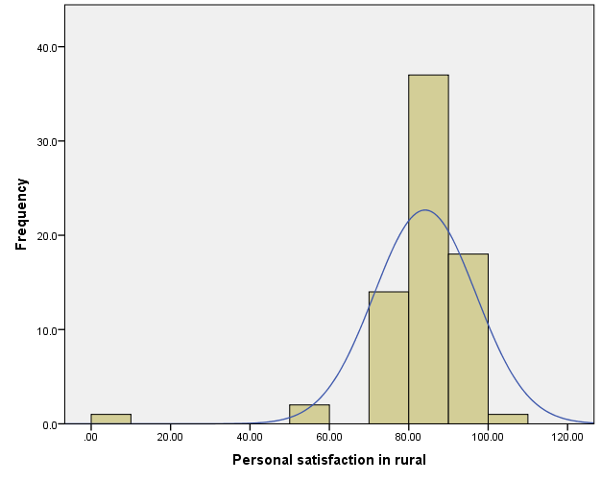
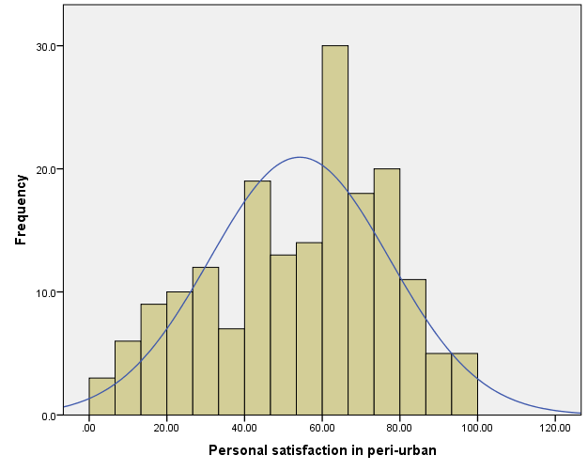

Figure D.1 Distribution of personal satisfaction scores
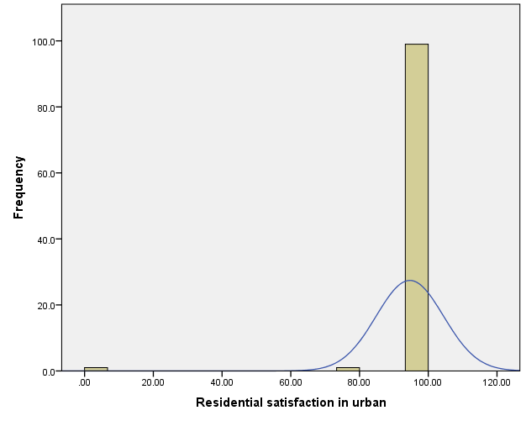
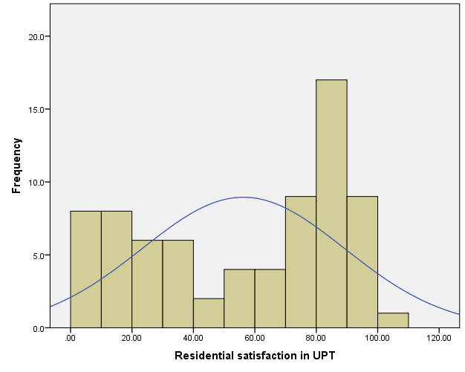
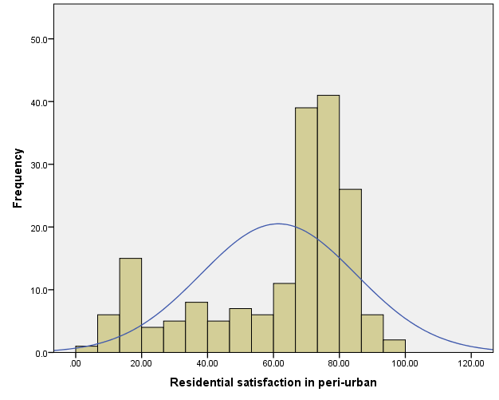
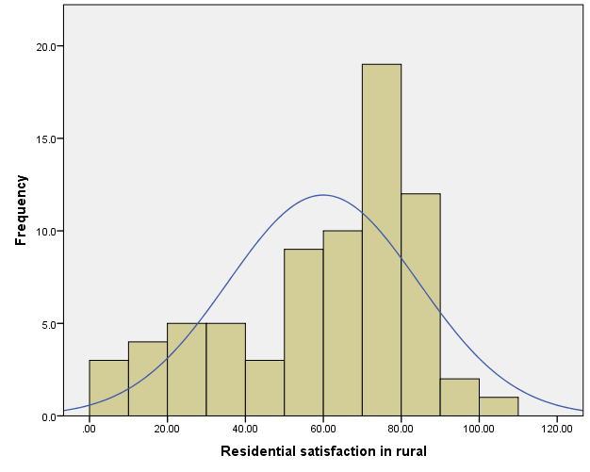

Figure D.2 Distribution of residential satisfaction scores
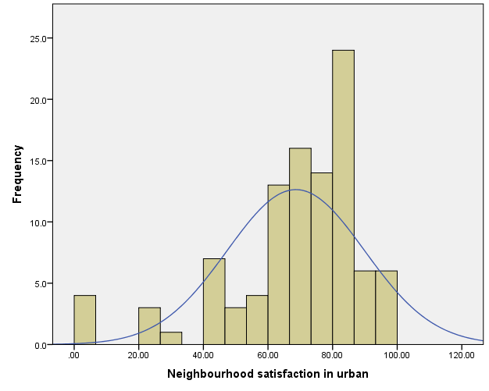
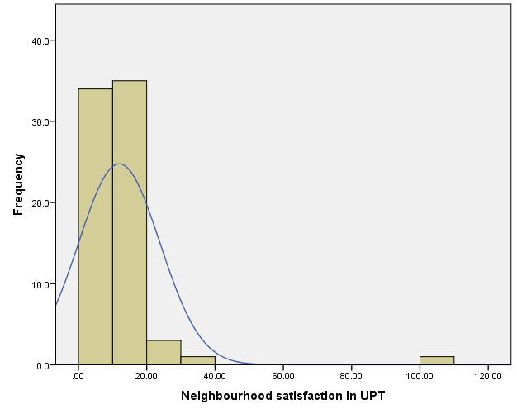
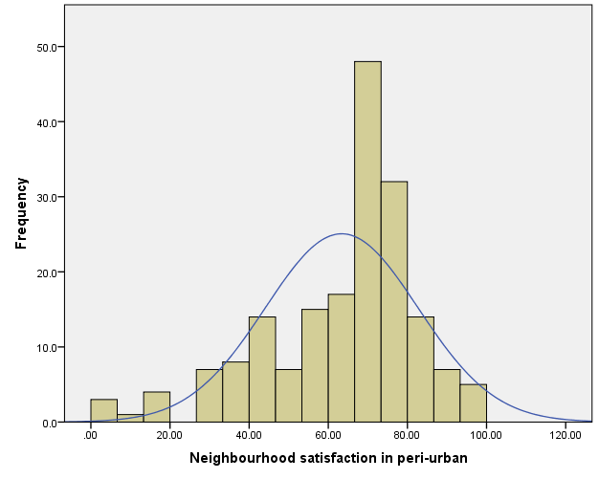
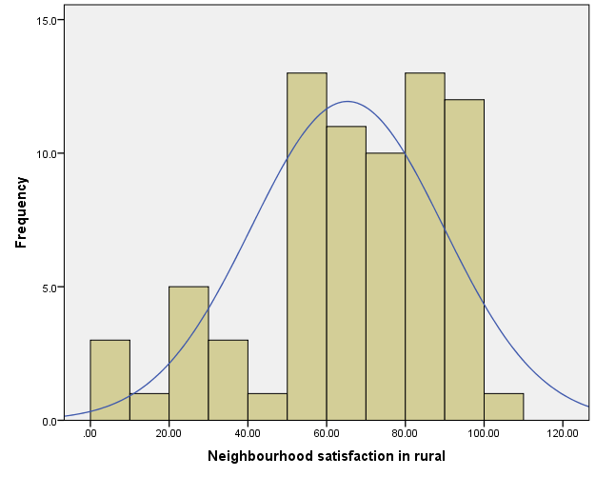

Figure D.3 Distribution of neighbourhood satisfaction scores
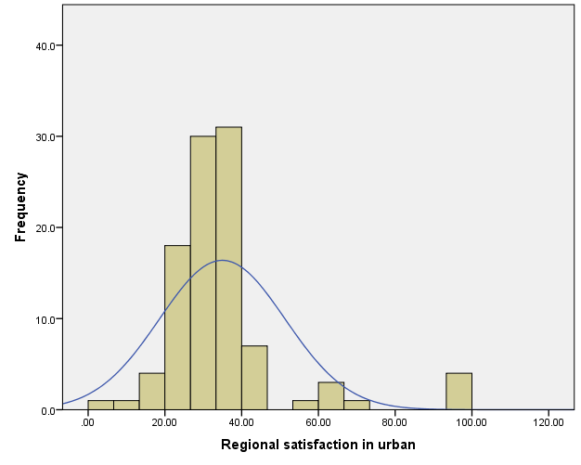
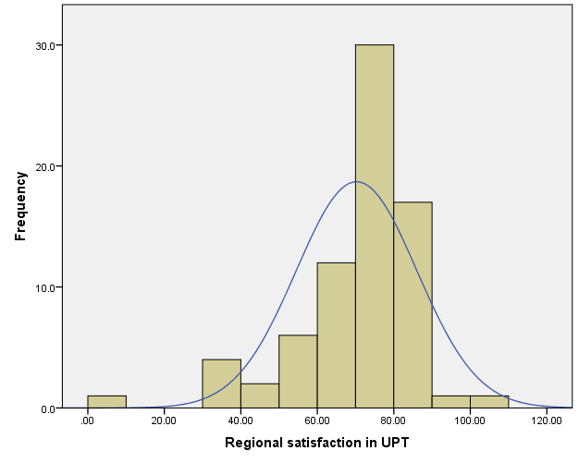
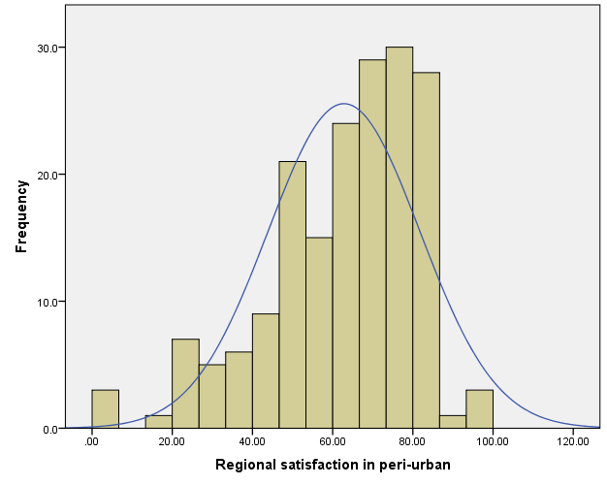
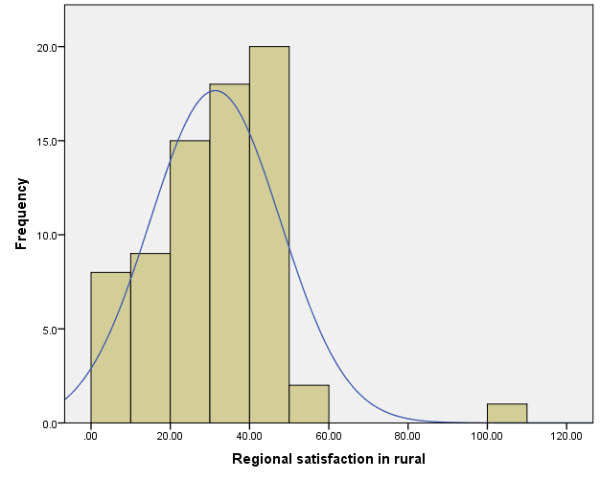

Figure D.4 Distribution of regional satisfaction scores
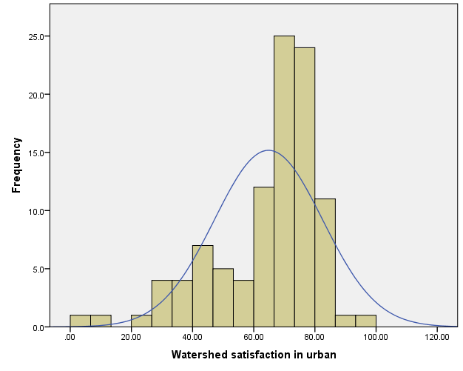
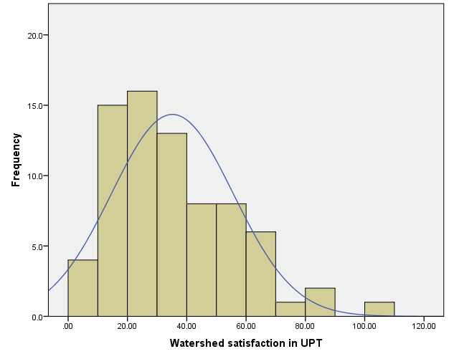
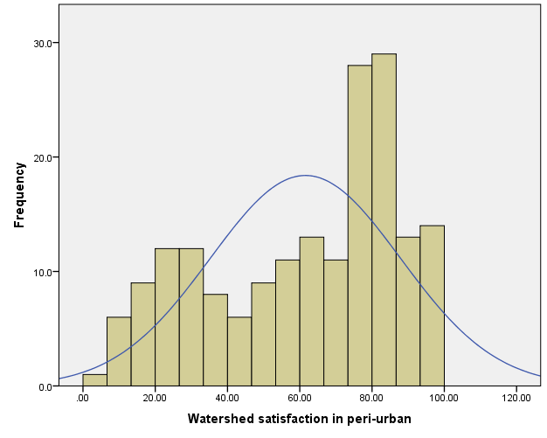
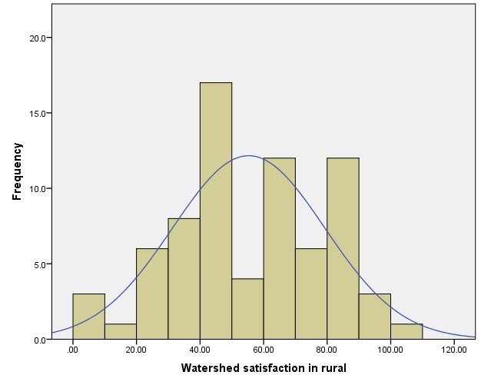

Figure D.5 Distribution of watershed satisfaction scores

APPENDIX E
Table E.1 Effect of socio-demographic attributes and perception of ecohydrological changes on the personal satisfaction
Coefficients (CATREG)
Independent variables: | Standardized Coefficients |  | df | F | Sig.
 | Beta | Bootstrap (1000) Estimate of Std. Error
Political boundary at district level | 0.29 | 0.10 | 4 | 7.856 | 0.000
Level of urbanisation | 0.31 | 0.11 | 3 | 7.902 | 0.000
Distance from the coast | 0.24 | 0.16 | 4 | 2.424 | 0.048
Type of settlement | 0.04 | 0.05 | 1 | 0.538 | 0.464
Occupation | 0.10 | 0.05 | 1 | 3.581 | 0.059
Gender | 0.02 | 0.04 | 1 | 0.435 | 0.510
Length of stay | -0.07 | 0.08 | 2 | 0.660 | 0.517
Household size | -0.10 | 0.06 | 2 | 3.354 | 0.036
Perception of changes in green open spaces surrounding human settlement | 0.13 | 0.06 | 2 | 4.519 | 0.011
Perception of changes in groundwater quality | 0.03 | 0.09 | 1 | 0.121 | 0.728
Perception of changes in river quality | 0.006 | 0.07 | 1 | 0.008 | 0.930
Perception of changes in flood event | 0.07 | 0.09 | 1 | 0.619 | 0.432
Perception of changes in drought event | -0.12 | 0.07 | 2 | 2.437 | 0.089
Perception of changes in climate | 0.03 | 0.07 | 1 | 0.182 | 0.670
Perception of changes in food | -0.18 | 0.07 | 1 | 6.301 | 0.012
Perception of changes in forest | -0.03 | 0.07 | 1 | 0.140 | 0.708
Current water problems (flood and or drought) | 0.09 | 0.05 | 5 | 3.914 | 0.002
Perception of current river water quality | 0.04 | 0.04 | 2 | 0.857 | 0.425
Perception of current groundwater quality | 0.12 | 0.04 | 7 | 8.731 | 0.000
Dependent variable: Personal satisfaction in the CMR

Table E.2 Effect of socio-demographic attributes and perception of ecohydrological changes on the residential satisfaction
Coefficients (CATREG)
Independent variables: | Standardized Coefficients |  | df | F | Sig.
 | Beta | Bootstrap (1000) Estimate of Std. Error
Political boundary at district level | 0.17 | 0.07 | 4 | 7.115 | 0.000
Level of urbanisation | 0.10 | 0.06 | 3 | 2.332 | 0.074
Distance from the coast | 0.26 | 0.09 | 4 | 8.584 | 0.000
Type of settlement | 0.12 | 0.06 | 1 | 4.600 | 0.033
Occupation | 0.06 | 0.04 | 1 | 2.079 | 0.150
Gender | 0.03 | 0.04 | 1 | 0.520 | 0.471
Length of stay | 0.12 | 0.06 | 3 | 3.401 | 0.018
Household size | 0.06 | 0.06 | 2 | 0.950 | 0.388
Perception of changes in green open spaces surrounding human settlement | -0.09 | 0.05 | 2 | 2.617 | 0.074
Perception of changes in groundwater quality | -0.08 | 0.07 | 1 | 1.364 | 0.244
Perception of changes in river quality | -0.07 | 0.06 | 2 | 1.388 | 0.251
Perception of changes in flood event | -0.12 | 0.13 | 1 | 0.845 | 0.358
Perception of changes in drought event | 0.02 | 0.08 | 2 | 0.070 | 0.932
Perception of changes in climate | 0.04 | 0.07 | 1 | 0.311 | 0.577
Perception of changes in food | -0.09 | 0.12 | 1 | 0.611 | 0.435
Perception of changes in forest | -0.06 | 0.06 | 2 | 1.295 | 0.275
Current water problems (flood and or drought) | 0.06 | 0.04 | 5 | 1.934 | 0.088
Perception of current river water quality | 0.09 | 0.04 | 2 | 4.542 | 0.011
Perception of current groundwater quality | 0.21 | 0.05 | 7 | 20.300 | 0.000
Dependent variable: Residential satisfaction in the CMR

Table E.3 Effect of socio-demographic attributes and perception of ecohydrological changes on the neighbourhood satisfaction
Coefficients (CATREG)
Independent variables: | Standardized Coefficients |  | df | F | Sig.
 | Beta | Bootstrap (1000) Estimate of Std. Error
Political boundary at district level | 0.35 | 0.13 | 4 | 7.555 | 0.000
Level of urbanisation | 0.24 | 0.22 | 3 | 1.158 | 0.326
Distance from the coast | 0.24 | 0.11 | 3 | 4.713 | 0.003
Type of settlement | 0.04 | 0.04 | 1 | 0.929 | 0.336
Occupation | 0.10 | 0.05 | 1 | 3.574 | 0.059
Gender | 0.08 | 0.04 | 1 | 3.152 | 0.077
Length of stay | 0.04 | 0.08 | 1 | 0.262 | 0.609
Household size | 0.07 | 0.07 | 1 | 0.874 | 0.351
Perception of changes in green open spaces surrounding human settlement | 0.10 | 0.05 | 2 | 3.458 | 0.032
Perception of changes in groundwater quality | -0.16 | 0.06 | 1 | 3.740 | 0.054
Perception of changes in river quality | -0.24 | 0.06 | 1 | 19.563 | 0.000
Perception of changes in flood event | -0.13 | 0.06 | 2 | 4.051 | 0.018
Perception of changes in drought event | 0.04 | 0.07 | 1 | 0.225 | 0.635
Perception of changes in climate | 0.10 | 0.06 | 2 | 2.401 | 0.092
Perception of changes in food | 0.04 | 0.08 | 1 | 0.289 | 0.591
Perception of changes in forest | -0.14 | 0.05 | 2 | 6.956 | 0.001
Current water problems (flood and or drought) | 0.20 | 0.06 | 5 | 12.095 | 0.000
Perception of current river water quality | 0.11 | 0.05 | 2 | 5.935 | 0.003
Perception of current groundwater quality | 0.08 | 0.04 | 7 | 4.570 | 0.000
Dependent variable: Neighbourhood satisfaction in the CMR

Table E.4 Effect of socio-demographic attributes and perception of ecohydrological changes on the regional satisfaction
Coefficients (CATREG)
Independent variables: | Standardized Coefficients |  | df | F | Sig.
 | Beta | Bootstrap (1000) Estimate of Std. Error
Political boundary at district level | 0.17 | 0.13 | 4 | 1.649 | 0.161
Level of urbanisation | 0.15 | 0.15 | 3 | 1.015 | 0.386
Distance from the coast | -0.11 | 0.20 | 2 | 0.323 | 0.724
Type of settlement | 0.17 | 0.07 | 1 | 6.496 | 0.011
Occupation | 0.04 | 0.04 | 1 | 1.092 | 0.297
Gender | 0.003 | 0.03 | 1 | 0.012 | 0.914
Length of stay | 0.19 | 0.06 | 2 | 9.882 | 0.000
Household size | 0.03 | 0.08 | 1 | 0.123 | 0.726
Perception of changes in green open spaces surrounding human settlement | -0.06 | 0.07 | 2 | 0.675 | 0.510
Perception of changes in groundwater quality | -0.05 | 0.07 | 1 | 0.612 | 0.434
Perception of changes in river quality | 0.06 | 0.07 | 2 | 0.782 | 0.458
Perception of changes in flood event | -0.08 | 0.08 | 1 | 0.923 | 0.337
Perception of changes in drought event | -0.08 | 0.06 | 2 | 1.893 | 0.152
Perception of changes in climate | -0.08 | 0.09 | 1 | 0.728 | 0.394
Perception of changes in food | 0.06 | 0.09 | 1 | 0.443 | 0.506
Perception of changes in forest | 0.08 | 0.11 | 1 | 0.604 | 0.437
Current water problems (flood and or drought) | 0.14 | 0.06 | 5 | 6.316 | 0.000
Perception of current river water quality | 0.05 | 0.04 | 2 | 1.676 | 0.188
Perception of current groundwater quality | 0.14 | 0.04 | 7 | 9.847 | 0.000
Dependent variable: Regional satisfaction in the CMR

Table E.5 Effect of socio-demographic attributes and perception of ecohydrological changes on the watershed satisfaction
Coefficients (CATREG)
Independent variables: | Standardized Coefficients |  | df | F | Sig.
 | Beta | Bootstrap (1000) Estimate of Std. Error
Political boundary at district level | 0.13 | 0.07 | 4 | 3.706 | 0.006
Level of urbanisation | 0.18 | 0.08 | 3 | 5.240 | 0.001
Distance from the coast | 0.11 | 0.10 | 2 | 1.153 | 0.317
Type of settlement | 0.03 | 0.04 | 1 | 0.605 | 0.437
Occupation | 0.02 | 0.03 | 1 | 0.493 | 0.483
Gender | 0.03 | 0.03 | 1 | 0.801 | 0.371
Length of stay | 0.07 | 0.05 | 2 | 1.766 | 0.172
Household size | 0.02 | 0.05 | 2 | 0.099 | 0.906
Perception of changes in green open spaces surrounding human settlement | -0.07 | 0.05 | 2 | 2.616 | 0.074
Perception of changes in groundwater quality | -0.13 | 0.05 | 2 | 7.483 | 0.001
Perception of changes in river quality | 0.05 | 0.06 | 1 | 0.857 | 0.355
Perception of changes in flood event | -0.01 | 0.07 | 1 | 0.009 | 0.923
Perception of changes in drought event | -0.32 | 0.06 | 2 | 31.920 | 0.000
Perception of changes in climate | -0.03 | 0.06 | 1 | 0.168 | 0.682
Perception of changes in food | 0.10 | 0.08 | 2 | 1.420 | 0.243
Perception of changes in forest | 0.04 | 0.04 | 2 | 0.862 | 0.423
Current water problems (flood and or drought) | 0.31 | 0.05 | 5 | 36.478 | 0.000
Perception of current river water quality | 0.11 | 0.04 | 2 | 8.061 | 0.000
Perception of current groundwater quality | 0.19 | 0.04 | 7 | 21.791 | 0.000
Dependent variable: Watershed satisfaction in the CMR

APPENDIX F

HOUSEHOLD SURVEY QUESTIONNAIRE (BENEFICIARIES PERSPECTIVE)
English Version

Planning for Water Security, Sustainability and Liveability in the Growing Coastal Urban Region:
A Case Study of Cirebon, Indonesia

Objective of the survey

To understand beneficiaries perspective regarding factors and water’s role for liveability and sustainability, important factors based on resident preference, resident’s experience of satisfaction, understanding of water influence for making liveable place, what preference strategy to improve ecohydrology in their place
Consent (More detailed information and signature in the Participant-Consent- Form)

All information will be kept strictly confidential for data analysis or research purposes only. We will not record respondent name. Any information given will not be linked directly to the respondent.

Name of the interviewer :
Interviewer’s Code :
Date of interview :
Time of interview : Start: Finish:

- Profile of respondent

A.1 Location
Name of the City/District (select one of the options below)
1 | 2 | 3 | 4 | 5
Cirebon City | Cirebon District | Kuningan District | Majalengka District | Indramayu District

Name of sub district and village:
Distance from the coast (km): (filled by the interviewer, Google Earth)
Type of settlement : 1. Formal 2. Non-Formal
Related Job : 1. Farmer
2. Non-Farmer
A.2 Sex : 1. Male 2. Female
A.3 Questions about the household
How long have you been living in this area? ……………………………………………….
How many people live in your household? .….…………………………………………….

- experiences of ecohydrology concerning urbanisation in the region

On this part, you will be asked about your experience during your stay in land use change and water problems due to urbanisation.
To what extent ecohydrological functions have changed in the past 10 to 20 years?
Are there any concerns on the change in land use, water cycle and climate? Please specify….

- Factors contributing to liveability

On this part, you will be asked about your preference about the importance and satisfaction of liveability indicators as well as the influence of water to other aspects of liveability.

Select one of the options (1-5) for the following liveability indicators

How much important the liveability indicators below to you?
Liveability Indicators |  | Not at all important | Slightly important | Moderately important | Important | Very important
Ecohydrology | Sufficient water availability | 1 | 2 | 3 | 4 | 5
 | Well maintained river | 1 | 2 | 3 | 4 | 5
 | Green open spaces in the public area | 1 | 2 | 3 | 4 | 5
 | Housing with garden spaces | 1 | 2 | 3 | 4 | 5
Social | Health-housing | 1 | 2 | 3 | 4 | 5
 | Health-settlement | 1 | 2 | 3 | 4 | 5
 | Healthy waterways | 1 | 2 | 3 | 4 | 5
 | Facilities and services for education, public health, amenities | 1 | 2 | 3 | 4 | 5
 | Flood protection | 1 | 2 | 3 | 4 | 5
 | Drought prevention | 1 | 2 | 3 | 4 | 5
Economy | Housing affordability | 1 | 2 | 3 | 4 | 5
 | Employment | 1 | 2 | 3 | 4 | 5
 | Mobility (transportation) | 1 | 2 | 3 | 4 | 5
 | Income | 1 | 2 | 3 | 4 | 5
 | Infrastructure related to water and sanitation/waste water treatment | 1 | 2 | 3 | 4 | 5

How much are you satisfied with liveability indicators below?
Liveability Indicators |  | Not at all Satisfied | Unsatisfied | Unsure | Satisfied | Very Satisfied
Ecohydrology | Sufficient water availability | 1 | 2 | 3 | 4 | 5
 | Well maintained river | 1 | 2 | 3 | 4 | 5
 | Green open spaces in the public area | 1 | 2 | 3 | 4 | 5
 | Housing with garden spaces | 1 | 2 | 3 | 4 | 5
Social | Health-housing | 1 | 2 | 3 | 4 | 5
 | Health-settlement | 1 | 2 | 3 | 4 | 5
 | Healthy waterways | 1 | 2 | 3 | 4 | 5
 | Facilities and services for education, public health, amenities | 1 | 2 | 3 | 4 | 5
 | Flood protection | 1 | 2 | 3 | 4 | 5
 | Drought prevention | 1 | 2 | 3 | 4 | 5
Economy | Housing affordability | 1 | 2 | 3 | 4 | 5
 | Employment | 1 | 2 | 3 | 4 | 5
 | Mobility (transportation) | 1 | 2 | 3 | 4 | 5
 | Income | 1 | 2 | 3 | 4 | 5
 | Infrastructure related to water and sanitation/waste water treatment | 1 | 2 | 3 | 4 | 5

- STRATEGY TO IMPROVE ECOHYDROLOGY FOR SUSTAINABILITY
On the last part, you will be asked your opinion to improve ecohydrology in your region.

What is the most important strategy to improve the condition of environment related to water in your region?

Who need to take the responsibility to improve water and environmental quality?

Are there, if any, strategies not mention above that you think very important to do?
(Particularly for farmer respondents, what is your strategy to minimise water consumption for irrigation or strategy to adapt with water situation)

