Supplementary Information
Observation of preQ₁-II riboswitch dynamics using single-molecule FRET

Chandani Warnasooriya, Clarence Ling, Ivan A. Belashov, Mohammad Salim, Joseph E. Wedekind and Dmitri N. Ermolenko

Department of Biochemistry & Biophysics and Center for RNA Biology, School of Medicine and Dentistry, University of Rochester, Rochester, NY 14642

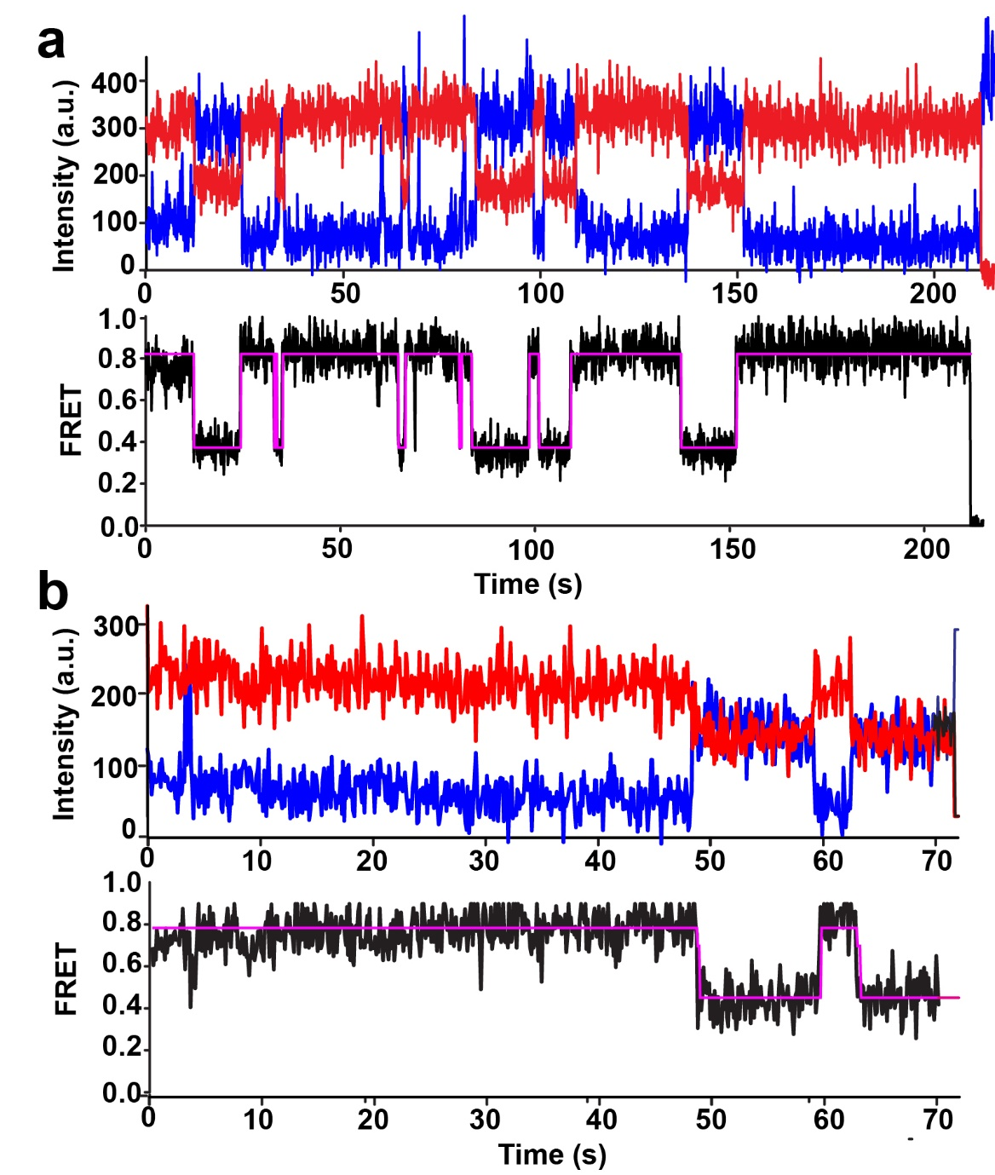
Supplementary Figure 1 | The Lrh preQ₁-II riboswitch samples multiple conformations. Representative smFRET traces show fluctuations of the riboswitch between the ~0.35 and ~0.8 FRET states (a), or ~0.5 and ~0.8 FRET states (b). The riboswitch was imaged in the presence of 0.5 mM Mg²⁺ and the absence of preQ₁. Observed intensities of donor and acceptor fluorescence and the calculated apparent FRET efficiency are shown in blue, red, and black, respectively. Hidden Markov Model fit is shown in magenta.

