**SUPPLEMENTARY INFORMATION**

**VETERINARY ANTIMICROBIALS AND ANTIPARASITICS IN FEE-FISHING PONDS: ANALYTICAL METHOD AND OCCURRENCE**

Natália Fernanda Tetzner and Susanne Rath*

Institute of Chemistry, Department of Analytical Chemistry, University of Campinas, P.O. Box 6154, 13083-970, Campinas, SP, Brazil.

______________________________________________________________________

*Corresponding author. E-mail address: susanne.rath@gmail.com

Table ST1 - Physicochemical properties of the drugs.

|  |  |
| --- | --- |
| **Analytes** | **Physicochemical properties** |
| **SULFONAMIDES/ TRIMETHOPRIM** |  |
| *Sulfadiazine (SDZ)* | Molecular formula: C10H10N4O2S  Molar mass (g mol-1): 250.3  pKa1/pKa2: 2.0/ 6.9  Water solubility (mg L-1): 77  Kow: 0.81 |
| *Sulfathiazole (STZ)* | Molecular formula: C9H9N3O2S2  Molar mass (g mol-1): 255.3  pKa1/pKa2: 2.0/ 6.9  Water solubility (mg L-1): 373  Kow: 1.12 |
| *Sulfamethazine (SMZ)* | Molecular formula: C12H14N4O2S  Molar mass (g mol-1): 278.3  pKa1/pKa2: 2.0/ 7.0  Water solubility (mg L-1): 1500  Kow: 6.3 |
| *Sulfamethoxazol (SMX)* | Molecular formula: C10H11N3O3S  Molar mass (g mol-1): 253.3  pKa1/pKa2: 2.0/ 6.2  Water solubility (mg L-1): 610  Kow: 7.8 |
| *Sulfadimethoxine (SDM)* | Molecular formula: C12H14N4O4S  Molar mass (g mol-1): 310.3  pKa1/pKa2: 1.9/ 6.1  Water solubility (mg L-1): 340  Kow: 42.7 |
| *Sulfaquinoxaline (SQX)* | Molecular formula: C14H12N4O2S  Molar mass (g mol-1): 300.3  pKa1/pKa2: 2.3/ 6.0  Water solubility (mg L-1): 120  Kow: 47.9 |
| *Trimethoprim (TMP)* | Molecular formula: C14H18N4O3  Molar mass (g mol-1): 290.3  pKa1: 7.2  Water solubility (mg L-1): 2334  Kow: 8.1 |
| **TETRACYCLINES** |  |
| *Oxytetracycline (OTC)* | Molecular formula: C22H24N2O9  Molar mass (g mol-1): 460.4  pKa1/pKa2/pKa3/pKa4: 2.8/ 7.4/ 8.4/ 12.0  Water solubility (mg L-1): 1399  Kow: 0.1 |
| **QUINOLONES/FLUOROQUINOLONES** |  |
| *Oxolinic Acid (AOX)* | Molecular formula: C13H11NO5  Molar mass (g mol-1): 261.2  pKa1: 5.6  Water solubility (mg L-1): 0.44  Kow: 22.4 |
| *Ciprofloxacin (CIP)* | Molecular formula: C17H18FN3O3  Molar mass (g mol-1): 331.3  pKa1/pKa2: 5.8/ 8.7  Water solubility (mg L-1): 11480  Kow: 1.9 |
| *Difloxacin (DIF)* | Molecular formula: C21H19F2N3O3  Molar mass (g mol-1): 399.4  pKa1/pKa2: 5.6/ 6.4  Water solubility (mg L-1): 1333  Kow: 7.8 |
| *Enrofloxacin (ENR)* | Molecular formula: C19H22FN3O3  Molar mass (g mol-1): 359.4  pKa1/pKa2: 5.7/ 6.7  Water solubility (mg L-1): 3397  Kow: 5.0 |
| *Norfloxacin (NOR)* | Molecular formula: C16H18FN3O3  Molar mass (g mol-1): 319.3  pKa1/pKa2: 5.8/ 8.7  Water solubility (mg L-1): 177900  Kow: 0.1 |
| *Sarafloxacin (SAR)* | Molecular formula: C20H17F2N3O3  Molar mass (g mol-1): 385.4  pKa1/pKa2: 5.8/ 8.7  Water solubility (mg L-1): 1139  Kow: 11.7 |
| *Flumequine (FLU)* | Molecular formula: C14H12FNO3  Molar mass (g mol-1): 261.3  pKa: 6.0  Water solubility (mg L-1): 29  Kow: 182.0 |
| **AMPHENICOLS** |  |
| *Florfenicol (FF)* | Molecular formula: C12H14Cl2FNO4S  Molar mass (g mol-1): 358.2  pKa1/pKa2: 8.5/ 13.6  Water solubility (mg L-1): 5936  Kow: 0.9 |
| *Chloramphenicol (CLF)* | Molecular formula: C11H12Cl2N2O5  Molar mass (g mol-1): 323.1  pKa1/pKa2: 8.7/ 13.6  Water solubility (mg L-1): 2400  Kow: 3.72 |
| *Thiamphenicol (TFC)* | Molecular formula: C12H15Cl1NO5S  Molar mass (g mol-1): 356.2  pKa1/pKa2: 8.8/ 13.6  Water solubility (mg L-1): 4800  Kow: 0.25 |
| **BENZIMIDAZOLES** |  |
| *Albendazole (ALB)* | Molecular formula: C12H15N3O2S  Molar mass (g mol-1): 265.3  pKa1/pKa2: 4.3/ 9.7  Water solubility (mg L-1): 40.76  Kow: 1380.4 |
| *Mebendazole (MEB)* | Molecular formula: C16H13N3O3  Molar mass (g mol-1): 295.3  pKa1/pKa2: 3.4/ 9.2  Water solubility (mg L-1): 50.08  Kow: 676.1 |
| *Oxfendazole (OXF)* | Molecular formula: C15H13N3O3S  Molar mass (g mol-1): 315.4  pKa1/pKa2: 3.6/ 9.3  Water solubility (mg L-1): 407.2  Kow: 42.7 |
| *Thiabendazole (TIA)* | Molecular formula: C10H7N3S  Molar mass (g mol-1): 201.2  pKa1/pKa2: 4.1/ 10.3  Water solubility (mg L-1): 339.2  Kow: 295.1 |

pKa: acid/base dissociation constants; Kow: octanol/water partition coefficient. **Source:** Chemspider; ChemAxon.

Table ST2: Water quality of fee-fishing ponds.

|  |  |  |  |  |  |  |  |
| --- | --- | --- | --- | --- | --- | --- | --- |
| **Fee-fishing lake** | **Temperature**  **(oC)** | **pH** | **Conductivity**  **(mS cm-1)** | **Dissolved oxygen**  **(mg L-1)** | **Redox potential**  **(mV)** | **Turbidity**  **(NTU)** | **Total dissolved solids**  **(g L-1)** |
| 1 | 28.7 | 9.2 | 0.10 | 9.1 | 87 | nd | 0.065 |
| 2 | 28.4 | 7.2 | 0.11 | 4.2 | 88 | nd | 0.073 |
| 3a | 27.5 | 7.2 | 0.09 | 5.1 | 130 | nd | 0.054 |
| 3b | 27.4 | 7.4 | 0.09 | 7.5 | 107 | nd | 0.027 |
| 4a | 28.8 | 7.5 | 0.08 | 7.1 | 123 | nd | 0.053 |
| 4b | 28.9 | 7.5 | 0.08 | 6.6 | 75 | nd | 0.053 |
| 5a | 28.9 | 6.5 | 0.08 | 6.1 | 156 | nd | 0.024 |
| 5b | 27.8 | 6.6 | 0.08 | 4.5 | 179 | nd | 0.009 |
| 6 | 23.0 | 7.2 | 0.11 | 3.6 | 37 | 32 | 0.092 |
| 7 | 23.9 | 6.9 | 0.06 | 8.6 | 99 | 181 | 0.035 |
| 8a | 23.4 | 6.9 | 0.06 | 5.2 | 125 | 110 | 0.040 |
| 8b | 21.3 | 7.0 | 0.06 | 7.5 | 134 | 142 | 0.043 |
| 9a | 27.1 | 9.1 | 0.07 | 11.5 | 86 | 49 | 0.046 |
| 9b | 26.7 | 7.9 | 0.05 | 8.5 | 130 | 278 | 0.033 |
| 9c | 26.2 | 7.5 | 0.03 | 11.0 | 196 | 299 | 0.020 |
| 10a | 24.7 | 6.8 | 0.07 | 7.3 | 74 | 122 | 0.045 |
| 10b | 25.5 | 6.5 | 0.17 | 6.1 | 93 | 111 | 0.11 |
| 11 | 23.1 | 6.8 | 0.07 | 7.1 | 80 | 20 | 0.043 |

nd: not determined.

Table ST3: On-line SPE steps: valves position and gradient used for the QSM and BSM pumps during sample loading, elution, wash and conditioning steps.

|  |  |  |  |  |  |  |  |  |  |
| --- | --- | --- | --- | --- | --- | --- | --- | --- | --- |
| **SPE Steps** | **Injection** | **Column Manager** | | **QSM pump, 0.95 mL min-1** | | | | **BSM pump, 0.3 mL min-1** | |
|  | t (min) | Left (L) | Right (R) | A (%) | B (%) | C (%) | D (%) | A1 (%) | A2 (%) |
| Injection/ Load | 0.0 | 1 | 1 | 98 | 2 | 0 | 0 | 80 | 20 |
| Elution | 1.0 | 1 | 2 | 98 | 2 | 0 | 0 | 80 | 20 |
| 3.0 | 1 | 1 | 98 | 2 | 0 | 0 | 10 | 90 |
| Wash SPE column | 3.5 | 1 | 1 | 2 | 60 | 0 | 38 | 10 | 90 |
| 4.0 | 1 | 1 | 2 | 60 | 0 | 38 | 10 | 90 |
| 5.5 | 1 | 1 | 2 | 60 | 0 | 38 | 80 | 20 |
| Conditioning/ Equilibration | 6.0 | 1 | 1 | 98 | 2 | 0 | 0 | 80 | 20 |
| 8.0 | 1 | 1 | 98 | 2 | 0 | 0 | 80 | 20 |

A and C: water, B: methanol, D: acetonitrile, A1: water with 0.1% acetic acid, B1: methanol.

Table ST4 - SRM acquisition parameters for analytes.

|  |  |  |  |  |  |
| --- | --- | --- | --- | --- | --- |
| **Analyte** | **ESI** | **Precursor ion (*m/z*)** | **Cone Voltage (V)** | **Quantification ion (*m/z*)/CE (V)** | **Quantification ion (*m/z*)/CE (V)** |
| SDZ | + | 250.9 | 34 | 91.9/28 | 156.0/14 |
| STZ | + | 255.9 | 34 | 155.9/14 | 91.9/30 |
| SMZ | + | 279.0 | 44 | 185.9/16 | 92.0/32 |
| SMX | + | 253.9 | 34 | 92.0/28 | 155.9/16 |
| SDM | + | 311.0 | 44 | 155.9/22 | 92.0/34 |
| SQX | + | 301.0 | 38 | 155.9/14 | 91.9/28 |
| SDM-d6 | + | 317.1 | 65 | 162.2/20 | 108.1/28 |
| TMP | + | 290.9 | 50 | 123.0/22 | 230.1/24 |
| TET | + | 445.1 | 30 | 410.1/18 | 154.0/28 |
| OXI | + | 461.1 | 34 | 426.1/20 | 201.0/40 |
| AOX | + | 261.9 | 26 | 159.9/36 | 129.9/38 |
| FLU | + | 261.9 | 34 | 201.9/32 | 125.9/46 |
| CIP | + | 332.1 | 42 | 231.0/36 | 245.1/24 |
| DIF | + | 400.1 | 44 | 70.1/42 | 306.1/32 |
| ENR | + | 360.1 | 42 | 72.1/34 | 84.0/32 |
| NOR | + | 320.1 | 42 | 282.1/30 | 189.0/50 |
| SAR | + | 386.1 | 40 | 348.1/32 | 270.1/44 |
| CIP-d8 | + | 340.1 | 20 | 322.1/22 | 296.1/18 |
| FF | - | 356.0 | 30 | 184.9/20 | 335.9/20 |
| CLF | - | 321.0 | 30 | 151.9/20 | 257.2/20 |
| TFC | - | 354.0 | 30 | 184.9/20 | 289.8/15 |
| FF-d3 | - | 359.0 | 30 | 187.9/20 | 338.9/20 |
| ALB | + | 266.1 | 42 | 234.0/18 | 191.2/32 |
| MEB | + | 296.1 | 40 | 105.2/35 | 264.8/20 |
| OXF | + | 316.0 | 43 | 159.0/32 | 191.0/20 |
| TIA | + | 202.0 | 50 | 175.0/25 | 131.0/35 |
| ALB-d3 | + | 269.0 | 45 | 234.0/19 | 191.0/30 |

CE: collision energy.

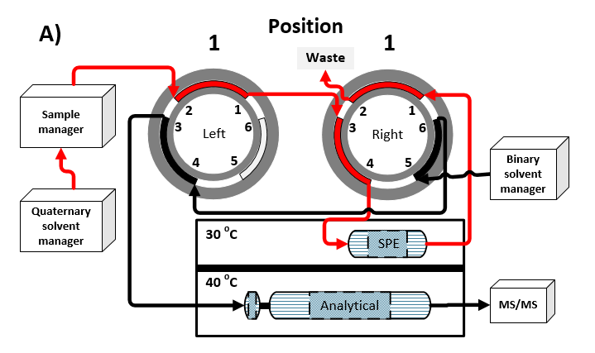

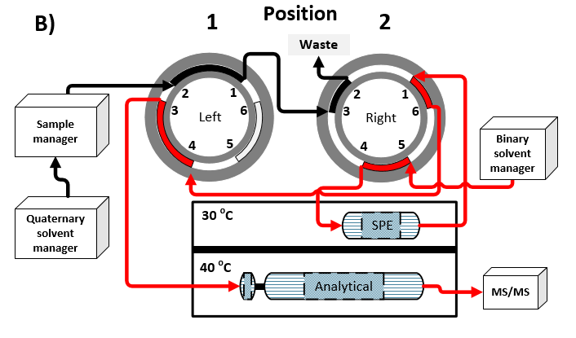

**FigureS1 -** Schematic diagram of the solvent flow direction in the on-line SPE system (direct flush): a) Valve positions - left 1 and right 1: sample is loaded in the SPE column; b) left 1 and right 2: retained analytes are eluted from the SPE column to the analytical column.

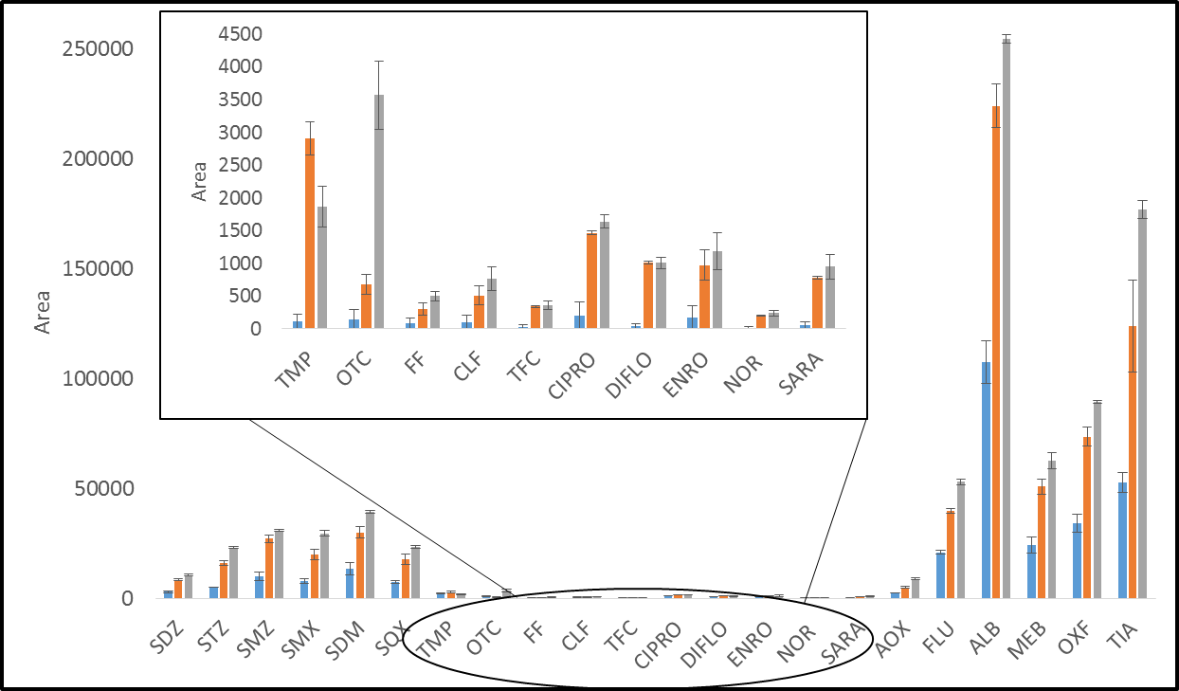

Figure S2 – Areas of the chromatographic peaks of the analytes with *on-line* SPE-UHPLC-MS/MS using different sample volumes ( 100 µL, 200 µL and 250 µL)

**Table ST5 –** Results (mean value, n= 3) of the water samples collected in the fee-fishing ponds in Campinas-SP, Brazil.

|  |  |  |  |  |  |  |  |  |  |  |  |  |  |  |  |  |  |  |
| --- | --- | --- | --- | --- | --- | --- | --- | --- | --- | --- | --- | --- | --- | --- | --- | --- | --- | --- |
| **Analyte** | **FF 1** | **FF 2** | **FF 3a** | **FF 3b** | **FF 4a** | **FF 4b** | **FF 5a** | **FF 5b** | **FF 6** | **FF 7** | **FF 8a** | **FF 8b** | **FF 9a** | **FF 9b** | **FF 9c** | **FF 10a** | **FF 10b** | **FF 11** |
| **Type of activity** | CR | CR | FP | FP | FP | FP | FP | FP | FP | FP | CR | FP | FP | FP | FP | FP | FP | FP |
| **Sulfonamides and trimethoprim** | | | | | |  |  |  |  |  |  |  |  |  |  |  |  |  |
| SDZ | n.d. | n.d. | n.d. | n.d. | n.d. | n.d. | n.d. | n.d. | n.d. | n.d. | n.d. | n.d. | n.d. | n.d. | n.d. | n.d. | n.d. | n.d. |
| STZ | n.d. | n.d. | n.d. | n.d. | n.d. | n.d. | n.d. | n.d. | n.d. | n.d. | n.d. | n.d. | n.d. | n.d. | n.d. | n.d. | n.d. | n.d. |
| SMZ | n.d. | n.d. | n.d. | n.d. | n.d. | n.d. | n.d. | n.d. | n.d. | n.d. | n.d. | n.d. | n.d. | n.d. | n.d. | n.d. | n.d. | n.d. |
| SMX | n.d. | n.d. | n.d. | n.d. | n.d. | n.d. | n.d. | n.d. | n.d. | n.d. | n.d. | n.d. | n.d. | n.d. | n.d. | n.d. | n.d. | n.d. |
| SDM | n.d. | n.d. | n.d. | n.d. | n.d. | n.d. | n.d. | n.d. | n.d. | n.d. | n.d. | n.d. | n.d. | n.d. | n.d. | n.d. | n.d. | n.d. |
| SQX | n.d. | n.d. | n.d. | n.d. | n.d. | n.d. | n.d. | n.d. | n.d. | n.d. | n.d. | n.d. | n.d. | n.d. | n.d. | n.d. | n.d. | n.d. |
| TMP | **< LOQ** | n.d. | n.d. | n.d. | n.d. | n.d. | n.d. | n.d. | n.d. | n.d. | n.d. | n.d. | n.d. | n.d. | n.d. | n.d. | n.d. | n.d. |
| **Tetracyclines** | | | | | |  |  |  |  |  |  |  |  |  |  |  |  |  |
| OTC | n.d. | n.d. | n.d. | n.d. | n.d. | n.d. | n.d. | n.d. | n.d. | n.d. | n.d. | n.d. | n.d. | n.d. | n.d. | n.d. | n.d. | n.d. |
| **Amphenicols** | | | | | |  |  |  |  |  |  |  |  |  |  |  |  |  |
| FF | **0.42** | **0.74** | n.d. | n.d. | n.d. | n.d. | n.d. | n.d. | n.d. | n.d. | n.d. | n.d. | n.d. | n.d. | n.d. | n.d. | n.d. | n.d. |
| TFC | **< LOQ** | n.d. | n.d. | n.d. | n.d. | n.d. | n.d. | n.d. | n.d. | n.d. | n.d. | n.d. | n.d. | n.d. | n.d. | n.d. | n.d. | n.d. |
| CLF | n.d. | n.d. | n.d. | n.d. | n.d. | n.d. | n.d. | n.d. | n.d. | n.d. | n.d. | n.d. | n.d. | n.d. | n.d. | n.d. | n.d. | n.d. |
| **(Fluoro)quinolones** | | | | | |  |  |  |  |  |  |  |  |  |  |  |  |  |
| AOX | n.d. | n.d. | n.d. | n.d. | n.d. | n.d. | n.d. | n.d. | n.d. | n.d. | n.d. | n.d. | n.d. | n.d. | n.d. | n.d. | n.d. | n.d. |
| FLU | n.d. | n.d. | n.d. | n.d. | n.d. | n.d. | n.d. | n.d. | n.d. | n.d. | n.d. | n.d. | n.d. | n.d. | n.d. | n.d. | n.d. | n.d. |
| CIPRO | n.d. | n.d. | n.d. | n.d. | n.d. | n.d. | n.d. | n.d. | n.d. | n.d. | n.d. | n.d. | n.d. | n.d. | n.d. | n.d. | n.d. | n.d. |
| ENRO | n.d. | n.d. | n.d. | n.d. | n.d. | n.d. | n.d. | n.d. | n.d. | n.d. | n.d. | n.d. | n.d. | n.d. | n.d. | n.d. | n.d. | n.d. |
| NOR | n.d. | n.d. | n.d. | n.d. | n.d. | n.d. | n.d. | n.d. | n.d. | n.d. | n.d. | n.d. | n.d. | n.d. | n.d. | n.d. | n.d. | n.d. |
| SARA | n.d. | n.d. | n.d. | n.d. | n.d. | n.d. | n.d. | n.d. | n.d. | n.d. | n.d. | n.d. | n.d. | n.d. | n.d. | n.d. | n.d. | n.d. |
| **Benzimidazoles** | | | | | |  |  |  |  |  |  |  |  |  |  |  |  |  |
| ALB | **0.05** | n.d. | n.d. | n.d. | n.d. | n.d. | **0.31** | n.d. | n.d. | n.d. | n.d. | n.d. | n.d. | n.d. | n.d. | n.d. | n.d. | n.d. |
| MEB | n.d. | n.d. | n.d. | n.d. | n.d. | n.d. | n.d. | n.d. | n.d. | n.d. | n.d. | n.d. | n.d. | n.d. | n.d. | n.d. | n.d. | n.d. |
| OXF | n.d. | n.d. | n.d. | n.d. | n.d. | n.d. | n.d. | n.d. | n.d. | n.d. | n.d. | n.d. | n.d. | n.d. | n.d. | n.d. | n.d. | n.d. |
| TIA | n.d. | n.d. | n.d. | n.d. | n.d. | n.d. | **0.45** | n.d. | n.d. | n.d. | n.d. | n.d. | n.d. | n.d. | n.d. | n.d. | n.d. | n.d. |

n.d.: not detected; Concentration in µg L-1; FF: fee-fishing pond; CR: “Catch & Release”; FP: “Fish & Pay”