Supplementary information
Borneol and α-asarone as adjuvant agents for improving blood-brain barrier permeability of puerarin and tetramethylpyrazine by activating adenosine receptors
Jun-Yong Wu^{1,2,3}, Yong-Jiang Li^{1,2,3}, Le-Yang^{1,2,3}, Yi-Yun Hu^{1,2,3}, Xiong-Bin Hu^{1,2,3}, Tian-Tian Tang^{1,2,3}, Jie-Min Wang^{1,2,3}, Xin-Yi Liu^{1,2,3}, Da-Xiong Xiang^{1,2,3,*}
- Department of Pharmacy, The Second Xiangya Hospital, Central South University, Changsha 410011, Hunan, China
- Institute of Clinical Pharmacy, Central South University, Changsha 410011, Hunan, China
- Institute of Clinical Pharmacy, Central South University, Changsha 410011, Hunan, China

* Corresponding author at:
Department of Pharmacy, The Second Xiangya Hospital, Central South University, Changsha 410011, Hunan, China; Email: xiangdaxiong@csu.edu.cn

A

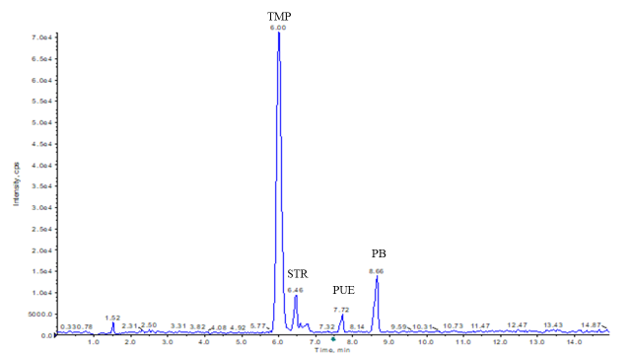

B

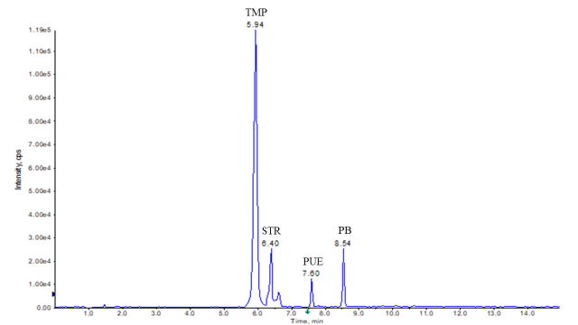

Figure S1. (A)The chromatogram map of mixed standard plasma sample. (B)The chromatogram map of mixed standard brain tissue homogenate sample. PB: Phenobarbital; STR: strychnine; TMP: Tetramethylphrazine; PUE: Puerarin

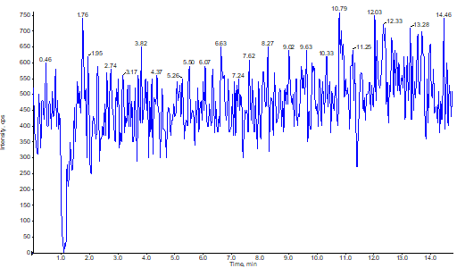
A

B
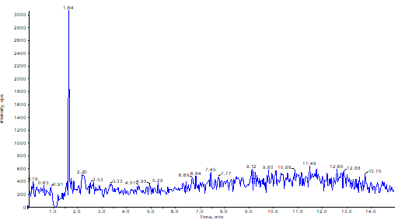

Figure S2. (A) The chromatogram map of blank plasma sample; (B) The chromatogram map of blank brain tissue homogenate sample.

Table S1. Linear regression equations, correlation coefficients and the limit of quantitation for PUE and TMP in plasma samples.
 | Linear range  (ng mL⁻¹) | Linear regression equations | correlation coefficients (R²) | limit of quantitation (ng mL⁻¹)
PUE | 1.17 — 1000 | y = 0.0188x - 0.0167 | 0.9999 | 0.58
TMP | 8.67 — 1833 | y = 0.0049x + 0.0871 | 0.9987 | 6.51

Table S2. Linear regression equations, correlation coefficients and the limit of quantitation for PUE and TMP in brain tissue homogenate samples.
 | Linear range  (ng mL⁻¹) | Linear regression equations | correlation coefficients (R²) | limit of quantitation (ng mL⁻¹)
PUE | 1.17 — 1000 | y = 0.0101x - 0.0114 | 0.9999 | 0.45
TMP | 8.67 — 1833 | y = 0.0087x + 0.0480 | 0.9998 | 5.33

Table S3. Matrix effects of PUE in plasma samples.
 | Low dose (2.5ng mL⁻¹) |  | Median dose (66.7ng mL⁻¹) |  | High dose (800ng mL⁻¹)
 | A₁ | A₀ | A₁ | A₀ | A₁ | A₀
Area | 3569 | 3800 | 156428 | 142529 | 1589854 | 1829686
 | 3346 | 4069 | 153926 | 151997 | 1646856 | 1766822
 | 2946 | 4057 | 151882 | 139639 | 1658973 | 1596833
 | 3128 | 3370 | 161367 | 144377 | 1766364 | 1878782
 | 3558 | 3823 | 152991 | 143933 | 1807060 | 1795511
RSD (%) | 8.21 | 7.41 | 2.43 | 3.17 | 5.31 | 6.05
Matrix effects (%) | 86.55 |  | 107.49 |  | 95.51

Table S4. Matrix effects of TMP in plasma samples.
 | Low dose (16.7ng/mL) |  | Median dose (200ng/mL) |  | High dose (1500ng/mL)
 | A₁ | A₀ | A₁ | A₀ | A₁ | A₀
Area | 21401 | 25074 | 297580 | 315496 | 2021970 | 1931426
 | 25511 | 24846 | 298730 | 324566 | 1858499 | 2024699
 | 26550 | 25467 | 283502 | 309271 | 1935335 | 1886077
 | 28350 | 27391 | 297915 | 307196 | 1810692 | 1879648
 | 24355 | 26631 | 313430 | 308591 | 1969334 | 2065324
RSD (%) | 10.29 | 4.20 | 3.55 | 2.30 | 4.42 | 4.27
Matrix effects (%) | 97.49 |  | 95.27 |  | 98.04

Table S5. Matrix effects of PUE in brain tissue homogenate samples.
 | Low dose (2.5ng mL⁻¹) |  | Median dose (66.7ng mL⁻¹) |  | High dose (800ng mL⁻¹)
 | A₁ | A₀ | A₁ | A₀ | A₁ | A₀
Area | 1826 | 2256 | 82512 | 88479 | 826294 | 784904
 | 2096 | 2159 | 76012 | 86151 | 723373 | 780847
 | 1930 | 2521 | 79188 | 86415 | 719407 | 899115
 | 1926 | 2265 | 82469 | 85741 | 791131 | 825247
 | 2102 | 2312 | 90216 | 91256 | 746065 | 766638
RSD (%) | 6.06 | 5.83 | 6.44 | 2.62 | 6.07 | 6.62
Matrix effects (%) | 85.82 |  | 93.69 |  | 93.83

Table S6. Matrix effects of TMP in brain tissue homogenate samples.
 | Low dose (16.7ng/mL) |  | Median dose (200ng/mL) |  | High dose (1500ng/mL)
 | A₁ | A₀ | A₁ | A₀ | A₁ | A₀
Area | 16849 | 16616 | 194056 | 200590 | 2043952 | 1973054
 | 16055 | 15113 | 195611 | 209741 | 1947170 | 2035847
 | 15187 | 17420 | 193399 | 205508 | 1951649 | 1927725
 | 16976 | 13961 | 201656 | 211731 | 2100273 | 1896512
 | 16304 | 14394 | 208621 | 200936 | 2022783 | 2061531
RSD (%) | 4.40 | 9.50 | 3.25 | 2.45 | 3.22 | 3.53
Matrix effects (%) | 104.99 |  | 96.58 |  | 101.73

Table S7. Accuracy, intra-day and inter-day recovery of PUE in plasma samples.
 | Low dose  (2.5ng mL⁻¹) |  | Median dose (66.7ng mL⁻¹) |  | High dose  (800ng mL⁻¹)
 | Concentration (μg/ml) | Recovery (%) | Concentration (μg/ml) | Recovery (%) | Concentration (μg/ml) | Recovery (%)
Day 1 | 2.49 | 99.46 | 68.71 | 103.02 | 1096.76 | 109.68
 | 2.47 | 98.72 | 68.27 | 102.36 | 1079.28 | 107.93
 | 2.55 | 101.89 | 61.61 | 92.37 | 1063.29 | 106.33
 | 2.48 | 99.29 | 58.51 | 87.72 | 977.74 | 97.77
 | 2.34 | 93.50 | 62.66 | 93.95 | 1065.65 | 106.57
Day 2 | 2.55 | 102.15 | 68.27 | 102.36 | 1060.05 | 106.00
 | 2.72 | 108.75 | 61.61 | 92.37 | 1064.08 | 106.41
 | 2.43 | 97.37 | 58.51 | 87.72 | 1073.99 | 107.40
 | 2.13 | 85.15 | 62.66 | 93.95 | 1002.76 | 100.28
 | 2.22 | 88.73 | 72.91 | 109.32 | 968.74 | 96.87
Day 3 | 2.36 | 94.42 | 66.94 | 100.36 | 968.95 | 96.90
 | 2.28 | 91.31 | 69.62 | 104.38 | 892.65 | 89.26
 | 2.63 | 105.20 | 68.55 | 102.78 | 956.81 | 95.68
 | 2.33 | 93.32 | 67.90 | 101.80 | 1001.05 | 100.11
 | 2.66 | 106.31 | 68.12 | 102.13 | 1047.63 | 104.76
RSD_{intra-day} (%) | 3.13 |  | 6.91 |  | 4.36
RSD_{inter-day} (%) | 3.52 |  | 6.74 |  | 3.87

Table S8. Accuracy, intra-day and inter-day recovery of TMP in plasma samples.
 | Low dose (16.7ng/mL) |  | Median dose (200ng/mL) |  | High dose (1500ng/mL)
 | Concentration (μg/ml) | Recovery (%) | Concentration (μg/ml) | Recovery (%) | Concentration (μg/ml) | Recovery (%)
Day 1 | 16.71 | 100.06 | 220.31 | 110.16 | 1489.21 | 99.28
 | 16.93 | 101.38 | 201.42 | 100.71 | 1429.94 | 95.33
 | 15.88 | 95.09 | 206.15 | 103.08 | 1592.24 | 106.15
 | 14.78 | 88.50 | 195.84 | 97.92 | 1538.40 | 102.56
 | 16.49 | 98.74 | 197.68 | 98.84 | 1682.14 | 112.14
Day 2 | 16.31 | 97.66 | 205.54 | 102.77 | 1456.78 | 97.12
 | 16.99 | 101.74 | 199.14 | 99.57 | 1435.20 | 95.68
 | 17.31 | 103.65 | 203.23 | 101.62 | 1459.29 | 97.29
 | 16.54 | 99.04 | 191.25 | 95.63 | 1589.14 | 105.94
 | 17.34 | 103.83 | 195.42 | 97.71 | 1572.84 | 104.86
Day 3 | 15.98 | 95.69 | 192.54 | 96.27 | 1529.27 | 101.95
 | 16.91 | 101.26 | 198.09 | 99.05 | 1548.75 | 103.25
 | 15.84 | 94.85 | 199.08 | 99.54 | 1548.19 | 103.21
 | 16.59 | 99.34 | 209.17 | 104.59 | 1620.20 | 108.01
 | 15.92 | 95.33 | 203.85 | 101.93 | 1438.20 | 95.88
RSD_{intra-day} (%) | 5.35 |  | 4.79 |  | 6.26
RSD_{inter-day} (%) | 5.08 |  | 2.28 |  | 6.65

Table S9. Accuracy, intra-day and inter-day recovery of PUE in brain tissue homogenate samples.
 | Low dose  (2.5ng mL⁻¹) |  | Median dose (66.7ng mL⁻¹) |  | High dose  (800ng mL⁻¹)
 | Concentration (μg/ml) | Recovery (%) | Concentration (μg/ml) | Recovery (%) | Concentration (μg/ml) | Recovery (%)
Day 1 | 2.59 | 103.54 | 60.83 | 91.21 | 829.95 | 99.60
 | 2.46 | 98.27 | 69.48 | 104.17 | 814.83 | 97.78
 | 2.59 | 103.49 | 74.21 | 111.27 | 853.93 | 102.48
 | 2.69 | 107.61 | 58.23 | 87.31 | 839.93 | 100.80
 | 2.42 | 96.94 | 66.50 | 99.70 | 807.19 | 96.87
Day 2 | 2.73 | 109.35 | 69.23 | 103.80 | 815.39 | 97.85
 | 2.46 | 98.36 | 63.39 | 95.04 | 814.93 | 97.80
 | 2.44 | 97.41 | 55.50 | 83.20 | 845.35 | 101.45
 | 2.55 | 102.12 | 69.49 | 104.19 | 835.24 | 100.23
 | 2.82 | 112.94 | 70.34 | 105.46 | 839.48 | 100.74
Day 3 | 2.58 | 103.17 | 81.49 | 122.18 | 831.29 | 99.76
 | 2.14 | 85.70 | 72.50 | 108.69 | 815.48 | 97.86
 | 2.10 | 83.95 | 69.49 | 104.19 | 825.23 | 99.03
 | 2.46 | 98.32 | 59.29 | 88.89 | 856.95 | 102.84
 | 2.48 | 99.18 | 64.23 | 96.30 | 855.04 | 102.61
RSD_{intra-day} (%) | 4.26 |  | 9.80 |  | 2.27
RSD_{inter-day} (%) | 5.33 |  | 8.72 |  | 2.39

Table S10. Accuracy, intra-day and inter-day recovery of TMP in brain tissue homogenate samples.
 | Low dose (16.7ng/mL) |  | Median dose (200ng/mL) |  | High dose (1500ng/mL)
 | Concentration (μg/ml) | Recovery (%) | Concentration (μg/ml) | Recovery (%) | Concentration (μg/ml) | Recovery (%)
Day 1 | 15.60 | 93.44 | 184.59 | 92.29 | 1432.95 | 95.53
 | 17.63 | 105.57 | 182.96 | 91.48 | 1643.20 | 109.55
 | 16.29 | 97.57 | 194.46 | 97.23 | 1390.44 | 92.70
 | 16.84 | 100.85 | 199.48 | 99.74 | 1523.13 | 101.54
 | 15.90 | 95.23 | 205.18 | 102.59 | 1487.39 | 99.16
Day 2 | 15.82 | 94.75 | 220.48 | 110.24 | 1429.39 | 95.29
 | 16.53 | 99.01 | 217.29 | 108.65 | 1565.04 | 104.34
 | 16.83 | 100.79 | 198.48 | 99.24 | 1590.34 | 106.02
 | 17.65 | 105.72 | 204.41 | 102.20 | 1580.76 | 105.38
 | 17.43 | 104.39 | 203.29 | 101.65 | 1589.02 | 105.93
Day 3 | 16.85 | 100.92 | 185.93 | 92.96 | 1459.49 | 97.30
 | 15.36 | 91.96 | 204.29 | 102.15 | 1529.29 | 101.95
 | 17.88 | 107.05 | 192.40 | 96.20 | 1603.02 | 106.87
 | 17.99 | 107.71 | 198.23 | 99.12 | 1521.25 | 101.42
 | 15.22 | 91.16 | 201.43 | 100.72 | 1486.39 | 99.09
RSD_{intra-day} (%) | 4.89 |  | 4.93 |  | 6.48
RSD_{inter-day} (%) | 4.55 |  | 6.90 |  | 6.53

