Supplemental File for
The enhanced effect of oxalic acid on the electroreduction of Cr(VI) via formation of intermediate Cr(VI)-oxalate complex
Yijie Liu^{1,2}, Shuaishuai Xin², Bo Jiang^{1,2,*}
1 State Key Laboratory of Petroleum Pollution Control, CNPC Research Institute of Safety and
Environmental Technology, Beijing, 102206, China
2 School of Environmental and Municipal Engineering, Qingdao University of Technology, Qingdao 266033, PR China;

*Corresponding author: bjiang86upc@163.com (B. Jiang)

Number of pages (including this page):7
Number of figures:4
Number of Table: 1

Fig. S1.The speciation distribution of Cr(VI) species at pH 0~12.
Fig. S2. Variation of Cr(VI) and H₂O₂ concentrations during the direct reduction. ([Cr(VI)]₀ = 1.0 mM, [H₂O₂] = 16.2 mg L⁻¹, pH = 3.0, [Ox]₀ = 5.0 mM).
Fig. S3. Effect of EtOH and Ox on Cr(VI) reduction in electrolysis system. ([Cr(VI)]₀ = 1.0 mM, [EtOH]₀ = 50 mM, [Ox]₀ = 5.0 mM, pH =3.0, I = 20 mA).
Fig. S4. Effect of Ox concentration on the current efficiency of Cr(VI) reduction.
([Cr(VI)]₀ = 1.0 mM, I = 20 mA, pH = 3.0).
Table. S1. Results summarized for Cr(VI) reduction in electrolysis system. (Unless otherwise specified, [Cr(VI)]₀ = 1.0 mM, pH = 3.0, I = 20 mA, [Ox]₀ = 5.0 mM).

Fig. S1
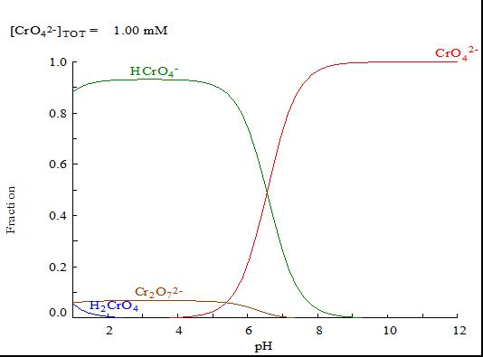

Fig. S2

Fig. S3

Fig. S4

Table S1.
NO. | Variation parameters | Reduction  time (h) | Average  reduction rate(mM h⁻¹) | Reduction efficiency | Current efficiency
1. | 0.1 mM Cr(VI) | 0.5 | 0.2 | 99% | 16%
2. | 0.2 mM Cr(VI) | 0.67 | 0.3 | 100% | 24%
3. | 0.5 mM Cr(VI) | 1 | 0.48 | 97% | 39%
4. | 1.0mM Cr(VI) | 1.5 | 0.66 | 99% | 53%
5. | 2.0 mM Cr(VI) | 1.5 | 0.64 | 48% | 51%
6. | 0 mM Ox | 1.5 | 0.23 | 36% | 19%
7. | 2.0 mM Ox | 1.5 | 0.38 | 58% | 31%
8. | 4.0 mM Ox | 1.5 | 0.55 | 83% | 44%
9. | 5.0 mM Ox | 1.5 | 0.66 | 99% | 53%
10. | 10 mM Ox | 1.3 | 0.74 | 99% | 61%
11. | pH 2.0 | 1 | 0.96 | 97% | 78%
12. | pH 2.5 | 1.3 | 0.72 | 97% | 60%
13. | pH 3.0 | 1.5 | 0.66 | 99% | 53%
14. | pH 3.5 | 1.5 | 0.28 | 43% | 23%
15. | 10 mA | 1.5 | 0.38 | 58% | 62%
16. | 20 mA | 1.5 | 0.66 | 99% | 53%
17. | 30 mA | 1.17 | 0.84 | 97% | 44%
18. | 40 mA | 1 | 0.96 | 97% | 39%

