Supplementary Materials

Comparative evaluation of triacylglycerols, fatty acids, and volatile organic compounds as markers for authenticating sesame oil

CONTENTS
Supplementary Table 1.
Triacyglycerol compositions (%) in edible oils selected for multivariate analysis in this study

Supplementary Table 2.
Fatty acid compositions (%) in edible oils selected for multivariate analysis in this study

Supplementary Table 3.
Volatile organic compound compositions (a.u. $×$ 10⁴) in edible oils selected for multivariate analysis in this study

Supplementary Figure 1.
Representative chromatograms of identified triacyglycerol compositions in oil samples analyzed in this study.

Supplementary Figure 2.
Representative chromatograms of identified fatty acid compositions in oil samples analyzed in this study.

Supplementary Figure 3.
Analytical ion chromatograms of identified volatile organic compound compositions in oil samples analyzed in this study. Unique mass was used for calculations for a particular peak.

Supplementary Table 1. Triacyglycerol compositions (%) in edible oils selected for multivariate analysis in this study
Oil sampleª | LLLn | LLL | PLL | OOL | OOO | POO
SSO 1 | nd | 13.06 | 5.14 | 22.56 | 7.25 | 9.15
SSO 2 | nd | 15.29 | 5.77 | 21.48 | 7.66 | 7.67
SSO 3 | nd | 13.44 | 5.18 | 21.64 | 7.12 | 9.41
SSO 4 | nd | 10.22 | 4.54 | 23.40 | 9.85 | 11.74
SSO 5 | nd | 9.96 | 4.80 | 23.56 | 9.90 | 11.27
SSO 6 | nd | 9.64 | 5.02 | 23.75 | 10.96 | 11.31
CO 1 | nd | 18.68 | 12.72 | 16.78 | 5.41 | 4.05
CO 2 | nd | 16.10 | 11.99 | 17.51 | 4.97 | 4.77
CO 3 | nd | 22.95 | 13.93 | 13.73 | 3.39 | 2.67
SSO:CO (95:5) | nd | 11.58 | 5.05 | 23.30 | 8.79 | 9.05
SSO:CO (95:5) | nd | 12.49 | 5.11 | 22.72 | 7.91 | 9.57
SSO:CO (95:5) | nd | 14.22 | 5.67 | 21.34 | 7.05 | 8.99
SSO:CO (95:5) | nd | 9.11 | 4.18 | 26.80 | 9.41 | 10.22
SSO:CO (95:5) | nd | 11.06 | 5.04 | 21.83 | 7.79 | 10.49
SSO:CO (95:5) | nd | 10.60 | 5.06 | 23.28 | 8.96 | 10.89
SSO:CO (90:10) | nd | 12.42 | 5.31 | 22.57 | 8.75 | 8.96
SSO:CO (90:10) | nd | 13.00 | 5.42 | 22.38 | 8.07 | 9.39
SSO:CO (90:10) | nd | 14.63 | 5.97 | 21.01 | 6.78 | 8.15
SSO:CO (90:10) | nd | 10.22 | 4.56 | 24.03 | 8.07 | 9.98
SSO:CO (90:10) | nd | 12.03 | 6.16 | 21.42 | 7.72 | 9.48
SSO:CO (90:10) | nd | 10.77 | 5.77 | 23.42 | 8.02 | 10.47
SSO:CO (80:20) | nd | 12.72 | 6.00 | 22.24 | 8.34 | 8.15
SSO:CO (80:20) | nd | 13.23 | 5.82 | 21.88 | 7.20 | 8.33
SSO:CO (80:20) | nd | 11.75 | 6.20 | 22.95 | 7.77 | 8.05
SSO:CO (80:20) | nd | 10.63 | 4.86 | 25.25 | 7.62 | 9.48
SSO:CO (80:20) | nd | 12.45 | 6.64 | 21.66 | 7.22 | 8.42
SSO:CO (80:20) | nd | 11.76 | 6.20 | 22.98 | 7.67 | 8.06
SBO 1 | 4.50 | 24.18 | 14.71 | 10.13 | 4.01 | 5.07
SBO 2 | 5.29 | 27.30 | 14.49 | 8.97 | 3.27 | 4.20
SBO 3 | 4.21 | 26.40 | 14.69 | 8.76 | 4.74 | 3.81
SSO:SBO (95:5) | nd | 12.71 | 4.58 | 23.27 | 6.44 | 8.87
SSO:SBO (95:5) | 0.10 | 14.70 | 5.75 | 22.73 | 8.55 | 9.43
SSO:SBO (95:5) | nd | 13.33 | 4.88 | 20.83 | 5.09 | 11.95
SSO:SBO (95:5) | 0.10 | 8.74 | 5.28 | 24.43 | 10.29 | 10.99
SSO:SBO (95:5) | 0.05 | 11.43 | 4.43 | 22.55 | 7.10 | 10.23
SSO:SBO (95:5) | nd | 11.10 | 3.84 | 19.11 | 9.46 | 9.95
SSO:SBO (90:10) | nd | 13.17 | 5.01 | 22.29 | 7.16 | 8.82
SSO:SBO (90:10) | 0.19 | 15.52 | 6.66 | 20.66 | 9.47 | 10.56
SSO:SBO (90:10) | nd | 14.16 | 4.62 | 19.81 | 6.58 | 8.60
SSO:SBO (90:10) | 0.17 | 12.58 | 5.47 | 23.13 | 9.58 | 10.75
SSO:SBO (90:10) | 0.01 | 12.04 | 5.23 | 22.69 | 6.29 | 8.75
SSO:SBO (90:10) | nd | 12.03 | 4.44 | 23.01 | 8.81 | 9.79
SSO:SBO (80:20) | nd | 13.76 | 6.02 | 21.83 | 7.05 | 8.31
SSO:SBO (80:20) | 0.41 | 15.78 | 6.88 | 20.65 | 8.01 | 8.86
SSO:SBO (80:20) | 1.05 | 18.67 | 4.36 | 15.78 | 13.58 | 9.79
SSO:SBO (80:20) | 0.39 | 13.75 | 6.22 | 21.87 | 8.73 | 10.16
SSO:SBO (80:20) | 0.36 | 15.52 | 5.52 | 17.41 | 8.95 | 11.65
SSO:SBO (80:20) | 0.45 | 14.07 | 6.69 | 21.69 | 8.14 | 10.05
ª Each sample was analyzed in triplicate.
SSO, sesame oil; CO, corn oil; SBO, soybean oil.
nd: not detected.
Supplementary Table 2. Fatty acid compositions (%) in edible oils selected for multivariate analysis in this study
Oil sampleª | C16:0 | C18:0 | C18:1(n-7) | C18:2 | C18:3(n-3) | C20:2 | C22:2
SSO 1 | 8.78 | 5.31 | 0.80 | 45.29 | 0.33 | 0.17 | 0.13
SSO 2 | 8.87 | 5.03 | 0.83 | 45.85 | 0.35 | 0.18 | 0.13
SSO 3 | 8.84 | 5.15 | 0.82 | 46.03 | 0.36 | 0.18 | 0.16
SSO 4 | 9.16 | 5.54 | 0.83 | 42.91 | 0.30 | 0.22 | 0.14
SSO 5 | 9.11 | 5.84 | 0.80 | 43.63 | 0.31 | 0.25 | 0.14
SSO 6 | 9.19 | 5.70 | 0.85 | 42.98 | 0.30 | 0.23 | 0.14
CO 1 | 11.24 | 2.04 | 0.67 | 51.13 | 1.09 | 0.41 | 0.21
CO 2 | 11.08 | 1.92 | 0.62 | 53.21 | 1.04 | 0.29 | 0.18
CO 3 | 10.97 | 1.78 | 0.57 | 55.26 | 1.01 | 0.29 | 0.17
SSO:CO (95:5) | 8.90 | 5.18 | 0.87 | 46.24 | 0.30 | 0.16 | 0.12
SSO:CO (95:5) | 9.28 | 5.15 | 0.87 | 44.72 | 0.37 | 0.21 | 0.11
SSO:CO (95:5) | 9.20 | 5.02 | 0.87 | 46.59 | 0.35 | 0.16 | 0.08
SSO:CO (95:5) | 9.52 | 5.51 | 0.90 | 42.45 | 0.33 | 0.25 | 0.12
SSO:CO (95:5) | 9.62 | 5.74 | 0.85 | 43.77 | 0.37 | 0.26 | 0.11
SSO:CO (95:5) | 9.67 | 5.40 | 0.89 | 42.87 | 0.35 | 0.23 | 0.10
SSO:CO (90:10) | 8.93 | 4.99 | 0.81 | 46.30 | 0.39 | 0.17 | 0.16
SSO:CO (90:10) | 9.42 | 4.98 | 0.85 | 45.17 | 0.42 | 0.20 | 0.13
SSO:CO (90:10) | 9.31 | 4.86 | 0.86 | 47.02 | 0.37 | 0.15 | 0.11
SSO:CO (90:10) | 9.65 | 5.28 | 0.91 | 43.00 | 0.38 | 0.26 | 0.11
SSO:CO (90:10) | 10.06 | 4.77 | 0.92 | 44.73 | 0.38 | 0.27 | 0.12
SSO:CO (90:10) | 9.78 | 5.20 | 0.86 | 43.48 | 0.38 | 0.25 | 0.12
SSO:CO (80:20) | 9.29 | 4.68 | 0.78 | 46.72 | 0.47 | 0.21 | 0.15
SSO:CO (80:20) | 9.62 | 4.68 | 0.82 | 45.99 | 0.48 | 0.21 | 0.13
SSO:CO (80:20) | 9.53 | 4.52 | 0.82 | 47.86 | 0.45 | 0.21 | 0.11
SSO:CO (80:20) | 9.88 | 4.94 | 0.87 | 43.82 | 0.46 | 0.26 | 0.11
SSO:CO (80:20) | 10.19 | 4.42 | 0.89 | 45.74 | 0.45 | 0.29 | 0.12
SSO:CO (80:20) | 9.95 | 4.78 | 0.83 | 44.93 | 0.46 | 0.26 | 0.11
SBO 1 | 10.49 | 4.19 | 1.42 | 54.04 | 5.65 | 0.31 | 0.46
SBO 2 | 10.73 | 4.07 | 1.46 | 53.42 | 5.29 | 0.32 | 0.53
SBO 3 | 10.49 | 4.17 | 1.42 | 54.29 | 5.64 | 0.29 | 0.46
SSO:SBO (95:5) | 8.76 | 5.27 | 0.85 | 46.20 | 0.57 | 0.17 | 0.15
SSO:SBO (95:5) | 9.21 | 5.27 | 0.90 | 44.73 | 0.58 | 0.21 | 0.14
SSO:SBO (95:5) | 9.16 | 5.13 | 0.91 | 46.55 | 0.55 | 0.18 | 0.11
SSO:SBO (95:5) | 9.52 | 5.59 | 0.96 | 42.58 | 0.55 | 0.23 | 0.12
SSO:SBO (95:5) | 9.94 | 5.04 | 0.98 | 44.37 | 0.56 | 0.25 | 0.12
SSO:SBO (95:5) | 9.64 | 5.52 | 0.94 | 42.82 | 0.59 | 0.23 | 0.12
SSO:SBO (90:10) | 8.87 | 5.20 | 0.88 | 46.62 | 0.82 | 0.18 | 0.17
SSO:SBO (90:10) | 9.33 | 5.22 | 0.93 | 45.14 | 0.82 | 0.21 | 0.14
SSO:SBO (90:10) | 9.24 | 5.09 | 0.94 | 46.92 | 0.83 | 0.20 | 0.12
SSO:SBO (90:10) | 9.59 | 5.52 | 0.98 | 43.11 | 0.78 | 0.25 | 0.13
SSO:SBO (90:10) | 9.96 | 5.00 | 1.00 | 44.91 | 0.83 | 0.24 | 0.13
SSO:SBO (90:10) | 9.69 | 5.47 | 0.95 | 43.39 | 0.84 | 0.23 | 0.13
SSO:SBO (80:20) | 9.09 | 5.08 | 0.93 | 47.47 | 1.35 | 0.17 | 0.21
SSO:SBO (80:20) | 9.55 | 5.09 | 0.99 | 46.01 | 1.30 | 0.23 | 0.18
SSO:SBO (80:20) | 9.41 | 4.99 | 0.99 | 47.72 | 1.35 | 0.19 | 0.16
SSO:SBO (80:20) | 9.75 | 5.37 | 1.03 | 44.21 | 1.27 | 0.25 | 0.17
SSO:SBO (80:20) | 10.08 | 4.91 | 1.04 | 45.94 | 1.38 | 0.26 | 0.16
SSO:SBO (80:20) | 9.83 | 5.32 | 1.02 | 44.51 | 1.36 | 0.24 | 0.18
ª Each sample was analyzed in triplicate.
SSO, sesame oil; CO, corn oil; SBO, soybean oil.
Supplementary Table 3. Volatile organic compound compositions (a.u. $×$ 10⁴) in edible oils selected for multivariate analysis in this study
Oil sampleª | Pyridine | Pyrazine | Thiazole | 2-Methyl pyrazine | 2,3-Dimethyl pyrazine | 2-Propenal
SSO 1 | 106.24 | 202.88 | 48.55 | 2390.14 | 139.13 | nd
SSO 2 | 158.57 | 425.30 | 130.73 | 4157.86 | 178.86 | nd
SSO 3 | 126.72 | 408.92 | 100.80 | 3595.92 | 143.30 | nd
SSO 4 | 156.87 | 623.52 | 134.50 | 5622.57 | 209.37 | nd
SSO 5 | 129.51 | 462.90 | 82.36 | 3173.84 | 147.00 | nd
SSO 6 | 94.95 | 462.55 | 74.58 | 2890.77 | 134.98 | nd
CO 1 | nd | nd | nd | nd | nd | 45.08
CO 2 | nd | nd | nd | nd | nd | 19.95
CO 3 | nd | nd | nd | nd | nd | 10.44
SSO:CO (95:5) | 89.09 | 176.72 | 40.13 | 2112.51 | 124.66 | 0.73
SSO:CO (95:5) | 150.45 | 407.11 | 120.63 | 4110.03 | 181.63 | 0.47
SSO:CO (95:5) | 118.07 | 399.37 | 94.64 | 3581.27 | 148.04 | 0.55
SSO:CO (95:5) | 82.72 | 420.80 | 66.51 | 2596.37 | 120.27 | 1.04
SSO:CO (95:5) | 138.37 | 574.41 | 119.73 | 5167.81 | 194.58 | 0.71
SSO:CO (95:5) | 118.04 | 444.18 | 76.35 | 3057.43 | 141.31 | 0.65
SSO:CO (90:10) | 94.03 | 186.54 | 42.36 | 2229.88 | 131.58 | 0.78
SSO:CO (90:10) | 158.81 | 429.73 | 127.33 | 4338.36 | 191.72 | 0.49
SSO:CO (90:10) | 124.63 | 421.55 | 99.90 | 3780.23 | 156.26 | 0.58
SSO:CO (90:10) | 87.31 | 444.18 | 70.21 | 2740.61 | 126.96 | 1.10
SSO:CO (90:10) | 146.06 | 606.32 | 126.38 | 5454.92 | 205.39 | 0.75
SSO:CO (90:10) | 124.60 | 468.86 | 80.59 | 3227.29 | 149.16 | 0.69
SSO:CO (80:20) | 105.79 | 209.86 | 47.65 | 2508.61 | 148.03 | 0.87
SSO:CO (80:20) | 178.66 | 483.44 | 143.25 | 4880.66 | 215.68 | 0.55
SSO:CO (80:20) | 140.20 | 474.25 | 112.39 | 4252.76 | 175.80 | 0.66
SSO:CO (80:20) | 98.23 | 499.70 | 78.98 | 3083.19 | 142.83 | 1.24
SSO:CO (80:20) | 164.31 | 682.11 | 142.17 | 6136.78 | 231.07 | 0.84
SSO:CO (80:20) | 140.17 | 527.47 | 90.66 | 3630.70 | 167.81 | 0.77
SBO 1 | nd | nd | nd | nd | nd | 100.18
SBO 2 | nd | nd | nd | nd | nd | 17.43
SBO 3 | nd | nd | nd | nd | nd | 74.17
SSO:SBO (95:5) | 101.49 | 194.43 | 44.07 | 2365.52 | 141.31 | 1.26
SSO:SBO (95:5) | 140.80 | 398.97 | 114.36 | 4142.73 | 183.45 | 0.58
SSO:SBO (95:5) | 115.69 | 376.64 | 86.89 | 3484.10 | 146.37 | 1.42
SSO:SBO (95:5) | 81.17 | 407.52 | 63.58 | 2535.68 | 118.58 | 0.65
SSO:SBO (95:5) | 139.44 | 567.44 | 116.42 | 5206.00 | 197.51 | 1.06
SSO:SBO (95:5) | 109.11 | 411.67 | 69.14 | 2898.39 | 136.54 | 1.39
SSO:SBO (90:10) | 107.13 | 205.23 | 46.52 | 2496.94 | 149.16 | 1.33
SSO:SBO (90:10) | 148.63 | 421.13 | 120.71 | 4372.88 | 193.64 | 0.62
SSO:SBO (90:10) | 122.12 | 397.57 | 91.72 | 3677.66 | 154.51 | 1.50
SSO:SBO (90:10) | 85.68 | 430.16 | 67.11 | 2676.55 | 125.16 | 0.69
SSO:SBO (90:10) | 147.18 | 598.96 | 122.89 | 5495.22 | 208.48 | 1.12
SSO:SBO (90:10) | 115.18 | 434.54 | 72.98 | 3059.41 | 144.13 | 1.46
SSO:SBO (80:20) | 120.52 | 230.89 | 52.33 | 2809.05 | 167.81 | 1.50
SSO:SBO (80:20) | 167.20 | 473.77 | 135.80 | 4919.49 | 217.85 | 0.69
SSO:SBO (80:20) | 137.39 | 447.26 | 103.18 | 4137.37 | 173.82 | 1.68
SSO:SBO (80:20) | 96.39 | 483.92 | 75.50 | 3011.12 | 140.81 | 0.77
SSO:SBO (80:20) | 165.58 | 673.83 | 138.25 | 6182.12 | 234.54 | 1.26
SSO:SBO (80:20) | 129.57 | 488.86 | 82.10 | 3441.83 | 162.14 | 1.65
ª Each sample was analyzed in triplicate.
SSO, sesame oil; CO, corn oil; SBO, soybean oil.
nd, not detected.

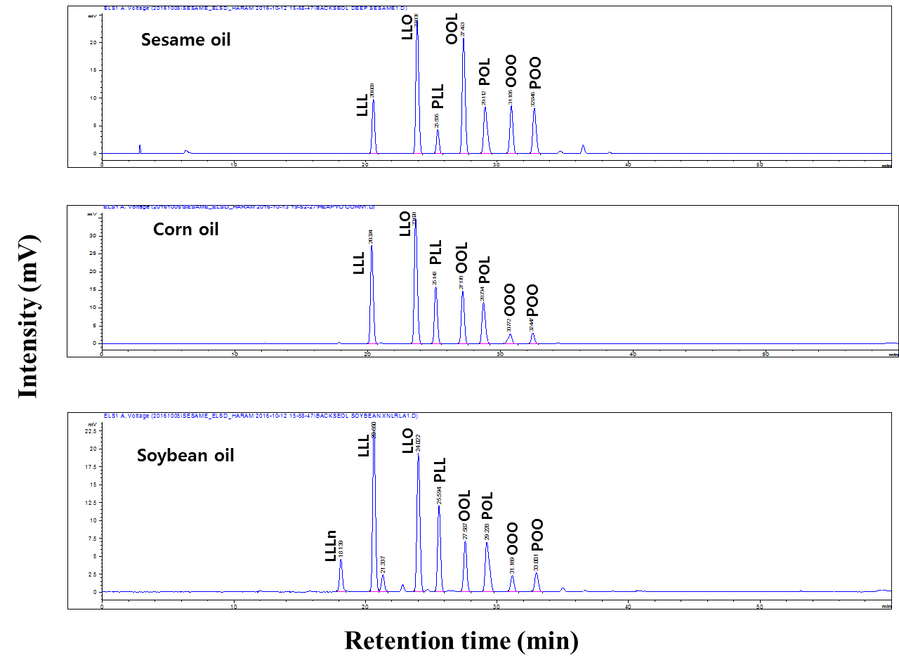
Supplementary Figure 1. Representative chromatograms of identified triacyglycerol compositions in oil samples analyzed in this study.
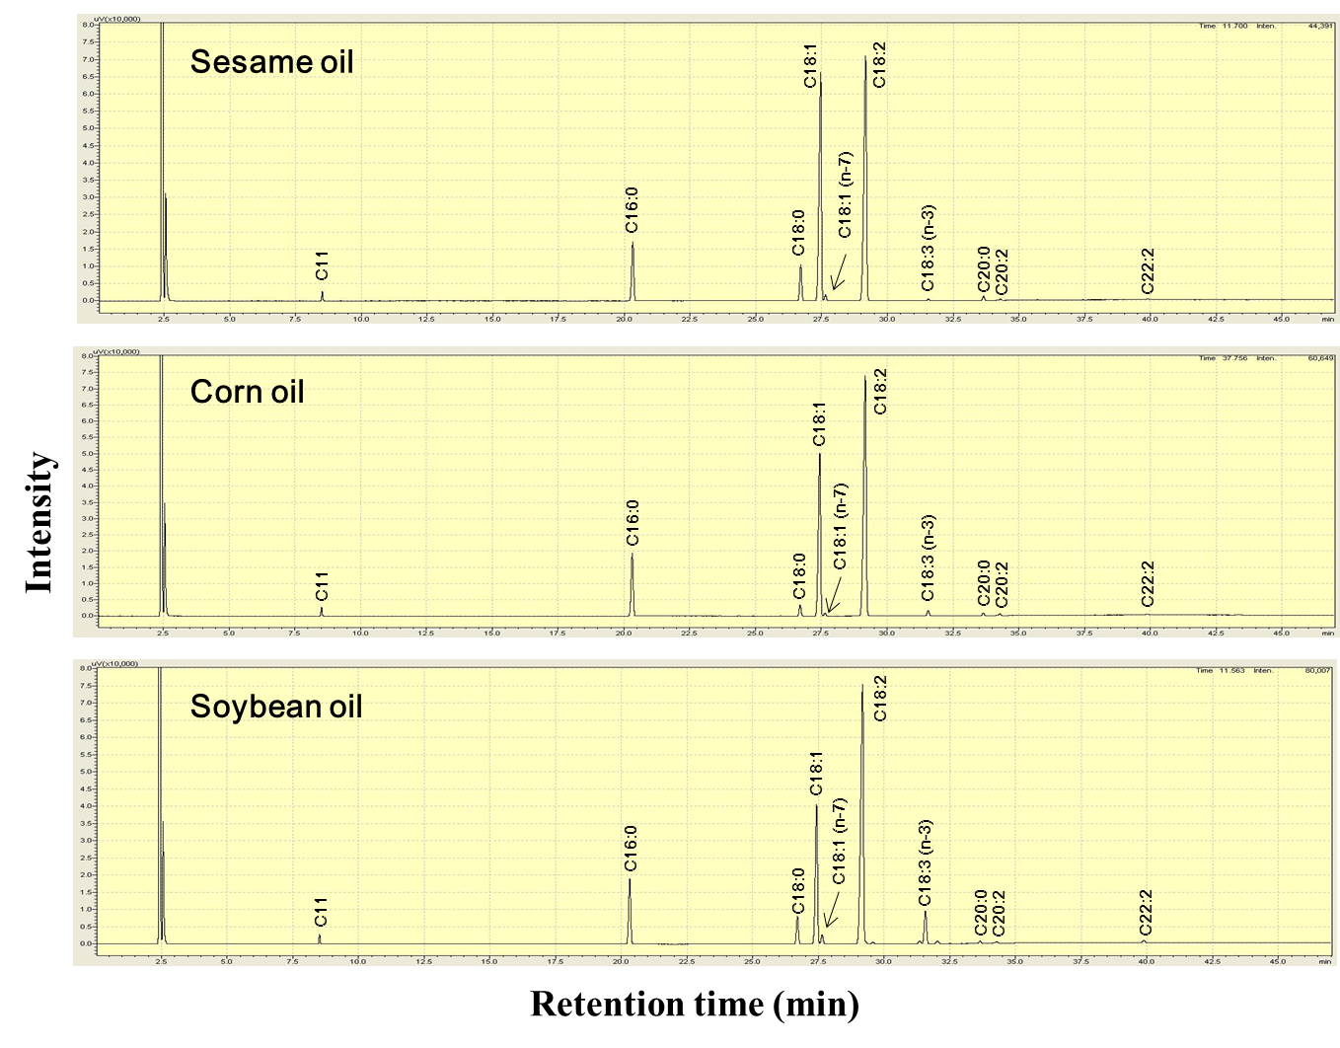
Supplementary Figure 2. Representative chromatograms of identified fatty acid compositions in oil samples analyzed in this study.
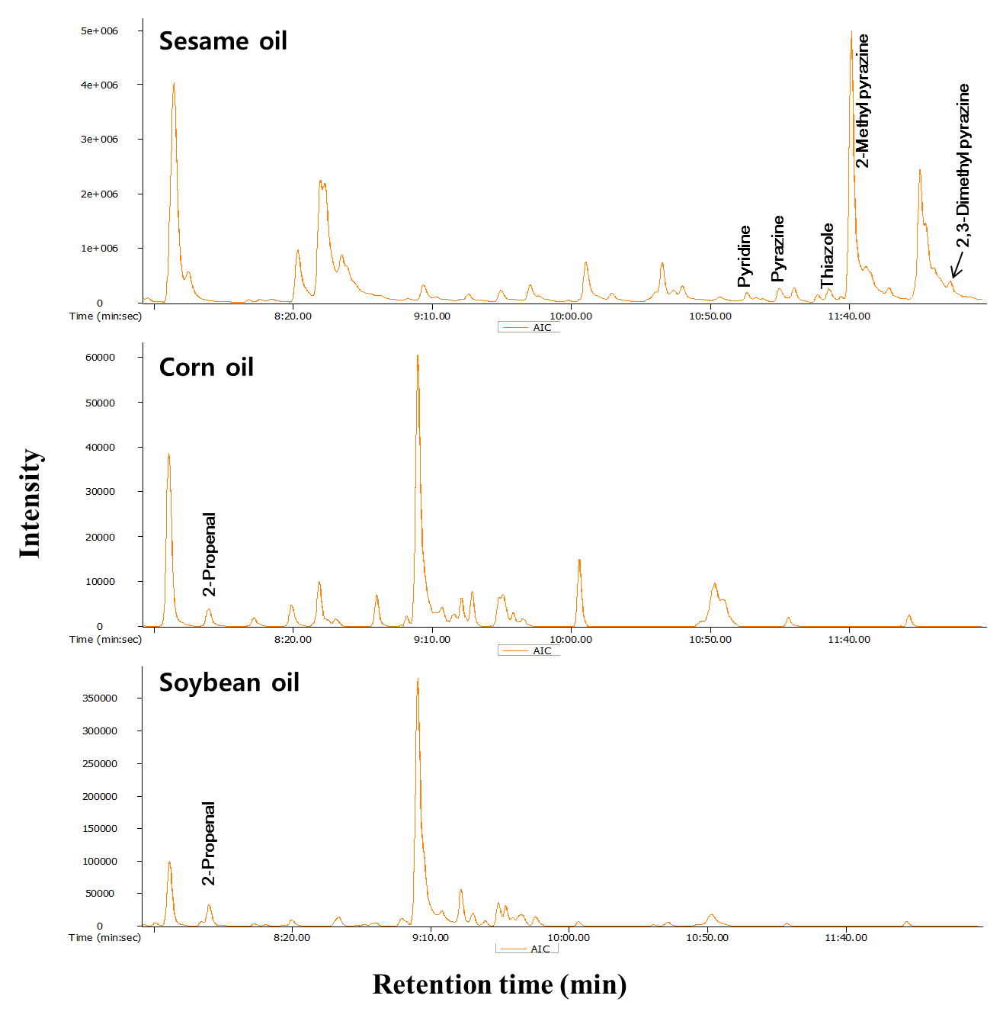
Supplementary Figure 3. Analytical ion chromatograms of identified volatile organic compound compositions in oil samples analyzed in this study. Unique mass was used for calculations for a particular peak.

