Effect of Fine-Grain Percent on Soil Strength Properties Improved By Biological Method

Nader Hataf*, Reyhaneh Jamali
Department of Civil and Environmental Engineering, Shiraz University, Shiraz, Iran
*corresponding author

Abstract: In many civil engineering projects, the foundation soils do not provide the required mechanical properties and therefore, there is a need to improve the soil. Compaction, soil reinforcement, soil mixing with natural or chemical additives are common soil stabilization methods to improve the soil characteristics. The incidence of some environmental problems in traditional improvement techniques has encouraged engineers to explore new methods. Recently in this category, a new technique in geotechnical engineering called biogeotechnology is introduced to improve the mechanical properties of the soil. It is an environmentally friendly approach which uses biological methods to solve geotechnical problems. This technique uses minerals producer microorganisms. This study investigates the possibility of improving soil strength properties with microbial calcite precipitation and the effect of fine-grained percentages in this regard. In order to determine the soil strength properties, direct shear test in the consolidated drained state has been on untreated and treated soil samples. The results showed that this method is applicable to improve all soil samples (from 100% coarse-grained (i.e. sand) to 100% fine-grained (i.e. clay)). However, increasing the strength in the sand is much more enhanced than that for finer soils. It was found that a considerable increase in cohesion of treated soil can be achieved for soil samples with maximum 10% fine content.

Key words: Biological Improvement, Soil Strength Properties, Effect of Fine-Grained Percent

- INTRODUCTION
Development of urban infrastructures is necessary to meet the needs of growing community. This issue is directly related to the access to suitable land that can be used for construction. Improving soil physical properties is necessary in some cases where the ground has not the sufficient strength to bear the applied load and/or when soil settlement, erosion and liquefaction are major concerns. Compaction, soil reinforcement, soil nailing, soil mixing with chemicals, lime or cement, grouting are common soil stabilization methods to improve soil characteristics. At the same time the environmental conditions for living in urban areas is declining (DeJong et al., 2010). Lately, environmental impacts of these traditional methods urged researchers to pay more attention to ecological approaches for treating the soils.
Currently, biological techniques using natural inherent microorganisms in soil are being investigated in this regard (DeJong et al. 2006; Whiffin et al. 2007; Ivanov & Chu 2008). Microorganisms can catalyze chemical reactions within the soil resulting in precipitation (or dissolution) of inorganic minerals. Researchers all over the world have shown the improvement of soil properties using microbiological processes.
Many researchers have mentioned that microbial mineral precipitation method is more effective in sandy soils compared to silts or clay (Kim et al., 2013) and most researchers have used granular soil for experiment and in-situ studies.
Thus, in previous studies the use of this method in fine grained soils has not received considerable attention. In this study microbial induced calcium carbonate precipitation (MICP) by urea hydrolysis is used to reinforce soils with different percentage of fine particles.

- PREVIOUS STUDIES
As cited, the traditional ground improvement methods may have undesirable environmental impact. Effects on underground water supplies, producing a lot of carbon dioxide and the toxicity and also problems such as high energy consumption, need expensive equipment are examples of such impacts. Therefore Engineers have been urged to examine new ways of soil improvement including environmentally friendly substances such as sewage sludge ash, bottom ash, bacteria in the soil and so on to solve these problems (Karol, 2003).
The history of research on new environmentally friendly methods is briefly mentioned as follows.
Lin et al. (2007) used sewage sludge ash and hydrated lime to stabilize a layey soil. Chen and Lin (2009) also investigated of using of sewage sludge ash and cement to stabilize clay. The results showed a significant increase in unconfined compressive strength of stabilized samples compared to the untreated samples.
Tempest, and Pando ( 2013) investigated the effect of sewage sludge ash to stabilize clayey soils. Having performed unconfined compression strength and plate loading tests, they found that the sewage sludge ash can improve the soils that can not be treated with other kinds of ashes.
Güllü and Girisken (2013) in a study investigated the geotechnical performances of fine grained soils treated with industrial sewage sludge and showed that industrial sewage sludge can be potensially used to improve and stabilize these soils.
Güllü, (2014a) used bottom ash to treat fine-grained soil. Güllü, (2014b). studied the effect of using bottom ash on strength and elastic properties of clay.
Güllü (2015a) in a study used bottom ash, lime and superplasticiser to treat fine-grained soil. He showed the improvement in unconfined compressive strength and freeze–thaw resistance of stabilised soil with respect to untreated soil.. Güllü (2015b) investgated the viscouse behaviore of cement mixtures with clay, sand, lime and bottom ash for jet grouting and found that diferent stabilizer used with cement have promising effect on rheological behavior of the soil and solve some of the environmental problems. Rajakumar and Meenambal (2015) in a study on utilization of bottom ash to stabilize expansive soil subgrades showed promising effect on strength improvement. Güllü, (2016a) used jet grout cement mixture with various stabilizers to treat the fine grain soil. He also presented a novel approach for prediction of rheological characteristics of jet grout cement mixtures via genetic expression programming Güllü, (2016b). Güllü, et al. showed the use of ranking measure for performance assessment of correlations for the compression index of treated soil.
Using Response Surface Methodology, Güllü and Fedakar (2016a) reported the optimum value of 19.95 percent of sludge ash for initial assessment of improvement for sandy soils. Güllü, and Fedakar, (2016b) used factorial experimental approach and effect size on the CBR testing results for the usable dosages of wastewater sludge ash with coarse-grained material.
Güllü, (2017) presented a new prediction method to rheological behavior of grout with bottom ash for jet grouting columns. Güllü, et al. (2017) studied on the use of cement based grout with glass powder for deep mixing. Güllü, and Fedakar (2017) studied on the prediction of unconfined compressive strength of silty soil stabilized with bottom ash, jute and steel fibers via artificial intelligence.

In the present research the process of the microbial calcium carbonate precipitation using soil inherent bacteria to improve soil strength properties as an environmental friendly approach has been studied. There are a number of investigtions showing the satisfactory results in this regard.
The discovery by Nadson (1903) who showed that microbes can precipitate calcium carbonate (CaCO3) lead in the development of Geomicrobiology or Bioremediation method. This is a new method which is based on the role of microorganisms in the changing the soil properties and has attracted a lot of attention in geotechnical engineering. Among the recent applications of Bioremediation method improving foundation bearing capacity, reducing susceptibility to earthquake-induced liquefaction, reducing the swell potential beneath foundations and roadways, enhancing slope stability, facilitating excavations and tunneling, and reducing permeability for groundwater control might be mentioned (Blauw et al., 2009). These have been known and investigated by many researchers. The improving occurs through the changes in the mechanical properties of soil such as shear strength, compressibility, hydraulic conductivity, etc. The roles of the microorganisms in these applications can be divided into three main categories: mineral precipitation, mineral transformation, and biopolymer and biofilm accumulation (Kavazavanjian and Karatas, 2008). In the first category carbonate precipitation is perhaps the earliest and most widely studied (Cheng, et al., 2014). Carbonate precipitation that results in a change in mechanical properties of soil can be used for temporary and permanent engineering applications. The optimal microbial mineral precipitation mechanism should be identified through a screening process, based on the site characteristics and then applied in-situ (Kim et al., 2013).
The use of mineral precipitation in the shearing behavior improvement of granular soils has been studied by many researchers (DeJong et al., 2006; Whiffin et al., 2007; Chou et al., 2011; Akayuli et al., 2013).
A comprehensive investigation was conducted by Villarraga and coworkers using compacted specimens of inorganic silt (Mitchell and Santamarina, 2005). The silt and pore water enriched with Bacillus Subtilis were thoroughly mixed prior to compaction, at water contents on the dry and the wet side of optimum. Cured compacted specimens were tested. Results showed an increase in undrained strength, undrained stiffness, drained strength and a decrease in permeability. It was also found that the extent of the effects depends on the compaction moisture content relative to the Proctor optimum, and is influenced by gas generation and changes in saturation.
A series of laboratory hydraulic conductivity and strength tests on biologically treated clayey silt (CL-ML) was conducted by Martin et al. ,1996. The triaxial test was used to measure the strength of samples cured for 40 days. It was found that the permeability was reduced by factors up to about 100 compared to the untreated soil and remained constant with time, and the strength increased up to about 50% during the first week (Martin et al., 1996).

Materials and Tests

Soil samples
To evaluate the effects of fine grain percentage on soil shear strength parameters treated using a biological method in this study, two types of soils have been used, a poorly graded sand as coarse grained soil and a clay with low plasticity as fine-grained soil. Figures 1 and 2 show the grain size distribution curves for these soils. Mixed soil samples in the range of from 100 percent coarse grained to 100 percent fine grained (finer than 75 um), were made at intervals of 10%, Table 1.

Table 1: Soil samples used
Fine grained  (%) | Coarse grained  (%) | Sample ID
0 | 100 | A
10 | 90 | A₁
20 | 80 | A₂
30 | 70 | A₃
40 | 60 | A₄
50 | 50 | AB
60 | 40 | B₄
70 | 30 | B₃
80 | 20 | B₂
90 | 10 | B₁
100 | 0 | B

Coarse-grained and fine grained soil properties used in this study were evaluated using ASTM standards and illustrated in Tables 2 and 3, respectively. It is noteworthy that on other samples that have been prepared with different percentages of fine-grained soil standard Proctor tests were also performed and the results are shown in Table 4.

Table 2. Coarse-grained soil properties used
Value | Parameter
2.41<6 | Uniformity Coefficient (C_{u})
1≤1.04≤3 | Concavity Coefficient (Cc)
0.76 mm | D₁₀
1.2 mm | D₃₀
1.83 mm | D₆₀
 | Fine percent
SP | Soil Classification based on Unified System
2.63 | Specific gravity (ASTM D854)
15.5 | Optimum moisture content (ASTM D698), (%)
1.8 | Maximum dry density (ASTM D698), gr/cm³
0 | Consolidated drained Cohesion (ASTM D3080), kPa
44.22 | Consolidated drained friction angle (ASTM D3080), degree

Fig. 1. grain size distribution for coarse grained soil (sand)

Tables 3. Fine grained soil properties
Value | Parameter
2.69 | Specific gravity (ASTM D854)
34.9 | Liquid Limit (ASTM D4318), LL
22.6 | Plastic Limit (ASTM D4318), PL
12.3 | Plasticity Index (ASTM D4318), PI
25.6 | Finer than 2 um (%)
100 | Finer than 75 um (%)
CL | Soil Classification based on Unified System
15 | Optimum moisture content (ASTM D698), (%)
1.82 | Maximum dry density (ASTM D698), gr/cm³
40.2 | Consolidated drained Cohesion (ASTM D3080), kPa
16.37 | Consolidated drained friction angle (ASTM D3080), degree

Fig. 2. grain size distribution for fine grained soil (clay)

Table 4. Optimum moisture content and max. dry unit weight of soilsamples
Soil sample | Optimum moisture content (%) | Max. dry density, gr/cm³
A₁ | 14.89 | 1.87
A₂ | 12.61 | 2.0
A₃ | 8.90 | 2.15
A₄ | 9.10 | 2.1
AB | 9.50 | 1.96
B₄ | 10.00 | 1.93
B₃ | 11.99 | 1.9
B₂ | 13.00 | 1.86
B₁ | 15.05 | 1.84

The results shown in Table 4 has obtained by conductin Proctor tests on soil samples according to ASTM D698.
Considering that the samples were prepared manually in order to ease up the specimen preparation for all samples an average dry density, approximately equal to 70 percent of the maximum dry density of the samples (i.e. 1.37 g/ cm³) and the moisture content equal to 15% as the moisture have been chosen.

The bacteria used
Bacillus Sphaericus bacteria was used for biological soil stabilization. The Bacillus Sphaericus have been selected for this study due to its high activity in producing calcium carbonate. The optical density of bacterial solution was measured. Components of liquid culture media are presented in Table 5. CaCl₂ solution was used to be mixed with bacteria solution and added to soil as a precipitating agent.

Table 5: Ingredients of culture media
Components of liquid culture media | g/L
Sodium Bicarbonate | 2.12
Nutrient Broth | 3
Ammonium Chloride | 10
Yeast extract | 20
Urea | 10

Transmission of bacteria and calcium chloride solution to soil samples

After the full growth and measurement of the concentration of bacteria, the solution containing the bacteria was added to the soil as soon as possible using a syringe.
The process was that the necessary amount of solution containing 10% of bacteria and calcium chloride solution transmitted to into the syringe and the syringe was shaken for 30 seconds before adding the solution to the soil.
After mixing with solution, soil samples gently kneaded with plastic gloves. The soil sample were then kept in a sealed container (with fix humidity) for 24 hours is maintained.

Soil sample compaction and storage
After 24 hours, the soil was transferred to a 10 x 10 x 2 cm direct shear box and was compacte to prespecified density. Compaction of dry soil samples after mixing with water was also conducted manually. Samples were stored for 4 days at ambient temperature and fixed moisture content before preparation to perform direct shear tests.

Direct shear test
Direct shear tests were performed according to the standard ASTM D 3080 to determine the shear strength parameters of the soil.
It is noteworthy to mention that for improved samples with bacteria, bacteria and calcium chloride solution (with 1 to 1 ratio) has provided part of desired water content. But in untreated specimens, the moisture content of the samples was supplied with water only. Having kept the moisture content the samples were compacted in shear box 24 hours after mixing. All samples were then kept in shear box for 24 hours to ensure saturation.

Controlling measures
As mentioned by previous researchers, one of the most important parameters in biological enrichment testing, especially in the case of calcite deposition is pH. Therefore, during the various stages of sample preparation in this study pH level was measured and controlled.
Scanning Electron Microscopy (SEM) and X-ray diffraction analysis (XRD) were also performed.

Results and Discussions
The changes of untreated and treated soil characteristics with respect to changes in fine grain content are illustrated in this section.

  - Untreated soil characteristics

Specific gravity, voids ratio and minimum voids ratio
In this study, the changes of determined according to ASTM D854with respect to the fine grained percentage for untreated soil were determined and illustrated in Fig. 3a. According to this figure, the specific gravity decreases with the value of the fine grain percentage increase showing a minimum at 30% and then increases. Almost the same trends have been observed for the void ratio change with fine grain percentage, Figs. 3b and 3c.

a

b

c
Fig. 3. Changes of a) specific gravity, b)voids ratio, c) minimum voids ratio of untreated soil with respect to fine content

Maximum dry density
The changes in maximum dry density determined from Proctor tests against the changes in fin grain content are illustrated in Fig. 4.

Fig. 4. Changes of maximum dry density of untreated soil with respect to fine content

As it can be seen from this figure, increasing the amount of clay increases the amount of maximum dry density up to an optimal value of fine content (between 30 to 40 percent) and reduces afterwards. The cause of this can be related to the fact that up to this optimum range, role of clay particles is filling the pores and then preventing the displacement and soil compaction by surrounding the sand particles, afterwards.

Shear strength parameters
To determine the shear strength parameters of untreated soil 11 direct shear tests on untreated soil samples were conducted and the results are shown in Figs.5a and b. Fig. 5a shows the variation of soil cohesions and Fig. 5b illustrates the changes in friction angle with changes in soil fine grain content.
Fig. 5a shows that compared to untreated samples the cohesion of treated specimens is higher at any percentage of fine clay content. This is beacause that the clay fills the voids in mixture of sand and clay and surrounding sand particles and therefore increasing the the adhesion.
As you can see from Fig. 5b angle of internal friction in untreated soil decreases with increasing the percentage of fine clay. This reduction, however, is not significant for up to clay content around 30% showing the changes of the mix toward cohesive soil characteristic.

a

b
Fig. 5. Changes of a) cohesion, b)friction angle of treated and untreated soil with respect to fine content

  - Biologically treated soil characteristics

    - Cohesion
Soil samples treated using Bacillus Sphaericus bacteria as cited earlier are tested using direct shear apparatus to determine the changes in shear strength parameters with respect to changes in fine grain content. The changes in cohesion in percent with respect to those for untreated soil are shown in Fig. 6.
According to the figure, the maximum percentage increase is related to the sample with 10% fine content (i.e. 450%). Then a dramatic decrease in cohesion can be observed with increase in the percentage of the fine content up to about 30%. There is small decrease, however, can be seen in cohesion afterwards.
Soils with 100% coarse-grain (i.e. sand) compared to other samples had the most improvement, which is in agreement with results reported by previous researchers (Mitchell and Santamarina, 2005; DeJong et al. 2006; Ivanov and Chu, 2008; Van Paassen et al., 2009 and Akayuli et al., 2013) who used gravel and sand biologically treated and qualitatively have shown that the effect of this method, is most effective for granular soils. Kim et al. )2013( also reported that the amount of calcium carbonate within treated samples of sand was approximately two times of that for silt sample.
In coarse grained soils due to the existence of relatively large pores in the soil and larger interconnections between these spaces, bacteria do not trap. They move more freely from one pore to the other and as a result show greater activity and develop more uniform distribution of Calcite carbonate in the soil. This leads to less inhibitory effect on the bacteria than in other samples. Therefore, MICP method is more effective in increasing shear strength for sandy soils with low fine content (i.e. less than 30% fine).

Fig. 6. Changes of cohesion of biologically treated soil with respect to fine content

    - Friction angle
Internal friction angle of improved soil by MICP method against changes in percentage of fine content is shown in Fig. 7. Again the internal friction angle decreases as the fine grain (or clay) content of the samples increases. On the other hand, comparing the values of friction angle for treated and untreated soil reveals that this parameter has not been affected by MICP, especially after employing shear forces during direct shear testing.

Fig. 7. Changes of the internal friction angle of biologically treated soil with respect to fine content

    - pH level
The variations of pH level for treated soil samples against time are illustrated in Fig.8. As it can be seen with the activity of microorganisms, the pH increases first and decrease with time.

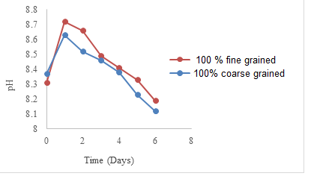

Fig. 8. pH level variation with time for treated soil samples

    - Calcite crystals
Figures 9 to11 show the scanning Electron Microscopy (SEM) images of untreated and treated soil samples. The left pictures show the SEM images of untrated soil samples, while the right images are of treated soil specimens. The white spots in the latter images show the microbial induced calcium carbonate precipitation (MICP) between soil particles due to the activity of microoranisms.
By comparing the images of 100% coarse grained soil samples before and after the improvement using biological methods (MICP), formation of calcite crystals and their density in the treated samples is obvious, Fig. 9. This indicates the effectiveness of the MICP method for coarse grained soil.

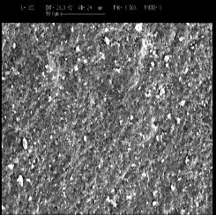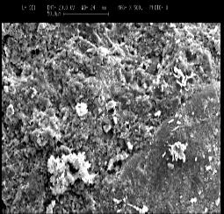
a

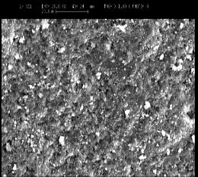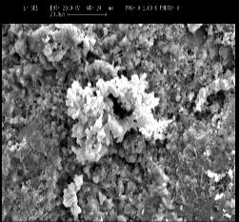
b

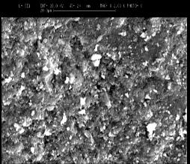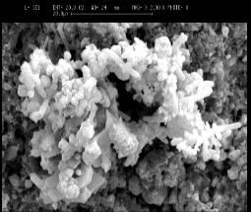
c
Fig. 9. Scanning Electron Microscopy (SEM) images of 100% coarse grained untreated (left), treated (right) soil samples: a)500 times magnification, b)1000 times magnification, c) 2000 times magnification

The same images are shown for fine grain soil in Figs. 10. Comparing the images of the soil samples with 100% fine grain content before and after the improvement using biological methods with calcite precipitation, show low levels and thin coverage of calcite crystals over the soil particles.

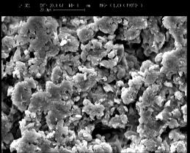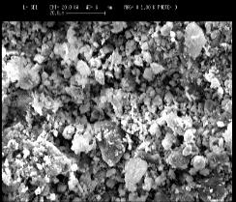
a

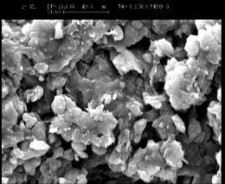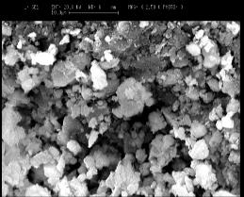
b

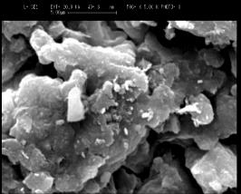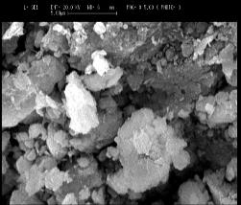
c
Fig. 10. Scanning Electron Microscopy (SEM) of fine grained untreated (left), treated (right) soil samples: a)1000 magnification, b)2500 times magnification, c) 5000 times magnification

Fig. 11. shows SEM image of fine grained treated and coarse grained treated soil samples. Having compared the soil samples with 100 % coarse grain and 100% fine grain treated by MICP show that the calcite crystals in coarse grained soil samples are thicker and greater. This represents the effectiveness of this method for coarse-grained soil rather than in fine grained soil.

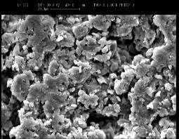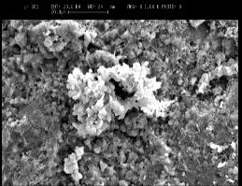
Fig. 11. SEM of fine grained treated (left), coarse grained treated (right) soil samples: 1000 times magnification

    - X-Ray Diffraction analysis
XRD analysis was carried out under angles between 20 to 35, two-theta, on three soil samples (i.e. 100 percent coarse grained, 80 percent corse grained and 100 percent fine grained). The results were analyzed and shown in figures 12a, b and c. In this analysis, calcite have been considered as the main material in the soil under study.

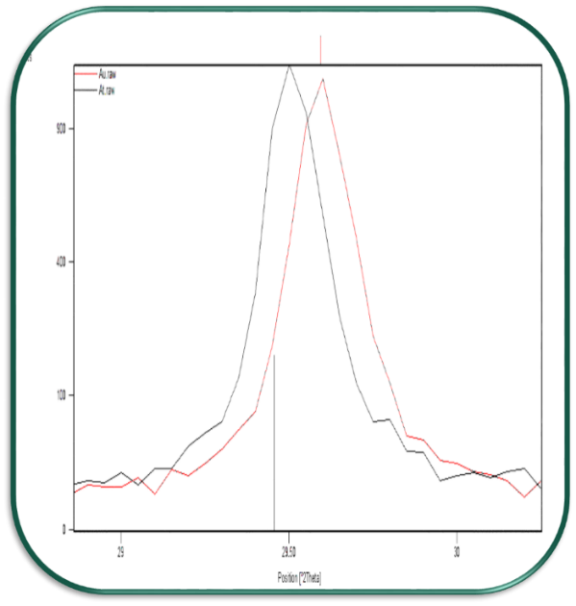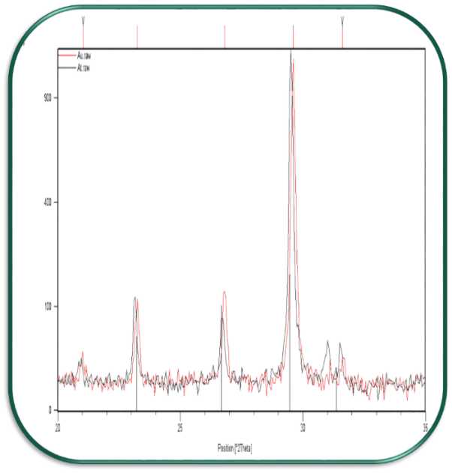
a

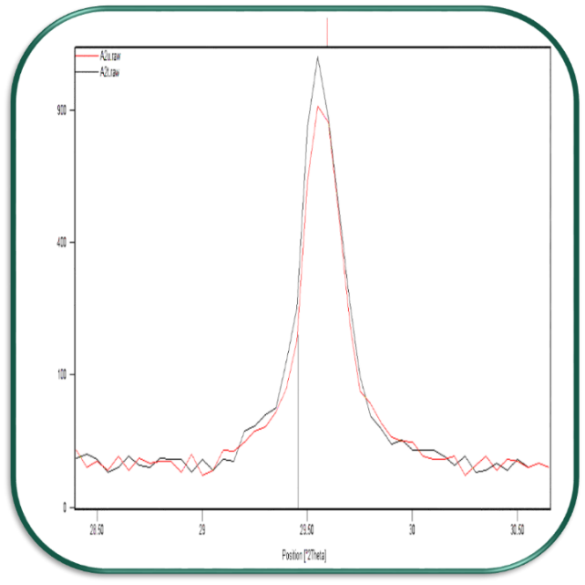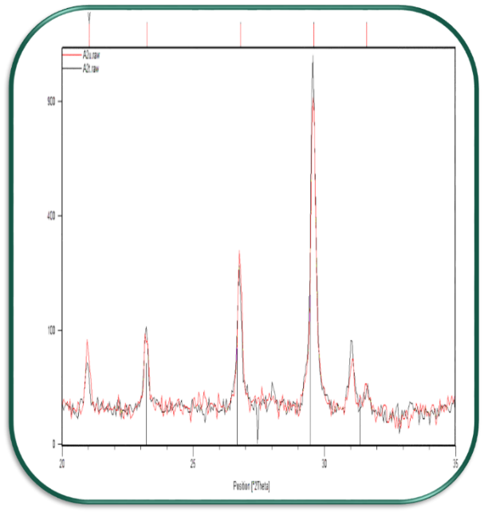
b
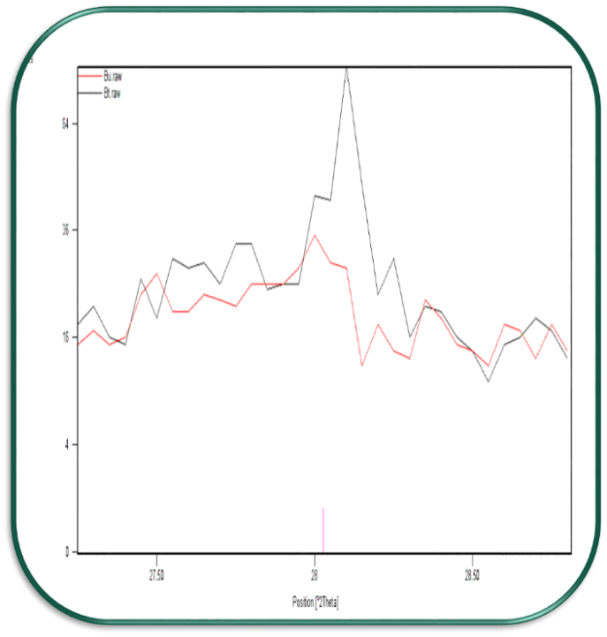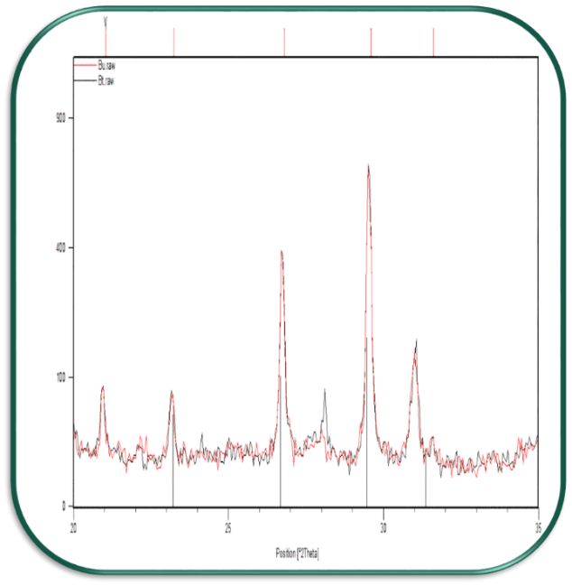
c
Fig.12. Compliance of standard peaks of calcite on peaks of XRD graph for: a)100% coarse grained untreated and treated soil samples (100%), b) 80% coarse grained, c) 100% fine grained, indicating the presence of calcite in the sample respectively. (Dark colored charts, graphs for improved sample XRD, XRD graph chart with brightly colored for untreated samples and vertical lines are standard calcite peaks). The right image is zoomed at an angle of 29.5 degrees.

As it can be seen from these figures, comparing the peak for calcite in all soil samples, shows increase of the amount of calcite in the treated samples. These results confirme that the shear strength increase in treated samples can be attributed to the increase of microbial deposits of calcite for all treated samples upto 30% fine graine content.

  - CONCLUSIONS
From the results of this study the followings can be concluded:
- The calcite crystal formation using MICP method in coarse grained soil samples is thicker and greater. This represents the effectiveness of this method for coarse-grained soil rather than in fine grained soil.
- The shear strength of all samples treated using MICP method increases. With increasing the percentage of fine grain content, the shear strength decreases up to 30% of fines and then almost remains constant.
- The considerable increase in cohesion of treated soil can be achieved for soil samples with maximum 10% fine content. Then a dramatic decrease in cohesion can be observed with increase in the percentage of the fine content up to about 30%. There is small decrease, however, can be seen in cohesion afterwards.
- The internal friction angle decreases as the fine grain content of the treated samples increases, which is the same for untreated soil specimens. Showing that this parameter has not been affected much by MICP method.
- Due to the improvement in shear strength of samples treated by MICP, the acceptable range of fine grain or clay content is from 0 to 20%. In other words, up to 20% fine grain in sand has not undesired effect of calcite precipitation.

REFERNCES
Akayuli, D. C., Ofosu, B., Nyako, S. O. and Opuni, K. O. (2013). The influence of observed clay content on shear strength and compressibility of residual sandy soils. International Journal of Engineering Research and Applications (IJERA), 3(4), 2538-2542.
Blauw, M., Lamber, J. W. M. and Latil, M. N. (2009). Biosealing: A method for in situ sealing of leakages. Ground improvement technologies and case histories, 125-130.
Cadersa, A. S., Seeborun, A. K. & Yuk A. C. C. (2014). Use of Coal Bottom Ash as Mechanical Stabiliser in Subgrade Soil. Journal of Engineering. 1-6 .
Chen, L. & Lin, D. F. (2009). Stabilization treatment of soft subgrade soil by sewage sludge ash and cement. Journal of Hazardous Materials. 162, 321-327.
Cheng, L., Shahin, M.A., Cord-Ruwisch, R., Addis, M., Haranto, T. and Elms, C. (2014). Soil stabilisation by microbial induced calcium carbonate precipitation: investigation of some important physical and environmental aspects.7th International Congress on Environmental Geotechnics, Australia.
Chou, C. W., Seagren, E. A., Aydilek, A. H. & Lai, M. (2011). Biocalcification of sand through ureolysis. ASCE Journal of Geotechnical and Geoenvironmental Engineering, 137(12), 1179–1189.
DeJong, J.T., Fritzges, M.B. & Nusslein, K. (2006). Microbially induced cementation to control sand response to undrained shear. Journal of Geotechnical and Geoenvironmental Engineering, 132(11), 1381-1392.
DeJong, J. T., Mortensen, M. B., Martinez, B. C. & Nelson, D. C. (2010). Biomediated soil improvement. Ecological Engineering, 36(2), 197–210.
Güllü, H. & Girisken, S. (2013). Performance of fine-grained soil treated with industrial wastewater sludge. Environmental Earth Sciences, 70, 777-788.
Güllü, H. (2014a). A factorial experimental approach for effective dosage rate of stabilizer: An application for fine-grained soil treated with bottom ash. Soils and Foundations, 54 (3), 462-477.
Güllü, H. (2014b). Function Finding via Genetic Expression Programming for Strength and Elastic Properties of Clay Treated with Bottom Ash. Engineering Applications of Artificial Intelligence, 35, 143–157.
Güllü, H. (2015a): Unconfined compressive strength and freeze–thaw resistance of fine-grained soil stabilised with bottom ash, lime and superplasticiser, Road Materials and Pavement Design, 16(3), 608-634.
Güllü, H. (2015b). On the Viscous Behavior of Cement Mixtures with Clay, Sand, Lime and Bottom Ash for Jet Grouting. Construction and Building Materials, 93, 891-910.
Güllü, H. & Fedakar, H.I. (2016a). Response Surface Methodology for Optimization of Stabilizer Dosage Rates of Marginal Sand Stabilized with Sludge Ash and Fiber Based on UCS Performances. KSCE Journal of Civil Engineering.
Güllü, H. (2016a). Comparison of rheological models for jet grout cement mixtures with various stabilizers. Construction and Building Materials, 127, 220-236.
Güllü, H. (2016b). A nowel approach to prediction of jet grout cement mixtures via genetic expression programming. Nueral Comput and Applic, DOI: 10.1007/s00521-016-2360-2.

Güllü, H. & Fedakar, H.İ. (2016b). Use of factorial experimental approach and effect size on the CBR testing results for the usable dosages of wastewater sludge ash with coarse-grained material. European Journal of Environmental and Civil Engineering.
Güllü, H., Canakci, H., & Alhashemy, A. (2016). Use of ranking measure for performance assessment of correlations for the compression index. European Journal of Environmental and Civil Engineering. Doi: /10.1080/19648189.2016.1210036.
Güllü, H. (2017). A new prediction method to rheological behavior of grout with bottom ash for jet grouting columns. Soils and Foundations Vol.57, No.3.
Güllü, H, Canakci, H, Al Zangana, I.F. (2017) Use of cement based grout with glass powder for deep mixing. Construction and Building Materials, 137, 12-20.
Ivanov, V. & Chu, J. (2008). Applications of microorganisms to geotechnical engineering for bioclogging and biocementation of soil in situ. Reviews in Environmental Science and Biotechnology, 7(2), 139-153.
Karol, R.H. (2003). Chemical grouting and soil stabilization. Revised and Expanded, Taylor & Francis Group.
Kavazanjian, E. Jr & Karatas, I. (2008). Microbiological improvement of the physical properties of soil. In Proceedings of the 6th International Conference on Case Histories in Geotechnical Engineering.
Kim, D., Park, K. and Kim, D. (2013). Effects of ground conditions on microbial cementation in soils. Materials, 7, 143-156.
Lin, D. F., Lin, K. L., Hung, M. J. & Luo, H. L. (2007). Sludge ash/hydrated lime on the geotechnical properties of soft soil. Journal of Hazardous Materials. 145, 58-64.
Martin, G. R., Yen, T. F., and Karimi, S. (1996). “Application of biopolymer technology in silty soil matrices to form impervious barriers.” Proc., 7th Australia-New Zealand Geomechanics Conference, Adelaide,Australia.
Mitchell, J. K. & Santamarina, J. C. (2005). Biological considerations in geotechnical engineering. Journal of Geotechnical and Geoenvironmental Engineering, 131, 1222–1233.
Nadson, G.A. (1903). “Microorganisms as Geologic Agents, I”. Tr Komisii Isslect Min Vodg St, Petersburg: Slavyanska.
Rajakumar, C. & Meenambal, T. (2015). Experimental Study on Utilization of Bottom Ash to Stabilize Expansive Soil Subgrades. International Journal of ChemTech Research. 8 (3), 997-1005.
Tempest, Q. B. & Pando, M. A. 2013. Characterization and demonstration of reuse applications of sewage sludge ash. International Journal of GEOMATE. 4, 552-559.

Van Paassen, L. A., Harkes, M. P., Van Zwieten, G. A., Van der Zon, W. H., Van der Star, W. R. L. & Van Loosdrecht, M. C.M. (2009). Scale up of BioGrout: a biological ground reinforcement method. In Proceedings of the 17th Internationl Conference of Soil Mechanic Geotechnique Engineering, Alexandria, 2328–2333.
Whiffin, V. S., Van Paassen, L. A. and Harkes, M. P. (2007). Microbial carbonate precipitation as a soil improvement technique. Geomicrobiol Journal, 24(5), 417–423.

