Online appendix
Politicising Immigration in Western Europe
Edgar Grande, Tobias Schwarzbözl and Matthias Fatke

In this appendix, we provide additional information about the elections included in our analysis and on the classification of parties, namely challenger parties, moderate right parties and moderate left parties and the operationalization of the variables used in the study. Moreover, additional empirical analyses are presented.

Overview of national elections covered by our dataset
Table 1 gives an overview of the national elections covered by our dataset in each country. Our focus is on national parliamentary elections in all countries except for France, where we considered the first round of the presidential elections.
[Table 1]

Coding of parties into party types and party families
Table 2 summarizes our categorisation of challenger parties, moderate right parties and moderate left parties. While the classification of moderate left parties creates no problems in the countries covered by our study, the classification of four parties deserves further explanation: the Swiss Radical Party (Freisinn-Demokratische Partei; FDP), the Dutch Liberal Party (Volkspartij voor Vrijheid en Democratie, VVD), the Swiss People’s Party (Schweizerische Volkspartei; SVP) and the Austrian Freedom Party (Freiheitliche Partei Österreichs; FPÖ). The Swiss FDP is the most delicate case. Being in government since the late 19th century and holding moderate policy positions, good reasons exist for including it in the category of mainstream parties. We follow conventional classifications in the literature and exclude it (see, e.g., Meguid 2005; Wagner 2012). We checked the consequences of this classification with our data and found that including this party would make no difference. The Dutch VVD is another critical case. Being a liberal party on economic and cultural issues in the post-war decades, it has accommodated to a restrictive position on immigration in the last two decades. Since it has done so less consistently and in an opportunistic rather than ideological way, we include this party in the category of moderate right mainstream parties. This is again in line with previous classifications (Meguid 2005; Wagner 2012). The Swiss SVP and the Austrian FPÖ also raise some classification problems. These parties have been in government for longer periods, thus violating the first criterion of a challenger party. However, both parties represent mainstream parties which have radically transformed their ideological profiles on issues such as immigration and European integration in the late 1980s and early 1990s. Because of their ideological stance and the role they have played in domestic politics in the last two decades, they can both be considered radical right challenger parties. For this reason, they are consistently included in the family of new radical populist right parties in the scholarly literature (Kitschelt 1995; Mudde 2007; Kriesi et al. 2008). They certainly meet the second criterion of a challenger party and we therefore include them in the category of challenger parties as well.
[Table 2]

Operationalisation of salience, polarisation and politicisation
To study the politicisation of immigration, we opt for data on political contestation during election campaigns collected from the mass media to analyse party behaviour in public election debates. This data on public election debates is taken from projects led by Hanspeter Kriesi and Edgar Grande (Kriesi et al. 2008; Kriesi et al. 2012; Kriesi 2016). It is based on quantitative content analysis of newspaper articles. For each country, a quality newspaper and a tabloid newspaper were chosen. The newspapers included are: Die Presse & Kronenzeitung (Austria); Le Monde & Le Parisien (France); Süddeutsche Zeitung & Bild (Germany); NRC Handelsblad & Algemeen Dagblad (Netherlands); The Times & The Sun (UK); Neue Zürcher Zeitung & Blick (Switzerland). Articles referring to politics were selected and subsequently coded using the core sentence approach, a method developed by Kleinnijenhuis and Pennings (2001). It treats ‘core sentences’, which consist of a relation between a subject (party actors) and an object (issues) as the unit of analysis. The approach allows building an issue category on immigration which comprises of all statements of party actors on immigration and integration policies.
In line with the scholarly literature (De Wilde 2011; Hutter and Grande 2014), we conceptualise politicisation as a multi-faceted process which includes both the public visibility of conflict (i.e., its salience) and the polarisation of actors on a contentious issue. Following Hutter and Grande (2014), Hutter et al. (2016) and Hoeglinger (2016), we measure politicisation of the immigration issue in election campaigns by multiplying the salience of the issue with its degree of polarisation. This literature shows for European integration issues that these two dimensions of politicisation are independent and that multiplying them provides meaningful results. This is confirmed by our own data, in which both dimensions of politicisation are uncorrelated (r = -0.03, t = -0.16), i.e., they measure different aspects of politicisation. Both variables are measured at the systemic level (i.e. at the level of the overall party system) and are then multiplied to arrive at an overall indicator of politicisation.
Salience in this context refers to the visibility of the immigration issue in relation to other issues in an election campaign. Accordingly, the indicator is operationalised as the percentage share of core sentences on immigration compared to the number of all observations during an election.
Polarisation is measured as the positional variance between parties about the immigration issue. To ensure that the position of relevant parties has a greater influence on the indicator than that of small and less relevant parties, we weight this variable by the visibility of individual parties (Hutter and Grande 2014: 1008). The coded positions range from -1 to 1 (with three intermediate categories), which means that the polarisation between parties can take values between 0 and 1 with the latter indicating a maximum of polarisation.

Overview of politicisation scores by country
Table 3 gives detailed information about the mean values of our politicisation indicator and its individual components (salience and polarization) by country for the period from 1990 until 2017. To facilitate interpretation, we include additional information such as mean values for the entire period.
[Table 3]

Additional analyses on the dimensions of politicisation (salience and polarization)
The focus of the article rests on the politicisation of immigration. Our main dependent variable is the national level of politicisation of immigration issues. Our conceptualisation of politicisation emphasizes political conflict, the “scope of conflict” more specifically, and refers to the “dynamics of the expansion of the scope of political conflict” (Schattschneider 1975 [1960]: 16). It assumes that politicisation is a multi-faceted process and focuses on the public visibility of conflict (i.e., its salience) and the polarisation of actors on an issue. Here, we provide additional insights on these two components of politicisation (i.e., salience and polarization) and the issue entrepreneurship of the party types and families under scrutiny.
Figures 1 and 2 show the results of our analysis for individual dimensions of politicisation, namely salience and polarization. These analyses provide additional insights into the development and the national patterns of politicisation. A comparison of both figures reveals that politicisation has been clearly driven by polarization. Polarisation has been above average in every country in most of the elections. We observe marked peaks in Germany in the 1990s, in France in 2002 and in the Netherlands in 2012. The trend line in the case of polarisation is less clear. Polarisation has been increasing in most countries compared to the 1970s with two remarkable exceptions, namely France and Switzerland, where polarisation was strong in the 1970s already. Figure 1 also shows an increasing salience of immigration issues. In contrast, we find less elections in which salience is clearly above average, and these elections are distributed across the entire period of our study.
In sum, immigration has been a low salient but highly polarising issue in comparison to other issues in national elections. Because of its strong polarising force, the immigration issue seems to be ideally suited for politicisation.
[Figure 1]
[Figure 2]

Additional analyses on the relationship between socio-economic factors and the politicisation of immigration
In the main article, we use two indicators to analyse the relationship between socio-economic factors and the politicisation of immigration in election campaigns, namely the share of incoming migrants to a country in relation to the country’s population and the unemployment rate. On unemployment and other economic indicators we use the data provided by the Comparative Political Data Set (CPDS) (Armingeon et al. 2016). Data on immigration is provided by the International Migration Database of the Organization for Economic Co-operation and Development (OECD). Data are available online on the website http://stats.oecd.org/viewhtml.aspx?datasetcode=MIG&lang=en#. It includes officially registered immigration only.
To ensure the validity of our results, we carried out several additional analyses. We calculated (a) the relationship between our politicisation indicator and the two independent variables used in the main article (unemployment and immigration) with a one year time lag; (b) an alternative measurement of immigration (i.e., the inflow of asylum seekers as the percentage share of the total population) in the year of the election and with a one year time lag; (c) an alternative measure of economic grievances (i.e., the annual growth of the real and nominal GDP in the year of the election) and with a one year time lag of the independent variable; and (d) the relationship between the components of our politicisation index (salience and polarisation) and socio-economic factors (unemployment and immigration). The results are shown in Figure 3. They corroborate the findings presented in the main article as we find no strong positive relationship between politicisation or its components and different socio-economic variables.
[Figure 3]

Additional information on the measurement of salience and position in manifestos and the validation of this approach
A crucial step in the analysis presented in the main article is to measure the issue entrepreneurial strategies of different party families regarding immigration issues. Following Hobolt and de Vries (2015), we understand issue entrepreneurs as parties that promote an issue and adopt a position that deviates from the mean position in the in the party system (Hobolt and de Vries 2015: 1168).
To measure this concept in a way that is independent from our measurement of the politicisation of immigration issues in mass mediated debates, we opt for data from party manifestos. We explore how much attention a party puts on immigration issues relative to other topics in its manifesto and the position it takes on this issue.
The main difficulty in this respect is that the issue categories of the Manifesto Project do not include immigration (see Lehmann and Zobel 2018: 2). For this reason, we provide novel indicators for parties’ issue attention and their positions on the topic in party manifestos. We use the manifestoR corpus which allows applying text mining approaches to the manifestos covered by the Marpor project (Lehmann et al. 2017; Volkens et al. 2017). Our approach follows two steps. In a first step, we use country-specific keyword lists to identify sentences addressing immigration issues. Based on this information, we calculate parties’ issue attention as the percentage share of sentences on immigration in relation to all sentences in a manifesto. In a subsequent step, we draw a sample of 20 sentences on immigration from each manifesto to manually code a party’s position. Here, we differentiate between supportive (+1), neutral (0) and skeptical positions (-1) and use the mean value from these codings to arrive at a position score for each party. This coding was performed by the researchers in collaboration with student assistants with very good language skills.
Since the positional deviance from the mean position of the party system is a crucial component of issue entrepreneurship that can only be calculated on the basis of information on all relevant parties in that party system, we not only coded the manifestos of the party families on which our main theoretical focus lies in the paper, but for all parties which gained more than five percent of the votes in the respective election under study. Positional deviance is then calculated as the distance of a party’s position from the mean position of the party system at the time of the election. Following Hobolt and de Vries (2015: 1169), both variables are then multiplied to get an overall measure of a party’s issue entrepreneurial strategy.
Keyword based approaches, like all methods of quantitative text analysis, require careful validation (Grimmer and Stewart 2013). To assess the validity of our coding approach, we first explore the face validity of the results. Figure 4 shows boxplots and the individual scores of all coded parties on the salience of and position on immigration issues by party family. These results provide initial evidence for the validity of our findings. In line with the literature on issue entrepreneurial strategies, we find that parties of the radical right put weight on the issue. Moreover, the analysis reveals that these parties have by far the most negative stance on immigration, while green parties show the most positive positions, which is both very much in line with expectations from the existing literature.
In addition to this first inspection of the results obtained from our coding approach, we take advantage of the fact that a recent study conducted by (Lehmann and Zobel 2018) also provides measure on the salience and position of parties on immigration based on a crowd-sourced coding approach of party manifestos that are also part of our analysis. This allows systematically comparing our results on issue salience and position on immigration based on the coding approach described above with the method of Lehmann and Zobel (2018) to test the validity of our findings.
[Figure 4]

Manifestos from Austria, Germany, Netherlands and Switzerland are covered in both analyses and are used for this validation. The results of these comparisons show that both indicators for salience are highly correlated (r = 0.94, t = 20.31). The same holds true for the position on immigration issues (r = 0.82, t = 10.72). The scatter plots presented in Figure 5, which show separately for salience and position for each of these four countries, provide additional evidence in this regard.
Based on these results, we conclude that our coding approach provides a valid measure of issue salience and issue positions on immigration in party manifestos. This in turn allows measuring issue entrepreneurship for parties and party families at a given election in a way that is independent from our measurement of the politicization of the issue in mass mediated campaign debates.
[Figure 5]

Additional analyses on differences between mainstream parties in government and opposition
In the main article, we distinguish between mainstream parties of the moderate left and the moderate right and explore the role of issue entrepreneurship of these parties and how it relates to the politicisation of immigration. In addition, one might argue that the behaviour of mainstream parties is influenced by its status in the political system rather than by its ideological orientation. Accordingly, especially mainstream parties in opposition are likely to emphasise new issues (van de Wardt 2015). To explore this argument in more detail on the basis of our data, we coded two dummy variables which indicate for moderate left and moderate right parties whether they have been in government (1) or not (0) during the election campaigns covered by our dataset. We then calculated the mean issue entrepreneurship score for moderate left and moderate right parties depending on the composition of the government as provided by Armingeon et al. (2016).
Figure 6 shows the results of this analysis. For moderate left parties (right panel), we find a difference in issue entrepreneurship depending on whether such parties are in opposition or not. This is in line with the expectation that parties in opposition have higher values of issue entrepreneurship. Issue entrepreneurship of moderate left mainstream parties is more pronounced when they are not in government. Parties of the moderate right (left panel), also seem to mobilise the issue more when they are in opposition, although to a much lesser extent. However, both findings are not statistically significant. Moreover, it must be pointed out that the argument is difficult to apply for all the countries in our sample. For the case of Switzerland, we do not have moderate left or moderate right parties in opposition for the period covered by our analysis. Taken together, we find no clear evidence for the argument that mainstream parties in opposition put more emphasis more on the issue (van de Wardt (2015). For this reason we do not present them in the main text.
[Figure 6]

Additional regression models with all independent variables
Table 4 reports a multivariate regression model with both socio-economic as well as issue entrepreneurship variables. We are somewhat cautious to include too many independent variables because of the limited number of observations. The results, however, remain the same as in the reported regression model in the main text. In fact, the relationship between issue entrepreneurship of radical right parties appears to be even more substantial.
[Table 4]

Additional regression models with salience and polarisation as dependent variables
Table 5 and Table 6 report the results for regression models with salience and polarisation as dependent variables, respectively. Since the dependent variable in our main analysis consists of the product of salience and polarisation, it is not too surprising that the relationships with each constituent variable differ. While for salience, the coefficient for issue entrepreneurship of radical right parties is significant when controlling for their vote share, it is mainly issue entrepreneurship of moderate left parties that is associated with immigration issues being more salient in election campaigns. For polarisation, on the other hand, none of the issue entrepreneurship variables reaches statistical significance. Therefore, it becomes evident that politicisation is indeed a distinct phenomenon and we cannot expect to extend explanations of politicisation to its constituent elements.
[Table 5]
[Table 6]

Table 1: Elections covered in the analysis
Country | Benchmark election | Elections included
Austria* | 1975 | 1994, 1999, 2002, 2006, 2008, 2013
UK | 1974 | 1992, 1997, 2001, 2005, 2010, 2015
France** | 1978 | 1988, 1995, 2002, 2007, 2012, 2017
Germany | 1976 | 1994, 1998, 2002, 2005, 2009, 2013, 2017
Netherlands | 1972 | 1994, 1998, 2002, 2003, 2006, 2010, 2012
Switzerland | 1975 | 1991, 1995, 1999, 2003, 2007, 2011
* In the Austrian case, the snap election of 1995 is not included.
** In the French case, data on the parliamentary election in 1978 was collected for the 1970s. The election in 1988 is the first presidential election included in our sample.
*** Most recent elections in Austria (2017), the Netherlands (2017), Switzerland (2015) and the United Kingdom (2017) are not included in the analysis since no manifesto data is available yet for these elections.

Table 2: Coding of parties per country
 | Challenger parties | Mainstream parties
 | Radical right | Moderate left | Moderate right
Austria | FPÖ, BZÖ | SPÖ | ÖVP
UK | UKIP | Labour | Conservatives
France | FN | PS | UDF, RPR/UMP
Germany | AfD | SPD | CDU/CSU
Netherlands | LPF, PVV | PVDA | CDA, VVD
Switzerland | SVP | SP | CVP

Table 3: Politicisation of immigration in national elections
Country | Politicization | Salience | Polarization
Austria | 2.57 | 6.81 | 0.36
UK | 0.83 | 5.03 | 0.19
Germany | 3.18 | 8.15 | 0.42
Netherlands | 2.51 | 6.70 | 0.38
Switzerland | 2.37 | 6.81 | 0.36
France | 3.46 | 11.78 | 0.2
maximum | 6.77 | 19.70 | 0.76
minimum | 0.00 | 0.84 | 0.00
mean | 2.34 | 7.51 | 0.32

Figure 1: The salience of immigration in national elections per country over time 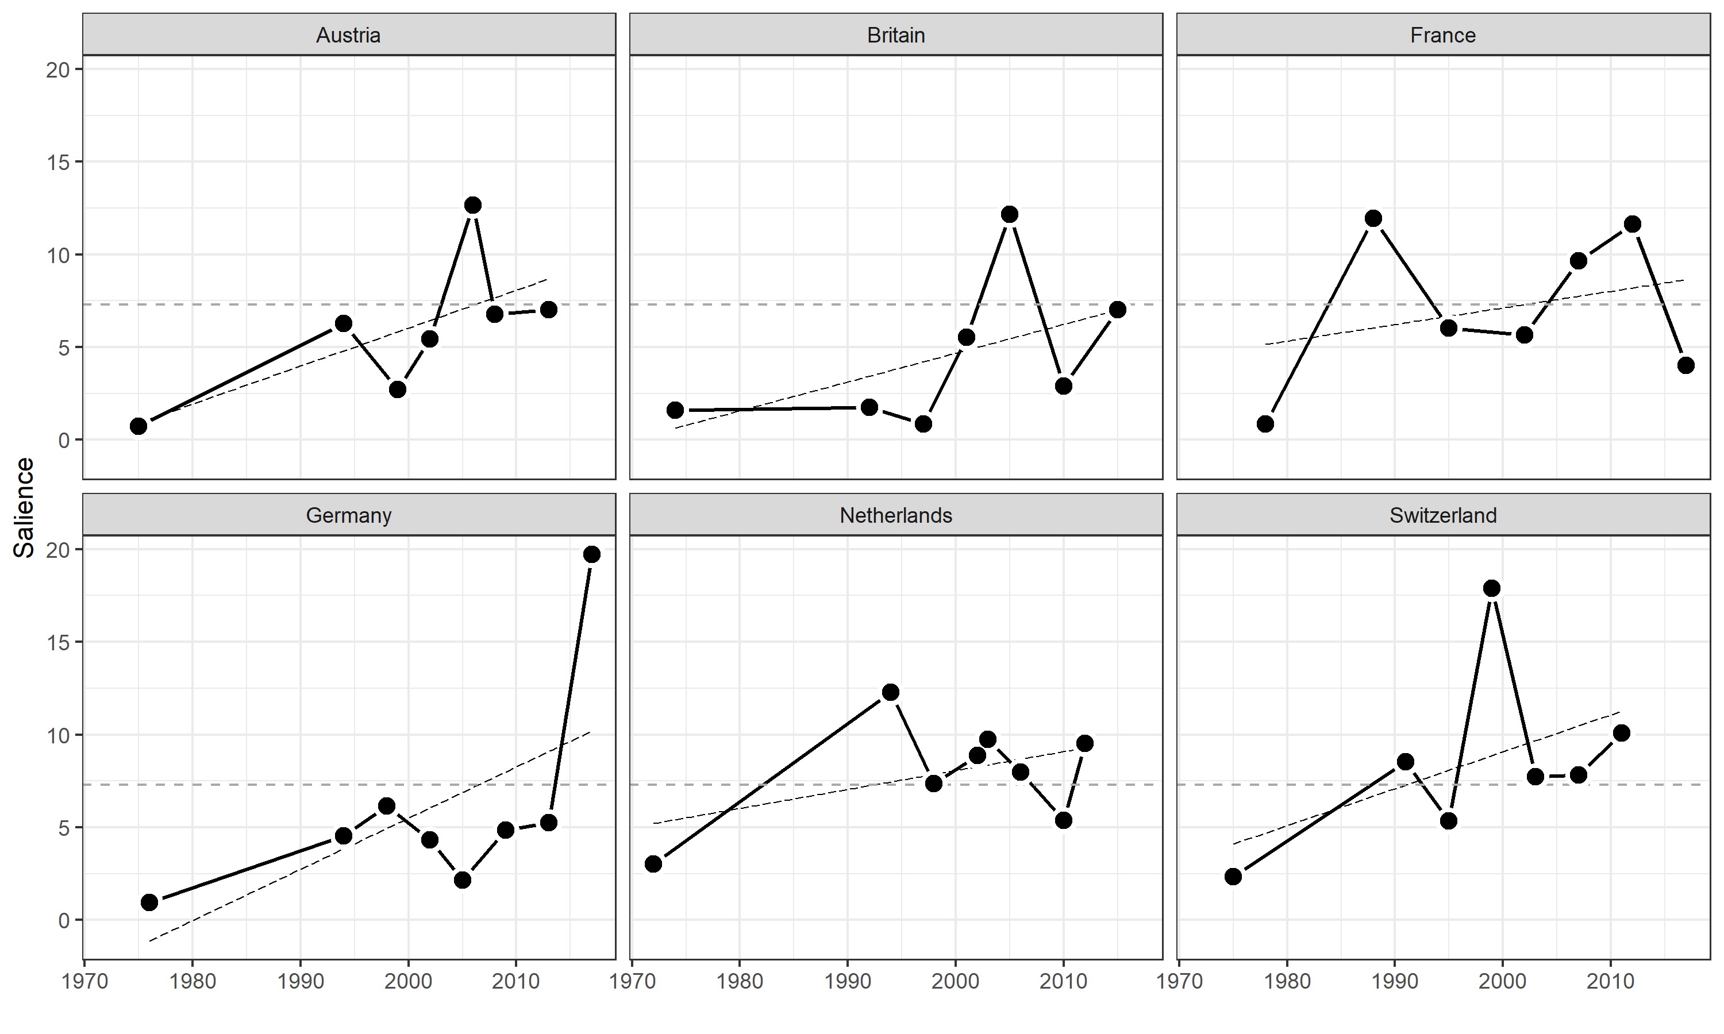
Figure 2: The polarisation of immigration in national elections per country over time
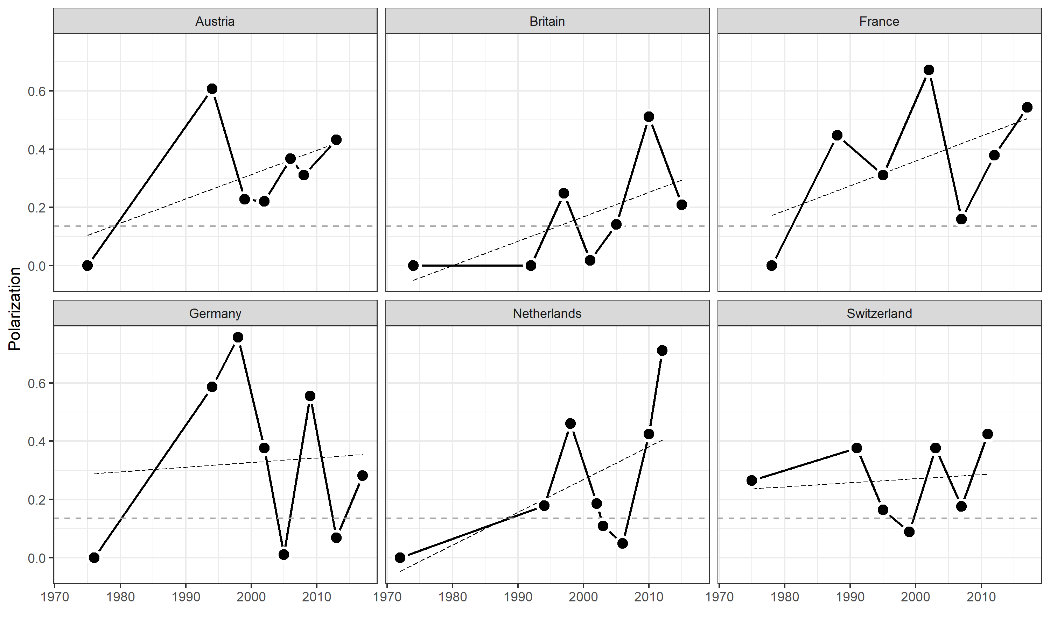

Figure 3: Additional analyses on the relationship between politicisation and socio-economic factors
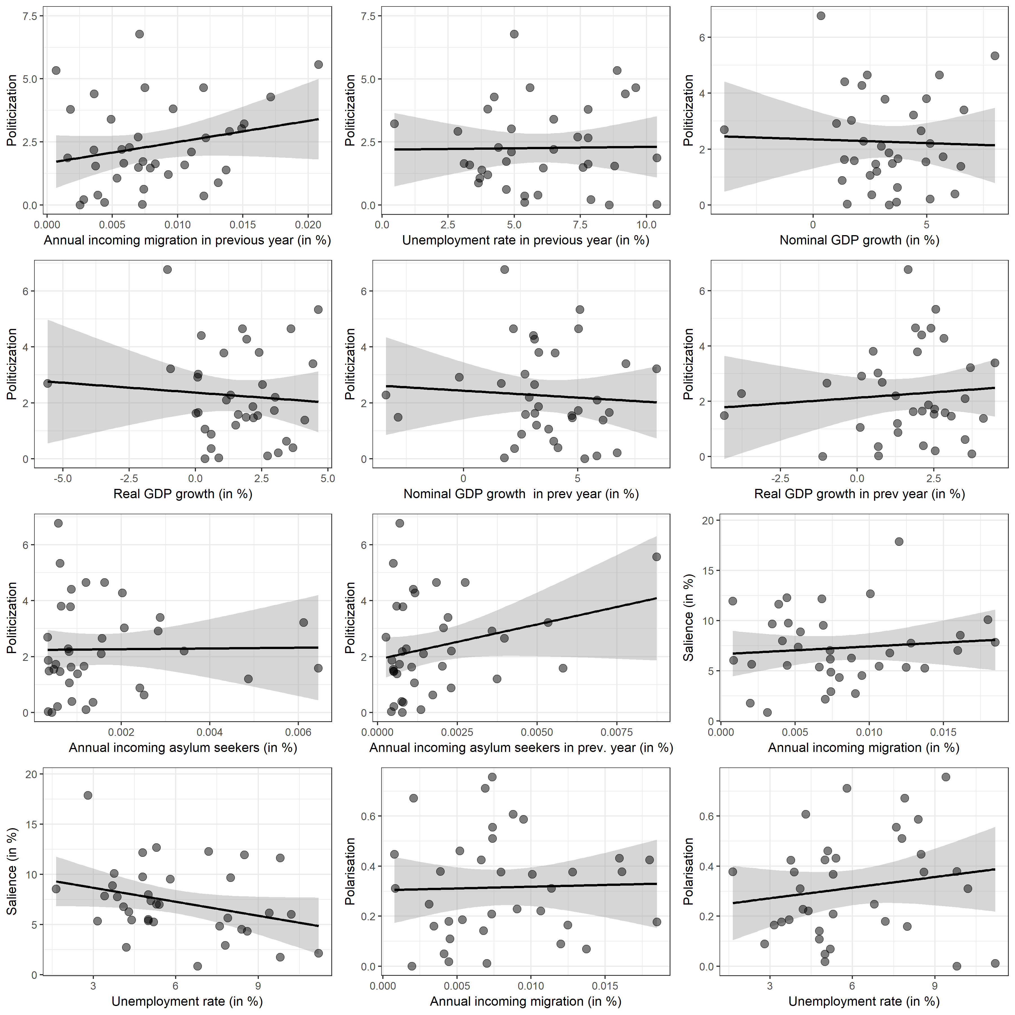
Figure 4: Salience and position as measured in party manifestos
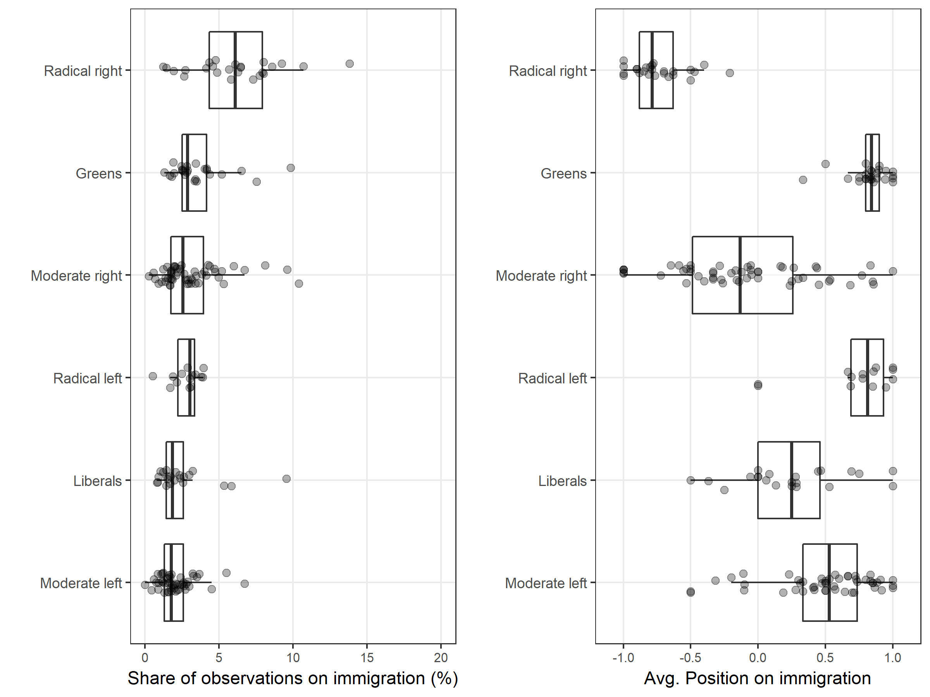

Figure 5: Validation of salience and position with data from Lehmann and Zobel (2018)
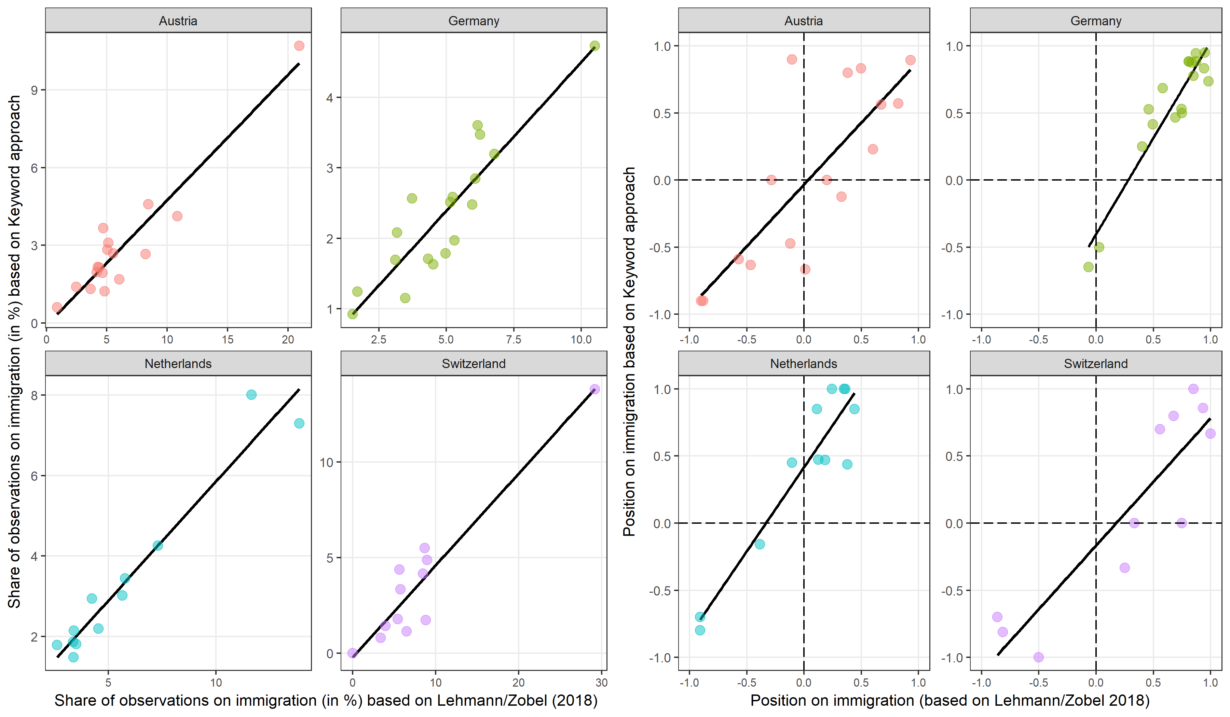

Figure 6: Issue entrepreneurship by status and party family
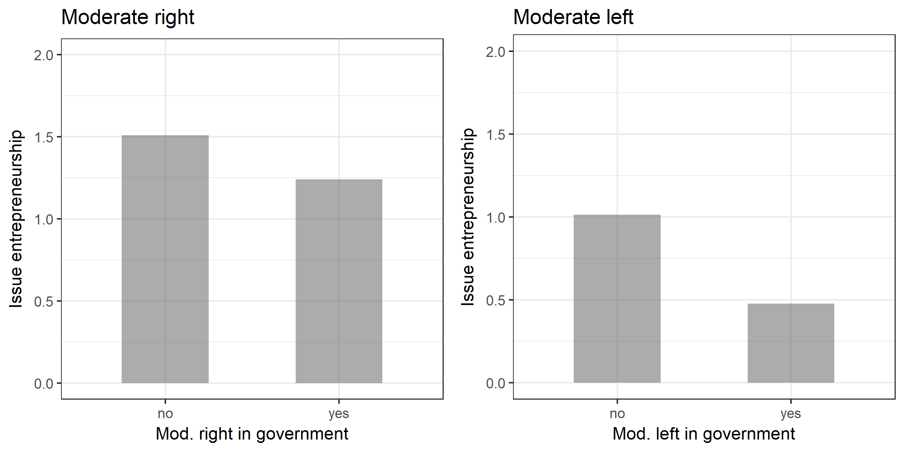

Table 4: Linear regression models of politicisation of immigration issues in national elections
 | Model 1
 | Estimate | Std. Error
Intercept | 0.90 | 1.35
Radical populist right | 0.22* | 0.09
Moderate right | 0.14 | 0.23
Moderate left | -0.07 | 0.14
Annual incoming migration | 0.11 | 0.15
Unemployment rate | -0.32 | 76.26
R² | 0.19
Note: White’s robust standard errors clustered for countries are computed; * p<.05 ** p<.01; N=38.

Table 5: Linear regression models of salience of immigration issues in national elections
 | Model 1 |  | Model 2
 | Estimate | Std. Error | Estimate | Std. Error
Intercept | 5.83** | 1.01 | 6.12** | 1.05
Radical populist right | 0.31 | 0.19 | 0.45* | 0.22
Moderate right | -0.27 | 0.41 | -0.31 | 0.41
Moderate left | 1.44** | 0.43 | 1.73** | 0.41
Vote share (RRPs) |  |  | -0.09 | 0.05
R² | 0.26 |  | 0.29
Note: White’s robust standard errors clustered for countries are computed; * p<.05 ** p<.01; N=38.

Table 6: Linear regression models of polarisation of immigration issues in national elections
 | Model 1 |  | Model 2
 | Estimate | Std. Error | Estimate | Std. Error
Intercept | 0.26** | 0.06 | 0.25** | 0.06
Radical populist right | 0.01 | 0.01 | 0.01 | 0.01
Moderate right | 0.04 | 0.03 | 0.04 | 0.02
Moderate left | -0.04 | 0.02 | 0.01 | 0.01
Vote share (RRPs) |  |  | 0.00 | 0.00
R² | 0.12 |  | 0.13
Note: White’s robust standard errors clustered for countries are computed; * p<.05 ** p<.01; N=38.

References
Armingeon, K., Isler, C., Knöpfel, L., Weisstanner, D., and Engler, S. (2016) Comparative Political Data Set 1960-2014., Bern: Institute of Political Science, University of Berne.
De Wilde, P. (2011) 'No Polity for Old Politics? A Framework for Analyzing the Politicization of European Integration'. Journal of European Integration 33(5): 559-75.
Grimmer, J. and Stewart, B.M. (2013) 'Text as Data: The Promise and Pitfalls of Automatic Content Analysis Methods for Political Texts'. Political Analysis 21(3): 267-97.
Hobolt, S.B. and de Vries, C.E. (2015) 'Issue Entrepreneurship and Multiparty Competition'. Comparative Political Studies 48(9): ﻿1159-85.
Hoeglinger, D. (2016) Politicizing European Integration: Struggling with the Awakening Giant, Basingstoke: Palgrave Macmillan.
Hutter, S. and Grande, E. (2014) 'Politicizing Europe in the national electoral arena: A comparative analysis of five West European countries, 1970-2010'. Journal of Common Market Studies 52(5): 1002-18.
Hutter, S., Grande, E., and Kriesi, H. (2016) (eds.) 'Politicising Europe. Integration and Mass Politics', in. Cambridge: Cambridge University Press.
Kitschelt, H. (1995) The Radical Right in Western Europe. A Comparative Analysis, Ann Arbor: University of Michigan Press.
Kleinnijenhuis, J. and Pennings, P. (2001) 'Measurement of party positions on the basis of party programmes, media coverage and voter perceptions', in M. Laver (ed.), Estimating the Policy Positions of Political Actors. London: Routledge, pp. 162-82.
Kriesi, H. (2016) 'The Politicization of European Integration'. Journal of Common Market Studies 54(Annual Review): 32–47.
Kriesi, H., Grande, E., Dolezal, M., Helbling, M., Höglinger, D., Hutter, S., and Wüest, B. (2012) Political Conflict in Western Europe: Cambridge University Press.
Kriesi, H., Grande, E., Lachat, R., Dolezal, M., Bornschier, S., and Frey, T. (2008) West European Politics in the Age of Globalization, Cambridge: Cambridge University Press.
Lehmann, P., Matthieß, T., Merz, N., Regel, S., and Werner, A. (2017) Manifesto Corpus. Version: 2017-2., Berlin: WZB Berlin Social Science Center.
Lehmann, P. and Zobel, M. (2018) 'Positions and saliency of immigration in party manifestos: A novel dataset using crowd coding'. European Journal of Political Research Online first: 08 February 2018: 1-28.
Meguid, B.M. (2005) 'Competition Between Unequals: The Role of Mainstream Party Strategy in Niche Party Success'. American Political Science Review 99(3): 347-59.
Mudde, C. (2007) Populist Radical Right Parties in Europe, Cambridge: Cambridge University Press.
Schattschneider, E.E. (1975 [1960]) The Semi-Sovereign People: A Realist´s View of Democracy in America, Hinsdale, Illinois: The Dryden Press.
van de Wardt, M. (2015) 'Desperate Needs, Desperate Deeds: Why Mainstream Parties Respond to the Issues of Niche Parties'. West European Politics 38(1): 93-122.
Volkens, A., Lehmann, P., Matthieß, T., Merz, N., Regel, S., and Weßels, B. (2017) 'The Manifesto Data Collection. Manifesto Project (MRG/CMP/MARPOR). Version 2017b', in: Wissenschaftszentrum Berlin für Sozialforschung (WZB).
Wagner, M. (2012) 'Defining and measuring niche parties'. Party Politics 18(6): 845-64.

The Swiss SVP has held political office in the entire period of this study. The Austrian FPÖ was in government from 1983 until 1986 and from 2000 until 2006.
We do not include ‘actor expansion’, a third dimension of politicisation (see Hutter and Grande (2014), in our analysis because it is inherently associated with our main explanatory variable, namely issue entrepreneurship of challenger parties.
Numbers of asylum seekers are again provided by the International Migration Database of the Organization for Economic Co-operation and Development (OECD) at http://stats.oecd.org/viewhtml.aspx?datasetcode=MIG&lang=en#.

