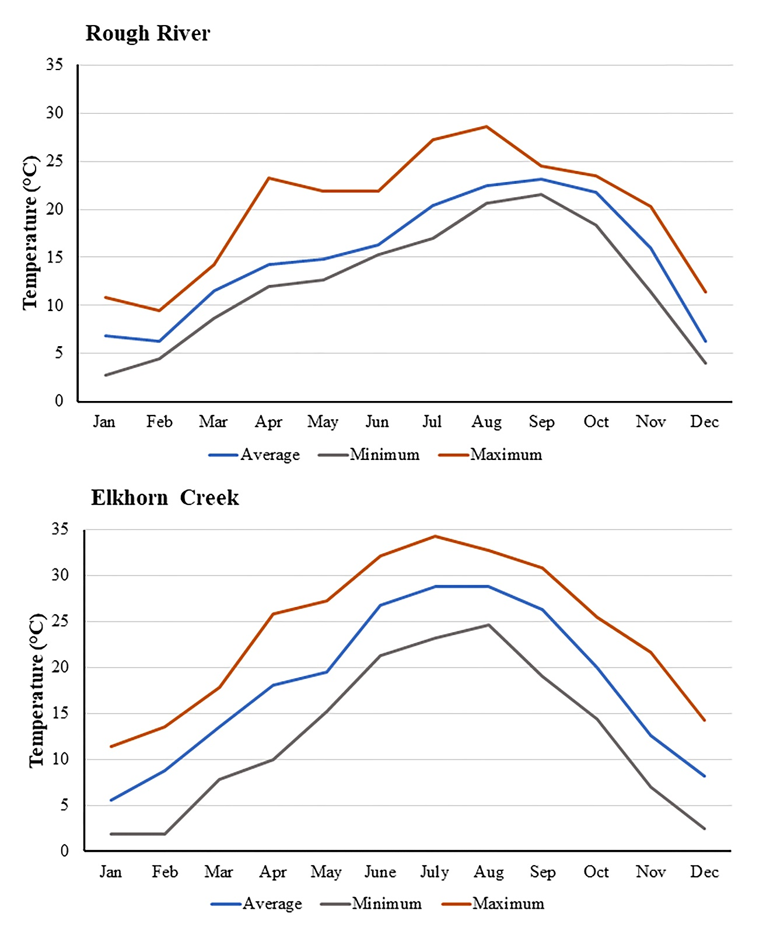

Supplemental material. Monthly water temperatures (average, minimum, and maximum) in the Rough River near Falls of Rough at Dam, Kentucky, USA and Elkhorn Creek near Frankfort, Kentucky, USA in 2016. All data were obtained from USGS (2017a, 2017b).

