**Fe3O4-graphene oxide nanocomposite: synthesis of 5-****sulfanyl tetrazole derivatives of alkyls, indoles and pyrroles**

Mahrokh Baghershiroudia, Kazem D.Safaa*

a Organosilicon Research Laboratory, Faculty of Chemistry, University of Tabriz, Tabriz, 5166614766, Iran

Tel: +98 (0)41 33393124 Fax: +98 (0)41 3334 0191

Corresponding author, e-mail: dsafa@tabrizu.ac.ir

**SUPPLEMENTARY MATERIALS**

**Experimental**

Chemicals were either purchased from Merck or synthesized in our laboratory. Commercial reagents and solvents were used without further purification. The IR spectra were recorded on a Bruker Tensor 270 spectrometer using KBr discs. 1H and 13C NMR spectra were recorded on a Bruker FT- 400 MHz spectrometer at room temperature with DMSO-d6 and CDCl3 as solvents. Elemental analyses were performed on an Elementar Vario EL III instrument. X-ray diffraction (XRD) patterns of the samples were recorded on a Siemen's diffractometer with Cu-Kα radiation at 35 kV in the scan range of 2θ from 10° to 80°. The surface morphologies of samples were examined by a scanning electron microscope (SEM) (LEO 1430VP) under vacuum at an operating voltage of 35 kV. Dried samples were gold coated by sputtering for 15 S. Transmission electron microscope (TEM) images are recorded by using LEO -906 instrument. The magnetic properties were analyzed using a vibrating sample magnetometer at room temperature (VSM; AGFM, Kashan, Iran).

**General procedure for the synthesis of alkyl thiocyanates:**

The intermediate alkyl thiocyanates were prepared according to the procedure described in the literature. [1]

**Typical procedure for the synthesis of 3-thiocyanato indoles and 2-thiocyanato pyrroles:**

Thiocyanation of indoles and pyrroles were performed according to the procedure described in the literatures. [2, 3]

**Typical procedure for the synthesis of the 5-sulfanyltetrazoles:**

Fe3O4@GO (0.03 g) was added to thiocyanate (alkyl, indole or pyrrole) (1 mmol), trimethylsilyl azide (TMSN3) (1.5 mmol), and DMF/MeOH (9:1) (6 mL) and the mixture was stirred at 80 °C for 6 h. After completion of the reaction (as indicated by TLC), the catalyst was separated by applying an external magnetic field and washed three times with ethanol and water. Then, the reaction mixture was treated with ethyl acetate and 1N HCl. The resulting organic layer was separated and dried with anhydrous Na2SO4, and concentrated. An aqueous solution of NaOH (0.25N) was added to the residue and the resulting mixture was stirred for 30 min at room temperature. The mixture was washed with ethyl acetate, and then concd HCl was added to obtain the pH value of the water layer to 1. The aqueous layer was extracted with ethyl acetate (×3) and the combined organic layers were washed with 1 N HCl. The organic layer was dried over anhydrous Na2SO4 and concentrated.

**3-((1H-tetrazol-5-yl)thio)-1H-indole (4a):**

Brown solid; Yield 90%, m.p.= 210-211°C (Lit. [4] 210.4-211.6°C). IR (KBr, cm–1): 3271, 2475, 2335, 1654, 1524, 1509, 1310, 1042, 742, 606. 1H NMR (400 MHz, DMSO-*d*6): δ = 7.12–7.16 (m, 1H, ArH), 7.21–7.24 (m, 1H, ArH), 7.45 (d, J = 7.9 Hz, 1H, ArH), 7.51 (d, J = 8.1 Hz, 1H, indole ring), 7.88 (d, J = 2.3 Hz, 1H, ArH), 11.83 (s, 1H, -NH of indole). 13C NMR (100 MHz, DMSO- *d*6): δ = 94.01, 112.71, 117.81, 120.32, 122.31, 128.25, 132.95, 136.58, 155.28. Anal. calcd. for C9H7N5S: C 49.76, H 3.26, N 32.24, S 14.76%.Found: C 49.70, H 3.07, N 32.12, S 14.62%.

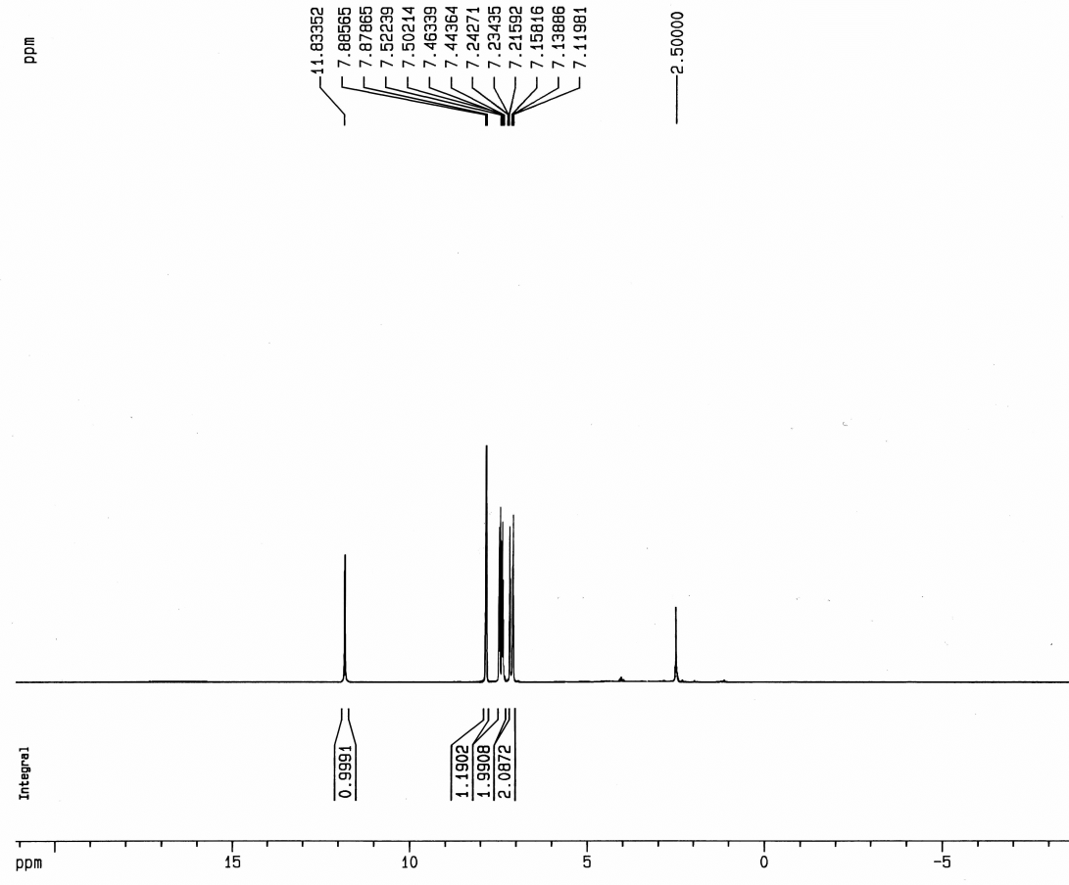



1H NMR spectrum of 3-((1H-tetrazol-5-yl)thio)-1H-indole (**4a)** in DMSO

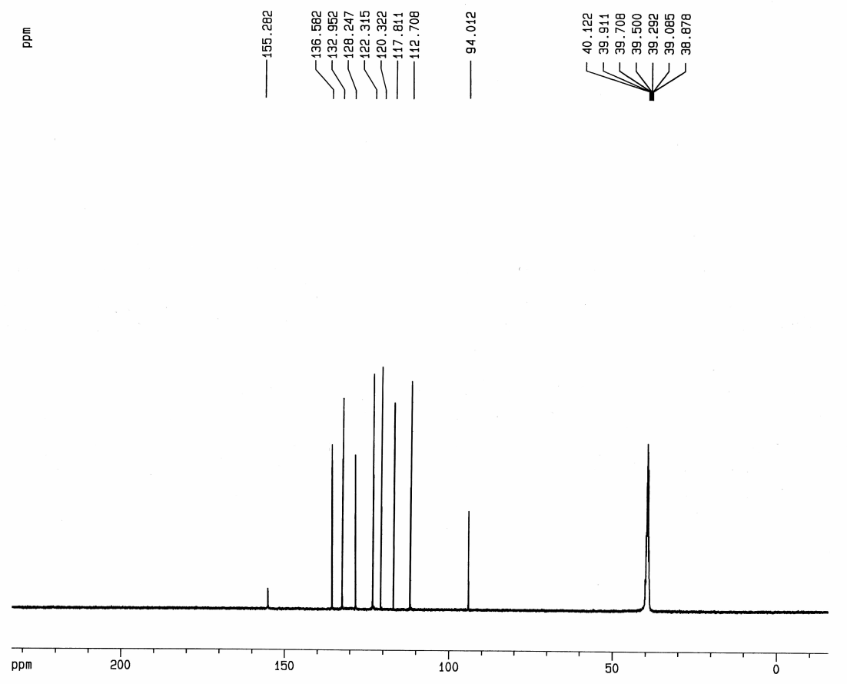



13C NMR spectrum of 3-((1H-tetrazol-5-yl)thio)-1H-indole (**4a)** in DMSO

**3-((1H-tetrazol-5-yl)thio)-5-bromo-1H-indole (4b):**

Brown solid; Yield 92%, m.p.= 209-211°C (Lit. [4] 209.5–211.3°C). IR (KBr, cm–1): 3272, 2377, 1566, 1497, 1311, 1218, 1110, 1033, 883, 870, 795, 744, 674. 1H NMR (400 MHz, DMSO-*d*6): δ = 7.33 (dd, J=8.6 and 1.7 Hz, 1H, ArH), 7.49 (d, J= 8.6 Hz, 1H, ArH), 7.93 (d, J = 2.8 Hz, 1H, ArH), 7.63 (s, 1H, indole ring), 12.03 (s, 1H, , -NH of indole). 13C NMR (100 MHz, DMSO- *d*6): δ = 94.12, 113.28, 114.43, 120.27, 124.91, 130.41, 134.61, 135.41, 155.02. Anal. calcd. for C9H6BrN5S: C 36.50, H 2.04, N 23.65, S 10.83%.Found: C 36.35, H 2.18, N 23.44, S 10.99%.

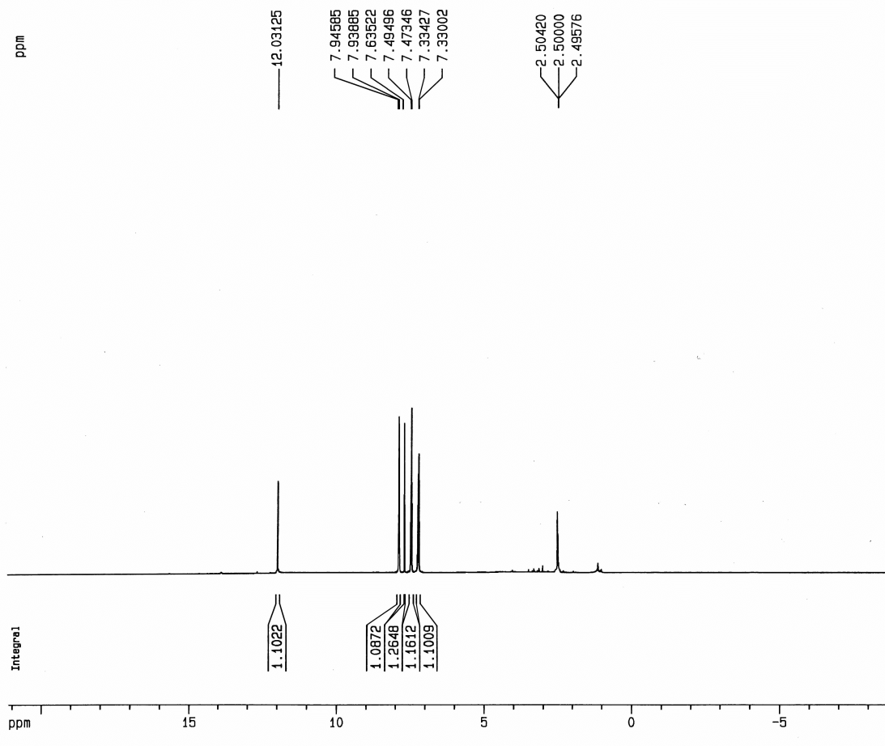



1H NMR spectrum of 3-((1H-tetrazol-5-yl)thio)-5-bromo-1H-indole (**4b)** in DMSO

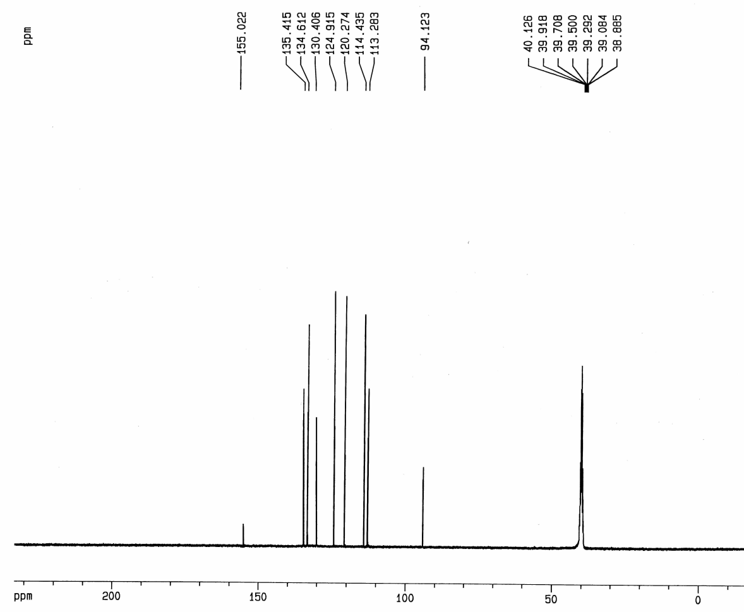



13C NMR spectrum of 3-((1H-tetrazol-5-yl)thio)-5-bromo-1H-indole (**4b)** in DMSO

**3-((1H-tetrazol-5-yl)thio)-5-methoxy-1H-indole (4c):**

Brown solid; Yield 60%, m.p.= 174-176°C (Lit. [5] 174.5–176.0°C). IR (KBr, cm–1): 3417, 3281, 2833, 2672, 1624, 1584, 1485, 1307, 1276, 1043, 813, 870, 685, 579. 1H NMR (400 MHz, DMSO-*d*6): δ = 3.73 (s, 3H, CH3), 6.85 (dd, J= 8.8 and 2.3 Hz, 1H, ArH), 6.91 (d, J = 2.3 Hz, 1H, ArH), 7.40 (d, J=8.8 Hz, 1H, indole ring), 7.81 (d, J=2.8 Hz, 1H, ArH), 11.64 (s, 1H, , -NH of indole). 13C NMR (100 MHz, DMSO- *d*6): δ = 55.32, 93.39, 99.5, 112.44, 113.09, 129.01, 131.42, 133.42, 154.41, 155.21. Anal. calcd. for C10H9N5OS: C 48.57, H 3.67, N 28.32, S 12.97%.Found: C 48.41, H 3.88, N 28.14, S 12.78%.

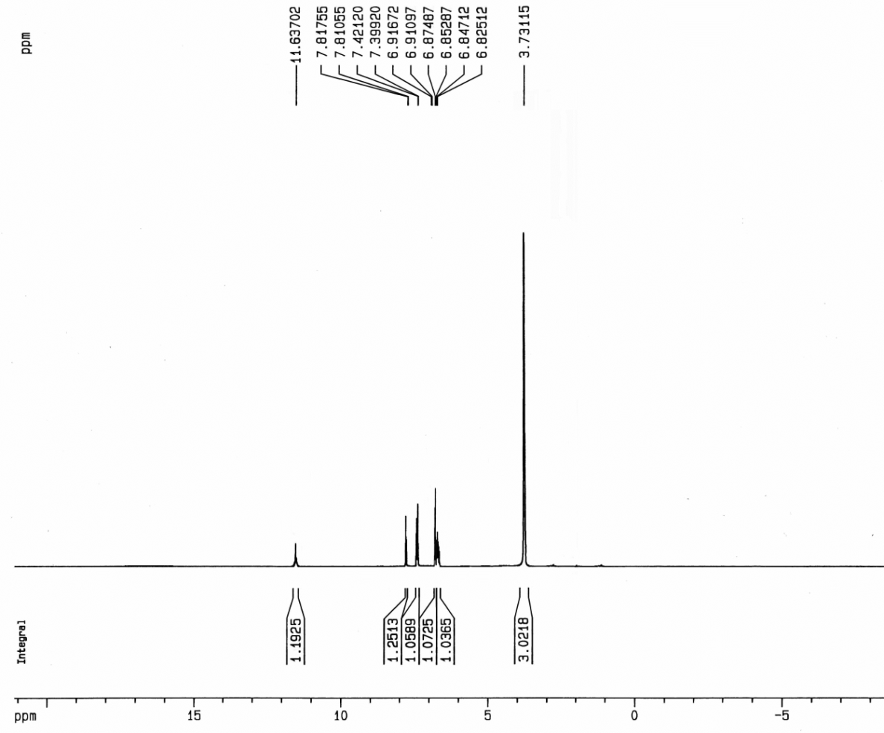



1H NMR spectrum of 3-((1H-tetrazol-5-yl)thio)-5-methoxy-1H-indole (**4c)** in DMSO

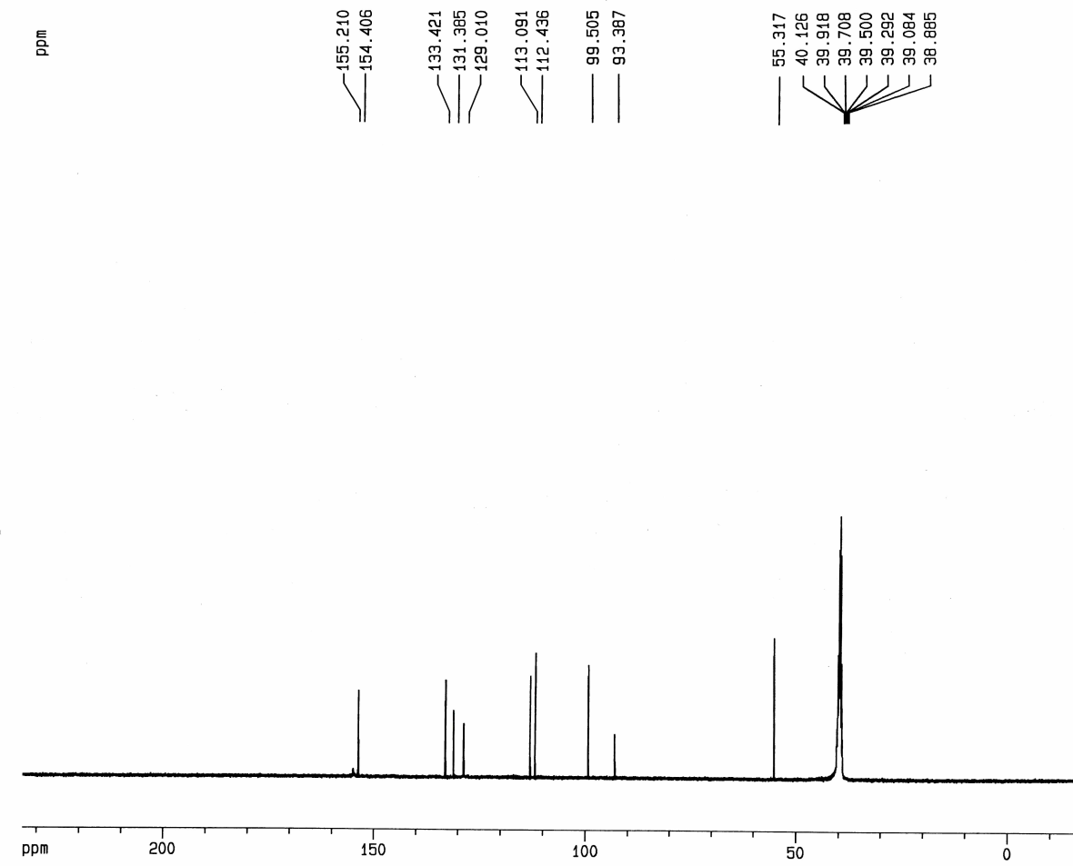



13C NMR spectrum of 3-((1H-tetrazol-5-yl)thio)-5-methoxy-1H-indole (**4c)** in DMSO

**3-((1H-tetrazol-5-yl)thio)-2-methyl-1H-indole (4d):**

Light brown solid; Yield 80%, m.p.= 184-186°C (Lit. [4] 184.5–185.7°C). IR (KBr, cm–1): 3340, 3051, 2341, 1547, 1516, 1315, 1234, 1035, 742. 1H NMR (400 MHz, DMSO-*d*6): δ = 2.53 (s, 3H, CH3), 7.05-7.09 (m, 1H, ArH), 7.11-7.16 (m, 1H, ArH), 7.39-7.43 (m, 2H, ArH), 11.68 (s, 1H, , -NH of indole). 13C NMR (100 MHz, DMSO- *d*6): δ = 11.62, 91.11, 111.30, 117.11, 120.09, 121.50, 129.20, 135.46, 143.22, 155.31. Anal. calcd. for C10H9N5S: C 51.93, H 3.92, N 30.28, S 13.86%.Found: C 51.69, H 4.24, N 30.52, S 13.77%.

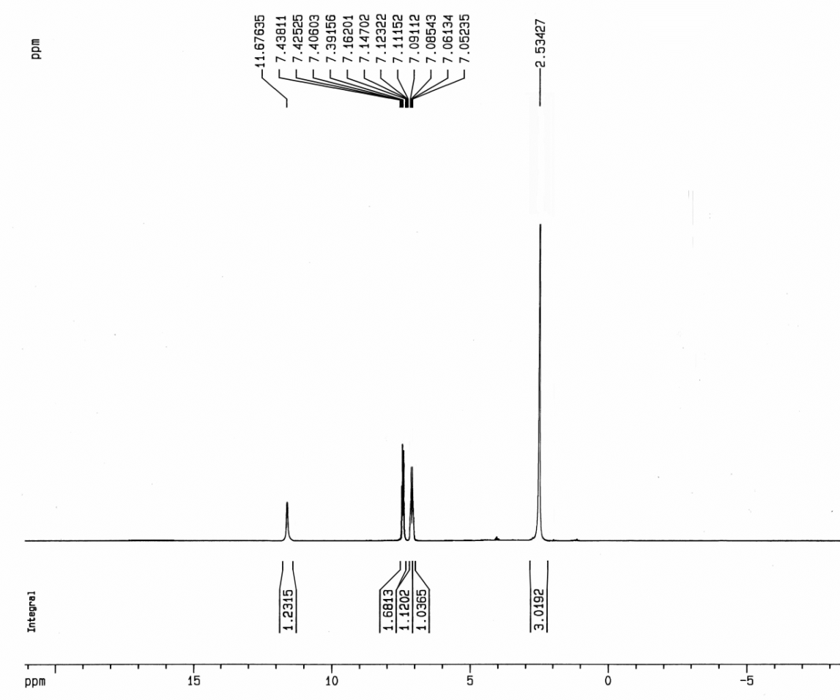



1H NMR spectrum of 3-((1H-tetrazol-5-yl)thio)-2-methyl-1H-indole (**4d)** in DMSO

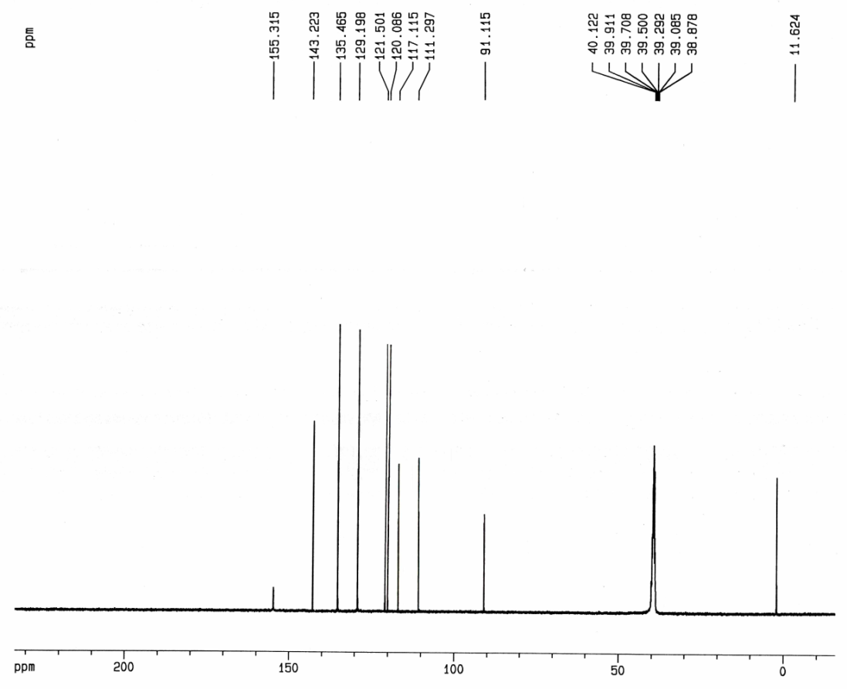



13C NMR spectrum of 3-((1H-tetrazol-5-yl)thio)-2-methyl-1H-indole (**4d)** in DMSO

**5-((1-phenyl-1H-pyrrol-3-yl)thio)-1H-tetrazole (5a):**

Yellow solid; Yield 92%, m.p.= 160-161°C (Lit. [4] 160.1–161.4°C). IR (KBr, cm–1): 3119, 2367, 1596, 1485, 1374, 1322, 1039, 830, 741, 701. 1H NMR (400 MHz, DMSO-*d*6): δ = 6.38-6.40 (m, 1H, -NH of pyrrole), 6.82 (dd, J= 3.6 and 1.6, 1H, pyrrole ring), 7.35-7.45 (m, 6H, ArH). 13C NMR (100 MHz, DMSO- *d*6): δ = 109.90, 111.43, 121.60, 126.01, 127.74, 128.10, 128.69, 138.28, 155.01. Anal. calcd. for C11H9N5S: C 54.31, H 3.73, N 28.79, S 13.18%.Found: C 54.45, H 3.64, N 28.90, S 13.03%.

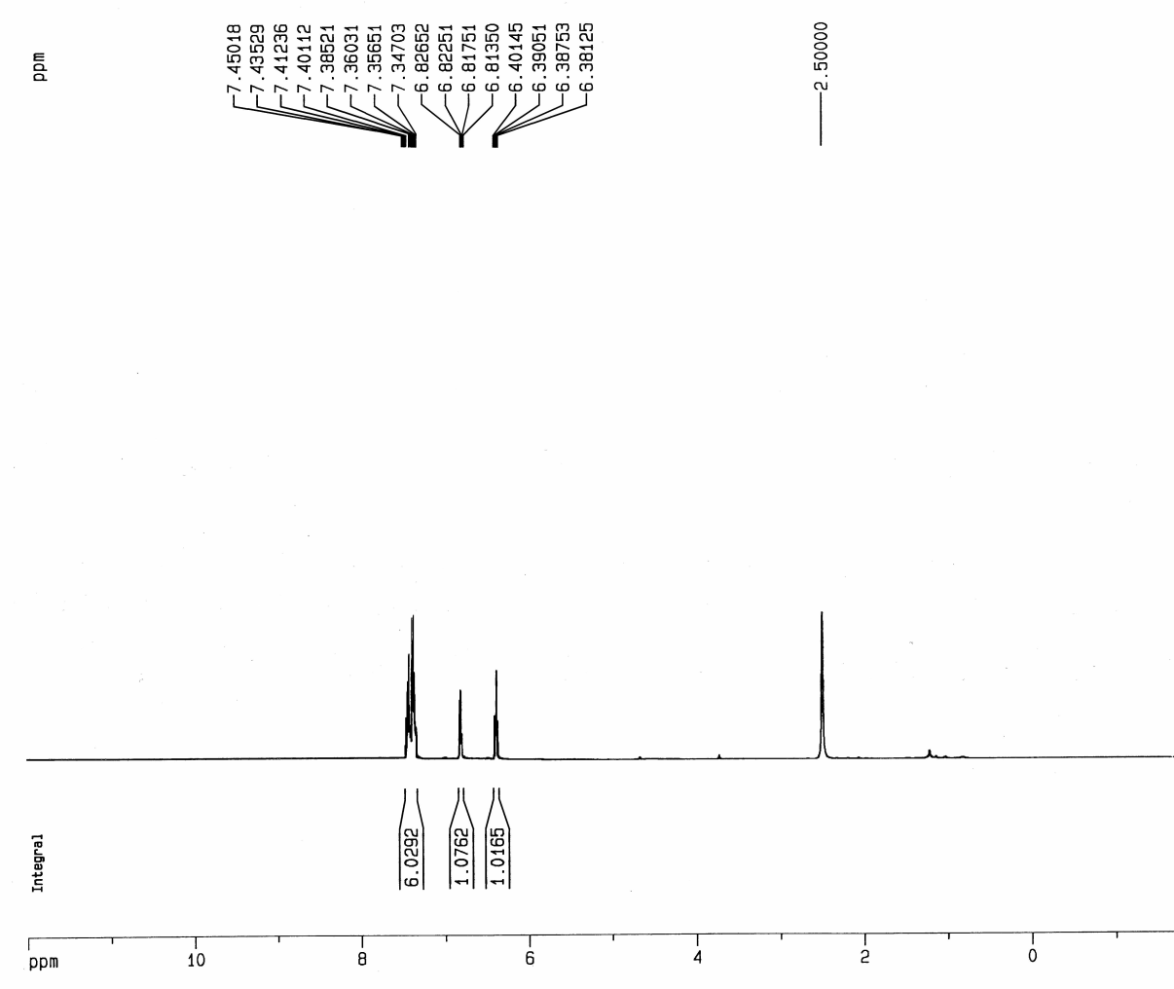



1H NMR spectrum of 5-((1-phenyl-1H-pyrrol-3-yl)thio)-1H-tetrazole (**5a)** in DMSO

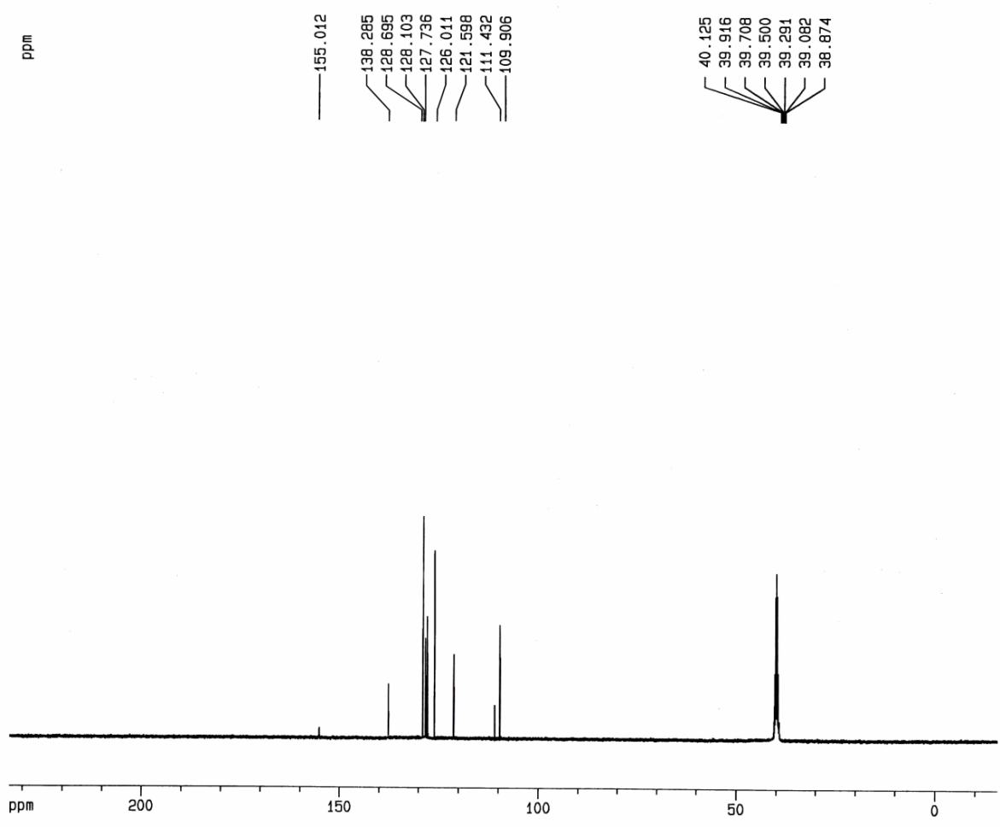



13C NMR spectrum of 5-((1-phenyl-1H-pyrrol-3-yl)thio)-1H-tetrazole (**5a)** in DMSO

**5-((1-(4-methoxyphenyl)-1H-pyrrol-3-yl)thio)-1H-tetrazole (5b):**

Light brown solid; Yield 90%, m.p.= 163-164°C (Lit. [5] 163.3–163.8°C). IR (KBr, cm–1): 3117, 2364, 1607, 1516, 1253, 1038, 832, 741, 619. 1H NMR (400 MHz, DMSO-*d*6): δ =3.76 (s, 3H, CH3), 6.35-6.38 (m, 1H, -NH of pyrrole), 6.79 (dd, J= 3.6 and 1.7, 1H, pyrrole ring), 6.96 (d, J= 8.8 Hz, 2H, ArH), 7.24-7.27 (m, 1H, ArH). 13C NMR (100 MHz, DMSO- *d*6): δ = 55.28, 109.60, 111.50, 113.87, 121.22, 127.51, 128.41, 131.30, 155.10, 158.59. Anal. calcd. for C12H11N5OS: C 52.73, H 4.06, N 25.62, S 11.73%.Found: C 52.48, H 4.37, N 25.84, S 11.64%.

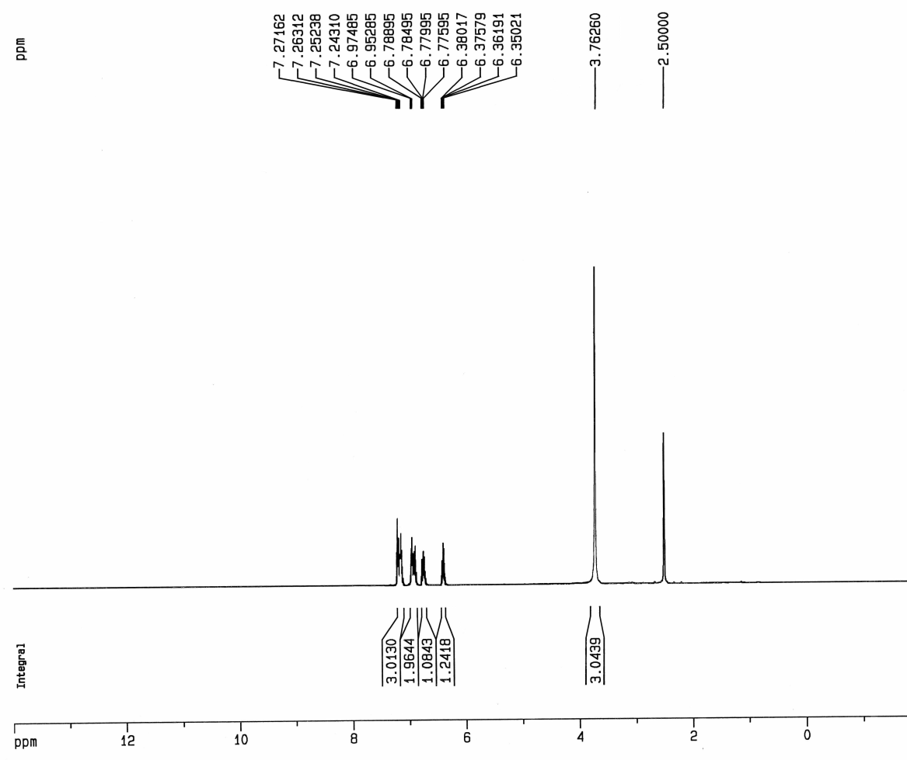

1H NMR spectrum of 5-((1-(4-methoxyphenyl)-1H-pyrrol-3-yl)thio)-1H-tetrazole (**5b)** in DMSO

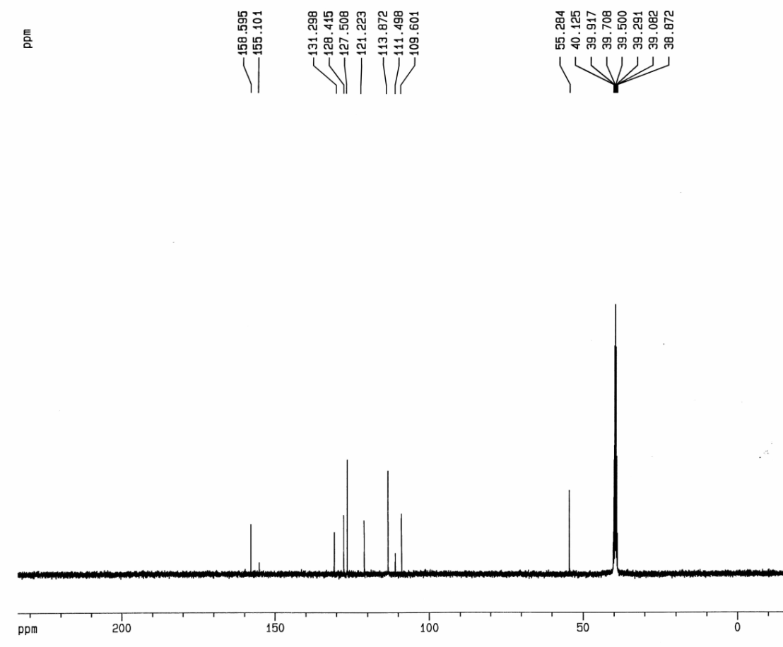



13C NMR spectrum of 5-((1-(4-methoxyphenyl)-1H-pyrrol-3-yl)thio)-1H-tetrazole (**5b)** in DMSO

**5-((1-(4-chlorophenyl)-1H-pyrrol-3-yl)thio)-1H-tetrazole (5c):**

Orange solid; Yield 91%, m.p.= 171-173°C (Lit. [4] 171.2–173.1°C). IR (KBr, cm–1): 3128, 2362, 1495, 1311, 1095, 835, 741. 1H NMR (400 MHz, DMSO-*d*6): δ = 6.40 (dd, J= 3.7 and 3.0, 1H, pyrrole ring), 6.82 (dd, J= 3.7 and 1.8, 1H, pyrrole ring), 7.35 (dd, J= 3.0 and 1.8, 1H, pyrrole ring), 7.40 (d, J= 8.8 Hz, 2H, ArH), 7.50 (d, J= 8.8 Hz, 2H, ArH). 13C NMR (100 MHz, DMSO- *d*6): δ = 110.16, 111.62, 121.88, 127.86, 128.24, 128.10, 128.79, 132.33, 138.19, 155.03. Anal. calcd. for C11H8ClN5S: C 47.57, H 2.90, N 25.22, S 11.54%.Found: C 47.41, H 3.04, N 25.01, S 11.36%.

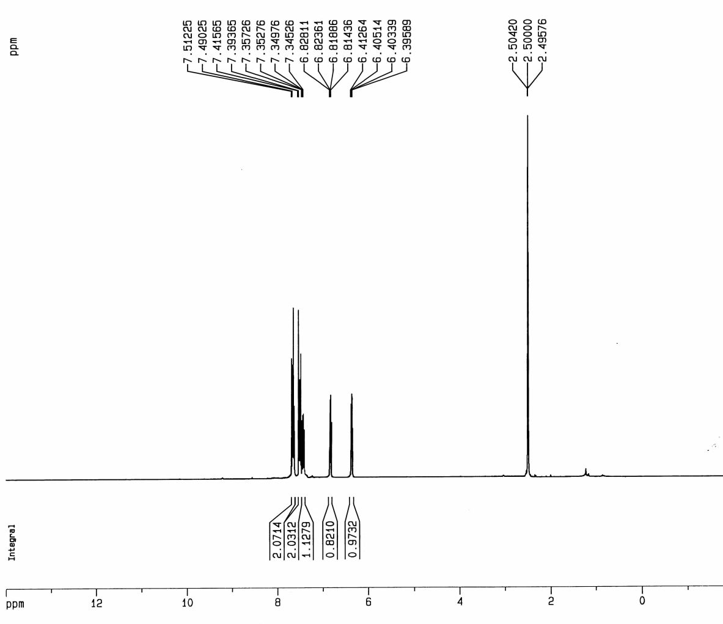



1H NMR spectrum of 5-((1-(4-chlorophenyl)-1H-pyrrol-3-yl)thio)-1H-tetrazole (**5c)** in DMSO

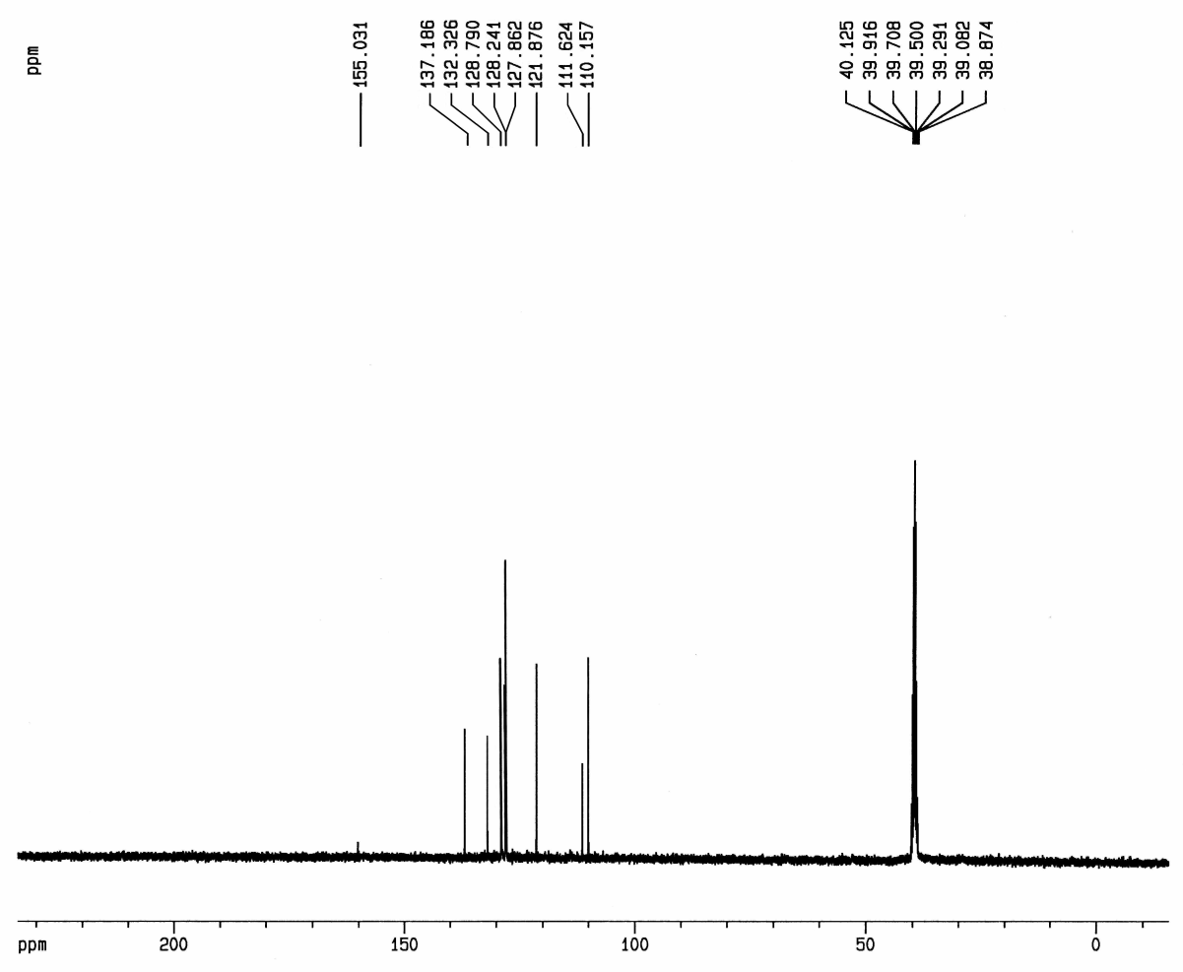



13C NMR spectrum of 5-((1-(4-chlorophenyl)-1H-pyrrol-3-yl)thio)-1H-tetrazole (**5c)** in DMSO

**5-(Pentylthio)-1H-tetrazole (6a):**

Colorless solid; Yield 82%, m.p.= 64-66 °C (CCl4) (Lit. [6] 65-67 °C). IR (KBr, cm–1): 3068, 2962, 2929, 2859, 2811, 2702, 2550, 2498, 2363, 1525, 1463, 1431, 1360, 1308, 1262, 1213, 1039, 984, 893, 825, 781, 726, 687, 644. 1H NMR (400 MHz, DMSO-*d*6): δ = 0.84 (t, J = 7.0 Hz, 3 H, CH3), 1.24–1.35 (m, 4 H, CH2CH2), 1.64 (t, J = 7.0 Hz, 2 H, CH2), 3.19 (t, J = 7.0 Hz, 2 H, S-CH2). 13C NMR (100 MHz, DMSO- *d*6): δ = 13.92, 21.68, 28.88, 30.13, 32.08, 154.43. Anal. calcd. for C6H12N4S: C 41.84, H 7.02, N 32.53, S 18.61%. Found: C 41.91, H 7.19, N 32.45, S 18.53%.

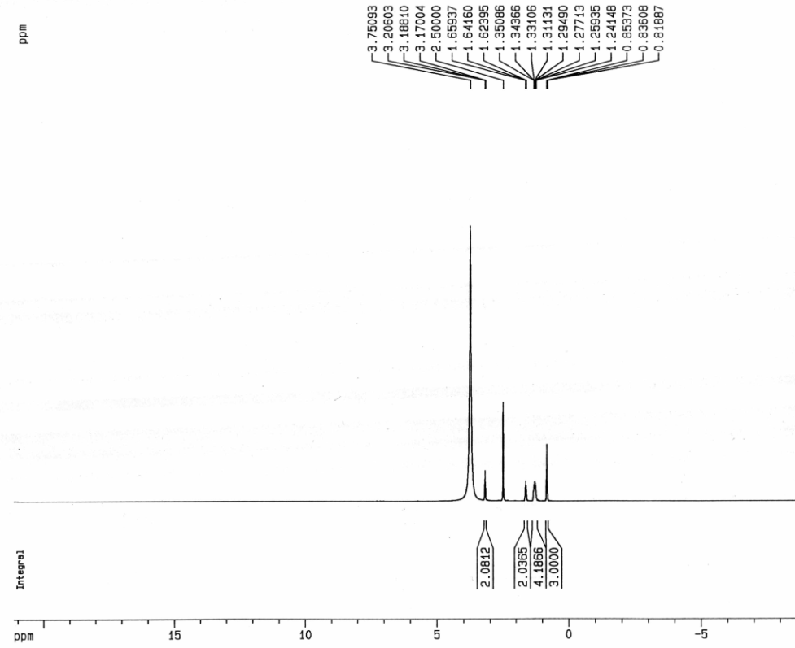



1H NMR spectrum of 5-(Pentylsulfanyl) -1H-tetrazole (**6a)** in DMSO

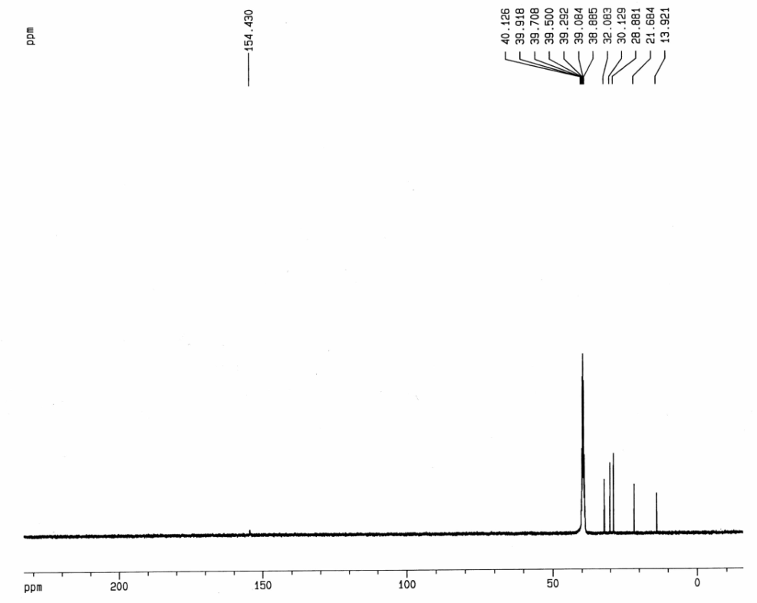



13C NMR spectrum of 5-(Pentylsulfanyl) -1H-tetrazole (**6a)** in DMSO

**5-(Hexylthio)-1H-tetrazole (6b):**

Colorless solid; Yield 84%, m.p.= 85-88 °C (CCl4) (Lit. [7] 87 °C). IR (KBr, cm–1): 3062, 2930, 2860, 2703, 2551, 1520, 1465, 1377, 1310, 1038, 897. 1H NMR (400 MHz, DMSO-*d*6): δ = 0.84 (t, J = 7.0 Hz, 3 H, CH3), 1.22–1.26 (m, 4 H, CH2CH2), 1.37–1.40 (m, 2H, CH2), 1.67–1.70 (m, 2H, CH2), 3.19 (t, J = 7.0 Hz, 2H, S-CH2). 13C NMR (100 MHz, DMSO- *d*6): δ = 13.85, 22.09, 27.67, 29.17, 30.79, 32.13, 154.32. Anal. calcd. for C7H14N4S: C 45.14, H 7.58, N 30.08, S 17.21%.Found: C 45.31, H 7.70, N 29.90, S 17.15%.

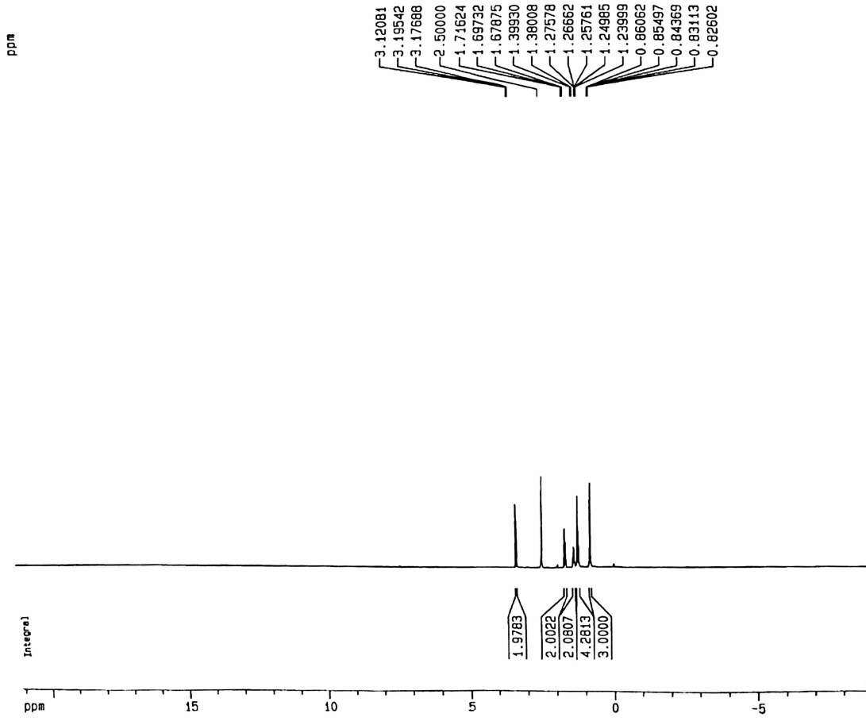



1H NMR spectrum of 5-(Hexylsulfanyl)-1H-tetrazole (**6b)** in DMSO

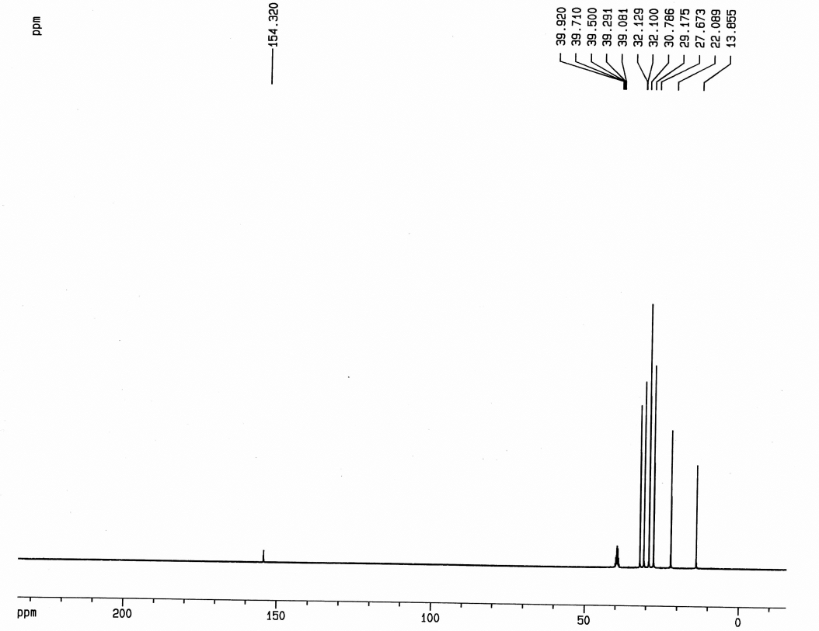



13C NMR spectrum of 5-(Hexylsulfanyl)-1H-tetrazole (**6b)** in DMSO

**5-(Octyllthio)-1H-tetrazole (6c):**

Colorless solid; Yield 80%, m.p.= 88-90 °C (CCl4). IR (KBr, cm–1): 2958, 2930, 2881, 2704, 2610, 2477, 1523, 1460, 1379, 1316, 1042, 754. 1H NMR (400 MHz, DMSO-*d*6): δ = 0.88 (t, J = 7.0 Hz, 3H, CH3), 1.22–1.35 (m, 10H, 5(CH2)), 1.62–1.66 (m, 2H, CH2), 3.17 (t, J = 7.0 Hz, 2H, S-CH2). 13C NMR (100 MHz, DMSO- *d*6): δ = 13.98, 21.88, 28.50, 28.92, 29.45, 30.19, 32.02, 36.48, 155.35. Anal. calcd. for C9H18N4S: C 33.32, H 5.59, N 38.86, S 22.23%.Found: C 33.08, H 5.91, N 39.08, S 22.15%.

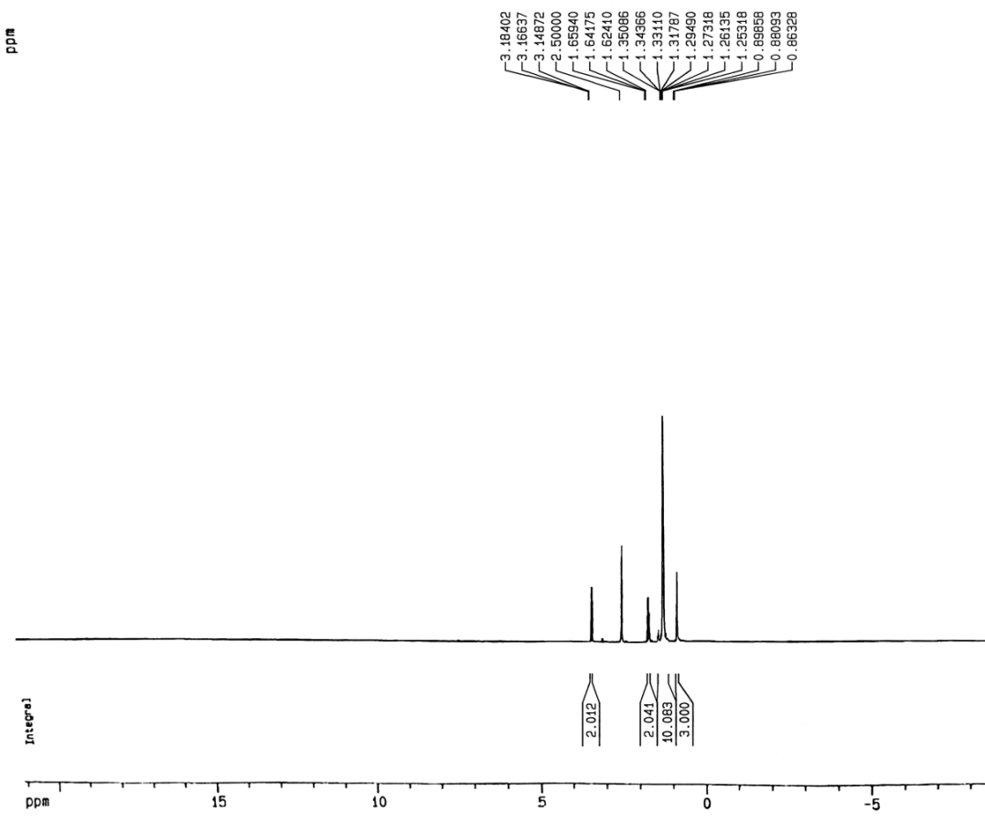



1H NMR spectrum of 5-(Octyllthio)-1H-tetrazole (**6c)** in DMSO

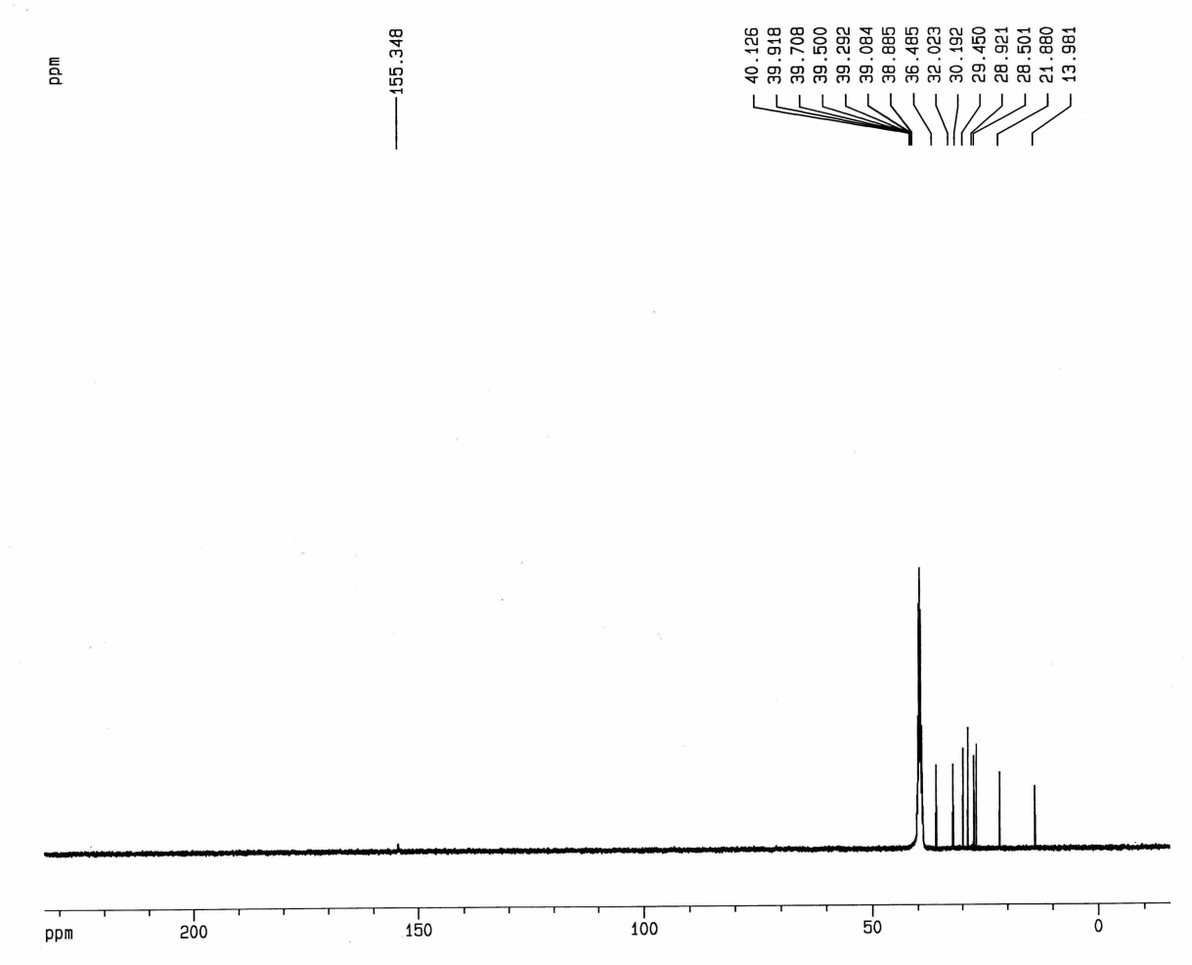



13C NMR spectrum of 5-(Octyllthio)-1H-tetrazole (**6c)** in DMSO

1. Benfodda, Z., et al., *A new synthesis of alkane and polyfluoroalkanesulfonyl chlorides.* Heteroatom Chemistry, 2009. **20**(6): p. 355-361.

2. Wu, G., et al., *Regioselective thiocyanation of aromatic and heteroaromatic compounds using ammonium thiocyanate and oxone.* Tetrahedron letters, 2005. **46**(35): p. 5831-5834.

3. C Silveira, C., M. P Fortes, and S. R Mendes, *Cerium (III) chloride as a catalyst in the Clauson-Kaas reaction: synthesis and reactivity of N-Aryl-2-thiocyanatopyrroles.* Current Organic Chemistry, 2012. **16**(12): p. 1540-1548.

4. Kuhn, B.L., et al., *Facile, efficient and eco-friendly synthesis of 5-sulfenyl tetrazole derivatives of indoles and pyrroles.* Tetrahedron Letters, 2014. **55**(9): p. 1648-1652.

5. Fortes, M.P., et al., *A convenient eco-friendly system for the synthesis of 5-sulfenyl tetrazole derivatives of indoles and pyrroles employing CeCl 3· 7H 2 O in PEG-400.* RSC Advances, 2014. **4**(65): p. 34519-34530.

6. Myznikov, L., et al., *One-pot synthesis of 5-alkylsulfanyl-1H-tetrazoles from alkyl halides.* Russian Journal of General Chemistry, 2017. **87**(6): p. 1313-1316.

7. Vorona, S., et al., *An improved protocol for the preparation of 5-substituted tetrazoles from organic thiocyanates and nitriles.* Synthesis, 2014. **46**(06): p. 781-786.