1,2-Benzisoxazole-3-acetamide Derivatives as Dual Agents for DPP-IV Inhibition and Anticancer Activity
Shubhendu Karandikar ¹, Rina Soni^{1*}, Shubhangi S Soman^{1*}, Shweta Umar², Balakrishnan Suresh²
¹Department of Chemistry, ²Department of Zoology, Faculty of Science, The M. S. University of Baroda, Vadodara - 390 002, India.
*Corresponding author’s e-mail: shubhangiss@rediffmail.com
*Corresponding author’s e-mail: src_rina@outlook.com
Ph. No.: +91-265-2795552

Synthesis of 4-hydroxycoumarin (7)
A solution of 2’-hydroxyacetophenone 5 (1.0 eq) in diethyl carbonate 6 (15.0 eq) (Diethyl carbonate is used as both, reagent and solvent) was slowly and CAREFULLY added to pulverized sodium (3.0 eq) under anhydrous conditions. During addition, reaction mixture turns brown with exothermic reaction (HIGHLY EXOTHERMIC !!). The mixture was allowed to stand for 10 min and heated in water bath around 70-80 ºC for 1h. The mixture was then allowed to cool at room temperature and the unreacted sodium metal was decomposed using slow addition of methanol/ethanol. The slurry was poured into crushed ice. The aqueous layer was washed with toluene (2 x 25 mL). The aqueous layer was acidified with conc. HCl till pH~2. The solid separated out was filtered and washed with cold water. The crude product was recrystallized from acetonitrile-ethanol (9:1), as light cream coloured crystals of 4-hydroxycoumarin 7. (Yield = 45 %; M. P.: 211-213ºC)
Synthesis of 1,2-Benzisoxazol-3-acetic acid (8)
To a solution of 4-hydroxycoumarin 7 (10.0 g, 61.7 mmol) in methanol (100 mL), was added NH₂OH.HCl (15.0 g, 216 mmol, 3.5 eq) and NaHCO₃ (18.1 g, 216 mmol, 3.5 eq). The resulting mixture was refluxed for 15 hours at 65 ºC. The completion of reaction was checked by TLC using pet. ether : ethyl acetate (1:1). After completion of reaction, excess of methanol was distilled off under vacuum to give residue. The residue was dissolved in 10% NaHCO₃ solution (500 mL) and filtered to remove insoluble impurities. The filtrate was acidified with conc. HCl till pH 2. The solid obtained was filtered and washed with hot 5% ethyl acetate in pet ether to give 1,2-benzisoxazol-3-acetic acid 8 as a white solid (Yield = 40 %, M. P.: 122ºC).
Preparation of substituted glycinamide derivatives as TFA salt (10):
A mixture of boc-glycine (1.0 mmol), 1-ethyl-3-(3-dimethylaminopropyl)carbodiimide hydrochloride (1.5 mmol) (EDCI), 1-hydroxybenzotriazole (1.0 mmol) (HOBt), triethylamine(2.0 mmol) and amine (1º and 2º) (1.10 mmol) in dichloromethane (50 mL) (DCM) was stirred at room temperature for 16 h. The reaction was monitored using TLC. On completion of the reaction, it was washed with water (2 x 20 mL), brine (1 x 10 mL), dried over anhydrous sodium sulphate and the solvent evaporated under reduced pressure to give the crude product which was then purified by column chromatography using silica gel as stationary phase and DCM:MeOH (95:5) as eluent to yield desired N-Boc glycinamide as white solid. Compounds were deprotected by stirring in 10% trifluoroacetic acid (TFA) in DCM. On completion of the reaction after monitored by TLC, the solvent was evaporated under reduced pressure. Compound was dissolved in DCM and concentrated under reduced pressure to remove excess of TFA to give compounds 10 as trifluoroacetic acid salt and were directly used for next step without any purification.

Characterization data for compounds 9b-d and 11b-e.
1-(2-(Benzo[d]isoxazol-3-yl)acetyl)pyrrolidine-2-carboxamide (9b)
White solid, Yield: 44 %; M.P: 160-162 ᵒC; IR (KBr) 3500, 3456, 3394, 3211, 1641, 1624, 1448, 864, 765, 754 cm⁻¹; ¹H-NMR (400 MHz, CDCl₃): δ 1.99-2.12 (m, 4H), 2.32-2.34 (m,1H), 3.63-3.74 (m, 2H), 4.08 (s, 2H), 4.60-4.62 (m ,1H), 5.61 (br s, 1H), 7.06 (br s, 1H), 7.34 (s, 1H), 7.58 (br s, 1H), 7.77 (d, J=7.6 Hz, 1H); ¹³C-NMR (100 MHz, CDCl₃): δ 24.86, 28.08, 32.74, 48.04, 59.91, 109.97, 121.30, 121.94, 123.86, 130.34, 153.25, 163.24, 167.33, 173.39; Anal. Calc. for C₁₄H₁₅N₃O₃; C, 61.53; H, 5.53; N, 15.38; found: C, 61.62; H, 5.48; N, 15.45 %; ESI-MS: 290.7 [M+H]⁺.
1-(2-(Benzo[d]isoxazol-3-yl)acetyl)pyrrolidine-2-carbonitrile (9c)
White solid, Yield: 40 %; M.P: 146-148 ᵒC; IR (KBr) 2964, 2945, 2892, 2877, 2239, 1654, 1609, 1442, 1427, 1407, 1294, 864, 840, 805, 762 cm⁻¹; ¹H-NMR (400 MHz, CDCl₃): δ 2.14-2.29 (m, 4H), 3.63-3.67 (m, 1H), 3.76- 3.80 (m, 1H) 3.80-4.13 (m, 2H), 4.73-4.75 (m, 1H), 7.32-7.36 (m, 1H), 7.56-7.57 (m, 2H),7.86-7.87(m, 1H) ; ¹³C-NMR (100 MHz, CDCl₃): δ 25.19, 30.05, 32.73, 46.69, 47.05, 109.80, 118.07, 121.24, 122.47, 123.91, 130.29, 152.59, 163.39, 166.29; Anal. Calc. for C₁₄H₁₃N₂O₂; C, 65.87; H, 5.13; N, 16.46; found: C, 65.69; H, 5.37; N, 16.56 %; ESI-MS: 255.9 [M+H]⁺ and 277.9 [M+Na]⁺.
2-(Benzo[d]isoxazol-3-yl)-N-(pyridin-3-ylmethyl)acetamide (9d)
White solid, Yield: 71 %; M.P: 142-144 ᵒC; IR (KBr) 3220, 3041, 2925, 1670, 1606, 1581, 1328, 1239, 1229, 1045, 860, 836, 793, 752, 716 cm⁻¹; ¹H-NMR (400 MHz, CDCl₃): δ 4.02 (s, 2H), 4.44 (d, J=6.0 Hz, 2H), 7.19-7.22 (m, 1H), 7.27-7.28 (br s, 1H), 7.34 (dt, J=6.4, 1.6 Hz, 1H), 7.56-7.61 (m, 3H), 7.78 (d, J=8.0 Hz, 1H), 8.45 (s, 1H), 8.46 (s, 1H); ¹³C-NMR (100 MHz, CDCl₃): δ 33.46, 41.31, 109.94, 121.13, 121.85, 123.60, 123.98, 130.51, 133.57, 135.60, 148.85, 149.08153.62, 163.17, 167.11; Anal. Calc. for C₁₅H₁₃N₃O₂; C, 67.40; H, 4.90; N, 15.72; found: C, 67.55; H, 5.12; N, 16.03 %; ESI-MS: 268.1 [M+H]⁺.
2-(Benzo[d]isoxazol-3-yl)-N-(2-((4-fluorophenyl)amino)-2-oxoethyl)acetamide (11b)
Yellowish white solid, Yield: 41 %; M.P: 210-212 ᵒC; IR (KBr) 3380, 3294, 2960, 2915, 2853, 1697, 1655, 1618, 1563, 1521, 1323, 857, 840, 747, 734, cm⁻¹; ¹H-NMR (400 MHz, CDCl₃): δ 3.97 (d, J=5.6 Hz, 2H), 4.04 (s, 2H), 7.13-7.17 (m, 2H), 7.35-7.39 (m, 1H), 7.58-7.65 (m, 3H), 7.72 (d, J=8.4 Hz, 1H), 7.92 (d, J=8.0 Hz, 1H), 8.87 (br t, 1H), 10.15 (s, 1H); ¹³C-NMR (100 MHz, CDCl₃): δ 32.38, 43.32, 109.97, 115.89, 121.33, 121.41, 121.88, 123.31, 123.98, 130.69, 135.69, 154.80, 162.79, 167.86, 167.95; Anal. Calc. for C₁₇H₁₄FN₃O₃; C, 62.38; H, 4.31; N, 12.84; found: C, 62.24; H, 4.15; N, 12.73 %; ESI-MS: 350.1 [M+Na]⁺.
2-(Benzo[d]isoxazol-3-yl)-N-(2-((4-chlorophenyl)amino)-2-oxoethyl)acetamide (11c)
White solid, Yield: 32%; M.P: 218-220 ᵒC; IR (KBr) 3380, 3284, 2916, 1699, 1655, 1608, 1548, 1521, 1490, 1339, 1008,838, 772, 747 cm⁻¹; ¹H-NMR (400 MHz, CDCl₃): δ 3.97 (d, J = 5.6 Hz, 2H), 4.03 (s, 2H),7.36-7.50 (m, 3H), 7.60- 7.70 (m, 4H), 7.72 (d, J=8.4 Hz, 1H), 7.92 (d, J=8.0 Hz, 1H), 8.80 (br t, 1H), 10.16 (br s, 1H); ¹³C-NMR (100 MHz, CDCl₃): δ 32.36, 43.38, 109.97, 121.14, 121.87, 123.31, 124.00, 127.33, 129.15, 130.71, 138.22, 154.78, 162.79, 167.97, 168.10; Anal. Calc. for C₁₇H₁₄ClN₃O₃; C, 59.40; H, 4.11; N, 12.22; found: C,59.53; H, 4.26; N, 12.37 %; ESI-MS: 343.8 [M+H]⁺.
2-(Benzo[d]isoxazol-3-yl)-N-(2-((3-fluorophenyl)amino)-2-oxoethyl)acetamide (11d)
Off white solid, Yield: 64%; M.P: 190-192 ᵒC; IR (KBr) 3328, 3274, 2972, 2917, 1685, 1649, 1572, 1550, 1343, 1030, 824, 773, 758 cm⁻¹; ¹H-NMR (400 MHz, CDCl₃): δ 3.97 (d, J=5.6 Hz, 2H), 4.04 (s, 2H), 6.86-6.91 (m ,1H), 7.27-7.40 (m, 3H), 7.57-7.66 (m, 3H), 7.72 (d, J=8.4 Hz, 1H), 7.93 (d, J=8.0 Hz ,1H), 8.85 (t, J=5.6 Hz, 1H), 10.28 (s, 1H); ¹³C-NMR (100 MHz, CDCl₃): δ 32.32, 43.37, 106.17, 110.00, 115.27, 121.87, 123.34, 124.01, 130.74, 130.98, 140.93, 154.80, 161.38, 162.77, 163.78, 168.00, 168.35; Anal. Calc. for C₁₇H₁₄FN₃O₃; C, 62.38; H, 4.31; N, 12.84; found: C, 62.56; H, 4.41; N, 12.89 %; ESI-MS: 328.1 [M+H]⁺ and 350.1 [M+Na]⁺
2-(Benzo[d]isoxazol-3-yl)-N-(2-((3-chlorophenyl)amino)-2-oxoethyl)acetamide (11e)
White solid, Yield: 45%; M.P: 186-188 ᵒC; IR (KBr) 3325, 3269, 3105, 1687, 1649, 1599, 1298, 1030, 864, 823, 775, 756 cm⁻¹; ¹H-NMR (400 MHz, CDCl₃): δ 3.97 (d, 2H), 4.04 (s, 2H), 7.09-7.12 (d, J=1.2 Hz, 1H), 7.32-7.40 (m, 2H), 7.43-7.44 (m, 1H), 7.64-7.65 (m, 1H), 7.72 (d, J=8.0 Hz, 1H), 7.79-7.80 (m, 1H), 8.84-8.87 (br t, 1H), 10.25 (s, 1H); ¹³C-NMR (100 MHz, CDCl₃): δ 32.33, 43.40, 109.99, 117.92, 119.00, 121.87, 123.32, 123.99, 130.72, 130.98, 133.54, 133.60, 140.70, 154.78, 162.78, 168.03, 168.38; Anal. Calc. for C₁₇H₁₄ClN₃O₃; C, 59.40; H, 4.11; N, 12.22; found: C, 59.51; H, 4.20; N, 12.34 %; ESI-MS: 344.1 [M+H]⁺.
Biological activity screening
DPP-IV inhibitory activity
In vitro enzyme (DPP-IV) inhibitory activity was determined using fluorescence based assay. Gly-Pro-Aminomethylcoumarin (AMC) was used as a substrate to measure DPP-IV activity. Cleavage of the peptide bond by DPP-IV releases the free AMC group, resulting in fluorescence that is analyzed using an excitation wavelength of 350-360 nm and emission wavelength of 450-465 nm. Human recombinant DPP-IV enzyme procured from Enzo Life Science (batch no BML-SE434-9091), substrate, H-Gly-Pro-AMC procured from Enzo life science (batch no. BML-P189-9091) and assay buffer, having pH. 7.8 were used in the assay DPP-IV activity was measured by mixing reagents in 96-well plate (order of addition of reagents: assay buffer, enzyme, solvent/inhibitor and finally substrate). Both the enzyme and 96-well plate were incubated for 30 min and the resulting fluorescence was measured using Spectra Max Fluorometer (Molecular Devices, Sunnyvale CA) by exciting at 360 nm and emission at 460 nm with the excitation filter at 360 nm and emission filter at 460 nm at sensitivity of 45.
MTT assay
The half minimal inhibitory concentration was evaluated using MTT [3-(4,5-dimethylthiazol-2-yl)-2,5-diphenyltetrazolium bromide] assay as per standard protocol. Cells were plated in a 96-well plate (1 x 10⁴ cells/well) and incubated overnight in 100 µl DMEM media supplemented with 10% FBS. Each compound was added in 0.5, 1, 10, 25, 50, 75, 100 µM conc. and incubated further for 48h. 20 µl of MTT solution (5 mg/mL in PBS) was added and further plate was incubated for 4h. Supernatant solution was removed and the blue formazan was dissolved in 100µl of acidified isopropanol. The absorbance was measured using microplate reader at 570 nm (Metertech Ʃ960)
Cell viability (%) = (average absorbance of treated groups/average absorbance of control group) × 100%. IC₅₀ values were calculated using GraphPad Prism.

¹H-NMR of ethyl 1-2-(benzo[d]isoxazol-3-yl)acetyl)pyrrolidine-2-carboxylate (9a)
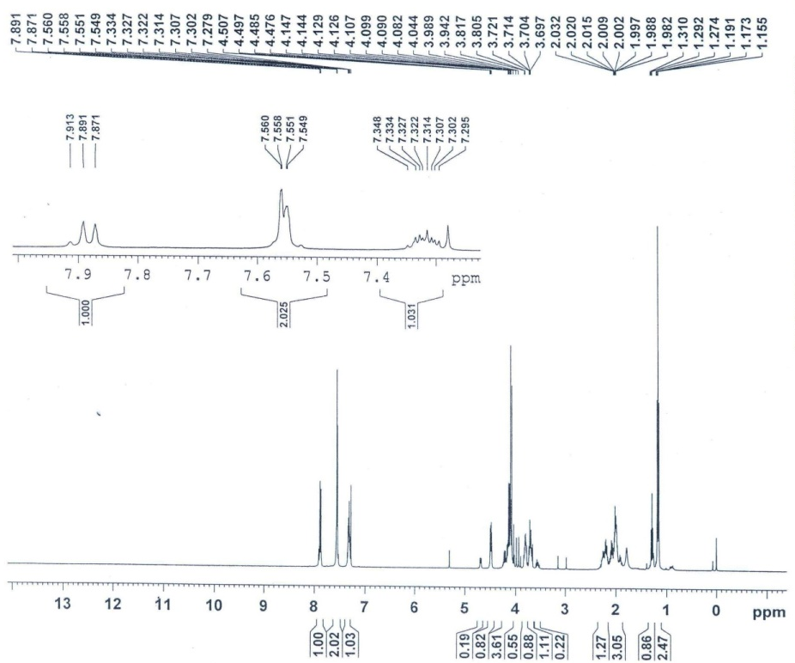
¹³C-NMR of ethyl 1-2-(benzo[d]isoxazol-3-yl)acetyl)pyrrolidine-2-carboxylate (9a)
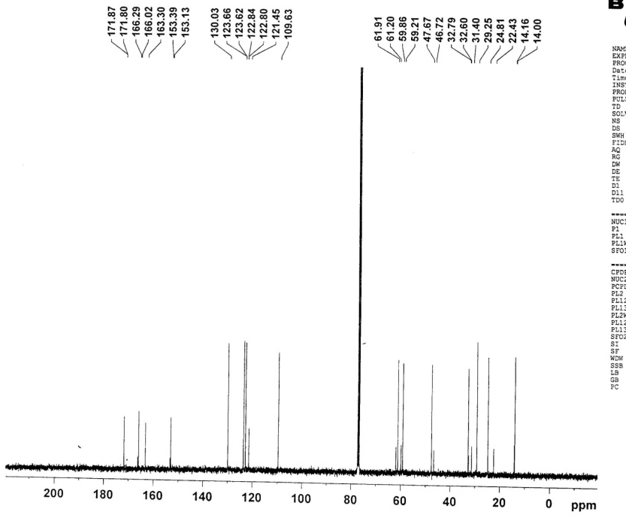

IR of ethyl 1-2-(benzo[d]isoxazol-3-yl)acetyl)pyrrolidine-2-carboxylate (9a)
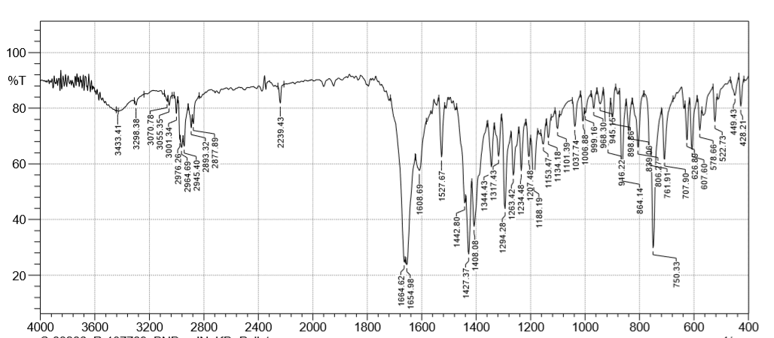

ESI-MS of ethyl 1-2-(benzo[d]isoxazol-3-yl)acetyl)pyrrolidine-2-carboxylate (9a)

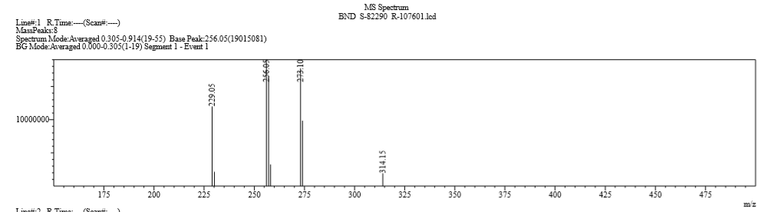

¹H-NMR of 1-(2-(Benzo[d]isoxazol-3-yl)acetyl)pyrrolidine-2-carboxamide (9b)
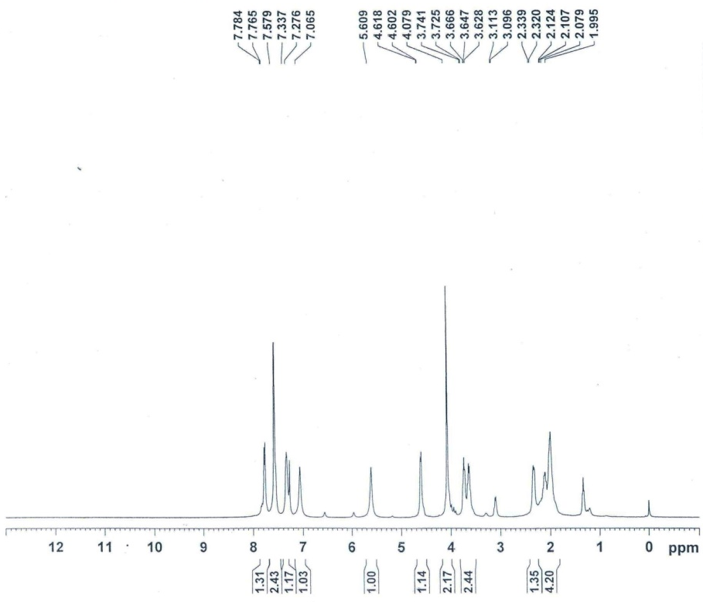
¹³C-NMR of 1-(2-(Benzo[d]isoxazol-3-yl)acetyl)pyrrolidine-2-carboxamide (9b)
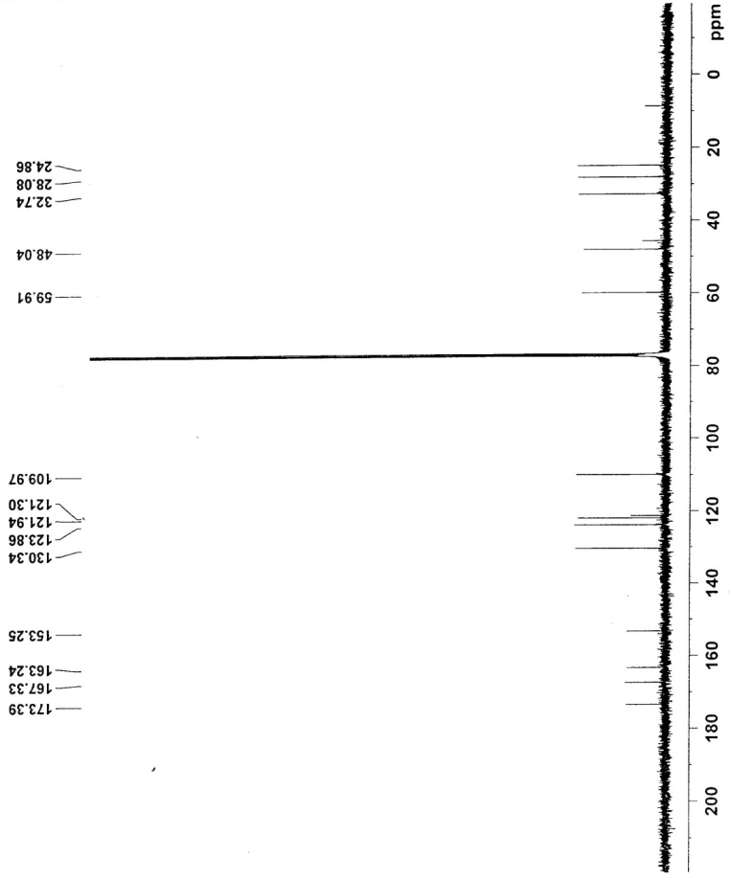
IR of 1-(2-(Benzo[d]isoxazol-3-yl)acetyl)pyrrolidine-2-carboxamide (9b)

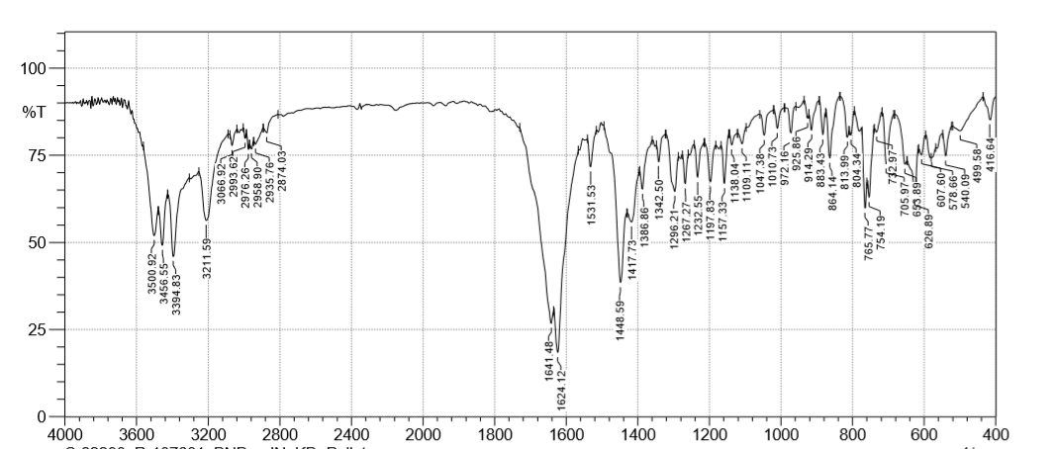

ESI-MS of 1-(2-(Benzo[d]isoxazol-3-yl)acetyl)pyrrolidine-2-carboxamide (9b)

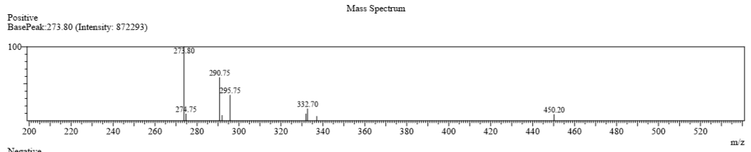

¹H-NMR of 1-(2-(Benzo[d]isoxazol-3-yl)acetyl)pyrrolidine-2-carbonitrile (9c) 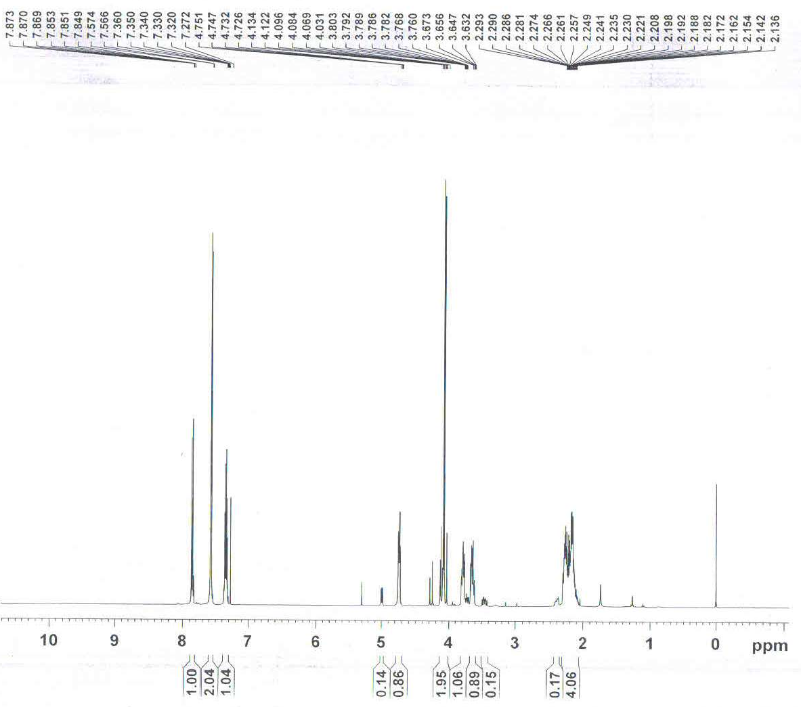
¹³C-NMR of 1-(2-(Benzo[d]isoxazol-3-yl)acetyl)pyrrolidine-2-carbonitrile (9c)
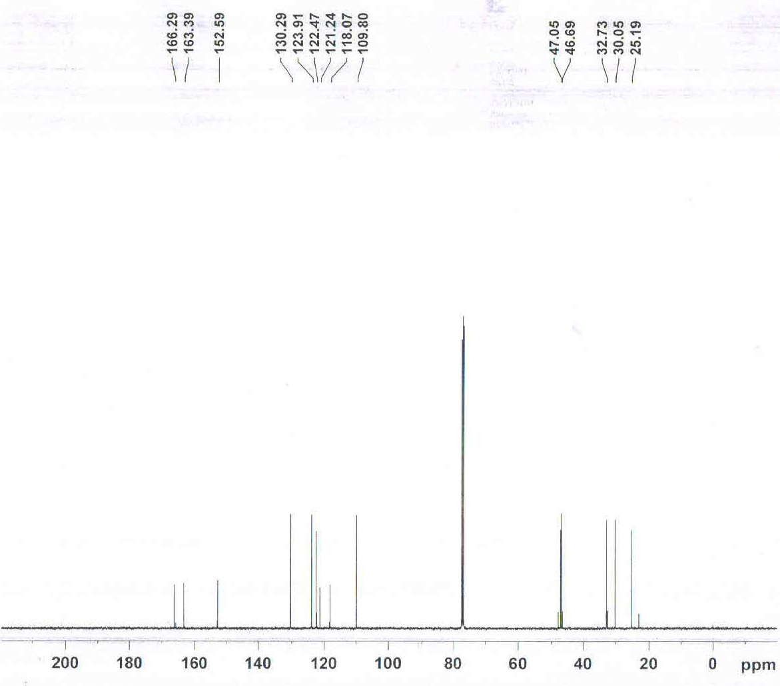

IR of 1-(2-(Benzo[d]isoxazol-3-yl)acetyl)pyrrolidine-2-carbonitrile (9c)

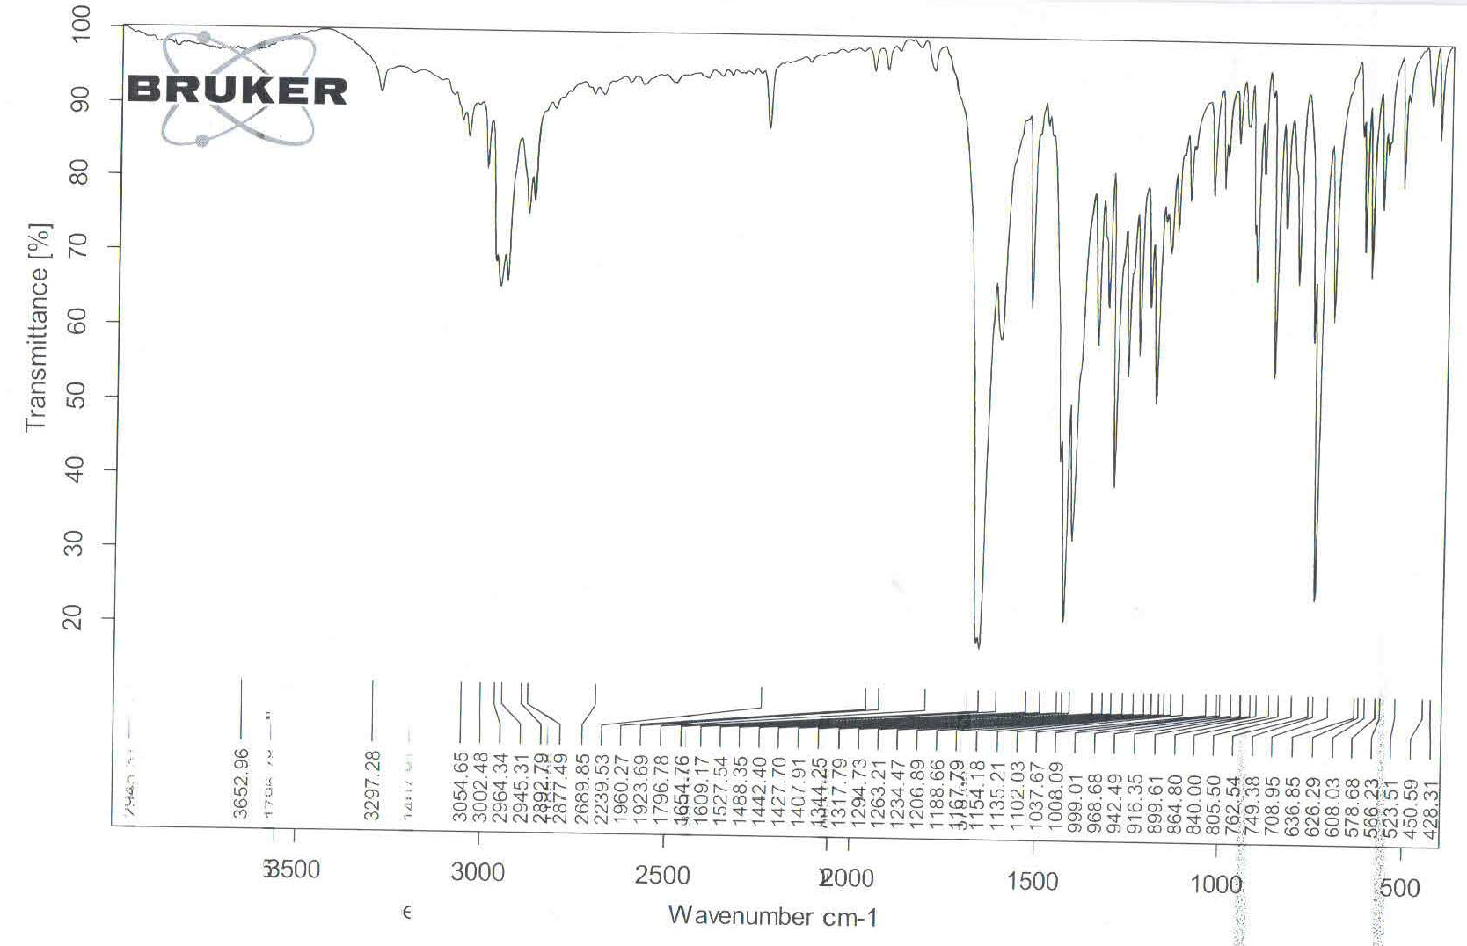

ESI-MS of 1-(2-(Benzo[d]isoxazol-3-yl)acetyl)pyrrolidine-2-carbonitrile (9c)
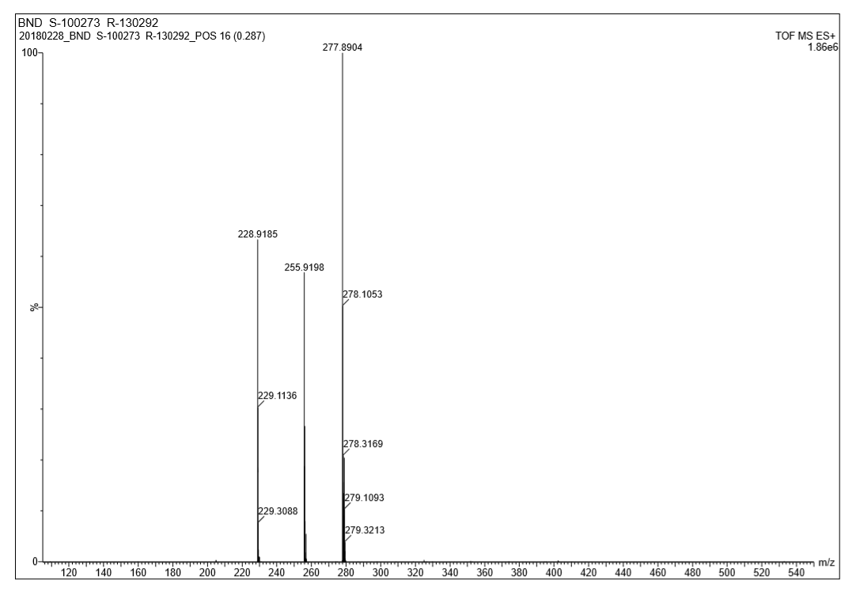
¹H-NMR of 2-(Benzo[d]isoxazol-3-yl)-N-(pyridin-3-ylmethyl)acetamide (9d) 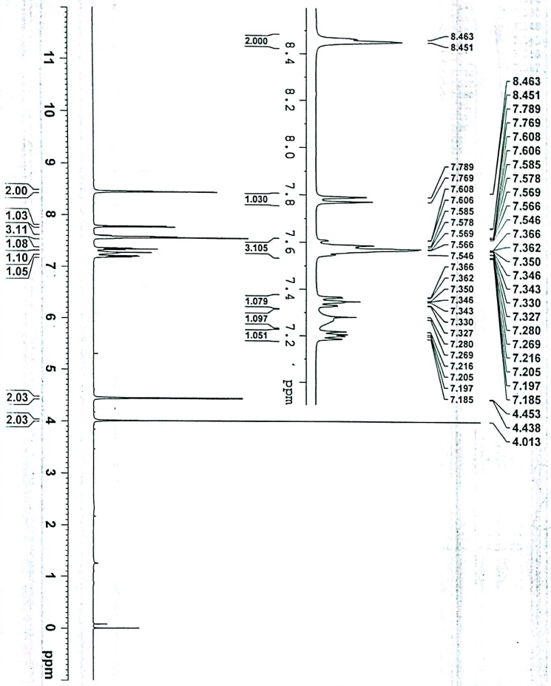
¹³C-NMR of 2-(Benzo[d]isoxazol-3-yl)-N-(pyridin-3-ylmethyl)acetamide (9d)
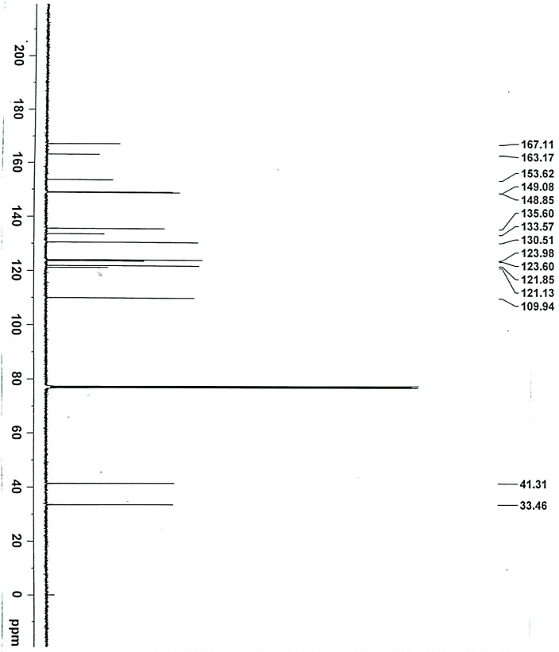

IR of 2-(Benzo[d]isoxazol-3-yl)-N-(pyridin-3-ylmethyl)acetamide (9d)
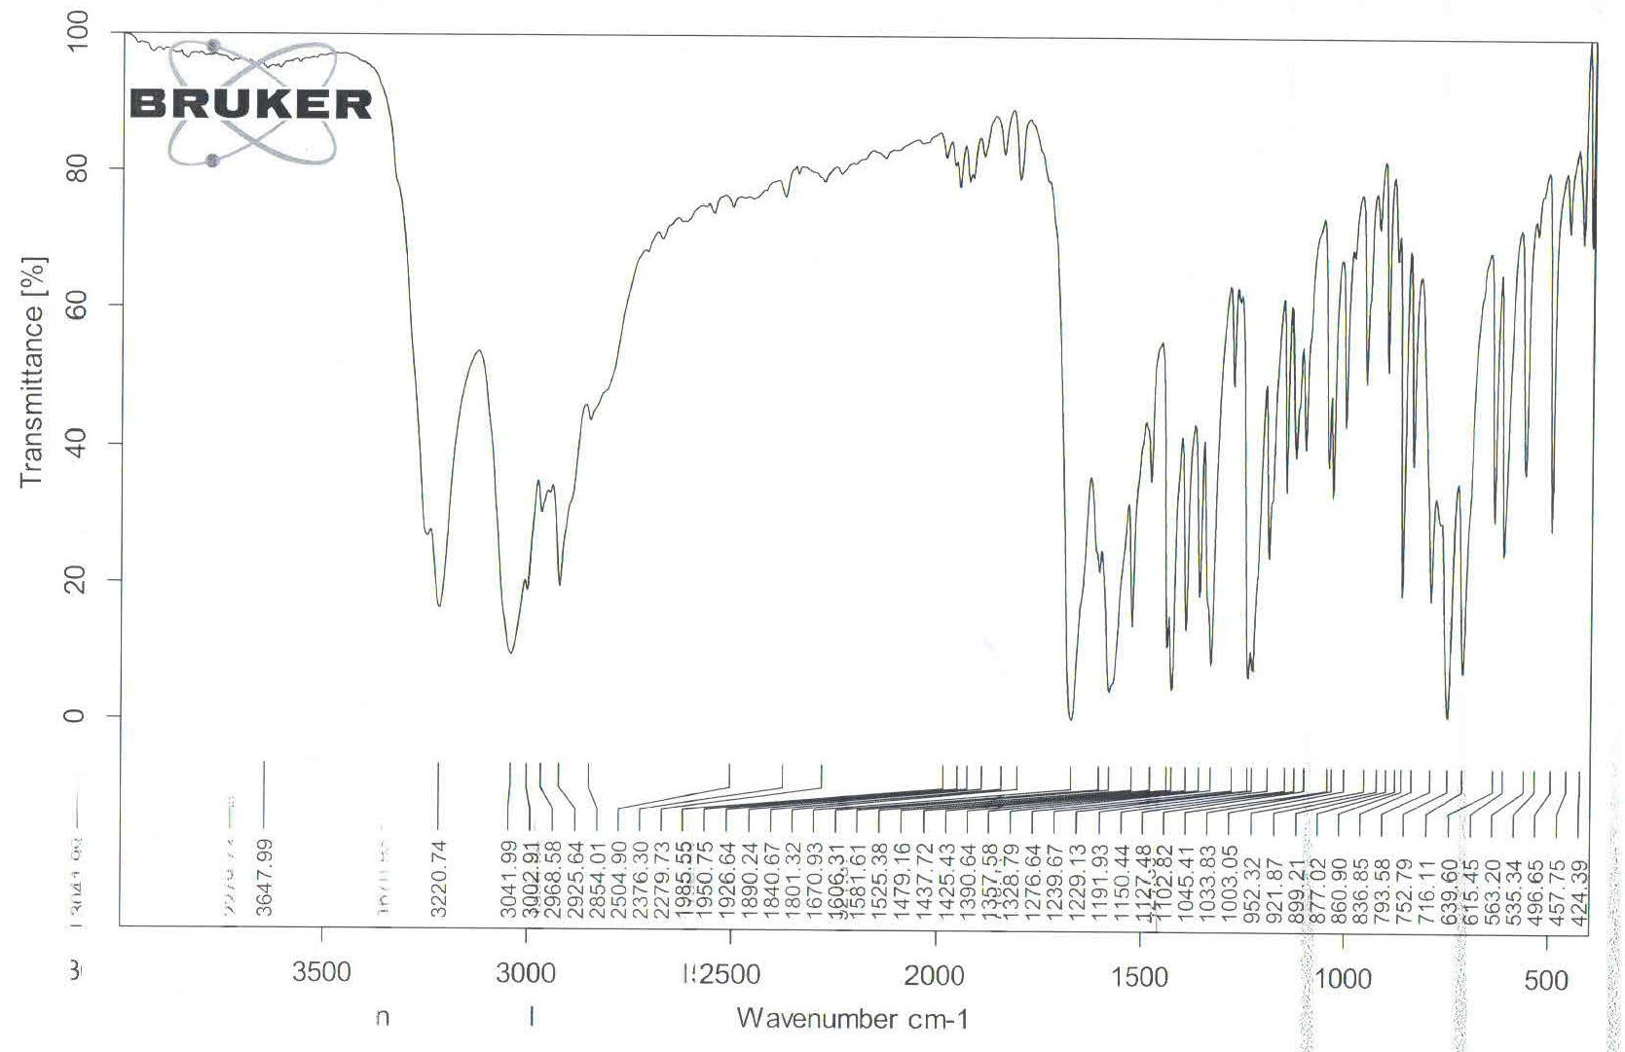

ESI-MS of 2-(Benzo[d]isoxazol-3-yl)-N-(pyridin-3-ylmethyl)acetamide (9d)
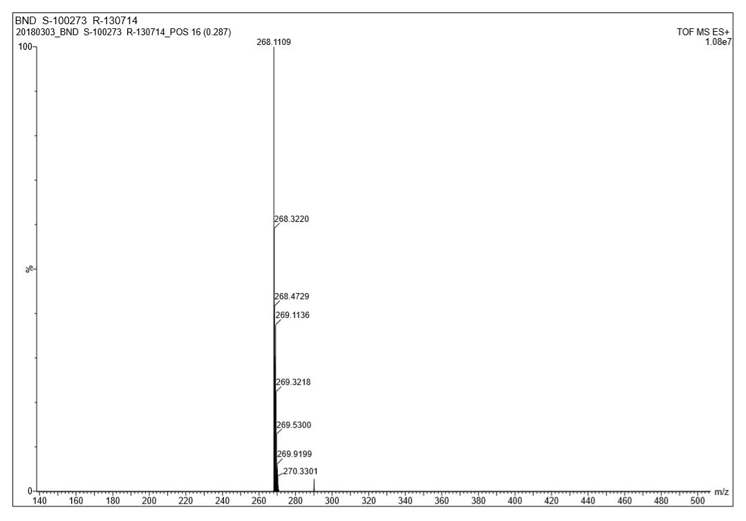

¹H-NMR of 2-(Benzo[d]isoxazol-3-yl)-N-(2-oxo-2-(p-tolylamino)ethyl)acetamide (11a) 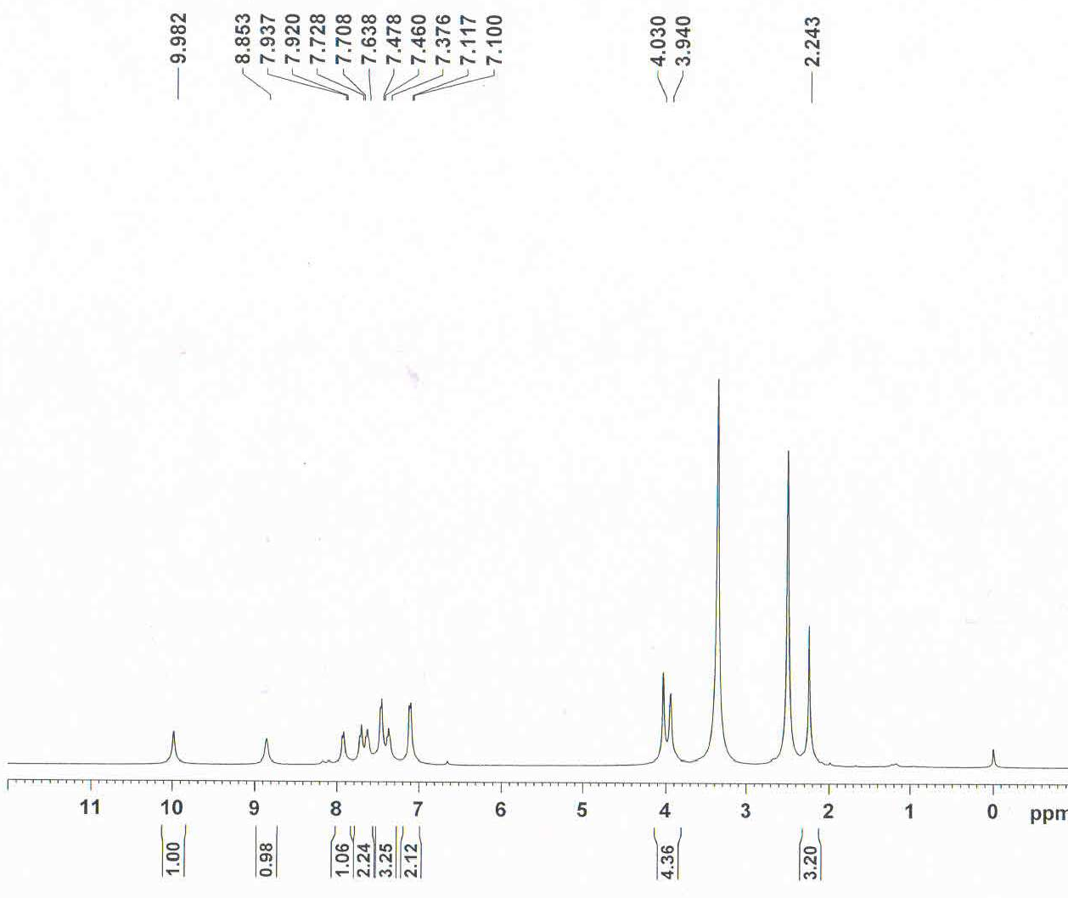
¹³C-NMR of 2-(Benzo[d]isoxazol-3-yl)-N-(2-oxo-2-(p-tolylamino)ethyl)acetamide (11a)
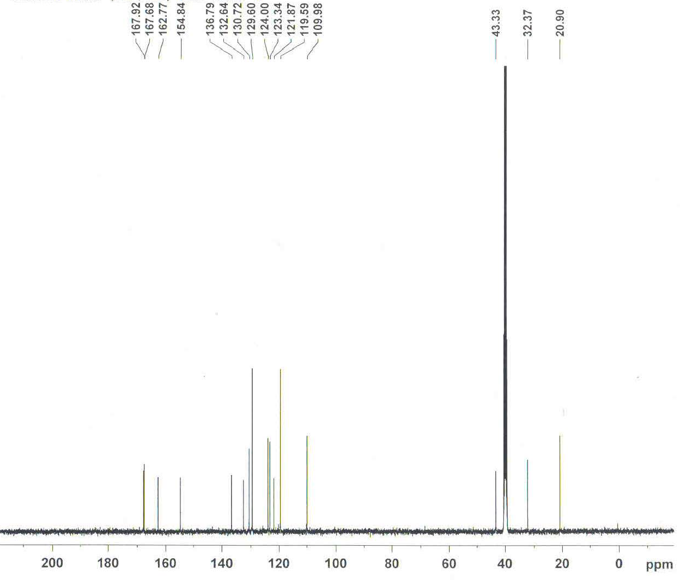
IR of 2-(Benzo[d]isoxazol-3-yl)-N-(2-oxo-2-(p-tolylamino)ethyl)acetamide (11a)
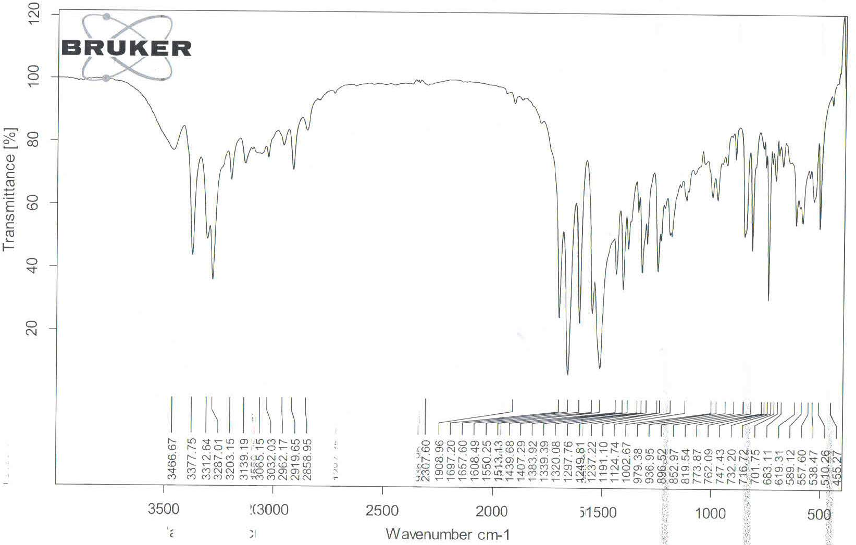
ESI-MS of 2-(Benzo[d]isoxazol-3-yl)-N-(2-oxo-2-(p-tolylamino)ethyl)acetamide (11a)
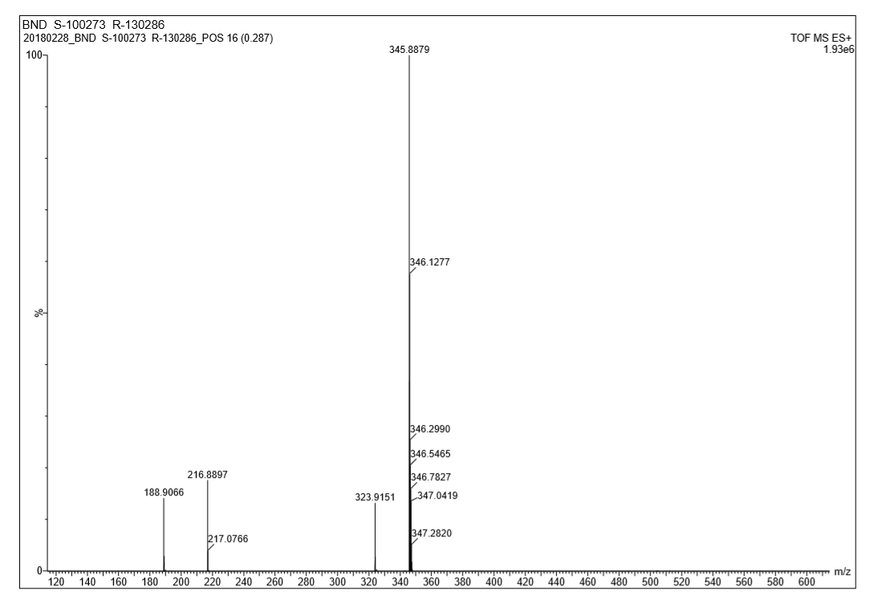

¹H-NMR of 2-(Benzo[d]isoxazol-3-yl)-N-(2-((4-fluorophenyl)amino)-2-oxoethyl)acetamide (11b)
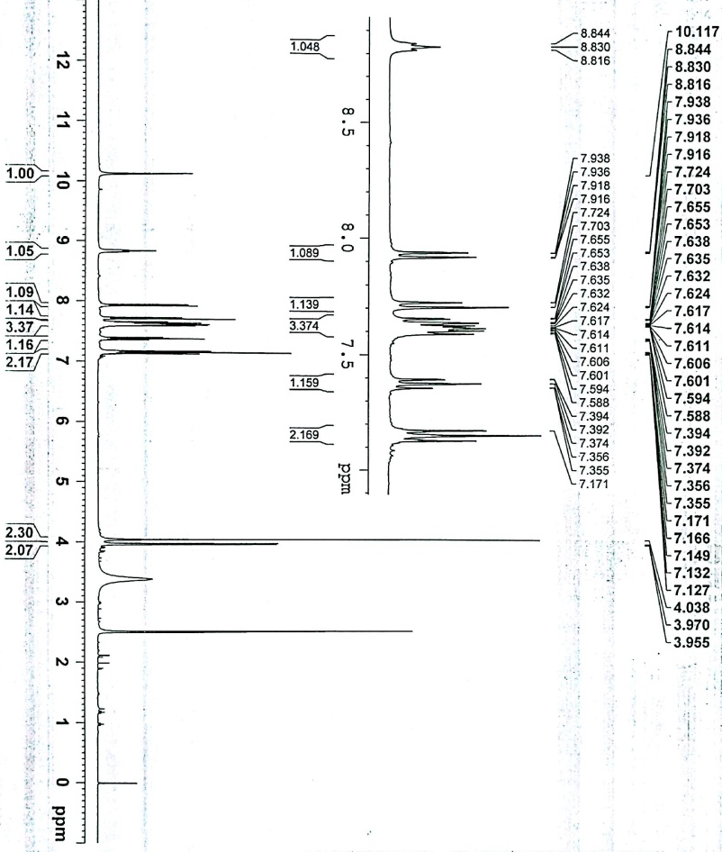
¹³C-NMR of 2-(Benzo[d]isoxazol-3-yl)-N-(2-((4-fluorophenyl)amino)-2-oxoethyl)acetamide (11b)
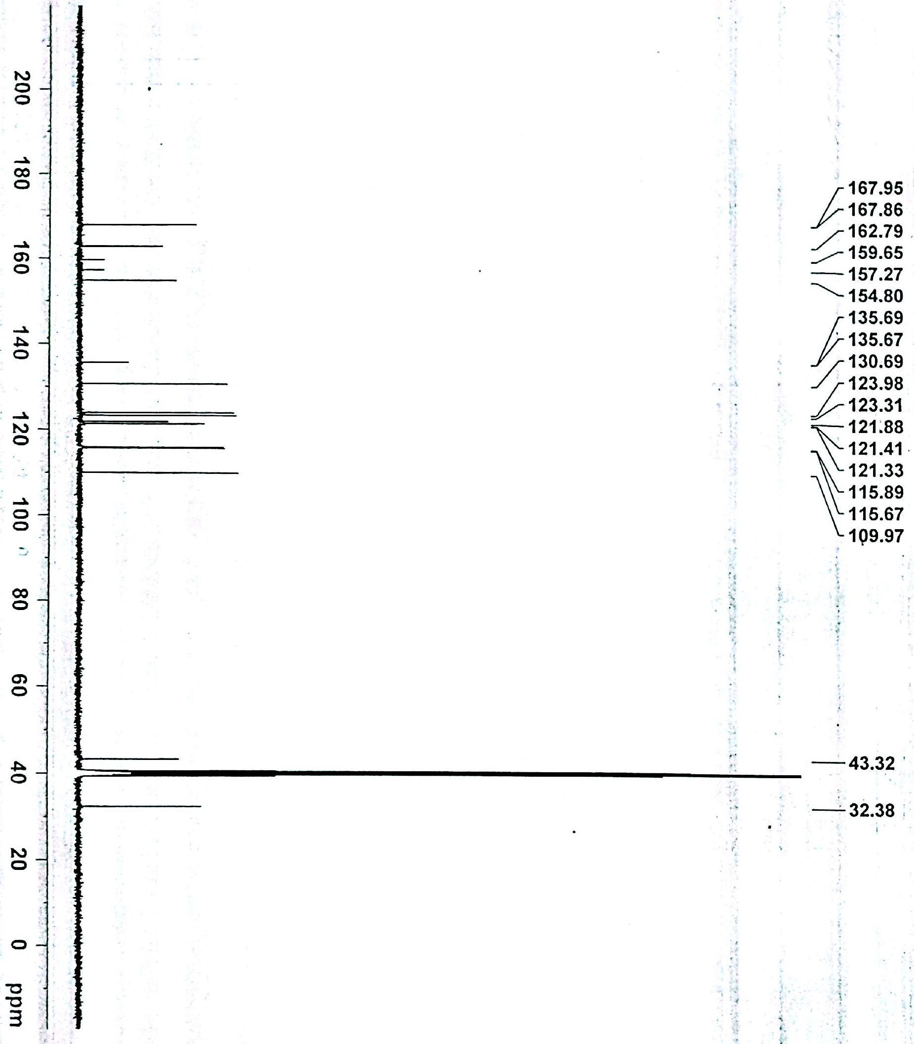

IR of 2-(Benzo[d]isoxazol-3-yl)-N-(2-((4-fluorophenyl)amino)-2-oxoethyl)acetamide (11b)
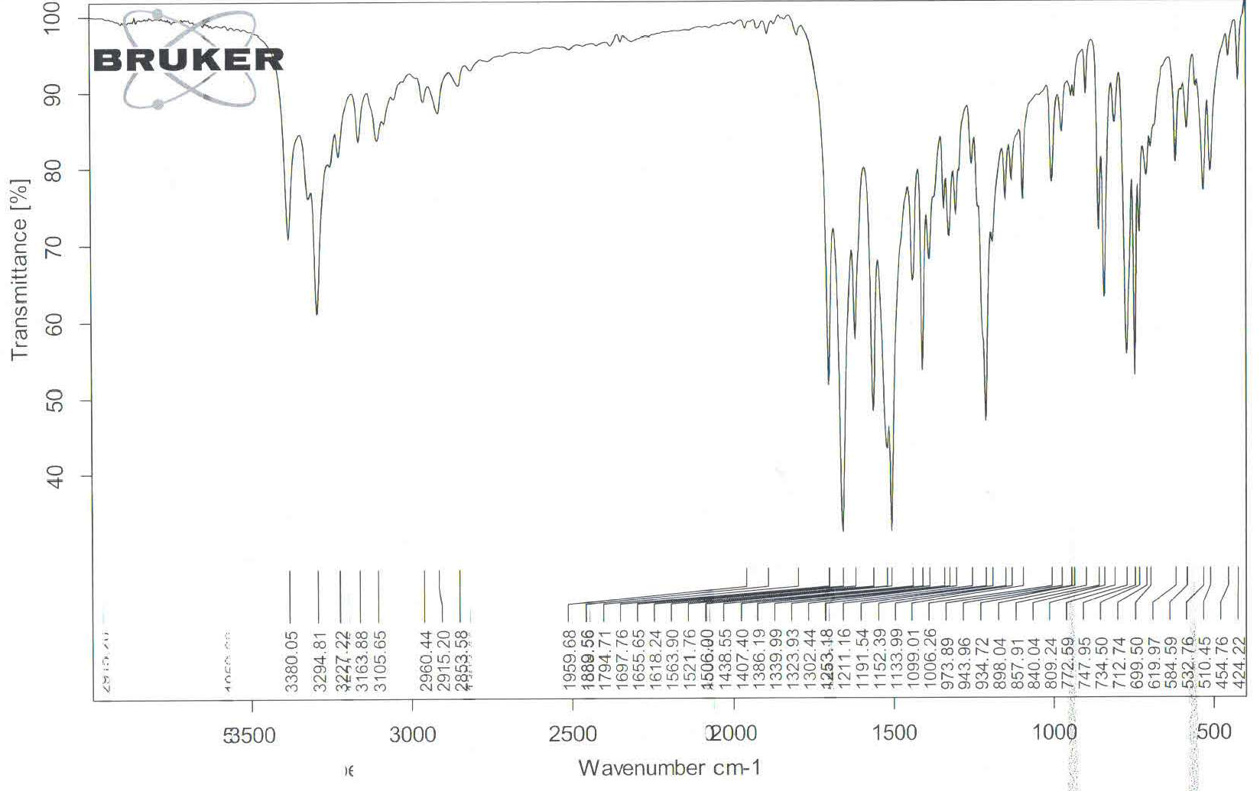
ESI-MS of 2-(Benzo[d]isoxazol-3-yl)-N-(2-((4-fluorophenyl)amino)-2-oxoethyl)acetamide (11b)
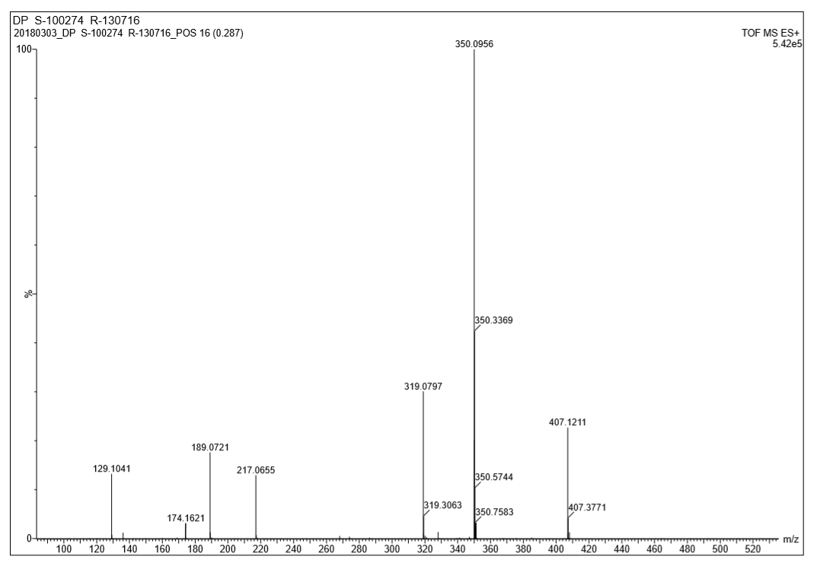
¹H-NMR of 2-(Benzo[d]isoxazol-3-yl)-N-(2-((4-chlorophenyl)amino)-2-oxoethyl)acetamide (11c)
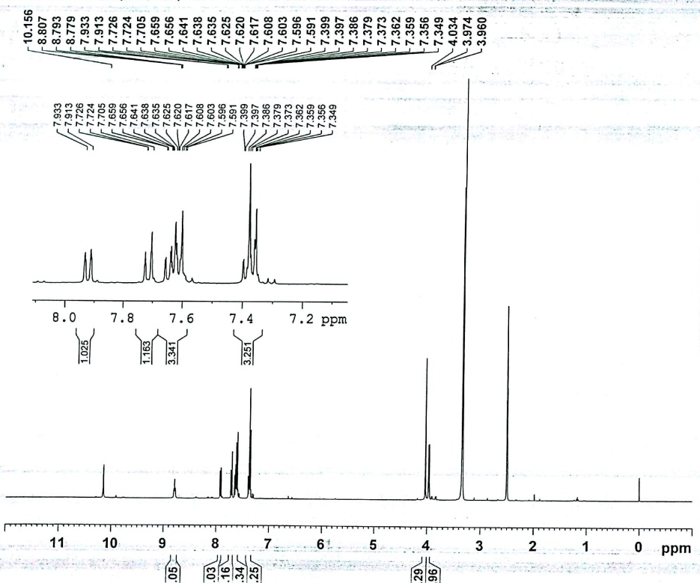
¹³C-NMR of 2-(Benzo[d]isoxazol-3-yl)-N-(2-((4-chlorophenyl)amino)-2-oxoethyl)acetamide (11c)
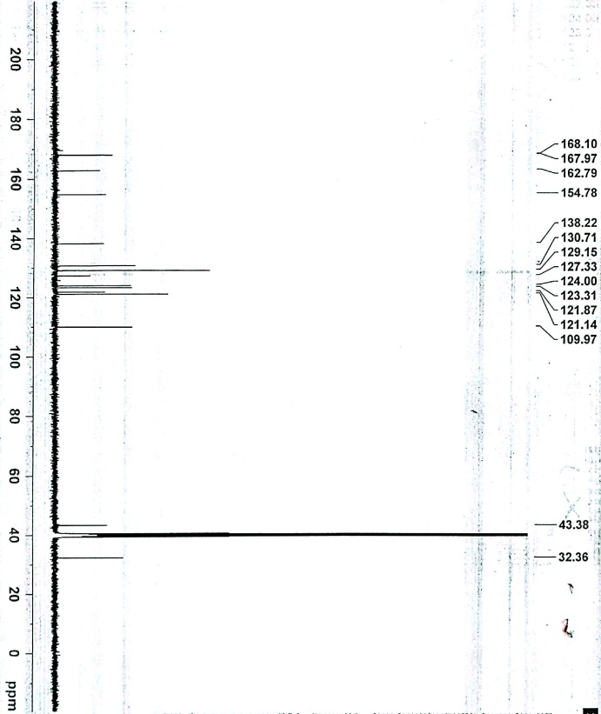

IR of 2-(Benzo[d]isoxazol-3-yl)-N-(2-((4-chlorophenyl)amino)-2-oxoethyl)acetamide (11c)
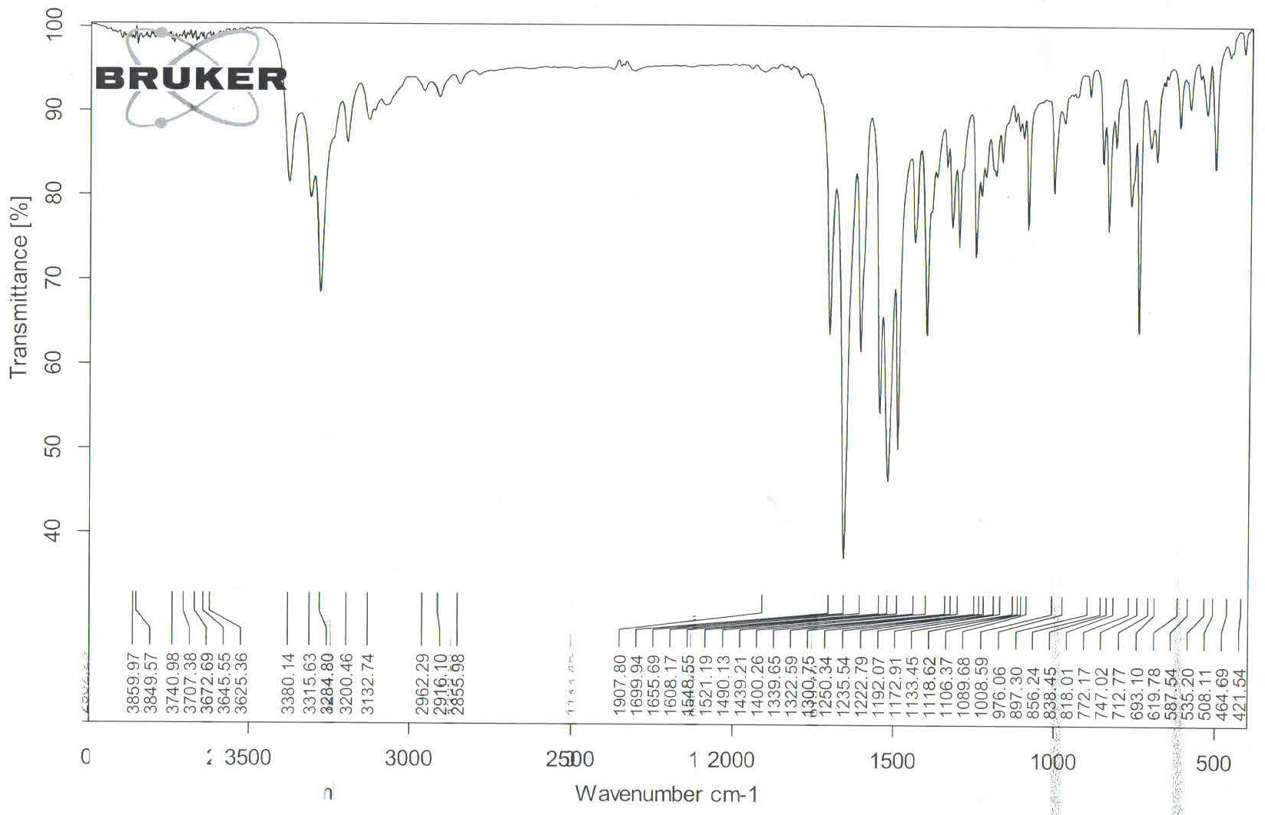
ESI-MS of 2-(Benzo[d]isoxazol-3-yl)-N-(2-((4-chlorophenyl)amino)-2-oxoethyl)acetamide (11c)
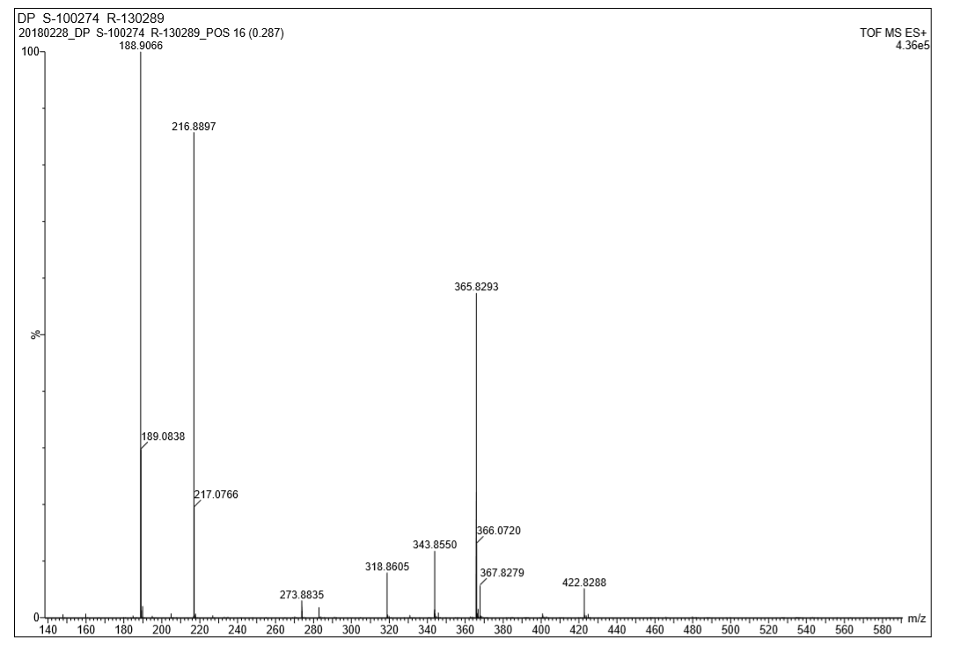
¹H-NMR of 2-(Benzo[d]isoxazol-3-yl)-N-(2-((3-fluorophenyl)amino)-2-oxoethyl)acetamide (11d)
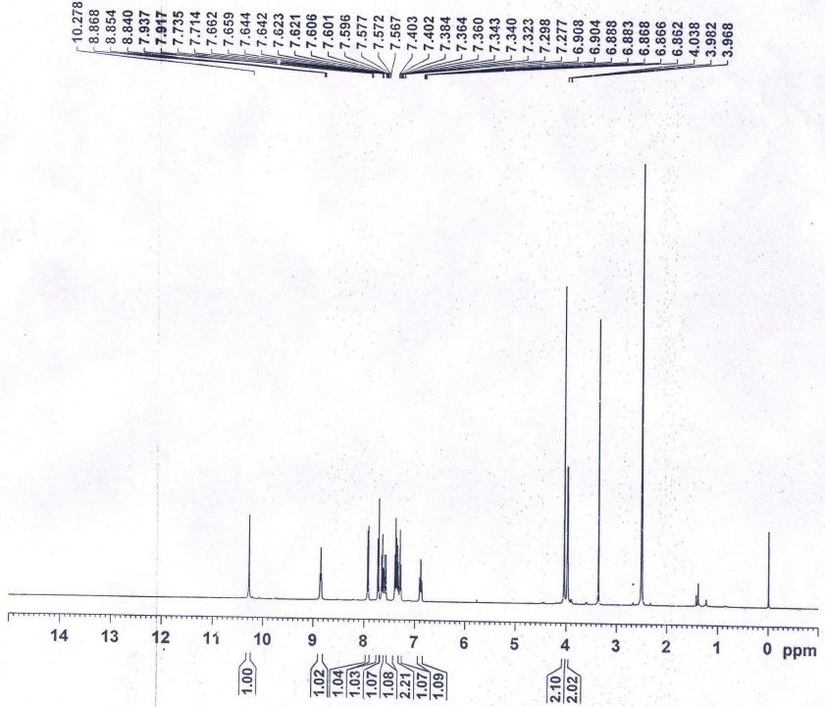
¹³C-NMR of 2-(Benzo[d]isoxazol-3-yl)-N-(2-((3-fluorophenyl)amino)-2-oxoethyl)acetamide (11d)
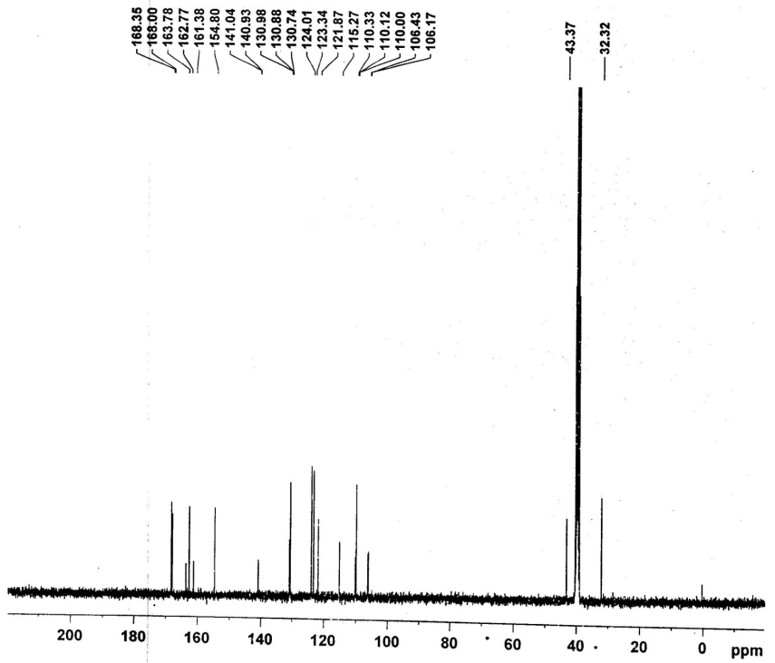
IR of 2-(Benzo[d]isoxazol-3-yl)-N-(2-((3-fluorophenyl)amino)-2-oxoethyl)acetamide (11d)
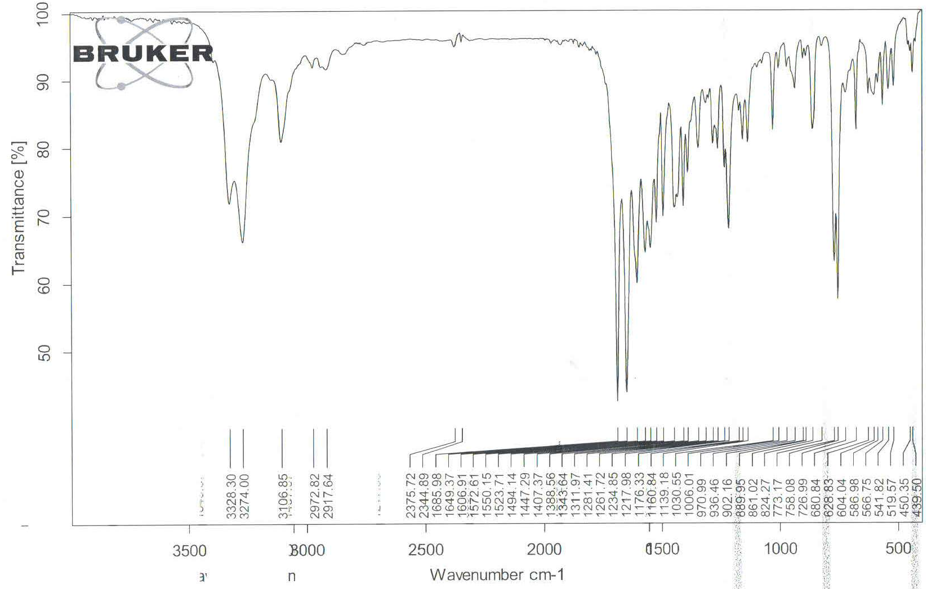
ESI-MS of 2-(Benzo[d]isoxazol-3-yl)-N-(2-((3-fluorophenyl)amino)-2-oxoethyl)acetamide (11d)
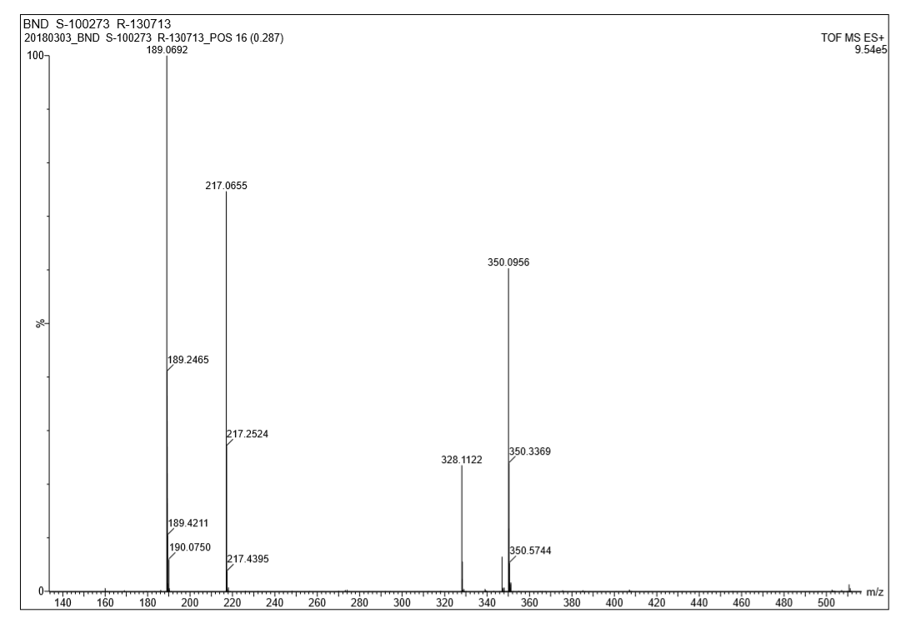

¹H-NMR of 2-(Benzo[d]isoxazol-3-yl)-N-(2-((3-chlorophenyl)amino)-2-oxoethyl)acetamide (11e)
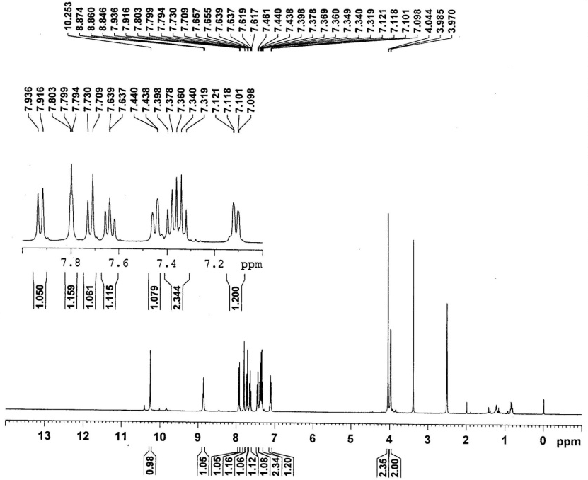
¹³C-NMR 2-(Benzo[d]isoxazol-3-yl)-N-(2-((3-chlorophenyl)amino)-2-oxoethyl)acetamide (11e)
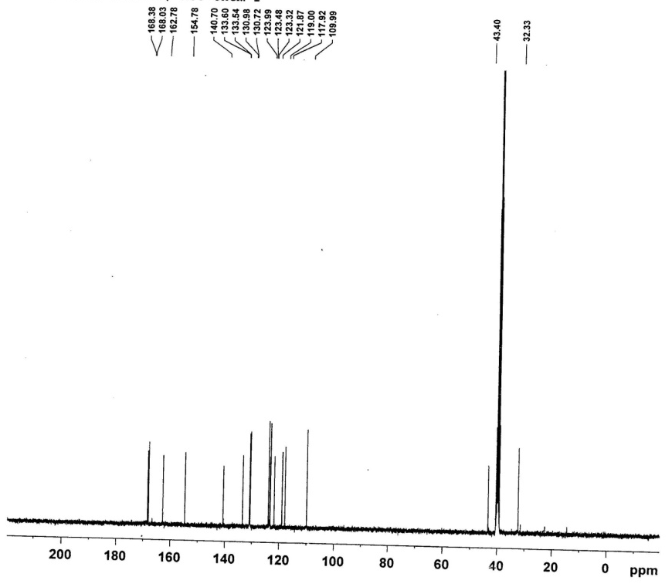
IR of 2-(Benzo[d]isoxazol-3-yl)-N-(2-((3-chlorophenyl)amino)-2-oxoethyl)acetamide (11e)
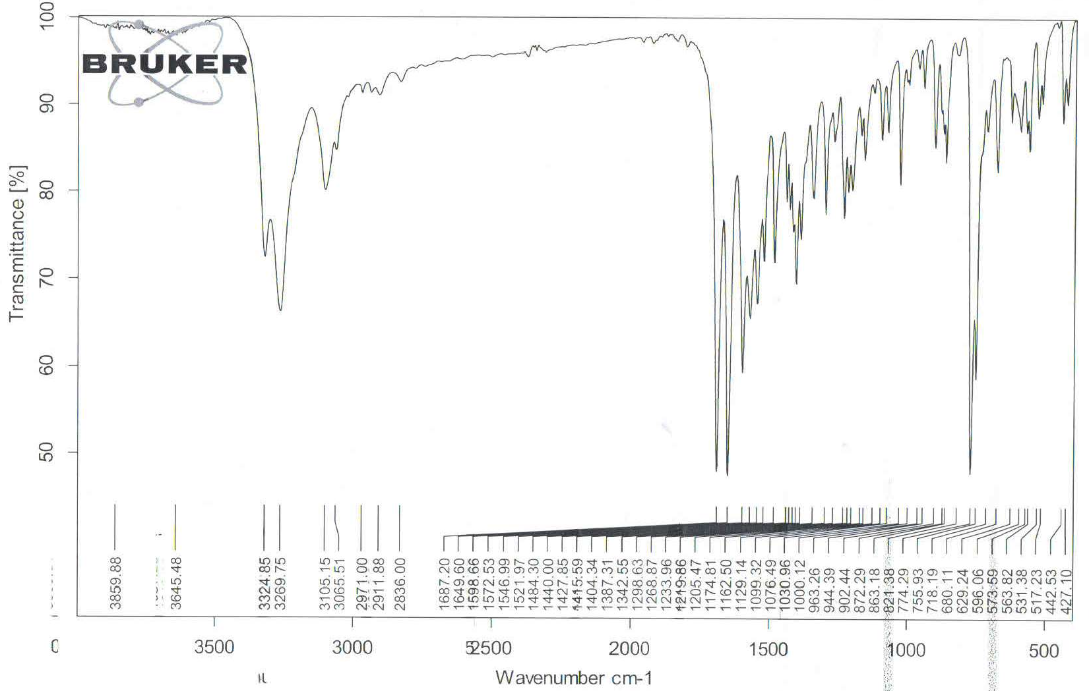
ESI-MS of 2-(Benzo[d]isoxazol-3-yl)-N-(2-((3-chlorophenyl)amino)-2-oxoethyl)acetamide (11e)

