Supplementary Material

Computational prediction on photophysical properties of two excited state intramolecular proton transfer (ESIPT) fluorophores bearing the benzothiazole group
Keke Wen, Xugeng Guo*, and Jinglai Zhang*
Department of Chemistry, College of Chemistry and Chemical Engineering, Henan University, Kaifeng 475004, People’s Republic of China

Correspondence
Xugeng Guo, Jinglai Zhang, College of Chemistry and Chemical Engineering, Henan University, Kaifeng 475004, P.R. China
*E-mail: xgguo@henu.edu.cn (X.G.); zhangjinglai@henu.edu.cn (J.Z.)

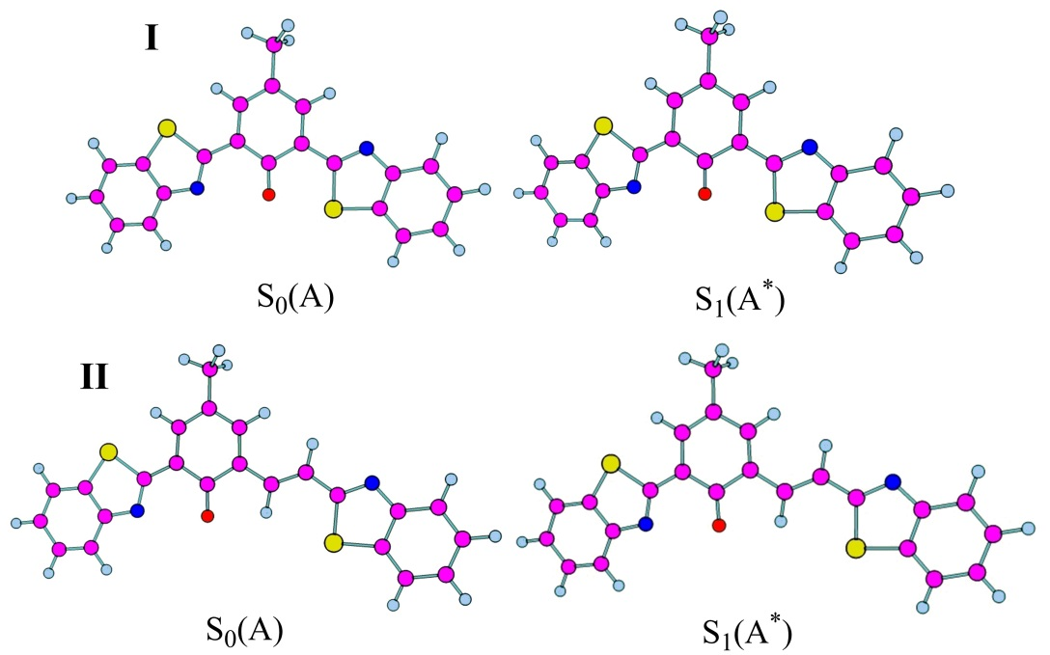
Figure S1. PBE0/TD-PBE0 optimized S₀ and S₁ structures of deprotonated anion conformers.

Table S1. Absorption and emission wavelengths (λ, in nm) and the corresponding oscillator strengths (f) of molecules I and II obtained by the TD-PBE0 calculations in combination with a PCM model using hexane and DMF as solvents, respectively, along with previously computational results and experimentally available data.
Conformer | Transitionª | Solvent | λ_{cal}ª | fª | λ_{cal}^{b} | f^{b} | λ_{exp}
I
S₀(E) | S₀ → S₁ | Hexane | 367 | 0.57 | 367 | 0.40 | 369^{c}
 | S₀ → S₂ | Hexane | 322 | 0.28 | - | - | 330^{c}
S₀(A) | S₀ → S₁ | DMF | 459 | 0.77 | 516 | 0.67 | 491^{c}
 | S₀ → S₄ | DMF | 323 | 0.16 | - | - | 325^{c}
S₁(K*) | S₁ → S₀ | Hexane | 560 | 0.41 | 624 | 0.28 | 568^{c}
S₁(A*) | S₁ → S₀ | DMF | 491 | 0.79 | 560 | 0.53 | 516^{c}
II
S₀(E) | S₀ → S₁ | Hexane | 403 | 0.96 | 389 | 0.71 | 383^{d}
 | S₀ → S₂ | Hexane | 340 | 0.22 | - | - | 312^{d}
S₀(A) | S₀ → S₁ | DMF | 547 | 0.98 | 586 | 0.83 | 528^{d}
 | S₀ → S₄ | DMF | 360 | 0.34 | - | - | 372^{d}
 | S₀ → S₁₀ | DMF | 296 | 0.44 | - | - | 306^{d}
S₁(E*) | S₁ → S₀ | Hexane | 475 | 0.90 | - | - | -
S₁(K*) | S₁ → S₀ | Hexane | 616 | 0.63 | 633 | 0.44 | 626^{d}
S₁(A*) | S₁ → S₀ | DMF | 582 | 0.84 | 648 | 0.63 | 616^{d}
ª TD-PBE0/6-311+G(d,p) calculations from this work.
^{b} TD-B3LYP/6-31+G(d,p) calculations from previous work [1].
^{c} Experimental values from Ref. [2].
^{d} Experimental values from Ref. [1].

References
[1] X. Zhang, J.-Y. Liu, W.-W. Ma, and M.-L. Yang, J. Mater. Chem. B 4 6662 (2016).
[2] X. Zhang and J-Y. Liu, Dyes Pigm. 125 80 (2016).

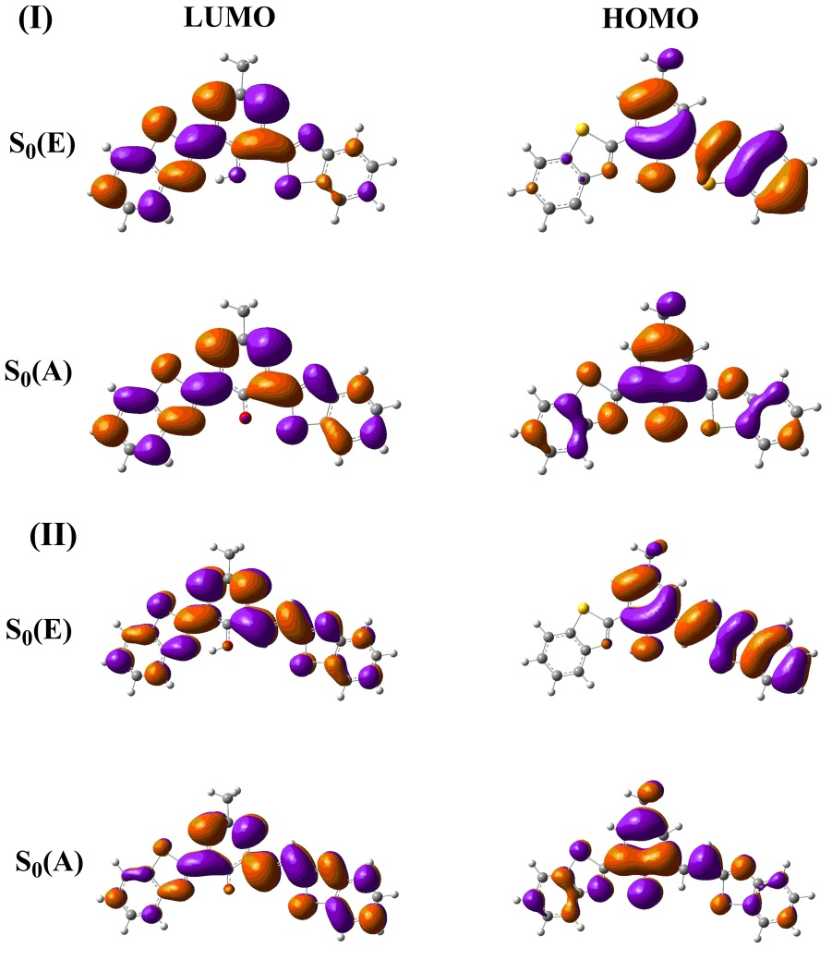
Figure S2. Frontier molecular orbitals for the investigated molecules in the ground state.

