Supplementary Material

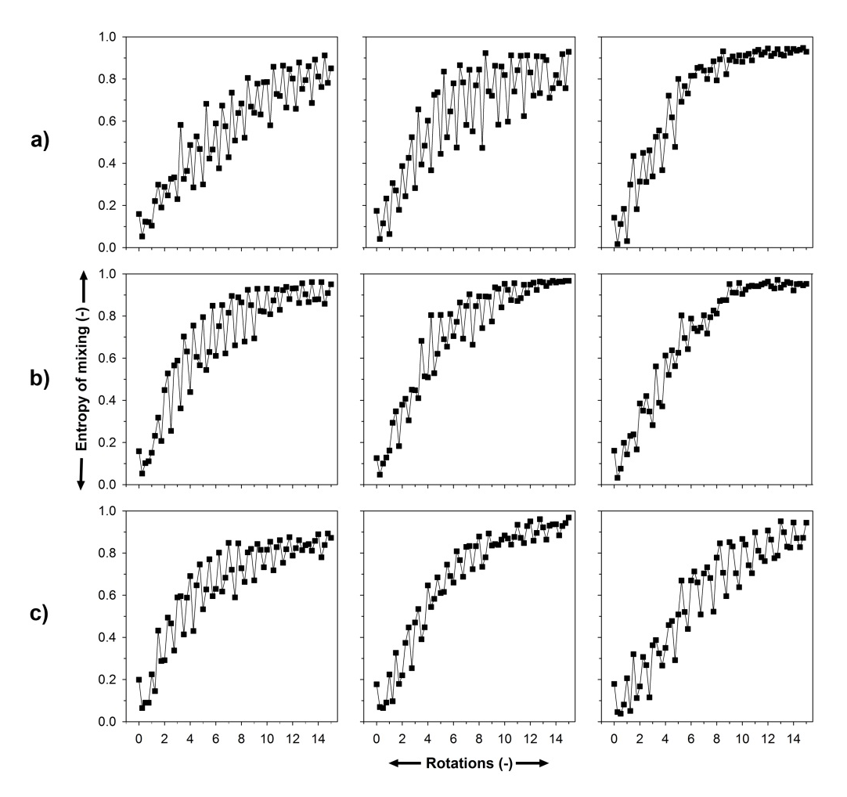
Figure S1. Scatter plot of the left segment for the fill levels a) 60% ,b) 70% ,c) 80%

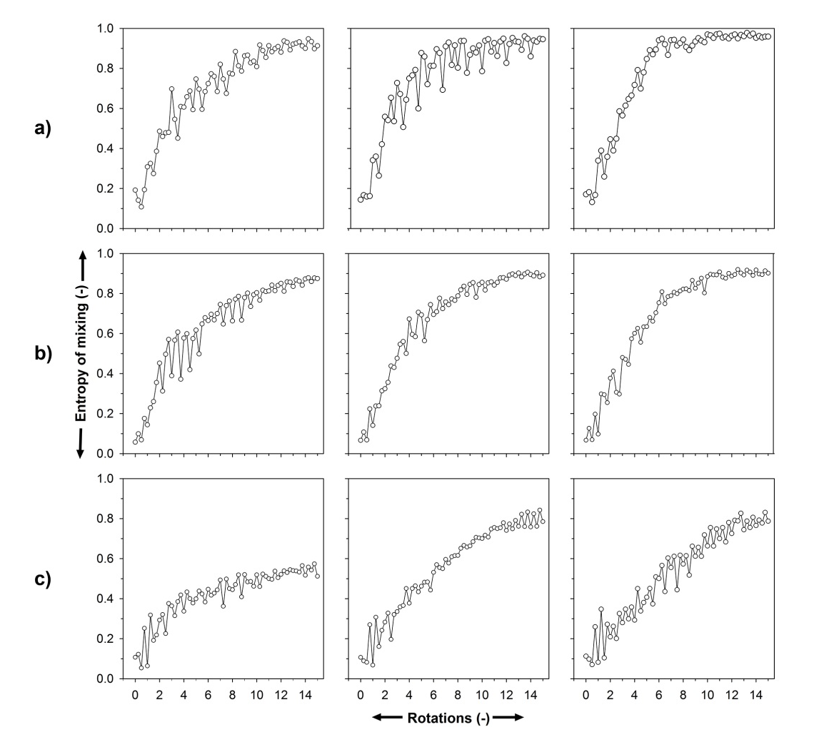
Figure S2. Scatter plot of the centre segment for the fill levels a) 60% ,b) 70% ,c) 80%

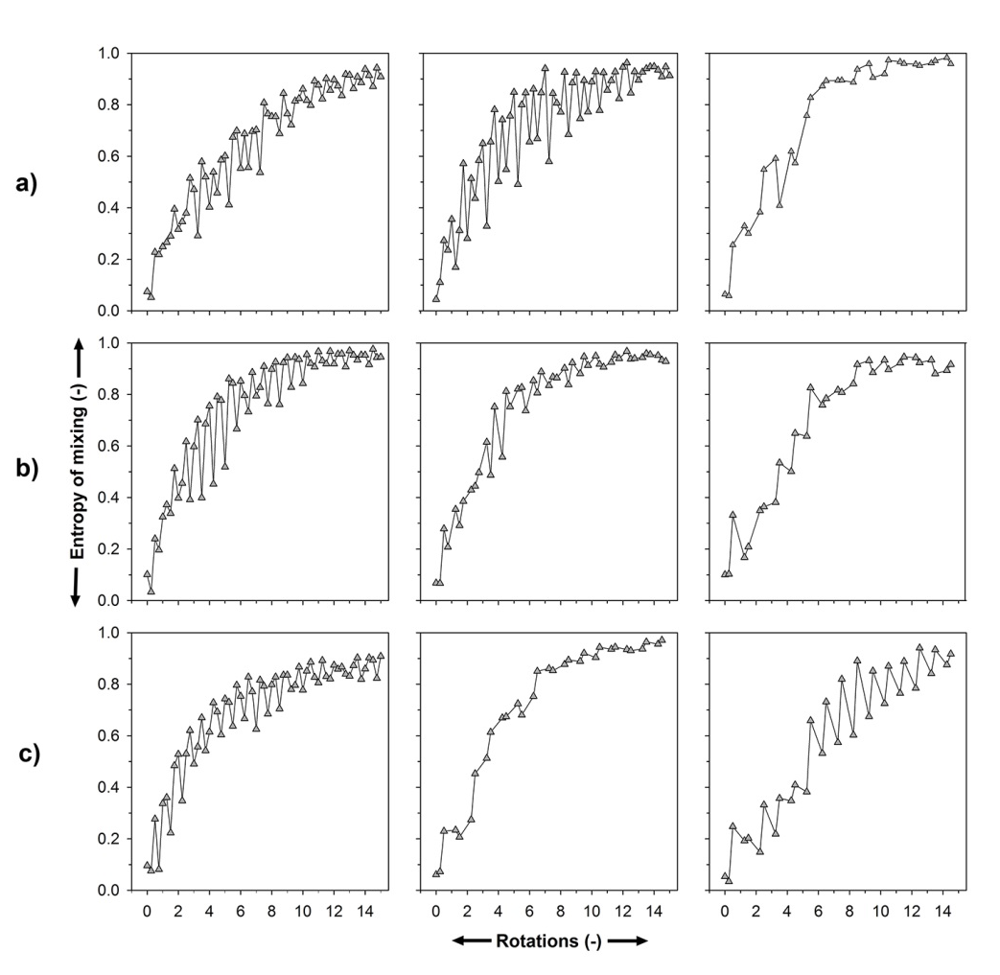
Figure S3. Scatter plot of the right segment for the fill levels a) 60% ,b) 70% ,c) 80%

